# Programming Example Task

## Goal

Provide a rest service written in Java, using spring boot with a gradle build file that provides the following endpoints:

[Anand] – I am providing code with gradle as well as maven files. I had to use maven since using gradle plug-in I was able to package War file but for debugging, I was not able to attach external debugger to tomcat process.

1. GET : http://<server_url>/math/add?n1=<numeric param 1>&n2=<numeric param 2>
2. POST : http://<server_url>/math/add (allow for form params 1&2 in a POST body)
3. GET : http://<server_url>/time/now

1 and 2 add two numbers. 3 should fetch time for MST at time of call from another service (<https://www.developer.aero/WaitTime-API/Try-it-Now> for YYC is a free one) and simplify the result to timezone and current time. Return the result or the timestring in a rational JSON document.

[Anand] – I am not able to access below REST API. Even after registering, system does not guild me to get free API key. It says to contact Ashish Kapoor. So, I have implemented integration with other public API. Data accuracy was not intention while implementing integration.

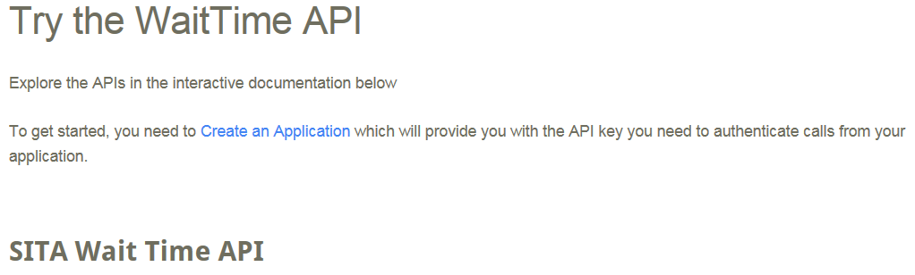

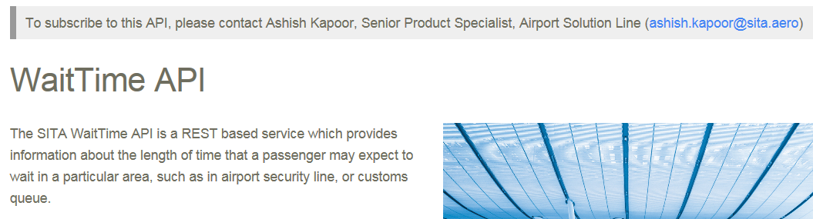

## 

## Artifacts

The resulting server should be supplied with the following:

* A set of integration tests asserting server functionality (postman test suites, restassured tests or bash scripts preferred)
  + - [Anand] here are add (GET) test results
    - [Anand] here are add (POST) test results
    - Did not have preferred tools. Since I already had Fiddler set-up providing fiddler logs
    - In Spring boot, there is very good Integration as well as Unit test support. This helps in CICD pipeline as well. Git Commit -> Build with tests on -> Code Analysis -> publish in artifactory.
* Documentation detailing instructions for running the service (preferably on AWS or a cloud instance)
  + - [Anand] Since Spring boot is used, application cab be packaged in JAR as well as WAR file. Development and testing work was done using WAR packaging since it makes debugging part easy.
    - For deploying on cloud application should be packaged as JAR and just by using JAVA –JAR application.jar command deployment can be done
* Documentation detailing any service design, security choices regarding api keys or credentials or implementation preferences
  + - [Anand] – in demo application, key is read from prop file.
    - In real app, it can be read from config server
    - In general for other security concerns, Spring Security module should be implemented to address cross cutting security concerns. Spring Security has multiple options to integrate with various systems like LDAP, AD, SAML as well as OAuth2.
    - Specifics can be decided after more knowledge of what kind of authentication server/system is in place and if authentication is within organization or external.
* A link to the github repository containing the code
  + - [Anand] - I don’t have Github set-up presently, I will try to make code available on GitHub. Otherwise on google cloud.
* A dockerfile providing packaging as a docker container is optional - if omitted, please provide reasons why in the implementation document.
* Explain how caching could be performed and pros/cons
  + - [Anand] – This aspect depends on the cache level (http level, service level, repository level etc.
    - In general, distributed cache should be preferred over centralized cache which offers scalability by compromising little bit of performance.
    - In-process cache has issue of data duplication over multiple node in cluster scenario where load balance diverts request from node to node so same requests go to different node and populate cache with same contents on different nodes.
    - Multi-layer cache can be implemented as well for optimum performance.
    - Cache policy: write-through policy is better in general keeping data integrity in mind.

## Fiddler traces – GET request and response

GET http://localhost:8090/devtest/math/add?n1=4&n2=-20 HTTP/1.1

User-Agent: Fiddler

Host: localhost:8090

Content-Length: 10

content-type: application/json

**Response:**

HTTP/1.1 200 OK

Server: Apache-Coyote/1.1

Content-Type: application/json;charset=UTF-8

Transfer-Encoding: chunked

Date: Thu, 09 Nov 2017 23:28:29 GMT

{"data":-16.0}

------------------------------------------------------------------

GET http://localhost:8090/devtest/math/add?n1=4&n2=- HTTP/1.1

User-Agent: Fiddler

Host: localhost:8090

Content-Length: 10

content-type: application/json

**Response:**

HTTP/1.1 400 Bad Request

Server: Apache-Coyote/1.1

Content-Type: application/json;charset=UTF-8

Transfer-Encoding: chunked

Date: Thu, 09 Nov 2017 23:28:45 GMT

Connection: close

{"error":{"code":"400","message":"Http Message Conversion Exception","details":"Could not convert http message to target type. Failed to convert value of type 'java.lang.String' to required type 'java.lang.Double'; nested exception is java.lang.NumberFormatException: For input string: \"-\""}}

------------------------------------------------------------------

GET http://localhost:8090/devtest/math/add?n1=4 HTTP/1.1

User-Agent: Fiddler

Host: localhost:8090

Content-Length: 10

content-type: application/json

**Response:**

HTTP/1.1 400 Bad Request

Server: Apache-Coyote/1.1

Content-Type: application/json;charset=UTF-8

Transfer-Encoding: chunked

Date: Thu, 09 Nov 2017 23:28:57 GMT

Connection: close

{"error":{"code":"1103","message":"Missing params in request","details":"Required Double parameter 'n2' is not present"}}

------------------------------------------------------------------

GET http://localhost:8090/devtest/math/add?n1=4&n2=abc HTTP/1.1

User-Agent: Fiddler

Host: localhost:8090

Content-Length: 10

content-type: application/json

**Response:**

HTTP/1.1 400 Bad Request

Server: Apache-Coyote/1.1

Content-Type: application/json;charset=UTF-8

Transfer-Encoding: chunked

Date: Thu, 09 Nov 2017 23:29:16 GMT

Connection: close

{"error":{"code":"400","message":"Http Message Conversion Exception","details":"Could not convert http message to target type. Failed to convert value of type 'java.lang.String' to required type 'java.lang.Double'; nested exception is java.lang.NumberFormatException: For input string: \"abc\""}}

------------------------------------------------------------------

## Fiddler traces – POST request and response

POST http://localhost:8090/devtest/math/add HTTP/1.1

User-Agent: Fiddler

Host: localhost:8090

Content-Length: 17

content-type: application/json

{n1:2.2,n2:3.5}

**Response:**

HTTP/1.1 400 Bad Request

Server: Apache-Coyote/1.1

Content-Type: application/json;charset=UTF-8

Transfer-Encoding: chunked

Date: Thu, 09 Nov 2017 22:34:32 GMT

Connection: close

{"error":{"code":"400","message":"Http Message Conversion Exception","details":"Could not convert http message to target type. JSON parse error: Unexpected character ('n' (code 110)): was expecting double-quote to start field name; nested exception is com.fasterxml.jackson.core.JsonParseException: Unexpected character ('n' (code 110)): was expecting double-quote to start field name\n at [Source: java.io.PushbackInputStream@28173833; line: 2, column: 2]"}}

------------------------------------------------------------------

POST http://localhost:8090/devtest/math/add HTTP/1.1

User-Agent: Fiddler

Host: localhost:8090

Content-Length: 17

content-type: application/json

{n1:2.2,n2:3.5}

**Response:**

HTTP/1.1 400 Bad Request

Server: Apache-Coyote/1.1

Content-Type: application/json;charset=UTF-8

Transfer-Encoding: chunked

Date: Thu, 09 Nov 2017 22:35:02 GMT

Connection: close

{"error":{"code":"400","message":"Http Message Conversion Exception","details":"Could not convert http message to target type. JSON parse error: Unexpected character ('n' (code 110)): was expecting double-quote to start field name; nested exception is com.fasterxml.jackson.core.JsonParseException: Unexpected character ('n' (code 110)): was expecting double-quote to start field name\n at [Source: java.io.PushbackInputStream@5a187e40; line: 2, column: 2]"}}

------------------------------------------------------------------

POST http://localhost:8090/devtest/math/add HTTP/1.1

User-Agent: Fiddler

Host: localhost:8090

Content-Length: 21

content-type: application/json

{'n1':2.2,'n2':3.5}

**Response:**

HTTP/1.1 400 Bad Request

Server: Apache-Coyote/1.1

Content-Type: application/json;charset=UTF-8

Transfer-Encoding: chunked

Date: Thu, 09 Nov 2017 22:35:12 GMT

Connection: close

{"error":{"code":"400","message":"Http Message Conversion Exception","details":"Could not convert http message to target type. JSON parse error: Unexpected character (''' (code 39)): was expecting double-quote to start field name; nested exception is com.fasterxml.jackson.core.JsonParseException: Unexpected character (''' (code 39)): was expecting double-quote to start field name\n at [Source: java.io.PushbackInputStream@238dbfe4; line: 2, column: 2]"}}

------------------------------------------------------------------

POST http://localhost:8090/devtest/math/add HTTP/1.1

User-Agent: Fiddler

Host: localhost:8090

Content-Length: 19

content-type: application/json

{"n1":2.2,"n2":3.5}

**Response:**

HTTP/1.1 200 OK

Server: Apache-Coyote/1.1

Content-Type: application/json;charset=UTF-8

Transfer-Encoding: chunked

Date: Thu, 09 Nov 2017 22:35:48 GMT

{"data":5.7}

------------------------------------------------------------------

POST http://localhost:8090/devtest/math/add HTTP/1.1

User-Agent: Fiddler

Host: localhost:8090

Content-Length: 16

content-type: application/json

{"n1":2.2,"n2":}

**Response:**

HTTP/1.1 400 Bad Request

Server: Apache-Coyote/1.1

Content-Type: application/json;charset=UTF-8

Transfer-Encoding: chunked

Date: Thu, 09 Nov 2017 22:36:08 GMT

Connection: close

{"error":{"code":"400","message":"Http Message Conversion Exception","details":"Could not convert http message to target type. JSON parse error: Unexpected character ('}' (code 125)): expected a value; nested exception is com.fasterxml.jackson.core.JsonParseException: Unexpected character ('}' (code 125)): expected a value\n at [Source: java.io.PushbackInputStream@393b1bda; line: 1, column: 17]"}}

------------------------------------------------------------------

POST http://localhost:8090/devtest/math/add HTTP/1.1

User-Agent: Fiddler

Host: localhost:8090

Content-Length: 10

content-type: application/json

{"n1":2.2}

**Response:**

HTTP/1.1 400 Bad Request

Server: Apache-Coyote/1.1

Content-Type: application/json;charset=UTF-8

Transfer-Encoding: chunked

Date: Thu, 09 Nov 2017 22:36:31 GMT

Connection: close

{"error":{"code":"1102","message":"Invalid parameter provided","details":"Mandatory field is required. field name = 'n2'"}}

------------------------------------------------------------------