**FOREST FIRE PREDICTION**

1.1Introduction:

Predicting what might happen in the future has always been considered as mysterious activity that scientists try to turn into a scientific activity based on well-established theories and mathematical models. In our modern society, prediction can be used in order to test our scientific understanding of the behavior of complex systems or phenomena related to many real-world problems encountered in a variety of fields and applications . It can also be used as a potential guide or basis for decision making, particularly in preventing catastrophes and/or their undesirable consequences. Recently, for example, the entire world has been terrified by the natural catastrophe Japan had witnessed, as well as by the nuclear disaster that has followed it . If this catastrophe were accurately predicted and simple decisions were made in order to prevent the resulting disaster, thousands of human lives would have been preserved and thousands of square miles in a crowded country would have been prevented from becoming uninhabitable for several decades. Unfortunately, it is only after this catastrophe has occurred that other countries, especially France and Germany, has started to seriously look how prediction can be used for preventing similar disasters. Hence, the decision of German government to close seven nuclear reactors suspected of triggering a disaster .In addition to natural and environmental issues, prediction can also be used in many other fields and applications, including finance, medicine, telecommunications, etc. In this paper, we are interested in predicting forest fires, which

is an important real-world problem from which suffer, each year, a great num-

ber of countries and regions throughout the world . And the main object

of this paper is to introduce a novel approach to deal with this problem, which

also seems to be of an overwhelming complexity. This approach is a neural-networks-based heuristic whose description is provided . A brief reminder of artificial neural networks and the used architecture and learning algorithm precede this description. The learning database we used to train the resulting neural network , and examples of illustrating results are presented and discussed . Our conclusionand some suggestions and directions for future work are given .

**1.2 Objectives**

* To improve forest fire prevention in the Alphine territory with the creation of a shared forest fire danger warning system based on metrological conditions affecting fire potential and forestry types mostly prone to forest fires, both in current and in future climate.
* To optimize the forest fire prevention and supression procedures to preserve the alphine forests and gurantre the forest ecosystem services.
* To define common protocol for danger level interpretation, with the univocal European forest fire danger scale establishment and resulting preparedness planning.
* To facilitate modulation and coordination of altering processes and means dislocation in the different regions, reducing fire potentials impact and increasing public awareness.

**1.3 Problem Statement**

Minimize the cost and time to respond to fires by staging firefighting assets as close as possible to where fires are likely to occur.

**2.Review Of Literature**

Literature survey plays a very important role in the project development. Literature survey provides the required knowledge about the project and its background. It also helps in following the best practices in project development. Literature survey also helps in understanding the risk and feasibility of the project. The feasibility of the project depends upon the risk of the project. If the resources, time and money are not available for the project development, then the risk is higher. Literature survey also gives light on various tools, platforms and operating systems suitable for project development. Once programming begins then the programmers require a lot of support and advice.

* In this paper, author describes the capabilities of various algorithms in predicting several weather phenomena such as temperature, windy, humidity, rainfall these parameters concluded that major techniques like decision trees, artificial neural networks, clustering and regression algorithms are suitable to predict weather phenomena. This shows that the decision trees and k-means clustering are best-suited data mining techniques for this application .
* Many authors conclude that classification and summarization are the two main data mining techniques widely use in Weka and Rapid Miner tool for weather forecasting.
* In a prediction model of vegetable price was set by applying the neural network based genetic algorithm. Taking mushrooms price as an example **3.Data Collection**

Forest Fires are affected by several factors such as tempertature ,wind ,RH . It is very difficult to collect data based on these factors; we take only the most permissible forest price as experimental data. For long time forecasting, daily frequency data is preferred. Monthly data are used for forecasting because it has less noise. **4. Random Forest Regression**

The Random Forest is one of the most effective machine learning models for predictive analytics, making it an industrial workhorse for machine learning.

Background

The random forest model is a type of additive model that makes predictions by combining decisions from a sequence of base models. More formally we can write this class of models as:

g(x)=f0(x)+f1(x)+f2(x)+...

where the final model g is the sum of simple base models fi. Here, each base classifier is a simple decision tree. This broad technique of using multiple models to obtain better predictive performance is called model ensembling. In random forests, all the base models are constructed independently using a different subsample of the data.

**5.Methodology:**

* Twenty-five years’ data considered
* Eighty percent for training and 20% for testing
* R language(open source) used
* R neuralnet package for model generation
* A three layer model generated
* Seven hidden nodes
* Correlation and mean square error calculated
* Validation done using 20% dataset
* Models generated separately for the 2 locations

1. **4.1 Exploratory Data Analysis**

**4.1.1. Figures and Tables**

**Data Set**

This is a difficult regression task, where the aim is to predict the burned area of forest fires, in the northeast region of Portugal, by using meteorological and other data

Attribute Information:

For more information, read [Cortez and Morais, 2007].

1. X - x-axis spatial coordinate within the Montesinho park map: 1 to 9

2. Y - y-axis spatial coordinate within the Montesinho park map: 2 to 9

3. month - month of the year: 'jan' to 'dec'

4. day - day of the week: 'mon' to 'sun'

5. FFMC - FFMC index from the FWI system: 18.7 to 96.20

6. DMC - DMC index from the FWI system: 1.1 to 291.3

7. DC - DC index from the FWI system: 7.9 to 860.6

8. ISI - ISI index from the FWI system: 0.0 to 56.10

9. temp - temperature in Celsius degrees: 2.2 to 33.30

10. RH - relative humidity in %: 15.0 to 100

11. wind - wind speed in km/h: 0.40 to 9.40

12. rain - outside rain in mm/m2 : 0.0 to 6.4

13. area - the burned area of the forest (in ha): 0.00 to 1090.84

(this output variable is very skewed towards 0.0, thus it may make

sense to model with the logarithm transform).



**Node Form**

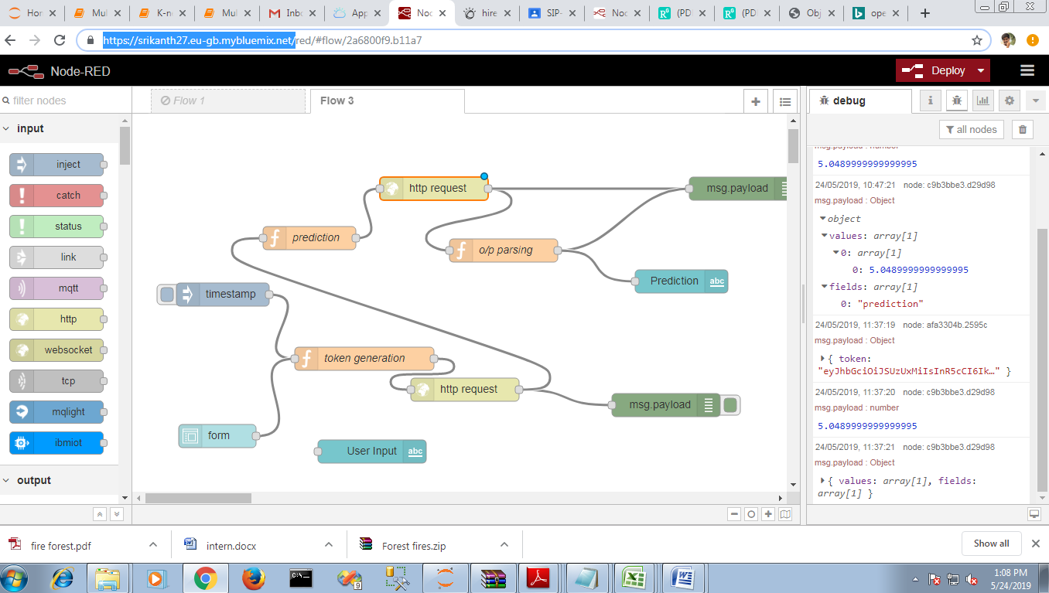

**Predicted Value**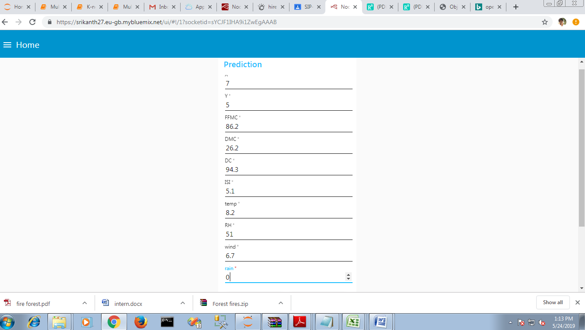



**6.Conclusion**

In this paper a neural-networks-based approach to the problem of predicting forest fires has been presented and discussed. The proposed neural network is a multilayer perception whose number and size of hidden layers can be heuristically determined for each application using its available data examples. The learning algorithm used to train this neural network is the back propogation algorithm ensures the convergence to a local minimum of the global error observed at the output layer of the network. This algorithm has been coded using C++ language and the resulting program was applied to real test data related to the Montesinho natural park in Portugal, which is one of the world regions most concerned with forest _res. The used dataset is publicly available at the UCI machine learning repository .Results of this application are satisfying and encourage the continuation of this study in order, for instance, to reduce the sensitivity of the method to architectural and algorithmic parameters, particularly the size of hidden layers and the stopping criterion .An example of future work would be the use of genetic algorithms in order to optimize the architectural parameters of the network , which tend to search the space of possible solutions globally, thus reducing the chance of getting stuck in local maxima .