**DATA FLOW DIAGRAM (DFD)**

A data flow diagram (DFD) is a graphical representation of the” flow” of data through an information system. A data flow diagram can also be used for the visualization of data processing(Structural design).It is common practice for a designer to draw a context level DFD first which show the interaction between the system and outside entities the context-level DFD is the ”exploded” to show more details of the system being modelled.

**Basic DFD Symbols**

* **Rectangles** - representing external *entities*, which are sources or destinations of data.
* **Arrows** - representing the *data flows*, this can either be electronic data or physical items. It shows the directional movement of data to and from External Entities, the process and Data Stores.
* **Open-ended rectangles** or **two parallel lines** – representing data *stores*, including electronic stores such as databases or XML files and physical stores such as filing cabinets or stacks of paper.
* **Circle or a Rounded Rectangle-** representing processes, which take data as input, do something to it, and output it. It is used to represent functions.

**DATA FLOW DIAGRAM**

- Source or Destination of Data

- Data Flow

- Data Proccessing

**Level 0:**

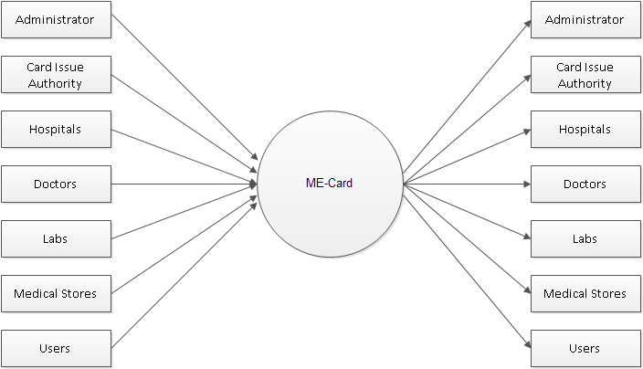

**Level 1: Administrator**

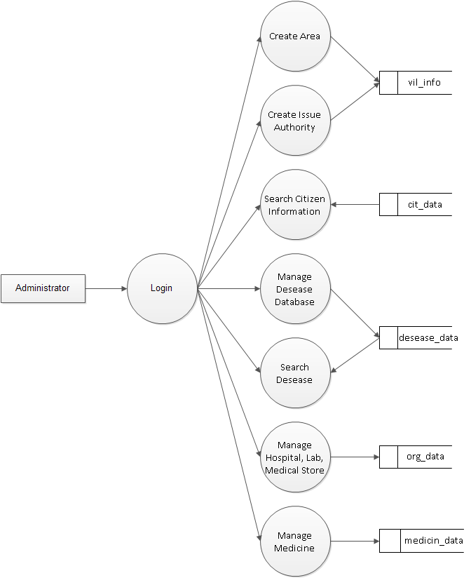

**Level 1: Issue Authority**

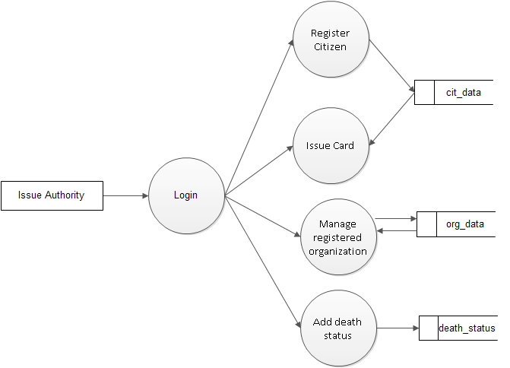

**Level 1: Hospitals**

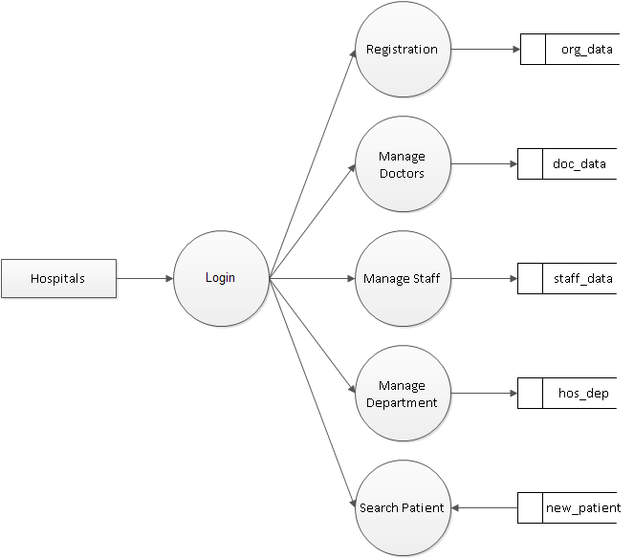

**Level 1: Receptionist**

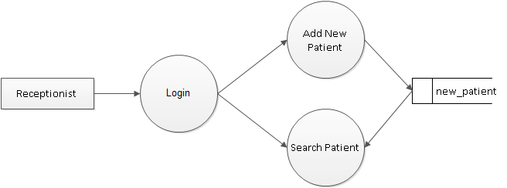

**Level 1: Doctors**

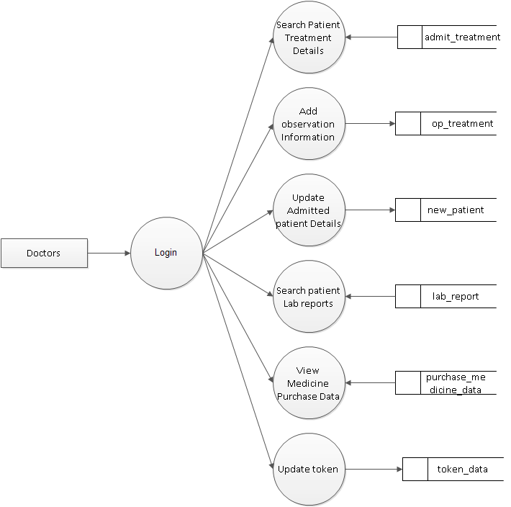

**Level 1: Admited patient report manager**

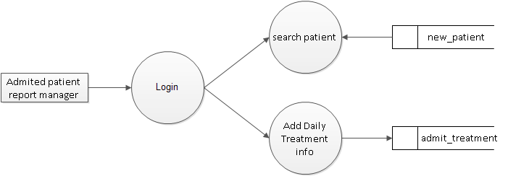

**Level 1: Labs**

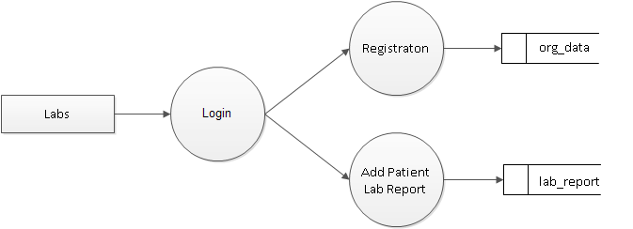

**Level 1: Medical Store**

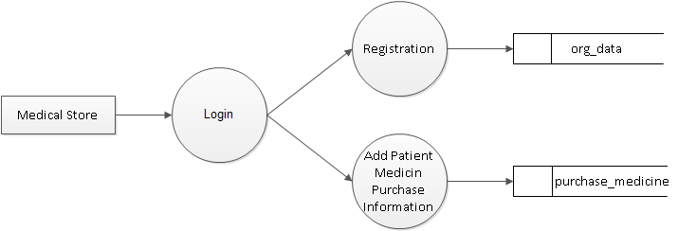

**Level 1: Users**

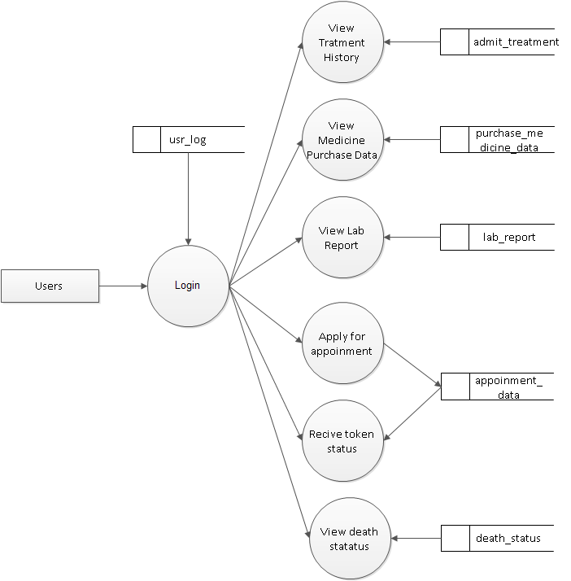

**USE CASE DIAGRAM**

**Administrator**

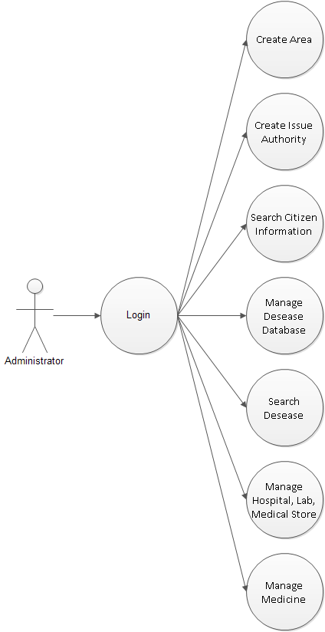

**Admited patient report manager**

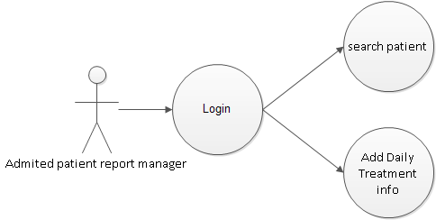

**Doctors**

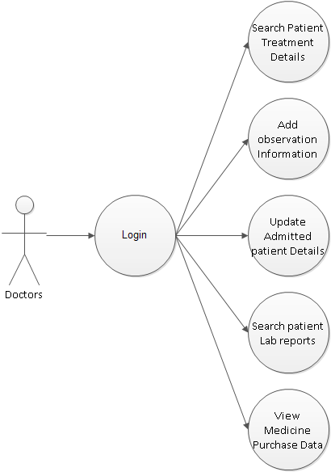

**Issue Authority**

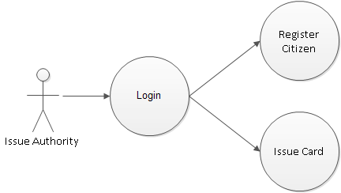

**Labs**

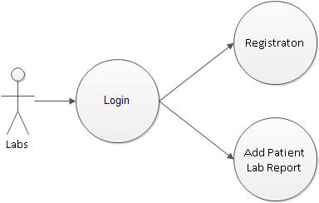

**Medical store**

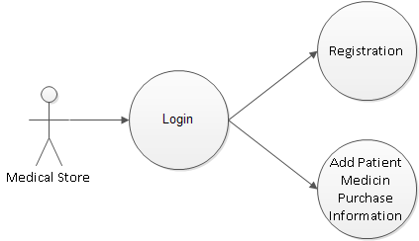

**Receptionist**

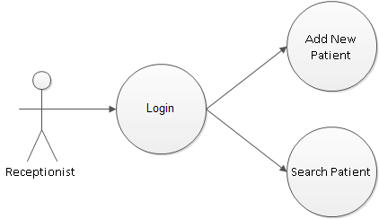

**Users**

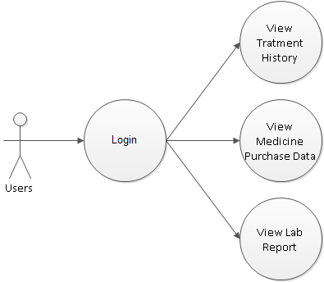

**Hospital**

