**PUBLIC EYES**

Today we the people of Kerala facing lot of social issues that not retiring by the government. Everyone use social media for posting problems that face by the public. This is all because of we don’t have any system to post our problem that face by people. That is why we decide to develop complete posting and monitoring system. This project is developed for public to pot the problem that found around us. This project is developed for our government to get information’s from public. In this portal a registered user can post the social relevant problems face by the public like bad roads, waste deposited in public, unauthorized parking etc. to concern department of the government. A user can register to this portal and upload their complaint through valid photographs to the corresponding department. While corresponding department login to our system they can easily monitor the problem that facing by the public.

After analyzing the post from the public, department can taker immediate actions or assign some authority to monitor the problem. After rectifying the problem the department can give feedback to the corresponding public through valid photographs. Administrator is the most powerful user in the portal. He can manage different department and view user complaints. Admin can monitor department feedback.

The entire web portal is developed using HTML, CSS, and JavaScript as front end development tools, and PHP as Server side tool and MySQL as the backend. To enable mobile responsive property Bootstrap is loaded.

**Hardware and software Requirements**

**Software Requirements**

Language : PHP

IDE : Net Beans

Frontend : HTML,CSS, Bootstrap, JavaScript

Backend : My SQL

Web Server : Apache

Web Browser : IE/Chrome/Safari/Opera

Operating System : Windows 7 or Higher

**Hardware Requirements**

Processor : Intel Pentium C2D/AMD

RAM : 1GB / Above

Hard Disk free space : 10 GB

Display : LCD 18”, 1024x768 / Above

Media : USB /DVD

Existing System

In existing system we don’t have any method to post the required. Always people post problem through the social medica.but while posting through this media always find that people used to abuse other because of posting problem related to their party .this is only because we don’t have any portal to post our view and problem .

Proposed system

In proposed system we are trying to overcome the problems that face by the people of kerala.so we developing a system that useful for the public to post their problem in this site with a valid photography of that problem. Through this site each and every department can login and they can monitor the problem that face by the people and they can take immediate action to solve the problem. After solving the problem they can contact to the public that post the issue and have pass the problem solving pic to them.so it help people government relational and government can easily monitor the problems of the people.

DFD

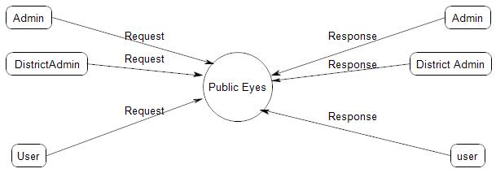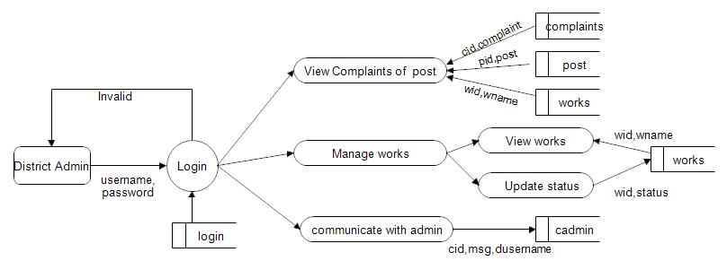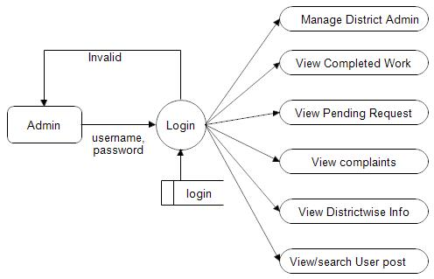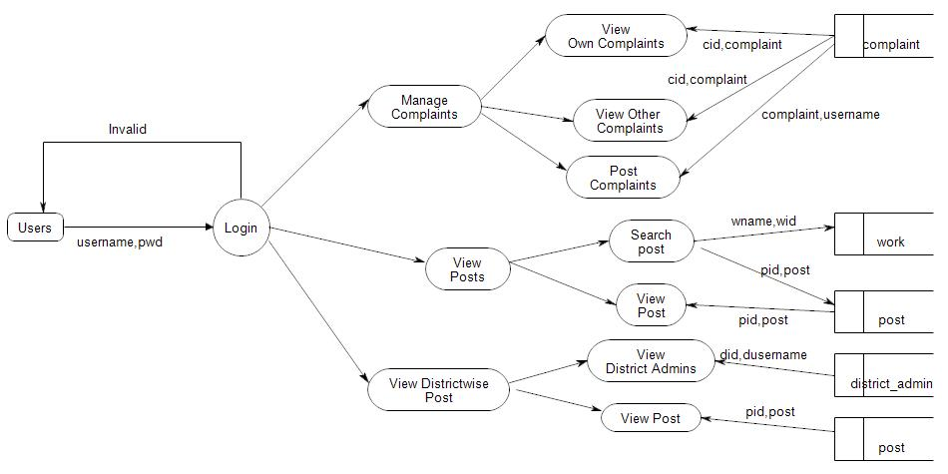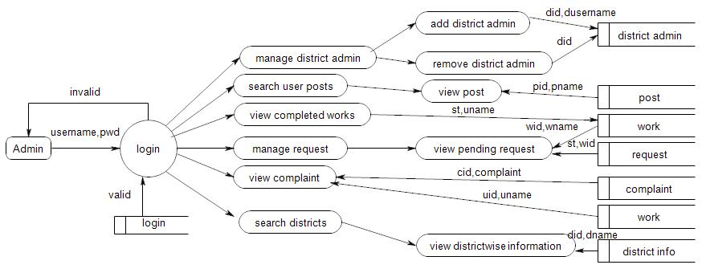

* Admin
  + Add District Admin
  + Manage District Admin
  + View Complaints
  + View Pending Posts
  + View One touch Posts
  + View Normal Post
  + View Spam Report
* District Admin
  + View posts
  + View Post send by user
  + Take Action on user Post
* User
  + Registration
  + Update profile
  + Post one Touch Posts
  + Post Normal Post
  + View All Posts
  + View Pending Posts
  + Send post to district Admin
  + Spam other posts
  + View Post action by district admin
  + Post Complaints