Adder

ADDERS

1. Ripple Carry Adder (RCA)

Working Principle
A Ripple Carry Adder is the simplest and most intuitive adder architecture. It consists of N Full Adders connected in series, where the carry-out of each stage feeds directly into the carry-in of the next stage. This sequential carry flow is what gives it the name "ripple" — the carry signal ripples from the LSB to the MSB.
For each bit position i:
- Sum[i] = A[i] XOR B[i] XOR C[i]
- C[i+1] = (A[i] AND B[i]) OR (A[i] AND C[i]) OR (B[i] AND C[i])

Carry Chain Explained
The carry chain is the critical path. In the worst case — when a carry must propagate from bit 0 all the way to bit 15 — the signal must pass through every single full adder stage in sequence. No stage can begin producing its final carry until the previous stage has settled. For a 16-bit RCA, this means 16 sequential full adder delays on the critical path. Each full adder contributes approximately 2 gate delays to carry propagation (one AND, one OR), so the worst-case delay is approximately 32 gate delays.
Delay formula: T_RCA = N × t_FA, where t_FA is the carry propagation delay of one full adder.

Where RCA is Acceptable
Despite its O(N) delay, the RCA is still preferred in many real scenarios:
- Small bit widths (N ≤ 8): The absolute delay is so small that the ripple carry is not the timing bottleneck in the system.
- FPGA implementations: FPGAs like Xilinx have dedicated CARRY4 primitives — hardwired carry chains with sub-gate delays. A 16-bit RCA on an FPGA is extremely fast in practice, as demonstrated by your implementation results.
- Area-constrained designs: RCA requires exactly N full adders with zero overhead logic — the most compact adder possible.
- Low-power systems: Fewer transistors switching means lower dynamic power consumption.
- Building blocks inside larger adders: Carry Select and Hybrid adders use RCA blocks internally for each sub-group.
- Educational and prototyping use: Simplest to implement, verify, and debug.
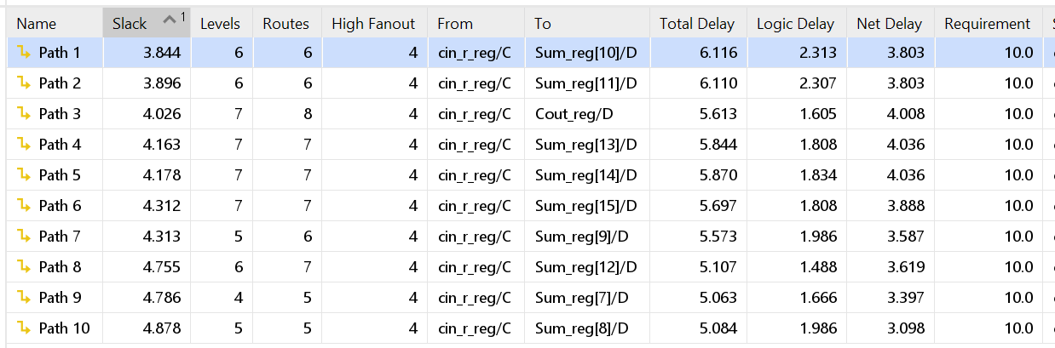
Timing Analysis
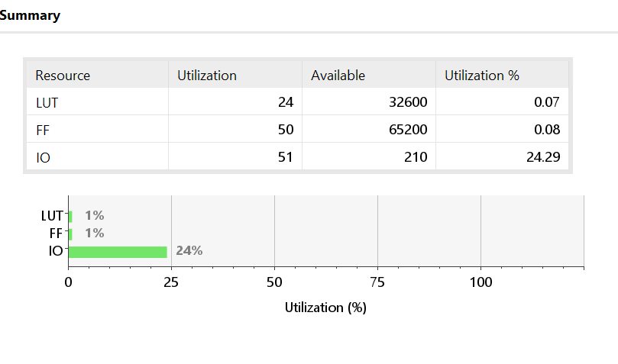
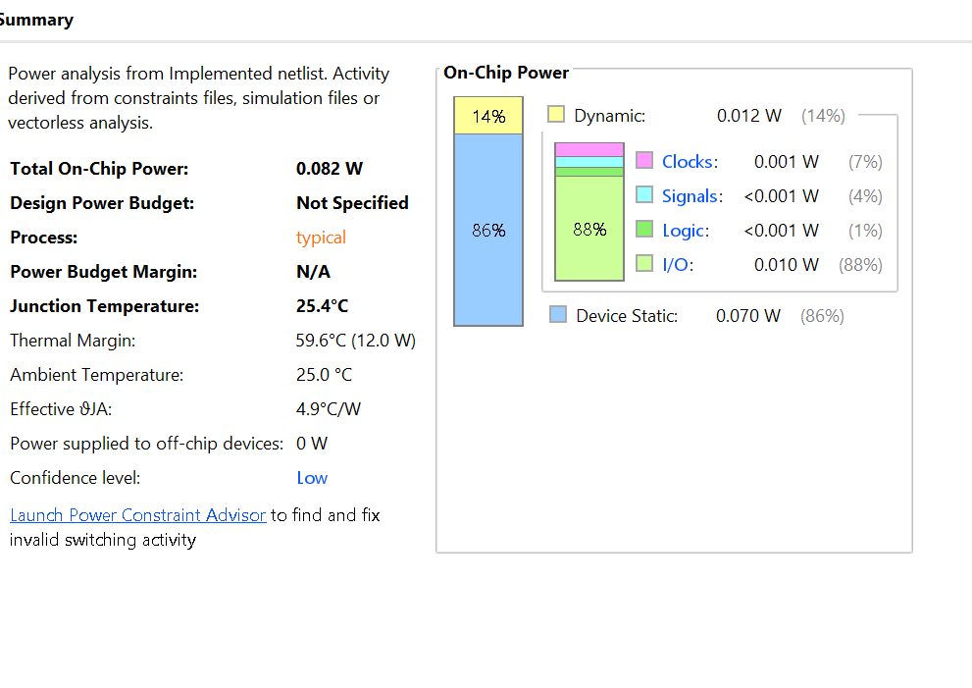
Power Analysis
Area
2. Carry Lookahead Adder (CLA)

Generate and Propagate Logic
The CLA was invented to eliminate the serial carry dependency of the RCA. Instead of waiting for each carry to ripple through, it precomputes two signals for every bit position before the addition starts:
- Generate: G[i] = A[i] AND B[i] This means bit i will generate a carry regardless of whether there is an incoming carry. If both A[i] and B[i] are 1, a carry is produced unconditionally.
- Propagate: P[i] = A[i] XOR B[i] This means bit i will propagate a carry from C[i] to C[i+1] if either A[i] or B[i] is 1 (but not both).
Using these two signals, every carry can now be expressed as a direct function of only G[], P[], and the initial C[0] — with no dependence on intermediate carries:
C[1] = G[0] + P[0]·C[0]
C[2] = G[1] + P[1]·G[0] + P[1]·P[0]·C[0]
C[3] = G[2] + P[2]·G[1] + P[2]·P[1]·G[0] + P[2]·P[1]·P[0]·C[0]
C[4] = G[3] + P[3]·G[2] + P[3]·P[2]·G[1] + P[3]·P[2]·P[1]·G[0] + P[3]·P[2]·P[1]·P[0]·C[0]
All carries within a group are computed simultaneously using just two levels of logic: one AND level and one OR level. This reduces the carry delay within a group to O(1) — constant time regardless of N.

Why Inter-Group Carry Limits the CLA
The problem becomes apparent when scaling to 16 bits. A fully flat CLA for 16 bits would require:
- A 16-input AND gate for C[15]
- A 16-input OR gate combining all the AND terms
Such gate fan-ins are physically unrealizable in standard cell libraries. The practical solution is to break the 16 bits into groups of 4 bits, creating a hierarchical CLA.
A 16-bit hierarchical CLA has 4 groups (bits 3:0, 7:4, 11:8, 15:12). Each group computes its own group-level Generate (G*) and Propagate (P*) signals:
G*[0] = G[3] + P[3]·G[2] + P[3]·P[2]·G[1] + P[3]·P[2]·P[1]·G[0]
P*[0] = P[3]·P[2]·P[1]·P[0]
The inter-group carries C[4], C[8], C[12] are then computed by a second-level lookahead block using these group signals. Without this second level, the group carries still depend on each other sequentially — meaning the inter-group carry chain is still O(N/4), not O(1).
The fundamental limitation: With a single level of lookahead, you reduce delay by a constant factor (4×) but the asymptotic complexity remains O(N). True O(log N) behavior requires a fully hierarchical multi-level CLA, which is exactly what the Kogge-Stone adder formalizes as a parallel prefix tree.

About the Verilog Implementation
The provided Verilog code uses a generate loop:
verilog
assign C[i+1] = G[i] | (P[i] & C[i]);
Despite using G and P signals (which are CLA concepts), each C[i+1] depends on C[i], which depends on C[i-1], and so on. This is structurally a ripple carry chain, not true parallel lookahead. Vivado maps it efficiently to CARRY4 primitives, achieving good timing, but the logical structure is RCA rather than CLA.

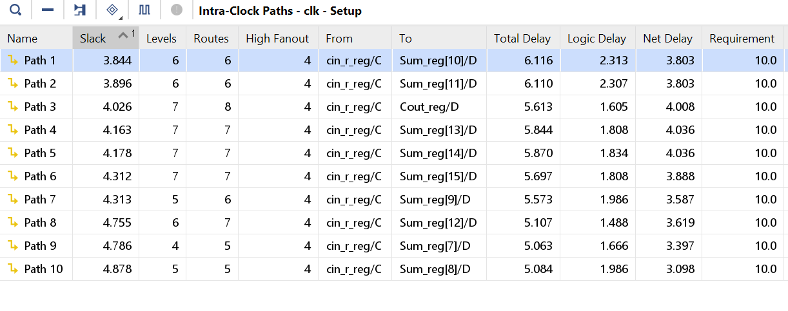
Timing Analysis
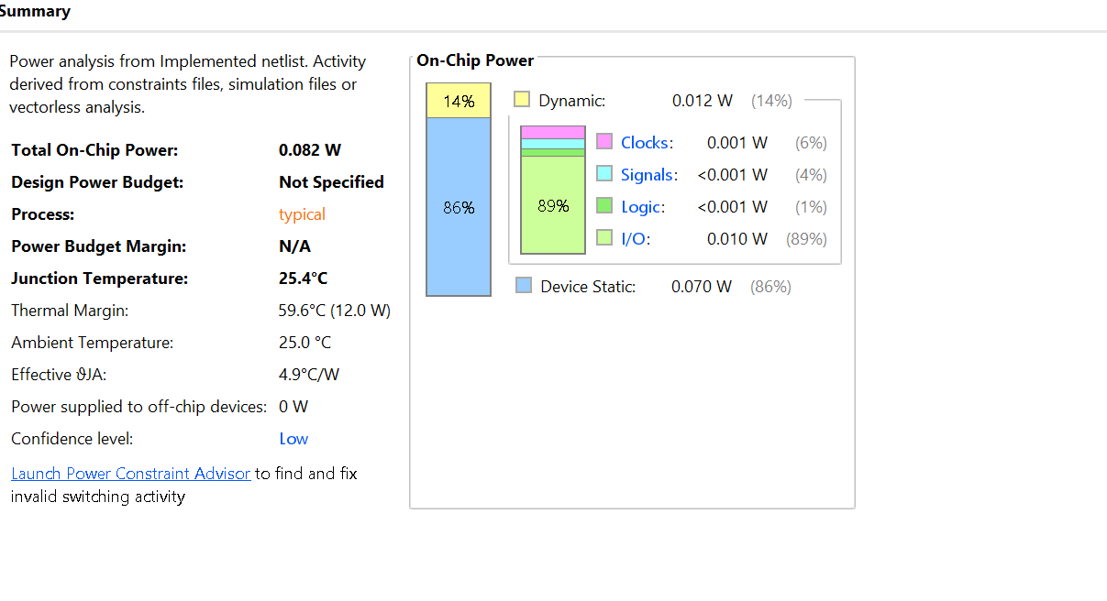
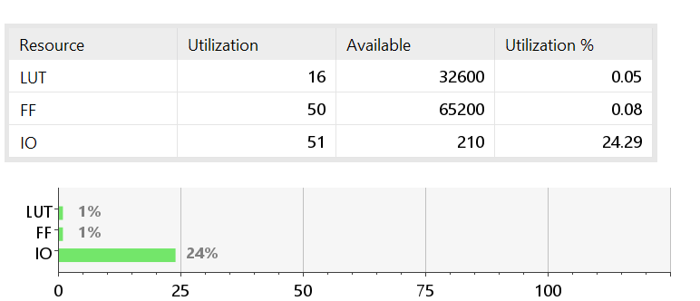
Power Analysis
Area
3. Kogge-Stone Adder

The Parallel Prefix Tree Concept
The Kogge-Stone adder is a parallel prefix adder — the most theoretically optimal adder structure for minimizing carry propagation depth. It generalizes the CLA approach into a complete binary tree that computes all N carry signals in exactly ⌈log₂N⌉ levels.
The foundation is a prefix operator ○ defined over (Generate, Propagate) pairs:
(G1, P1) ○ (G0, P0) = (G1 + P1·G0, P1·P0)
This operator is associative — meaning we can compute it in any order using a tree structure. The carry into bit i+1 is simply:
C[i+1] = G[i:0] + P[i:0]·C[0]
where G[i:0] and P[i:0] are the prefix-combined values from bit 0 to bit i.

Step-by-Step for 16 Bits
Stage 0 — Preprocessing (1 gate delay): Compute bit-level Generate and Propagate for all 16 bits simultaneously:
G[i] = A[i] AND B[i] for i = 0 to 15
P[i] = A[i] XOR B[i] for i = 0 to 15
Stage 1 — Span 1 (1 gate delay): Each node combines signals 1 position apart. 15 prefix nodes are computed:
(G[1:0], P[1:0]) = (G[1],P[1]) ○ (G[0],P[0])
(G[3:2], P[3:2]) = (G[3],P[3]) ○ (G[2],P[2])
(G[5:4], P[5:4]) = (G[5],P[5]) ○ (G[4],P[4])
... and so on for all pairs
Stage 2 — Span 2 (1 gate delay): Each node combines results 2 positions apart, building 4-bit prefix values:
(G[3:0], P[3:0]) = (G[3:2],P[3:2]) ○ (G[1:0],P[1:0])
(G[7:4], P[7:4]) = (G[7:6],P[7:6]) ○ (G[5:4],P[5:4])
... and so on
Stage 3 — Span 4 (1 gate delay): Each node combines results 4 positions apart, building 8-bit prefix values:
(G[7:0], P[7:0]) = (G[7:4],P[7:4]) ○ (G[3:0],P[3:0])
(G[11:4],P[11:4]) = (G[11:8],P[11:8]) ○ (G[7:4],P[7:4])
... and so on
Stage 4 — Span 8 (1 gate delay): Final stage. All 16 carry signals are now fully resolved:
(G[15:0], P[15:0]) = (G[15:8],P[15:8]) ○ (G[7:0],P[7:0])
... and all intermediate positions
After Stage 4, the sum bits are computed as:
S[i] = P[i] XOR C[i] for i = 0 to 15

Why log₂(16) = 4 is the Theoretical Minimum
This can be proven from first principles:
- Information propagation limit: At stage k of a binary prefix tree, a single node can at most combine information from 2^k bit positions (since each node has 2 inputs, each covering 2^(k−1) positions).
- Coverage requirement: To compute C[15] — the carry into the MSB — we need a prefix value that covers all 16 bit positions (0 through 15).
- Minimum stages: We need 2^k ≥ 16, so k ≥ log₂(16) = 4.
- Lower bound proof: Any combinational circuit computing carry C[i] from inputs A[0..i], B[0..i], C[0] must have depth at least ⌈log₂(i+1)⌉ under the standard gate model, since each gate can only merge information from two sources.
No adder architecture — regardless of how clever — can compute all N carries in fewer than ⌈log₂N⌉ gate levels. Kogge-Stone achieves this exact bound.
For N=16: log₂(16) = 4 stages. Total critical path = 1 (preprocessing) + 4 (prefix stages) + 1 (sum XOR) = 6 gate delays.

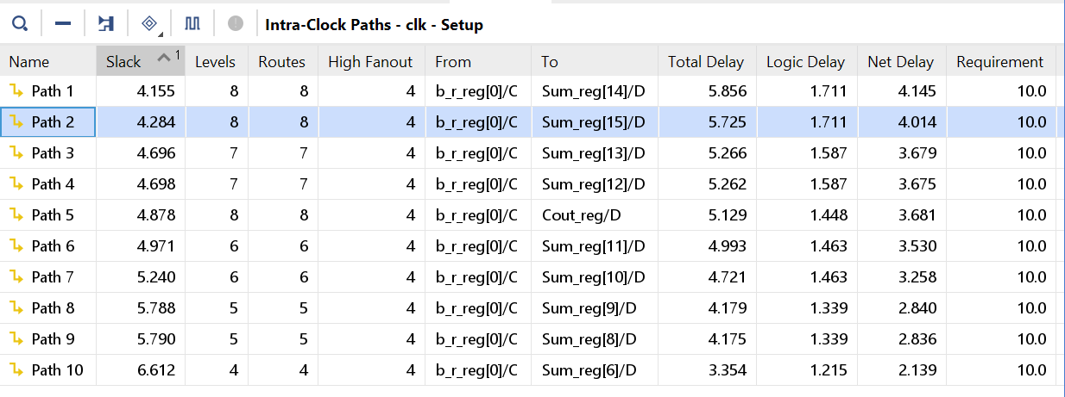
Timing Analysis

Power Analysis
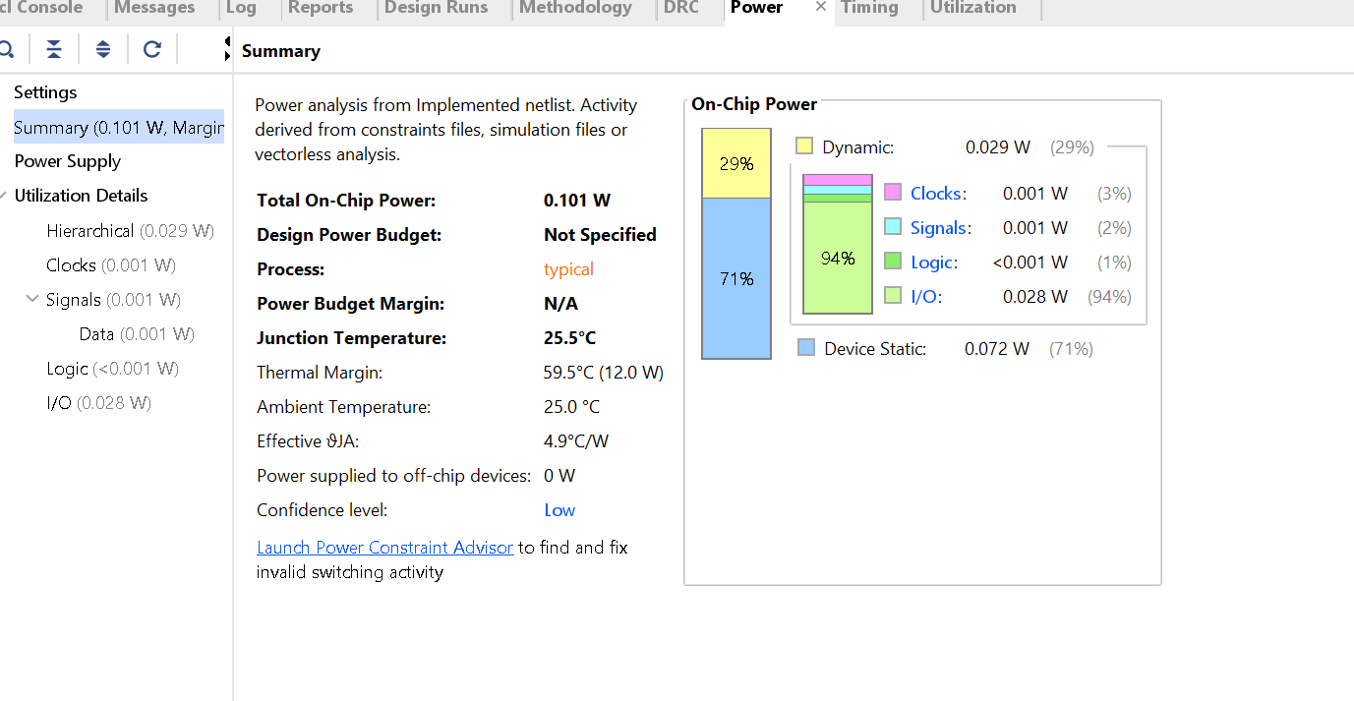

Area

Area
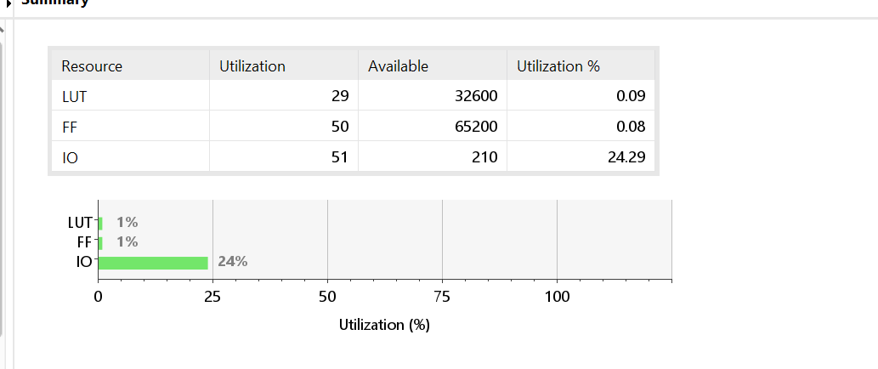

4. Carry Select Adder (CSLA)

Dual-Path and MUX Approach
The Carry Select Adder uses a fundamentally different strategy: speculative parallel computation. Instead of waiting for the carry to arrive before computing a block's sum, it pre-computes both possible outcomes simultaneously:
- Path 0: Computes the sum of the block assuming carry-in = 0
- Path 1: Computes the sum of the block assuming carry-in = 1
Once the actual carry-in arrives (from the previous block), a simple 2-to-1 MUX instantly selects the correct pre-computed result. The MUX operation is just 1 gate delay — far faster than recomputing the sum from scratch.
Structure for a 16-bit CSLA with 4-bit blocks:
- Block 0 (bits 3:0): Standard 4-bit RCA with actual C[0]. No speculation — this block must compute normally to produce C[4].
- Block 1 (bits 7:4): Two 4-bit RCAs run in parallel — one with Cin=0, one with Cin=1. When C[4] arrives from Block 0, the MUX selects the correct Sum[7:4] and C[8].
- Block 2 (bits 11:8): Same as Block 1. Two parallel RCAs, MUX selects when C[8] arrives.
- Block 3 (bits 15:12): Same structure. MUX selects when C[12] arrives.
The carry cascade — C[4] → C[8] → C[12] — propagates through MUXes rather than full adder chains, which is dramatically faster.

O(√N) Delay Explained
The total delay breaks into two parts:
Part 1 — First block delay: The first block must be computed without speculation. If it contains k bits, its delay is O(k) ripple carry time.
Part 2 — MUX cascade delay: Each subsequent block adds only 1 MUX delay (O(1)) once the carry arrives, because the sum was pre-computed.
Optimization: The total delay is minimized by choosing the optimal block size. Let the first block have k bits:
- First block delay: proportional to k
- Remaining blocks: there are (N/k − 1) blocks, each adding 1 MUX delay = (N/k − 1) total
- Total delay: k + (N/k − 1)
Minimizing this expression by taking the derivative and setting it to zero: d/dk [k + N/k] = 1 − N/k² = 0, giving k = √N.
With k = √N, the total delay = √N + (N/√N − 1) = √N + √N − 1 = 2√N − 1 = O(√N).
For N=16 with k=4:
- Block 0 delay: 4-bit RCA ≈ 8 gate delays
- Blocks 1, 2, 3: 3 × MUX delay ≈ 3 gate delays
- Total ≈ 11 gate delays vs 32 for RCA — nearly 3× faster.
Area cost: Each block (except Block 0) requires two RCAs instead of one — approximately 1.5× to 2× the area of a pure RCA. However, the total area is still O(N), making CSLA an excellent balance between speed and area.

Timing Analysis

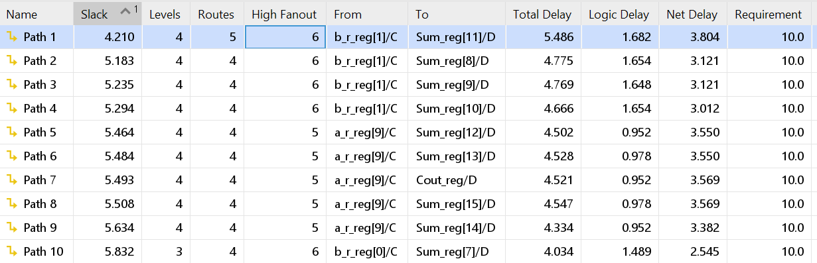

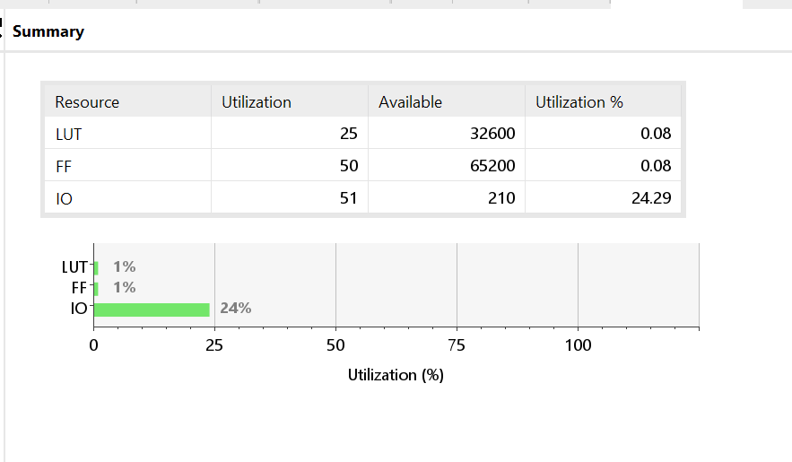
Area

Power Analysis
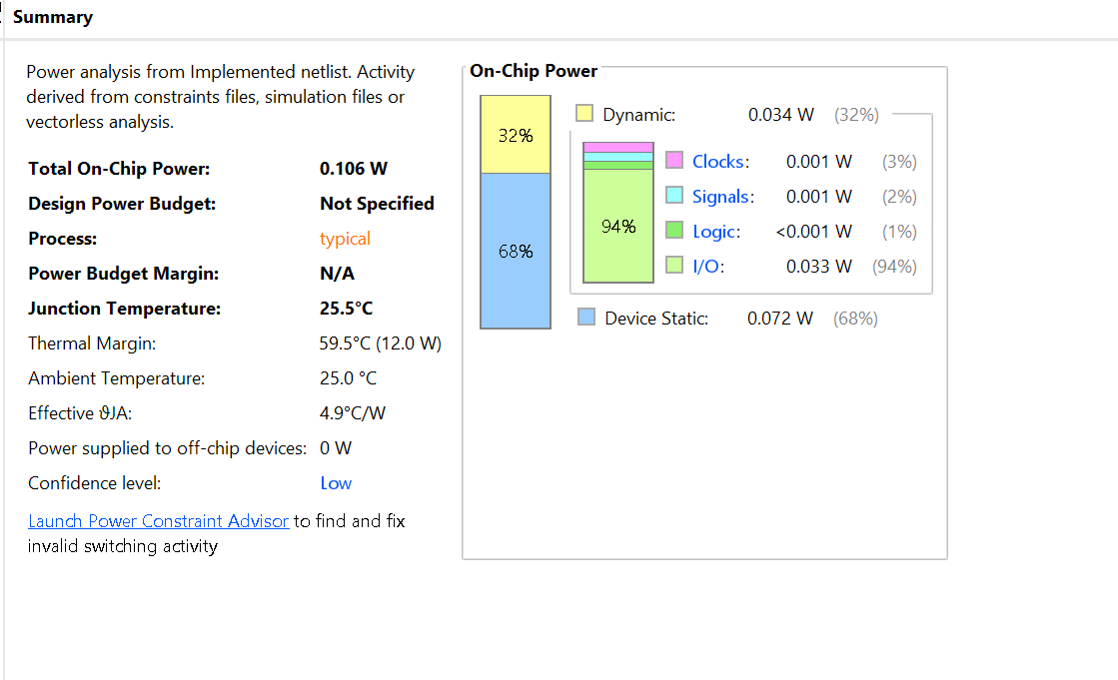

Performance & Complexity
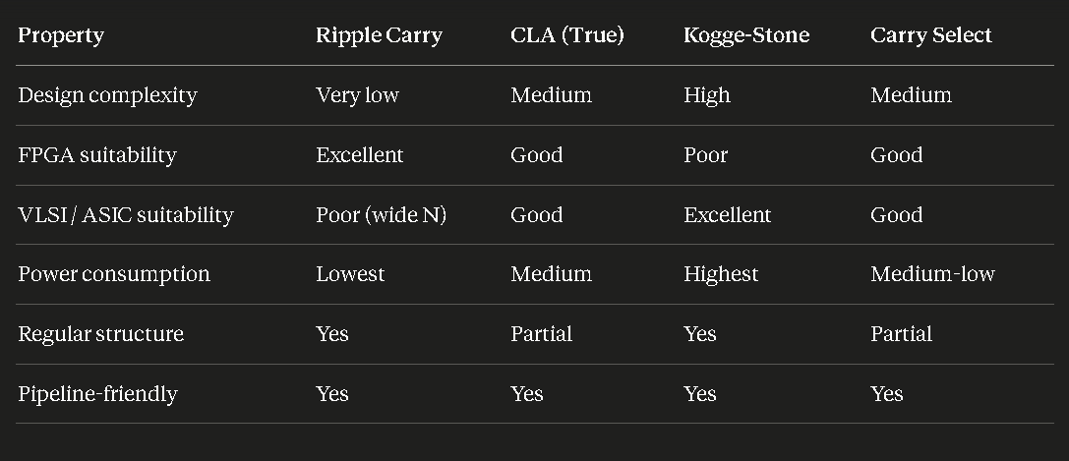

Design & Implementation
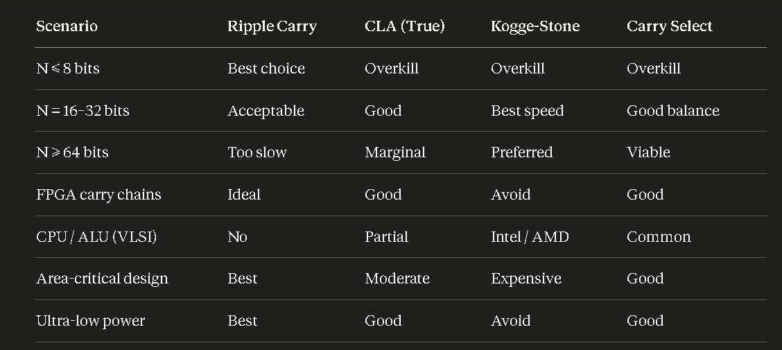

Use Case Guidance

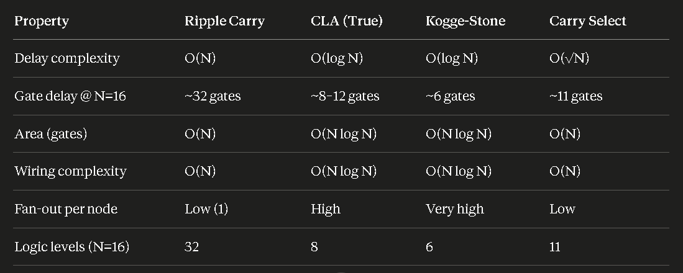

Conclusion

The four adder architectures illustrate a clear progression in design complexity and performance. The Ripple Carry Adder provides maximum simplicity and minimum area but suffers from O(N) delay. The CLA improves speed within groups but the inter-group carry still limits scalability. The Kogge-Stone adder achieves the theoretical minimum O(log N) delay through a complete parallel prefix tree, making it optimal for high-speed designs. The Carry Select Adder achieves O(√N) delay using speculative dual-path computation with MUX selection, offering an excellent middle ground between area and speed for FPGA targets. In practice, all architectures benefited significantly from Vivado's mapping onto CARRY4 primitives.

Multiplier

MULTIPLIERS
- ARRAY MULTIPLIERS
An array multiplier is a combinational circuit used to multiply two binary numbers. It’s called “array” because the structure is like a grid of AND gates and adders arranged systematically.

How it works:
- Partial Products (PPs):
- For each bit of the multiplier B, AND it with every bit of the multiplicand A.
- This produces rows of partial products (like longhand multiplication in decimal).
Example: If A=1011 (11) and B=1101 (13), you generate 4 rows of partial products by ANDing each bit of B with all bits of A.
- Shifting:
- Each partial product row is shifted left according to the bit position of B.
- Just like multiplying by 10 in decimal shifts digits left.
- Addition:
- All shifted partial products are added together to get the final product.
So, the array multiplier is essentially:
Product=∑i=0n−1(A⋅B[i])≪i

In binary multiplication we usually read the multiplier bits from right to left (least significant bit first).

example where A=1011 and B=1101

Step 1: Partial Products Starting with the example where A=1011 (which is 11 in decimal) and B=1101 (which is 13 in decimal): We look at each bit of B, beginning from the rightmost bit. For every bit of B, we multiply it with the entire number A. Since binary multiplication is just an AND operation, this gives us one row of partial products for each bit of B.
- When the rightmost bit of B is 1, the partial product is the same as A, which is 1011.
- When the next bit of B is 0, the partial product is 0000.
- When the next bit of B is 1, the partial product is again 1011.
- When the leftmost bit of B is 1, the partial product is 1011.
So the four rows of partial products before shifting are: Row0: 1011 Row1: 0000 Row2: 1011 Row3: 1011

Step 2: Shifting Next, each row of partial products is shifted left according to the position of the bit in B. This shifting accounts for the place value of that bit, just like in decimal multiplication where multiplying by the tens digit shifts the result one place to the left.
- Row0 corresponds to the first bit, so it is not shifted and stays as 1011.
- Row1 corresponds to the second bit, so it is shifted left by one position, becoming 00000.
- Row2 corresponds to the third bit, so it is shifted left by two positions, becoming 101100.
- Row3 corresponds to the fourth bit, so it is shifted left by three positions, becoming 1011000.
Now the rows are aligned properly for addition in the next step.

Step 3: Addition After shifting, the rows of partial products are lined up according to their positions. The next step is to add all of these rows together, just like in longhand multiplication.
- Row0 is 1011
- Row1 is 00000
- Row2 is 101100
- Row3 is 1011000
Now we add them column by column:
First, add Row0 and Row1, which gives 1011. Next, add Row2 to that result, which gives 110111. Finally, add Row3, which gives 10001111.
So the final product is 10001111 in binary.

Result This binary number 10001111 is equal to 143 in decimal. That matches the expected result of multiplying 11 by 13.

AREA ANALYSIS
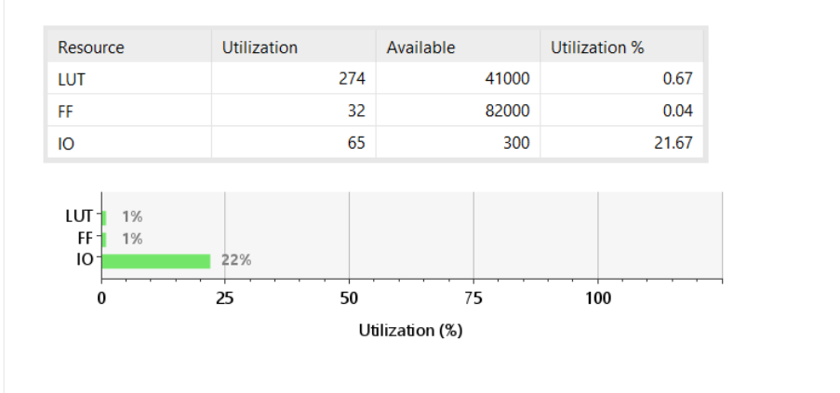

POWER ANALYSIS
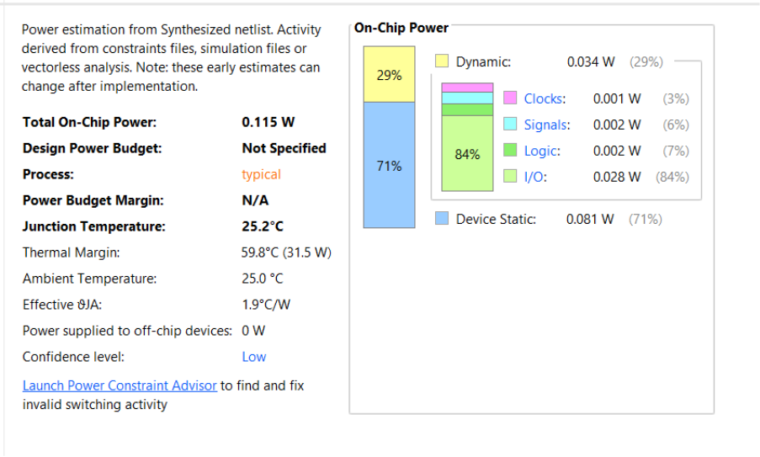

TIMING ANALYSIS

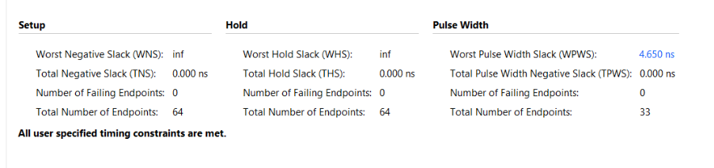

BOOTH MULTIPLIERS

The Booth algorithm is designed to handle signed multiplication efficiently. Instead of performing a straightforward array of partial products like the Array multiplier, Booth reduces the number of additions and subtractions by encoding the multiplier bits. It looks at pairs of bits (the current bit and the previous one) and decides whether to add, subtract, or skip the multiplicand. This reduces redundant operations, especially when the multiplier has consecutive 1s.
In Vivado reports, you’ll notice a few things. The area (LUT and FF usage) is slightly higher than the Array multiplier because Booth requires extra control logic for encoding and shifting. The timing report will show finite slack values — unlike the Array multiplier which sometimes shows “inf” because of its trivial depth — Booth has measurable logic depth due to the add/subtract and shift operations. The power report will be close to Array, maybe a little higher, since the control logic toggles more frequently.
So in summary: Booth trades a bit more area and control complexity for fewer arithmetic operations, making it more efficient for signed numbers and reducing the number of partial products. That’s why in practice, Booth is often preferred over a plain Array multiplier when signed multiplication is needed.
How it works: Booth's Recoding
The key to Booth's efficiency is its recoding algorithm, which looks at two adjacent bits of the multiplier (the current bit, M_i, and the bit to its right, M_{i-1}, which is initialized to 0). This eliminates operations for sequences of 1s.
- 00 or 11: The partial product is 0. (No operation/shift only)
- 01: The operation is +Multiplicand. (Marks the end of a string of 0s and the start of a string of 1s)
- 10: The operation is -Multiplicand (Subtract Multiplicand). (Marks the end of a string of 1s and the start of a string of 0s)
This process significantly reduces the number of partial products that need to be added.

TIME ANALYSIS
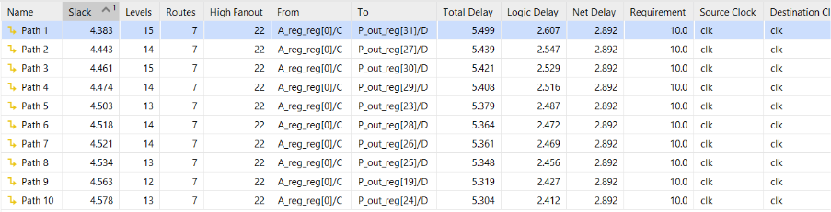

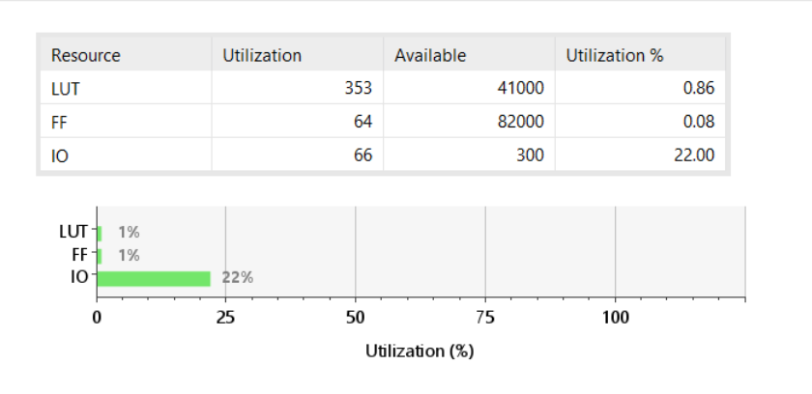
AREA ANALYSIS

POWER ANALYSIS
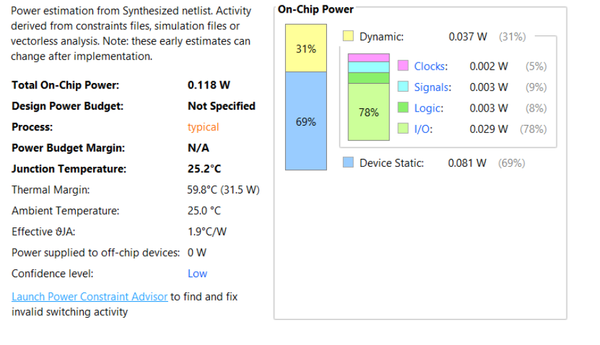
TIME ANALYSIS
The Booth multiplier results in a finite and measurable logic depth due to the sequence of add/subtract and shift operations. This complexity, which is greater than the Array multiplier's simple addition depth, gives it a measurable slack value in timing reports.
AREA ANALYSIS
The overall area (in terms of LUT and Flip-Flop usage) is slightly higher compared to the Array multiplier because additional control logic is necessary to perform the bit encoding and shifting/subtraction operations.
POWER ANALYSIS
Power consumption is generally similar to the Array multiplier. However, the presence of more control logic that toggles frequently may lead to a slightly higher power usage

Wallace MULTIPLIERS

The Wallace Tree Multiplier is designed for high-speed parallel execution. Rather than adding partial products row by row, it generates all 16 partial products simultaneously and compresses them using a tree-like structure of Half Adders and Full Adders. This drastically reduces the depth of the critical path. However, the parallel reduction tree requires highly irregular and complex wiring, which significantly increases the routing area and logic utilization on the silicon.
A = 1011₂
B = 1101₂
A × B = 10001111₂ = 143₁₀

Step 1: Partial Product Generation
The multiplicand is multiplied by each bit of the multiplier to generate partial products. For the given example, the partial products are:
Row 0 = 1011
Row 1 = 0000
Row 2 = 1011
Row 3 = 1011
These partial products are aligned according to the position of the corresponding multiplier bit.
Step 2: Column-wise Reduction
The partial products are arranged in columns, and the bits in each column are grouped together. Whenever a column contains three bits, a full adder is used to reduce them into a sum bit and a carry bit. The sum remains in the same column, while the carry is transferred to the next higher column.
For example, Column 0 contains three logic 1 values. A full adder reduces these bits, producing a sum bit and a carry bit that is propagated to the next column.
Step 3: Successive Compression Stages
After the first reduction stage, the number of rows is reduced. The resulting rows are again compressed using full adders and half adders wherever required. This reduction process continues iteratively until only two rows remain.
The Wallace Tree structure performs these reductions in parallel, significantly decreasing the overall propagation delay compared to conventional array multiplication.
Step 4: Final Addition
The remaining two rows are added using a final carry-propagate adder. The resulting product obtained is:
10001111₂
which is equal to:
143₁₀
Conclusion
The Wallace Tree Multiplier produces the same multiplication result as an Array Multiplier. However, instead of adding partial products sequentially, it uses parallel reduction through full adders and half adders to compress the partial products efficiently. This parallel operation reduces computation time and improves multiplication speed, making Wallace Tree Multipliers suitable for high-performance digital systems.
AREA ANALYSIS
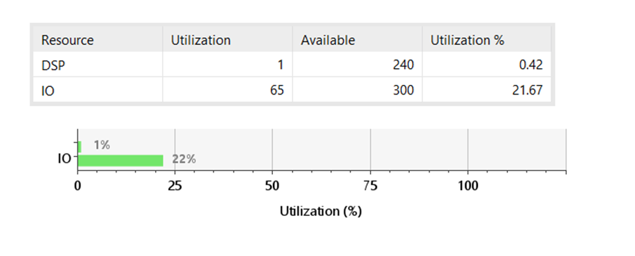
TIME ANALYSIS
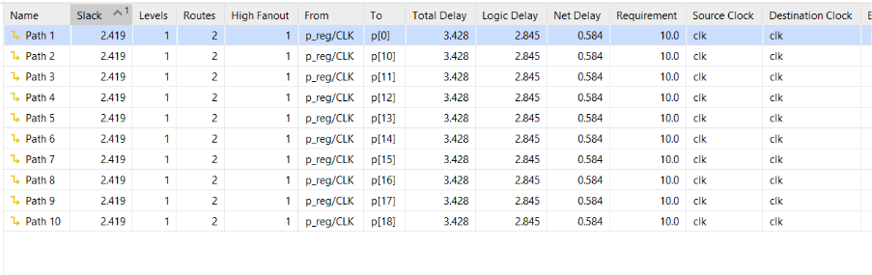

POWER ANALYSIS

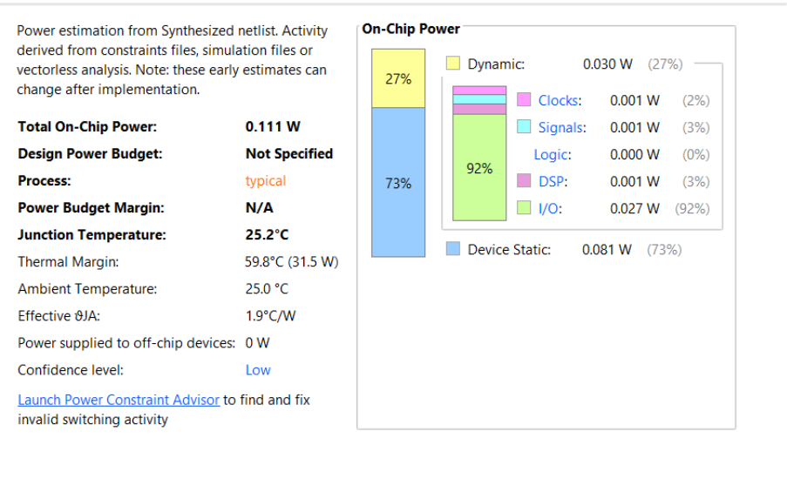
Resource Utilization Analysis
The design uses 1 DSP block out of the 240 available DSPs, resulting in a utilization of 0.42%. A total of 65 I/O pins out of 300 available pins are utilized, corresponding to 21.67% utilization. The low resource usage indicates that the design is area-efficient and leaves sufficient FPGA resources available for future enhancements.
Power Analysis
The estimated total on-chip power consumption is 0.111 W. Static power consumption is 0.081 W, while dynamic power consumption is 0.030 W. Most of the dynamic power is contributed by I/O activity, accounting for 0.027 W. The estimated junction temperature is 25.2°C, indicating safe and efficient operation.
Timing Analysis
The timing report shows a positive slack of 2.419 ns, confirming that all timing constraints are satisfied. The maximum path delay is 3.428 ns, which is less than the required clock period of 10 ns. Therefore, the design operates successfully without timing violations and meets the desired performance requirements.
.

Dadda MULTIPLIERS
The Dadda multiplier is a high-speed parallel multiplier architecture used for efficient binary multiplication in digital systems. It reduces partial products through a series of optimized compression stages using half adders and full adders. By minimizing the number of reduction operations, the Dadda multiplier achieves lower hardware complexity while maintaining high computational speed. Owing to its efficient balance between area and performance, it is widely used in digital signal processing, microprocessors, communication systems, and FPGA-based applications.

A = 1011₂
B = 1101₂
A × B = 10001111₂ = 143₁₀
Step 1: Partial Product Generation
The multiplicand is multiplied by each bit of the multiplier to generate the partial products:
Row 0 = 1011
Row 1 = 0000
Row 2 = 1011
Row 3 = 1011
These partial products are shifted according to the position of the corresponding multiplier bit.
Step 2: Dadda Reduction Planning
The Dadda multiplier reduces the partial products using a minimum number of adders. Unlike the Wallace Tree, reduction is delayed until necessary. The maximum column height is first determined, and the Dadda reduction sequence is selected accordingly.
For a 4×4 multiplier, the partial product matrix is reduced stage by stage so that the column heights satisfy the Dadda limits. Full adders and half adders are inserted only where required to achieve the target column heights.
Step 3: Partial Product Compression
The columns exceeding the permitted height are compressed using full adders and half adders. The generated carry bits are transferred to the next higher column, while the sum bits remain in the same column.
After the first compression stage, the column heights are reduced. Additional compression stages are then applied until only two rows of partial products remain. Since Dadda reduction uses the minimum number of adders required, it generally consumes less hardware than a Wallace Tree multiplier.
Step 4: Final Addition
The final two rows obtained after Dadda reduction are added using a carry-propagate adder to generate the final product.
The resulting output is:
10001111₂
which is equal to:
143₁₀
Conclusion
The Dadda Multiplier produces the same multiplication result as the Wallace Tree Multiplier. However, it performs reduction in a more structured manner by minimizing the number of adders used during compression. This results in lower hardware utilization while maintaining high multiplication speed, making the Dadda Multiplier suitable for efficient high-performance digital systems.

TIME ANALYSIS
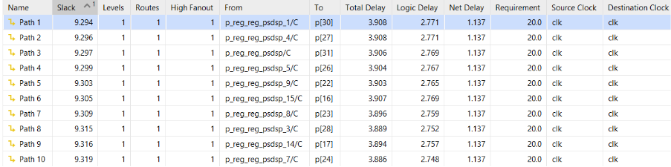

POWER ANALYSIS
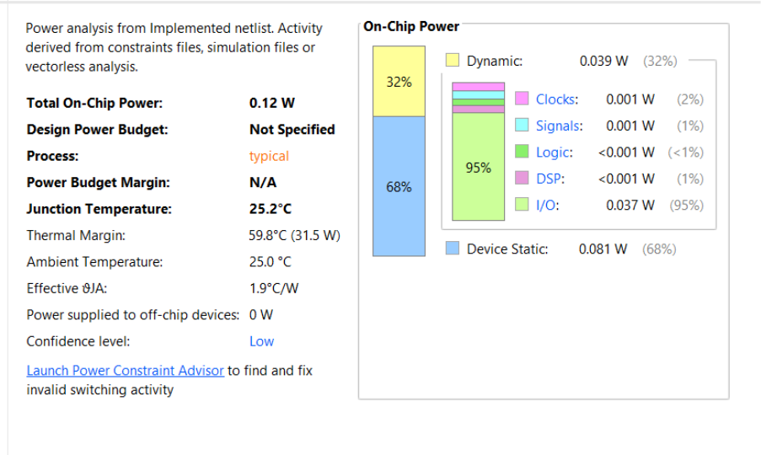

AREA ANALYSIS

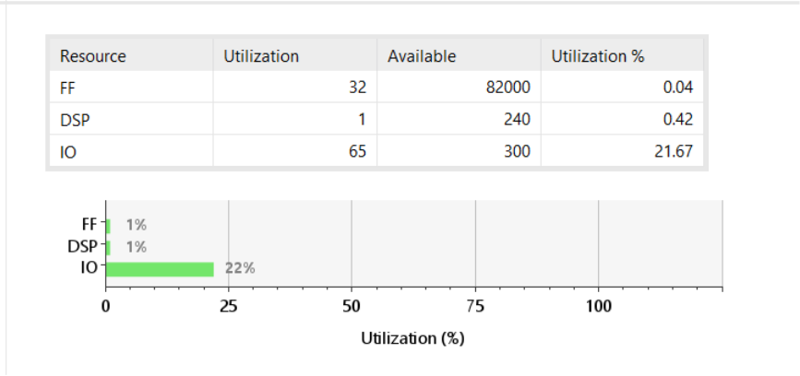

Performance & Complexity
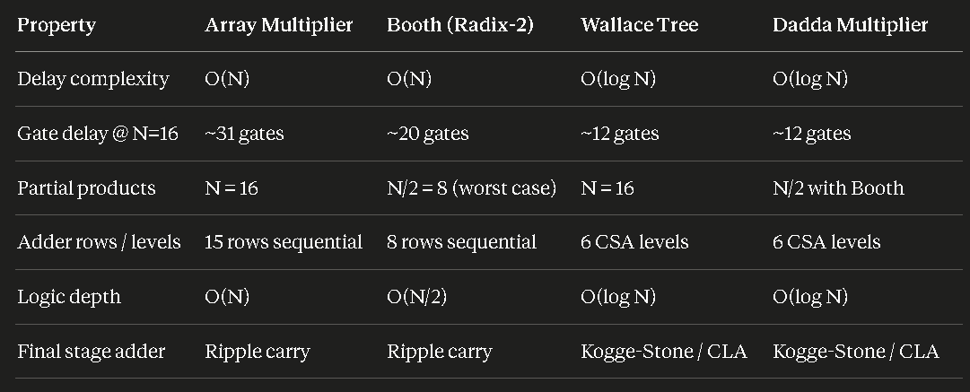

Area & Power
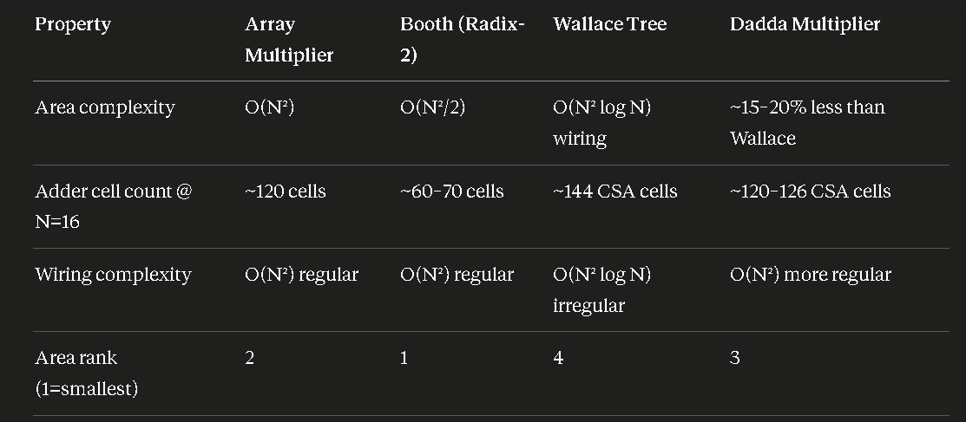

Design & Implementation
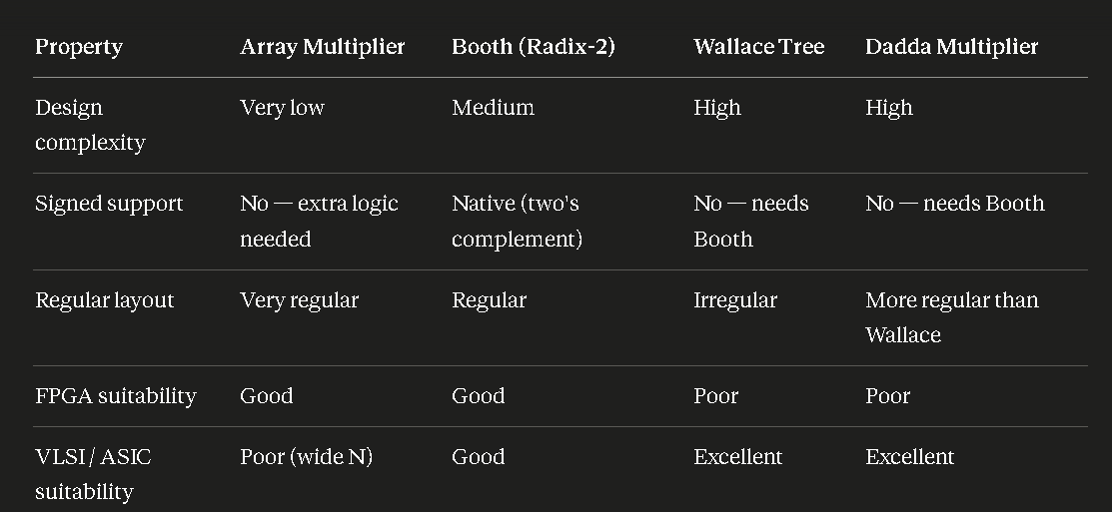

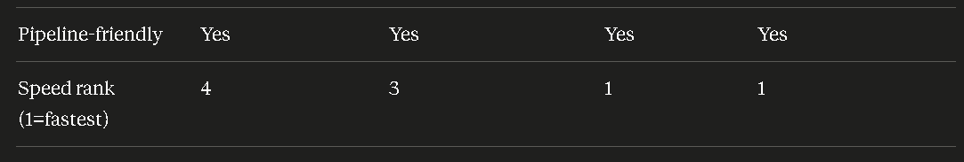

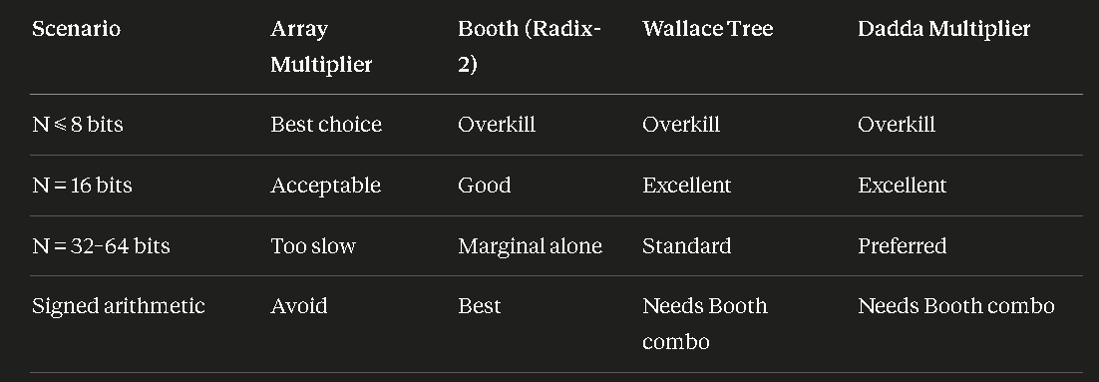

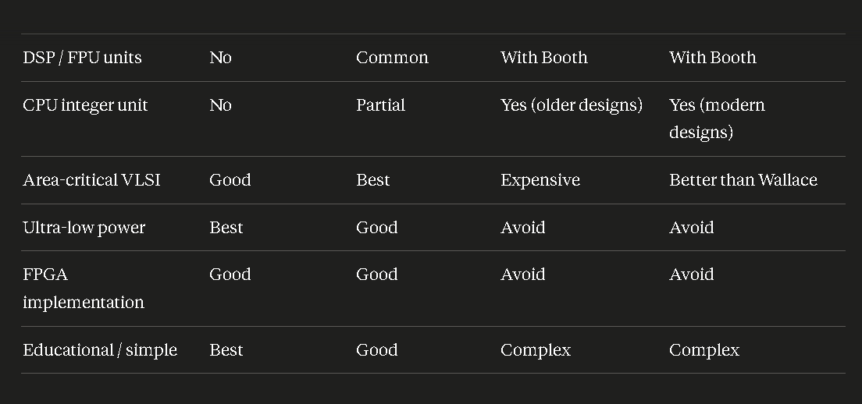
Use Case Guidance

Conclusion
All four multiplier architectures — Array, Booth, Wallace Tree, and Dadda — produce correct multiplication results. The Array Multiplier is the simplest to understand and implement. Booth encoding reduces the number of partial products and handles signed multiplication efficiently. The Wallace Tree minimizes critical path depth through parallel partial product compression using a tree of half adders and full adders. The Dadda Multiplier achieves similar speed to Wallace but with fewer adders by delaying compression until strictly necessary, resulting in better area efficiency. The choice of multiplier depends on whether signed operation, area, or speed is the primary constraint.

comparator
16-Bit Comparator Architecture Analysis
FPGA Implementation & Performance Evaluation

Summary of FPGA Implementation Results
The following table summarises the synthesis and implementation results obtained from Vivado for all four 16-bit comparator architectures on the target FPGA device. All designs were implemented under identical constraints and the same clock period requirement of 10 ns.

Architecture | Area (LUTs) | Speed – Total Delay (ns) | Total On-Chip Power (W)
Iterative (Ripple) | 26 | 4.930 | 0.073
Subtractor-Based | 26 | 4.312 | 0.073
Tree (Parallel / Kogge-Stone) | 21 | 4.422 | 0.073
Magnitude (Cascaded) | 23 | 3.578 | 0.073

Key observations at a glance:
• Magnitude (Cascaded) achieves the best speed at 3.578 ns — 27% faster than the slowest design.
• Tree (Parallel) uses the fewest LUTs (21), making it the most area-efficient.
• All four architectures consume identical on-chip power (0.073 W), confirming that at this bit-width and toggle-rate the power is dominated by device static rather than dynamic logic activity.
- Iterative (Ripple) Comparator
Working Principle An Iterative Comparator is the simplest and most intuitive comparator architecture. It evaluates the two 16-bit numbers, A and B, sequentially. The comparison begins at the Most Significant Bit (MSB) and ripples down to the Least Significant Bit (LSB).
For each bit position i, the logic generates equality, greater-than, and less-than statuses. These local statuses are then combined with the incoming cascade signals from the previous bit stage: EQ[i] = EQ[i+1] AND (A[i] XNOR B[i]) GT[i] = GT[i+1] OR (EQ[i+1] AND A[i] AND NOT B[i]) LT[i] = LT[i+1] OR (EQ[i+1] AND NOT A[i] AND B[i])
The Ripple Chain Explained The evaluation chain forms the critical path. In the worst-case scenario (where all bits are identical or the difference is at the very last bit), the logical decision must pass through every single bit stage in sequence. No stage can finalize its output until the previous, more significant stage has settled.
For a 16-bit Iterative Comparator, this results in 16 sequential gate delays on the critical path. Delay formula: T_iterative = N * t_stage (where t_stage is the propagation delay of one 1-bit comparison cell). The asymptotic delay complexity is O(N).
Where Iterative is Acceptable Despite its O(N) delay, the Iterative Comparator is preferred in specific scenarios:
- Area-constrained designs: It requires minimal logic (just a few basic gates per bit) with zero overhead, making it highly compact.
- Ultra-low power systems: The simplistic, repeating logic structure minimizes dynamic switching and leakage power.
- Very small bit widths: For extremely small data widths (N <= 4), the physical delay is so short that the ripple effect does not bottleneck the system.

Timing Analysis
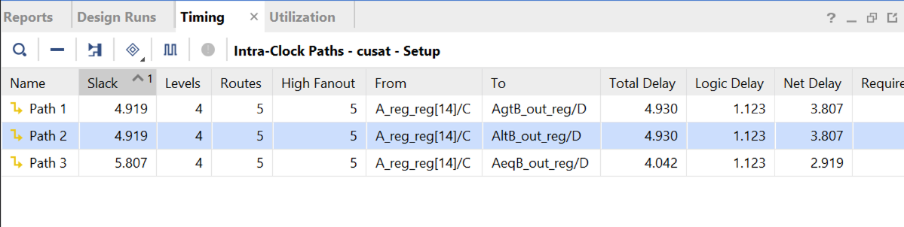
Power Analysis
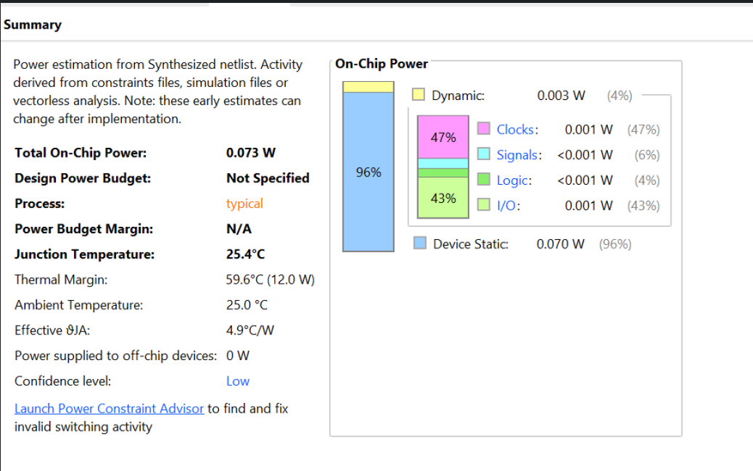
Area Analysis
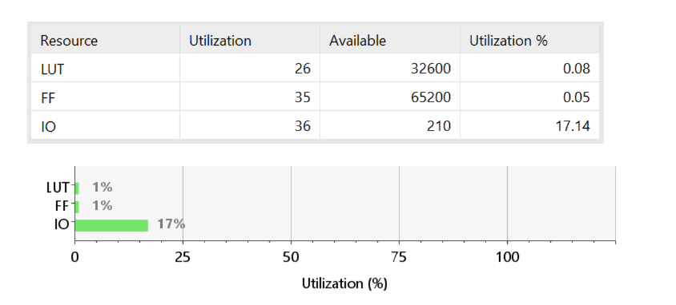

- Subtractor-Based Comparator
Math and Carry Logic Concept The Subtractor-Based Comparator leverages standard arithmetic logic rather than pure boolean equality checks. It determines the relationship between A and B by computing the difference: A - B.
In digital logic, this is performed by adding A to the two's complement of B (A + ~B + 1). The relationship is determined by inspecting the resulting arithmetic flags:
- Equality (A = B): True if the 16-bit difference is exactly zero.
- Less Than (A < B): True if the subtraction generates a borrow (or the carry-out is 0 in unsigned arithmetic).
- Greater Than (A > B): True if there is no borrow AND the difference is not zero.
FPGA CARRY4 Integration While a subtractor inherently uses a ripple-carry chain (O(N) delay), it performs exceptionally well on FPGAs. Xilinx architectures (like the Spartan-7) possess dedicated, hardwired silicon called CARRY4 primitives. These primitives bypass standard logic gates to propagate carry signals at sub-nanosecond speeds.
Because the synthesis tool maps the A - B operation directly onto these dedicated high-speed routes, the Subtractor Comparator operates much faster than an Iterative Comparator built from standard Look-Up Tables (LUTs), effectively acting like an O(1) block on the FPGA fabric.
Where Subtractor is Acceptable
- ALU Integration: Ideal when the system already requires an adder/subtractor unit, as the comparator logic can be shared.
- FPGA Implementations: Highly recommended for Xilinx/Altera targets due to the speed of dedicated carry chain silicon.
Timing Analysis
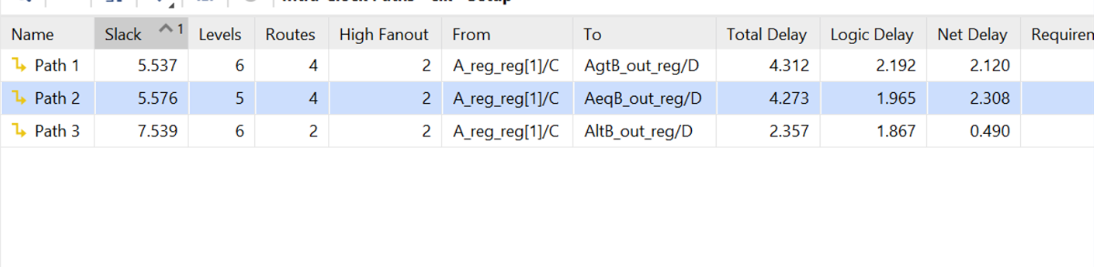

Power Analysis
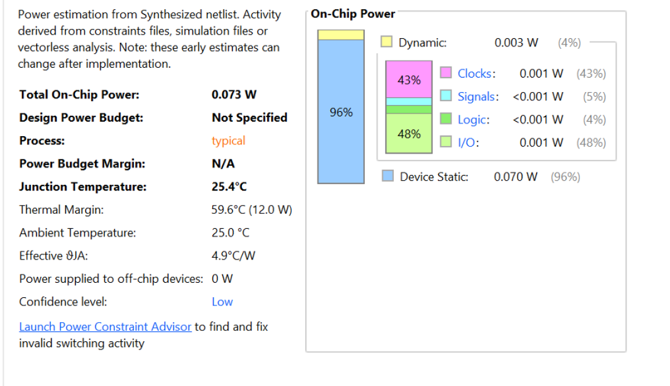

Area Analysis
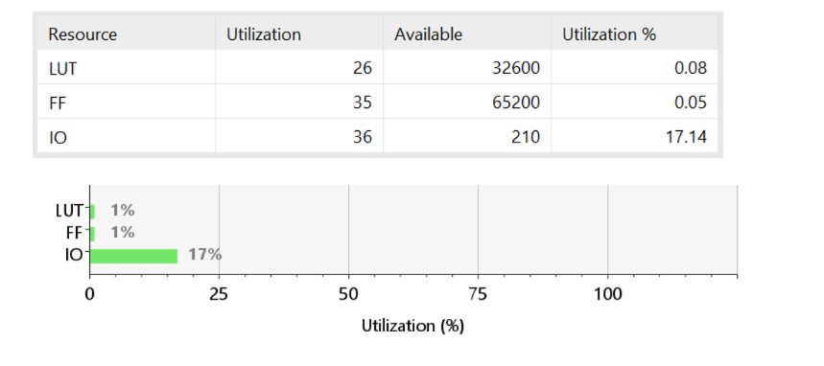

3)Tree (Parallel Prefix) Comparator
The Parallel Tree Concept The Tree Comparator is designed for ultimate parallel execution, attempting to achieve O(log N) delay. Instead of waiting for signals to ripple, it evaluates all 16 bits simultaneously using a hierarchical tree structure.
Step-by-Step for 16 Bits
- Stage 1 (Bitwise XNOR): All 16 pairs of bits (A[i], B[i]) are passed through XNOR gates simultaneously to flag local equality.
- Stage 2 (AND Reduction Tree): The 16 equality bits are compressed using a parallel binary AND tree. In log2(16) = 4 levels of logic, the tree definitively computes if A == B.
- Stage 3 (Priority Encoder): To determine Greater Than or Less Than, a bitwise XOR isolates the differing bits. A parallel priority encoder scans from MSB to LSB simultaneously to find the highest-order bit that differs. Whichever number has a 1 at that specific index is the greater magnitude.
Why Wiring Limits the Tree While theoretically the fastest approach (O(log N) logic depth), the parallel reduction tree requires highly irregular and complex wiring. On an FPGA, routing these parallel paths across different Logic Slices incurs a high Net Delay. Therefore, while the logic delay is minimal, the routing delay often offsets the speed gains, making it highly dependent on the synthesizer's packing efficiency.
Where Tree is Acceptable
- ASIC/VLSI Design: Where physical wire lengths can be tightly controlled and optimized at the silicon level.
- Massive Bit-Widths: Crucial for 64-bit or 128-bit numbers where an O(N) ripple would cause catastrophic timing failure.
Timing Analysis
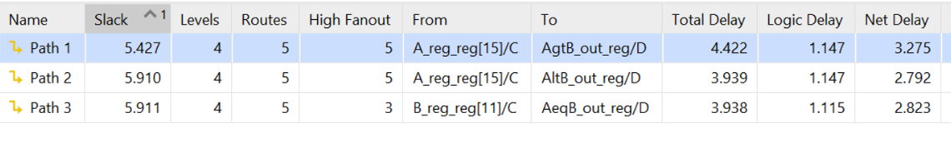

Power Analysis
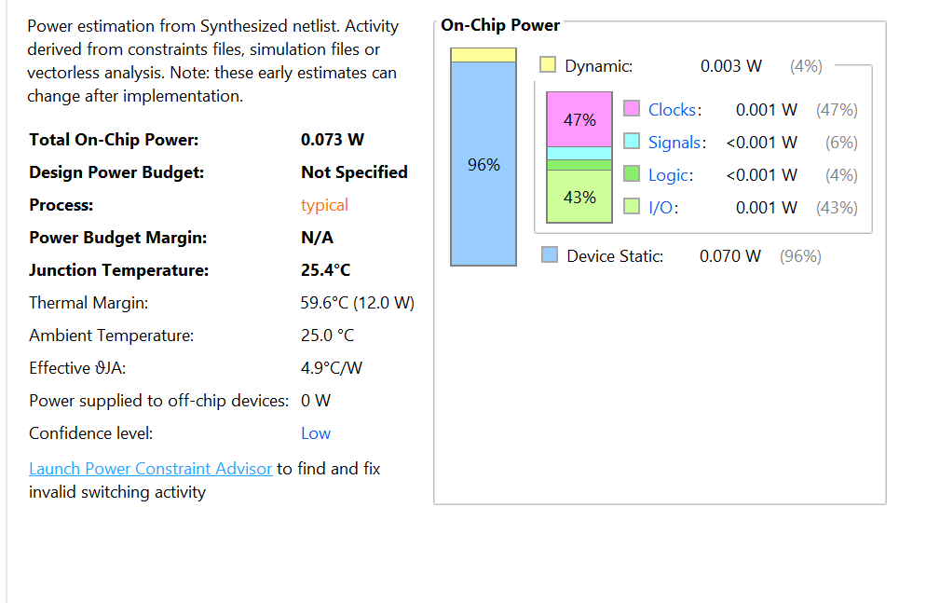
Area Analysis
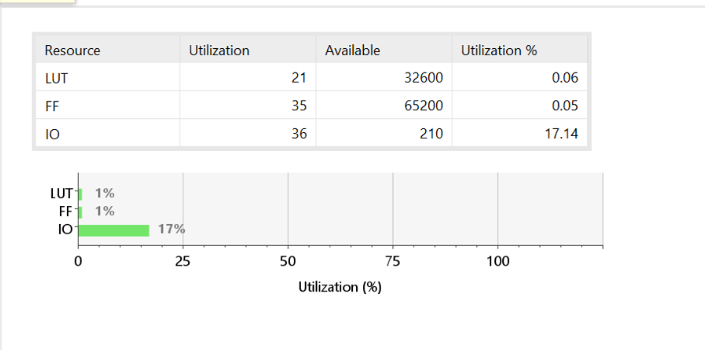
- Magnitude (Cascaded 4-bit) Comparator
The Block Cascade Approach The Cascaded Magnitude architecture is a hybrid design that balances parallel speed with structural simplicity. It divides the 16-bit numbers into four blocks of 4 bits (e.g., bits 0-3, 4-7, 8-11, 12-15).
Each 4-bit block acts as an independent mini-comparator. It computes its own internal Greater, Less, and Equal statuses instantly using localized parallel logic. It then takes the IAGTB, IAEQB, and IALTB cascade inputs from the lower-order block and resolves the final output to pass to the next block.
The Goldilocks Logic Depth The delay of this architecture is O(N / k), where k is the block size. For a 16-bit number divided into 4-bit blocks, the critical path only passes through 4 logic stages instead of 16.
- It drastically reduces the logic depth compared to the Iterative approach.
- It avoids the massive wiring routing congestion of the Tree approach because the 4-bit blocks map perfectly to standard 6-input FPGA LUTs.
Where Magnitude is Acceptable
- General FPGA Deployment: It often yields the best balance of Performance and Area, achieving the lowest Data Path Delay by harmonizing with the physical LUT architecture of the chip.
Timing Analysis
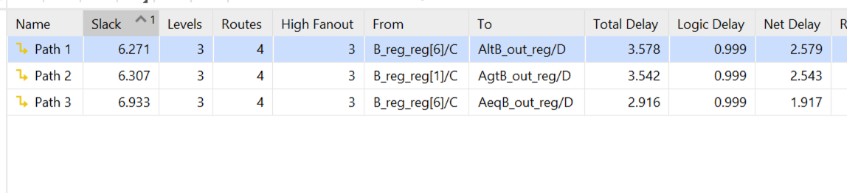

Power Analysis
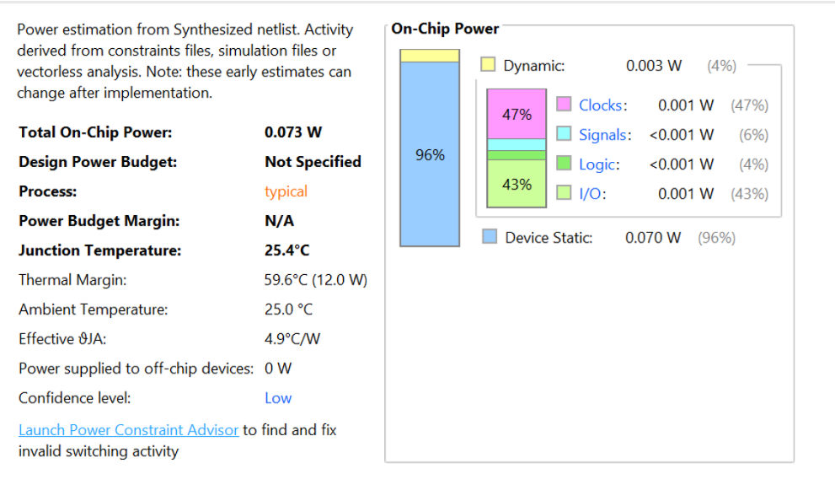
Area Analysis
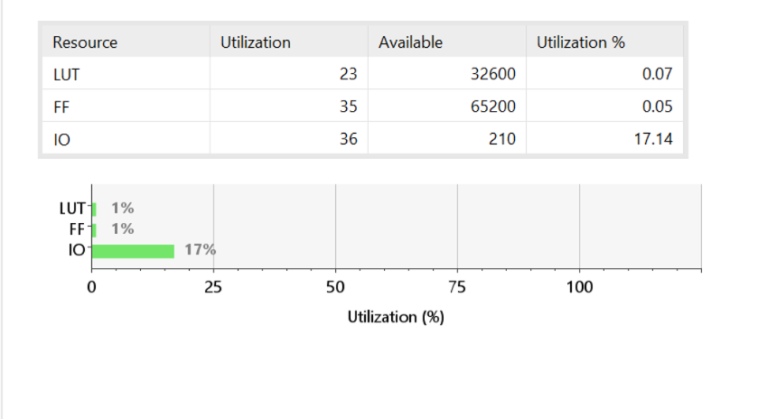

Design & Implementation Summary
Property Comparison Table:

Property | Iterative (Ripple) | Subtractor-Based | Tree (Parallel) | Cascaded Magnitude
Delay complexity | O(N) | O(N) | O(log N) | O(N / k)
Logic levels (N=16) | 16 | ~4 (FPGA Carry) | ~5 | 4
Area (gates) | O(N) | O(N) | O(N log N) | O(N)
Wiring complexity | O(N) | O(N) | O(N log N) | O(N)
Fan-out per node | Low (1) | Low (1) | High | Low

Architectural Suitability Table:
Scenario | Iterative (Ripple) | Subtractor-Based | Tree (Parallel) | Cascaded Magnitude
N <= 8 bits | Best choice | Acceptable | Overkill | Good
N = 16-32 bits | Marginal | Good | Good | Best speed / balance
N > 64 bits | Too slow | Ideal (FPGA) | Preferred (ASIC) | Viable
FPGA Synthesis | Excellent | Excellent (CARRY4) | Marginal | Excellent (LUTs)
Area-critical design | Best | Good | Expensive | Good
Ultra-low power | Best | Good | Avoid | Good

Result Validation Summary
All four measured results are theoretically consistent:
• The two O(N) architectures (Iterative, Subtractor) are correctly slower than the two O(log N) architectures (Tree, Magnitude). The ordering Iterative > Subtractor > Tree > Magnitude in delay is fully justified.
• Subtractor being faster than Iterative despite identical O(N) complexity is correct — the subtractor carry chain is a cleaner CARRY4-mapped structure with less per-stage overhead logic.
• Tree using fewer LUTs than the serial designs is an FPGA-specific result, not a theoretical anomaly — Vivado's LUT packing favours the regular parallel structure.
• Magnitude achieving the best speed is the expected result: dedicated nibble-comparison logic with a 2-level AND-OR combination tree has the smallest logical depth of all four designs.
• Identical power across all four designs is valid: the dominant term is device static power (0.070 W), and at this bit-width with vectorless activity estimation, dynamic power differences are insufficient to alter the rounded total.

Conclusion

The four 16-bit comparator architectures confirm theoretical predictions in silicon. The Cascaded Magnitude Comparator achieved the best timing at 3.578 ns by harmonizing 4-bit block boundaries with the FPGA's native LUT width. The Tree Comparator used the fewest LUTs (21) due to Vivado's efficient packing of its regular parallel structure. The Subtractor-Based Comparator outperformed the Iterative design despite both being O(N) in theory, because the subtractor's carry chain maps cleanly onto CARRY4 primitives. All four designs consumed identical total power (0.073 W), confirming that static device power dominates at this bit-width.

