Build a To-Do App with Django as Backend
This tutorial is based on the first two steps of the tutorial at https://www.digitalocean.com/community/tutorials/build-a-to-do-application-using-django-and-react

Open a folder on VSCode

Create a new folder called ‘django-todo-backend’
mkdir django-todo-backend

Change into this directory
cd django-todo-backend

Create a virtual environment
python -m venv venv

Activate the virtual environment
venv/scripts/activate (Windows)
or
source venv/bin/activate (Mac or Codespace)

Install Django
pip install Django

Create a new project in Django
django-admin startproject backend
This will create a directory called backend (which is the name of our project). Go through the files created in this directory. For more information on the different files go to the official Django tutorials at https://docs.djangoproject.com/en/6.0/intro/tutorial01/
The folder and file structure at this stage should be as shown below
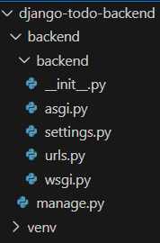 | 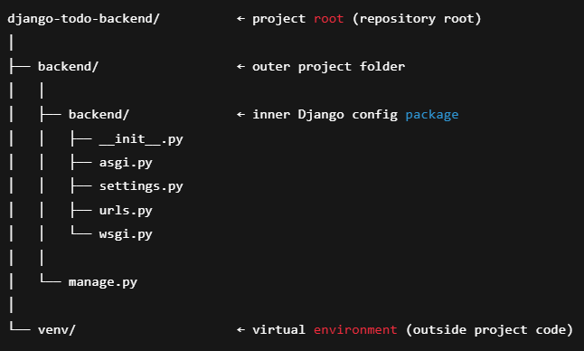

You will only be modifying the settings.py and urls.py files.

Create a new application (todo) in backend project
cd into the backend folder (cd backend) It is important to do this as we will need the manage.py file to run various commands/operations in Django.
Next run python manage.py startapp todo
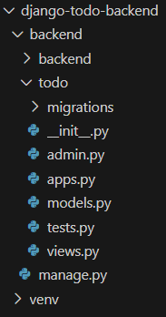

Following is an extract from https://docs.djangoproject.com/en/6.0/intro/tutorial01/ on what is an application and the difference between projects and apps in Django
“Each application you write in Django consists of a Python package that follows a certain convention. Django comes with a utility that automatically generates the basic directory structure of an app, so you can focus on writing code rather than creating directories.
Projects vs. apps
What’s the difference between a project and an app? An app is a web application that does something – e.g., a blog system, a database of public records or a small poll app. A project is a collection of configuration and apps for a particular website. A project can contain multiple apps. An app can be in multiple projects.”
Remember in the SQA module and the Flask todo/blog application, we had to manually create this structure for every component whereas Django creates this structure automatically for us.

Run migrations
python manage.py migrate

Run the server
Python manage.py runserver
http://127.0.0.1:8000/
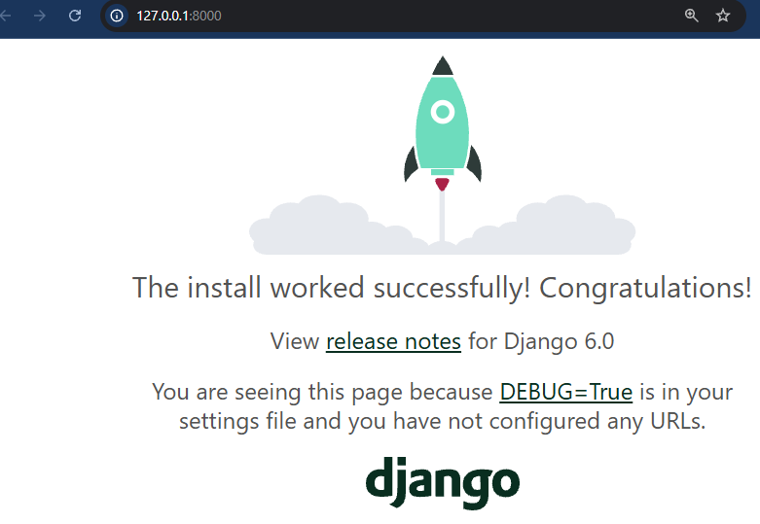

Register the todo application
INSTALLED_APPS = [
'django.contrib.admin',
'django.contrib.auth',
'django.contrib.contenttypes',
'django.contrib.sessions',
'django.contrib.messages',
'django.contrib.staticfiles',
'todo', #add this line
]

Define the Todo model
Open the todo/models.py file in your code editor and add the following lines of code:
from django.db import models

# Create your models here.

class Todo(models.Model):
title = models.CharField(max_length=120)
description = models.TextField()
completed = models.BooleanField(default=False)

def __str__(self):
return self.title

Every time you update or add a new model, you need to run the following commands
First create the migrations file python manage.py makemigrations todo
Apply the migrations to the database python manage.py migrate todo

Add the Todo model to admin
Open the todo/admin.py file with your code editor and add the following lines of code:
from django.contrib import admin
from .models import Todo

class TodoAdmin(admin.ModelAdmin):
list_display = ('title', 'description', 'completed')

# Register your models here.

admin.site.register(Todo, TodoAdmin)

Create a superuser account
Specify username, email (optional), and password to create a superuser account. Either make the password easy to remember (this is a local server right now) or remember the password. If you forget it, then just create another superuser.
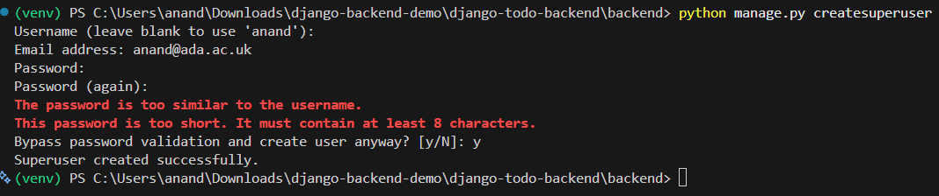

Test the Django Admin site
Make sure you run the Django server again python manage.py runserver
Access the admin site at http://127.0.0.1:8000/admin
Login with the username and password you used for the superuser. You should be able to add or modify new users/todos
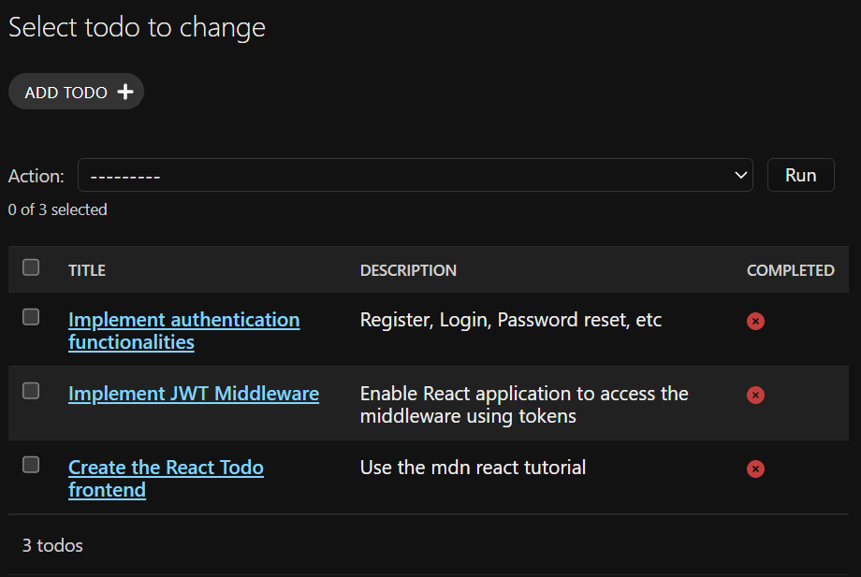

Setting up the APIs
In this step we will install and configure the Django REST framework and Django-cors-headers. Have a look at these links for further information. If you want a quick understanding of what CORS is then have a look at https://www.youtube.com/watch?v=4KHiSt0oLJ0

pip install djangorestframework django-cors-headers
Add the corheaders and rest_framework apps to the list of Installed apps
INSTALLED_APPS = [
'django.contrib.admin',
'django.contrib.auth',
'django.contrib.contenttypes',
'django.contrib.sessions',
'django.contrib.messages',
'django.contrib.staticfiles',
'corsheaders', # add this app
'rest_framework', # add this app
'todo',
]

Add the corsheaders middleware to the list of middlewares
MIDDLEWARE = [
'django.middleware.security.SecurityMiddleware',
'corsheaders.middleware.CorsMiddleware',
'django.contrib.sessions.middleware.SessionMiddleware',
'django.middleware.common.CommonMiddleware',
'django.middleware.csrf.CsrfViewMiddleware',
'django.contrib.auth.middleware.AuthenticationMiddleware',
'django.contrib.messages.middleware.MessageMiddleware',
'django.middleware.clickjacking.XFrameOptionsMiddleware',
]

Note, CorsMiddleware should be placed as high as possible, especially before CommonMiddleware. Middleware executes top to bottom on the request and bottom to top on the response, so CorsMiddleware must run before CommonMiddleware, CsrfViewMiddleware, and any middleware that may return an early response. If it is placed too low in the stack, CORS headers may not be added to error responses such as 404 or 403. This can cause preflight OPTIONS requests to fail and result in browser errors indicating that the Access-Control-Allow-Origin header is missing.

Add the following towards the end of the backend/settings.py file
CORS_ORIGIN_WHITELIST = [
'http://localhost:3000'
]

Note, you should replace 'http://localhost:3000' with your actual frontend url whether the frontend is on render or Codespace or local.
If you are working in Codespace, I found it useful to add the following in addition to the above:
CORS_ALLOWED_ORIGIN_REGEXES = [
r"^https:\/\/.*-3000\.app\.github\.dev$",
]
This is because
• Codespaces generates dynamic subdomains.
• Hardcoding a single origin will break every time the Codespace URL changes.
• Regex allows all *-3000.app.github.dev frontend ports safely.

Creating serializers
You will need serializers to convert model instances to JSON so that the frontend can work with the received data.
Create a todo/serializers.py file with your code editor. Open the serializers.py file and update it with the following lines of code:
from rest_framework import serializers
from .models import Todo

class TodoSerializer(serializers.ModelSerializer):
class Meta:
model = Todo
fields = ('id', 'title', 'description', 'completed')
This code specifies the model to work with and the fields to be converted to JSON.

Creating the View
You will need to create a TodoView class in the todo/views.py file.
Open the todo/views.py file with your code editor and add the following lines of code:
from django.shortcuts import render
from rest_framework import viewsets
from .serializers import TodoSerializer
from .models import Todo

# Create your views here.

class TodoView(viewsets.ModelViewSet):
serializer_class = TodoSerializer
queryset = Todo.objects.all()

Set the API routes
Open the backend/urls.py file with your code editor and replace the contents with the following lines of code:
from django.contrib import admin
from django.urls import path, include
from rest_framework import routers
from todo import views

router = routers.DefaultRouter()
router.register(r'todos', views.TodoView, 'todo')

urlpatterns = [
path('admin/', admin.site.urls),
path('api/', include(router.urls)),
]

This code specifies the URL path for the API. This was the final step that completes the building of the API.
You can now perform CRUD operations on the Todo model. The router class allows you to make the following queries:
/todos/ - returns a list of all the Todo items. CREATE and READ operations can be performed here.
/todos/id - returns a single Todo item using the id primary key. UPDATE and DELETE operations can be performed here.
Let’s restart the server: python manage.py runserver

Test the REST endpoints
Point your browser to http://127.0.0.1:8000/api/todos/
You should be able to see all the todos we created through the admin interface
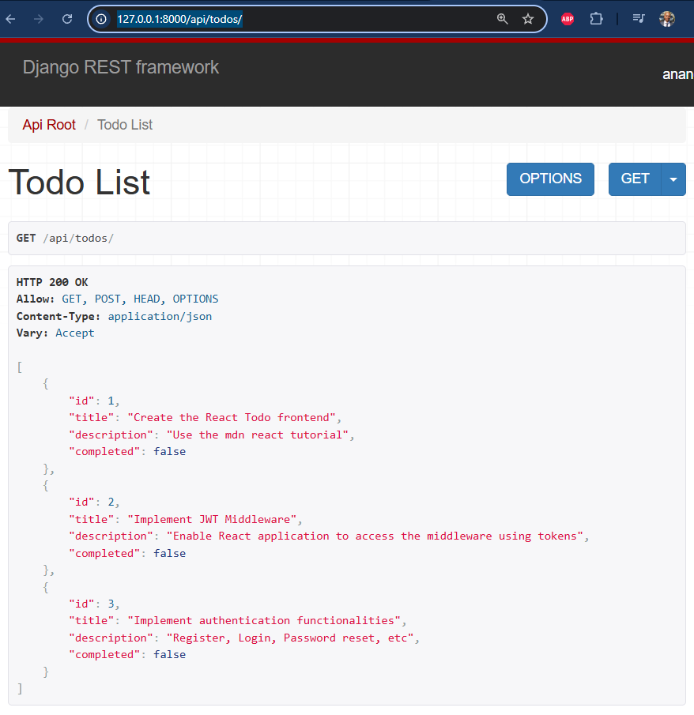

You can create a new todo and check if it was added correctly
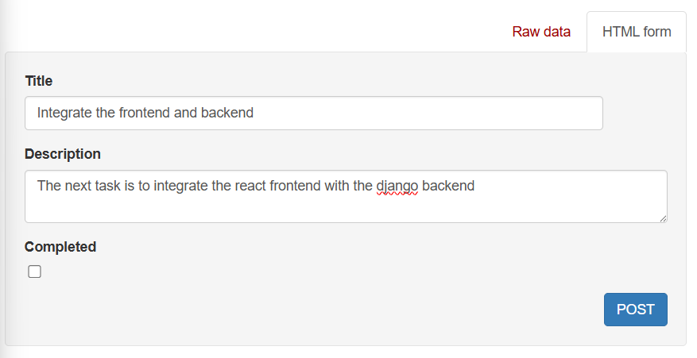
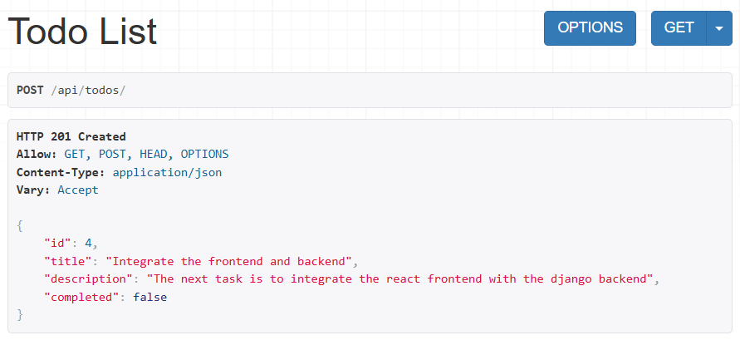
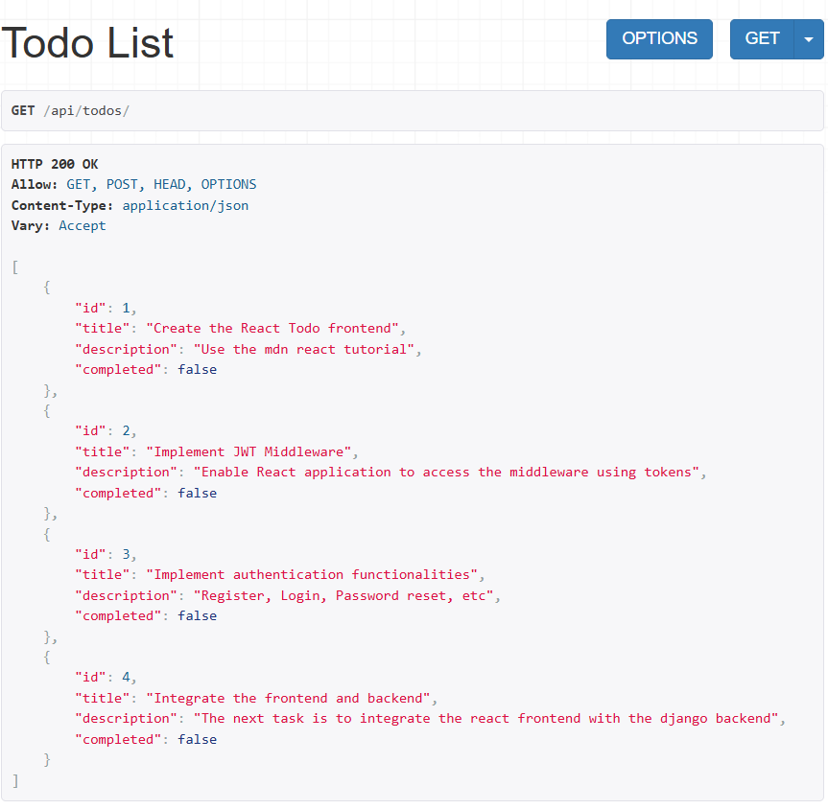
You can also perform DELETE and UPDATE operations on specific Todo items using the id primary keys. Use the address structure /api/todos/{id} and provide an id.
Add 1 to the URL to examine the Todo item with the id of “1”. Navigate to http://localhost:8000/api/todos/1 in your web browser:
