Express Stock

Step 1
Open VSCode on folder named ‘express-stock-app-rebuild’

Initialise a new Node.js project with default settings
Run the command ‘npm init -y’ in the terminal
This will create a ‘package.json’ file with the following contents:
{
"name": "express-stock-app-rebuild",
"version": "1.0.0",
"main": "index.js",
"scripts": {
"test": "echo \"Error: no test specified\" && exit 1"
},
"keywords": [],
"author": "",
"license": "ISC",
"description": ""
}

Have a look at https://docs.npmjs.com/cli/v9/configuring-npm/package-json if you want more information on what is the package.json file.

npm install --save express
Install express as a production dependency

npm install nodemon --save-dev
Install nodemon as a development dependency

npm install pug
Install pug for templates

Add the following lines to the package.json
"scripts": {
"test": "echo \"Error: no test specified\" && exit 1",
"start": "node app.js",
"dev": "nodemon app.js"
},
The start and dev commands have been added. These commands allow you to run the node application either through nodemon (Dev) as “npm run dev” or through Node (Prod) as “npm start”

app.js:
const express = require("express");
const app = express();
const port = 3000;
const productRoutes = require('./routes/productRoutes');

app.set('view engine', 'pug');
app.set('views', './views');
app.use(express.static('./public'));

// Use product routes
app.use('/', productRoutes);

app.listen(port, () => {
console.log(`Server listening on port ${port}`);
console.log(`Visit http://localhost:${port}`);
});

routes/productRoutes.js
Create a folder called ‘routes’ in the project root and inside it create the file ‘productRoutes.js’
const express = require("express");
const router = express.Router();
const stockController = require("../controllers/stockController");

router.get("/", stockController.index);

module.exports = router;

controllers/stockController.js
Create a folder called ‘controllers’ in the project root and inside it create the file ‘stockController.js’
const products = {};

exports.index = async (req, res) => {
try {
res.render("index", { products: products });
} catch (err) {
console.error(err);
res.status(500).send("Error fetching products.");
}
};

public/styles.css
Create a folder called ‘public’ in the project root and inside it create the file ‘styles.css’
body {
font-family: sans-serif;
margin: 20px;
}

table {
width: 100%;
border-collapse: collapse;
}

th, td {
border: 1px solid #ddd;
padding: 8px;
text-align: left;
}

th {
background-color: #f0f0f5;
}

form {
margin-bottom: 20px;
}

label {
display: block;
margin-bottom: 5px;
}

input[type="text"], input[type="number"], select {
width: 100%;
padding: 8px;
border: 1px solid #ddd;
box-sizing: border-box;
}

views/index.pug
html
head
title Stock Control System
link(rel='stylesheet', href='/styles.css')
body
h1 Stock Inventory

Verify if you have all the folders and files created according to what is shown below:
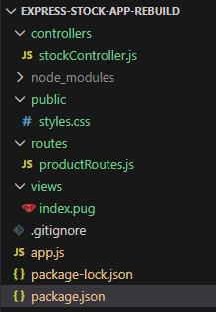

Run the application with node app.js or npm run dev
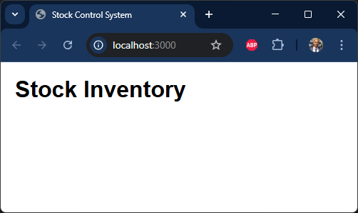
At this stage, you can verify your implementation by comparing your code with the reference solution available at https://github.com/anandveeraswamy/express-stock-app-rebuild/tree/697af66ae7a085cbfe77d36e5ae4209772cfdb34

Step 2: Introduce the product model

Install sequelize and sqlite3
npm install sequelize
npm install sqlite3

Add config file for database
config/database.js
module.exports = {
dialect: "sqlite",
storage: "./database.sqlite",
};

models/index.js
Create a folder called ‘models’ in the project root and inside it create the file ‘index.js’.
const { Sequelize, DataTypes } = require("sequelize");
const config = require("../config/database.js");

const sequelize = new Sequelize({
dialect: config.dialect,
storage: config.storage,
});

const db = {};

db.sequelize = sequelize;
db.Sequelize = Sequelize;

db.Product = require("./product.js")(sequelize, DataTypes);

module.exports = db;

Explanation of the above code:
const { Sequelize, DataTypes } = require("sequelize");
- Sequelize → The main ORM class used to create a database connection.
- DataTypes → Used when defining models (e.g., STRING, INTEGER, BOOLEAN).

const sequelize = new Sequelize({
dialect: config.dialect,
storage: config.storage,
});
This creates the database connection instance.
- dialect → Database type (e.g., sqlite, postgres, mysql)
- storage → Used for SQLite (file path)

const db = {};
Creating a db Object (Model Registry Pattern)
This object acts as a container for:
- the Sequelize connection
- Sequelize library reference
- all defined models
This is a common architectural pattern in Sequelize projects.
db.sequelize = sequelize;
db.Sequelize = Sequelize;
Attaching Sequelize References. This allows other parts of the application to access the DB connection.
db.Product = require("./product.js")(sequelize, DataTypes);
Imports product.js
Immediately invokes it as a function and Passes in:
- sequelize (the connection)
- DataTypes

models/product.js
module.exports = (sequelize, DataTypes) => {
const Product = sequelize.define('Product', {
id: {
type: DataTypes.STRING,
primaryKey: true
},
name: {
type: DataTypes.STRING,
allowNull: false
},
price: {
type: DataTypes.FLOAT,
allowNull: false
},
quantity: {
type: DataTypes.INTEGER,
allowNull: false
},
type: {
type: DataTypes.STRING,
allowNull: false
}
});

return Product;
};

Add the database prebuild script:
Create a folder called ‘scripts’ in the project root and inside it create the file ‘databasePrebuild.js’.
scripts/databasePrebuild.js
const db = require('../models');
const { Product} = db;

async function prebuildDatabase() {
try {
// Sync the database and create tables
await db.sequelize.sync({ force: true });

console.log('Database synced. Creating sample data...');

// Create sample products
const products = await Product.bulkCreate([
{ id: 'CLO001', name: 'T-Shirt', price: 19.99, quantity: 100, type: 'clothing' },
{ id: 'CLO002', name: 'Jeans', price: 49.99, quantity: 50, type: 'clothing' },
{ id: 'ELE001', name: 'Smartphone', price: 599.99, quantity: 30, type: 'electronics' },
{ id: 'ELE002', name: 'Laptop', price: 999.99, quantity: 20, type: 'electronics' },
]);

console.log('Sample data created successfully.');
} catch (error) {
console.error('Error creating sample data:', error);
} finally {
await db.sequelize.close();
}
}

prebuildDatabase();

Update package.json file the database prebuild script
Update the package.json file with just the last line
"scripts": {
"test": "echo \"Error: no test specified\" && exit 1",
"start": "node app.js",
"dev": "nodemon app.js",
"database:prebuild": "node scripts/databasePrebuild.js"
},

Run the prebuild script
npm run database:prebuild
After you run this command, you will notice that a new file called “database.sqlite” will be created in your project root folder. You will not be able to view it since it is not a text file.

Add the SQLite Viewer extension by Florian Klampfer
In order to view files with the extension sqlite, click on the extensions icon and search for ‘sqlite viewer’. Install the extension authored by Florian Klampfer as shown below
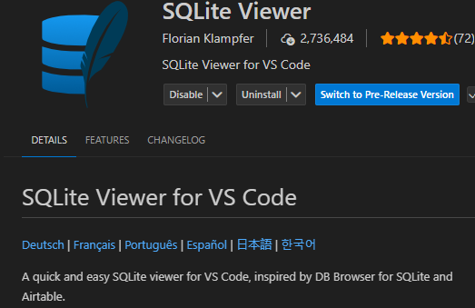
Check the database file in sqlite viewer
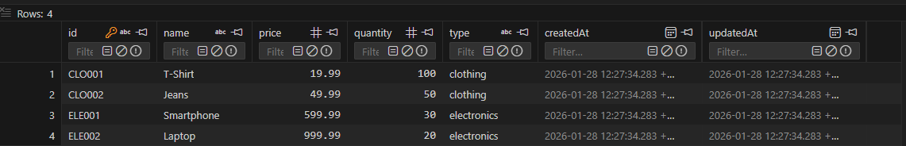

At this stage, you can verify your implementation by comparing your code with the reference solution available at the following GitHub commit:
https://github.com/anandveeraswamy/express-stock-app-rebuild/tree/fdf00cb955c5390c99cfc487c4be3dd308651065

Step 3: fetch and show records from the products table

Update the index.pug with the following:
html
head
title Stock Control System
link(rel='stylesheet' href='/styles.css')
body
h1 Stock Inventory

//- Display products
table
thead
tr
th ID
th Name
th Price
th Quantity
th Type
th Actions
tbody
each product in products
tr
td= product.id
td= product.name
td= product.price
td= product.quantity
td= product.type
td
a(href=`/details/${product.id}`) View Details
form(action=`/delete/${product.id}` method="post" style="display:inline;")
input(type="hidden" name="_method" value="DELETE")
button(type="submit") Delete

Update controllers/stockController.js with the following:
const db = require("../models");
const Product = db.Product;

exports.index = async (req, res) => {
try {
const products = await Product.findAll();
res.render("index", { products: products });
} catch (err) {
console.error(err);
res.status(500).send("Error fetching products.");
}
};

Check the index page at http://localhost:3000/
Run ‘npm run dev’ in the terminal to view the product records as shown below:
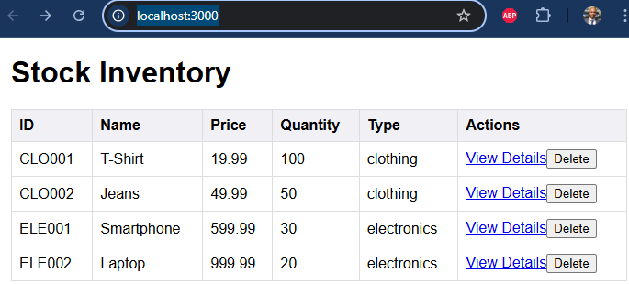
At this stage, you can verify your implementation by comparing your code with the reference solution available at the following GitHub commit:
https://github.com/anandveeraswamy/express-stock-app-rebuild/tree/0e5960e2bac8d74d53c88d3333fda6d3d48ef7a6

Step 4: Get product details

Add details.pug file in the views folder with the following content:
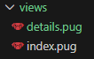
html
head
title Product Details
link(rel='stylesheet', href='/styles.css')
body
h1 Product Details

//- Display product information
p ID: #{product.id}
p Name: #{product.name}
p Price: #{product.price} GBP
p Quantity: #{product.quantity}
p Type: #{product.type}

//- Link back to the inventory list
a(href="/") Back to Inventory

Add new route for product details
Add the following line in the routes/productRoutes.js file:
router.get("/details/:id", stockController.getDetails);

The updated file will be as follows:
const express = require("express");
const router = express.Router();
const stockController = require("../controllers/stockController");

router.get("/", stockController.index);

router.get("/details/:id", stockController.getDetails);

module.exports = router;

Add the getDetails function in the controller
Add the following function to the controllers/stockController.js file
exports.getDetails = async (req, res) => {
try {
const { id } = req.params;
const product = await Product.findByPk(id);

if (!product) {
return res.status(404).send("Product not found.");
}

res.render('details', { product: product });
} catch (err) {
console.error(err);
res.status(500).send("Error fetching product details.");
}
};

Test the ViewDetails route
From the index page click on view details link for the products which should give you the details of each product alone
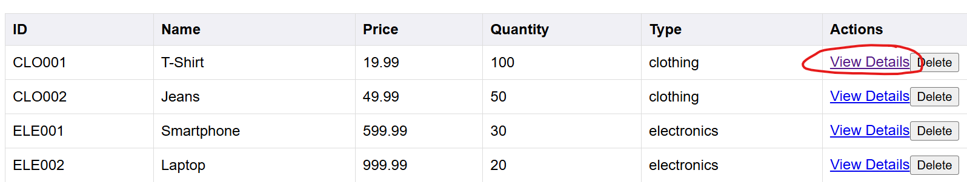
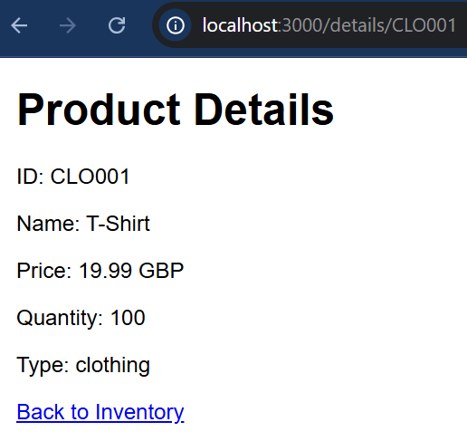
At this stage, you can verify your implementation by comparing your code with the reference solution available at the following GitHub commit: https://github.com/anandveeraswamy/express-stock-app-rebuild/tree/3b0e6d011b655b82db56f7a7582167df25b4096f

Implement search and sort functionalities

Update index.pug to add search and sort elements
html
head
title Stock Control System
link(rel='stylesheet' href='/styles.css')
body
h1 Stock Inventory

//- Search form (new)
form(action="/search" method="get")
input(type="text" name="query" placeholder="Search products" value=searchQuery)
button(type="submit") Search

//- Sort options (new)
form(action="/sort" method="get")
select(name="sortBy" onchange="this.form.submit()")
option(value="name" selected=sortBy === 'name') Sort by Name
option(value="price" selected=sortBy === 'price') Sort by Price

//- Display products
table
thead
tr
th ID
th Name
th Price
th Quantity
th Type
th Actions
tbody
each product in products
tr
td= product.id
td= product.name
td= product.price
td= product.quantity
td= product.type
td
a(href=`/details/${product.id}`) View Details
form(action=`/delete/${product.id}` method="post" style="display:inline;")
input(type="hidden" name="_method" value="DELETE")
button(type="submit") Delete

Add the routes for search and sort
In the routes/productRoutes.js file add the following routes:
// GET search products
router.get('/search', stockController.search);

// GET sort products
router.get('/sort', stockController.sort);

Add the search and sort functions in the controller
In the controllers/stockController.js add the following op import and the two new functions. The entire code is below:
const db = require("../models");
const Product = db.Product;
const { Op } = require('sequelize');

exports.index = async (req, res) => {
try {
const products = await Product.findAll();
res.render("index", { products: products });
} catch (err) {
console.error(err);
res.status(500).send("Error fetching products.");
}
};

exports.getDetails = async (req, res) => {
try {
const { id } = req.params;
const product = await Product.findByPk(id);

if (!product) {
return res.status(404).send("Product not found.");
}

res.render('details', { product: product });
} catch (err) {
console.error(err);
res.status(500).send("Error fetching product details.");
}
};

exports.search = async (req, res) => {
try {
const { query } = req.query;
// Search for products where the name matches the query
// The `Op.like` operator is used for pattern matching
const products = await Product.findAll({
where: {
name: { [Op.like]: `%${query}%` },
},
});
res.render("index", { products, searchQuery: query });
} catch (err) {
console.error(err);
res.status(500).send("Error searching products.");
}
};

exports.sort = async (req, res) => {
try {
// Fetch all products and sort them by name in ascending order
const products = await Product.findAll({
order: [["name", "ASC"]],
});
res.render("index", { products, sortBy: "name" });
} catch (err) {
console.error(err);
res.status(500).send("Error sorting products.");
}
};

Test the new functionalities
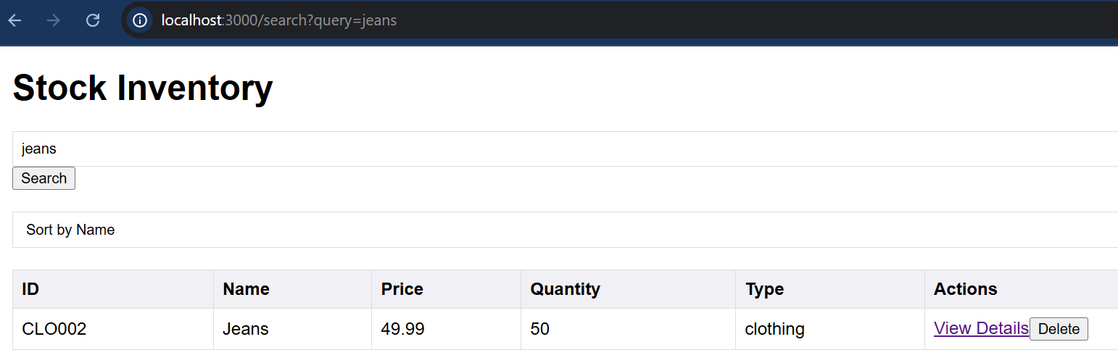
Sort by name ascending order
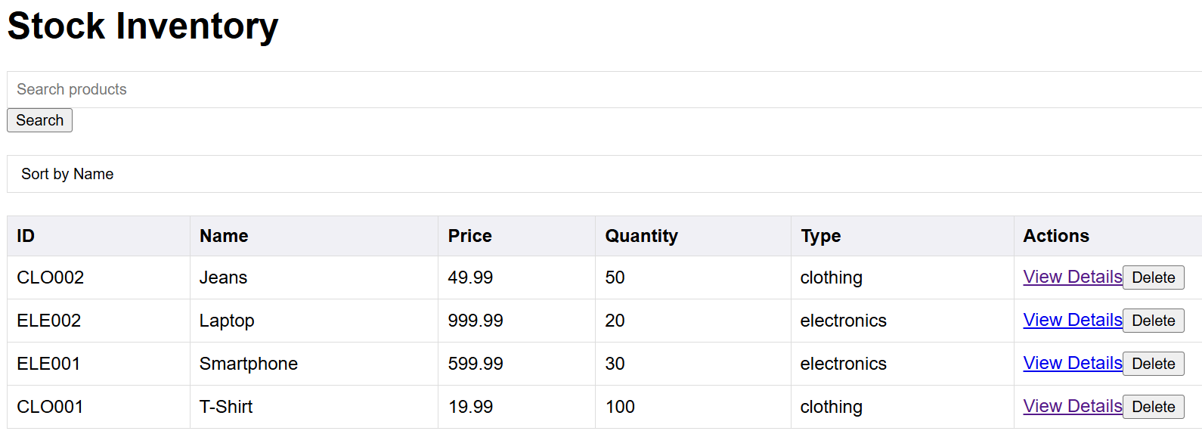
At this stage, you can verify your implementation by comparing your code with the reference solution available at the following GitHub commit:
https://github.com/anandveeraswamy/express-stock-app-rebuild/tree/739aeae60c9256d73201a62d42e948f8f0b187ab

Step 6: Implement product creation
So far we have been adding records through a script, lets see how we can allow users to create new products through an interface.
Update the index.pug to update the interface to add a new product
Views/index.pug
html
head
title Stock Control System
link(rel='stylesheet' href='/styles.css')
body
h1 Stock Inventory

//- Search form
form(action="/search" method="get")
input(type="text" name="query" placeholder="Search products" value=searchQuery)
button(type="submit") Search

//- Sort options
form(action="/sort" method="get")
select(name="sortBy" onchange="this.form.submit()")
option(value="name" selected=sortBy === 'name') Sort by Name
option(value="price" selected=sortBy === 'price') Sort by Price

//- Add new product form
form(action="/create" method="post")
label(for="id") ID:
input(type="text" id="id" name="id" required)
br
label(for="name") Name:
input(type="text" id="name" name="name" required)
br
label(for="price") Price:
input(type="number" id="price" name="price" step="0.01" required)
br
label(for="quantity") Quantity:
input(type="number" id="quantity" name="quantity" required)
br
label(for="type") Type:
select(id="type" name="type" required)
option(value="") Select a type
option(value="clothing") Clothing
option(value="electronic") Electronic
br
button(type="submit") Add Product

//- Display products
table
thead
tr
th ID
th Name
th Price
th Quantity
th Type
th Actions
tbody
each product in products
tr
td= product.id
td= product.name
td= product.price
td= product.quantity
td= product.type
td
a(href=`/details/${product.id}`) View Details
form(action=`/delete/${product.id}` method="post" style="display:inline;")
input(type="hidden" name="_method" value="DELETE")
button(type="submit") Delete

Add the route for adding new product
In the routes/productRoutes.js
// POST create a new product
router.post('/create', stockController.create);

Note that this route uses post functionality since it is updating the database.

Add the create function in the controller
exports.create = async (req, res) => {
try {
// Destructure the request body to get product details
console.log(req.body);
const { id, name, price, quantity, type } = req.body;

// Create a new product in the database
const product = await Product.create({
id, name, price, quantity, type
});

// Redirect to the home page after successful creation
res.redirect('/');
} catch (err) {
console.error(err);
res.status(500).send("Error creating product.");
}
};

Update app.js to support post functionality
const express = require("express");
const app = express();
const port = 3000;
const productRoutes = require('./routes/productRoutes');

app.set('view engine', 'pug');
app.set('views', './views');
app.use(express.static('./public'));
app.use(express.urlencoded({ extended: true })); // newly added
app.use(express.json()); // newly added

// Use product routes
app.use('/', productRoutes);

app.listen(port, () => {
console.log(`Server listening on port ${port}`);
console.log(`Visit http://localhost:${port}`);
});

Test new product creation
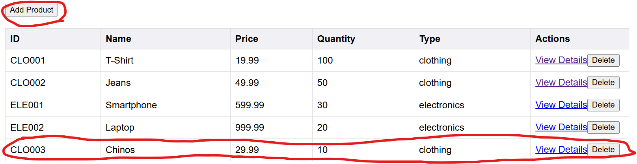
At this stage, you can verify your implementation by comparing your code with the reference solution available at the following GitHub commit: https://github.com/anandveeraswamy/express-stock-app-rebuild/tree/dabb6f4c1b2b773b27419ab98e09c6cd63ee61a5

Step 7: Add Clothing and Electronic tables with a one-to-one relationship with the product table

Add the new models - clothing and electronic
Note, I am keeping the table names singular. Sequelize will automatically pluralise these names from ‘clothing’ to ‘clothings’ and ‘electronic’ to ‘electronics’.

Add the clothing model
In models, create a new module clothing.js. Following is the code in the models/clothing.js
module.exports = (sequelize, DataTypes) => {
const Clothing = sequelize.define('Clothing', {
size: {
type: DataTypes.STRING
},
material: {
type: DataTypes.STRING
}
});

Clothing.associate = (models) => {
Clothing.belongsTo(models.Product);
};

return Clothing;
};

Add the electronic model
In models, create a new module electronic.js. Following is the code in the models/electronic.js
module.exports = (sequelize, DataTypes) => {
const Electronic = sequelize.define('Electronic', {
brand: {
type: DataTypes.STRING
},
warranty: {
type: DataTypes.STRING
}
});

Electronic.associate = (models) => {
Electronic.belongsTo(models.Product);
};

return Electronic;
};

Update the product model to associate with the electronic and clothing models
Add the following code just before the return statement of the models/product.js
Product.associate = (models) => {
Product.hasOne(models.Clothing);
Product.hasOne(models.Electronic);
};

This code defines one-to-one relationships between Product and its specialised types (Clothing and Electronic). It ensures that each product can have exactly one associated clothing record and one associated electronic record, with foreign keys automatically managed by Sequelize. It implements a relational specialisation pattern where subtype-specific data is stored in separate tables.
The full code of models/product.js is as follows:
module.exports = (sequelize, DataTypes) => {
const Product = sequelize.define("Product", {
id: {
type: DataTypes.STRING,
primaryKey: true,
},
name: {
type: DataTypes.STRING,
allowNull: false,
},
price: {
type: DataTypes.FLOAT,
allowNull: false,
},
quantity: {
type: DataTypes.INTEGER,
allowNull: false,
},
type: {
type: DataTypes.STRING,
allowNull: false,
},
});

Product.associate = (models) => {
Product.hasOne(models.Clothing);
Product.hasOne(models.Electronic);
};

return Product;
};

Associate the clothing, electronic and product models:
In models/index.js insert the following lines of code:
db.Clothing = require('./clothing.js')(sequelize, DataTypes);
db.Electronic = require('./electronic.js')(sequelize, DataTypes);

// Set up associations
Object.keys(db).forEach(modelName => {
if (db[modelName].associate) {
db[modelName].associate(db);
}
});

The full model/index.js code for your reference is
const { Sequelize, DataTypes } = require("sequelize");
const config = require("../config/database.js");

const sequelize = new Sequelize({
dialect: config.dialect,
storage: config.storage,
});

const db = {};

db.sequelize = sequelize;
db.Sequelize = Sequelize;

db.Product = require("./product.js")(sequelize, DataTypes);
db.Clothing = require('./clothing.js')(sequelize, DataTypes);
db.Electronic = require('./electronic.js')(sequelize, DataTypes);

// Set up associations
Object.keys(db).forEach(modelName => {
if (db[modelName].associate) {
db[modelName].associate(db);
}
});

module.exports = db;

Explanation of this code is below
Object.keys(db).forEach(modelName => {
if (db[modelName].associate) {
db[modelName].associate(db);
}
});

Loads each model and then iterates through them to execute their associate methods, ensuring that relationships between models are defined only after all models have been initialised. This pattern prevents circular dependency issues and centralises database configuration.

Update the stockController.js file to fetch the additional fields from the newly created models/tables
In controllers/stockControllers.js file, make the following changes

Initialise the clothing and electronics models
Add the following to create local references to the clothing and electronics models defined in clothing.js and electronics.js
const Clothing = db.Clothing;
const Electronic = db.Electronic;

Modify the getDetails function to fetch data from the clothing and electronic models
exports.getDetails = async (req, res) => {
try {
const { id } = req.params;
const product = await Product.findByPk(id, {
include: [
{ model: Clothing, required: false },
{ model: Electronic, required: false }
]
});

if (!product) {
return res.status(404).send("Product not found.");
}

res.render("details", { product: product });
} catch (err) {
console.error(err);
res.status(500).send("Error fetching product details.");
}
};

The full code of controllers/stockController.js is as follows:
const db = require("../models");
const Product = db.Product;
const Clothing = db.Clothing;
const Electronic = db.Electronic;
const { Op } = require('sequelize');

exports.index = async (req, res) => {
try {
const products = await Product.findAll();
res.render("index", { products: products });
} catch (err) {
console.error(err);
res.status(500).send("Error fetching products.");
}
};

exports.getDetails = async (req, res) => {
try {
const { id } = req.params;
const product = await Product.findByPk(id, {
include: [
{ model: Clothing, required: false },
{ model: Electronic, required: false }
]
});

if (!product) {
return res.status(404).send("Product not found.");
}

res.render("details", { product: product });
} catch (err) {
console.error(err);
res.status(500).send("Error fetching product details.");
}
};

exports.search = async (req, res) => {
try {
const { query } = req.query;
// Search for products where the name matches the query
// The `Op.like` operator is used for pattern matching
const products = await Product.findAll({
where: {
name: { [Op.like]: `%${query}%` },
},
});
res.render("index", { products, searchQuery: query });
} catch (err) {
console.error(err);
res.status(500).send("Error searching products.");
}
};

exports.sort = async (req, res) => {
try {
// Fetch all products and sort them by name in ascending order
const products = await Product.findAll({
order: [["name", "ASC"]],
});
res.render("index", { products, sortBy: "name" });
} catch (err) {
console.error(err);
res.status(500).send("Error sorting products.");
}
};

exports.create = async (req, res) => {
try {
// Destructure the request body to get product details
console.log(req.body);
const { id, name, price, quantity, type } = req.body;

// Create a new product in the database
const product = await Product.create({
id, name, price, quantity, type
});

// Redirect to the home page after successful creation
res.redirect('/');
} catch (err) {
console.error(err);
res.status(500).send("Error creating product.");
}
};

Update the databasePrebuild.js script to include clothing and electronic models as well:
Note the type for electronic has changed from ‘electronics’ to ‘electronic’. This is a typo/bug that has been fixed here.
const db = require('../models');
const { Product} = db;
const { Clothing } = db;
const { Electronic } = db;

async function prebuildDatabase() {
try {
// Sync the database and create tables
await db.sequelize.sync({ force: true });

console.log('Database synced. Creating sample data...');

// Create sample products
const products = await Product.bulkCreate([
{ id: 'CLO001', name: 'T-Shirt', price: 19.99, quantity: 100, type: 'clothing' },
{ id: 'CLO002', name: 'Jeans', price: 49.99, quantity: 50, type: 'clothing' },
{ id: 'ELE001', name: 'Smartphone', price: 599.99, quantity: 30, type: 'electronic' },
{ id: 'ELE002', name: 'Laptop', price: 999.99, quantity: 20, type: 'electronic' },
]);
// Create sample clothing items
await Clothing.bulkCreate([
{ ProductId: 'CLO001', size: 'M', material: 'Cotton', color: 'White', brand: 'FashionCo', gender: 'Unisex' },
{ ProductId: 'CLO002', size: '32', material: 'Denim', color: 'Blue', brand: 'DenimWear', gender: 'Unisex' },
]);

// Create sample electronics items
await Electronic.bulkCreate([
{ ProductId: 'ELE001', brand: 'TechGiant', warranty: '1 year', model: 'X2000', powerConsumption: 5, dimensions: '150x75x8mm' },
{ ProductId: 'ELE002', brand: 'LaptopPro', warranty: '2 years', model: 'UltraBook', powerConsumption: 45, dimensions: '350x240x18mm' },
]);

console.log('Sample data created successfully.');
} catch (error) {
console.error('Error creating sample data:', error);
} finally {
await db.sequelize.close();
}
}

prebuildDatabase();

Update details.pug to see the additional fields from the electronic and clothing models
The new code that has been added just before the anchor (a) tag is shown below:
//- Display additional details based on product type
if product.type === 'clothing' && product.Clothing
p Size: #{product.Clothing.size}
p Material: #{product.Clothing.material}
else if product.type === 'electronic' && product.Electronic
p Brand: #{product.Electronic.brand}
p Warranty: #{product.Electronic.warranty}

The full code of views/details.pug is shown below:
html
head
title Product Details
link(rel='stylesheet', href='/styles.css')
body
h1 Product Details

//- Display product information
p ID: #{product.id}
p Name: #{product.name}
p Price: #{product.price} GBP
p Quantity: #{product.quantity}
p Type: #{product.type}

//- Display additional details based on product type
if product.type === 'clothing' && product.Clothing
p Size: #{product.Clothing.size}
p Material: #{product.Clothing.material}
else if product.type === 'electronic' && product.Electronic
p Brand: #{product.Electronic.brand}
p Warranty: #{product.Electronic.warranty}

//- Link back to the inventory list
a(href="/") Back to Inventory

Build the database with the new models and test the additional fields are displayed in the details route
We will change the other parts of the code to include the new models but for now run the prebuild script with the command “npm run database:prebuild” to build the models including electronic and clothing models. Run “npm run dev” and click on the view details links to confirm that the additional clothing and electronic fields are displayed correctly:
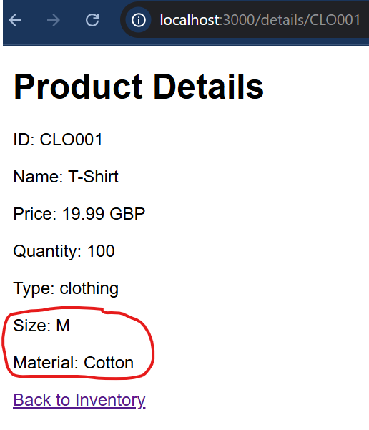 | 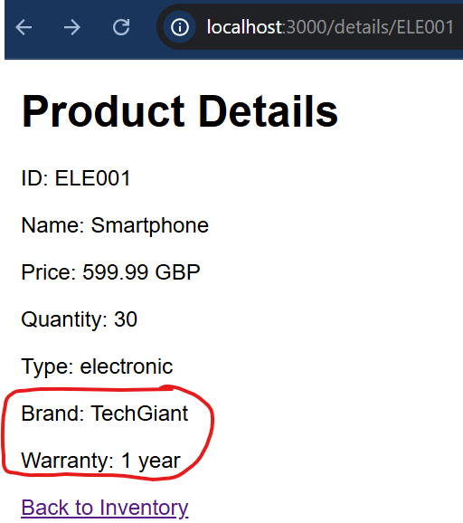
At this stage, you can verify your implementation by comparing your code with the reference solution available at the following GitHub commit: https://github.com/anandveeraswamy/express-stock-app-rebuild/tree/ddefb32b75a7ad91b8619062beffde541f2eb099

Step 8 Add subtype fields on product create and conditional UI for clothing/electronics

Update index.pug to conditionally render additional fields for the clothing and electronic model

Add the following code in Views/index.pug just before the submit button:
//- Conditional fields for clothing and electronics
div(id="clothingFields" style="display: none;")
label(for="size") Size:
input(type="text" id="size" name="size")
br
label(for="material") Material:
input(type="text" id="material" name="material")
div(id="electronicFields" style="display: none;")
label(for="brand") Brand:
input(type="text" id="brand" name="brand")
br
label(for="warranty") Warranty:
input(type="text" id="warranty" name="warranty")
br

This is adding the additional clothing and electronic fields. Note that the clothing and electronic fields are grouped into respective divs and both divs are initially set to “display:none” which means they will not be displayed initially.

Add the following JS code to conditionally render the clothing or electronic fields depending on a change event of the typeselect field
Note JS code should always be added at the end so all the elements used in the JS are rendered before they are called/used.
//- JavaScript for conditional fields
script.
const typeSelect = document.getElementById('type');
const clothingFields = document.getElementById('clothingFields');
const electronicFields = document.getElementById('electronicFields');

function updateFields() {
if (typeSelect.value === 'clothing') {
clothingFields.style.display = 'block';
electronicFields.style.display = 'none';
} else if (typeSelect.value === 'electronic') {
clothingFields.style.display = 'none';
electronicFields.style.display = 'block';
} else {
clothingFields.style.display = 'none';
electronicFields.style.display = 'none';
}
}

typeSelect.addEventListener('change', updateFields);

// Initialize fields on page load
updateFields();

The complete index.pug file for your reference is as follows:
html
head
title Stock Control System
link(rel='stylesheet' href='/styles.css')
body
h1 Stock Inventory

//- Search form
form(action="/search" method="get")
input(type="text" name="query" placeholder="Search products" value=searchQuery)
button(type="submit") Search

//- Sort options
form(action="/sort" method="get")
select(name="sortBy" onchange="this.form.submit()")
option(value="name" selected=sortBy === 'name') Sort by Name
option(value="price" selected=sortBy === 'price') Sort by Price

//- Add new product form
form(action="/create" method="post")
label(for="id") ID:
input(type="text" id="id" name="id" required)
br
label(for="name") Name:
input(type="text" id="name" name="name" required)
br
label(for="price") Price:
input(type="number" id="price" name="price" step="0.01" required)
br
label(for="quantity") Quantity:
input(type="number" id="quantity" name="quantity" required)
br
label(for="type") Type:
select(id="type" name="type" required)
option(value="") Select a type
option(value="clothing") Clothing
option(value="electronic") Electronic
br
//- Conditional fields for clothing and electronics
div(id="clothingFields" style="display: none;")
label(for="size") Size:
input(type="text" id="size" name="size")
br
label(for="material") Material:
input(type="text" id="material" name="material")
div(id="electronicFields" style="display: none;")
label(for="brand") Brand:
input(type="text" id="brand" name="brand")
br
label(for="warranty") Warranty:
input(type="text" id="warranty" name="warranty")
br
button(type="submit") Add Product

//- Display products
table
thead
tr
th ID
th Name
th Price
th Quantity
th Type
th Actions
tbody
each product in products
tr
td= product.id
td= product.name
td= product.price
td= product.quantity
td= product.type
td
a(href=`/details/${product.id}`) View Details
form(action=`/delete/${product.id}` method="post" style="display:inline;")
input(type="hidden" name="_method" value="DELETE")
button(type="submit") Delete

//- JavaScript for conditional fields
script.
const typeSelect = document.getElementById('type');
const clothingFields = document.getElementById('clothingFields');
const electronicFields = document.getElementById('electronicFields');

function updateFields() {
if (typeSelect.value === 'clothing') {
clothingFields.style.display = 'block';
electronicFields.style.display = 'none';
} else if (typeSelect.value === 'electronic') {
clothingFields.style.display = 'none';
electronicFields.style.display = 'block';
} else {
clothingFields.style.display = 'none';
electronicFields.style.display = 'none';
}
}

typeSelect.addEventListener('change', updateFields);

// Initialize fields on page load
updateFields();

Update stockController.js to retrieve the additional fields and add these as records to the clothing or electronic models
Update the create function in controllers/stockController.js
exports.create = async (req, res) => {
try {
// Destructure the request body to get product details
console.log("hi", req.body);
const { id, name, price, quantity, type, size, material, brand, warranty } = req.body;

// Create a new product in the database
const product = await Product.create({
id, name, price, quantity, type
});

// Based on the product type, create associated Clothing or Electronic record
if (type === 'clothing') {
await Clothing.create({ ProductId: product.id, size, material });
} else if (type === 'electronic') {
await Electronic.create({ ProductId: product.id, brand, warranty });
} else {
return res.status(400).send("Invalid product type.");
}

// Redirect to the home page after successful creation
res.redirect('/');
} catch (err) {
console.error(err);
res.status(500).send("Error creating product.");
}
};

Test the new functionalities by creating a new clothing and electronic product and check if the new fields are shown in the details view.
At this stage, you can verify your implementation by comparing your code with the reference solution available at the following GitHub commit: https://github.com/anandveeraswamy/express-stock-app-rebuild/tree/0c8fdeba138e27f4edaa20ba137d658f105cf625

Step 9: Add conversion currency API

install the axios library
npm install axios

Update details.pug
Add the following code to views/details.pug just above the “Back to Inventory” link
//- Currency conversion form
h2 Currency Conversion
form(action=`/details/${product.id}/convert` method="get")
label(for="currency") Convert to USD:
input(type="hidden" name="currency" value="USD")
button(type="submit") Convert to USD

//- Display converted price if available
if convertedPrice
p Converted Price: #{convertedPrice} USD

Notice the form action field include a route with a dynamic part, the product id.

Add the route for the conversion
Add the following code in routes/productRoutes:
// GET currency conversion
router.get('/details/:id/convert', stockController.convertCurrency);

Add the conversion function in the stockController.js
First add the axios import
const axios = require('axios');

And then add the convertCurrency function:
exports.convertCurrency = async (req, res) => {
const { id } = req.params;
const targetCurrency = req.query.currency || 'USD'; // Updated to use query parameter or default to USD

try {
const product = await Product.findByPk(id, {
include: [
{ model: Clothing, required: false },
{ model: Electronic, required: false }
]
});

if (!product) {
return res.status(404).send("Product not found.");
}

const response = await axios.get(`https://api.exchangerate-api.com/v4/latest/GBP`);

const exchangeRate = response.data.rates[targetCurrency];

const convertedPrice = targetCurrency === 'GBP'
? product.price
: (product.price * exchangeRate).toFixed(2);

res.render('details', {
product: product,
convertedPrice: convertedPrice,
targetCurrency: targetCurrency,
originalCurrency: 'GBP'
});

} catch (error) {
console.error('Error fetching exchange rates or product:', error);
res.status(500).send("Error converting currency.");
}
};
At this stage, you can verify your implementation by comparing your code with the reference solution available at the following GitHub commit: https://github.com/anandveeraswamy/express-stock-app-rebuild/tree/1128c982609c740d7a57d51b4ef80729a84ca5f7

Step 10 Introducing tests – unit test

Firstly install the jest test library
npm install jest

create a tests folder with a test file
In the main project route, create the ‘tests’ folder and inside it create the file ‘stockController.test.js’
A popular convention is to have all the tests in the ‘tests’ folder and have different test files ending with ‘filename.test.js’ however, jest is very flexible. Although we give simple examples, you are encouraged to think about how best to organise your tests and test files.
Add the following code in the tests/stockController.test.js file:
const stockController = require('../controllers/stockController');
const db = require('../models');

describe('Stock Controller', () => {
// Unit Tests
describe('Unit Tests', () => {
test('Create a new product', async () => {
// Mocking the request and response objects
// This allows us to test the controller function in isolation
const mockReq = {
body: {
id: 'TEST001',
name: 'Test Product',
price: 9.99,
quantity: 100,
type: 'clothing'
}
};
const mockRes = {
// Jest mock function to simulate the redirect method
redirect: jest.fn()
};

// Call the controller method directly
await stockController.create(mockReq, mockRes);

// Verify the product was created in the database
const product = await db.Product.findByPk('TEST001');
expect(product).not.toBeNull();
expect(product.name).toBe('Test Product');
// Check if the mock redirect function was called with the correct argument
expect(mockRes.redirect).toHaveBeenCalledWith('/');
});

// More unit tests...
});

})

Modify the package.json file
Replace the following line:
"test": "echo \"Error: no test specified\" && exit 1",

With
"test": "jest",

Run the test
In the terminal type ‘npm run test’. You should see output similar to below:
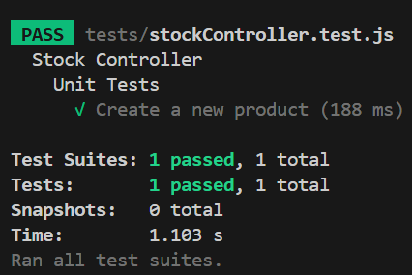
However, if you run the tests again, it will fail with a unique constraint failed error since the record you tried to add already exists. Lets see how to fix these issues and make your tests more consistent in the next steps.
At this stage, you can verify your implementation by comparing your code with the reference solution available at the following GitHub commit: https://github.com/anandveeraswamy/express-stock-app-rebuild/tree/012cee4c28eff4b6722e1ff9405f99469475cbce

Step 11: Introducing Integration tests
For integration testing, we use Supertest to simulate real HTTP requests to the Express application, allowing us to test the full request–response lifecycle, including routing, middleware, controllers, and database interactions. The beforeAll hook is used to initialise a clean and consistent database state before any tests run, ensuring repeatable and reliable results. The afterAll hook then closes the database connection once all tests have completed, preventing resource leaks and allowing the test runner to exit cleanly.

Install supertest
Run ‘npm install supertest’

Add the integration test
Add the following code to the tests/stockController.js files
Add the following two imports at the top
const request = require('supertest');
const app = require('../app');

Add the beforeAll hook soon after the imports. Remember this hook will automatically be called by jest
// Jest hook to run before all tests
beforeAll(async () => {
// Sync the database and force true to drop existing tables
await db.sequelize.sync({ force: true });
});
Add the afterAll hook at the end of the file. Remember this hook will automatically be called by jest after all the tests have completed.
// Jest hook to run after all tests
afterAll(async () => {
// Close the database connection
await db.sequelize.close();
});

Add a new describe block for the integration tests:
// Integration Tests
describe('Integration Tests', () => {
test('Create a product and retrieve it', async () => {
// Using supertest to simulate HTTP requests
// This tests the entire request-response cycle, including routing
const newProduct = {
id: 'INT001',
name: 'Integration Test Product',
price: 19.99,
quantity: 50,
type: 'electronic'
};

await request(app)
.post('/create')
.send(newProduct)
.expect(302); // Expecting a redirect status code

const response = await request(app)
.get('/')
.expect(200);

// Checking the response body for the created product
expect(response.text).toContain('Integration Test Product');
});

// More integration tests...
});

The full tests/stockController.test.js code is as follows:
const request = require('supertest');
const stockController = require('../controllers/stockController');
const db = require('../models');
const app = require('../app');

// Jest hook to run before all tests
beforeAll(async () => {
// Sync the database and force true to drop existing tables
await db.sequelize.sync({ force: true });
});

describe('Stock Controller', () => {
//Unit Tests
describe('Unit Tests', () => {
test('Create a new product', async () => {
// Mocking the request and response objects
// This allows us to test the controller function in isolation
const mockReq = {
body: {
id: 'TEST001',
name: 'Test Product',
price: 9.99,
quantity: 100,
type: 'clothing'
}
};
const mockRes = {
// Jest mock function to simulate the redirect method
redirect: jest.fn()
};

// Call the controller method directly
await stockController.create(mockReq, mockRes);

// Verify the product was created in the database
const product = await db.Product.findByPk('TEST001');
expect(product).not.toBeNull();
expect(product.name).toBe('Test Product');
// Check if the mock redirect function was called with the correct argument
expect(mockRes.redirect).toHaveBeenCalledWith('/');
});

// More unit tests...
});

// Integration Tests
describe('Integration Tests', () => {
test('Create a product and retrieve it', async () => {
// Using supertest to simulate HTTP requests
// This tests the entire request-response cycle, including routing
const newProduct = {
id: 'INT001',
name: 'Integration Test Product',
price: 19.99,
quantity: 50,
type: 'electronic'
};

await request(app)
.post('/create')
.send(newProduct)
.expect(302); // Expecting a redirect status code

const response = await request(app)
.get('/')
.expect(200);

// Checking the response body for the created product
expect(response.text).toContain('Integration Test Product');
});

// More integration tests...
});

})

// Jest hook to run after all tests
afterAll(async () => {
// Close the database connection
await db.sequelize.close();
});

Make the following changes to the app.js file
Add the following import at the top:
const db = require('./models');

Delete the following code:
app.listen(port, () => {
console.log(`Server listening on port ${port}`);
console.log(`Visit http://localhost:${port}`);
});

And add the following code:
db.sequelize.sync().then(() => {
if (require.main === module) {
app.listen(port, () => {
console.log(`Server listening on port ${port}`);
console.log('Database synchronized');
});
}
}).catch((error) => {
console.error('Unable to synchronize the database:', error);
});

module.exports = app;

We conditionally start the Express server only when the application is run directly, allowing Supertest to import and test the app without opening a real network port, while ensuring the database is fully initialised before handling requests.
Originally, placing app.listen() directly in app.js caused the server to start automatically as soon as the file was imported. This is acceptable during normal development, but it becomes problematic for testing because importing the app as part of a test suite unintentionally starts a real HTTP server, which can lead to port conflicts, hanging test processes, and unreliable test execution.
Supertest, however, is designed to work with the Express application instance, not a running server. It injects HTTP requests directly into the Express app without binding to a network port. To support this, the app must be importable without triggering app.listen(), allowing Supertest to control the request–response flow safely and predictably during integration tests.
Run ‘npm test’ and you should now see two tests passing as shown below:
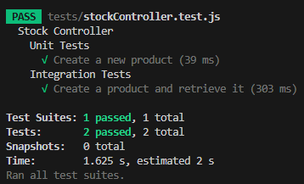

At this stage, you can verify your implementation by comparing your code with the reference solution available at the following GitHub commit: https://github.com/anandveeraswamy/express-stock-app-rebuild/tree/42a7ff347c93caa4a11740de5aac81d19ab36017

Step 12: Add Sad path testing
Sad path testing focuses on how the system behaves when things go wrong, such as invalid input or failed operations.
Add the following describe block in tests/stockController.test.js
// Edge Cases and Robust Testing Suggestions
describe('Edge Cases and Robust Testing', () => {
test('Create a product with invalid data', async () => {
// Testing error handling and validation
const invalidProduct = {
id: 'INVALID001',
name: 'Invalid Product',
// Missing required fields: price, quantity, type
};

const response = await request(app)
.post('/create')
.send(invalidProduct)
.expect(500); // Expecting an error status code

expect(response.text).toContain('Error creating product');
});

// More edge case tests...
});

Run ‘npm test’ and you should now see three tests passing as shown below:
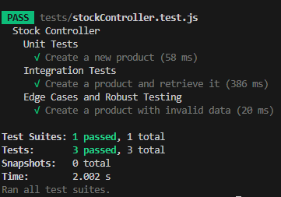
At this stage, you can verify your implementation by comparing your code with the reference solution available at the following GitHub commit: https://github.com/anandveeraswamy/express-stock-app-rebuild/tree/19e4cf968404569eb44c4412544ae7774f589b6a

