# ETSCRI-ePSD linking with etscri-conll2lod.sh

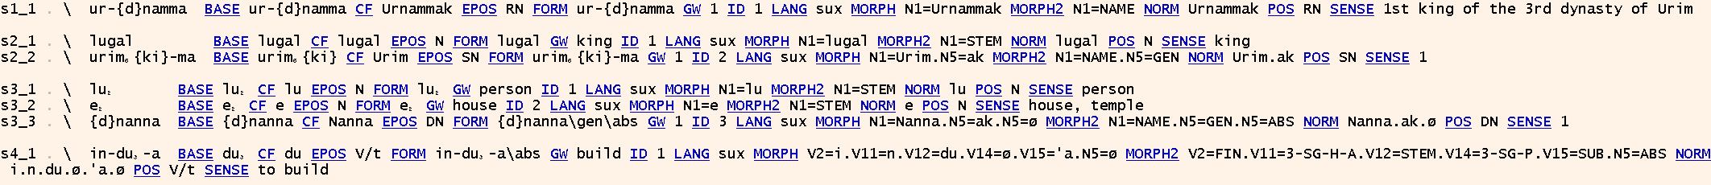bash etscri-conll2lod.sh -grammar

This shows the original annotations in a dependency visualization. Without syntactic dependencies, the first two columns are not meaningful, but the compact representation of annotations can still be useful.

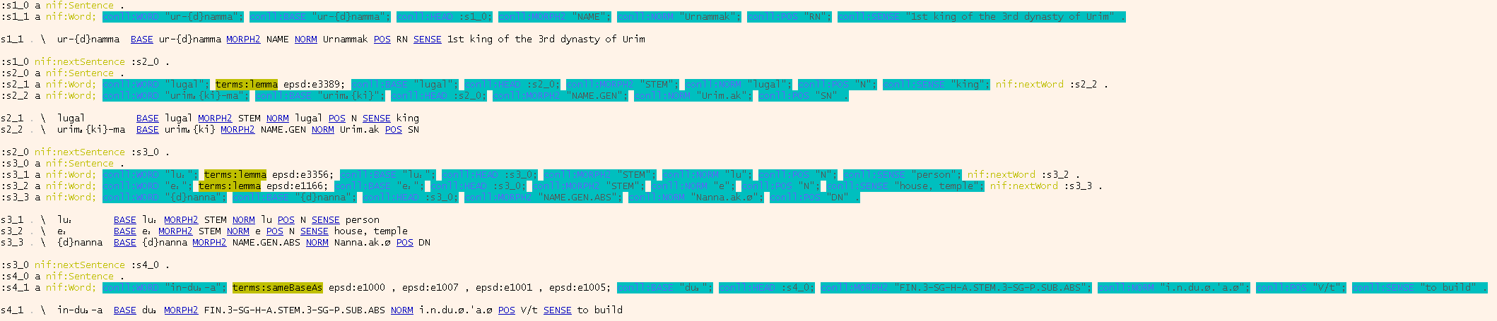bash etscri-conll2lod.sh -debug –grammar

Using -debug, we show selected original anotations only (in the same view as –grammar), together with the corresponding RDF code (syntax highlighting, same elements removed). Note that only the RDF shows dictionary links.

bash etscri-conll2lod.sh # full RDF output

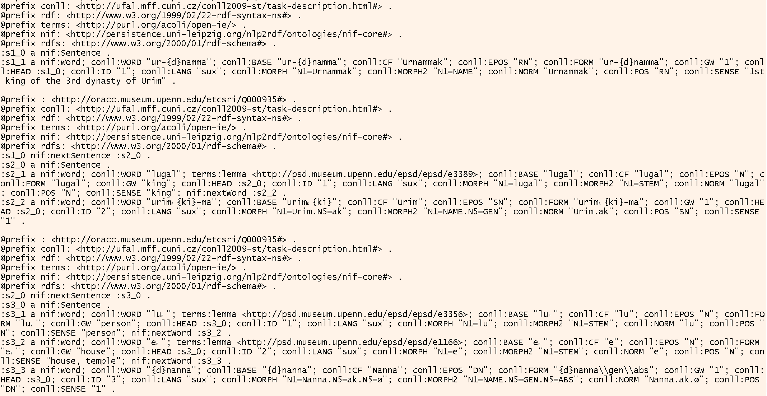

Without parameters, we just write CoNLL-RDF. CoNLL-RDF is a relatively compact, application-specific subset of Turtle. However, as sentences are processed individually (i.e., with one Apache Jena Model created for each sentence), the prefixes are redundantly spelled out.

CoNLL2RDF does not show this behavior, but requires the entire dataset to be held in memory, hence, we build on CoNLLStreamExtractor.