Version Control with Git
References:
- Version control with git (http://it-ebooks.info/book/919/)
- Pro git (http://git-scm.com/book)
- Github basics: http://git-scm.com/book/en/Getting-Started-Git-Basics

Introduction
Git is a fast, open source, distributed version control system.
Version control is critical for any non-trivial software project. When using a version control system you take snapshots of the state of your project (commits) at regular intervals. If you make a mistake you can easily go back to a previous snapshot. It’s like a big undo button for your project.
Version control can also be used to:
- Identify the person that changed a file.
- Identify the changes made to a file over time
- Work on new features but still be able to go back and fix a bug in the released version of the software. (Example: create a branch to work on a new feature. Get a call reporting a bug with existing released version (maybe in a file you are right in the middle of editing). No problem. Switch back to the master branch and change the file, commit changes and build and test and release fix. Switch back to branch you made earlier and continue working on new features. You can merge the state of the files you are working on with the existing files later.)
Git is a version control system, a simple command line tool for keeping a history on the state of your source code projects.
You tell it to track files in your project and periodically commit the state of the project when you want a saved point. Then you can share that history with other developers for collaboration, merge between their work and yours, and compare or revert to previous versions of the project or individual files.
Git lets you switch between branches in a single working directory
Instead of only having branches for major development line departures, Git developers routinely create, merge and destroy multiple branches a week, or even per day. Often each feature or bug you are working on can have its own branch, merged in only when it is complete. This model allows you to experiment quickly, easily and safely - without having to go through hoops to get back to where you where. It enables and encourages a non-linear development cycle, where you can work on multiple lines of thought in parallel without them stepping on each other.
Git is a peer-to-peer distributed version control system. The whole repository is local. There is no special centralized server. You can, however, clone a repository and push and pull updates from the origin of the clone. The “central” repository is entirely a convention. There is nothing that makes one client more special than another.
Installing Git
If you are using repositories hosted at github.com you will need to create an account at github.com. Basic user accounts are free (repositories associated with a free account are public and restricted to open source content).
You need to download and install a git. There are many clients available. I recommend github for Windows: http://windows.github.com/.
Execute the file downloaded from http://windows.github.com/. This will install github for windows and other tools.
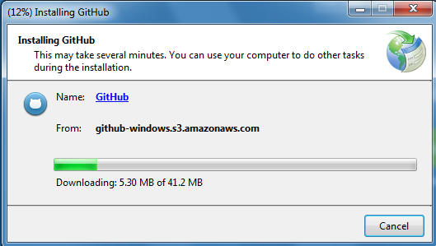
Run it (the program you installed should show up on the start menu as an option) and sign on with github username and password.
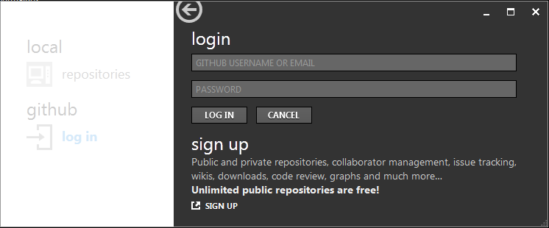
You should see your local and remote repositories:
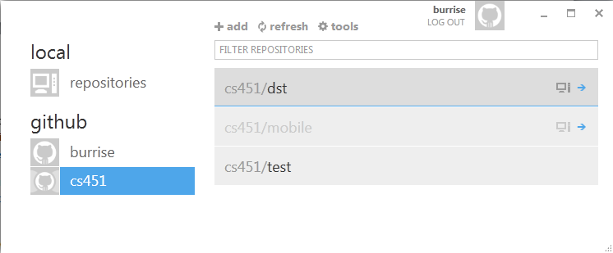
If you ever forget were local repositories are stored on your computer, hover the mouse over the repository name:
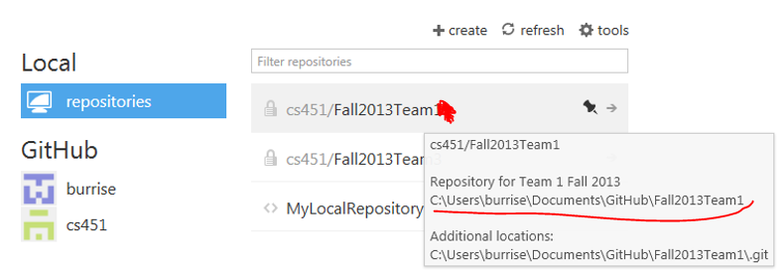
To configure preferences, go to tools / options. Verify the desired options are selected/entered. You may need to enter your name and email the first time you use github for Windows. The shell is the command line tool for entering git (and general UNIX) commands. PowerShell seems to be popular, but for the work in this class either shell is acceptable.
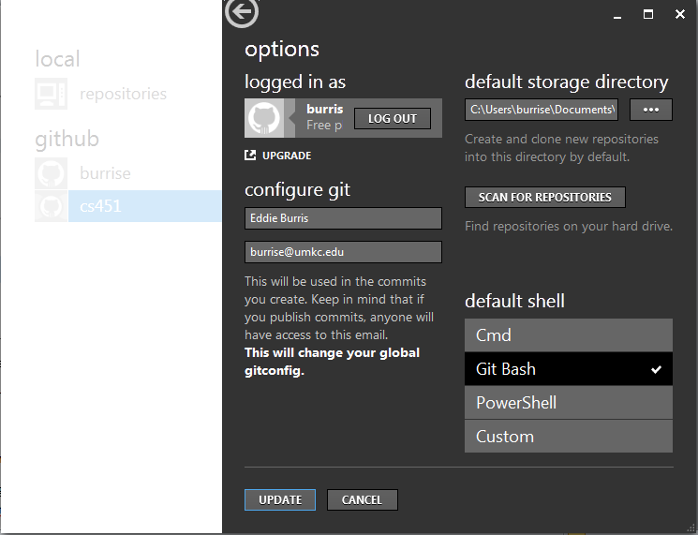

You may want to change default storage directory. If the GUI doesn’t recognize existing repositories, click Scan for Repositories.
Cloning and updating a repository
The first think you probably want to do is clone a repository from github.com.
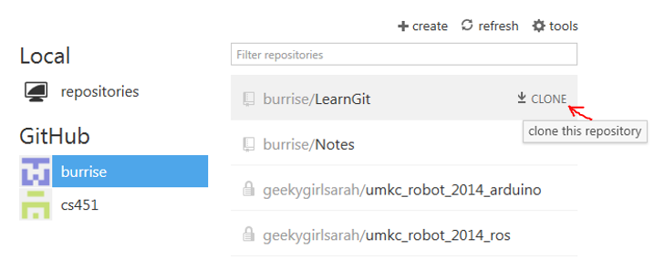
After cloning, the repository should show up as a local repository:
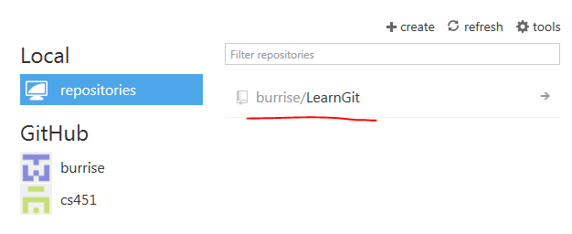
Notice, cloning caused the repository to be downloaded into your default github directory:
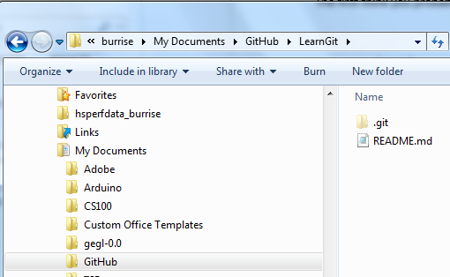
Note, you may have to change the default storage directory. The GUI may have a problem with network path names. To create a temporary local repository, I recommend going to settings and entering c:\temp as your default storage directory.
To add a file to the repository, create the file in the local copy of the repository:
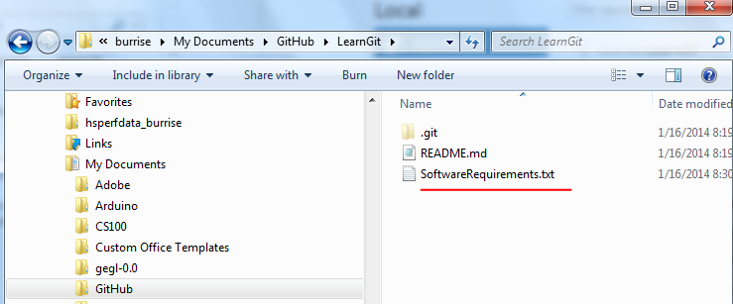
First you want to commit your changes:
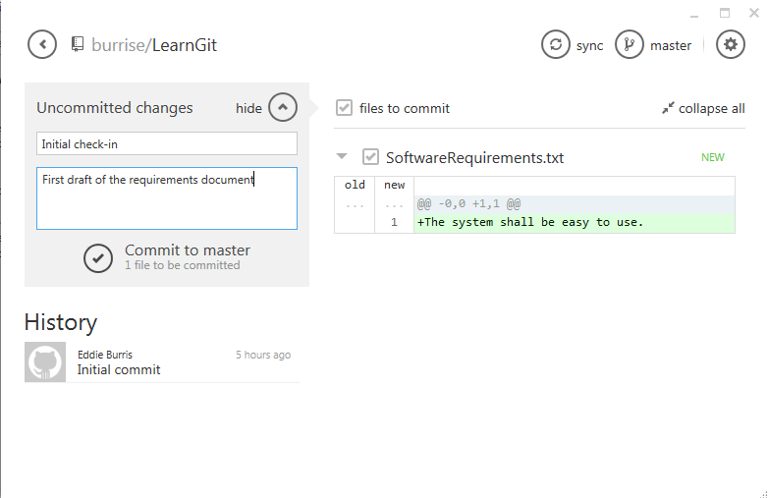
Note, commit just commits the changes locally. It doesn’t update the remote repository. You can make several changes locally committing each one.
Notice, there is a difference between uncommitted changes and unsynced changes. After we made the change to the file locally, we had an uncommitted change and an unsynced change. After committing it, we had just unsynced changes.
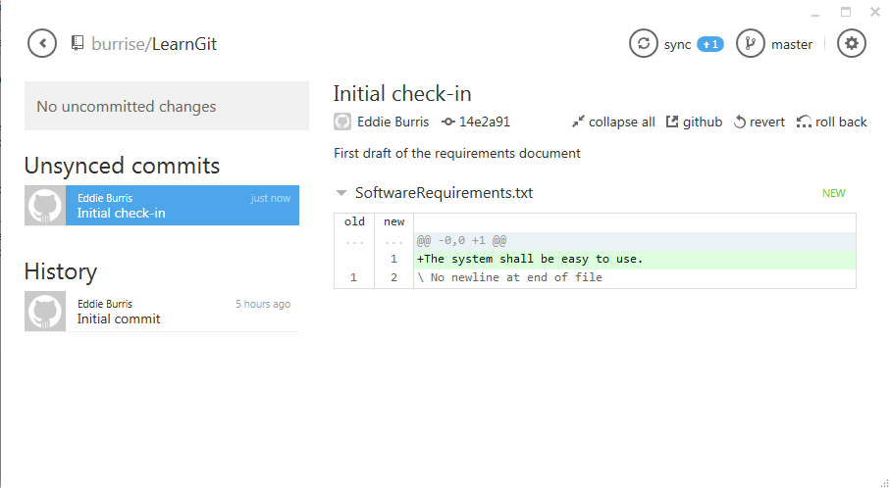
If you want your changes to show up on github.com, sync your local commits:
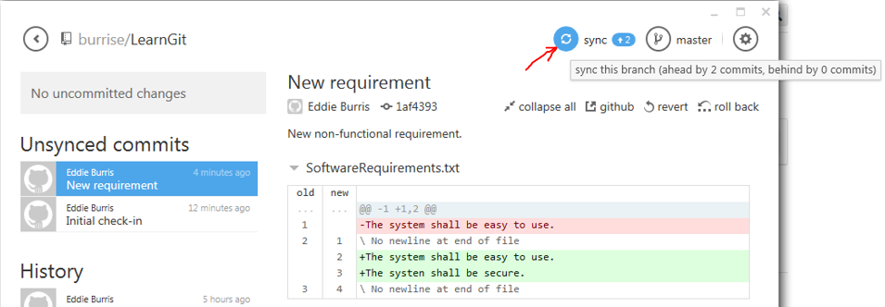
Notice the importance of doing local commits. For example, if you do three commits and one sync, you can undo to the point of any one of the three commits.
To add collaborators (e.g. for class exercise): go to repository on github.com, select settings, select collaborators. Add user ID’s of collaborators.
Branching and Merging
If you plan to make several changes for some upcoming feature or bug fix, you probably want to create a new branch.
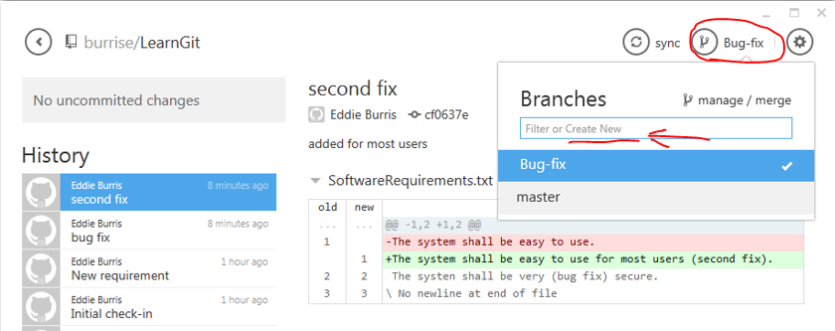

Try this: create a new branch and make and commit a few changes (a few commits each with a new change). Now switch back to the master branch. Notice the local files regressed. Github for windows changes files on the file system to match the selected branch. Keeping the example going, make a change on the master branch to one of the files changed on the new branch.
Switch back to new branch and notice change on master isn’t there.
To merge branches, select merge branch:
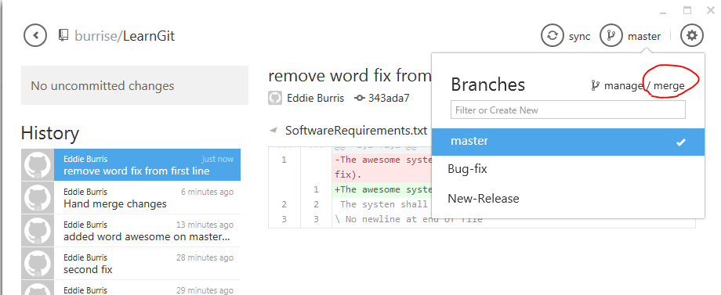
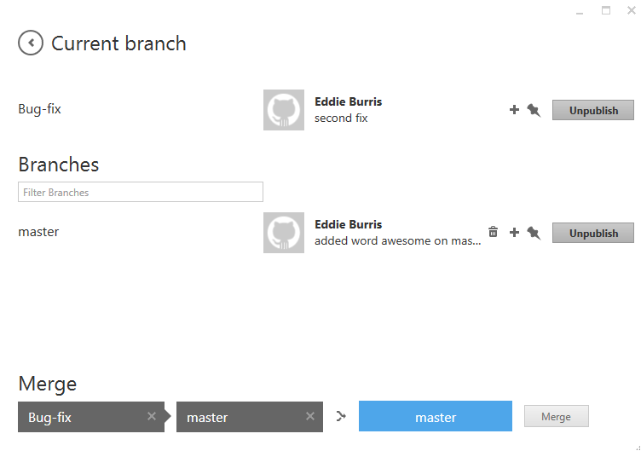
After you merge, don’t forget to sync changed branch:
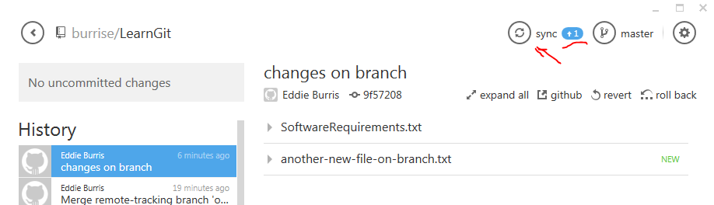
Note, it can’t do miracles. You may have to hand-merge the changes.
Try: create branch. Add new file in branch. Update existing file in master branch. Merge new branch back into master branch.
You can delete a branch from github for windows:
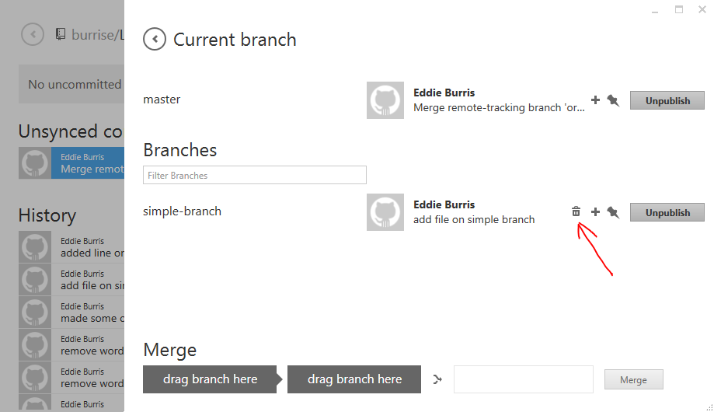
Or github.com.
Forking
To fork a repository, go to the repository and select “Fork”.
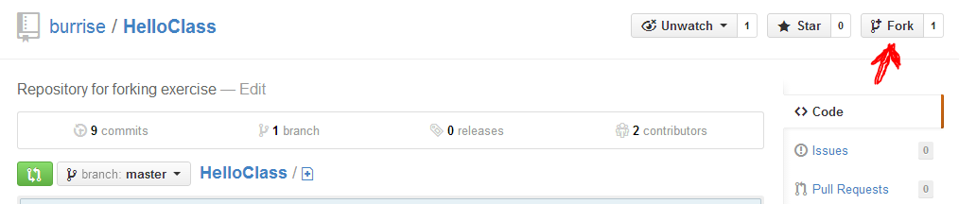
You will need to fork it to another account.
Make changes (commit and sync) on the copy.
When you are ready to merge your changes with the forked repository, sell “Pull Request”:
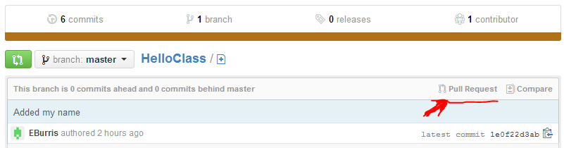
Consider showing network graph for HelloClass or other repository:
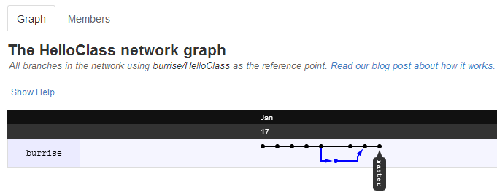
Consider discussion “social coding”.
Working from the command line
Things you can’t do from the GUI, you can do from the shell. To open a git shell, right click repository and select open shell here.
Once you have a shell you can:
$ cd q:
Or other network drive.

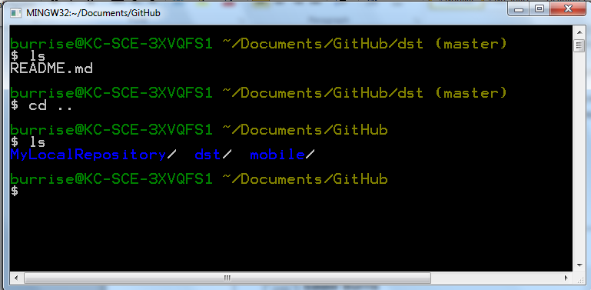
You can use the cd command to move to a different directory / repository.
Common Tasks
How to check out a branch:
Got to github.com and find the URL To your repository.
Open the shell (see above).
cd to directory where you want repository to be created.
Enter:
$ git clone -b team1 https://github.com/cs451/dst.git
team1 is the name of the branch. https://github.com/cs451/dst.git is the URL to the repository that contains the branch.
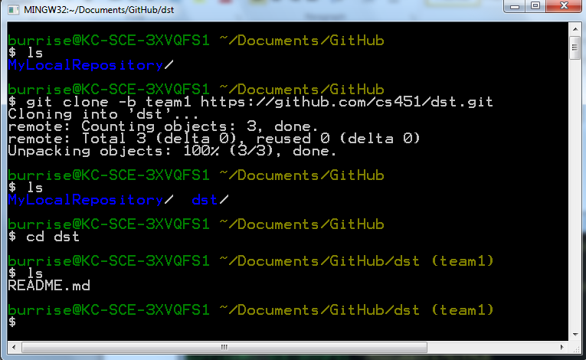
Notice, the files in the repository get copied down and are available on the file system:
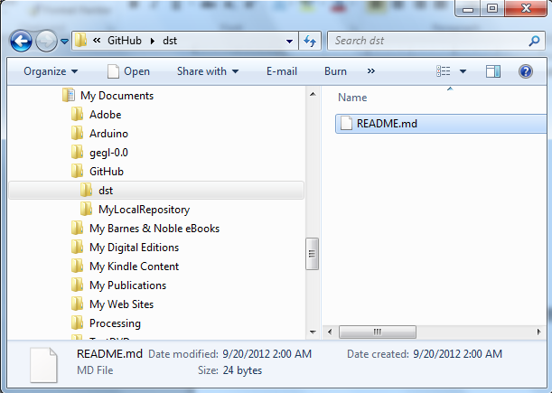
How to add a file to a branch and upload (push) it to github:
Step 1: create a file in the repo directory.
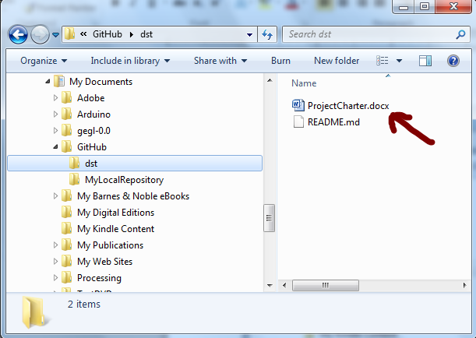
If you want, issue the git status command to check the status of the new file:
$ git status
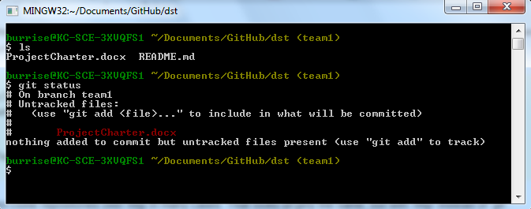
Step 2: add the file to the repo:
$ git add ProjectCharter.docx
git add is used to add a new file and stage a file for commit. You might change 2 files but stage or add only one for the next commit. This allows you to control which files are committed. You don’t have to commit all changed files each time you commit.
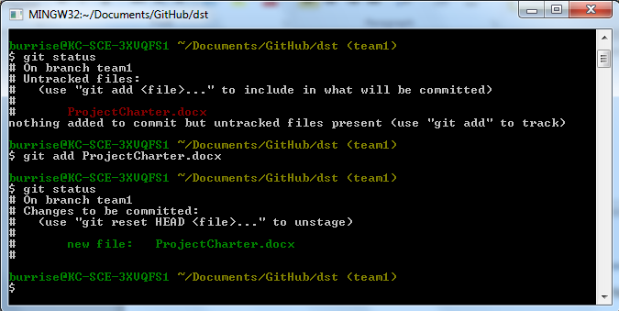
Notice the file is staged to be committed.
Step 3: commit the change:
$ git commit -m "Initial version of project charter"
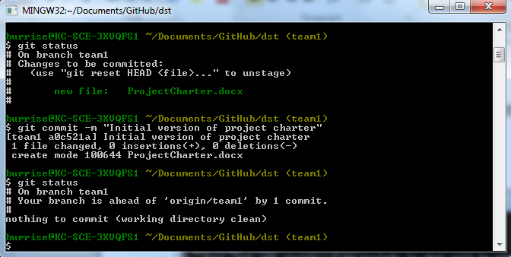
Note, the change is committed to the local repository. It is not visible on github.com.
Step 4: push the changes to github.com:
$ git push origin team1
Note, ‘team1’ is the branch we are working on.
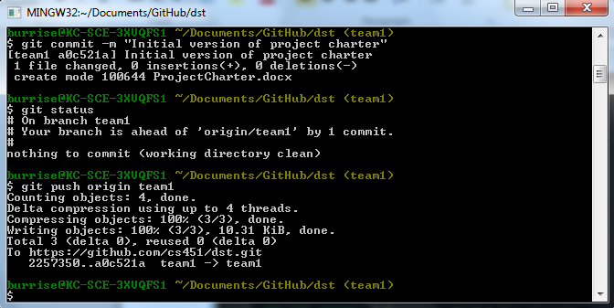
Changes are now visible on github.com:
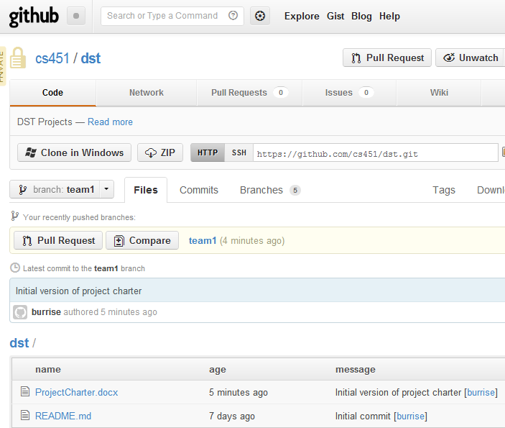
How to update a local repository with the latest changes pushed to a branch:
If two or more programmers are working on changes to the same branch, programmer A might commit and push a change and then programmer B would need to pull these updated files into his/her directory.
To pull changes a coworker has pushed to a central repository:
$ git pull origin team1
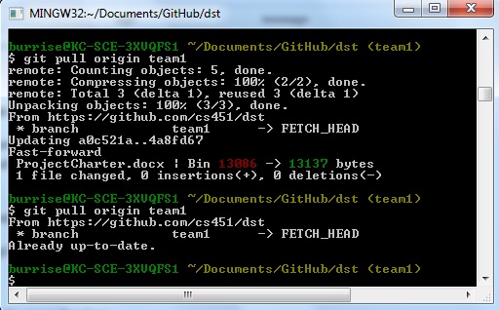
Note, repeating the command shows the message you get when there are no changes to copy down.
Concepts
You can commit all files that have been changed:
$ git commit –am “commit message”
OR, add files to the staging area and commit only files that have been staged:
$git add filename
$git commit –m “commit message”

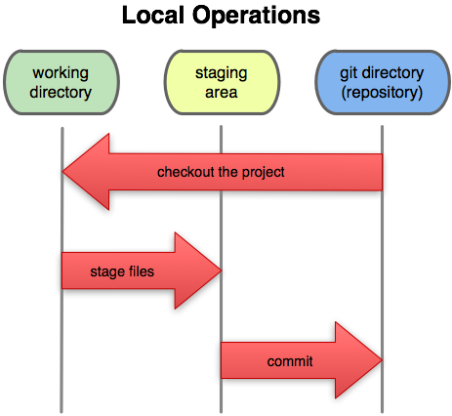
Note, git uses the ‘git add’ command both to begin tracking files and also to stage changes to them
Git Commands
$ git status
List branches:
$ git branch
Create a branch:
$ git branch <new branch name>
Switch to a branch:
$ git checkout <branch name>
Example:
$ git checkout master
Push changes back to the server:
$ git push origin
Push a branch back to the server:
$ git push origin <branch name>
If you get errors pushing back changes it’s usually because the file changed on the server since you copied it. If it is a text file the following command will update your local copy with changes on the server:
$ git pull
Clone a repo:
$ git clone <repo URL>
Clone a specific branch:
$ git clone -b <branch name> <repo URL>
The following will commit all files:
$ git commit –am ‘Commit message’
The following will commit only files that are staged:
$ git commit
To stage a file:
$ git add filename
To stage all changed files in the dir:
$ git add .

References
http://learn.github.com/p/intro.html - Nice introductory video from github.
http://gitref.org/index.html - Nice reference. One of the best I have found.
Miscellaneous Notes
Set editor in msysgit
git config --global core.editor "'C:/Program Files/Notepad++/notepad++.exe' -multiInst -notabbar -nosession -noPlugin"
From: http://stackoverflow.com/questions/1634161/how-do-i-use-notepad-or-other-with-msysgit
I used: git config --global core.editor "'C:/Windows/notepad.exe'"
git config --global core.editor vi
also works

