**Name – Anand Kumar**

**Phone Number – 9315992643**

**E- Mail –** [**anandkumar26sep00@gmail.com**](mailto:anandkumar26sep00@gmail.com)

**RC TEXT DETECTION**

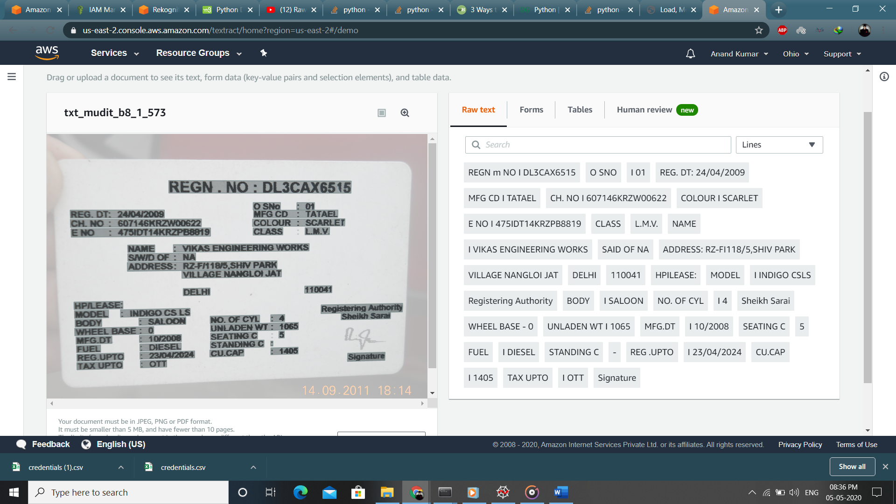

**Approach :**

**Installing Dependencies :**

**pip install boto3**

**pip install imutils**

**pip install opencv-python**

1. Used Amazon Web Service Textract for Detecting Text in Image (Cred.csv).
2. Loaded All the files’ name (in ‘Test_Data’ Folder) in a list.
3. Iterated over that List for selecting each image.
4. Used GrayScale and made a function for reducing noise in the image for better text detection and that image is as ‘temp.jpg’ in the directory.
5. Then that ‘temp’ image is read in ‘Bytes’ using file handling and sent to AWS and is received using detect_document_text client function.
6. We receive all the text in the image and then we use feature detection functions for finding the required data.
7. For Registration Number we will search for text of length 10 and having a state code in the first two characters like ‘HR’,’DL’,’GJ’,etc.
8. For Manufacture Number we search for words having length 7 and having a ’/’ in the word .
9. For Registration date we search for words of length 10 and if ‘/’ is present we split the string into list and the replace 2nd and 5th index by ‘/’ for better result and then list is converted back into string.

10) For Chassis Number we search for all words of length 17 and if the first

two letter is equal to ‘ma’ then that will be chassis number.

11) For Engine Number we search for the text ‘E’ or ‘ENGINE’ and enable a flag variable

and then search for the text afterwards having length atleast 6. The first word to

satisfy this condition that will be engine number.

12) For Name we search for the text ‘Name’ and then find the next texts, if

It is ‘:’ or ‘No’ or any small length word then we proceed to the next text

and keep adding texts to the string until ‘S/W/D’ is found and the resulting string will

be name.

All the informations are stored in a xlsx file and added row wise according to the count of images (in the loop).

Illustration - 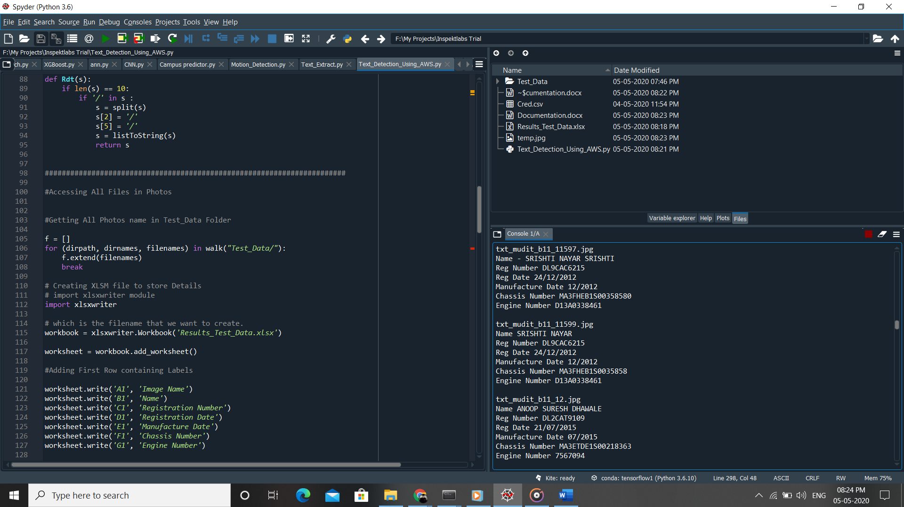

**For Running the code –**

First select the directory as Inspektlab Trial (Folder Name).

Select all the codes and execute at once. All the details of each image will be printed and the xlsx file will get updated after each iteration. After all the images are traversed the Result_Test_Data.xlsx file will get saved at the directory ‘Inspektlab Trial/’. If the algo is not able to find the desired result then None will be assigned to it.