Top IT Technology :-
Blockchain , Data Science , Machine Automation (ML), IoT, 5G ,
CyberSecurity, Cloud Computing, VR & AR, Edge Computing, AI,
Metaverse, Bioinformatics and genetics Engineering, Game
Development, Web Development, etc Software Development

SDLC –> Software(product, solutions) Development Life Cycle :-
The SDLC is a process by which software is developed and deployed. It’s a
process that encompasses every phase of software creation, from
conception to maintenance after the software is released.

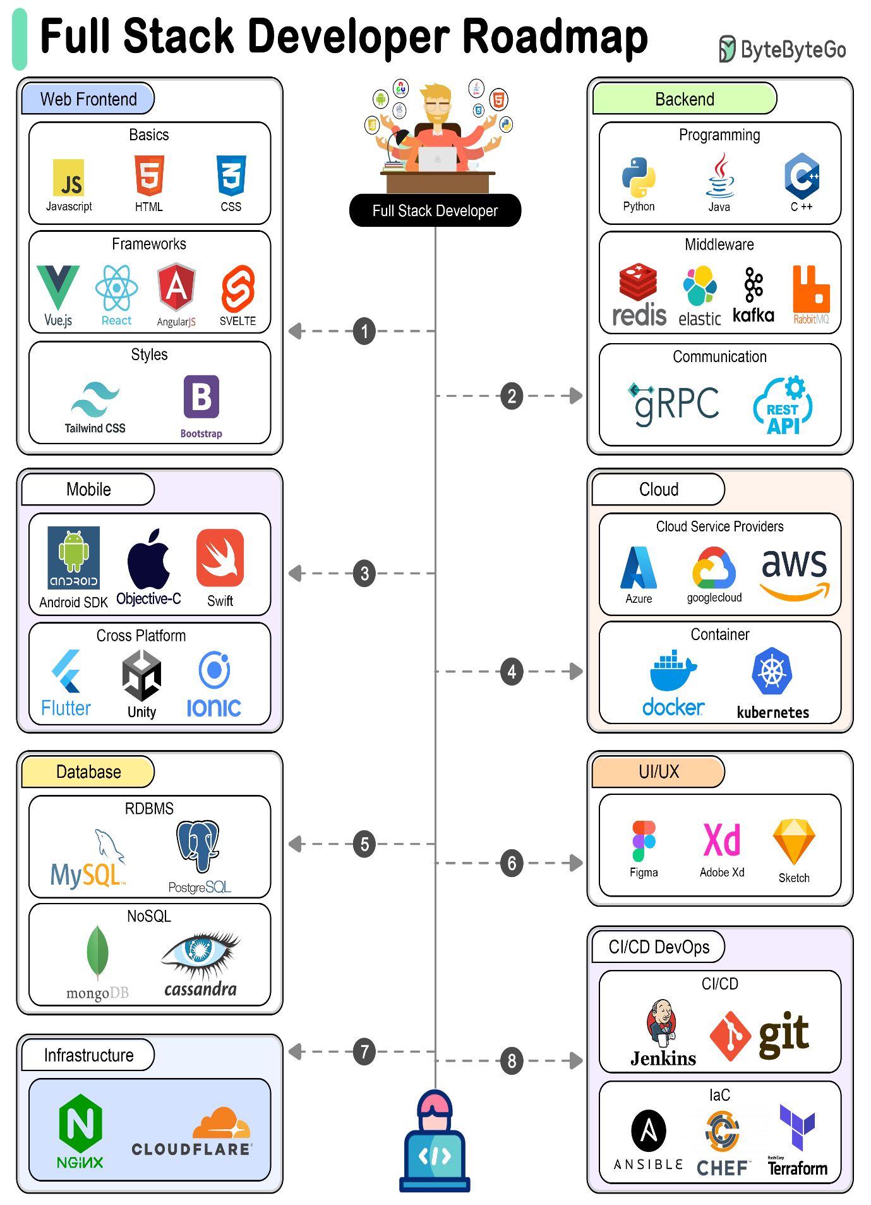

💻 What is a Computer?
A computer is an electronic device that accepts data (input), processes it according to instructions (processing), stores it, and produces useful information (output).
It works on the principle of Input → Process → Output → Storage.

🧩 Components of a Computer
1. Input Devices
Used to enter data and instructions.
- Examples: Keyboard, Mouse, Scanner, Microphone, Webcam, Touchscreen

2. Output Devices
Used to display or communicate results.
- Examples: Monitor, Printer, Speakers, Projector

3. Storage Devices
Used to store data permanently or temporarily.
- Primary Storage (fast, temporary): RAM, Cache
- Secondary Storage (permanent): Hard Disk, SSD, Pen Drive, CD/DVD

4. Central Processing Unit (CPU)
The brain of the computer – executes instructions.
- ALU (Arithmetic Logic Unit): Performs calculations & logical operations
- CU (Control Unit): Directs data flow and controls components
- Registers: Small, high-speed storage inside CPU

5. Memory
- RAM (Random Access Memory): Temporary, volatile memory for currently running tasks
- ROM (Read Only Memory): Permanent memory with essential instructions (like BIOS)

6. Motherboard
The main circuit board that connects CPU, memory, storage, and peripherals together.

7. Power Supply (SMPS)
Converts electricity from AC (wall supply) to DC to power computer components.

8. Communication Devices
Used for networking and Internet.
- Examples: Modem, Network Interface Card (NIC), Wi-Fi adapter

✅ Summary:
A computer = Input + Output + CPU + Memory + Storage + Motherboard + Power + Communication.

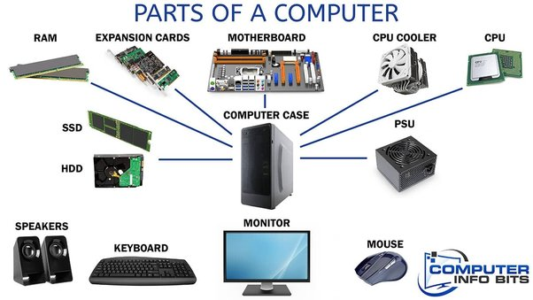

🌐 Internet
The Internet is a global network of interconnected computers and devices that communicate using a standard protocol called TCP/IP (Transmission Control Protocol/Internet Protocol).
It allows devices worldwide to exchange data, share resources, and access services like whatsapp email etc..
Key Features:
- Decentralized Network – No single authority controls the whole Internet.
- Protocols – Communication rules (e.g., HTTP, HTTPS, FTP, SMTP).
- Services – Email, Web (WWW), Cloud, IoT, Streaming, etc.
- Identifiers – Every device has a unique IP address. Domain names map to IPs via DNS (Domain Name System).
- Reference :- https://youtu.be/x3c1ih2NJEg

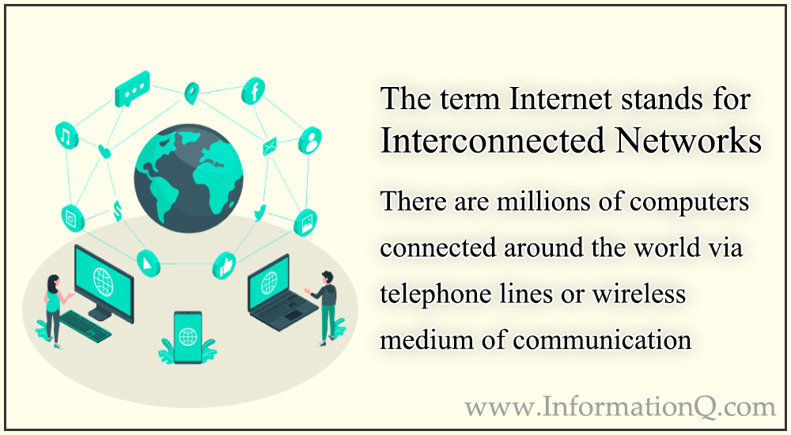

🖥️ Client-Server Architecture
This is a distributed computing model used to design applications and systems over a network.
1. Definition
- Client: A device or application that sends requests (like a web browser).
- Server: A powerful system or software that listens, processes requests, and sends back responses (like a web server).
Example:
When you type www.google.com in your browser:
- Client (your browser) → sends request → Google’s server.
- Server processes → finds result → sends response back.
- Client displays result to you.

2. Working of Client-Server
- Client Initiates Request → using protocols like HTTP/HTTPS.
- Server Processes Request → fetches data or performs operations.
- Server Responds → sends back HTML, JSON, files, or other data.
- Client Displays/Uses Response.

3. Types of Servers
- Web Server – Handles web pages (Apache, Nginx).
- Application Server – Executes business logic (Node.js, Express, Django).
- Database Server – Stores & manages data (MySQL, MongoDB, PostgreSQL).
- File Server – Provides file storage and access.
- Mail Server – Manages emails (SMTP, IMAP, POP3).

4. Advantages
- Centralized control of data and security.
- Scalability – Servers can be upgraded based on services
- Data integrity – Same updated data served to all clients.
- Easier maintenance – Updates applied at server side.

5. Disadvantages
- Single point of failure – If server crashes, clients can’t access services.
- High cost – Servers are expensive to maintain.
- Network dependency – Requires reliable internet/network connection.

6. Real-Life Examples
- Web Browsing – Browser (client) ↔ Web Server.
- Banking Systems – Mobile app (client) ↔ Bank server.
- Online Games – Player (client) ↔ Game server.
- Email Services – Outlook/Gmail client ↔ Mail server.

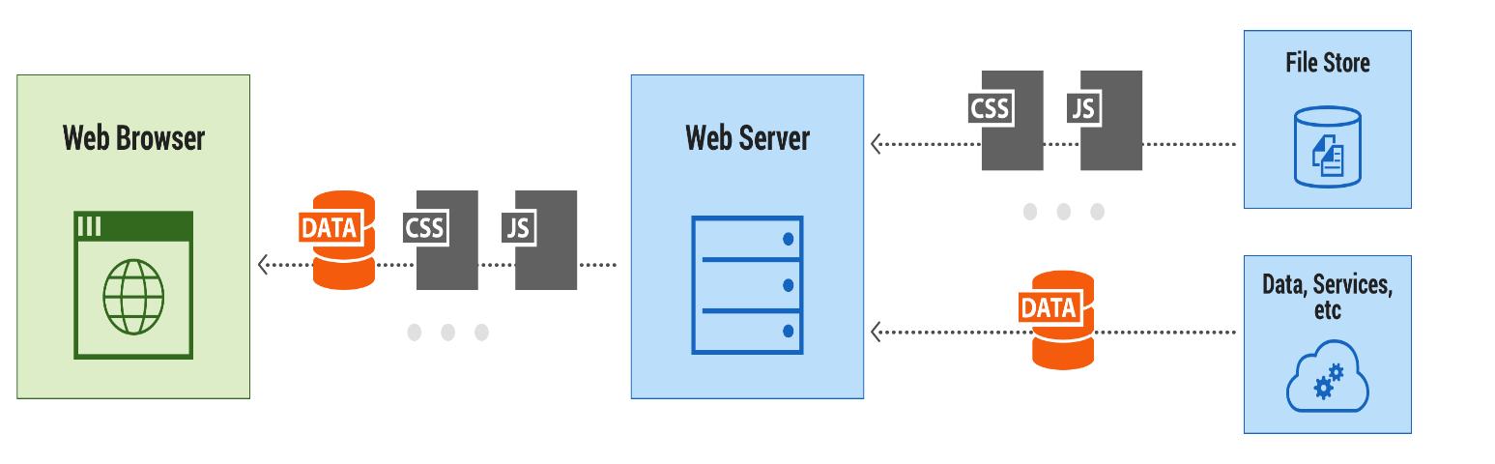
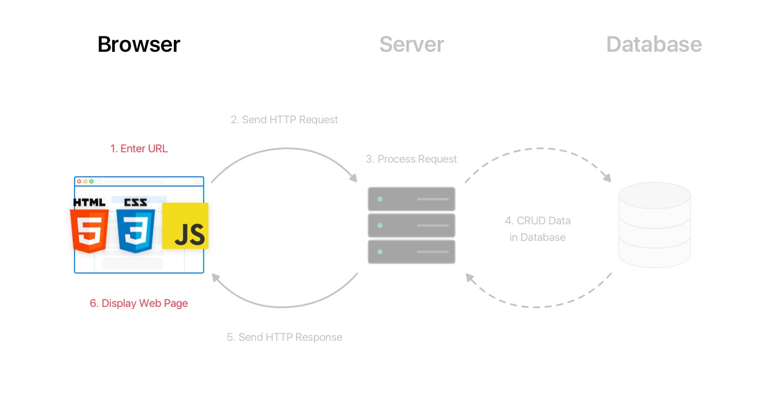

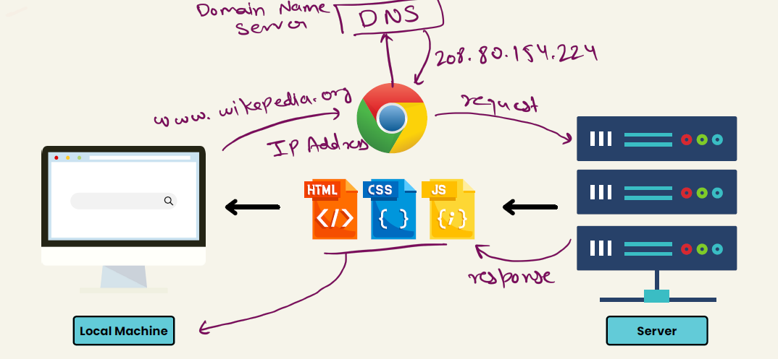

HTML/CSS/JavaScript uses in web development->

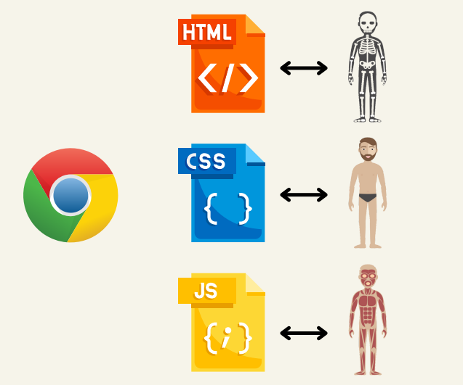

Install Tools-> VS Code(auto save) , Live server, any browser for compiling HTML/CSS/JS

