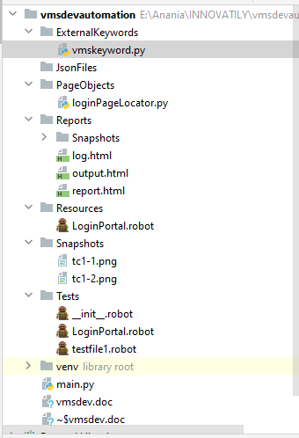

Vmskeywords.py
import os
def create_folder(foldername):
os.mkdir("E:/Anania/Ideavat/"+foldername)
def delete_folder(foldername):
os.rmdir("E:/Anania/Ideavat/"+foldername)

Loginpage locators.py
# Browser url
browser="chrome"
url="http://vmsdev.innovatily.com/admin"
# Login Page element
uname="name:username"
upwd="name:password"
loginbutton='xpath://button[@value="Log In"]'

Reosurecs/Loginportal
*** Settings ***
Library SeleniumLibrary
Library Collections
Library ../ExternalKeywords/vmskeyword.py
Variables ../PageObjects/loginPageLocator.py
*** Keywords ***
#Create webdriver Chrome executable_path=C:/Users/SachinGC/AppData/Local/Programs/Python/Python37-32/Scripts
Open Browser ${url} ${browser}
Maximize Browser Window
Login
[Arguments] ${UserName} ${Password}
clear element text ${uname}
input text ${uname} ${UserName}
input text ${upwd} ${Password}
# Clear Element Text name:username
# input text name:username ${UserName}
# input text name:password ${Password}
# click element xpath://button[@value="Log In"]
click element ${loginbutton}
#Wait Until Element Is Visible xpath://div[@id="content"]/div/app-dashboard/div/div[1]/h2
Wait Until Page Contains Visitor Overview
Capture Page Screenshot .//Snapshots/tc1-1.png
${PageTitle}= Get Title
Scrollto
[Arguments] ${elementtoscrollto}
Execute Javascript window.scrollTo(0,2000)
# Scroll Element Into View ${elementtoscrollto}
# Wait Until Element is visible ${elementtoscrollto} timeout=5s
# Set Focus To Element ${elementtoscrollto}
# Click Element ${elementtoscrollto}*
LoginPortal
OpenPage
Login arec test
ClickNewVisitor
#sleep 2 seconds
click Link xpath://ul[@id='accordionSidebar']/li[2]/a
Wait Until Page Contains Visitor Details Capture
Click Element xpath://button[contains(.,'New Visitor')]
Capture Page Screenshot .//Snapshots/tc1-2.png
Scrollto (//input[@type='text'])[26]
ClickProfile
Click Element xpath://a[@id='userDropdown']
Click Element css:.dropdown-item:nth-child(1)
ClosePage
close browser
Foldercreation
[Arguments] ${foldername}
create_folder ${foldername}

__init__.robot:
*** settings ***
Library SeleniumLibrary
Suite Setup BeforeEachTestSuite
Suite Teardown AfterEachTestSuite
*** Keywords ***
BeforeEachTestSuite
log to console Before
log Before started
AfterEachTestSuite
log to console After
log After End

Tests/loginportal:
***settings***
Documentation Login to vmsdev
Resource ../Resources/LoginPortal.robot
#Test Setup LoginPortal #excutes before each testcase
#Test Teardown ClosePage
Default Tags Sanity
Force Tags Regression
*** test cases ***
[Setup] LoginPortal
NewVisitor
[Tags] Smoke
ClickNewVisitor
Profile
ClickProfile
[Teardown] ClosePage
#LoginGoogle
# OpenPage https:/www.google.com chrome

Testfile1.robot:
***settings***
Documentation Learn RobotFrameWork
Library SeleniumLibrary
Library Collections
Resource ../Resources/LoginPortal.robot
Default Tags Sanity
Force Tags Regression
Library ../ExternalKeywords/vmskeyword.py
#*** variables ***
#${browser} chrome
#${url} http://vmsdev.innovatily.com/admin
*** test cases ***
usingExternalKeyword
Foldercreation vigilents
delete_folder vigilent
varaibleandlist
[Tags] Smoke
${var1}= set variable variabaletest
log to console ${var1}
#list
@{list1} create list item1 1 2 item4 item5
${list1_length} get length ${list1}
log to console ${list1_length}
${list1_item} get from list ${list1} 0
log to console ${list1_item}
FOR ${item} IN ${list1}
log to console ${item}
END
keywordtest
${keywt} set variable log to console
Run Keyword ${keywt} this is what will be printed
#run keyword with condition
${keyvalue}= set variable YES
Run Keyword If '${keyvalue}'=='YES' log to console vlaue found
Run Keyword If '${keyvalue}'=='NO' log to console vlaue not found
TimeoutAndSpeed
Set Selenium Speed 2 seconds
# Set Selenium Timeout 20 seconds
# Set Selenium Implicit Wait 20 seconds

