SLIIT FACULTY OF COMPUTING
BSc (Hons) in Information Technology

PROJECT PROPOSAL REPORT

DozerNet
Web Based JCB Management System

Group ID: 2026 Y2 S1 MLB B4G2 09

G. Ananian IT25102642
Theekshana A.D. IT25101810
Jayawardhana A.G.D.L. IT25100798
Perera M.A.S.A. IT25103606
Ruvendi R.G.K. IT25101701
Thathsara J.P.T. IT25103683

SE2030 Software Engineering
Academic Year 2026 | Year 2, Semester 1
Submission Date: 7 August 2026

Contents
1. Introduction
1.1 Project Overview and Problem
1.2 Purpose of the Proposed System
1.3 Objectives
1.4 Target Users and Stakeholders
1.5 Scope and Boundaries
2. System Overview Diagram
3. Functional Requirements
4. Nonfunctional Requirements
5. Major Stakeholders and Users
6. Six Major System Functions
7. Minor Functions
8. System Limitations and Constraints
9. Project Timeline
10. Conclusion

1. Introduction
1.1 Project Overview and Problem
DozerNet is a Java based web application that coordinates JCB machine rentals together with the related customer, fleet, operator, maintenance, payment, and administrative work. The platform links customers who need excavation or earth moving services with available machines and qualified operators through one shared system.
In practice, JCB rental work is still often arranged by phone calls, messaging applications, and separate manual records. Details about a customer request, machine readiness, operator assignment, maintenance status, job progress, invoices, and payments can sit in different places. That scatter makes it hard to confirm readiness, avoid double booking, verify private machines and independent operators, and keep a complete history of each rental job.
DozerNet responds to this problem with one verified platform backed by a central relational database. Customers can browse machines, place booking requests with a clear job site, follow status updates, and complete payment before an operator is assigned. Administrators can review bookings, verify private owners and drivers, manage fleet and operator records, schedule maintenance, issue invoices, record payments, and view reports.
1.2 Purpose of the Proposed System
The purpose of DozerNet is to replace disconnected phone based coordination with a transparent and traceable digital workflow. The system gives customers, private JCB owners, operators, and administrators a shared view of the work while ensuring that only approved machines and verified operators take part in rental activity.
Central idea: every booking should connect an identified customer, an available and serviceable JCB, a verified operator, a defined hire period, a documented job site, and a traceable invoice and payment record before field work begins.
1.3 Objectives
The primary objective is to develop a practical web based JCB management system that improves the efficiency, accuracy, and transparency of the rental process. The specific objectives are to:
- Provide secure registration, login, logout, profile management, and role based access.
- Allow customers to browse JCBs by type or job category, request bookings with district and address details, cancel eligible requests, view history, and receive in app status alerts.
- Maintain a verified inventory of company owned and privately owned JCB machines.
- Manage company operators and independently registered drivers, including licence checks and assignment only after payment is confirmed.
- Connect maintenance schedules and repair records to machine status so machines under service are not offered for booking.
- Create an invoice when a booking is approved, collect payment through a demo card portal or recorded cash or bank transfer, then allow operator assignment and later job completion.
- Apply object oriented design and recognised design patterns in a modular Java web application.
1.4 Target Users and Stakeholders
The main users are customers, private JCB owners, operators or drivers, and administrators. Customers request services; private owners contribute verified machines; operators perform assigned work; and administrators verify records, approve activities, and oversee the platform.
1.5 Scope and Boundaries
The project covers a browser based application with six integrated modules: Customer Management, Booking and Rental Management, Fleet (JCB) Management, Operator Management, Maintenance and Service Management, and Payment and Administration. The current version does not include a native mobile application, automatic GPS tracking, or a live commercial payment gateway. Machine readiness is derived from booking, maintenance, and verification records rather than live vehicle location. Customer payment online is demonstrated through a simulated card portal; administrators can also record cash, bank transfer, or card payments manually.

2. System Overview Diagram
Figure 1 shows how the four user roles connect to the DozerNet web application and how the six modules share one MySQL database. A separate notification channel carries in app alerts (with a demo email log during development).
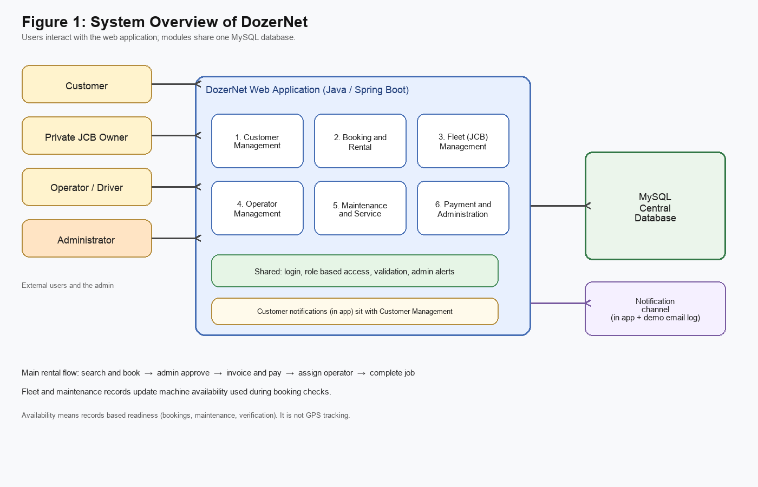
Figure 1: High level structure and information flow of DozerNet
How the System Works
Role based users enter the platform through the functions that match their responsibilities. Customers mainly use Customer Management and Booking and Rental Management, and they also receive in app notifications for booking and payment events. Private JCB owners submit machine information through Fleet Management. Operators use Operator Management to view assignments and update work status. The administrator supervises approvals and works across maintenance and payment administration as well as the other modules.
The six modules exchange information through one MySQL database. A booking request is checked against machine status and overlapping bookings. When an administrator approves a request, an unpaid invoice is created at once. After payment is recorded, an operator may be assigned. When the operator marks the job complete, the booking is closed. Fleet and maintenance updates feed back into machine status so the catalogue and booking checks stay consistent.
Availability in this report means readiness calculated from current booking, maintenance, and verification records. It does not mean GPS based vehicle tracking.

3. Functional Requirements
Functional requirements describe the actions that DozerNet must support. The list below reflects the system as built for the academic prototype.
ID | Area | Required System Behaviour
FR01 | Customer accounts | Register with NIC, log in, log out, update a profile, change password while signed in, view booking history, and read in app notifications.
FR02 | Search and browse | Browse and filter machines by type, job category, or keyword on location or model, and open machine details.
FR03 | Booking requests | Submit a booking for selected dates with Sri Lanka district and job site address, and cancel pending or unpaid approved requests where rules allow.
FR04 | Booking approval | Allow the administrator to approve, reject, or cancel eligible bookings and prevent overlapping allocations.
FR05 | Company fleet | Add, view, update, and delete company owned JCB records and maintain machine status.
FR06 | Private fleet | Allow private owners to register with NIC, list machines, set pricing, and receive requests after admin verification.
FR07 | Operators | Add company operators, register independent drivers, verify licences, and assign operators only after the related invoice is paid.
FR08 | Job progress | Allow assigned operators to view work and move status from assigned to in progress to completed.
FR09 | Maintenance | Schedule maintenance, record completed repairs and parts used, keep service history, and set machines to maintenance status when required.
FR10 | Financial records | Generate an invoice on booking approval, collect payment via demo card or recorded cash, bank transfer, or card, and support partial payment states.
FR11 | Administration | Manage user accounts, view reports, see paid bookings awaiting operators, and review fleet whereabouts for paid active deployments.
FR12 | Customer alerts | Deliver in app notifications to customers for booking and payment milestones (with a demo email log for development).

4. Nonfunctional Requirements
Nonfunctional requirements define the quality standards expected from DozerNet. They guide design and testing even when they do not appear as separate user functions.
ID | Quality | Requirement
NFR01 | Security | Passwords are stored with secure hashing. Role based access control limits each user to permitted screens. Forms validate input before processing.
NFR02 | Performance | Under normal demonstration conditions, common actions such as login, search, opening records, and submitting forms should respond within about 2 to 3 seconds.
NFR03 | Usability | Navigation, labels, forms, and error messages should stay clear for non technical users.
NFR04 | Reliability | Booking, maintenance, invoice, and payment records must avoid conflicting updates. A machine must not hold overlapping approved bookings.
NFR05 | Scalability | The data model should allow more machines, owners, operators, customers, and bookings without redesigning the whole system.
NFR06 | Maintainability | The Java application should keep modular responsibilities and recognised design patterns so defects and later changes are easier to handle.

Verification approach: these qualities will be checked through role access tests, response time observations, form validation tests, conflict scenarios, and module integration tests. Maintainability is supported through clear class responsibilities, consistent naming, version control, and code review within the group.

5. Major Stakeholders and Users
DozerNet uses four major user roles. Their responsibilities are separated so that customers can request services, private owners can contribute verified machines, operators can perform assigned work, and administrators can control approvals and platform records.
Stakeholder | Main Interaction with DozerNet | Expected Benefit
Customer | Search for JCBs, submit and cancel bookings, update a profile, track status, pay invoices, and read notifications. | A clearer rental process without repeated phone calls.
Private JCB Owner | Register, submit machine details, maintain listing pricing, and wait for verification before listings appear. | Access to rental demand through an approved listing.
Operator / Driver | Register as an independent driver or work as a company operator, provide licence details, view assignments, and update job status. | Clear work assignments and a visible progress record.
Administrator | Verify owners, drivers, and machines; approve bookings; manage fleet, operators, maintenance, invoices, payments, users, and reports. | Central control of safety, records, and daily operations.

A customer booking can proceed only when the requested machine is available and serviceable. After approval, payment must be completed before an operator is assigned. A private owner listing becomes visible only after administrator approval. An independent driver can be assigned only after licence verification. The administrator therefore acts as the control point that links customer demand with verified supply.
Access principle: each role should see only the information and actions needed for its responsibilities. Administrative functions are protected through role based access control.

6. Six Major System Functions
The project is divided into six major functions, with one function assigned to each group member from requirements through implementation and demonstration.
6.1 Customer Management
Module Owner: G. Ananian (IT25102642)
Primary Users: Customer
Customer Management provides the account and self service features needed before and after a rental request. It keeps customer identity, profile, booking history, and customer facing notifications in one place.
Main tasks
- Register a customer account with required field checks, including a unique NIC that cannot be changed later.
- Log in and log out using secure session handling.
- Update authorised profile information and change the account password while signed in.
- View a customer dashboard, booking history, and current status.
- Read in app notifications for booking decisions, payment reminders, invoice updates, and operator assignment.
Typical workflow: a new customer registers with NIC details, signs in, updates the profile if needed, and then uses the same account to submit bookings, follow alerts, and open invoices.
Expected outcome: customers can manage their own accounts, stay informed through notifications, and track rental activity without depending on repeated phone calls.
6.2 Booking and Rental Management
Module Owner: Theekshana A.D. (IT25101810)
Primary Users: Customer / Administrator
Booking and Rental Management controls the request, review, approval, and cancellation stages of a JCB rental. It connects customer demand with fleet information and triggers invoice creation when a booking is approved.
Main tasks
- Capture hire dates together with a Sri Lanka district and a job site address or landmark.
- Reject overlapping bookings for the same machine and respect machine maintenance status.
- Allow cancellation of pending requests and of unpaid approved bookings where rules allow.
- Allow the administrator to approve or reject requests.
- On approval, create an unpaid invoice so payment can proceed before operator assignment.
Typical workflow: the customer selects a machine, enters dates and job site details, submits the request, and waits for administrative review. Approval opens the payment step rather than immediate field assignment.
Expected outcome: a conflict aware booking process with a clear approval status and a documented job site.

6.3 Fleet (JCB) Management
Module Owner: Jayawardhana A.G.D.L. (IT25100798)
Primary Users: Administrator / Private JCB Owner
Fleet Management maintains the trusted inventory of JCB machines available on the platform. It covers company owned equipment and approved machines listed by private owners, and it exposes a public catalogue with type and job category filters.
Main tasks
- Add, view, update, and delete company owned JCB records.
- Track machine status using booking and maintenance information.
- Allow private owners to register with NIC and submit machine listings.
- Allow the administrator to verify and approve owner listed vehicles.
- Provide an owner dashboard for listing pricing and related requests.
- Present a public catalogue filtered by machine type, job category, or keyword.
Expected outcome: one accurate and verified inventory of company and private JCB machines.
6.4 Operator Management
Module Owner: Perera M.A.S.A. (IT25103606)
Primary Users: Administrator / Operator
Operator Management maintains operator records and ensures that every approved and paid booking can be assigned to a verified and suitably qualified person.
Main tasks
- Add company employed operators to the system.
- Allow independent drivers to register with NIC, licence, and experience details.
- Verify driver licences and qualifications before assignment.
- Assign an available operator only when the related booking invoice is paid.
- Allow the operator to view assignments and update status through to completion.
Expected outcome: every field job is linked to a verified operator and has visible progress information.
6.5 Maintenance and Service Management
Module Owner: Ruvendi R.G.K. (IT25101701)
Primary Users: Administrator
Maintenance and Service Management keeps machines serviceable by recording planned maintenance and completed repair activity for each JCB.
Main tasks
- Schedule upcoming maintenance and set the machine status to maintenance when required.
- Record completed repairs, parts used, and cost.
- Maintain a service history for every machine.
- Return a machine to service only when the administrator chooses to do so after completion.
Expected outcome: machines under service are kept out of the booking pool until they are cleared.
6.6 Payment and Administration
Module Owner: Thathsara J.P.T. (IT25103683)
Primary Users: Administrator / Customer
Payment and Administration provides the financial and control records for approved rental work. In the built system an invoice is created when a booking is approved, and operator assignment waits until payment is confirmed.
Main tasks
- Generate an invoice when a booking is approved, using standard daily rate pricing.
- Allow the customer to pay through a demo card portal.
- Allow the administrator to record cash, bank transfer, or card payments, including partial payment states.
- Generate booking and revenue reports.
- Manage user accounts and present administrative summaries such as paid bookings awaiting assignment and fleet whereabouts for paid active deployments.
Expected outcome: transparent and traceable financial records that unlock operator assignment only after payment.

7. Minor Functions
Minor functions support the six major modules. Customer notifications are described under Customer Management rather than here, because they form part of the customer facing experience.
ID | Supporting Function | Purpose
MF01 | Role based login and logout | Authenticate users, open or close sessions, and send each role to the right dashboard.
MF02 | Search and filters | Filter machines by type, job category, or keyword so customers can narrow the catalogue.
MF03 | Admin and other role alerts | Notify administrators of new booking requests and received payments; notify owners and operators of verification and assignment events.
MF04 | Form validation | Check required fields, formats, and business rules and show clear messages.
MF05 | Administrator dashboard | Summarise pending work, paid bookings ready for assignment, and paid fleet whereabouts.

Authentication and role based redirection protect all modules. Search supports browsing before booking. Validation reduces incomplete data at registration, booking, fleet, operator, maintenance, and payment stages. The administrator dashboard brings together actions that are waiting for review.
8. System Limitations and Constraints
8.1 System Limitations
- The system is a web application only. A native Android or iOS application is outside the present scope.
- There is no realtime GPS tracking. Operators update job status manually.
- There is no live commercial payment gateway. Customers can use a demo card portal, and administrators can record cash, bank transfer, or card payments.
- Verification of private owners, machines, and independent drivers is manual and administrator driven.
- Machine readiness depends on timely booking, maintenance, and verification updates.
- Email delivery is demonstrated through application logs rather than a production mail service.
8.2 Technical and Project Constraints
- The system must be delivered as a Java web application under the module rules.
- Development is carried out by six students within one academic semester.
- The project is divided into six demonstrable major functions with clear individual ownership.
- Users need internet access and a modern web browser.
- Testing time, hosting resources, and access to real rental business data may be limited in the academic setting.
8.3 Assumptions
- Administrators enter and review booking, machine, operator, maintenance, invoice, and payment information carefully.
- Private owners and independent drivers provide genuine information and valid documents.
- A machine marked available is not under an unrecorded booking or maintenance restriction.
- Customers provide correct contact details so status messages can reach them.
Scope control: features such as live GPS, automated online commercial payments, and native mobile applications remain possible future extensions. They are excluded from the present prototype so that the work stays realistic and testable.

9. Project Timeline
The weekly plan follows the Week 3 to Week 14 format required by the module specification. Activities may overlap when integration needs collaboration between module owners.
Week | Focus | Planned Activities and Deliverables
3 | Proposal | Confirm scope, stakeholders, requirements, module ownership, proposal presentation, and proposal report.
4 | Foundation | Set up the development environment, repository, project structure, shared conventions, and initial database design.
5 | Customer | Build registration with NIC, profile, password change, customer dashboard, booking history access, and customer notifications.
6 | Fleet | Build company fleet records, private owner registration and listings, verification, catalogue filters, and job categories.
7 | Booking | Build booking requests with job site details, cancellation rules, approval, conflict checks, and invoice creation on approval.
8 | Operator | Build operator records, independent driver registration, verification, pay gated assignment, and job status updates.
9 | Integration I | Integrate Customer, Fleet, Booking, and Operator modules; resolve data and workflow issues; prepare progress evidence.
10 | Progress evaluation | Conduct the progress presentation and system demonstration and submit the Design Document.
11 | Maintenance | Build maintenance scheduling, repair records, parts used, service history, and status restrictions.
12 | Payment and integration | Complete invoices, demo card payment, admin payment recording, reports, user administration, and full integration testing.
13 | Final evaluation | Demonstrate the completed system, deliver the final presentation and viva, and submit final documentation.
14 | Closure | Apply permitted corrections, finalise the repository and documentation, and complete handover activities if required.

Team coordination: each member owns the assigned major module while shared integration, testing, documentation, and presentations are completed together. Version control, regular review, and early integration reduce last minute conflicts between modules.
10. Conclusion
DozerNet offers a practical answer to the fragmented way JCB rental work is commonly organised. By bringing customers, bookings, machines, operators, maintenance activity, invoices, payments, and administrative decisions onto one web platform, the team can improve visibility and reduce reliance on disconnected phone calls and informal records.
The design is useful because it supports both a company fleet and a verified private marketplace. Private owners can list machines for approval, and independent drivers can register with their licence details. Customers gain a clearer path from browsing to booking, payment, and job progress. Administrators keep control of verification, approval, maintenance related safety, and financial records.
Payment before operator assignment is an intentional control in the built system. Once a booking is approved, an invoice is created. Field assignment waits until payment is confirmed. That order keeps commercial and operational steps aligned for the academic prototype.
The work is feasible within the module because it is split into six owned functions with shared login, validation, and administrative support. Known limits such as the absence of GPS tracking, native mobile apps, and a live payment gateway keep the first version realistic and testable.
Through staged development, early integration, and shared documentation, the team aims to present a stable prototype at the progress stage and a complete demonstrable system at the final evaluation. DozerNet therefore remains a suitable software engineering project with clear stakeholder value and balanced individual responsibility.
Proposed result: a transparent, centralised, and verified JCB rental platform that connects customers, private owners, operators, and administrators through one consistent workflow.

