

ANDD
AI NATIVE DISTRIBUTED DATACENTERS
A Technical Architecture for Sovereign, Resilient,
AI-Managed Edge Infrastructure

Whitepaper v2.0 • March 2026
contact@andd.network • andd.network

Table of Contents
01 Executive Summary
02 The Case for Decentralization
03 ANDD Architecture Overview
04 Technical Architecture
05 Bandwidth & Connectivity
06 Energy & Mitigation Strategies
07 AI-Native Operations
08 Resilience Through Decentralization
09 Payment Architecture
10 DePIN Integration & Pressure Test
11 Opportunity Zone Alignment
12 Implementation Roadmap
13 Conclusion

01 Executive Summary
The global compute infrastructure serving AI, critical services, and digital economies is dangerously concentrated. Fewer than 30 hyperscale campuses process the vast majority of U.S. AI inference, financial transactions, government data, and emergency communications.
This concentration creates single points of failure for national security, economic continuity, and community resilience — and leaves underserved regions permanently behind.
The ANDD Model
A network of hundreds to thousands of sub-2MW edge datacenters, deployed across Opportunity Zones, forming an interconnected mesh fabric entirely managed by AI. Autonomous onboarding, billing, provisioning, and maintenance — no human operators required for standard operations.

<2MW | 100s+ | 4 | 99.99%
Per Site | Locations | HW Domains | SLA Target

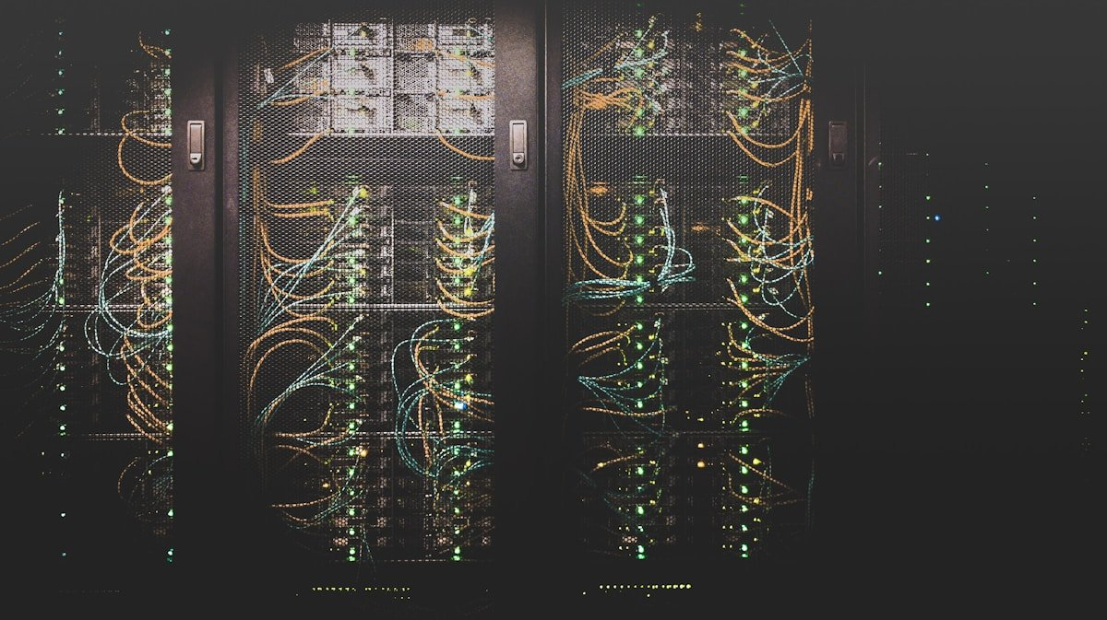
Enterprise-grade edge infrastructure
This whitepaper details the four hardware domains, bandwidth and energy profiles, AI-native operations model, payment architecture spanning fiat to crypto micro-transactions, and a rigorous pressure test against existing DePIN projects.
02 The Case for Decentralization
The Concentration Problem
Northern Virginia hosts over 70% of East Coast internet traffic. The top five metro markets account for the majority of U.S. datacenter capacity. This creates compounding vulnerabilities:
• National Security. A coordinated attack on fewer than a dozen campuses could degrade federal agencies, financial markets, and defense communications simultaneously.
• Latency Inequality. Communities >50ms from hyperscale regions cannot access real-time AI, telemedicine, or autonomous vehicle coordination.
• Sovereignty Erosion. Government data depends on three to four hyperscale vendors' operational decisions and pricing.
• Grid Strain. A single 300MW campus demands the output of a small power plant, straining regional grids.

Concentrated infrastructure leaves most communities behind
Why Now
• AI Inference at the Edge. 60–70% of all AI compute is inference — latency-sensitive, geographically distributed, ideal for edge.
• DePIN Needs Upgrading. Consumer hardware hits reliability ceilings. Enterprise customers need 99.99% uptime and compliance.
• Federal Policy Tailwind. Opportunity Zones (8,764 tracts), bipartisan AI infrastructure support, rural broadband funding.
The AI-Native Unlock
Previous distributed datacenter attempts failed on economics — sub-2MW sites can’t justify full operations teams. ANDD inverts this: AI handles onboarding, provisioning, billing, monitoring, and maintenance. The marginal cost of a new site approaches hardware cost alone.
03 Architecture Overview

Interconnected mesh fabric — no single point of failure
Three-Tier Mesh Fabric
Tier | Component | Power | Role
3 | AI Control Plane | Distributed | Global routing, billing, capacity planning
2 | Regional Hubs | 1–2MW | Aggregation, peering, training GPUs
1 | Edge Nodes | 200kW–500kW | Local compute, inference, storage

Connectivity Per Node
Link Type | Medium | Bandwidth
Primary uplink | Fiber / microwave | 10+ Gbps
Redundant uplink | Diverse fiber / 5G / LEO sat | 1–10 Gbps
Mesh peering | Direct node-to-node | 10 Gbps
2nd hub path | Via mesh or direct | Variable

Site Layout
System | Components | Spec
IT | Compute (x4–8) + AI (x2–4) + Storage (x2–4) | Configurable mix
Network | Leaf-spine + edge router | 100/400GbE + BGP
Power | Utility + ATS + UPS + solar/BESS | Microgrid capable
Cooling | DLC + immersion + air economizer | PUE 1.15–1.25
04 Technical Architecture
AI Accelerators

Purpose-built silicon for edge inference
Accelerator | TDP | Memory | Tier
NVIDIA L4 | 72W | 24GB | Edge (efficient)
NVIDIA L40S | 300W | 48GB | Edge (inference)
AMD MI300X | 750W | 192GB HBM3 | Edge / Hub
AMD MI325X | 750W | 256GB HBM3e | Edge / Hub
Intel Gaudi 3 | ~600W | 128GB HBM2e | Edge (cost)
NVIDIA H100 | 700W | 80GB HBM3 | Hub (train)
NVIDIA H200 | 700W | 141GB HBM3e | Hub (large)
NVIDIA B200 | 1,000W | 192GB HBM3e | Hub (train)
GB200 NVL2 | 2,700W | 384GB HBM3e | Hub (liquid)

Edge AI Feasibility
Workload | Hardware | Power | Latency
LLM 7–13B | 1x L40S | 300W | 20–100ms/tok
LLM 70B | 2–4x H100 | 700W–1.4kW | 50–200ms/tok
Image/video | 1x L4 | 72W | 5–20ms
Speech | 1x L4 | 72W | <100ms
RAG pipeline | 1–2x H100 | 1–2kW | 100–500ms
Fraud detection | 1x L40S | 300W | <50ms

Software Stack
Layer | Components
AI Management | Onboarding, Provisioning, Billing, SLA agents
Orchestration | K3s/RKE2, Istio mesh, AI scheduler
Infrastructure | SDN (OVS/VPP), Ceph/MinIO, AI-controlled DCIM
Hardware | BMC/Redfish, GPU drivers, SONiC/Cumulus

Security
• Zero-trust: mTLS on all workload-to-workload communication
• Hardware root of trust: TPM 2.0, measured boot, remote attestation
• Tenant isolation: SR-IOV, SEV-SNP/TDX confidential compute
• Physical: Biometric access, AI surveillance, SCIF options
• Compliance: FedRAMP, SOC 2, HIPAA, CJIS, ITAR
05 Bandwidth & Connectivity
Tier | Primary | Redundant | Mesh | Total
Edge 200kW | 10G | 1–10G | 10G | 20–30G
Edge 500kW | 40G | 10G | 25G | 50–75G
Hub 1–2MW | 100G | 40G | 100G | 200–300G

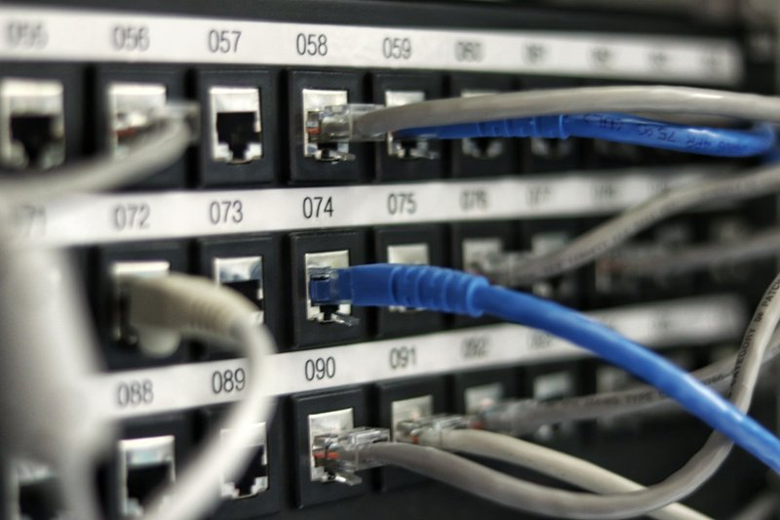
Redundant, multi-path connectivity
Backhaul by Geography
Type | Primary | Backup
Urban | Multi-carrier fiber 10–40G | 5G/LTE 1–5G
Suburban | Fiber 10–40G | Diverse fiber 10G
Rural | Licensed wireless / LEO sat 1–10G | 5G/LTE

Protocol Stack
• Underlay: eBPF + SRv6 segment routing
• Overlay: WireGuard/MACsec + VXLAN/GENEVE
• Peering: Automated BGP with RPKI
• DNS: Anycast across all nodes
• GSLB: AI-driven, latency/cost/carbon aware
06 Energy & Mitigation
Tier | IT | Cooling | Infra | Total | PUE
Edge 200kW | 150kW | 25kW | 25kW | 200kW | 1.15–1.25
Edge 500kW | 380kW | 65kW | 55kW | 500kW | 1.15–1.25
Hub 2MW | 1,500kW | 280kW | 220kW | 2MW | 1.15–1.25

Cooling Comparison
Technology | Cooling kW | IT Capacity | PUE
Air (DX) | 150–200kW | 300–350kW | 1.40–1.80
Rear-door HX | 75–125kW | 375–425kW | 1.20–1.40
Direct liquid | 40–75kW | 425–460kW | 1.10–1.20
Immersion (1φ) | 15–30kW | 470–485kW | 1.02–1.06
Immersion (2φ) | 10–20kW | 480–490kW | 1.01–1.04

30% More Compute, Same Power
Moving from air cooling to immersion saves ~300kW per MW — increasing usable compute by 30% within the same power envelope.
Renewable Economics
Component | Spec | Cost | Value
Solar | 100kW carport | ~$150K | 175 MWh/yr
BESS (LFP) | 500kWh/250kW | ~$200K | 2hr backup + cycling
IRA ITC | 30–50% | –$105K–$175K | Capital reduction
Grid services | Freq. reg + DR | — | $50–200K/yr/MW

Effective payback: 2–4 years after incentives.
Federal Funding
Program | Amount | Use
DOE GRIP | $10.5B | Microgrids, DER
DOE LPO | $400B+ | Clean energy lending
ARPA-E COOLERCHIPS | $42M | DC cooling R&D
IRA ITC | 30–50% | Solar, BESS, fuel cells
NTIA BEAD | $42.45B | Broadband + edge
07 AI-Native Operations

AI agents manage the entire datacenter lifecycle
Traditional operations require full-time staff per site, establishing a ~5MW minimum viable size. ANDD eliminates this with autonomous AI agents:
Agent | Function
Orchestration | Coordinates sub-agents, escalates exceptions
Onboarding | Lead qualification, proposals, KYC, provisioning
Provisioning | Workload mapping, node placement, auto-scaling
Billing | Sub-second metering, invoicing, fiat+crypto reconciliation
Maintenance | Sensor telemetry, digital twins, preventive scheduling
SLA Guardian | Threshold monitoring, auto-remediation, credit issuance

1 Human per 20–50 Nodes
A 10–25x improvement over traditional staffing. Humans handle exceptions, strategy, physical maintenance, and compliance oversight.
Self-Hosting Architecture
• Foundation LLM runs on ANDD’s own GPUs — no external API dependency
• Specialized models for maintenance, networking, billing
• Staged rollout: shadow → canary → full, with auto-rollback
• Full reasoning chain logging for auditability
08 Resilience Through Decentralization

Distributed architecture eliminates single points of failure
Payments
Distributed card authorization, ACH, FedNow gateways across hundreds of nodes. Local store-and-forward during backbone disruptions. Crypto rails as backup settlement layer.
Energy Grid
Distributed SCADA/EMS hosting. Edge compute for DER control loops (<10ms). Virtual power plant from distributed BESS. Microgrid islanding during emergencies.
Emergency Services
Local NG911 hosting. FirstNet edge compute. Emergency operations center computing. LEO satellite backhaul when terrestrial networks fail.
Utilities & Water
Local SCADA for water/wastewater/gas. Semi-air-gapped operation. AI anomaly detection for contamination and cyber intrusion.
Quantified Advantage
Architecture | Per-Unit Uptime | System Availability
Single hyperscale | 99.99% | 99.99% (67 min/yr down)
ANDD mesh (100 nodes) | 99.95% per node | 99.9999%+ (graceful degradation)
09 Payment Architecture
Fiat Tiers
Tier | Model | Methods | Use Case
Starter | Monthly | Card, ACH | Startups
Professional | Monthly/Annual | ACH, wire | Mid-market
Enterprise | Annual | Wire, PO | Large enterprise
Government | Multi-year | Treasury/PO | Federal/state/local

Crypto & Micro-Transactions
Rail | Use Case | Finality | Cost/Tx
Ethereum L1 | Enterprise contracts | ~12 min | $1–$20
Solana | High-frequency | Sub-second | ~$0.001
L2 (Arbitrum/Base) | Medium-frequency | Minutes | $0.01–0.10
Payment channels | Micro-transactions | Instant | Near-zero

Smart Contract SLAs
Programmable SLAs encode uptime targets, latency floors, and measurement periods. Oracle-fed performance data triggers automatic stablecoin credit issuance on breach — no human claims process.
Hybrid Orchestration
Customer | Primary | Secondary | Micro-Tx
Enterprise | Wire/ACH | Card | N/A
Government | PO/Treasury | ACH | N/A
Startup | Card | USDC | Per-API
DePIN | Stablecoin | Payment channel | Per-request
Web3 | USDC/token | Payment channel | Per-request
10 DePIN Pressure Test
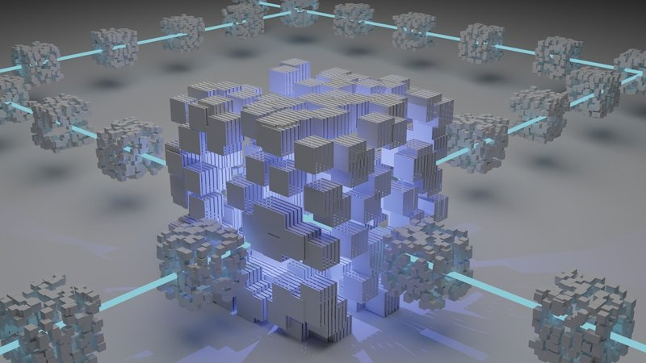
Enterprise-grade backbone for decentralized protocols
Lessons from DePIN Projects
Project | Success | Failure | ANDD Fix
Helium | 900K+ hotspots | No SLA, wrong locations | AI-driven demand placement
Filecoin | 22+ EiB capacity | Empty capacity, slow retrieval | Utilization-based incentives
Render | Real 3D rendering demand | Consumer GPUs can’t do AI | Datacenter-grade GPUs
Akash | 70–85% cheaper | No SLA enforcement | Smart contract SLAs
io.net | GPU clustering for ML | Heterogeneous, high latency | Homogeneous co-located HW

The Enterprise-Grade Gap
Dimension | Consumer DePIN | ANDD
Uptime | 90–98% | 99.99% SLA-backed
Redundancy | None | N+1 power/cooling/network
Security | None | Biometric, surveillance
Compliance | None | FedRAMP, SOC 2, HIPAA
Power | Residential | UPS + BESS + fuel cell
Cooling | Consumer fans | DLC + immersion
Connectivity | Broadband | Multi-provider, SLA
Sovereignty | Unknown | Per-tenant geo-restrictions

ANDD Completes DePIN
The tokenomics and demand aggregation work. The physical infrastructure needs upgrading to enterprise grade. ANDD provides that backbone.
What Can Be Built on ANDD
Category | Examples | Why Edge Required
Smart City / IoT | Traffic, sensors, digital twins | <10ms control loops
Autonomous Vehicles | V2X, HD maps, inference | Safety-critical latency
Health AI | Diagnostics, monitoring | HIPAA + low latency
Edge AI / MLOps | Model serving, RAG, agents | GPU at the edge
DePIN Protocols | Compute, storage, wireless | Enterprise backbone
Fintech | Payments, fraud detection | Compliance + <50ms
Content Delivery | Video, gaming, AR/VR | Bandwidth offload
Defense | Classified, SIGINT, C2 | Sovereign infrastructure
Emergency Services | NG911, FirstNet, alerts | Functions during disasters
AgTech | Precision ag, drones | Rural edge compute
11 Opportunity Zone Alignment
Tier | Incentive | Requirement | Benefit
1 | Capital gains deferral | Invest in QOF | Defer tax; rolling 5-yr window
2 | Basis step-up | Hold 5+ years | 10% (30% rural)
3 | 10-year exclusion | Hold 10+ years | Zero tax on appreciation

Community Impact (200kW Node)
Impact | Estimate
Construction jobs | 15–30 (6–12 month build)
Permanent jobs | 1–3 technicians
Property tax | $50K–$150K/yr
Utility revenue | $150K–$300K/yr
Multiplier | 1.5–2.0x direct spending
Digital benefit | Gigabit + AI + edge compute
12 Implementation Roadmap
Phase | Timeline | Milestones
Foundation | Mo 1–12 | AI layer, 200kW design, 3–5 pilots, SOC 2, QOF
Formation | Mo 12–24 | 20–50 nodes, hubs, >90% autonomous, FedRAMP
Scale | Mo 24–48 | 100–300 nodes, smart SLAs, federal customers
Continental | Mo 48–72 | 500–1000+ nodes, full autonomy, VPP
13 Conclusion
The concentration of compute into hyperscale campuses was an artifact of an era when operational economics demanded scale and AI didn’t exist as an operational tool. That era is ending.
ANDD demonstrates that AI-native operations eliminate the economic barrier to distributed deployment. The marginal cost of a new edge node approaches hardware cost alone.
ANDD delivers:
• Sovereignty — compute stays where it’s governed
• Security — no single target degrades the network
• Resilience — survives what cripples centralized
• Equity — capabilities reach underserved communities
• DePIN — enterprise backbone for decentralized protocols
• Viability — fiat to crypto, subscriptions to micro-tx

The question is how quickly it can be deployed.
ANDD is the answer.

contact@andd.network • andd.network
This document contains forward-looking statements. Technical specifications represent design targets. Tax information is for informational purposes only.

