**Development of Automated Trash Collecting Boat using Machine Learning**

**Aryan Naik1, Aditya Kulkarni2, Anannya Chaudhary3, Savani Bondre4, Anil Kadu5**

*Department of Multidisciplinary Engineering,*

*Vishwakarma Institute of Technology, Pune, 411037*

---------------------------------------------------------------------***---------------------------------------------------------------------

**Abstract -** *In this research, a prototype for a Water Surface Mobile Garbage Collector Robot is presented with the aim of promoting awareness and monitoring the health of rivers through garbage collection using image processing. This device is designed to be utilized for clearing of small lakes, rivers, and sewages in India. Image processing is utilized for controlling the robot's navigation. The performance of the water garbage collector is evaluated based on its maneuvering control efficiency and garbage collection load capacity. The robot is capable of floating and moving around the water surface, and it should be constructed from durable, lightweight, and waterproof materials.*

*Key Words*: Raspberry pi, BLDC motor, computer vision, yolo, Arduino UNO

**1. INTRODUCTION**

Rivers are important to people as well as other organisms for a variety of reasons, including serving as transit hubs, providing habitat for marine flora and fauna, supporting human existence by supplying freshwater, hydration for plants, and regulating the earth's humidity[2].

The world's population is quickly growing, and various rivers were severely impacted by flooding. [3]. According to a survey, one of the primary causes of severe flooding in rivers is massive building upstream[3]. Heavy rains can transport sediments from inhabited regions, blocking drainage systems and causing flash floods in some locations, particularly cities.[4].Garbage can also clog drainage systems [5-6]. We frequently discover a lot of waste lying on the water in poor nations, including plastic leftovers, foaming agents, foliage, and metal bottles. Dry material drifting on the water's surface can obstruct water drainage in city canals and cause flooding. Human negligence is to blame, for instance reckless dumping of packaging for food, drinking straws, or plastic containers in public places.[7]. Plastic pollution cannot be avoided. It may happen anywhere. Aquatic life is endangered because plastic garbage may choke, smother, and kill it. Governments in various nations have taken preventative measures. While there has been modest improvement in water quality, several rivers remain polluted [2]. Many experiments are being undertaken to find more efficient methods for collection of waste on the water's surface[6-8]. This will help the government of the cities to improve the state of their aquatic bodies.

Garbage collectors can be both fixed[13] as well as mobile[8]-[12], and [13]-[17]. Mr. Rubbish Wheel, a wheel that floats on water and is powered by solar energy, collects garbage at the entrance of a river and transports it to the main Baltimore Harbor.It removes waste using a solar-powered hydraulic pump. In its first 22 months of operation, it gathered 127 dumpsters full of rubbish and debris totalling 420 tonnes [11]. The sole disadvantage of this technique is that pumps must be simple to maintain and repair in order to function properly. Water surface cleaning robots that are simple to maintain could be accomplished if a mechanical system where there is no automation based on electronics is employed [14]. Although, moving the cleaning boat pedals demands a large amount of manpower [14]. Because of its vast proportions, it is effective in collecting big volumes of rubbish.

Another study's garbage collector concept used a conveyor system. It is an excellent design for decreasing labor since the rubbish is automatically transferred to the collecting tray by the use of motor control; nevertheless, considerable energy usage is required to carry out efficient operation of the motor as the amount of trash being loaded on the tray of the collector grows [11]. A combination of smartphone capability with robotic capabilities that can be operated using a touch screen or other Android based technologies that allow for remote and easy operation.Some robots rely on Wifi networks and Bluetooth connections to receive commands from the operator, who can use a joystick, keyboard, or phone screen.

This research proposes a robot that collects mobile garbage on water bodies using a half-submerged propulsion characteristic that can be operated remotely using bluetooth technology. The collector's goal was to gather waste found on the surface of the water bodies without adding weight to the collector's body. The garbage collector's performance was assessed in terms of maneuvering control efficiency and rubbish collecting load capacity.

**1.1 Literature Survey**

Raschka [1] describes a framework for developing, training, and deploying machine learning technology using Python.Matthies [2] created an interactive system based on geometric scene understanding that is built in such a way that it reacts to the dynamic environment.A lightweight machine learning model was trained and constructed by Norris and Donald [3].

A Raspberry Pi was used to run the model. Even on a computationally constrained device like the Raspberry Pi, the approach proved to be effective. Pranay and Agrawal [4] proposed a multi-robot lake cleaning method. MATLAB was used to model three robot systems. The robots are permitted to travel at random, and it was thought that most portions would be covered over time. In simulation, the proposed strategy proved to be effective. Shreya Phirke and Abhay Patel [5] created a robot idea that has a strong mechanical framework, sensor fusion, and computer vision to enable autonomous cleaning .R Praveen and L Prabhu [6] conceived and constructed a 3D model of a beach cleaner robotic vehicle that is controlled using radio frequency could be utilized to clean the coastal areas.

In [8], an automatic garbage segregation robot for waste classification was created. Image processing is used to categorize trash as degradable/biodegradable, after which the robot deposits the waste into the appropriate container.[9] presents a multi-robot aquatic system for lake cleaning that makes use of numerous sensors and communication technology. The robot is self-contained and uses a recruitment navigation algorithm to walk the route and gather rubbish.[10] describes a pedal-powered boat for cleaning surface trash and garbage. The system comprises a pedal-powered boat with propellers attached to the shaft and a conveyor belt for garbage collection. There is also an explanation of a prototype model with design requirements.

**2. METHODOLOGY**

**2.1****Hardware model**

The hardware prototype was built by cutting an Aluminium sheet of 0.1 thickness into a single rectangular slab of 15*10 cm, four trapezium shaped slabs, two of which had a shorter length of 10 cm, a longer length of 15 cm, and sides of 6 cm each, and the trapeziums with larger areas had a shorter length of 15cm and a shorter length of 20cm. These five slabs were welded together to form a container. The bldc motors are linked to each of the two arms attached to either side of the container.

The bldc motors are linked to each of the two arms attached to either side of the container. In the front of the model, there is an arrangement portraying a conveyor belt with two BO motors attached to each rod for the conveyor belt to function.

**Components**

1. Raspberry Pi camera 5mp Version 1.3
2. Propeller
3. A2212 1000 K Volts BLDC motors
4. BO motors 100 RPM
5. Raspberry pi 4B
6. ESC module
7. 5200mAh 7.4V LiPo Battery
8. Arduino UNO

**2.2. Block Diagram**

*Fig2. Block diagram of the system*

**2.3. Detailed Working Of System**

The project described involves the design and implementation of a garbage collecting boat. The first step in the process was assembling the necessary hardware components. The boat's mobility is powered by BLDC motors, which allow for efficient and effective movement in the water. To control the boat's movement, certain conditions were set in the code, which allows for precise control over its direction. For instance, when the boat detects garbage in a particular direction, it turns towards that direction. To achieve this, one of the motors is turned off while the other continues to run, causing the boat to turn in the direction of the motor that is still operational.

In addition to the motors, a conveyor belt was also installed to collect the garbage. The belt is powered by BO motors, which ensure that it runs efficiently throughout the garbage collecting process. To ensure maximum efficiency, the conveyor belt is left running even when the boat is not collecting garbage.

To detect the garbage, the team used a Picamera, which captures images of the surrounding area. The data collected by the camera is then processed using Python programming. The team trained the model using the collected data to enable it to identify and locate garbage in the water.

When the boat is collecting garbage, it remains stationary to allow for the efficient collection of waste. To achieve this, the motors are temporarily turned off. Once the collection process is complete, the motors are turned back on, and the detection and collection process continues.

Overall, this project is an excellent example of how technology can be used to address environmental challenges. By combining various hardware components and programming techniques, the team was able to design a functional and efficient garbage collecting boat that can help keep water bodies clean.

*Fig.1 - Flowchart of YoloV7 Algorithm*

1. Input Image: This is the initial step of the algorithm where the input image containing objects to be detected is given as an input.

2. Image Preprocessing: The input image is preprocessed to make it compatible with the YOLOv7 model. This step includes image resizing, normalization, and color space conversion.

3. Backbone: The backbone network, CSPDarknet53, is used to extract features from the preprocessed image.

4. Neck: The features extracted from the backbone network are processed by the SPP-PAN neck network to create a feature map with higher-level features.

5. Head: The head network generates bounding boxes and class predictions for the objects in the image.

6. Post-processing: The predicted bounding boxes are filtered and refined using non-maximum suppression (NMS) and other techniques to remove redundant detections.

7. Output Detection: The final output of the algorithm is a list of detected objects with their corresponding class labels and bounding box coordinate

**3. RESULTS OBSERVED**

With the help of advanced image processing technology, the boat was able to detect and identify rubbish in the water. As soon as garbage was spotted, the motors were triggered, and the boat automatically moved towards the waste. Once it reached the rubbish, the boat paused, allowing the conveyor belt to scoop up the debris with precision and ease. The collected rubbish was then deposited into a trash can on board, ensuring that it was removed from the water and properly disposed of. This innovative solution not only helps to keep the waterways clean, but also helps to protect aquatic life and the environment as a whole.

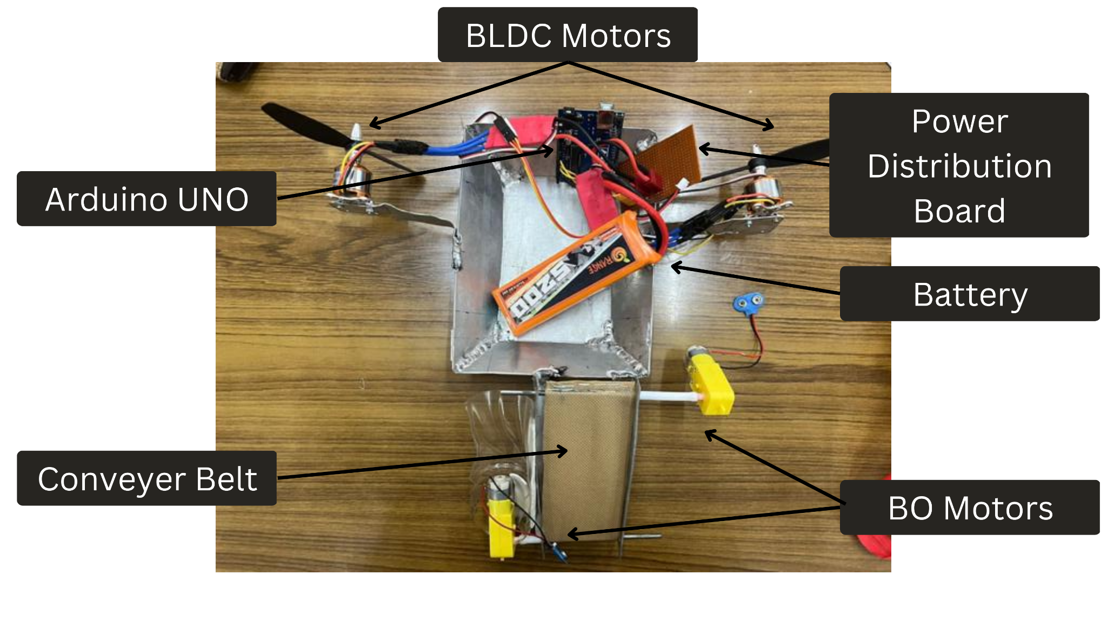

*Fig3. hardware implementation of the project*

*Fig 4. Output on the terminal when plastic is detected*

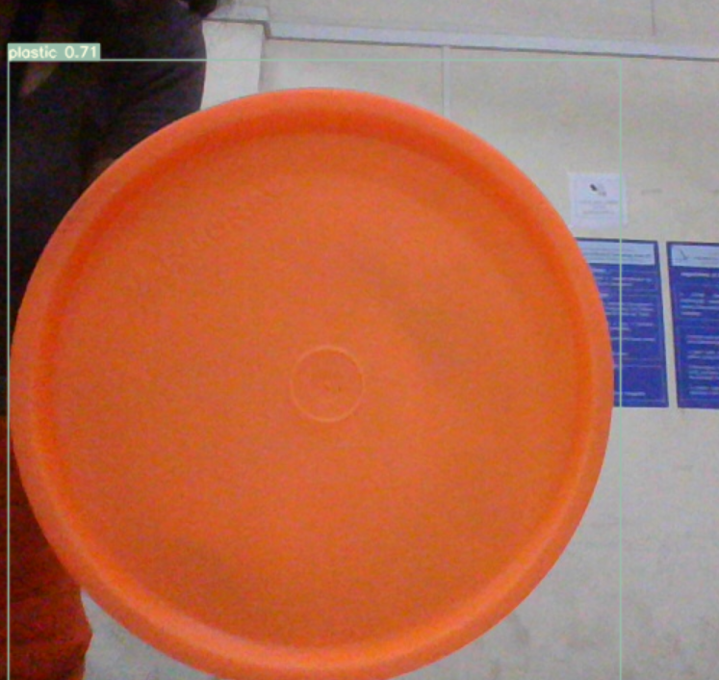

*Fig5. Detection of plastic box*

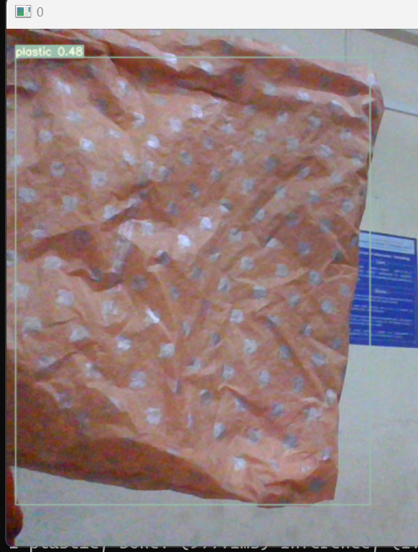

*Fig 6. Detection of plastic bag*

TABLE I. PERCENTAGE ACCURACY OF MODEL IN DIFFERENT SCENARIOS

|  |  |
| --- | --- |
| Item | Percentage accuracy according to model |
| Plastic box | 71% |
| Plastic bag | 48% |

**4. CONCLUSION**

The ability of a water trash collector prototype to gather rubbish on the water, float, and partially submerge in the water's surface was demonstrated in this study. Image processing was used to successfully regulate the forward, reverse, left and right turning of the water rubbish collector after numerous trial setups. It was able to gather up plastic bags and bottles successfully. The prototype may be enhanced further by employing high strength and waterproof materials for the collector body to eliminate the possibility of flooding. A self-sustaining solar panel may also power greater speed and torque DC motors.

**ACKNOWLEDGEMENT**

We would like to thank Prof. Anil Kadu for his guidance and valuable inputs given during the making of the project.

We are also thankful to Vishwakarma Institute of Technology for providing us with the necessary facilities to implement the project.

**REFERENCES**

[1] A. Christodoulou, P. Christidis, and B. Bisselink, “Forecasting the impacts of climate change on inland waterways,” *Transportation Research Part D-transport and Environment*, vol. 82, p. 102159, May 2020, doi: 10.1016/j.trd.2019.10.012.

[2] C. N. Weng, “Sustainable management of rivers in Malaysia: Involving all stakeholders,” *International Journal of River Basin Management*, vol. 3, no. 3, pp. 147–162, Sep. 2005, doi: 10.1080/15715124.2005.9635254.

[3] M. E. Toriman et al., “Integration of 1-d Hydrodynamic Model and GIS Approach in Flood Management Study in Malaysia,” *Research Journal of Earth Sciences*, vol. 1, no. 1, pp. 22–27, Jan. 2009.

[4] M. K. A. Kamarudin, M. E. Toriman, N. A. Wahab, H. Rosli, F. M. Ata, and M. H. M. Faudzi, “Sedimentation Study on Upstream Reach of Selected Rivers in Pahang River Basin, Malaysia,” *International Journal on Advanced Science, Engineering and Information Technology*, vol. 7, no. 1, p. 35, Feb. 2017, doi: 10.18517/ijaseit.7.1.971.

[5] R. Adhiharto and F. A. Komara, “Perancangan Konstruksi Trash Bucket Conveyor (TBC) Sebagai Mekanisme Pembersih Sampah Di Sungai,” *ResearchGate*, Aug. 2018.

[6] G. Khekare, U. Dhanre, G. T. Dhanre, and S. S. Yede, “Design of Optimized and Innovative Remotely Operated Machine for Water Surface Garbage Assortment,” *International Journal of Computer Sciences and Engineering*, vol. 7, no. 1, pp. 113–117, Jan. 2019, doi: 10.26438/ijcse/v7i1.113117.

[7] S. Huang *et al.*, “Plastic Waste Management Strategies and Their Environmental Aspects: A Scientometric Analysis and Comprehensive Review,” *International Journal of Environmental Research and Public Health*, vol. 19, no. 8, p. 4556, Apr. 2022, doi: 10.3390/ijerph19084556.

[8] H. Othman, M. I. Petra, L. C. De Silva, and F.-Y. Leu, “Automated trash collector design,” *Journal of Physics*, Jan. 2020, doi: 10.1088/1742-6596/1444/1/012040.

[9] A. H. A. Kader, M. K. M. Saleh, M. R. Jalal, O. O. Sulaiman, and W. N. W. Shamsuri, “Design of Rubbish Collecting System for Inland Waterways,” *Journal of Transport System Engineering*, vol. 2, no. 2, pp. 1–13, Sep. 2015.

[10] C. Balasuthagar, D. Shanmugam, and K. Vigneshwaran, “Design and fabrication of beach cleaning machine,” *IOP Conference Series*, Aug. 2020, doi: 10.1088/1757-899x/912/2/022048.

[11] S. Kong, M. Tian, C. Qiu, Z. Wu, and J. Yu, “IWSCR: An Intelligent Water Surface Cleaner Robot for Collecting Floating Garbage,” *IEEE Transactions on Systems, Man, and Cybernetics*, vol. 51, no. 10, pp. 6358–6368, Oct. 2021, doi: 10.1109/tsmc.2019.2961687.

[12] Lindquist and Adam, “Baltimore’s Mr. Trash Wheel,” *The Journal of Ocean Technology*, vol. 11, no. 2, pp. 28–35, 2016.

[13] C. Ranjan, S. Akhtar, D. Shaw, S. Nikhil, and B. R. S. Babu, *Design and demonstration of manual operated pedalo water boat for garbage collection from lake*. American Institute of Physics, 2019. doi: 10.1063/1.5141267.

[14] M. Geraeds, T. Van Emmerik, R. De Vries, and M. S. A. Razak, “Riverine Plastic Litter Monitoring Using Unmanned Aerial Vehicles (UAVs),” *Remote Sensing*, vol. 11, no. 17, p. 2045, Aug. 2019, doi: 10.3390/rs11172045.

[15] Z. Sakawi, “MUNICIPAL SOLID WASTE MANAGEMENT IN MALAYSIA: SOLUTION FOR SUSTAINABLE WASTE MANAGEMENT,” *Journal of Applied Sciences in Environmental Sanitation*, vol. 6, no. 1, pp. 29–38, Mar. 2011.

[16] M. N. Mohammed, S. Al-Zubaidi, S. H. K. Bahrain, M. Zaenudin, and M. Abdullah, *Design and Development of River Cleaning Robot Using IoT Technology*. 2020. doi: 10.1109/cspa48992.2020.9068718.

[17] A. Sinha, P. Bhardwaj, B. Vaibhav, and N. Mohommad, *Research and development of Ro-boat: an autonomous river cleaning robot*. SPIE, 2014. doi: 10.1117/12.2037898.

[18] K. B, S. M. Raghavendran, S. Kalyani, P. Suja, and V. K. G. Kalaiselvi, *Internet of Bins: Trash Management in India*. 2017. doi: 10.1109/iccct2.2017.7972277.

[19] N. Ruangpayoongsak, J. Sumroengrit, and M. Leanglum, *A floating waste scooper robot on water surface*. 2017. doi: 10.23919/iccas.2017.8204234.

[20] A. Jaywant and A. Sapkal, “Aqua Skimmer for Trash Collection,” *International Journal of Applied Engineering Research*, vol. 13, no. 5, pp. 5–8.