FUNCTIONAL REQUIREMENTS DOCUMENT
Project: DeliverEats – Food Delivery App
Author: Anandu Priyakumar
Version: 1.1 (revised)
Date: 5 November 2026

This is a simulated Business Analyst portfolio project. No real stakeholders, sign-offs, systems or test executions are involved.

Version History
Version | Date | Revised By | Reason for Change
1.0 | 28-07-2025 | Anandu Priyakumar | Initial FRD aligned with BRD v1.0.
1.1 | 05-11-2026 | Anandu Priyakumar | Revision aligned with BRD v1.1: MVP scope, status models, traceability, UAT status (see change summary).

Revision 1.1 Change Summary
- MVP scope aligned: live GPS tracking, push notifications and the admin dashboard moved to future enhancements (FE-01 to FE-03); real-time tracking replaced by order status milestones.
- Availability target aligned at 99.5% per month in both documents (BRD previously 95%).
- Cash on Delivery decision recorded: not supported in the MVP (RULE-08); checkout wireframe updated.
- Payment status and order status separated into two enumerations with an explicit order lifecycle.
- Rejected orders and failed payments defined: automatic payment reversal (FR-11, UC-14) added; complaints, manual refunds and ratings moved to future enhancements.
- UAT scenarios restated as 'Planned (not executed)' and expanded to 10 scenarios with test cases.
- Traceability repaired: every BR maps to FRs, use cases and UAT scenarios; FR-11 no longer shared by unrelated use cases.
- Fictional-celebrity approvers replaced with role-based simulated approvals, clearly labelled as simulated.
- Terminology standardised: real-time, third-party, As-Is, To-Be, Cash on Delivery.
- Added: in-scope delivery partner wireframe, OTP SMS gateway on the context diagram, business-use-case IDs (BUC-xx).

Document Approvals (Simulated)
All approvals below are simulated for the purpose of this portfolio project. They are role placeholders, not real stakeholder sign-offs.
Approver | Project Role | Approval Type | Date
Anandu Priyakumar | Business Analyst (Author) | Author sign-off | 05-11-2026
Mock Project Manager | Project Manager | Simulated approval (portfolio exercise) | 05-11-2026
Mock Product Owner | Product Owner (Restaurant side) | Simulated approval (portfolio exercise) | 05-11-2026
Mock Technical Lead | Technical Lead | Simulated approval (portfolio exercise) | 05-11-2026
Mock Project Sponsor | Project Sponsor | Simulated approval (portfolio exercise) | 05-11-2026

Following simulated approval, changes to this FRD would be governed by the project's change management process (impact analysis, review and approval).

Contents
1. Introduction
2. Project Scope
3. Functional Objectives / Prioritisation
4. Context Model and System Overview
5. Use Case Model
6. Functional Requirements
7. Data Requirements
8. Non-Functional Requirements
9. Assumptions and Constraints
10. Requirements Traceability Matrix
11. User Acceptance Testing (planned)
12. Glossary
13. Appendices (Wireframes, Activity Diagram, BRD reference)

1. Introduction

1.1 Purpose
This FRD defines the functional and non-functional specifications of the DeliverEats MVP, derived from BRD v1.1. It is written for developers, testers, UI/UX designers, solution architects and stakeholders.

1.2 Summary
DeliverEats lets customers browse restaurants, order, pay online and follow order status milestones; restaurants accept or reject and prepare orders; delivery partners collect and deliver them.

1.3 Background
Many local restaurants still take orders by phone and cash, leading to errors and inefficiency. DeliverEats provides one digital workflow for all parties and leaves room for later enhancements such as live GPS tracking, push notifications and an admin dashboard.

2. Project Scope

2.1 In-Scope (MVP)
- Registration with mobile/email and OTP; secure login for customers, restaurants and delivery partners
- Restaurant browsing and digital menus
- Cart and order placement
- Online payment through a payment gateway (Google Pay, Paytm) with automatic reversal on rejection or time-out
- Restaurant order management
- Delivery partner module: accept, pick up, deliver
- Order status milestones for customers
- In-app messages for payment failure and order rejection

2.2 Future Enhancements (not in MVP)
ID | Enhancement | Description
FE-01 | Live GPS order tracking | Map-based live location of the delivery partner (replaces status milestones).
FE-02 | Push notifications | Push alerts to customers, restaurants and delivery partners (MVP uses in-app messages and OTP SMS only).
FE-03 | Central admin dashboard | Admin UI for user management, platform monitoring, complaint handling and reports (MVP uses back-end tools run by the technical team).
FE-04 | Complaint handling and manual refunds | Customer complaints, admin review and manually issued refunds.
FE-05 | Ratings and reviews | Customers rate restaurants and delivery.
FE-06 | Cash on Delivery | Cash payment at the door. Excluded because RULE-02 requires successful payment before the order reaches the restaurant.

2.3 Out-of-Scope
- Loyalty and referral programmes
- Multiple-city delivery support
- Restaurant payroll or HR management
- Voice-based or AI ordering
- In-app chat between customers and delivery partners
- Integration with restaurant inventory systems

3. Functional Objectives / Prioritisation (MoSCoW)
Objective | MoSCoW | Description
Customer registration and secure login | Must | Access control for customers, restaurants and delivery partners
Browse restaurants and menus | Must | Discovery and selection of food
Cart and order placement | Must | Core ordering workflow
Secure online payment, with automatic reversal | Must | Digital transactions; protects customers when orders are rejected
Restaurant accept/reject and preparation status | Must | Restaurant-side control of the workflow
Delivery partner accept, pick up, deliver | Must | Without it no order can be fulfilled
Order status milestones for customers | Should | Transparency without live GPS
In-app payment-failure and rejection messages | Should | Keeps users informed
Live GPS tracking, push notifications, admin dashboard, complaints and refunds, ratings, Cash on Delivery | Won't (this release) | Future enhancements FE-01 to FE-06
Loyalty / referral programme | Won't | Out of scope

4. Context Model and System Overview

4.1 System Context Diagram
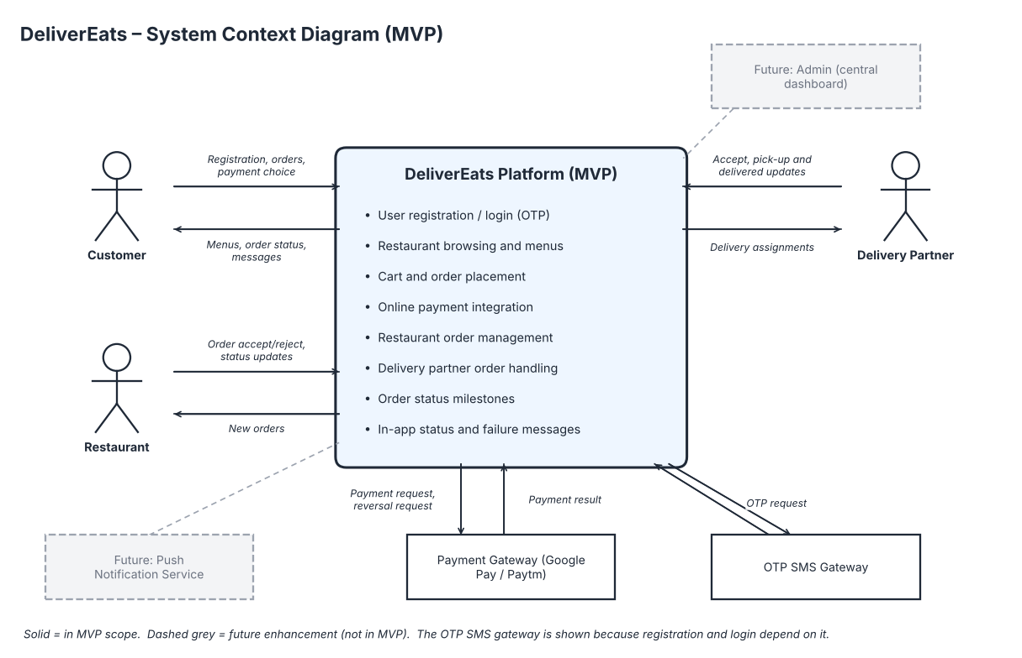
Figure 4.1 – System context (MVP)

4.2 External Interfaces
Interface | Type | Description | Phase
OTP SMS Gateway | Third-party API | Sends one-time passwords during registration (and login recovery). | MVP
Payment Gateway | Third-party payment API | Processes online payments (Google Pay, Paytm) and payment reversals. | MVP
Push Notification Service | Third-party API | Push alerts to customers, restaurants and delivery partners. | Future (FE-02)

In the MVP, status and failure messages are shown in-app; only OTP SMS is sent outside the app.

5. Use Case Model

5.1 Use Case Diagram
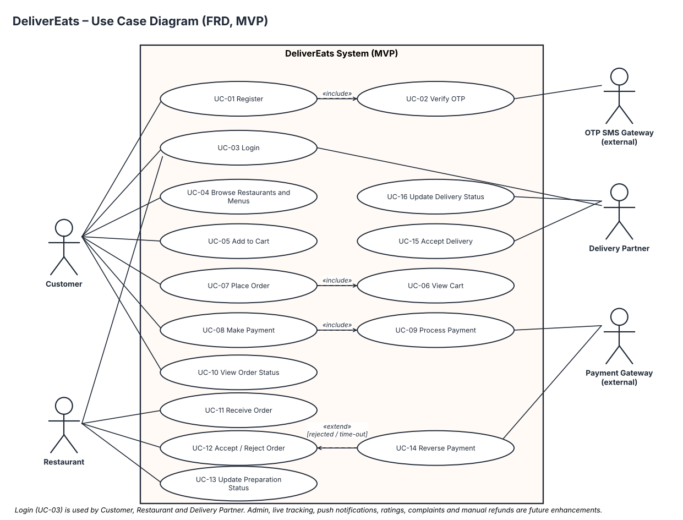
Figure 5.1 – Use cases (MVP)

5.2 Use Case Narratives
UC ID | Use Case | Actors | Preconditions | Postconditions | Flow | FRs | BUC
UC-01 | Register | Customer | App installed, internet access | Account created | Enter details > request OTP > verify OTP > account created | FR-01 | BUC-01
UC-02 | Verify OTP | Customer, OTP SMS Gateway | Registration started | OTP validated | System requests OTP send > user enters OTP > system validates | FR-01 | BUC-01
UC-03 | Login | Customer, Restaurant, Delivery Partner | Registered account | Access granted | Enter credentials > authenticate > access granted | FR-02 | BUC-02
UC-04 | Browse Restaurants and Menus | Customer | Logged in | Menu displayed | Browse list > select restaurant > view menu | FR-03 | BUC-03
UC-05 | Add to Cart | Customer | Logged in, menu displayed | Items stored in cart | Select item > add to cart | FR-04 | BUC-04
UC-06 | View Cart | Customer | Items in cart | Cart contents displayed | Open cart > view items, quantities, total > edit | FR-04 | BUC-04
UC-07 | Place Order | Customer | Cart not empty | Order created (Pending Payment) | Review cart > enter address > choose payment method > place order | FR-05 | BUC-05
UC-08 | Make Payment | Customer | Order created | Payment successful or failed | Pay via Google Pay/Paytm > await result > retry or cancel on failure | FR-06, FR-10 | BUC-06
UC-09 | Process Payment | Payment Gateway | Payment requested | Payment result returned | Receive request > process > return result | FR-06 | BUC-06
UC-10 | View Order Status | Customer | Order placed | Current milestone displayed | Open order > view status milestone | FR-09, FR-10 | BUC-07
UC-11 | Receive Order | Restaurant | Payment successful | Order visible on dashboard | Order appears with items, customer, amount | FR-07 | BUC-08
UC-12 | Accept / Reject Order | Restaurant | Order received | Order Accepted or Rejected | Open order > accept or reject (auto-reject after 5 min) | FR-07, FR-11 | BUC-08
UC-13 | Update Preparation Status | Restaurant | Order accepted | Status Preparing / Ready for pickup | Select order > update status | FR-07 | BUC-08
UC-14 | Reverse Payment | Payment Gateway | Order rejected or timed out | Payment status Refunded | System sends reversal request > gateway reverses > status updated | FR-11 | BUC-06, BUC-08
UC-15 | Accept Delivery | Delivery Partner | Order assigned | Order picked up | View assignment > accept > confirm pickup | FR-08 | BUC-09
UC-16 | Update Delivery Status | Delivery Partner | Order picked up | Status Delivered | After delivery > tap Delivered > system updates status | FR-08 | BUC-09

6. Functional Requirements
Each functional requirement traces to a business requirement in BRD v1.1 and to the use cases that realise it.
FR ID | Description | Priority | Supports BR | Use Cases
FR-01 | The system shall allow customers to register with mobile number and email, verified by an OTP sent through the OTP SMS gateway. | High | BR-01 | UC-01, UC-02
FR-02 | The system shall allow secure login for customers, restaurants and delivery partners. | High | BR-01 | UC-03
FR-03 | The system shall allow customers to browse restaurants and view their menus. | High | BR-02 | UC-04
FR-04 | The system shall allow customers to add menu items to a cart and view or edit the cart. | High | BR-03 | UC-05, UC-06
FR-05 | The system shall allow customers to submit an order from the cart with a delivery address and a payment method. | High | BR-03 | UC-07
FR-06 | The system shall process payment through the payment gateway (Google Pay, Paytm). The order shall be sent to the restaurant only after payment succeeds. On failure the customer shall be able to retry or cancel. | High | BR-04 | UC-08, UC-09
FR-07 | The system shall allow restaurants to view incoming orders, accept or reject them within 5 minutes (auto-reject on time-out) and update preparation status (Preparing, Ready for pickup). | High | BR-05 | UC-11, UC-12, UC-13
FR-08 | The system shall assign accepted orders to an available delivery partner and allow the partner to accept, mark Picked up and mark Delivered. | Medium | BR-06 | UC-15, UC-16
FR-09 | The system shall allow customers to view the current order status milestone (Placed, Accepted, Preparing, Ready for pickup, Picked up, Delivered). | Medium | BR-07 | UC-10
FR-10 | The system shall show in-app messages to the user on payment failure and on order rejection. | Medium | BR-08, BR-07 | UC-08, UC-10
FR-11 | The system shall automatically request a full payment reversal through the payment gateway when an order is rejected or times out. | High | BR-04, BR-05 | UC-12, UC-14

6.1 Business Rules Applied
Rule ID | Description
RULE-01 | Users must register with a valid mobile number and email, verified by OTP.
RULE-02 | Payment must be successfully processed before the order is sent to the restaurant.
RULE-03 | The system must immediately show an in-app message on payment failure or order rejection.
RULE-04 | Customers must be able to view the status milestone of their active orders in the app.
RULE-05 | A delivery partner must handle no more than one active delivery at a time.
RULE-06 | A restaurant must accept or reject an order within 5 minutes; otherwise the order is automatically rejected.
RULE-07 | When an order is rejected or times out, the full payment is automatically reversed to the original payment method.
RULE-08 | Only online payment methods (Google Pay, Paytm) are supported in the MVP. Cash on Delivery is not supported.

7. Data Requirements
MVP-level data elements, with validation rules. Payment status and order status are separate fields.
Field | Description | Type | Validation | Mandatory
Full Name | Customer's full name | Text | Letters and spaces only, max 50 characters | Y
Email Address | Unique email address | Email | Valid email format, no duplicates | Y
Mobile Number | Contact number used for OTP | Numeric (10 digits) | Exactly 10 digits, numerals only | Y
Password | Login password (stored as salted hash) | Hashed text | Min 8 characters with at least 1 uppercase letter, 1 number and 1 symbol | Y
Delivery Address | Delivery location entered by customer | Text | Max 200 characters | Y
Order ID | Unique identifier for each order | Alphanumeric (UUID) | System-generated | Y
Order Total | Total amount payable (INR) | Decimal | Greater than 0, 2 decimal places | Y
Payment Method | Method selected for payment | Enum | Google Pay, Paytm | Y
Payment Status | Status of the payment transaction | Enum | Pending, Successful, Failed, Refunded | Y
Order Status | Current lifecycle status of the order | Enum | Pending Payment, Placed, Accepted, Preparing, Ready for Pickup, Picked Up, Delivered, Rejected, Cancelled | Y
Restaurant ID | Restaurant fulfilling the order | Alphanumeric | System-generated | Y
Menu Item ID | Unique identifier for each menu item | Alphanumeric | System-generated | Y
User Role | Role of the logged-in user | Enum | Customer, Restaurant, Delivery Partner | Y

7.1 Order Lifecycle and Status Model
Payment Status values: Pending, Successful, Failed, Refunded. Order Status values and their usual payment status are:
Order Status | Payment Status | Meaning
Pending Payment | Pending | Order created; awaiting payment result. Restaurant cannot see it yet.
Placed | Successful | Payment succeeded; order sent to the restaurant.
Accepted | Successful | Restaurant accepted within 5 minutes.
Preparing | Successful | Restaurant is preparing the food.
Ready for Pickup | Successful | Food is ready; delivery partner assigned.
Picked Up | Successful | Delivery partner has collected the order.
Delivered | Successful | Delivery partner marked the order delivered.
Rejected | Refunded | Restaurant rejected the order or 5 minutes elapsed; payment reversed automatically (FR-11).
Cancelled | Failed | Customer cancelled after a failed payment; no money taken.

Key transitions: Pending Payment > Placed (payment succeeds) | Pending Payment > Cancelled (payment fails and customer cancels) | Placed > Accepted | Placed > Rejected (rejected or 5-minute time-out, payment Refunded) | Accepted > Preparing > Ready for Pickup > Picked Up > Delivered.

8. Non-Functional Requirements
NFR ID | Category | Requirement
NFR-01 | Performance | The system must respond to user actions within 2 seconds under normal load.
NFR-02 | Availability | The platform must achieve at least 99.5% availability per calendar month, excluding planned downtime (about 3.6 hours of unplanned downtime per 30-day month).
NFR-03 | Usability | The user interface must support intuitive navigation with a minimal learning curve for all user roles.
NFR-04 | Security | Sensitive data must be encrypted in transit (TLS) and at rest. Passwords must be stored as salted hashes, never in plain text.
NFR-05 | Maintainability | The platform must be modular so updates and fixes can be deployed with minimal disruption.
NFR-06 | Scalability | The system must be able to scale to a 5x increase in users with minimal performance degradation after the MVP.
NFR-07 | Compatibility | The app must support Android 10 and above. iOS (13+) may be considered in future releases.
NFR-08 | Backup & Recovery | Transactional data must be backed up every 24 hours and recoverable within 2 hours of a failure.
NFR-09 | Payment security | No card or UPI credentials are stored by DeliverEats; all payment data is handled by the third-party payment gateway.

9. Assumptions and Constraints

9.1 Assumptions
- Users have smartphones and stable internet.
- Restaurant partners will adopt the digital order management system.
- Delivery partners are available in the initial service area during operating hours.
- Third-party payment and SMS services work as intended without major integration issues.
- No legal or regulatory restriction blocks digital orders or payments in the launch region.
- Stakeholders give timely feedback during requirement finalisation and UAT.
- Basic administration is done by the technical team with back-end tools until FE-03 is built.

9.2 Constraints
- MVP supports one city or region.
- Only Android 10+ is supported in the first release.
- English only for the MVP.
- Budget and time exclude: loyalty, in-app chat, voice/AI ordering, multi-city support, inventory integration, live tracking, push notifications and the admin dashboard.
- No custom payment module; third-party gateways only.
- No marketing automation, CRM or accounting integration in the MVP.

10. Requirements Traceability Matrix (RTM)
BR > FR > Use Case > UAT scenario. The standalone RTM spreadsheet is in 05_requirements_analysis.
BR ID | Business Requirement | FR ID(s) | Use Cases | UAT
BR-01 | Customers must be able to register and log in to the DeliverEats app. Restaurants and delivery partners must be able to log in. | FR-01, FR-02 | UC-01, UC-02, UC-03 | UAT-01, UAT-02
BR-02 | Customers must be able to browse restaurants and view digital menus. | FR-03 | UC-04 | UAT-03
BR-03 | Customers must be able to build a cart and place food orders through the app. | FR-04, FR-05 | UC-05, UC-06, UC-07 | UAT-04, UAT-05
BR-04 | Customers must be able to pay securely online (Google Pay, Paytm). Payment must be returned automatically if an order is rejected or times out. | FR-06, FR-11 | UC-08, UC-09, UC-12, UC-14 | UAT-05, UAT-06, UAT-08
BR-05 | Restaurants must be able to receive, accept or reject incoming orders and update preparation progress. | FR-07, FR-11 | UC-11, UC-12, UC-13, UC-14 | UAT-07, UAT-08
BR-06 | Delivery partners must receive order assignments and update the delivery status. | FR-08 | UC-15, UC-16 | UAT-09
BR-07 | Customers must be able to view the status of their orders in the app (status milestones). | FR-09, FR-10 | UC-08, UC-10 | UAT-10
BR-08 | The platform must inform users in-app of payment failures and order rejections. | FR-10 | UC-08, UC-10 | UAT-06, UAT-08, UAT-10

11. User Acceptance Testing (UAT) – Planned
These are planned test scenarios. No tests have been executed because no working application exists; detailed test cases and a results tracker are in 06_testing.
UAT ID | Test Objective | Related FR | Acceptance Criteria | Status
UAT-01 | Register with mobile/email and verify OTP | FR-01 | Account is created; user is able to log in. Invalid OTP shows an error and does not create the account. | Planned (not executed)
UAT-02 | Login for each role | FR-02 | Valid credentials open the role's home screen; invalid credentials show an error and deny access. | Planned (not executed)
UAT-03 | Browse restaurants and view menu | FR-03 | Restaurant list is displayed; selecting a restaurant shows its menu categories and items with prices. | Planned (not executed)
UAT-04 | Add, edit and view cart | FR-04 | Cart shows correct items, quantities and total after each change. | Planned (not executed)
UAT-05 | Place order with successful payment | FR-05, FR-06 | Payment status Successful; order status Placed; order appears on the restaurant dashboard; Cash on Delivery is not offered. | Planned (not executed)
UAT-06 | Failed payment: retry or cancel | FR-06, FR-10 | In-app 'Payment failed' message is shown; order is not sent to the restaurant; retry re-attempts payment; cancel sets order to Cancelled. | Planned (not executed)
UAT-07 | Restaurant accepts order and updates preparation | FR-07 | Order status moves Accepted > Preparing > Ready for Pickup and each change is visible to the customer. | Planned (not executed)
UAT-08 | Order rejected or timed out with automatic payment reversal | FR-07, FR-10, FR-11 | Both orders become Rejected; payment status becomes Refunded; customer sees an in-app rejection message. | Planned (not executed)
UAT-09 | Delivery partner accepts, picks up and delivers | FR-08 | Statuses update to Picked Up and Delivered; a partner cannot hold more than one active delivery. | Planned (not executed)
UAT-10 | Customer views order status milestones | FR-09, FR-10 | Milestones Placed to Delivered display correctly with the current step highlighted; no live map is shown. | Planned (not executed)

12. Glossary
Term | Definition
FRD | Functional Requirements Document.
BRD | Business Requirements Document.
MVP | Minimum Viable Product, the first functional release.
OTP | One-Time Password used to verify identity at registration.
UAT | User Acceptance Testing: validation that the system meets business requirements.
Use Case | A scenario describing how an actor uses the system to reach a goal.
Cart | A temporary container for menu items chosen before ordering.
Delivery Partner | A person who collects food orders and delivers them to customers.
Order status milestone | A named step in the order lifecycle shown to the customer.
Payment reversal | Automatic return of payment when an order is rejected or times out.
Payment Gateway | A third-party service (e.g. Google Pay, Paytm) that processes online payments.
Restaurant Dashboard | The restaurant's interface for viewing and managing orders and menus.
System Context Diagram | A high-level view of the system and its external actors and systems.
Future enhancement | A feature excluded from the MVP and held in the future-enhancements backlog.

13. Appendices
Appendix | Title | Description
A | Wireframes | Seven MVP screens: login/registration, restaurant list and menu, cart and checkout, payment, order status, restaurant dashboard, delivery partner.
B | UML System Activity Diagram | End-to-end order lifecycle across system components.
C | BRD v1.1 Reference | Source business requirements document.

13.1 Appendix A – Wireframes
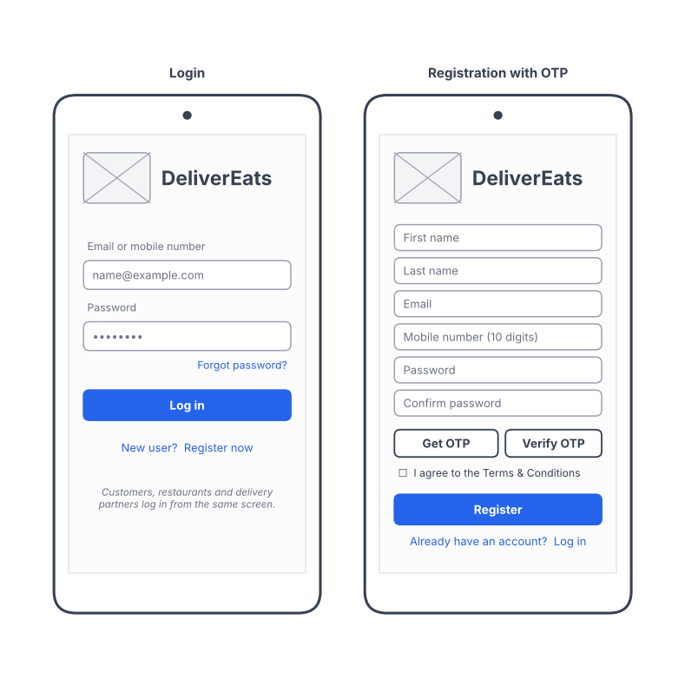
A.1 Login and registration
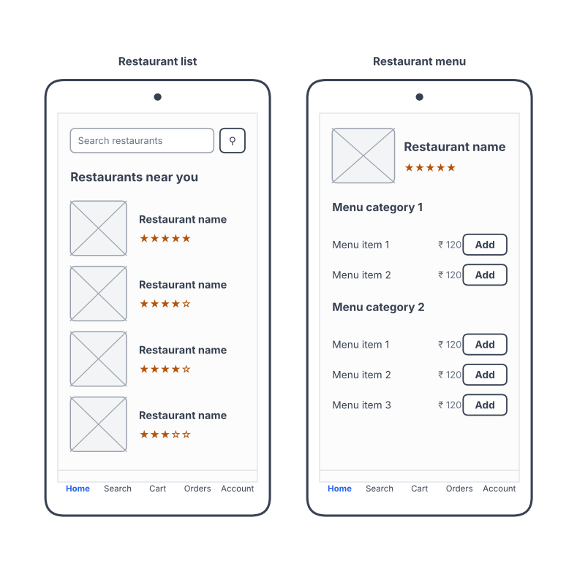
A.2 Restaurant list and menu

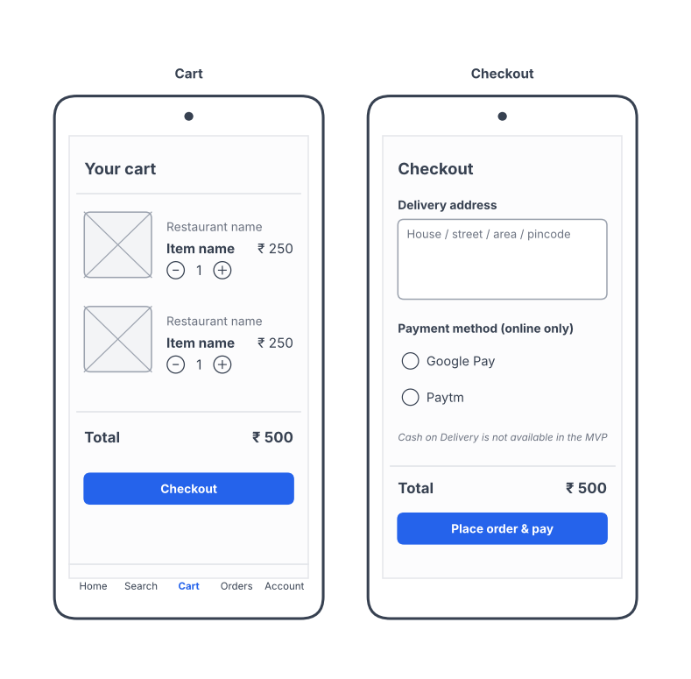
A.3 Cart and checkout (online payment only)
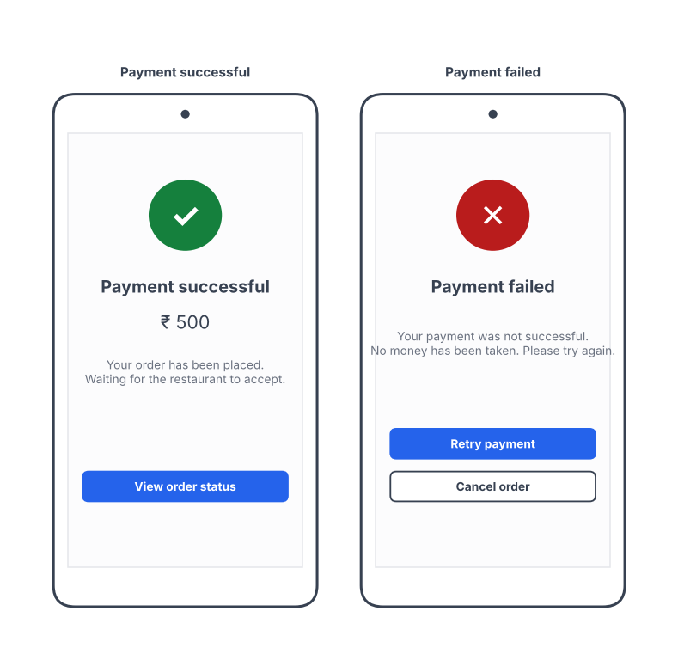
A.4 Payment success and failure

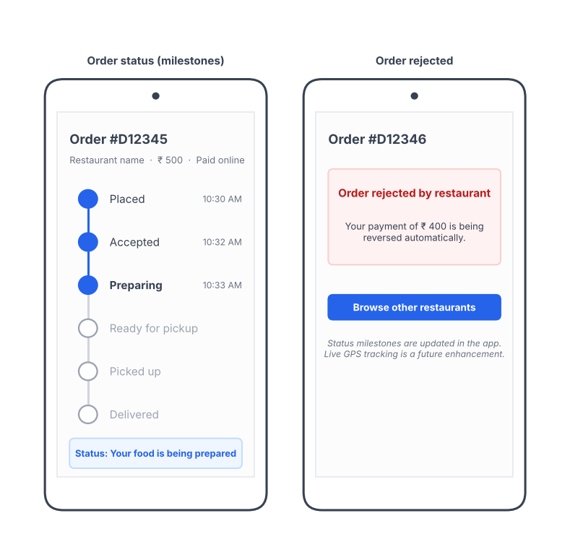
A.5 Order status milestones (live GPS map is a future enhancement)
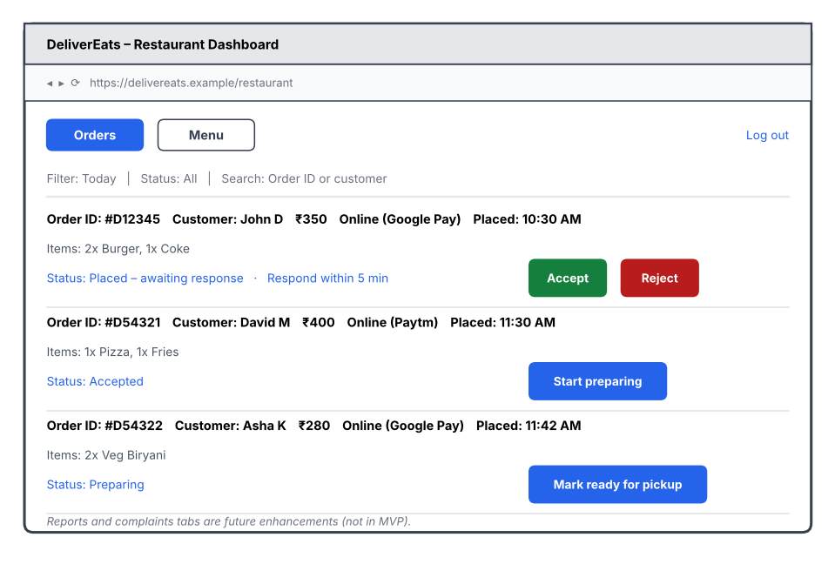
A.6 Restaurant dashboard (accept/reject and preparation status)

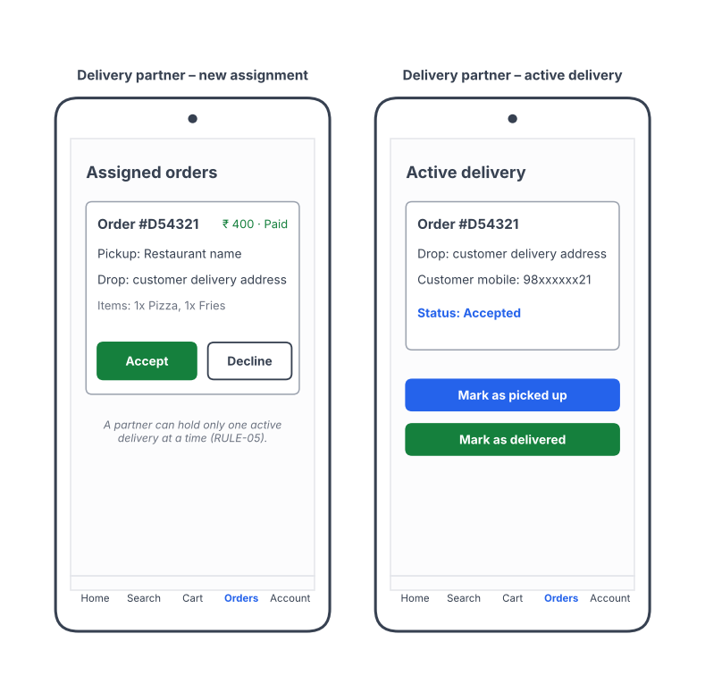
A.7 Delivery partner screens

13.2 Appendix B – UML System Activity Diagram
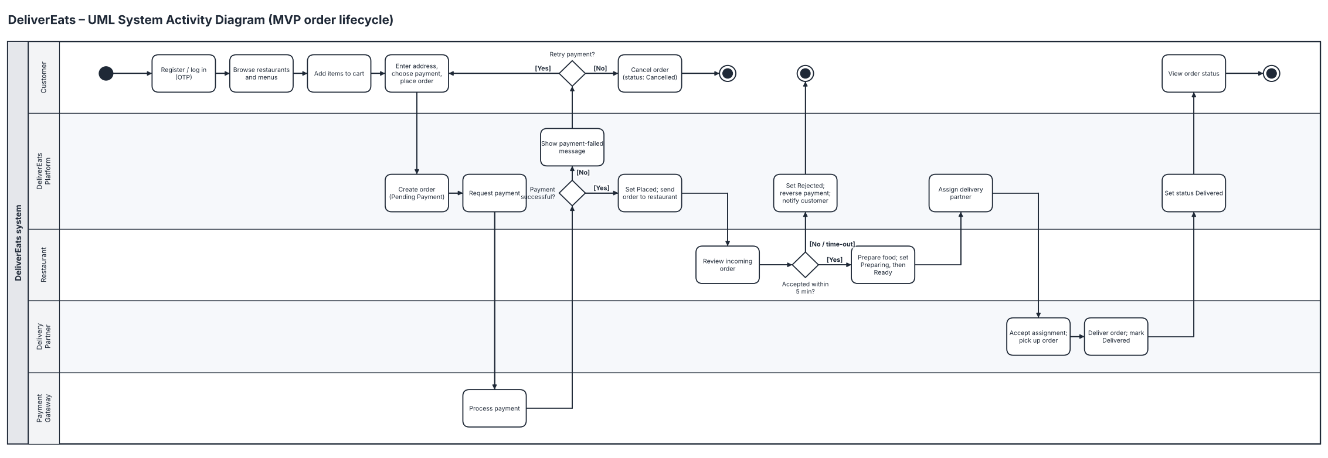
Figure B1 – MVP order lifecycle

13.3 Appendix C – BRD v1.1 Reference
See DeliverEats_BRD_v1.1.pdf in 01_requirements/BRD, which contains the business requirements referenced throughout this FRD.

