BUSINESS REQUIREMENTS DOCUMENT
Project: DeliverEats – Food Delivery App
Author: Anandu Priyakumar
Version: 1.1 (revised)
Date: 5 November 2026

This is a simulated Business Analyst portfolio project. No real stakeholders, sign-offs, systems or test executions are involved.

Version History
Version | Date | Revised By | Reason for Change
1.0 | 19-07-2025 | Anandu Priyakumar | Initial BRD for the DeliverEats mock project.
1.1 | 05-11-2026 | Anandu Priyakumar | Revision for consistency: MVP scope aligned, KPIs clarified, approvals marked as simulated (see change summary).

Revision 1.1 Change Summary
- MVP scope aligned: live GPS tracking, push notifications and the admin dashboard moved to future enhancements (FE-01 to FE-03); real-time tracking replaced by order status milestones.
- Availability target aligned at 99.5% per month in both documents (BRD previously 95%).
- Cash on Delivery decision recorded: not supported in the MVP (RULE-08); checkout wireframe updated.
- Payment status and order status separated into two enumerations with an explicit order lifecycle.
- Rejected orders and failed payments defined: automatic payment reversal (FR-11, UC-14) added; complaints, manual refunds and ratings moved to future enhancements.
- UAT scenarios restated as 'Planned (not executed)' and expanded to 10 scenarios with test cases.
- Traceability repaired: every BR maps to FRs, use cases and UAT scenarios; FR-11 no longer shared by unrelated use cases.
- Fictional-celebrity approvers replaced with role-based simulated approvals, clearly labelled as simulated.
- Terminology standardised: real-time, third-party, As-Is, To-Be, Cash on Delivery.
- Added: in-scope delivery partner wireframe, OTP SMS gateway on the context diagram, business-use-case IDs (BUC-xx).

Document Approvals (Simulated)
All approvals below are simulated for the purpose of this portfolio project. They are role placeholders, not real stakeholder sign-offs.
Approver | Project Role | Approval Type | Date
Anandu Priyakumar | Business Analyst (Author) | Author sign-off | 05-11-2026
Mock Project Sponsor | Project Sponsor | Simulated approval (portfolio exercise) | 05-11-2026
Mock Product Owner | Product Owner (Restaurant side) | Simulated approval (portfolio exercise) | 05-11-2026
Mock Technical Lead | Technical Lead | Simulated approval (portfolio exercise) | 05-11-2026

Following simulated approval, changes to this BRD would be governed by the project's change management process (impact analysis, review and approval).

Contents
1. Introduction
2. Executive Summary
3. Purpose and Background
4. Business Objectives
5. Project Scope (MVP and future enhancements)
6. Stakeholders
7. Business Requirements
8. Dependencies
9. High-Level Use Cases
10. Business Rules
11. Assumptions and Constraints
12. Risk and Mitigation
13. Success Criteria (KPIs)
14. Appendices (Glossary, As-Is, To-Be, Use Case Diagram)

1. Introduction
This Business Requirements Document (BRD) defines the business requirements for DeliverEats, a proposed online food delivery application that replaces the manual ordering still used by many local restaurants. The platform connects customers, restaurants and delivery partners through one app.
The document covers business objectives, scope, stakeholders, high-level use cases, business rules, assumptions, constraints, risks and success criteria. Supporting artefacts include As-Is and To-Be BPMN 2.0 diagrams and a high-level use case diagram. It is the input to the Functional Requirements Document (FRD).

2. Executive Summary
In many small and mid-sized restaurants, phone orders and cash payments cause delays, mistakes and poor customer experiences. DeliverEats will deliver a single app where customers browse menus, place orders, pay securely online and follow their order through status milestones, while restaurants manage incoming orders and delivery partners fulfil deliveries.
The MVP is deliberately focused. Live GPS tracking, push notifications, the central admin dashboard, complaint handling and refunds, and ratings are recorded as future enhancements and are not part of the MVP (see section 5).

3. Purpose and Background
This document records the business needs that the DeliverEats MVP must satisfy and the boundaries within which it will be built. It gives stakeholders a shared baseline before detailed functional specification begins.

4. Business Objectives
The following are proposed targets. They have not been achieved or measured, because DeliverEats is a simulated project.
- Launch a Minimum Viable Product of the DeliverEats platform within 3 months, covering restaurant browsing, digital menus, order placement, secure online payment, restaurant and delivery handling, and order status milestones.
- Partner with at least 10 local restaurants during the first phase so the app offers enough food variety by go-live.
- Reduce order-related issues (delays, miscommunications, inaccuracies) by at least 50% within 3 months of launch, measured per 100 orders against a baseline taken from pilot restaurants' manual records.
- Ensure all orders are paid through secure online methods, with at least 90% of payment attempts succeeding within 2 months of rollout.
- Maintain at least 99.5% platform availability per calendar month during the first 3 months after launch.

5. Project Scope

5.1 In-Scope (MVP)
- Customer registration (OTP verified) and login; login for restaurants and delivery partners
- Restaurant browsing and digital menus
- Cart and order placement
- Online payment (Google Pay, Paytm) including automatic payment reversal for rejected or timed-out orders
- Restaurant order management: accept/reject and preparation status
- Delivery partner assignment and status updates
- Order status milestones visible to the customer
- In-app messages for payment failure and order rejection

5.2 Future Enhancements (not in MVP)
ID | Enhancement | Description | Note
FE-01 | Live GPS order tracking | Map-based live location of the delivery partner (replaces status milestones). | Formerly BR-07 / FR-09 'real-time tracking'
FE-02 | Push notifications | Push alerts to customers, restaurants and delivery partners (MVP uses in-app messages and OTP SMS only). | Formerly BR-09 / FR-11
FE-03 | Central admin dashboard | Admin UI for user management, platform monitoring, complaint handling and reports (MVP uses back-end tools run by the technical team). | Formerly BR-08 / FR-10, UC-16, UC-17
FE-04 | Complaint handling and manual refunds | Customer complaints, admin review and manually issued refunds. | Formerly UC-18, UC-19
FE-05 | Ratings and reviews | Customers rate restaurants and delivery. | Formerly UC-10 'Rate Delivery'
FE-06 | Cash on Delivery | Cash payment at the door. Excluded because RULE-02 requires successful payment before the order reaches the restaurant. | Appeared in v1.0 checkout wireframe only

5.3 Out-of-Scope
- Loyalty and referral programmes
- Multiple-city delivery support
- Restaurant payroll or HR management
- Voice-based or AI ordering
- In-app chat between customer and delivery partner
- Integration with restaurant inventory systems

6. Stakeholders
Stakeholder Role | Department | Responsibility
Project Sponsor | Executive Management | Provides funding and strategic direction.
Project Manager | Project Management Office | Plans, executes and monitors activities, timelines, resources and risks.
Product Owner | Business Operations | Represents restaurant needs, prioritises features and validates requirements.
Business Analyst | Business Analysis | Gathers requirements, defines scope, documents business needs and rules.
Technical Lead | Information Technology | Oversees technical feasibility, architecture and development.
UI/UX Designer | Product Design | Designs intuitive interfaces for all user roles.
QA / Test Lead | Information Technology | Ensures quality through testing and validation.
Platform Operations | Operations | Supports restaurants and delivery partners; uses back-end tools for user management in the MVP (no admin dashboard).

7. Business Requirements
ID | Requirement | Priority
BR-01 | Customers must be able to register and log in to the DeliverEats app. Restaurants and delivery partners must be able to log in. | High
BR-02 | Customers must be able to browse restaurants and view digital menus. | High
BR-03 | Customers must be able to build a cart and place food orders through the app. | High
BR-04 | Customers must be able to pay securely online (Google Pay, Paytm). Payment must be returned automatically if an order is rejected or times out. | High
BR-05 | Restaurants must be able to receive, accept or reject incoming orders and update preparation progress. | High
BR-06 | Delivery partners must receive order assignments and update the delivery status. | Medium
BR-07 | Customers must be able to view the status of their orders in the app (status milestones). | Medium
BR-08 | The platform must inform users in-app of payment failures and order rejections. | Medium

8. Dependencies
Dependency | Description | Owner / Responsible Party
Restaurant onboarding | Restaurants complete registration, menu setup and training before launch. | Business Analyst / Restaurant Team
Delivery partner availability | Delivery partners are confirmed and assigned before go-live. | Operations Lead / Logistics Team
Payment gateway integration | Google Pay and Paytm are integrated and tested, including payment reversal. | Tech Lead / Finance Team
OTP SMS provider | A third-party SMS provider is contracted and tested for OTP delivery. | Tech Lead
Marketing outreach | Promotional campaigns launch 1-2 weeks before go-live. | Marketing Manager
Smartphone / internet access | End users and partners have suitable devices and connectivity. | All teams (awareness)

9. High-Level Use Cases
Business use case IDs (BUC-xx) are used here. The FRD refines them into detailed use cases (UC-xx) and records the parent BUC for each.
ID | Use Case | Actors | Description | Supports
BUC-01 | Register | Customer | Create an account using mobile/email verified by OTP. | BR-01
BUC-02 | Login | Customer, Restaurant, Delivery Partner | Securely access the DeliverEats system. | BR-01
BUC-03 | Browse Restaurants and Menus | Customer | Explore restaurants and view their digital menus. | BR-02
BUC-04 | Add to Cart | Customer | Select items and add them to the cart before ordering. | BR-03
BUC-05 | Place Order | Customer | Submit a food order with delivery address and payment method. | BR-03
BUC-06 | Make Payment | Customer | Pay for the order online; failed payments can be retried or cancelled. | BR-04, BR-08
BUC-07 | View Order Status | Customer | See the current status milestone of an active order. | BR-07, BR-08
BUC-08 | Manage Orders | Restaurant | Receive, accept or reject orders and update preparation status. | BR-05
BUC-09 | Manage Deliveries | Delivery Partner | Accept assigned orders and update delivery status. | BR-06

10. Business Rules
Rule ID | Description
RULE-01 | Users must register with a valid mobile number and email, verified by OTP.
RULE-02 | Payment must be successfully processed before the order is sent to the restaurant.
RULE-03 | The system must immediately show an in-app message on payment failure or order rejection.
RULE-04 | Customers must be able to view the status milestone of their active orders in the app.
RULE-05 | A delivery partner must handle no more than one active delivery at a time.
RULE-06 | A restaurant must accept or reject an order within 5 minutes; otherwise the order is automatically rejected.
RULE-07 | When an order is rejected or times out, the full payment is automatically reversed to the original payment method.
RULE-08 | Only online payment methods (Google Pay, Paytm) are supported in the MVP. Cash on Delivery is not supported.

11. Assumptions and Constraints

11.1 Assumptions
- Target users have smartphones with internet connectivity.
- Restaurant partners are willing to adopt DeliverEats.
- Delivery partners are available in the launch area.
- Payments and OTP SMS are provided by third-party services (Google Pay, Paytm, an SMS provider).
- Basic platform administration in the MVP is done by the technical team with back-end tools.

11.2 Constraints
- Initial launch is limited to one city or geographic area.
- Only Android devices are supported in the first release.
- The interface and content are English only during the MVP.
- Budget and timeline limit advanced features (AI suggestions, voice ordering, live tracking, push notifications, admin dashboard).

12. Risk and Mitigation
Risk | Impact | Likelihood | Mitigation Strategy
Low onboarding of restaurant partners | High | Medium | Early outreach with clear benefits; backup list of restaurants; onboarding support.
Delivery partner unavailability in target areas | High | Medium | Partner with multiple delivery agencies; maintain a buffer pool of local delivery partners.
Payment gateway failure during transactions | High | Low | Support two gateways (Google Pay, Paytm); retry logic; failed payments never reach the restaurant (RULE-02).
Restaurant ignores or rejects order after payment | High | Medium | 5-minute auto-reject (RULE-06) with automatic payment reversal (RULE-07); monitor rejection rate.
Customers not adopting the app quickly | Medium | Medium | Limited-time discounts; local social media campaigns.
Limited admin visibility in the MVP (no dashboard) | Medium | Medium | Technical team runs scheduled back-end reports; admin dashboard planned as FE-03.
Customers expect live tracking | Medium | Medium | Show clear status milestones and expected timelines; live GPS planned as FE-01.
System downtime or performance issues during MVP | High | Low | Cloud monitoring against the 99.5% target; restrict MVP to one city and Android only.
Scope creep during MVP | Medium | Medium | Freeze scope in this BRD; defer enhancements to the future-enhancements backlog.

13. Success Criteria (KPIs)
Targets are proposals. The Result column shows 'Not measured' because no real launch has taken place.
KPI | Target and definition | Data Source | Reporting | Result
Platform release readiness | MVP live within 3 months | Project schedule tracker | Weekly | Not measured (simulated project)
Restaurant onboarding | At least 10 local restaurants onboarded | Onboarding system logs | Monthly | Not measured (simulated project)
Order issue reduction | At least 50% fewer order issues (delays, miscommunications, inaccuracies) per 100 orders vs. baseline from pilot restaurants' manual records | Customer helpdesk reports; restaurant manual order records (baseline) | Monthly | Not measured (simulated project)
Digital payment success rate | All orders paid online (COD not supported); at least 90% of payment attempts succeed within 2 months of rollout | Payment gateway statistics | Weekly | Not measured (simulated project)
System availability | At least 99.5% per calendar month (unplanned downtime / total minutes), measured every minute, excluding planned maintenance | Monitoring tool logs | Daily / weekly summaries | Not measured (simulated project)

14. Appendices

14.1 Appendix A – Glossary of Terms
Term | Definition
BRD | Business Requirements Document: formal statement of business needs, scope, requirements, assumptions, constraints and success metrics.
FRD | Functional Requirements Document: detailed functional specification developed from the BRD.
MVP | Minimum Viable Product: the first functional release containing only core features.
KPI | Key Performance Indicator: a measurable value used to judge whether objectives are met.
BPMN | Business Process Model and Notation: the standard notation for modelling business processes.
As-Is / To-Be | The current process (As-Is) and the intended future process (To-Be).
OTP | One-Time Password sent by SMS to verify a user's identity.
Order status milestone | A named step in the order lifecycle (Placed, Accepted, Preparing, Ready for pickup, Picked up, Delivered) shown to the customer.
Payment reversal | Automatic return of a successful payment to the customer when an order is rejected or times out.
Cash on Delivery (COD) | Payment in cash at the door. Not supported in the MVP.
Future enhancement | A feature deliberately excluded from the MVP and recorded in the future-enhancements backlog.
Third-party | A service provided by an external company, e.g. the payment gateway or SMS provider.
Platform Operations | The team supporting restaurants, delivery partners and users, using back-end tools in the MVP.

14.2 Appendix B – As-Is Process Diagram (BPMN 2.0)
The current manual process of ordering and delivery in local restaurants, with numbered pain points that DeliverEats addresses.
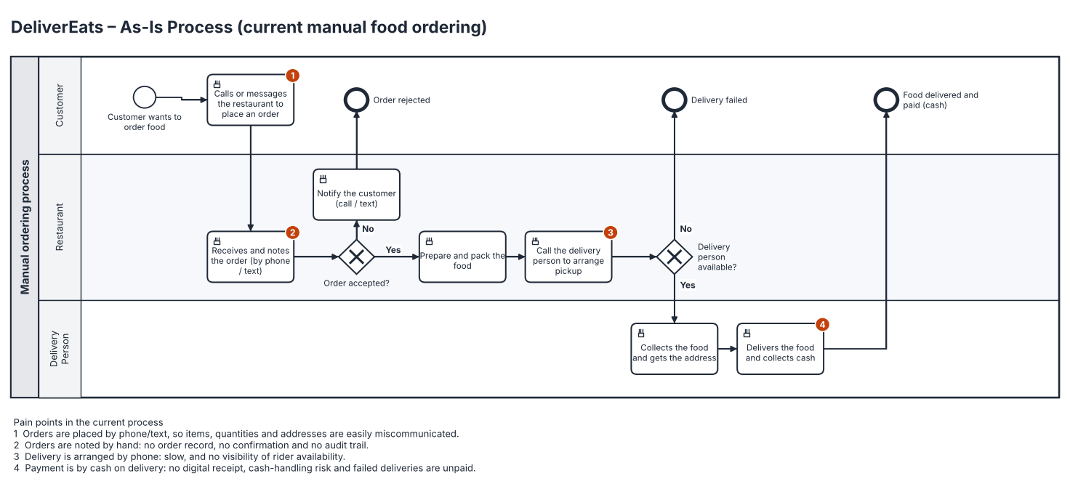
Figure B1 – As-Is process

14.3 Appendix C – To-Be Process Diagram (BPMN 2.0)
The MVP process after DeliverEats is implemented, including the payment-failure and rejection paths.
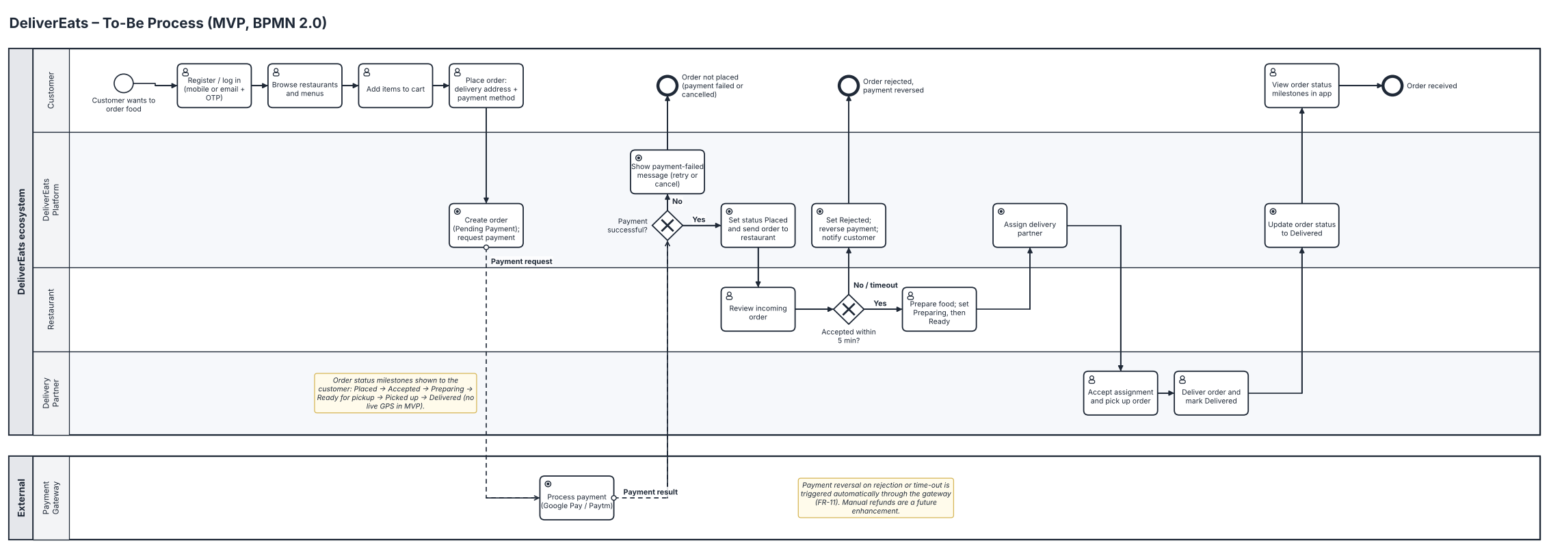
Figure C1 – To-Be process (MVP)

14.4 Appendix D – High-Level Use Case Diagram
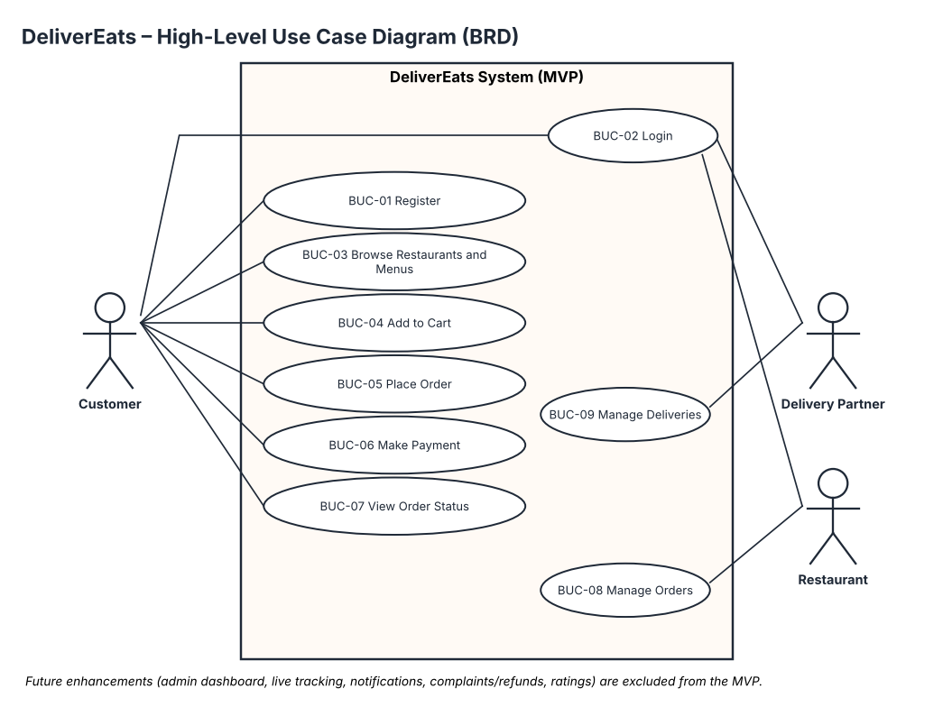
Figure D1 – High-level use cases (MVP)

