PROG32758 – Final Exam

991660474

Puneet Anand

**Build Path:**

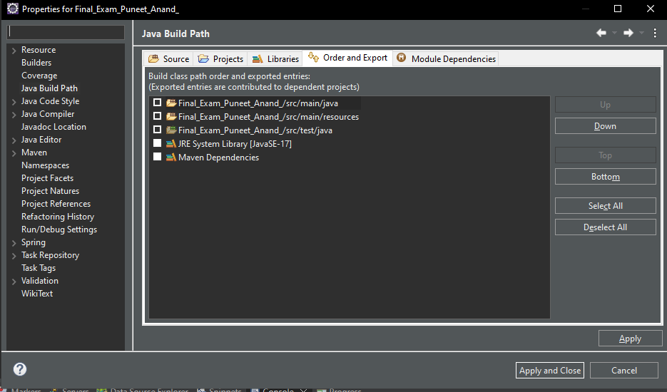

**Project Structure:**

**Console Output:**

**H2 DataBase:**

**SELECT ALL:**

**DELETE:**

**Login Page:**

**Security:**

**application-dev.properties**

**application.properties**

**Obvious Operations:**

**Before:**

**Deleting first entry:**

**Editing Honda Accord:**

**Supplemental Questions**

1. Transport Guarantee is used by Spring Security in order to ensure log in credentials are valid, and information is being transported in a secure manner over the HTTP/through the web application. It is a security constraint which helps in keeping transmission secure.
2. The application.properties file helps write properties to be used by the web application to the project. For example, when using an h2 database, we can see that we can specify not only the fact that we want to use h2, but also the log in credentials we want to give each user. For example, a dev could use a different log in for the databaser when compared to a general user.

1. A user would make use of the mySQL versus the H2 embedded database depending on the access one wants to give a user when using a WebApp. The mySQL usage would show up in the application.properties file where the user would instruct SpringBoot to use mySQL over H2 and provide credentials and queries required to use mySQL. The use of mySQL would likely require the use of WorkBench in order to set up the schema as well.
2. Junit is a testing method that is used in the Springboot Framework/in good coding practice. It tests whether the methods in a class use the inputs correctly, and creates a result which is expected. It is tested by asserting the expected input against the actual input to see if the test passes.
3. The UserDetailsServiceImpl.java file checks whether the username and password provided exist and also can set roles in order to authorize certain users to be allowed to make actions where users without that role may not have access to.