Methodology

The Fingerprinting Approach

Fingerprinting revisited
The end goal of the implemented project was to create a system that would allow for a laptop to be tracked using the fingerprinting technique as explained in the introduction. As opposed to calculating the location through triangulation, a fingerprinting technique locates the device by referring to a lookup table and returning the best matching reference point. This implicitly requires an initial environment training phase to populate the lookup table with reference points. Some software engineers insist that a database be implemented for storing the training data, however, we deal with managing these reference points in a simplistic lookup table.

Figure 3 shows a typical room, with 4 access point (blue diamonds), walls, and many manually placed reference points (red dots). When the laptop gets fingerprinted at a reference point in the training phase, it measures the strengths of the signals it has with each of the access points. This data are placed into a data structure as shown in figure 4. This unit of information can be defined and will from here on be referred to as a fingerprint.

Descriptive Label for RP | RSS₁ | RSS₂ | RSS₃ | RSS₄

This data structure is then in turn placed into the lookup table to eventually containing all the RPs. For each location, this data unit should be unique when 3 or more access points are used. Therefore the data unit represents a unique identifier for the location, or the location’s fingerprint. The training algorithm is gone into in more detail later.

Figure 3:
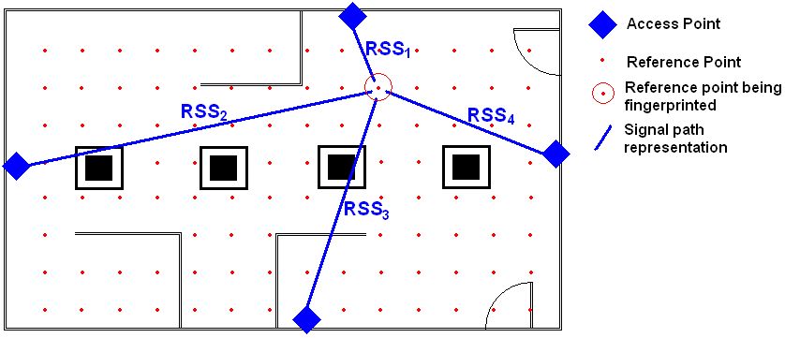

Once the fingerprinting lookup table has been created, a respective tracking algorithm can be implemented. A deterministic algorithm has been tested in this paper. A deterministic tracking algorithm has benifits in its simplicity but can still achieve effective results. It also allows for many different experimental algorithms such as Nearest Neighbour and K Nearest Neighbour where testing can be done with various values of K. These algorithms are dealt with in more detail later.

Software overview
The project was developed in the Linux operating system making use of open source software. A Linux package known as “wireless-tools” was the foundation of the software development in this project. The purpose of the wireless-tools software is to provide command line tools that allow one to set or monitor the operating system’s wireless configuration in a structured way. It forms part of many Linux operating system distributions.

Written in C code, the Wireless-tools package operates on memory that gets set by the wireless hardware driver itself. It functionally makes low level information provided by the driver available. The software provides tools to view the available access points with their respective configurations and to connect/disconnect to available wireless networks.

The wireless-tools source code was fully applicable to use for implementing wireless tracking and was well documented for programmer level customization.

Implementation

The learn algorithm
Location fingerprinting consists of two stages: ‘training’ and ‘positioning’ [lib 2007]. The training stage is executed first and creates a database of reference points that serves a purpose in the positioning stage. The learn function presented in this paper represents the algorithm encapsulating the training stage.

Once the laptop has strategically been placed at a selected reference point, the learn function is ready to be run. The learn function executes for about 5 to 10 seconds. The training stage consists of placing the laptop at a reference point, running the learn function, moving the laptop to the next reference point and so on. The command line function, the iwlist command, is executed as follows:

$ sudo iwlist interface learn rp_label output_filename

For example:

$ sudo iwlist wlan0 learn 0,0 mollyblackburnhall.txt

First of all, due to accessing restricted memory set by the hardware, the command needs to be run as root. [get that man page quote about root req]. the first argument is the network interface to use. On most machines that only have 1 wireless network card plugged in, this would be wlan0. The second argument is “learn”, the command the user wishes to perform using this wireless-tool. “learn” is the command added to the source code that will run the fingerprint training algorithm presented in the paper. Argument number 3 is the user specified label for the reference point about to be fingerprinted. Labels such as “0,0” for example can be employed as to represent a coordinate in the room. The final argument is the filename that you want the data to be written to. This file, serves as the lookup table when tracking the laptop in the positioning stage.

An implicit file in the program is the input/input_routers.txt file. The learning algorithm starts by reading from this file the number of access points to be used in the experiment, followed by reading the access points’ MAC addresses. The MAC addresses are required because more than likely, there will be other stray access points in wireless range during the experiment that need not be included. In theory, it would not hurt to use then as additional sources of fingerprinting information, however that was not done in this implementation.

The track algorithm

Software design

The Learn and Track Programs

Technique Overview
The experiment

In order to explain how the software was implemented, the exact standpoint of how the experiment was physically performed needs to be declared. The experiment was conducted in two phases: Calibration and Localization.

The calibration phase

Software Development Overview
In order to explain how the software was implemented, the exact standpoint of how the experiment was physically performed needs to be declared. The experiment was conducted in two phases: Calibration and Localization. The calibration phase

Functional requirements for testing localization

In order to explain how the software was implemented, the exact standpoint of how the experiment was physically performed needs to be declared. In order to explain the finer details of how the tracking software was developed, it is fundamental to state what the functional requirements are when tracking. At every instant when the location of the

Monitoring signal strengths associated with each access point
The signal strength between the Access points and the WLAN card translates to a distance that is required in the tracking algorithm. The received signal strength indicator (RSSI) will be needed at real time speed to enable a continuously updated location intervals.

Unique identification of access points
The mac addresses of each access point must be extracted

coordinates of the access points
NOT NEEDED

Map of the testbed
The environment in which the experiment will be conducted will be heavily trained with data. A map of which points in the room the device will be tracked in will be needed to display and reflect where the device is during testing.
Wireless

Software

Modification
In order to extract the received signal strength indication and relivant mac addresses of multiple access point, the iwlist tool source code was sufficient. The entire Wireless-tools package was compiled as various shared object files were required. The packages file list is given below: The software is written in C.

The iwlist command line tool, before the tracking functionality was added to it, consisted of functions such as scanning, power, bitrate and keys [man page] which returns results to the user about such statistics. 2 new functional options were added: learn and track.

Learn:
the learn function is required in the first, fingerprinting, phase of the experiment. It requires the user to input a location (as a label) which is to be fingerprinted and a database which to add the result to.
The algorithm is as follows:

Track
The track function is

iwconfig
Used to configure a wireless interface. Wireless tools uses the term interface to refer to a connection to an access point, router or adhoc network. It is easy to see how important this tool is in linux.

Iwspy
Used to monitor statistics such as signal strength, link quality and noise level of a cell you are currently connected to. This sounds like the ideal source code to modify to implement wireless tracking via the signal strength interpretation, however this tool is focused on only accessing the current access point. Wireless tracking requires reading from multiple access points.

Iwlist
qq

- wireless interface

