Llama.cpp and Llama-Benchmark
CS 431 - Intro to Performance, Modeling, & Analysis
08 December 2025

Marko Markoc ᐧ Brady Mcatee ᐧ Anant Prakash Pathak ᐧ Reid Wahl ᐧ Aaron Willett

Introduction
Llama (“Large Language Model Meta AI”) represents a family of large language models that stand out for being a powerful and largely open source alternative to the closed models such as GPT or Claude. Its open source nature allows for more customization and research, as well as local hosting. Local hosting across a wide range of platforms is also made possible by the parameter efficiency of the llama models, meaning they can perform well even at smaller sizes. Llama models achieve core transformer efficiency through optimizations like RMSNorm, pre-normalization, grouped-query attention (GQA), and reduced parameter counts in smaller variants, which improve training and inference speed while reducing memory usage. LLM performance relies on the balance between compute (FLOPs) and memory (bandwidth/capacity). Performance tends to shift from the compute-bound prompt processing to the memory-bound token generation.

Llama.cpp is an open source plain C/C++ implementation of the software libraries used for inference on large language models. It gained its popularity by efficiency, ease of deployment, and portability. Providing support for a wide range of hardware, it can run on top-of-the-line servers with GPUs as well as edge devices like laptops or phones.

In this paper, we will focus on evaluating the performance difference between different modes and platforms of the llama.cpp inference. We will look at answering the following set of questions:

- How much faster is GPU-accelerated inference compared to CPU-only inference for LLM workloads?
- Does llama.cpp achieve linear scaling as we add multiple GPUs?
- What is the impact of partial vs. full GPU offloading on inference performance?
- Does tensor split configuration (balanced vs. weighted) affect multi-GPU performance?
- How does inference performance vary within the same model family (Qwen3) as model size varies (0.6B, 4B, 8B)?
- What is the performance difference between Nvidia L40S and A30 GPUs? Does inference benefit more from the L40S’s increased core count and memory size, or from the A30’s hardware optimization for 64-bit floating point operations?

Llama.cpp does not provide effective multi-node scaling, so our experiments will focus on single-node performance.

Experimental Design
Our experiments were performed on the ORCA HPC cluster. ORCA is a 25-node cluster hosted at Portland State University that is used for both research and educational purposes. ORCA compute node specifications are as follows:

- AMD EPYC 9534 64-Core Processor
  - Provides 64 threads
- 568 GB of RAM
- 4 x Nvidia A30 GPU
  - 3,584 cores
  - 24GB memory
- 4 x Nvidia L40S GPU
  - 18,176 cores
  - 48GB memory

We used llama.cpp with the OpenBLAS and CUDA backends. Software versions:
- llama.cpp: b7157
- OpenBLAS: 0.3.29
- CUDA: 12.9.0

We built llama.cpp using the build guide in the documentation, with the following cmake command line:

cmake -B build -DGGML_BLAS=ON -DGGML_BLAS_VENDOR=OpenBLAS -DGGML_CUDA=ON

We have provided a build script, available in our project repository as deploy_llamacpp.sh.

In our evaluations, we used the Qwen3 model family with Q5_K_M quantization. Except where otherwise specified, we used model size 8B (8.2B parameters with 36 layers). This model offers a comprehensive suite of dense and mixture-of-experts (MoE) models. Qwen3 switches between Thinking Mode for complex reasoning (advanced math, coding, multi-step logic) and Standard Mode for fast, everyday conversations. It tackles advanced mathematics, debugs intricate code, and works through multi-step reasoning tasks with systematic analysis. The model generates creative content, maintains natural multi-turn conversations, and handles role-playing scenarios with strong instruction-following across various tones and formats. It integrates seamlessly with external tools and APIs to create automated workflows and task-specific agents that maintain reasoning capabilities throughout execution. With support for 100+ languages, Qwen3 enables consistent communication and translation across all supported languages, making it ideal for international applications, localization projects, and cross-cultural communication tools.

Results and Analysis

CPU vs. GPU Performance Characteristics
The performance differential between CPU-only and GPU-accelerated inference reveals fundamental architectural advantages of GPU computation for LLM workloads. Figure A presents the baseline comparison across offloading strategies.
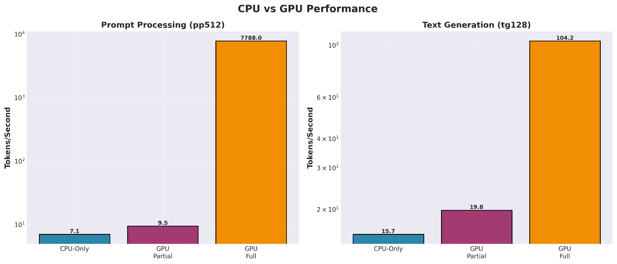
Prompt Processing Performance: CPU-only inference achieved 7.1 t/s for the 512-token prompt processing task. Partial GPU offloading, where only 10 of 36 layers executed on the GPU, improved performance marginally to 9.5 t/s – a mere 1.34x speedup. In stark contrast, full GPU offloading on the L40S GPU delivered 7788 t/s, representing an impressive 1102x speedup over the CPU baseline. This dramatic nonlinearity indicates significant overhead in hybrid CPU-GPU execution, where only 10 of 36 layers execute on the GPU.
Figure A
Text Generation Performance: The autoregressive generation phase exhibited markedly different scaling characteristics. CPU-only generation achieved 15.7 t/s with partial offloading reaching 19.8 t/s for a 1.26x speedup and full GPU offloading attaining 104.2 t/s for a 6.6x speedup. While substantial, this represents only 0.6% of the acceleration observed in prompt processing.
Architectural Interpretation: This performance asymmetry directly reflects the computation structure of transformer inference. Prompt processing is naturally parallel, ideal for allowing the GPU to process many operations concurrently. Conversely, autoregressive generation operates fundamentally differently. In autoregressive decoding, the model generates text by predicting the next token based on all previously generated tokens, continuing this process token by token until completion [Vaswani et al., 2017; ARM Education]. This creates two distinct computational phases: Prefill (prompt processing) and Decode (token generation). During the Prefill stage, all input tokens are known in advance and can be processed simultaneously using general matrix multiply (GEMM) operations, enabling massive parallelization. During the Decode stage, each output token must be generated sequentially—the model cannot begin computing token N+1 until token N has been generated and appended to the sequence [ARM Education]. This sequential dependency fundamentally limits parallelization: while individual operations within each token's forward pass (implemented as General Matrix-Vector multiply, or GEMV operations) still benefit from GPU acceleration, the token-to-token dependency creates a sequential bottleneck in the overall generation process. Our measurements reflect this architectural constraint: generation achieved only 6.65x speedup compared to 1102x for prompt processing, demonstrating that GPU acceleration effectiveness is directly constrained by the inherent sequentiality of autoregressive decoding. The dramatically smaller speedup for generation (6.6x vs. 1102x) demonstrates that GPU advantages are constrained when sequential dependencies prevent effective parallelization, even with identical hardware resources.

Inefficiency of Partial Offloading
A critical finding is the poor performance of partial GPU offloading. With 10 of 36 layers (27.8%) executing on the GPU, naive linear interpolation between CPU baseline (1x) and full GPU performance would suggest intermediate speedups. The data from our experiments (Figure B) revealed evidence to the contrary.
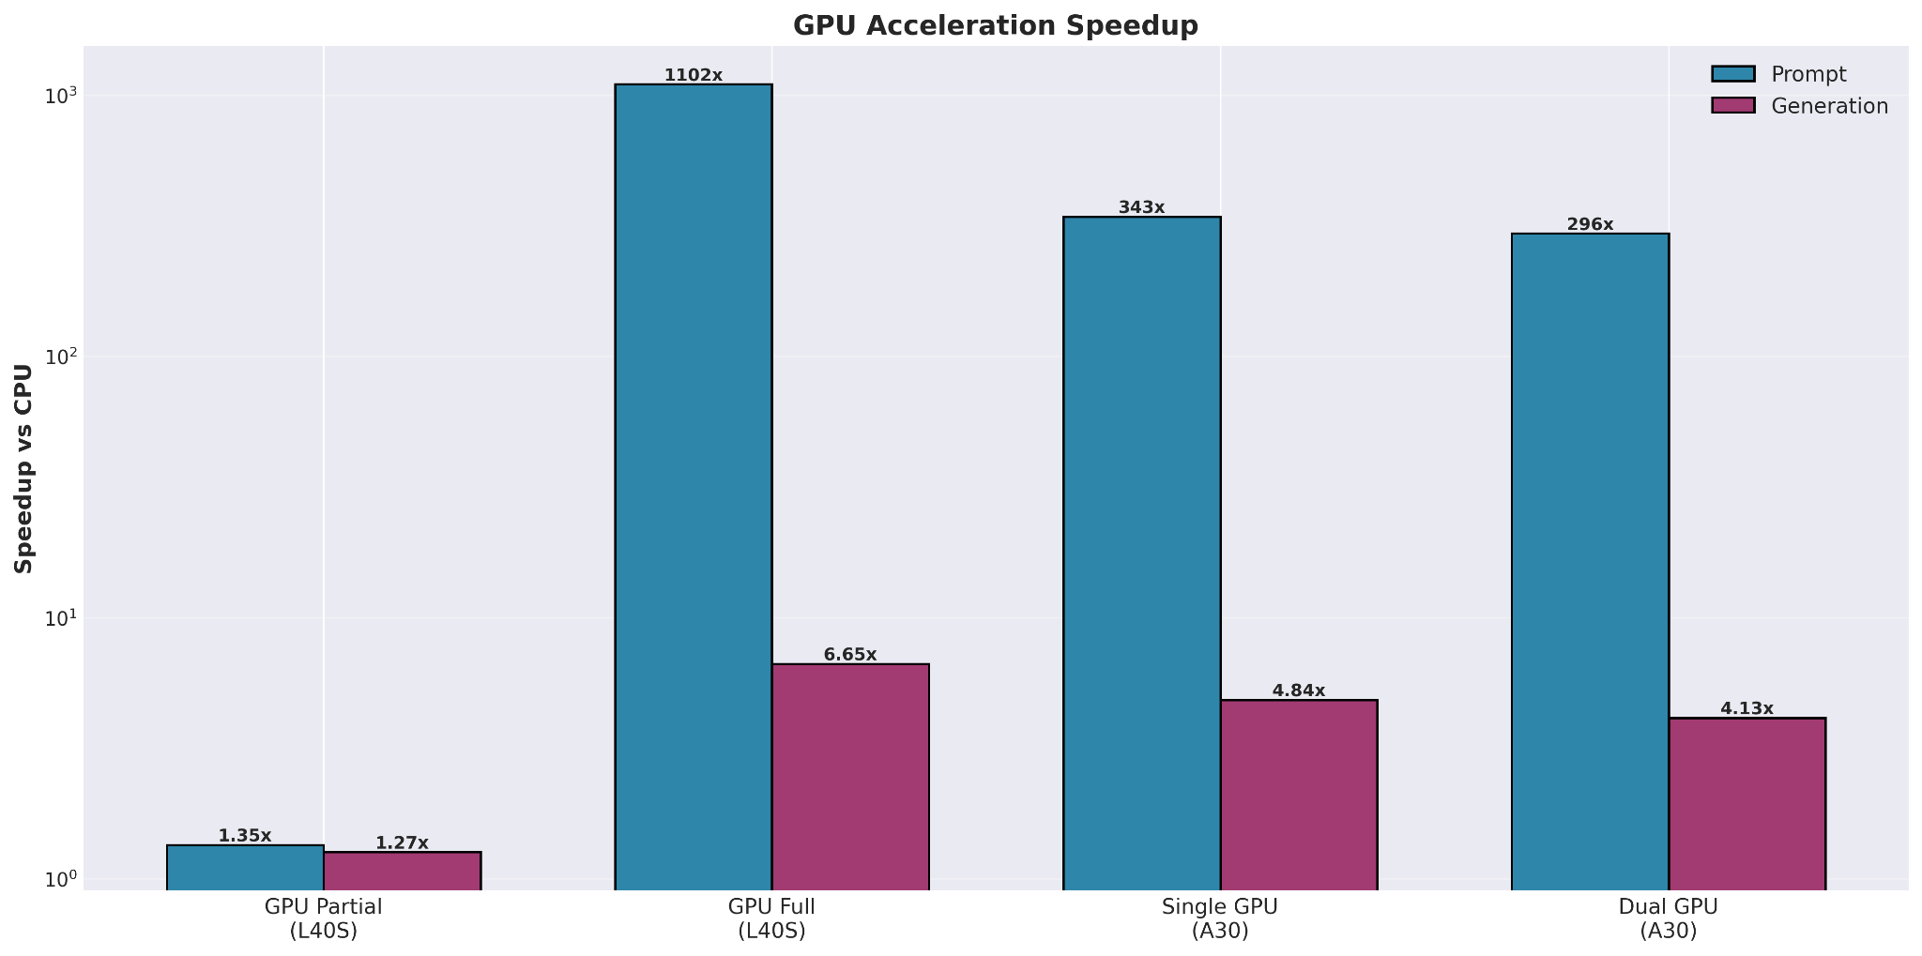
Figure B - Side by side graph of GPU architectures and speedup analysis
This severe degradation indicates substantial overhead in hybrid CPU-GPU execution. While we did not directly measure the sources of this overhead, the poor scaling suggests significant costs from the transitions required when execution alternates between CPU and GPU processing.
Practical Implications: These results demonstrate that partial offloading strategies are inefficient for deployment. Production systems should employ full GPU offloading when GPU memory permits, or remain CPU-bound if insufficient VRAM exists. Hybrid configurations waste GPU resources while delivering minimal performance improvement.

Multi-GPU Scaling Limitations
Multi-GPU configurations for the 8B parameter model demonstrate negative to zero scaling efficiency, contradicting conventional expectations from parallel computing. Figure C presents multi-GPU performance on the A30 hardware.
Single GPU Baseline: The A30 single-GPU configuration established a baseline of 2,425.56 t/s for prompt processing and 75.79 t/s for generation.
Dual GPU Performance: Distributing the model across two GPUs with a balanced 50:50 tensor split yielded 2,089.76 t/s (prompt) and 64.77 t/s (generation)—representing 13.8% and 14.5% performance losses respectively compared to single GPU operation.
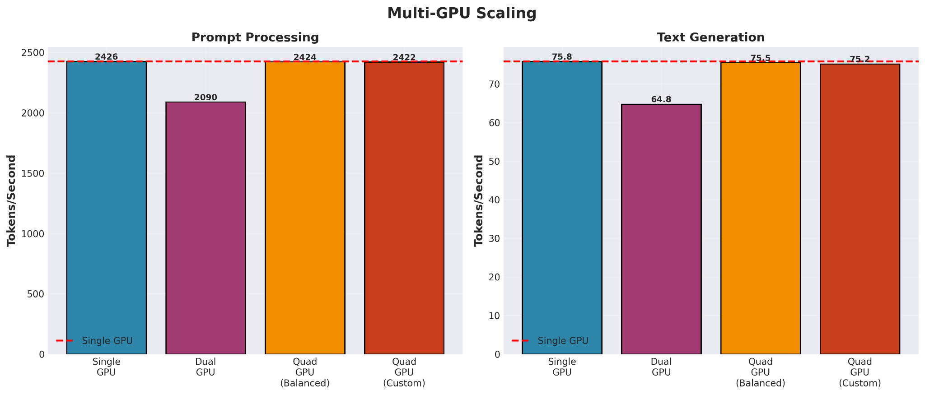
Quad GPU Performance: Distributing across four GPUs with balanced allocation (25%, 25%, 25%, 25%) produced 2,423.65 t/s (prompt) and 75.52 t/s (generation), effectively matching single-GPU throughput with zero scaling benefit. A weighted distribution (31.25%, 31.25%, 18.75%, 18.75%) produced nearly identical results at 2,421.56 t/s and 75.18 t/s, showing no advantage over balanced splitting.
Figure C - Scaling across number of GPUs and tensor split schemes. “Balanced” indicates (4, 4, 4, 4), while “custom” indicates (5, 5, 3, 3).
Analysis of Scaling Failure: This negative scaling behavior stems from a fundamental mismatch between model size and GPU memory capacity. The Qwen3-8B model in Q5_K_M quantization occupies 5.44 GB, fitting comfortably within a single A30's 24GB or L40S's 48GB VRAM. When artificially distributed across multiple GPUs, each forward pass requires transferring intermediate activation tensors between GPUs. The dual-GPU configuration suffers most severely (14% performance loss) because it maximizes inter-GPU communication while minimizing per-GPU computational density.
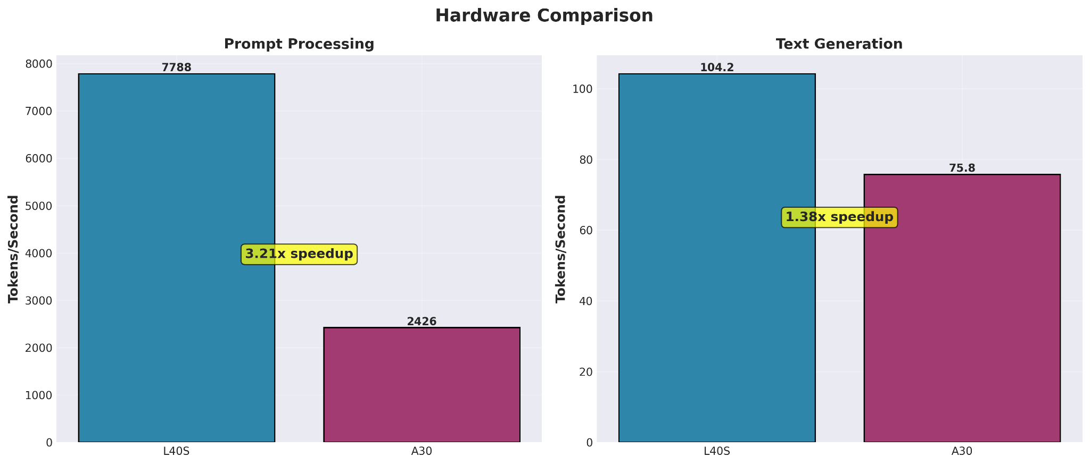
The quad-GPU configurations recover to match single-GPU performance not through genuine parallelism benefits, but through improved load balancing that reduces idle time. Fundamentally, distributing a model that fits in single-GPU memory creates artificial communication overhead without enabling any computational benefits.
Figure D
Scaling Predictions: These results indicate that multi-GPU benefits emerge only for models exceeding single-GPU memory capacity. Based on our observed scaling characteristics, we predict that models in the 70B parameter range (~35-40GB in similar quantization) would show positive multi-GPU scaling on this hardware, as distribution becomes necessary rather than artificial. The current implementation employs layer-wise model splitting; alternative parallelization strategies were not evaluated in this study.

Hardware Architecture Comparison
Direct comparison between NVIDIA A30 and L40S GPUs (Figure D) quantifies hardware-specific performance characteristics for LLM inference workloads.
Prompt Processing: The L40S achieved 7,788.02 t/s compared to the A30's 2,425.56 t/s, yielding a 3.21x performance advantage. Both measurements used full GPU offloading with otherwise identical software configurations (llama.cpp build, model quantization, test parameters).
Text Generation: For generation workloads, the L40S produced 104.24 t/s compared to the A30's 75.79 t/s—a 1.38x speedup. The hardware performance gap narrows substantially for generation (1.38x) compared to prompt processing (3.21x).
Performance Differential Analysis: The 2.3-fold difference in hardware advantage between workload types (3.21x vs 1.38x) suggests that L40S architectural characteristics provide greater benefit for highly parallel operations than for sequential operations. While we did not measure specific architectural features (clock speeds, memory bandwidth, cache hierarchies), the differential scaling across workload types indicates that the L40S's performance improvements are not uniform across all computational patterns.

Hardware Selection Implications: The L40S achieved 3.21x higher throughput than the A30 for prompt processing and 1.38x higher throughput for text generation. Organizations deploying LLM inference systems should select hardware based on their workload characteristics: applications processing large prompts (document analysis, long-context retrieval) benefit substantially from the L40S, while applications primarily generating text see a smaller performance differential.

Qwen3 Quantization Benchmarking
For most state of the art LLM models out there, there exist various quantized models of the same family. They can differ in terms of number of parameters and in numbers of layers or attention heads.

Lesser parameters ∝ lighter in weight(File Size/Memory),
faster inference (tokens/second),
diminished accuracy on complex or highly generalized tasks,
Lower floating point precision of each parameter

For Qwen3, to perform benchmarking tests we chose the following configurations:

Quantized weights | 0.6B (28 Layers), 4B (36 layers), 8B (36 layers)
GPU model | Nvidia L40S
# Nodes | 1
# GPUs | 1
Resources requested from Orca | salloc --cpus-per-task 64 --mem 200G --gres=gpu:1
Benchmark used | llama-bench

Tests - Prompt Processing & Token Generation:
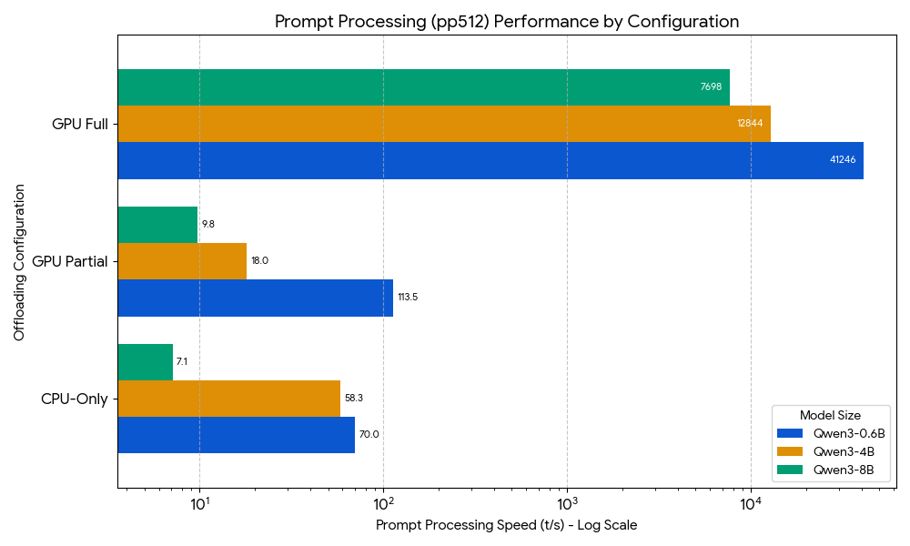
Note that prompt processing is shown on a log scale, as the “GPU Full” performance dominates that of the other two configurations.
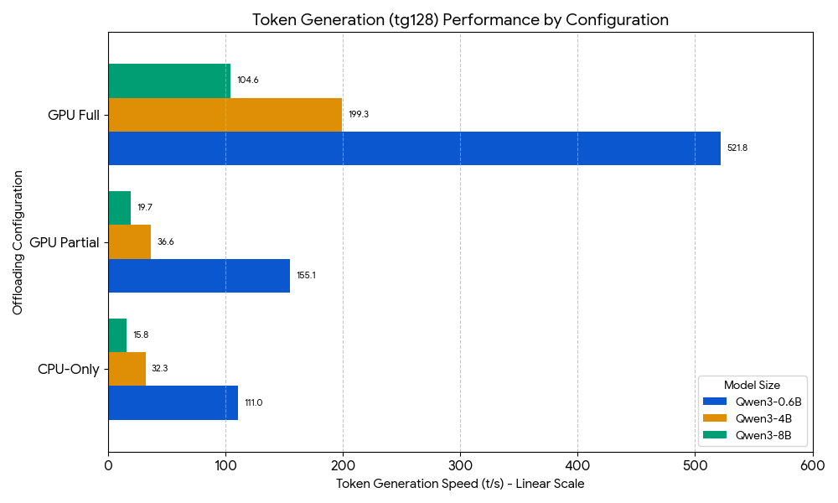

 | 8B (t/s) | 4B (t/s) | 4B (speedup) | 0.6B (t/s) | 0.6B (speedup)
PP: GPU Full | 7,698.0 | 12,844.0 | 1.67x | 41,246.0 | 5.36x
TG: GPU Full | 104.6 | 199.3 | 1.91x | 521.8 | 4.99x
PP: GPU Partial | 9.8 | 18.0 | 1.84x | 113.5 | 11.63x
TG: GPU Partial | 19.7 | 36.6 | 1.86x | 155.1 | 7.88x
PP: CPU-Only | 7.1 | 58.3 | 8.19x | 70.0 | 9.83x
TG: CPU-Only | 15.8 | 32.3 | 2.04x | 111.0 | 7.01x

The table shows the speedup by model size, workload, and hardware configuration. Performance on the 8B model is used as the baseline for each workload/hardware combination. (PP = prompt processing, TG = token generation.)

Discussion:
- Lighter models outperform the heavier models: Given any hardware configuration, the 0.6B model performs 5 to 11 times better than the 8B model under both workload types. The 4B model yields intermediate performance, as expected. Note, however, that the 4B model performed almost as well as the 0.6B model in the PP/CPU-Only configuration.
- Token generation is memory-bound: In the token generation test, tokens generated per second are far less in comparison to the prompt processing. Also the fact we know of the model’s architecture, that for each token that is generated, billions of parameters are transferred from VRAM to the cores for matrix multiplication and the whole process repeats again for the next token. Thus, the bottleneck for token generation is this massive data movement, therefore its safe to say token generation is a memory bound process. What can help? Reducing the data that needs transferring or increasing the transfer speed can improve the performance.
- Prompt processing is compute-bound: Because the entire input prompt is processed simultaneously using a massive matrix-matrix multiplication This operation has high arithmetic intensity, meaning the computational cores are fully utilized of GPUs or the CPUs, making the raw processing speed the bottleneck, not the memory transfer speed.
- Workload suitability: The Qwen3-0.6B model is best suited for high-speed, resource-constrained workloads like simple chatbots or edge devices, as its minimal size makes it the fastest across all benchmarks, while the Qwen3-8B model is better for complex computational (multi-step pattern matching and inference) and coding tasks where its greater structural complexity and knowledge would justify its lower speed.

Performance Profiling and Hotspot Analysis
To complement our benchmark analysis and identify optimization opportunities within llama.cpp, we conducted comprehensive profiling of both the CPU and GPU execution paths using standard profiling tools. This analysis reveals the computational hotspots and memory bottlenecks that limit the performance for the Qwen 8B model.

Profiling Methodology
For CPU profiling, we used gperftools to collect statistical sampling data at 1000 samples per second during a full llama-bench run, yielding 222,442 total samples across 18MB of raw profiling data. GPU profiling used NVIDIA Nsight Systems to capture kernel execution, memory transfer operations, and CUDA API call timings, producing a 2.1MB trace file. Both profiling sessions executed identical workloads to enable a direct comparison of architectural characteristics.

CPU Execution Analysis
CPU profiling data reveals that matrix multiplication operations dominate computational time, with sgemm_kernel_COOPERLAKE consuming 46.3% of total execution time. This single function, optimized for Intel Xeon Cooper Lake microarchitecture with AVX-512 instructions, represents the primary computational bottleneck for CPU inference. It is worth noting that the processor installed on the test machine is an AMD, and the reason for why this function was selected by llama.cpp/OpenBLAS remains to be explored.

Top CPU Hotspots:
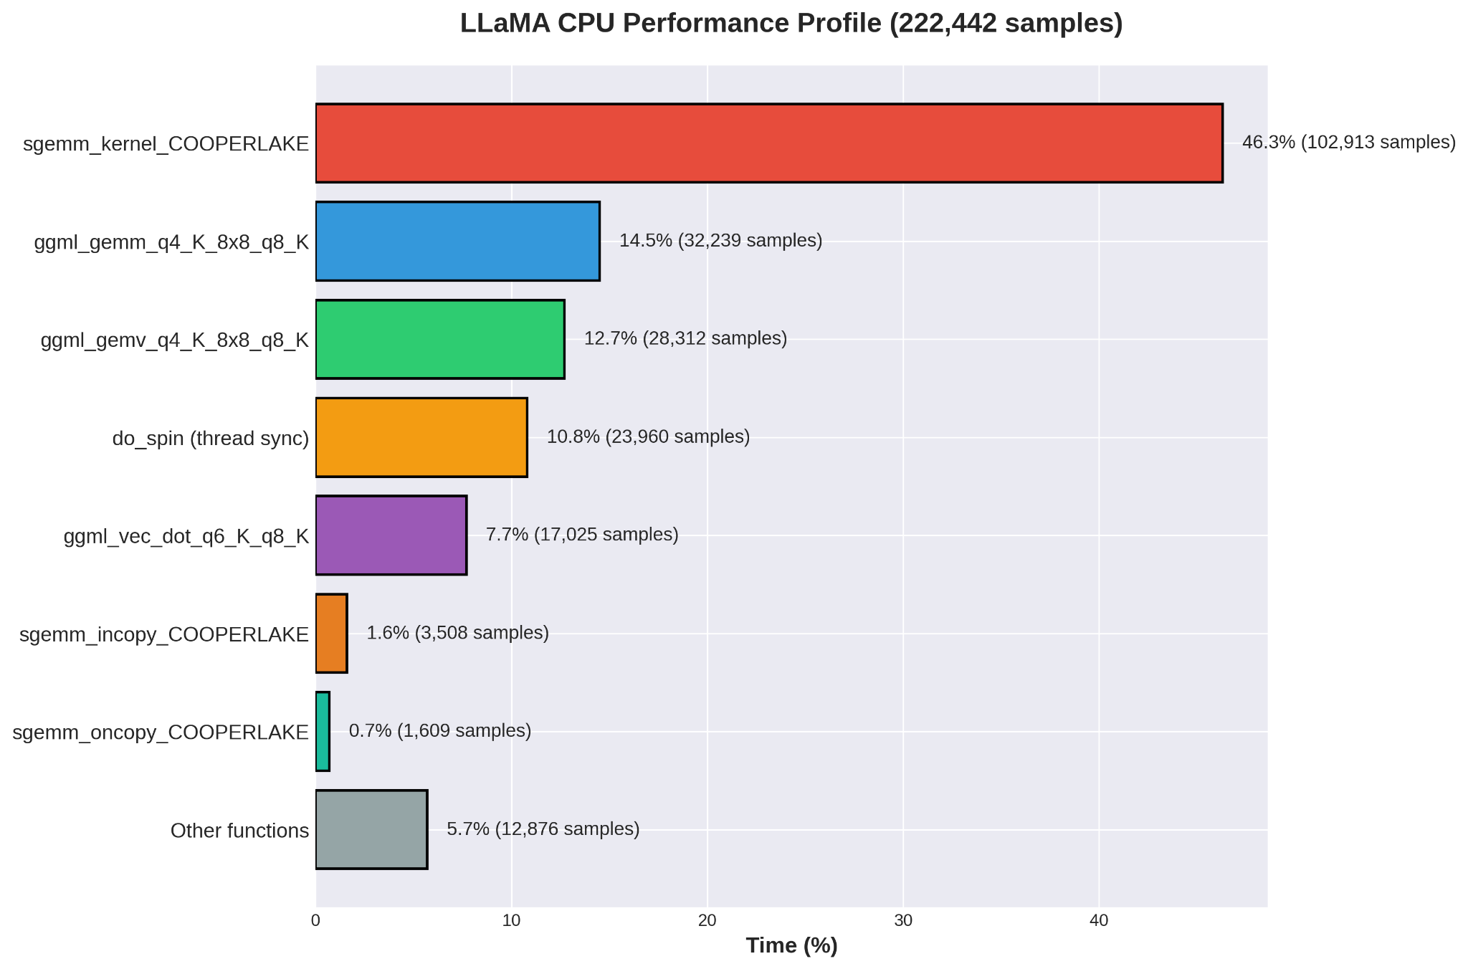

Quantized operations collectively account for 35.6% of execution time, demonstrating the critical role of reduced-precision computation in enabling CPU inference. The presence of Q4_K (4-bit) and Q6_K (6-bit) quantization kernels indicates that memory efficiency trades directly against computational complexity. Thread synchronization overhead (do_spin: 10.8%) suggests opportunities for optimization in parallel workloads distribution.

GPU Execution Analysis
GPU kernel profiling reveals even stronger concentration in quantized matrix operations, with mul_mat_q<Q4_K, 128> dominating at 67.5% of total GPU execution time. This kernel, executing 1,284 instances with an average duration of 661.4 microseconds, performs the bulk of inference computation. The secondary hotspot, mul_mat_q<Q6_K, 128> at 11.9%, reinforces that quantized operations drive GPU performance characteristics.

Kernel | Time % | Instances | Avg Time (μs)
mul_mat_q<Q4_K, 128> | 67.5% | 1284 | 661.4
mul_mat_q<Q6_K, 128> | 11.9% | 210 | 710.4
soft_max_f32 | 3.4% | 216 | 200.2
convert_unary<float, half> | 2.3% | 432 | 67.6
quantize_mmq_q8_1 | 1.7% | 1284 | 16.7

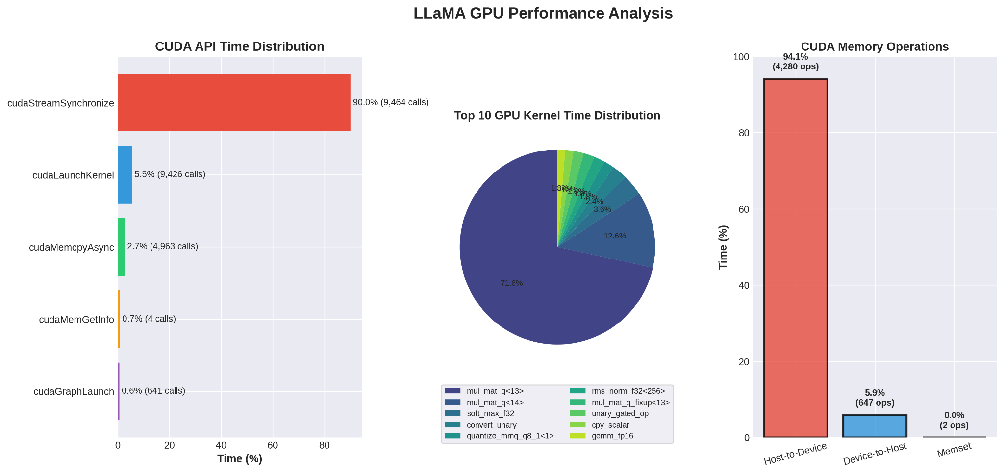

Memory transfer analysis shows that host-to-device transfers consume 94.1% of memory operation time (257.3ms total across 4,280 transfers), while device-to-host transfers account for only 5.9% (16.0ms across 647 transfers). This asymmetry reflects the inference pattern: weights must be loaded to GPU memory, but only final token predictions return to the host. CUDA API profiling reveals that cudaStreamSynchronize dominates API time at 90.0%, indicating synchronization overhead between CPU and GPU rather than kernel launch latency as the primary API bottleneck.

Optimization Opportunities
The profiling data identifies several concrete optimization opportunities. For CPU inference, the 10.8% of synchronization overhead suggests investigating alternative parallel execution strategies to reduce OpenMP barrier costs. For GPU inference, the 90% API time in stream synchronization points to opportunities in asynchronous execution and kernel fusion.

Conclusion
Our benchmark evaluation of the Qwen3 model family on the NVIDIA L40S, utilizing the llama.cpp framework, yielded critical insights into LLM inference bottlenecks and efficiency. We confirmed that full GPU offloading is essential, providing over 1000x acceleration for the parallel prompt processing phase (pp512) compared to the CPU-Only baseline. This contrasts sharply with the token generation phase (tg128), where we suspect one of the major bottlenecks to be the memory bandwidth (rate of transfer of data through data pipeline from VRAM to L2 & L1 cache to computational cores) because its sequential decoding requires repeatedly transferring billions of parameters from VRAM to the cores. This computational constraint meant that the structurally lighter Qwen3-0.6B model proved significantly more efficient, outperforming the 8B model by 5x-11x across all configurations. Finally, our experiments showed that using multiple GPUs for a model that already fits on one GPU (like Qwen3-8B on the A30 or L40S) is inefficient. This strategy created zero or even negative speedup because the layer-splitting method forces slow communication overhead between the GPUs. Therefore, achieving true parallel speed gains requires switching to methods like tensor parallelism.

Future Work
This time we ran with default options of llama-bench. We can explore more nuanced configurations like changing prompt length, context window sizes or running the model under multi-user load. We can explore benchmarking different families of LLM models and get interesting results from that. Next time, we can look to offload the model across multiple nodes and GPUs, thus opening options for much larger models beyond 8 Billion parameters. Instead of llama.cpp, which offers “layer slicing” as the strategy when it comes to offloading a big model across VRAM of multiple GPUs, but as we saw it provided near-zero speedup. It would be worth identifying the source of the overhead in hybrid GPU-CPU execution. In the future we can explore other frameworks like vLLM or ExLlamaV2 which provide tensor parallelism for efficient multi-GPU scaling.

References
- A. P. Pathak et al., "Performance Analysis and Modeling of LLM Inference (Project Repository)," GitHub, 2025. Accessed: Nov. 19, 2025. [Online]. Available: https://github.com/anant-pathak/perf-analysis-modeling-project
- ARM Education. "Explore llama.cpp architecture and the inference workflow," ARM Learning Paths. Accessed: Dec. 8, 2025. [Online]. Available: https://learn.arm.com/learning-paths/servers-and-cloud-computing/llama_cpp_streamline/2_llama.cpp_intro/
- Nvidia. “NVIDIA CUDA.” developer.nvidia.com/cuda. Accessed 08 December 2025.
- OpenMathLib. “OpenBLAS: An optimized BLAS library.” www.openblas.net. Accessed 08 December 2025.

