# Invoice

# Seller Information Invoice Information

Name : RAHUL GARG Invoice No: 8

Address : 1274sector42b\r\n\r\n Date: 2020-05-03

# Billing Information

Name: anant pahwa

Address: d zm,dbxf,gd

Payment : qtww1234

# Items

|  |  |  |  |
| --- | --- | --- | --- |
| **Description** | **Quantity** | **Rate** | **Amount** |
| Potato | 12 | 750.000 | 9000.0 |

|  |  |
| --- | --- |
| **Total** | **9000.0** |

**Signature**

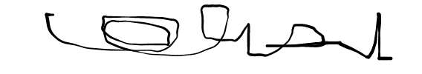

THIS IS A COMPUTER GENERATED INVOICE WHICH RECORDS A TRANSACTION BETWEEN BUYER AND SELLER