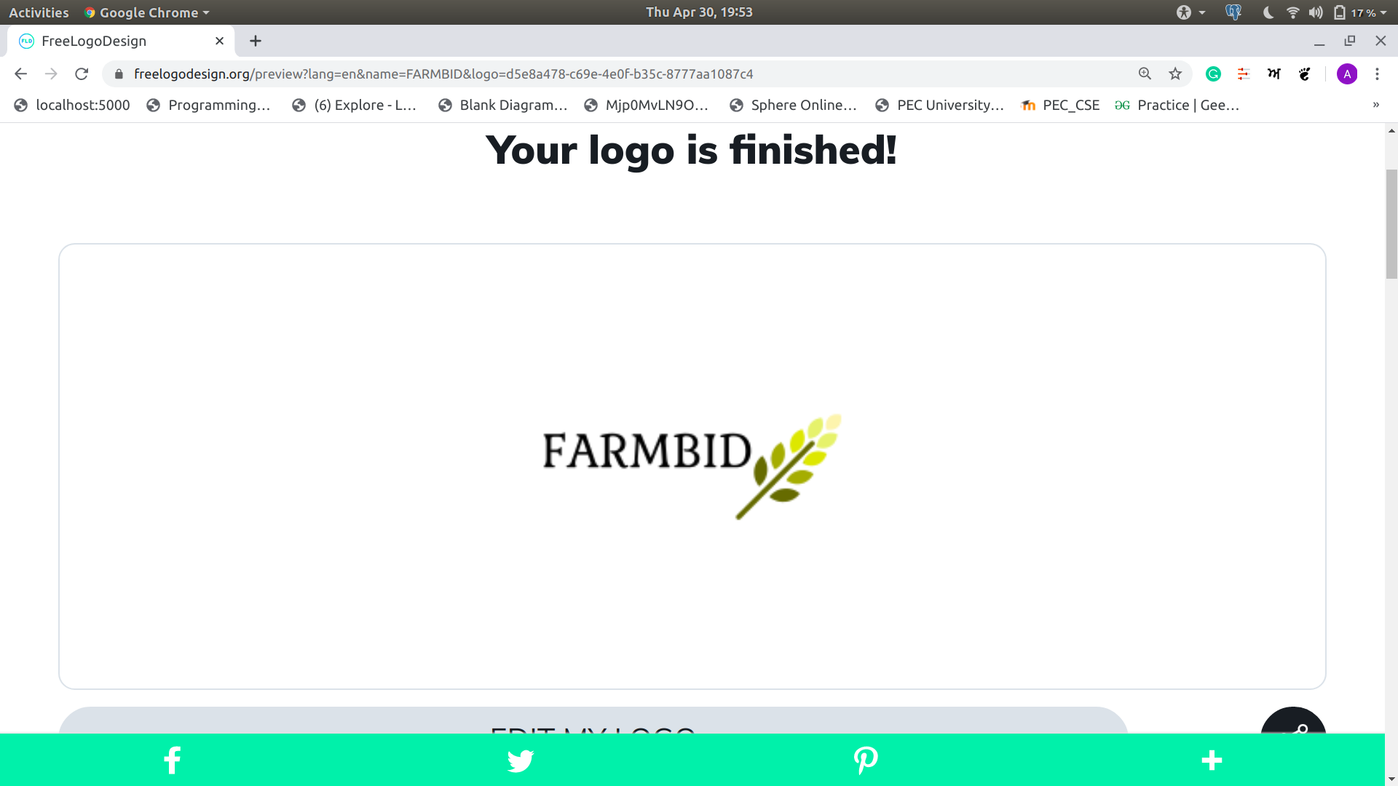**FARMBID**

YOUR ONE STOP SOLUTION FOR SELLING AND BUYING CROPS

INVOICE **INVOICE No: 13**

**DATE: 2020-05-04**

**Seller Details:**

NAME: RAHUL GARG

|  |  |
| --- | --- |
| ADDRESS: 1274sector42b\r\n\r\n  PINCODE:140103  GST NO.: 1234567890  Phone :8437008949 |  |

|  |
| --- |
| **Billing Address:**  NAME: Anant Pahwa  ADDRESS: d zm,dbxf,gd  PINCODE:160036  GST NO :1234567890  PHONE:9781396442 |

**Comments or special instructions: PLEASE MAKE IT AS QUCK AS POSSIBLE**

|  |  |  |  |
| --- | --- | --- | --- |
| **PAYMENT No.** | **P.O. NUMBER** | **TRANSPORT**  **NO** | **TERMS** |
| **12345677654321** | 25 | truckle | Paid |

|  |  |  |  |  |
| --- | --- | --- | --- | --- |
| **QUANTITY** | **DESCRIPTION** | | **UNIT PRICE** | **AMOUNT** |
|  |  | |  |  |
|  |  | |  |  |
| 12 | Cotton | | 45000.000 | 540000.0 |
|  |  | |  |  |
|  |  | |  |  |
|  |  | |  |  |
|  |  | |  |  |
|  |  | |  |  |
|  |  | SUBTOTAL | | 540000.0 |
|  |  |  | |  |
|  |  | TRANSPORTATION | | 5000 |
|  |  | **TOTAL DUE** | | 545000.0 |

If you have any questions concerning this invoice, contact 1800109108 or visit farmbid.azurewebsites.net

**THANK YOU FOR YOUR BUSINESS!**

THIS IS A COMPUTER-GENERATED INVOICE