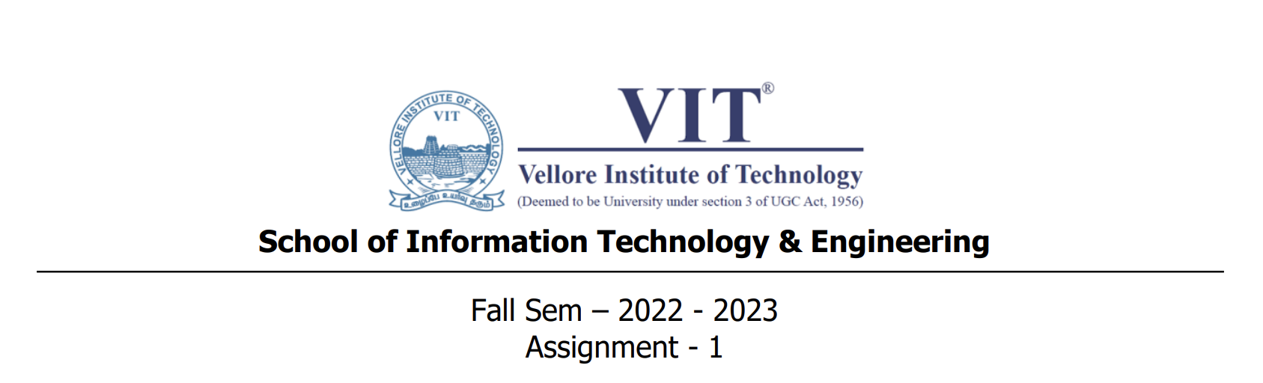

1. Write a Java program to print the sum (addition), multiply, subtract, divide and reminder of two numbers.

**CODE**

import java.util.*;

public class Question1

{

    public static void *main*(String[] args)

    {

        Scanner in = new Scanner(System.in);

        float a,b;

        System.out.println("Enter First Number");

        a=in.nextFloat();

        System.out.println("Enter Second Number");

        b=in.nextFloat();

        System.out.println("Addidtion --> "+(a+b));

        System.out.println("Multiplication --> "+(a*b));

        System.out.println("Substraction --> "+(a-b));

        System.out.println("Division --> "+(a/b));

        in.close();

    }

}

**OUTPUT**

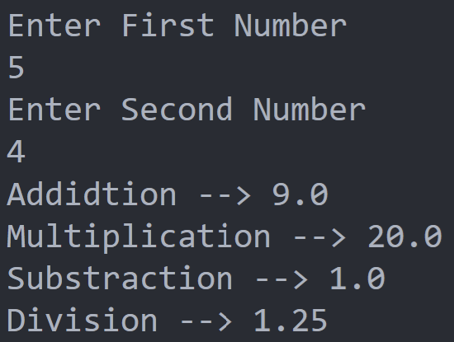

2. Write a Java program that takes a number as input and prints its multiplication table upto 10.

**CODE**

import java.util.*;

public class Question2

{

    public static void *main*(String[] args)

    {

        Scanner in = new Scanner(System.in);

        int n;

        System.out.println("Enter the Number!");

        n=in.nextInt();

        for(int i=1;i<11;i++)

        System.out.println(n+" * "+i+" = "+(n*i));

        in.close();

    }

}

**OUTPUT**

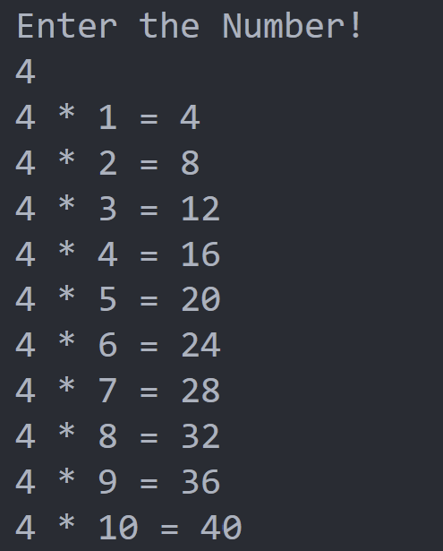

3. Write a Java program to print the area and perimeter of a rectangle

**CODE**

import java.util.*;

public class Question3

{

    public static void *main*(String[] args)

    {

        Scanner in = new Scanner(System.in);

        int l,b;

        System.out.println("Enter the Length of the Rectangle");

        l=in.nextInt();

        System.out.println("Enter the Breath of the Rectangle");

        b=in.nextInt();

        System.out.println("Area --> "+(l*b));

        System.out.println("Perimeter --> "+(l+b));

        in.close();

    }

}

**OUTPUT**

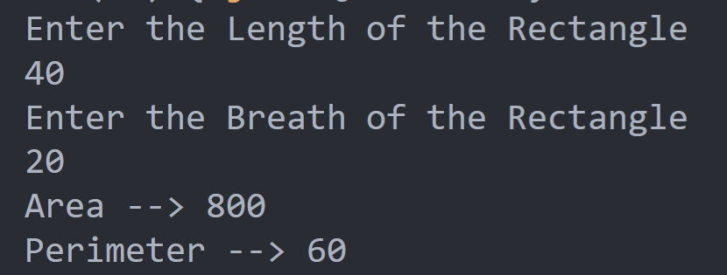

4. Write a Java program to swap two variables.(with and without using third variable)

**CODE**

import java.util.*;

public class Question4

{

    public static void *main*(String[] args)

    {

        Scanner in = new Scanner(System.in);

        int a,b,c;

        System.out.println("Enter Two Numbers");

        a=in.nextInt();

        b=in.nextInt();

        System.out.println("Originally A = "+a+" and B = "+b);

        c=a;

        a=b;

        b=c;

        System.out.println("After Switching A = "+a+" and B = "+b);

        in.close();

    }

}

**OUTPUT**

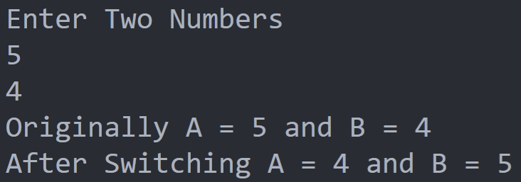

5. Write a Java program to convert a decimal number to hexadecimal number

**CODE**

import java.util.*;

public class Question5

{

    public static void *main*(String[] args)

    {

    Scanner in = new Scanner(System.in);

     System.out.print("Enter a decimal number : ");

     int num = in.nextInt();

*// For storing remainder*

     int rem;

*// For storing result*

     String str2="";

*// Digits in hexadecimal number system*

     char hex[]={'0','1','2','3','4','5','6','7','8','9','A','B','C','D','E','F'};

     while(num>0)

     {

       rem=num%16;

       str2=hex[rem]+str2;

       num=num/16;

     }

     System.out.println("Decimal to hexadecimal: "+str2);

     in.close();

    }

}

**OUTPUT**

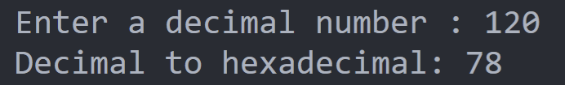

6. Write a Java program to convert a octal number to decimal number

**CODE**

import java.util.*;

public class Question6

{

public static void *main*(String[] args)

{

Scanner in = new Scanner(System.in);

System.out.println("Enter the Number");

int decimal = in.nextInt();;

int octal = convertDecimalToOctal(decimal);

System.out.printf("%d in decimal = %d in octal", decimal, octal);

}

public static int *convertDecimalToOctal*(int decimal)

{

int octalNumber = 0, i = 1;

while (decimal != 0)

{

octalNumber += (decimal % 8) * i;

decimal /= 8;

i *= 10;

}

return octalNumber;

}

}

**OUTPUT**

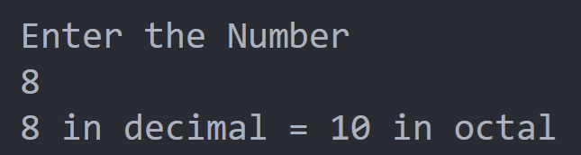

7. Write a Java program to convert a hexadecimal number to binary number

**CODE**

import java.util.Scanner;

class Question_7

{

Scanner scan;

int num;

void *getVal*()

{

System.out.print("HexaDecimal to Binary");

scan = new Scanner(System.in);

System.out.print("\nEnter the number :");

num = Integer.parseInt(scan.nextLine(), 16);}

void *convert*()

{

String binary = Integer.toBinaryString(num);

System.out.println("Binary Value is : " + binary);

}

}

class Question7

{

public static void *main*(String args[])

{

Question_7 obj = new Question_7();

obj.getVal();

obj.convert();

}

}

}

**OUTPUT**

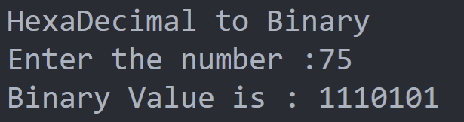

8. Write a Java program and compute the sum of the digits of an integer

**CODE**

import java.util.*;

public class Question8

{

    public static void *main*(String[] args)

    {

        Scanner in = new Scanner(System.in);

        int n,sum=0;

        System.out.print("Enter the Number -->");

        n=in.nextInt();

        for(;n!=0;n/=10)

        sum+=(n%10);

        System.out.println("Sum --> "+sum);

        in.close();

    }

}

**OUTPUT**

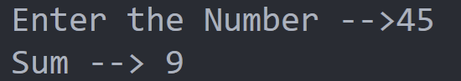

9. Write a Java program that accepts an integer (n) and computes the value of n+nn+nnn

**CODE**

import java.util.*;

public class Question9

{

    public static void *main*(String[] args)

    {

        Scanner in = new Scanner(System.in);

        float n;

        System.out.print("Enter a Number:");

        n=in.nextInt();

        float p = n + (n*n) + (n*n*n);

        System.out.print("Product --> "+p);

        in.close();

    }

}

**OUTPUT**

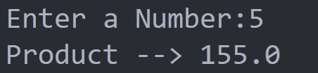

10. Write a Java program to create and display unique three-digit number using 1, 2, 3, 4. Also count how many three-digit numbers are there.

**CODE**

public class Question10

{

public static void *main*(String[] args) {

int amount = 0;

for(int i = 1; i <= 4; i++)

{

for(int j = 1; j <= 4; j++)

{

for(int k = 1; k <= 4; k++)

{

if(k != i && k != j && i != j)

{

amount++;

System.out.println(i + "" + j + "" + k);

}

}

}

}

System.out.println("Total number of the three-digit-number is " + amount);

}

}

**OUTPUT**

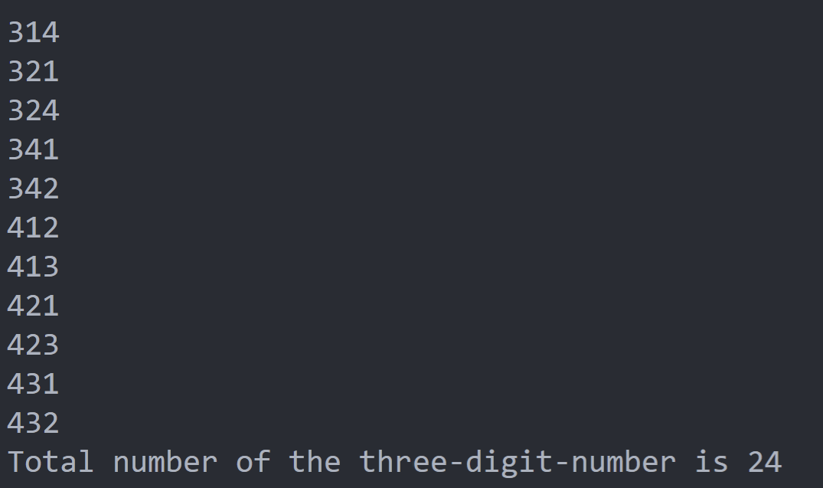

11. Write a Java program to convert seconds to hour, minute and seconds

**CODE**

import java.util.*;

public class Question11

{

    public static void *main*(String[] args)

    {

        Scanner in = new Scanner(System.in);

        System.out.print("Input seconds: ");

        int seconds = in.nextInt();

        int p1 = seconds % 60;

        int p2 = seconds / 60;

        int p3 = p2 % 60;

        p2 = p2 / 60;

        System.out.println( p2 + ":" + p3 + ":" + p1);

        in.close();

    }

}

**OUTPUT**

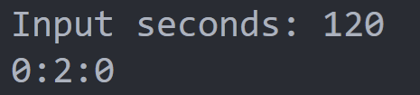

12. Write a Java program that accepts three integers from the user and return true if the second number is greater than first number and third number is greater than second number. If "abc" is true second number does not need to be greater than first number

**CODE**

import java.util.*;

public class Question12 {

public static void *main*(String[] args)

{

Scanner in = new Scanner(System.in);

System.out.print("Input the first number : ");

int x = in.nextInt();

System.out.print("Input the second number: ");

int y = in.nextInt();

System.out.print("Input the third number : ");

int z = in.nextInt();

System.out.print("The result is: "+test(x, y, z,true));

System.out.print("\n");

}

public static boolean *test*(int p, int q, int r, boolean xyz)

{

if(xyz)

return (r > q);

return (q > p && r > q);

}

}

**OUTPUT**

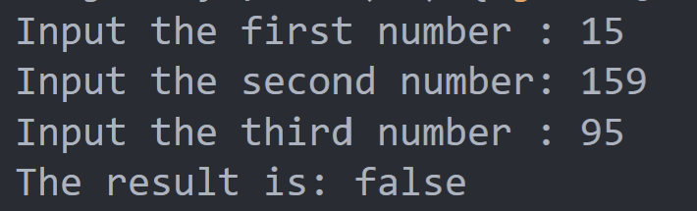

13. Write a Java program to find the number of values in a given range divisible by a given value. (For example x = 5, y=20 and p =3, find the number of integers within the range x..y and that are divisible by p i.e. { i :x ≤ i ≤ y, i mod p = 0 })

**CODE**

import java.util.Scanner;

public class Question13 {

public static void *main*(String[] args){

Scanner sc= new Scanner(System.in);

System.out.print("Enter the First number:");

int x = sc.nextInt();

System.out.print("Enter the Second number:");

int y = sc.nextInt();

System.out.print("Enter the Dividend:");

int p = sc.nextInt();

System.out.println("The Value is "+result(x,y,p));

}

public static int *result*(int x, int y, int p) {

if (x%p == 0)

return( y/p - x/p + 1);

return(y/p - x/p);

}

}

**OUTPUT**

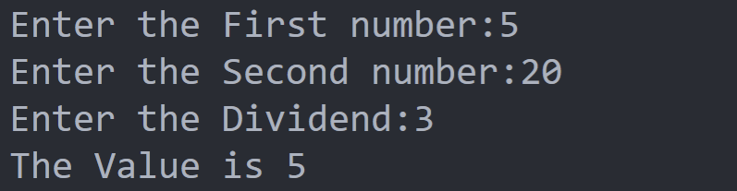

14. Write a Java program that accepts two integer values from the user and return the larger values. However if the two values are the same, return 0 and return the smaller value if the two values have the same remainder when divided by 6

**CODE**

import java.util.*;

public class Question14

{

    public static void *main*(String[] args)

    {

        Scanner in = new Scanner(System.in);

        int a,b;

        System.out.print("Enter First Number:");

        a=in.nextInt();

        System.out.print("Enter Second Number:");

        b=in.nextInt();

        if(a>b)

        {

            System.out.println(a);

            in.close();

            return;

        }

        else if(a==b)

        System.out.println(0);

        else if((a%6)==(b%6))

        if(a>b)

        System.out.println(b);

        else

        System.out.println(a);

        else

        System.out.println(b);

        in.close();

    }

}

**OUTPUT**

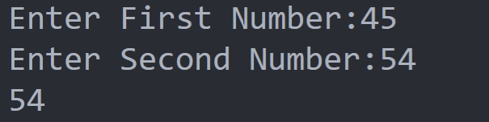

15. Write a Java program to test if the first and the last element of an array of integers are same. The length of the array must be greater than or equal to 2

**CODE**

import java.util.*;

public class Question15

{

    public static void *main*(String[] args)

    {

        Scanner in = new Scanner(System.in);

        int n,a[];

        System.out.print("Enter the Length of Array:");

        n=in.nextInt();

        if(!(n>2))

        {

            System.out.print("Enter the length atleast greater than 2:");

            in.close();

            return;

        }

        a=new int[n];

        System.out.print("Enter Element's of the Array --> ");

        for(int i=0;i<n;i++)

        a[i]=in.nextInt();

        if(a[0]==a[n-1])

        System.out.println("First and Last Elements are the Same");

        else

        System.out.println("First and Last Elements are NOT the Same");

        in.close();

    }

}

**OUTPUT**

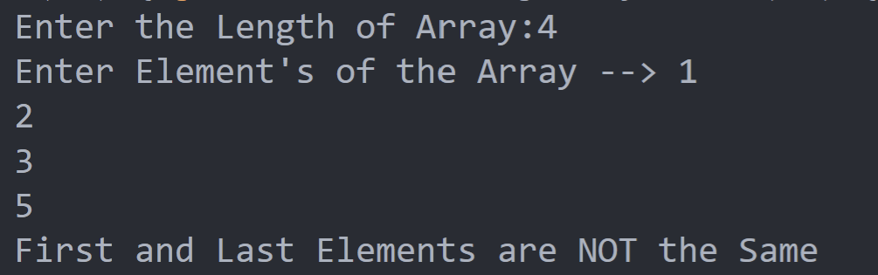

16. Write a Java program to convert a given string into lowercase

**CODE**

public class Question16 {

public static void *main*(String[] args){

Scanner in = new Scanner(System.in);

System.out.print("Input a String: ");

String line = in.nextLine();

line = line.toLowerCase();

System.out.println(line);

}

}

**OUTPUT**

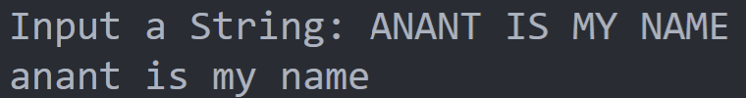

17. Write a Java program to extract the first half of a string of even length

**CODE**

import java.util.*;

public class Question17 {

public static void *main*(String[] args)

{

Scanner in = new Scanner(System.in);

System.out.println("Enter the String");

String main_string = in.nextLine();

System.out.println(main_string.substring(0, main_string.length()/2));

}

}

**OUTPUT**

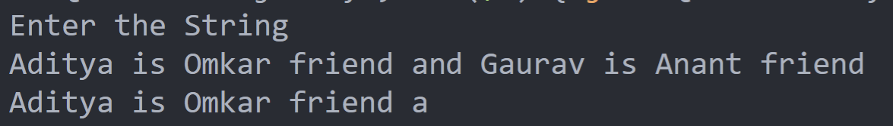

18. Write a Java program to create the concatenation of the two strings except removing the first character of each string. The length of the strings must be 1 and above.(If Str1 = Java and Str2 = Tutorial, then the result = avautorial

**CODE**

import java.util.*;

public class Question18 {

public static void *main*(String[] args)

{

Scanner in = new Scanner(System.in);

System.out.print("Enter the First String:");

String str1 = in.nextLine();

System.out.print("Enter the Second String:");

String str2 = in.nextLine();

System.out.println(str1.substring(1) + str2.substring(1));

}

}

**OUTPUT**

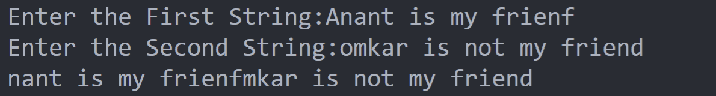

19. Write a Java program to multiply corresponding elements of two arrays of integers.

**CODE**

import java.util.*;

public class Question19

{

public static void *main*(String[] args)

{

Scanner in = new Scanner(System.in);

String result = "";

int l;

System.out.println("Enter the Length of Array");

l=in.nextInt();

int left_array[]=new int[l],right_array[]=new int[l];

System.out.println("Enter Elements of First Array");

for(int i=0;i<l;i++)

left_array[i]=in.nextInt();

System.out.println("Enter Elements of Second Array");

for(int i=0;i<l;i++)

right_array[i]=in.nextInt();

System.out.println("\nArray1: "+Arrays.toString(left_array));

System.out.println("\nArray2: "+Arrays.toString(right_array));

for (int i = 0; i < left_array.length; i++) {

int num1 = left_array[i];

int num2 = right_array[i];

result += Integer.toString(num1 * num2) + " ";

}

System.out.println("\nResult: "+result);

}

}

**OUTPUT**

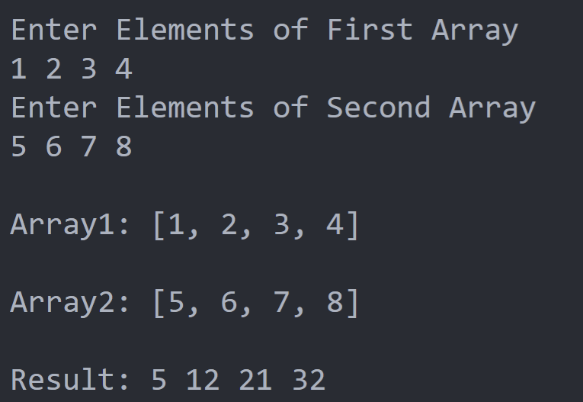

20. Write a Java program to check if a string starts with the word “Java”.

**CODE**

import java.util.*;

public class Question20 {

public static void *main*(String[] args)

{

Scanner in = new Scanner(System.in);

System.out.print("Enter The String:");

String string1 = in.nextLine();

System.out.println(string1.startsWith("Java"));

}

}

}

**OUTPUT**

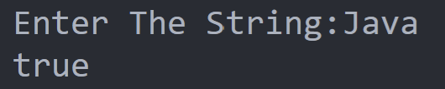

21. Write a Java program to print the transpose of a 2-dimensional array of integers

**CODE**

import java.util.*;

public class Set_2_Question_1

{public static void *main*(String[] args)

    {

        Scanner in = new Scanner(System.in);

        int r,c;

        System.out.print("Enter the Row of the 2D Matrix:");

        r=in.nextInt();

        System.out.print("Enter the Coloum of the 2D Matrix:");

        c=in.nextInt();

        System.out.print("Enter the Element of the Matrix:");

        int a[][]=new int[r][c];

        int A[][]=new int[c][r];

        for(int i=0;i<r;i++)

        for(int j=0;j<c;j++)

        a[i][j]=in.nextInt();

        System.out.println("Input Array -->\n");

        for(int i=0;i<r;i++)

        {

            for(int j=0;j<c;j++)

            System.out.print(a[i][j]+"\t");

            System.out.println();

        }

        for(int i=0;i<r;i++)

        for(int j=0;j<c;j++)

        A[j][i]=a[i][j];

        System.out.println("Transposed Array -->\n");

        for(int i=0;i<c;i++)

        {

            for(int j=0;j<r;j++)

            System.out.print(A[i][j]+"\t");

            System.out.println();

        }

        in.close();

    }

}

**OUTPUT**

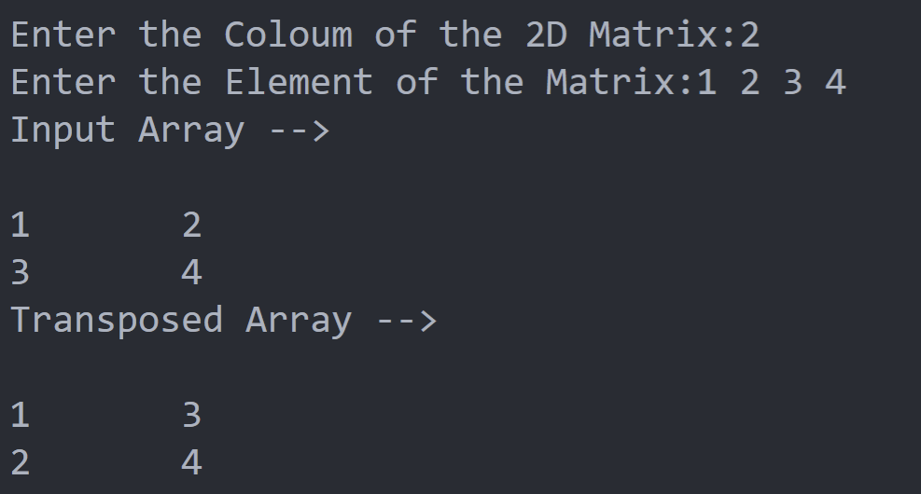

22. Write a Java program to divide the two given integers using subtraction operator

**CODE**

import java.util.*;

public class Set_2_Question_2

{

    public static void *main*(String[] args)

    {

        Scanner in = new Scanner(System.in);

        int a,b;

        System.out.print("Enter the First Number:");

        a=in.nextInt();

        System.out.print("Enter the Second Number:");

        b=in.nextInt();

        for(;a>=b;a-=b);

        System.out.print("Remainder: "+a);

        in.close();

    }

}

**OUTPUT**

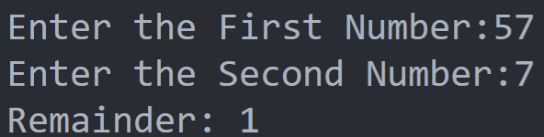

23. Write a Java program to insert and delete a specified node in the middle of a singly linked list. Sample Singly linked list: 10->20->30->40->50 Insert 25 at 3rd position: Result: 10->20->25->30->50 Delete the fourth node i.e. 40 Result: 10->20->25->40->50

**CODE**

import java.util.*;

public class Set_2_Question_3

{

    static int stack[];

    static int top;

*Set_2_Question_3*()

    {

        stack = new int[1000];

        top=-1;

    }

    static void *push*(int iteam)

    {

        ++top;

        stack[top]=iteam;

    }

    static void *push_position*(int position,int iteam)

    {

        if(position>top)

        {

            System.out.println("Addition Not Possible (Fill List to that position)");

            return;

        }

        for(int i=top+1;i>position;i--)

        {

            stack[i]=stack[i-1];

        }

        stack[position]=iteam;

        top++;

    }

    static void *Display*()

    {

        for(int i=0;i<=top;i++)

        {

            if(i!=top)

            System.out.print(stack[i]+" --> ");

            Else

            System.out.print(stack[i]);

        }

        System.out.println();

    }

    public static void *main*(String[] args)

    {

        Scanner in = new Scanner(System.in);

        Set_2_Question_3 x= new Set_2_Question_3();

        int choice=0,iteam,position;

        do

        {

            System.out.println("Enter 1 to Add Element to Linked List");

            System.out.println("Enter 2 to Add Element at Specified Position");

            System.out.println("Enter 3 to Display");

            System.out.println("Enter 4 to Exit");

            choice=in.nextInt();

            switch (choice)

            {

                case 1:

                System.out.println("Enter Element To Push!");

                iteam=in.nextInt();

                push(iteam);

                break;

                case 2:

                System.out.println("Enter Element To Push!");

                iteam=in.nextInt();

                System.out.println("Enter Position!");

                position=in.nextInt();

                push_position(position, iteam);

                break;

                case 3:

                Display();

            }

        } while (choice!=4);

        in.close();

    }

}

**OUTPUT**

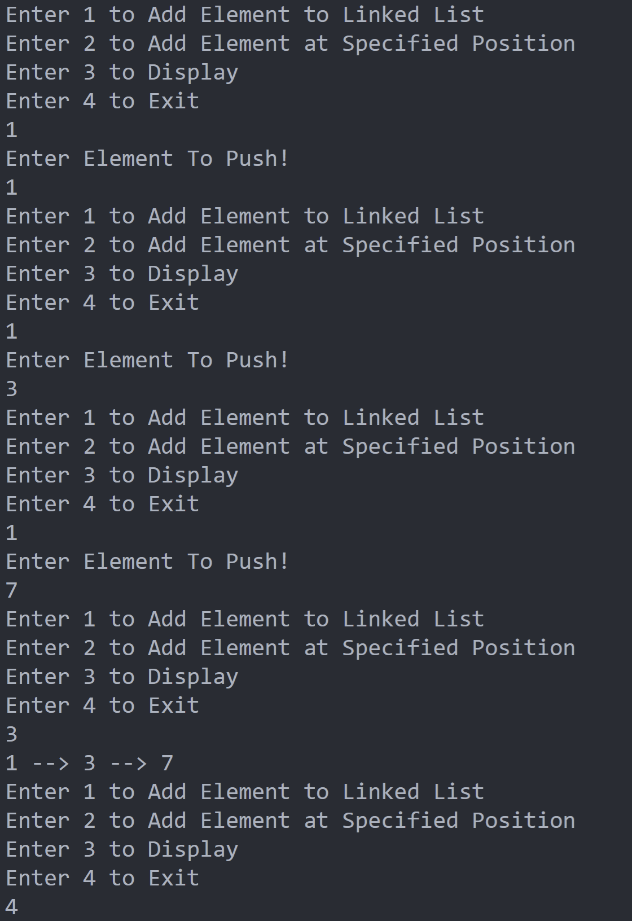

24.Write a Java program to remove duplicate letters and arrange in lexicographical order from a given string which contains only lowercase letters Original string: zxywooxz; After removing duplicate characters: xywoz

**CODE**

import java.util.*;

public class Set_2_Question_4

{

    public static void *main*(String[] args)

    {

        Scanner in = new Scanner(System.in);

        String input;

        System.out.println("Enter the String!");

        input=in.nextLine();

        char ch[]=new char[input.length()];

        ch=input.toCharArray();

        for(int i=0;i<input.length();i++)

        {

            char c=ch[i];

            for(int j=i+1;j<input.length();j++)

            if(c==ch[j])

            ch[j]='\0';

        }

        input="";

        for (char c : ch)

        input+=c;

        System.out.println("Formatted String --> "+input);

        in.close();

    }

}

**OUTPUT**

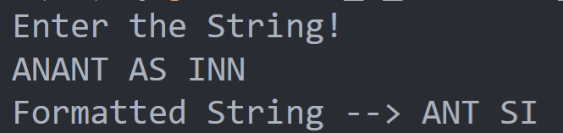

25.Write a Java program to sort a numeric array and a string array

**CODE**

import java.util.*;

public class Set_2_Question_5

{

    public static void *main*(String[] args)

    {

        Scanner in = new Scanner(System.in);

        int l1,l2;

        System.out.println("Enter Length of Integer Array!!");

        l1=in.nextInt();

        System.out.println("Enter Length of String Array!!");

        l2=in.nextInt()+1;

        int integer[]=new int[l1];

        String string[]=new String[l2];

        System.out.println("Enter the Elements of Integer Array -->");

        for(int i=0;i<l1;i++)

        integer[i]=in.nextInt();

        System.out.println("Enter the Elements of String Array -->");

        for(int i=0;i<l2;i++)

        string[i]=in.nextLine();

        for(int i=0;i<l1;i++)

        for(int j=0;j<l1;j++)

        if(integer[i]<integer[j])

        {

            int temp=integer[i];

            integer[i]=integer[j];

            integer[j]=temp;

        }

        System.out.println("Sorted Integer Array -->");

        for(int i=0;i<l1;i++)

        System.out.print(integer[i]+" ");

        System.out.println();

        for(int i=0;i<l2;i++)

        for(int j=0;j<l2;j++)

        if(string[j].compareTo(string[i])>0)

        {

            String temp=string[i];

            string[i]=string[j];

            string[j]=temp;

        }

        System.out.println("Sorted String Array -->");

        for(int i=0;i<l2;i++)

        System.out.print(string[i]+" ");

        System.out.println();

        in.close();

    }

}

**OUTPUT**

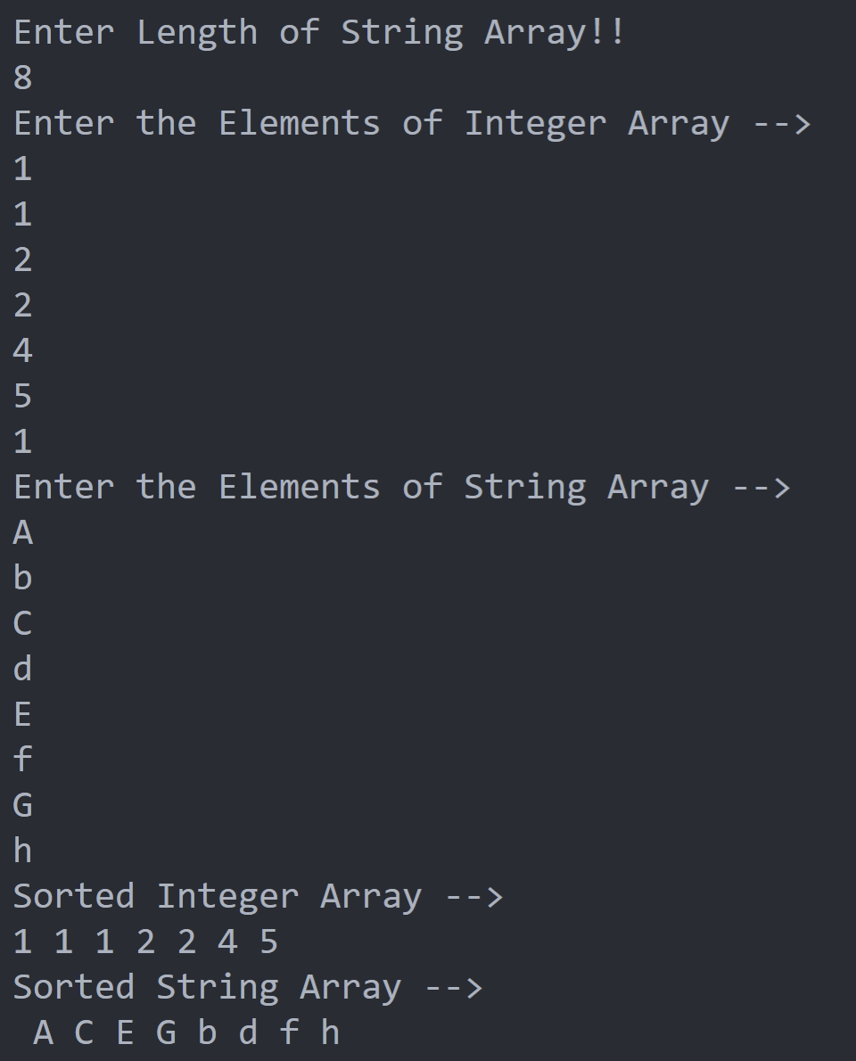

26. Write a Java program that returns the missing letter from an array of increasing letters (upper or lower). Assume there will always be one letter missing in the array. Example: Original array of elements: [p, q, s, t] Missing letter in the said array: r

**CODE**

import java.util.*;

public class Set_2_Question_6

{

    public static void *main*(String[] args)

    {

        Scanner in = new Scanner(System.in);

        int l;

        System.out.println("Enter the Length of the Array -->");

        l=in.nextInt();

        char ch[]=new char[l],c1,c2;

        System.out.println("Enter the Elements of the Array --> ");

        for(int i=0;i<l;i++)

        ch[i]=in.next().charAt(0);

        System.out.println("Missing Elements --> ");

        for(int i=0,j=1;j<l;i++,j++)

        {

            for(c1=ch[i],c2=ch[j];c1<c2;)

            {

                if(++c1 == c2)

                continue;

                System.out.print(c1+" ");

            }

        }

        in.close();

    }

}

**OUTPUT**

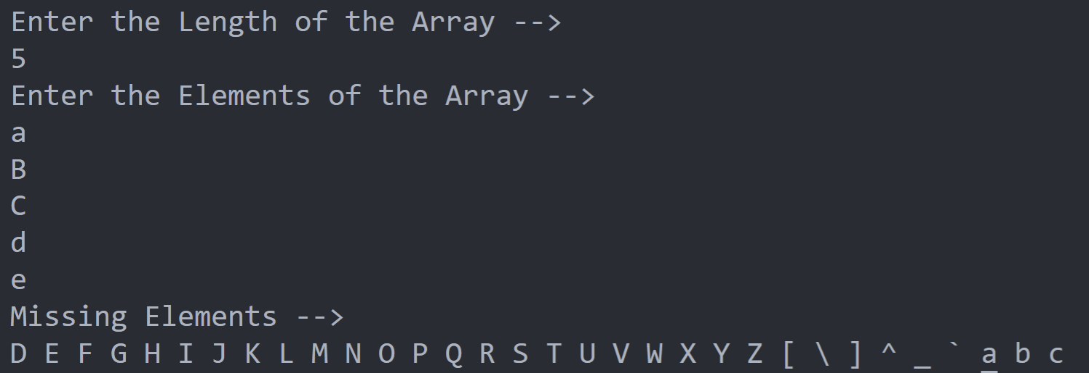

27. Write a Java program to form the largest number from a given list of non negative integers Example: Input : nums = {1, 2, 3, 0, 4, 6} Output: Largest number using the said array numbers: 643210

**CODE**

import java.util.*;

public class Set_2_Question_7

{

    public static void *main*(String[] args)

    {

        Scanner in = new Scanner(System.in);

        int l,result=0;

        System.out.print("Enter the Length of the Array:");

        l=in.nextInt();

        int integer[]=new int[l];

        System.out.print("Enter the Values --> ");

        for(int i=0;i<l;i++)

        integer[i]=in.nextInt();

        for(int i=0;i<l;i++)

        for(int j=0;j<l;j++)

        if(integer[i]>integer[j])

        {

            int temp=integer[i];

            integer[i]=integer[j];

            integer[j]=temp;

        }

        for (int i : integer)

        result=(result*10)+i;

        System.out.print("Largest number using the said array number is --> "+result);

        in.close();

    }

}

**OUTPUT**

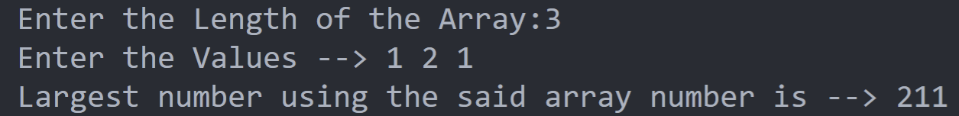

28.Write a Java program to compare two strings lexicographically. Two strings are lexicographically equal if they are the same length and contain the same characters in the same positions

**CODE**

import java.util.*;

public class Set_2_Question_8

{

    public static void *main*(String[] args)

    {

        Scanner in = new Scanner(System.in);

        String s1,s2;

        int choice;

        System.out.print("Enter First String (S1)-->");

        s1=in.nextLine();

        System.out.print("Enter Second String (S2)-->");

        s2=in.nextLine();

        System.out.println("Enter 1 to Compare S1 to S2");

        System.out.println("Enter 2 to Compare S2 to S1");

        choice=in.nextInt();

        switch (choice) {

            case 1:

            System.out.println(s1.compareTo(s2));

            break;

            case 2:

            System.out.println(s2.compareTo(s1));

            break;

            default:

            System.out.print("Enter Correct Choice!");

            break;

        }

        in.close();

    }

}

**OUTPUT**

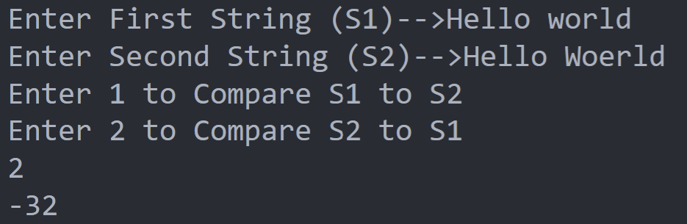

29.Write a Java program to get the contents of a given string as a character array

**CODE**

import java.util.*;

public class Set_2_Question_9

{

    public static void *main*(String[] args)

    {

        Scanner in = new Scanner(System.in);

        String string;

        System.out.println("Enter the String -->");

        string = in.nextLine();

        char ch[]=new char[string.length()];

        ch=string.toCharArray();

        System.out.println("Given String as Character Array -->");

        for (char c : ch)

        System.out.print(c+" ");

        in.close();

    }

}

**OUTPUT**

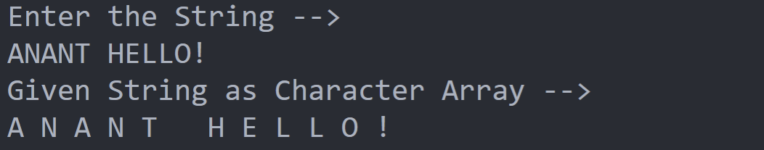

30.Write a Java program to return a new string using every character of even positions from a given string

**CODE**

import java.util.*;

public class Set_2_Question_10

{

    public static void *main*(String[] args)

    {

        Scanner in = new Scanner(System.in);

        String input,output="";

        System.out.println("Enter the Given String -->");

        input=in.nextLine();

        System.out.println("Input --> "+input);

        for(int i=1;i<input.length();i+=2)

        output+=input.charAt(i);

        System.out.println("Output --> "+output);

        in.close();

    }

}

**OUTPUT**

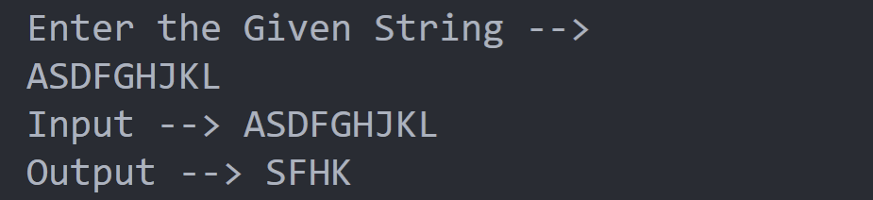

**NAME-ANANT KISHORE REG. NO. – 21BIT0553**