Week 3

1. Create a collection by the name blogPosts and it has 3 fields id, title and comments. In the collection the comments field is an array which consists of user details. Each collection consists of two user details inside the comments array- user name and text Demonstrate the following 1. Adding an element into araay

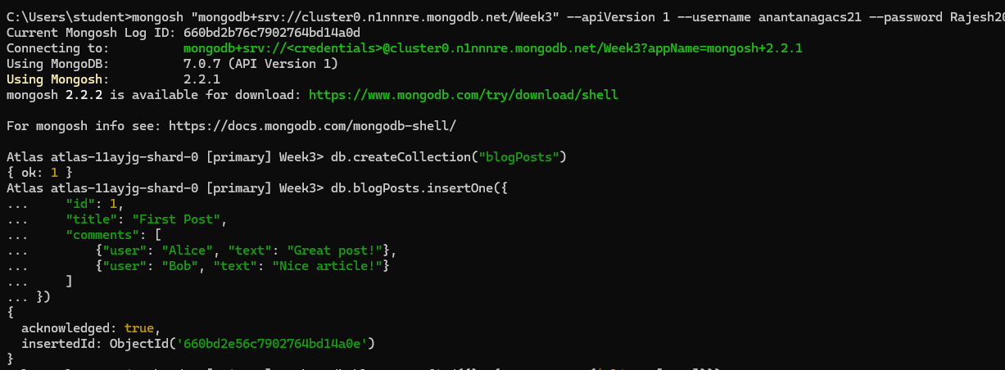

1. **Displaying the second element**:

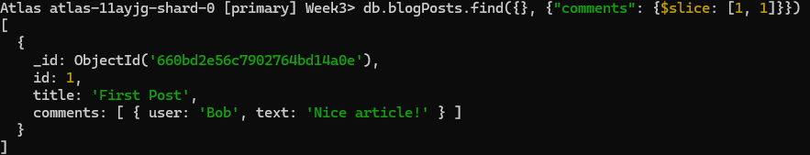

3. **Displaying the size of the array**: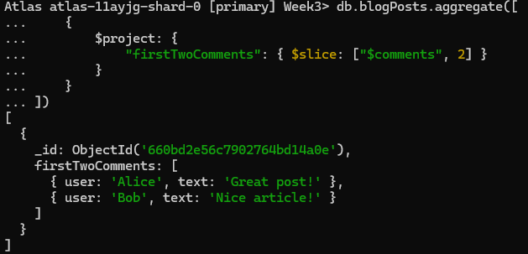

**4.** **Update the document with id 4 and replace the element present in the 1st index position of the array with another array**:

