

Comparing SQL Server 2005 and DB2 8.2: Focus on Development Productivity
SQL Server Technical Article

Published: July 2005

Summary: This white paper compares and contrasts SQL Server 2005 and DBA UDB 8.02 for the Microsoft Windows Platform with respect to features of interest to developers. The features discussed include both the database features and programming tools available on both platforms and how these features affect programmer productivity.

Copyright
The information in this document and any document referenced herein is provided for informational purposes only, is provided AS IS AND WITH ALL FAULTS, and cannot be understood as substituting for customized service and information that might be developed by Microsoft Corporation for a particular user based upon that user's particular environment. RELIANCE UPON THIS DOCUMENT AND ANY DOCUMENT REFERENCED HEREIN IS AT THE USER'S OWN RISK.

MICROSOFT CORPORATION PROVIDES NO WARRANTIES, EXPRESS, IMPLIED, OR STATUTORY, AS TO THE INFORMATION CONTAINED IN THIS DOCUMENT AND ANY DOCUMENT REFERENCED HEREIN. Microsoft Corporation provides no warranty and makes no representation that the information provided in this document or any document referenced herein is suitable or appropriate for any situation, and Microsoft Corporation cannot be held liable for any claim or damage of any kind that users of this document or any document referenced herein may suffer. Your retention of and/or use of this document and/or any document referenced herein constitutes your acceptance of these terms and conditions. If you do not accept these terms and conditions, Microsoft Corporation does not provide you with any right to use any part of this document or any document referenced herein.

Complying with the applicable copyright laws is the responsibility of the user. Without limiting the rights under copyright, no part of this document may be reproduced, stored in or introduced into a retrieval system, or transmitted in any form or by any means (electronic, mechanical, photocopying, recording or otherwise), or for any purpose, without the express written permission of Microsoft Corporation.

Microsoft may have patents, patent applications, trademarks, copyrights, or other intellectual property rights covering subject matter within this document. Except as provided in any separate written license agreement from Microsoft, the furnishing of this document does not give you, the user, any license to these patents, trademarks, copyrights or other intellectual property.

Information in this document, including URL and other Internet Web site references, is subject to change without notice. Unless otherwise noted, the example companies, organizations, products, domain names, e-mail addresses, logos, people, places, and events depicted herein are fictitious, and no association with any real company, organization, product, domain name, e-mail address, logo, person, place, or event is intended or should be inferred.

Microsoft, Visual Basic, Visual Studio, Windows, and Windows Server are either registered trademarks or trademarks of Microsoft Corporation in the United States and/or other countries.

© 2005 Microsoft Corporation. All rights reserved.

The names of actual companies and products mentioned herein may be the trademarks of their respective owners.

Contents
Introduction 1
Summary of Results 2
Visual Studio and .NET CLR Integration 2
Visual Studio Integration 2
.NET Integration 3
Developing SOA Applications 3
Transaction Isolation Choices 3
Procedural Extensions to SQL 4
Development of Procedural Code and Integration with the .NET Common Language Runtime 4
Integration with Visual Studio 8
Transaction Isolation Options 13
Service-Oriented Architecture Support-Related Features 15
Query Notifications 20
Transact-SQL Functionality and DB2 SQL 20
Additional Developer Tools and Frameworks 22
Comparison Summary 23
About the Author 26

Introduction
Almost every business application uses a relational database to safely store and manage data and to guarantee correct semantics when the data is being accessed by many simultaneous users. Using a database creates the necessity for database code to work in conjunction with other parts of the application code. Designing, developing, testing and verifying the correctness the database code for an application is the most time-consuming and error-prone part of any application that uses a database. Although the major relational databases provide many of the same features, programmer productivity is often overlooked as a key feature that contributes significantly to development costs and to total cost of ownership in any data-centric application.
This white paper is targeted at technology decision makers, IT managers, architects, and database application developers. This paper compares the features of Microsoft® SQL Server 2005 and DB2 Universal Database (UDB) 8.2 that are of interest to developers that are using .NET and Microsoft Visual Studio® to develop applications. Because DB2 is available on a variety of platforms with different functionality levels on a per-platform basis, the comparison will be limited to a number of different functionality areas. The exact parameters of the comparison are defined as follows. Additionally this paper will describe applications scenarios that will be facilitated by the new SQL Server 2005 functionality.
Basis for Comparison — Platforms and Database Editions:
SQL Server 2005 is available on Microsoft Windows® operating systems, including Microsoft Windows Server™ 2003, Windows XP Professional, and Windows 2000 Server. It is available in a 32-bit version for x86 processors and a 64-bit version. DB2 is available on different kinds of computer hardware and operating systems and the features are subtly different depending on which platform is chosen. This paper restricts the comparison to DB2 UDB version 8.2, which runs on Windows, Linux, or Unix operating systems. Additionally, it will compare the feature set for the 32-bit OS versions.
Both SQL Server 2005 and DB2 UDB 8.2 come as different feature versions with different licensing models. The SQL Server 2005 versions include a version called SQL Server Express, designed to allow developers to embed SQL Server in their own products. There is a similar IBM product, designed for a similar purpose, called DB2 UDB Express Edition. SQL Server Express is essentially free for development and deployment; DB2 Express is a cost item, but costs under $1000 per seat. SQL Server 2005 and other versions of SQL Server can communicate with a database version on Windows CE-based mobile devices running the SQL Server CE edition. DB2 UDB communicates with a variety of mobile and embedded devices, running a variety of operating systems, using a product called DB2 Everyplace. Using the same database on mobile devices and the main data repository facilitates data integration and makes it possible for programmers to take advantage of their current development skills. In this paper, we're going to concentrate on enterprise developer features without much discussion of specific feature matrices and without any discussion of mobile or embedded versions.
Although the main function of a relational database is to support the relational data model, both SQL Server 2005 and DB2 UDB 8.2 support nontraditional and nonrelational data access and storage, as part of an integrated product/feature line. We'll be covering these features as well, from a developer perspective.
Objective: This paper compares SQL Server 2005 and DB2 UDB 8.2 from the perspective of the Visual Studio database developer. The focus is on answering the question: "Which of the two databases is a more productive application development platform for the database application developer"?

Summary of Results
The observations in the paper are based on the publicly documented features and public statements of SQL Server 2005 and DB2 8.2. These features were selected because of their impact on application design or programmer productivity; both of these can reduce total cost of application ownership. The features can be used to simplify design or providing more granular design choices, and in addition make coding, testing and deployment easier and less error-prone. Here is the summary of the author's findings. The rest of the paper expands on these observations in detail.

Visual Studio and .NET CLR Integration
While both DB2 UDB 8.2 and SQL Server 2005 have been integrated with Visual Studio and the .NET, SQL Server's integration is more comprehensive, more seamless, more functional, and better performing than DB2 UDB 8.2.

Visual Studio Integration
DB2 UDB provides integration with Visual Studio as a plug-in to Visual Studio called "IBM DB2 Development Add-Ins for Visual Studio .NET." The DB2 add-ins offer quite a bit of Visual Studio functionality, but do not offer some important features that have an impact on developer productivity, including:
- Debugging of .NET stored procedures through Visual Studio. DB2 UDB 8.2 does allow SQL stored procedures to be debugged using Visual Studio.NET, but does not allow .NET stored procedures to be debugged. Developers will have to use a separate tool for debugging.
- Automatic deployment of all .NET database objects. DB2 UDB 8.2 does allow deployment of .NET procedures using a Visual Studio .NET DB2 Database Project. However, .NET user-defined functions (UDFs) may not be automatically deployed. SQL Server 2005 permits automatic deployment of all .NET database objects without the need to create a separate Database Project.
- Integration of BI Technologies: All of SQL Server BI technologies including Analysis services, Reporting Services and Integration Services are integrated with Visual Studio. However, none of DB2 UDB 8.2's BI technologies such as Warehouse Center or DB2 Intelligent Miner as integrated in any way with Visual Studio. Therefore, a .NET developer who wants to incorporate DB2's BI capabilities into their applications will have to learn to use a different tool, adversely affecting developer productivity.
The bottom line is that while SQL Server is completely integrated with Visual Studio, DB2's integration does not cover all of the developer requirements. With SQL Server, a .NET developer does not usually need any other tool beside Visual Studio for most aspects of application development. Other SQL Server 2005 tools, like SQL Server Management Studio, have the same look and feel. On the other hand, DB2 UDB 8.2 will require the use of its Java-based proprietary tools in addition to Visual Studio, resulting in a suboptimal development experience, increased learning curve and decreased productivity for the developer.

.NET Integration
On the surface it would appear that both DB2 UDB 8.2 and SQL Server 2005 offer the same type of integration with the Microsoft .NET CLR. However on a closer examination, it is clear that SQL Server has a tighter integration that offers more functionality, better performance and better manageability than DB2 UDB 8.2. The main reason for this difference is that while SQL Server hosts the .NET CLR "in-process," DB2 UDB hosts it "out-of-process." To the developer, this means that using .NET code can provide a significant performance boost over traditional procedural SQL extensions, making it another useful tool in the programmer's toolbox. Out of process CLR integration does not provide any significant advantage over separating the code into a different application tier.

Developing SOA Applications
Both DB2 UDB 8.2 and SQL Server provide the same basic set of features to enable the development of SOA based applications. However the difference in the way these are implemented in SQL Server simplifies the application topology and makes programming and deployment less error-prone SQL Server has easy to use features that are included in the database server and are seamlessly integrated. DB2 UDB 8.2 has spread the functionality across multiple products (database, application server, and queuing system) and the features are not well integrated. Furthermore many of the APIs are based on Java standards (such as Java Messaging Service) and offer no value to the .NET developer. SQL Server provides a well-designed, better-integrated, and more-productive platform for developing SOA applications than DB2 UDB 8.2.

Transaction Isolation Choices
One of the most important features of a database with respect to developing applications is support of transaction isolation. Both SQL Server 2005 and DB2 UDB 8.2 support transaction isolation using locking. However, only SQL Server 2005 offers the developer a choice of using locking or versioning to implement isolation. Being able to mix isolation styles also means the developer has the flexibility to spot-tune a piece of the application by using versioning. Long-running operations such as recalculations or reports can be completely consistent without affecting the other users. This increases programmer productivity because designing around long-running operations may make an application unnecessarily complex.

Procedural Extensions to SQL
SQL is the language that must be used to access data in a relational database, regardless of whether procedural code is written in .NET or SQL procedural extensions. SQL Server 2005's SQL-based extensions (Transact SQL) are richer than DB2 UDB 8.2's SQL/PL and Transact SQL offers a more natural way to accomplish exception handling. Transact SQL in SQL Server 2005 also includes OLAP functions and extensions to SQL functions not available in DB2 UDB 8.2. A more powerful procedural adjunct to SQL makes database programmers more productive. Richer, and less tedious error handling, makes for less complex and error-prone application code.
These observations are explained in greater detail later in the paper.

Development of Procedural Code and Integration with the .NET Common Language Runtime
The primary programming APIs supported by SQL Server 2005 are .NET, OLE DB/ADO and ODBC. In the case of SQL Server 2005, you can use .NET-based libraries to develop not only traditional client and middle tier code, but also procedural code and libraries that run inside SQL Server itself. You can also write code that performs administrative and monitoring tasks, code for Analysis Services (OLAP), and extensions to such SQL Server features as Integration Services, Reporting Services and Notification Services. This code is almost always developed using Visual Studio.NET. On DB2 UDB 8.2, Windows programmers can develop procedural code using SQL, Java, the .NET common language runtime, embedded programming using COBOL, or other languages. Using the .NET common language runtime on the server is only supported on DB2 UDB 8.2 for Windows. DB2 developers use a variety of development environments, and DB2 UDB has built-in support in the form of additions to Visual Studio.NET and Visual Studio 6.0. Execution engine-based languages facilitate rapid application development; .NET also adds the ability for a company to choose the programming language that matches the skill sets of their programmers.
SQL Server has always supported in-database procedural code that is written in Transact-SQL. Transact-SQL is a set of procedural extensions to SQL that is loosely related to ISO-ANSI SQL/PSM (persistent stored modules), defined in part 3 of the ANSI SQL specification. Transact-SQL is not completely compliant with SQL/PSM, but it does go beyond SQL/PSM to support additional system-defined aggregate, data manipulation, and mathematical functions. You write stored procedures to take advantage of the proximity of the code to the data; this cuts down on the number of network round trips from client to server. Additionally stored procedures are a way to ensure centralized administration and security.
In SQL Server 2005, procedural code can be written in .NET languages as well as Transact-SQL. C#, Visual Basic®.NET, and Managed C++ are specifically supported, but other .NET languages such as Fujitsu COBOL.NET can be used as well. The database objects that can be written in either .NET or Transact-SQL include stored procedures, user-defined functions, and triggers.
DB2 UDB supports procedural extensions to SQL by means of SQL PL programming. SQL PL is an implementation of procedural programming that is very close to ANSI SQL/PSM. There are a few DB2 extensions to SQL/PSM, but the implementation provides what is specified in the standard.
In DB2 UDB 8.2 running on Microsoft Windows operating systems, you can write stored procedures and user-defined functions in .NET languages. .NET joins Java, SQL PL, COM-based programming, and other languages such as traditional C and C++ as platform for DB2 procedural programming. Using .NET languages, you can write stored procedures and user-defined functions, triggers must be written in SQL PL. Writing code in a .NET language instead of SQL is better for performance when the code uses or implements complex mathematical formulas. This is especially true because Transact SQL runs under an interpreter. In DB2, the interpreter is a relatively new feature; Transact-SQL has always run interpreted. .NET code can access external resources (such as files, the event log, the registry, or external Web services) and can use existing .NET libraries such as the regular expression library (RegEx).
The major difference between SQL Server 2005 .NET procedures and DB2 UDB .NET procedures is how they are implemented. SQL Server 2005 hosts the .NET runtime directly in SQL Server's process (a Windows service). Because .NET procedures run in SQL Server's process, they are faster in some cases than Transact-SQL procedures (see the online paper "Using CLR Integration in SQL Server 2005" for a discussion of whether Transact-SQL or .NET procedures are faster for specific use cases). .NET procedures that run in process would always be faster than code that runs out-of-process, either in a different instance of SQL Server or in a separate middle-tier process.
Normally it is not a good idea to run native code directly inside a database process. Differences in memory management strategy, threading other resource management between a runtime (.NET) and SQL Server get in the way. The reason that it's possible (and safe) to run .NET code in SQL Server's process is that the .NET version 2.0 hosting APIs were updated to give the runtime host (in this case, SQL Server) the ability to control how the runtime should handle resource management. This feature is only available in .NET 2.0. SQL Server uses this host control feature to ensure that .NET cannot leak memory, load code not under SQL Server's control, or do anything else to affect the reliability and scalability of SQL Server. There are three code safety levels defined by SQL Server, which safety level is used is dependent not only on the DBA's choice, based on the fact that .NET reflection and special code attributes are used to prohibit code at the SAFE or EXTERNAL_ACCESS level from using unsafe programming practices. The final safety level, UNSAFE, is more like a safer extended stored procedure.
SQL Server procedural code can also be written as extended stored procedures (XPs), using the Open Data Services API. Additionally through special system stored procedures, code can call out to COM objects that are loaded into SQL Server's process. Because this code is not subject to any SQL Server controls, it's much less safe than .NET code. A well-meaning but badly written XP could cause memory leakage, thread management problems, or corrupt SQL Server's memory buffers. .NET code (except when using the UNSAFE level) will not cause these problems.
With SQL Server 2005 you can write stored procedures, user-defined functions and triggers in .NET code. DB2 UDB supports stored procedures and user-defined functions but not triggers. Additionally .NET user-defined types and user-defined aggregates can be created in SQL Server but not with DB2 UDB. We'll be discussing UDTs and UDAs in the next section.
DB2 UDB 8.2 runs .NET 1.1, a version that has very few knobs for host control. Because there is no way for DB2 UDB to control .NET code, it must run as FENCED NOT THREADSAFE mode. This means that each instance of any .NET procedure runs in its own process (an instance of db2fmp.exe). Although this ensures database reliability, this makes the code far less scalable than SQL PL code. SQL PL code always runs in the same process as DB2, as does C and C++ code that is specified as NOT FENCED. DB2 UDB DBAs can specify highly trusted code as NOT FENCED; this is roughly equivalent to a SQL Server extended stored procedure.
DB2 UDB 8.2 has a third option for code safety, known as FENCED THREADSAFE. Code running with this option runs a single execution engine with all instances of VM-based code sharing a single process. Java code can run as FENCED THREADSAFE in DB2 UDB 8.2 but .NET code cannot. This means DB2's .NET based code is confined to the least scalable execution choice.
One final difference is that, in SQL Server, .NET assemblies are cataloged to the database as ordinary database objects using the CREATE ASSEMBLY syntax. Assemblies are subject to security, are backed up and restored using ordinary database tools, and can be moved with the database. In DB2 UDB, the .NET assemblies are stored on the file system and must be secured and managed separately.
Both SQL Server 2005 and DB2 UDB 8.2 come with a .NET data provider. This provider is not only useful on the client side, but is used to access data inside .NET stored procedures, UDFs, and triggers. Although it is usually faster to access data using SQL, using the same .NET code to access data and do computations minimizes the extra instructions needed when .NET code needs to call SQL and do computations. An example where this would be beneficial would be code that does a large number of database fetches to perform a mathematical function, such a scientific analysis of many data points. Because the code is integrated with a database context, each provider has a "context class" (SqlContext and DB2Context) that encapsulates the connection and other database environment information. Because SQL Server 2005 .NET code runs in process with SQL Server, the classes in SQL Server's data provider are implemented to be more tightly integrated to provide better performance. Because SQL Server 2005 .NET code can be used to implement database triggers, a special SqlTriggerContext class encapsulates the information that a database trigger might use, such as access to data about what caused the trigger to fire and pseudo-tables that represent before and after data values. In addition the SQL Server data provider does not impersonate the caller or owner by default for added security. A WindowsIdentity property is exposed on the SqlContext in case the procedure needs to use impersonation manually. DB2 UDB also uses the Windows Identity.
User-defined aggregate and user-defined type support
SQL Server 2005 supports user-defined aggregates, coded as .NET classes. The new aggregate functions are defined to SQL Server using the CREATE AGGREGATE DDL statement. You implement user-defined aggregate classes by coding four well-known methods; you specify serialization details and optimization hints for the SQL query engine by means of the .NET SqlUserDefinedAggregate attribute class. The aggregate functions can be used anywhere in the SQL statement where system-defined aggregates are allowed, including the new ranking functions. The data type that is being aggregated is not necessarily the type returned by the aggregate; for example you could use a user-defined aggregate the counts the number of actual characters in VARCHAR fields; however that aggregate would return an INTEGER data type. User-defined aggregates are useful to implement domain-specific aggregate formulas. They are preferable to implementing the same function using a SQL cursor because the SQL query engine can operate on them using parallel processing and integrate them with the query plan. DB2 UDB 8.2 does not provide built-in user-defined aggregates; although you can code aggregate functions, these cannot be used by the query engine in all of the cases that built-in aggregates can.
Both SQL Server 2005 and DB2 UDB 8.2 provide support for two kinds of user-defined data types. The first kind of user-defined type is simply an alias for a type that already exists in the database. As an example, the type ZIPCODE can be defined as an alias for the SQL type VARYING CHARACTER(9). These are called user-defined data types (UDDTs) in SQL Server and distinct types in DB2 UDB. Distinct types are part of the ANSI SQL-2003 specification.
DB2 UDB also supports SQL structured types. These types can contain multiple data attributes, as relational tables do. Structured types can contain instances of other structured types as attributes and can also contain references to other structured types. Accessor and mutator methods are automatically generated for each attribute, but you can also define other instance methods. The structured type is always defined using the SQL CREATE TYPE statement. After the type is created, methods (other than the built-in attribute accessors and mutators) are added by using a separate CREATE METHOD DDL statement. Methods can be implemented in C++, Java, and some other languages, but cannot be SQLCLR code. In addition to using a structured type as a column in a table, you can also create typed tables and views.
DB2 UDB structured types can use object-oriented concepts such as inheritance and dynamic method dispatch. You define inheritance hierarchies by using the "UNDER" keyword in the CREATE TYPE statement. Dynamic method dispatch refers to the fact that methods of the base type can be reimplemented in derived types; at runtime, control will be dispatched to the appropriate method implementation depending on which type is used.
Support of specific functionality above the user-defined type functionality is provided in DB2 UDB 8.2 through an Extender architecture. Extenders may include user-defined types, user-defined functions, special tools, support applications, and APIs.
While SQL Server UDTs can be structured types or simple types in theory, it is not recommended to use UDTs for data that contains more than a single fact. For example, even though a date can be represented as month, day, and year, a date represents a single fact. SQL Server UDTs are meant to extend the scalar type system, not to implement structured types. SQL Server UDTs do not support inheritance or dynamic method dispatch when invoked from Transact-SQL. You can use UDTs as columns, but SQL Server has no concept of typed tables, typed views, or references to types.
SQL Server UDTs are implemented as .NET classes. These classes contain a .NET attribute class that defined to SQL Server how to allocate storage for the class and how to persist it in the database. The persisted representation is limited to 8000 bytes. .NET classes that are used as UDTs must implement a few well-known properties, methods, and interfaces so they behave like built-in SQL types. Although Transact-SQL does not "see" inheritance relationships, the classes can be implemented using .NET inheritance, and direct .NET-to-.NET calls will use the .NET object oriented concepts. Method overloading is specifically not supported. Public properties and fields of the class can be used as accessors and mutators, but only one mutator at a time can be specified in a Transact-SQL update statement. Additional public methods of the class are visible to Transact-SQL, a custom .NET attribute class is used to inform Transact-SQL whether these methods have accessor or mutator semantics.

Integration with Visual Studio
Both SQL Server 2005 and DB2 UDB provide integration with Visual Studio. Each provides both a data management and deployment Visual Studio project type along with a .NET CLR component project type. SQL Server 2005 also includes support for six different types of reporting ad business intelligence projects. Both SQL Server 2005 and DB2 UDB provide Visual Studio debugging of SQL procedural code, only SQL Server 2005 integration provides debugging of .NET procedural code.
The development tool of choice for programmers developing and debugging .NET procedural code for SQL Server 2005 is Visual Studio 2005. You can use two different project types with SQL Server databases, Database Projects and SQL Server Projects. You can also write client code in the same development environment.
You use a Database Project to write and debug Transact-SQL scripts. Template scripts are available for tables, views, stored procedures, and triggers. Additionally there is a graphic query builder that you can use when you add a new database query to the project. The layout of a Database Project is shown in Figure 1.
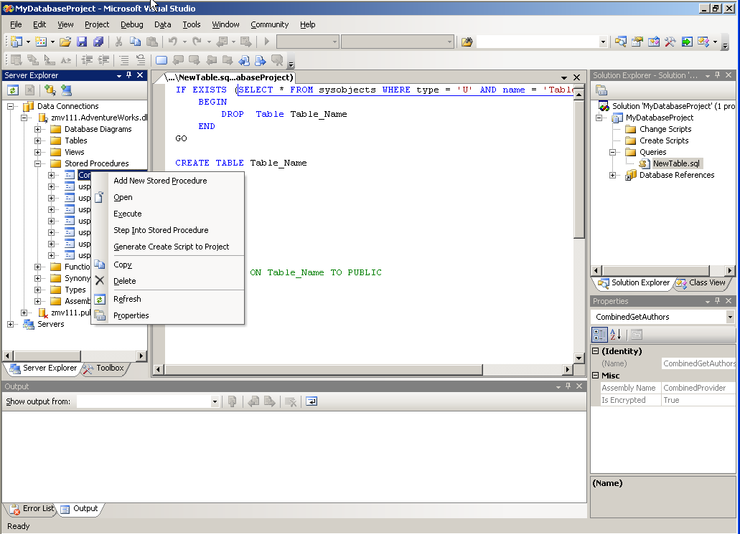
Figure 1 A Visual Studio Database Project
You use a SQL Server Project to write and debug CLR code that will be inside the database. SQL Server Projects are available for C#, VB.NET, and C++ languages. Template classes are available for stored procedures, user-defined functions, triggers, user-defined types, and user-defined aggregates. These database objects can be automatically deployed to the database and instance of your choice. Automatic deployment supports CREATE functionality but not ALTER functionality for CLR objects. You can write test scripts that are part of the project and debug using the test script of your choice with automatic debugging by choosing Debug/Start from the project's menus. Visual Studio 2005 permits a developer to debug Transact-SQL code as well as SQLCLR code, and you can debug from Transact-SQL into SQLCLR as well as the reverse. The developer can also debug from client-side code into Transact-SQL or SQLCLR procedural code or debug all three types of code simultaneously.
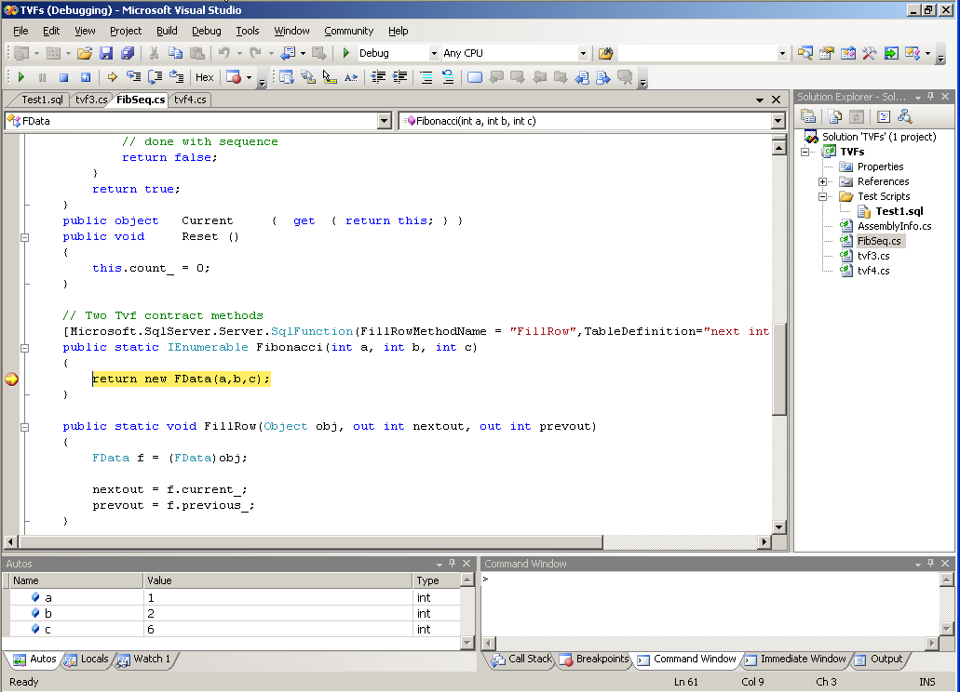
Figure 2 Debugging SQL Server 2005 code in Visual Studio
Visual Studio Server Explorer allows a programmer to explore SQL Server database objects. You can get a graphic tree view of tables, views, functions, procedures, synonyms, types, and assemblies. Most of the database object definitions are updatable in place, and the data in the objects can be viewed and updated in place with a "show data" menu entry, subject to the permissions of the user/programmer.
DB2 UDB 8.2 comes with additions (IBM DB2 Tools) for Visual Studio and Visual Studio 2003. The Visual Studio 2003 additions are worth further discussion, as these are a closer fit to the SQL Server 2005 extensions. You can use two different project types, DB2 Database Project and DB2 Class Library.
DB2 Database Projects are used to create and deploy database objects. There are templates and wizards to allow you to create and deploy tables, indexes, triggers, views, procedures, functions, and scripts. The database object wizards consist of a series of panels that guide you graphically through all of the steps and options that the object (for example, a table or view) provides. If you do not need graphic assistance, you can choose a template and code the details of the object definition yourself. There is also a wizard for CLR procedures which, in conjunction with the DB2 Class Library project, allow you to build and deploy the definition for a SQLCLR procedure to the database. You create the .NET code for the procedure with a DB2 Class Library project. The class library project contains a reference to the appropriate DB2 .NET data provider assembly and a template procedure. There does not appear to be any integrated debugging of SQLCLR procedures that run in DB2, though DB2 SQL PL procedures can be debugged in Visual Studio.
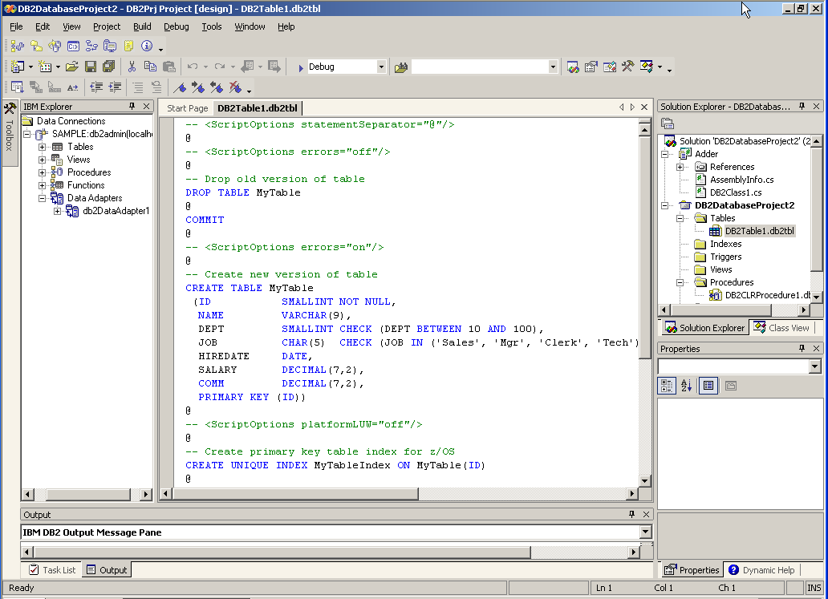
Figure 3 A DB2 Database Project
Although you can view DB2 tables, views, and procedures with Visual Studio Server Explorer, much more functionality is available for the DB2 database by using the IBM Explorer add-in. The IBM Explorer includes functionality for DB2 databases this is similar to Server Explorer's functionality for SQL Server. This includes the ability to view and create tables, indexes, triggers, views, procedures, and functions using a series of wizards. Additionally you can view and update data in tables and views, and filter the data that is shown in the view/update pane as well. For Windows .NET clients, there is an option to create a DB2DataAdapter (an object that encapsulates SELECT/INSERT/UPDATE/DELETE) on IBM Explorer. There is a wizard for this when using SQL Server.
Visual Studio 2005 can be used with a variety of Business Intelligence projects as well. Integration exists for SQL Server Analysis Services, SQL Server Integration Services, SQL Server Reporting Services and others. The list of available SQL Server Business Intelligence projects is shown in Figure 4. DB2's business intelligence projects are not integrated with Visual Studio.
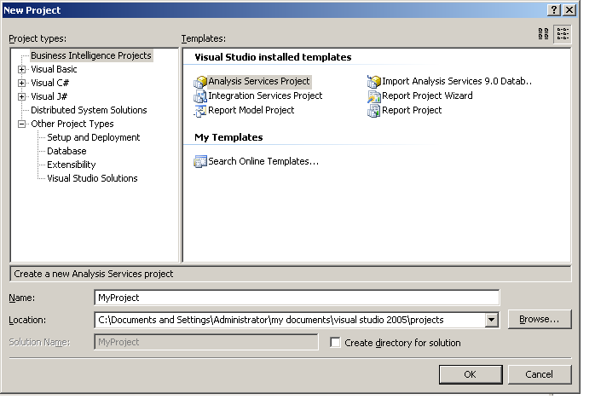
Figure 4 SQL Server Business Intelligence Projects
Other tools of interest to the application developer
SQL Server 2005 application developers can use other tools to develop, profile, and troubleshoot applications inside the database. SQL Server Management Studio (SSMS) is a tool that is shared between developers and DBAs. Although SSMS runs as a separate tool, it shares much of the basic look and feel and functionality, including Solutions and source code integration, with Visual Studio. With SSMS, you can use templates to develop procedures and other database objects. You can use SSMS to the query the database directly as well. Textual and graphic query plans are available for troubleshooting queries. In SSMS, the graphic query plan can also be saved in an XML format for full-fidelity review by other developers. Visual Studio can be used to develop and deploy reports as well as projects for integration and OLAP services. We'll discuss this later in the paper. SQL Server Profiler gives developers the ability to do real-time monitoring and tracing of SQL Server queries. SQLCMD is a command-line tool that can be used to run scripts. Running scripts is accomplished directly from the command-line or through scheduling SQL Agent jobs.
DB UDB 8.2 application developers use the graphic Command Center tool to develop and catalog procedural code and the CLP (command line processor) tool to execute them. You can use Query Patroller and Visual Assist to profile a query or get a graphic representation of a query plan.
The following list correlates developer tools between the two databases

Function | DB2 Tool | SQL Server Tool
GUI-based Query and Development | Command Center, Visual Studio | Visual Studio, SSMS
Develop DB Objects | Development Center, Visual Studio | Visual Studio, SSMS
Assisted Database Object Development | SQL Assist | Visual Studio, SSMS Templates
Command-line Processing | CLP | SQLCMD
Query Management | Query Patroller | Visual Studio, SSMS
Visual Plans | Visual Explain | SSMS Showplan
Query Profiling | Query Patroller | SQL Server Profiler
Schedule and run tasks and notify admins/devs | Task Center | SSMS

Transaction Isolation Options
Both SQL Server 2005 and DB2 UDB support the four ANSI SQL standard transaction isolation levels and implements them using locking. SQL Server 2005 and DB2 UDB use a combination of shared and exclusive locks to accomplish the necessary isolation, both lock at the row level by default, and use lock escalation techniques when the number of total locked rows are large. DB2 UDB 8.2 gives the DBA a little more granular control over lock escalation by control of the maxlock (percent of locks taken before lock escalation occurs) and locklist (maximum size of the lock list) parameters. The default isolation level of SQL Server 2005 and DB2 UDB is READ COMMITTED. This type of transaction isolation is also known as pessimistic isolation.
Both SQL Server 2005 and DB2 UDB have an implicit transaction mode. Implicit transactions are defined by the behavior that work is implicitly composed in a single transaction until COMMIT is called (also called setting autocommit off). SQL Server 2005 also supports user-defined transaction boundaries with transaction nesting by using BEGIN TRANSACTION/END TRANSACTION statements in Transact-SQL.
SQL Server 2005 adds the ability to accomplish isolation by versioning; that is, storing different versions of rows. Either statement level versioning or transaction level versioning can be specified. Using either type or versioning, writers will not block readers and readers will not lock by default (there is a query hint to force a read lock). Using statement level versioning, readers read always data as of the last committed transaction. Transaction level versioning reads consistent data as of the beginning of the transaction. Databases that support isolation by means of versioning must provide conflict detection so that attempting an update based on old data that has already been updated by a different user will cause the update to roll back. Versioning also includes the extra overhead of storing old versioning of rows in the process of being updated. SQL Server 2005 stores them row copies in the TEMPDB database. Support of transaction isolation by versioning is also known as optimistic isolation.
SQL Server 2005 supports transaction level versioning through a new transaction isolation level, called SNAPSHOT. Statement level versioning is accomplished by setting a database-level option. This option makes statement level versioning the default, that is, transactions started at the read committed isolation level will use statement-level versioning. Versioning is disabled by default; no versions will be saved unless one of the versioning options is enabled on the database.
The transaction isolation choices are listing in the following table.

Isolation Level | Special Options | Behavior | SQL Server  2005 | DB2 UDB 8.2
Read Uncommitted |  | RU locking | X | X
Read Committed |  | RC locking | X | X
Read Committed | DB Option | Statement level snapshot | X
Repeatable Read |  | RR locking | X | X
Serializable |  | Serializable locking | X | X
Snapshot | DB Option | Transaction level snapshot | X

Support of snapshot isolation enables SQL Server programmers to use selective application of snapshot semantics to resolve deadlock problems. Additionally, support of snapshot isolation eases conversion of applications that were built using versioning semantics (the two most well-known versioning databases are Oracle and RDB). Normally, applications are converted from versioning databases to locking databases must be rearchitected to avoid transaction deadlock and overall database slowdown because of locking. With SQL Server 2005 such conversion is much easier.
In general, snapshot isolation increases concurrency and reduces locking. For this reason, it is also known as "optimistic concurrency." Programming optimistic concurrency can be accomplished at the application level in a locking database by means of management through time stamps, or can be built into the database's transaction management. Building optimistic concurrency into the database makes application programming less complex and less error-prone. This feature is particularly useful in relational systems when there is little chance that two users will be trying to update the same row at the same time. An example would be a Web front-end, where users are modifying their own data only. In this case, it's likely that using optimistic concurrency could speed reporting and list processing, because data writers do not block data readers.
Implementation of versioning and locking give the database application designer more flexibility to use the best, most efficient transaction isolation level for the job. Versioning also gives the developer the ability to "spot tune" an application with a deadlock or lock conversion problem without rewriting the application in its entirety.

Service-Oriented Architecture Support-Related Features
XML Support
XML data can be stored in a relational database in three basic ways:
- Large character fields
- Decomposition and composition to/from relational tables
- An XML data type
ANSI standards for the last two types of storage, as well as rules for mapping SQL names to and from XML element or attribute names and SQL data types to and from XML Schema data types, are specified in part 14 of the ANSI SQL 2003 specification.
Both SQL Server 2005 and DB2 UDB support storing XML data as text. DB2 UDB comes with an XML Extender feature to enable extra support of XML in text columns. The XML Column enables storage of XML either of a pointer to a file or as column in a table. XML Columns use three XML user-defined data types (distinct types): XMLVARCHAR, XMLCLOB, and XMLFILE. You can build special "side-tables" to index the XML information for ease in query using Document Access Descriptor (DAD) files. You can replace individual element or attribute text values in XML Columns, use elements or attributes in SQL queries, and validate XML when it is inserted. The information in the documents can also be searched with NET Search Extender. SQL Server 2005 does not contain any specific functions for XML stored as text, but does provide XML views that enable queries against relational data as though it were XML. XML data is searchable using SQL Server Full-Text Search.
XML Collections are used in DB2 UDB to implement composition and decomposition. The mapping between XML and relational data is specified in Document Access Descriptor (DAD) files. DB2 UDB 8.2 supports the ANSI SQL 2003 composition and decomposition functions, namely XMLPARSE and XMLSERIALIZE. In addition the composition functions XMLAGG, XMLCONCAT, XMLELEMENT, XMLFOREST, XMLNAMESPACES, and XMLROOT. SQL Server 2005 supports decomposition of XML into relational data using the older OpenXML UDF and the new xml.nodes method on the XML data type. Using the nodes() method has the advantage that the XML is not loaded into a DOM before parsing it into simple types, resulting in substantial performance/storage savings. SQL Server 2005 supports composition of SQL to XML data by a proprietary extension to Transact-SQL, SELECT... FOR XML. Four variations of SELECT... FOR XML are supported, FOR XML RAW and FOR XML AUTO are the easiest to use and produces element-centric or attribute-centric XML. FOR XML EXPLICIT and FOR XML PATH can produce mixed elements and attributes; FOR XML EXPLICIT is more difficult to write but more expressive than FOR XML PATH. SQL Server 2005 does not support the ANSI SQL 2003 functions.
SQL Server 2005 adds a native XML data type. This is a first class built-in data type that follows the ANSI SQL 2003 standard. The type is stored internally as binary for ease in query and parsing. Multiple input encodings are supported; however, output is always UTF-16. XML fragments are supported as well as XML documents. The XML can be typed by a collection of XML schemas in standard XSD schema format. XSD schemas can be directly cataloged and stored in the database as XML SCHEMA COLLECTIONs. The XML SCHEMA COLLECTION is an "ordinary" database object. Columns, variables, and parameters that are typed by an XML SCHEMA COLLECTION are validated each time data is inserted or updated. XML SCHEMA COLLECTIONs also permit the versioning of XML Schemas by a combination of altering the XML data type column's validation and updating the XML SCHEMA COLLECTION.
DB2 does not have a native XML data type, but data stored with the XML Extender can be validated by an XML schema or DTD (document type definition). DB2 does not have the concept of in-database schema storage through a schema collection.
SQL Server 2005 has an implementation of a subset of the W3C XQuery language for in-database query of the XML data type. XQuery of XML data is supported by means of four methods on the XML data type: exist(), value(), query(), and nodes(). The methods can be used in SQL Server tables and views, XML-based check constraints, SQL queries, or queries on XML data type variables. SQL Server's XQuery operations are statically typed and there are two special XQuery functions sql:variable() or sql:column() that allow relational data to be included in the body of an XQuery. Four different types of XML indexes can be built to speed certain types of XQuery operations. XQuery operations are built into the SQL Server query engine itself to increase efficiency and the SQL and XQuery parts of a SQL statement are folded into a single query plan, with optimization of the entire plan. SQL Server 2005 supports in-place update of the XML data type by means of an extension to the XQuery vocabulary and the xml.modify() method. Insert, delete, and replace-value of operations are supported on the XML data type in place. The SQL Server 2005 full-text search feature is XML data type aware.
DB2 UDB XML Extender can optimize some XPath queries on the XML distinct type by means of side-tables. While side-tables are similar in implementation to one of SQL Server 2005's XML indexes, there is no equivalent to SQL Server's specialized secondary XML indexes that optimize certain XML data access patterns. XSLT can be stored CLOB data type and used with the functions XSLTTransformToClob and XSLTTransformToFile. DB2 UDB supports the concept of a federated database which is similar to the linked server concept in SQL Server 2005. XML data sources, including NICKNAMES (wrappers around Web Services using precompiled XPath queries) and a Websphere Application Server can be used as a Federated Server source and enables joining data from XML and DB2 relational tables.
Both SQL Server 2005 and DB2 UDB provide a mechanism to insert XML into the database from a file. SQL Server 2005 provides this through an extension to the INSERT INTO...SELECT... statement. DB2 UDB provides the XMLClobFromFile function and adds the XMLFileFromClob function to produce an XML output file.
Asynchronous operations
Every highly-scalable database application includes some tables that are better implemented as queues in a messaging system. Anywhere that one part of the application writes to a table and a different part reads and processes that table, the table is actually being used as a queue. Examples include order processing, running and scheduling jobs, and MRP (manufacturing resource planning) forecasting operations.
SQL Server 2005 introduces asynchronous, transactional queued operations inside the database using the Service Broker. Before this, database and queuing operations for these databases were separate products using MSMQ, MQ Series, or other message queuing products. Worth further discussion are some Service Broker-specific features as well as the benefit of having transactional queuing built in to the database.
SQL Server Service Broker is not a general-purpose queuing system. It provides functionality that is needed for the building database applications with asynchronous operations. The only queuing style that Service Broker supports is transactional queuing with guaranteed once and only once delivery. Service Broker services, queues, and other metadata are built into SQL Server as database objects. Its objects (even routing information) is defined using SQL DDL; its operations are invoked by DML extensions to Transact-SQL. The database objects are backed up and restored with the rest of SQL Server. There is no need to manage a separate Windows service for Service Broker. Service Broker shares a single transaction context with SQL Server; there is no need for distributed transactions.
MQ Series is a general-purpose queuing system featuring different qualities of service, and supports the publish-subscribe paradigm in addition to the endpoint-to-endpoint paradigm. DB2 has good integration with MQ Series in the form of system functions to send to receive MQ Series messages. DB2 and MQ Series can share a transaction manager if they run on the same computer, distributed transactions are not needed in this case. MQ Series runs as a separate product from DB2 UDB with its own Windows service and infrastructure, and must be managed separately. Its queues and messages are not stored in the database and cannot be backed up and restored with the database. An application that uses separate queuing and database products would be more complex because the code would have to be flexible enough to deal with either subsystem being unavailable. Having separate subsystems also increases the number of different possible points of failure. This means that troubleshooting and debugging are more labor intensive.
Service Broker also has some features not found in queuing systems. Service Broker works using conversations between two endpoints, and messages in a conversation are guaranteed to arrive in order, even when using multiple transactions in a conversation. Individual conversations can be grouped, and the conversation group is the unit of communication in a Service Broker application. Because the primitive is the conversation group rather than the message, you receive just the messages for the relevant conversation group without the need to peek the queue. State management is easier in the asynchronous portion of the application, because state can be stored in the database, using the conversation group identifier as a key.
Service Broker can use activation stored procedures in the database or signal external applications outside the database. Activation stored procedures can used to implement "multithreading" in stored procedures, multiple copies of the activation procedure will run concurrently, up to a user-defined maximum. Each copy of the activation procedure runs against the queue; the RECEIVE command gets the next conversation group that is not being serviced. By adjusting the number of activation procedure copies running at the time, it is possible to run more work during off-peak hours. MQ Series can use message triggers to signal external applications, but cannot directly define stored procedures as activators.
Both Service Broker and MQ Series can send messages in XML format. Service Broker messages can be validated by an XML SCHEMA COLLECTION. In addition Service Broker provides for named message types and enforces the fact that only the correct message types are sent from the correct endpoint. DB2 UDB has built-in support for sending XML-format messages through MQ Series.
HTTP database clients and Web Services
SQL Server 2005 users can access the database using proprietary libraries (TDS and network libraries) or HTTP and SOAP calls. Using HTTP and SOAP as an alternate client for database access, you communicate with the database by means of Web service protocols. SQL Server can use Internet Information Server (IIS) to expose SQL Server data, through an add-in known as SQLXML, and has in-database support for Web Services through HTTP Endpoints. SQLXML provides backward compatibility with previous versions of SQL Server; HTTP Endpoints are new in SQL Server 2005. DB2 UDB also uses proprietary client communication libraries and can communicate using HTTP, with an integrated Websphere Application Server or other Web server. As with .NET operations mentioned previously, running the connections inside the SQL Server process instead of in a separate Web server means a speedup in execution. If clients are just using HTTP as an adjunct to, or a replacement for, client libraries, in-process HTTP is preferred. If using a separate Web server process on the same computer is feasible; if network communication between the database and the Web server is fast; or if it is a requirement to mix database and Web operations with a set of static pages, then a separate Web server or application server would be preferred.
SQL Server HTTP Endpoints are defined as ordinary database objects and access is subject to SQL Server permissions, as well as a special CONNECT ENDPOINT permission. Endpoints can host specific sets of stored procedures and user-defined functions and also allow generic SQL statements. Each stored procedure or user-defined function generates a Web service operation. You can expose the generic WSDL (Web Services Description Language) generated by SQL Server or customize the WSDL for each operation. HTTP Endpoints do not require a Web server; the connection is made to SQL Server directly as with other two-tier client APIs. SQL Server security is always used, and authentication methods that send password (like basic authentication) must use SSL to accomplish the connection.
DB2 UDB supports Web services using an architecture known as WORF, the DB2 Web Services Object Runtime Framework. With this architecture, you generate a DADX file for each operation you want to support. Operations include sending XML content through the XML Extender, exposing stored procedures and user-defined functions, and supporting generalized SQL statements. The DADX file can shape the XML data from an XML Column or Collection, or simply define the stored procedure output. Strongly-typed WSDL is generated from DADX files, a generic WSDL message type is also exposes if generalized SQL is supported. Websphere or another application server, such as Apache, must be used with WORF. An integrated Websphere server, which runs as a separate process on the same computer, can also be used. Websphere is a separate product and a separate cost item.
SQL Server SQLXML supports Web services and HTTP shaping of SQL Server data through XSLT. SQL-XML Views (using XPath) and plain SQL statements can be directly exposed as HTTP calls (not recommended) or through files on the IIS server known as SQLXML templates. A special format called updategram can be used to update SQL Server data through an HTTP message. Internet Information Server must be used with SQLXML and permissions are defined through IIS and a special configuration tool.
DB2 has some specific Web service consumer functions supplied as system-defined functions. SQL Server 2005 can be a Web service consumer through SQLCLR procedures, with appropriate security if impersonation is performed inside the SQLCLR procedure. SQL Server 2005 can also consume Web Services through Integration Services

Query Notifications
SQL Server 2005 introduces notification support for SQL Server queries. You can use this support to send a command to SQL Server, and to request that a notification be generated if executing the same command again produces different results from those obtained initially. You accomplish this by using a dependency object that detects when the underlying data is changed. Commands that are sent to the server through any of the client APIs such as ADO.NET, OLE DB, Open Database Connectivity (ODBC), Microsoft ActiveX Data Objects (ADO), or SOAP may include a tag that requires a notification. For each statement that is executed as part of the request, the server creates a "Notification Subscription" that fires once for each statement that is included in the request. Notifications are delivered through a SQL Service Broker queue that applications can poll, and use activation services or blocking statements that return whenever the notifications are available. Query notifications are useful for enabling the caching of results in applications such as database driven Web sites.
DB2 UDB has no equivalent built-in functionality. DB2 developers would have to build the equivalent functionality by hand, possibly using the separate Websphere application server or MQ Series.

Transact-SQL Functionality and DB2 SQL
This section compares some of the SQL features in each product. Because both SQL Server's and DB2's main OLAP functionality are included in a separate OLAP server that can interoperate with relational server, this portion will compare the relational database features, concentrating on the features that are new in SQL Server 2005 and, when appropriate, the correspondence with the ANSI SQL 2003 specification.
OLAP Functions
Both SQL Server 2005 and DB2 UDB 8.2 support the ANSI SQL 2003 ranking and ordering functions. DB2 supports the standard ROW_NUMBER(), RANK(), and DENSE_RANK() functions, SQL Server 2005 supports these and adds the NTILE(n) function. Both databases support partitioning using the PARTITION BY keyword in the OVER() clause. DB2 also supports windowing and sliding windows by using window aggregation groups, support for this is optional in ANSI SQL 2003.
SQL Server 2005 supports the PIVOT and UNPIVOT function in SQL statements. These functions are part of the ANSI SQL 2003 OLAP functions. The PIVOT expression in a SQL statement is used to provide aggregate groupings (these can be system-defined aggregates; SQL Server supports user-defined aggregates) based on the values in a specific column. PIVOT can also be used to normalize unnormalized data based on column values; it pivots column values into columns. This is useful if the database contains "property tables," where each value in the referenced table contains different name-value property pairs. UNPIVOT can be use to perform the opposite operation as PIVOT, that is denormalize normalized data into property-value pairs in a single column in a target table. DB2 supports pivoting and creating pivot tables using DB2 Cube Views.
SQL Server 2005 Analysis Services also supports the MDX query language, which consists of a rich set of multidimensional extensions to SQL. MDX queries enable a vast array of OLAP-specific functions that go well beyond the ANSI specification. Usage of MDX is only available when data has been defined using the SQL Server Analysis Services feature, although OLAP data (cubes) can be stored in the SQL Server database, a specialized OLAP data storage facility, or a combination of the two.
Exception Handling
DB2 UDB uses the standard SQL PL exception handling facilitates, called handler-types for conditions. The supported handler types are CONTINUE, EXIT, and UNDO handlers. The three general conditions that are supported are SQL EXCEPTION xxxxx, SQL WARNING nnnnn (where nnnnn is a specific SQLSTATE code), and NOT FOUND. The handlers can specify a single SQL statement or a block of SQL code. Errors can be SIGNALed and RESIGNALed, inside or outside of handler code.
SQL Server 2005 uses TRY-CATCH semantics. This is more similar to languages like C++, .NET, and Java. In SQL Server 2005 you can define user-specific errors and signal them by means of the RAISERROR Transact-SQL statement inside of outside of the CATCH block, although you cannot rethrow an error. There are special system-defined functions that work inside CATCH blocks to return rich error information and the state of a transaction in progress.
Function Types
Both SQL Server 2005 and DB2 UDB2 8.2 support scalar and table-valued functions. DB2 UDB 8.2 supports OLE DB-based table functions. In SQL Server 2005, table functions that return data from other data sources is accomplished by using linked servers and four-part table names.
SQL Server has a special syntax to accomplish JOINs between a base table and a user-defined function, when the user-defined function uses the base table for input. Both INNER and OUTER JOINs are supported by use of the CROSS APPLY and OUTER APPLY syntax. The UDF can use parameters that are columns from the selected table values. This is particularly useful for joining a table with the results of a parts explosion, for example, to produce kit lists or return-to-stock lists. Early users of these functions report that a single CROSS APPLY may be able to replace a large block of cursor-based Transact-SQL. This functionality is not available in DB2 UDB 8.2.
DB2 UDB 8.2 extends the concept of a user-defined function by allowing modifications to data within the function by specifying MODIFIES SQL DATA clause is specified in the CREATE FUNCTION statement.

Additional Developer Tools and Frameworks
Both SQL Server 2005 and DB2 UDB include additional tools that provide offline integration with other data sources, Online analytic processing (OLAP), Extract, Transform, and Load capabilities. With SQL Server 2005 this functionality is bundled with the database, with DB2 UDB the functionality may be bundled or sold separately. For example, the DB2 OLAP Server is separate product from DB2 UDB; SQL Server Analysis Services is included as part of the SQL Server 2005 product.
Although these additional developer tools and offerings mostly provide similar functionality, SQL Server 2005 has some additional tools not found in the DB2 UDB family. SQL Server Reporting Services is a Web services-based system for report design, generation, storage, and distribution. SQL Server Notification Services is an application framework for building reliable, scalable applications that notify end users of interesting events through a variety of distribution channels. For example, a bank could use SQL Server Notification Services to notify a credit card customer whenever a charge greater than customer-determine amount is made to their credit card.
The following table lists additional related product offerings.

Function | DB2 Feature | Separate Cost? | SQL Server Feature | Separate Cost?
Reporting | No | - | SQL Server Reporting Services | No
Application Framework for Notifications | No | - | SQL Server Notification Services | No
Full-text searching | Net Search Full-text Extender | No | SQL Server Full-text Search | No
ETL | Information Integrator/Data Warehouse Center | Yes | SQL Server Integration Services | No
OLAP Processing | Warehouse Center/Cube views | Yes | SQL Server Analysis Services | No
Data Mining | DB2 Intelligent Miner | Yes | SQL Service Data Mining | No

The following table lists additional tools provided for development and support with the additional features. Note that some of the additional tools are not available with DB2 UDB 8.2, third-party tools most be used.

Function | DB2 Tool | SQL Server Tool
Report SETUP and administration | No | Reporting Web Application
End-user OLAP and relational queries | No | Report Builder
Client tools | DB2 Office Pro | Microsoft Office
Client setup | Data Links Manager | SQL Configuration Manager
Database administration | Control Center | SQL Server Management Studio
OLAP administration and development | Data Warehouse Center, Warehouse Manager | Visual Studio
Metadata management | Information Center | SQL Server Integration Services
Configure satellite database servers and replication | Satellite Configuration Center, Replication Center | SQL Server Management Studio

Comparison Summary

Feature | SQL Server 2005 | DB2 UDB 8.2
CLR Integration
Integration with CLR | Yes  (In-process) | Yes  (out-of-process)
.NET Stored Procedures | Yes | Yes
.NET Triggers | Yes | No
.NET User Defined Functions | Yes | Yes
.NET User Defined Types | Yes | No (User-Defined Types are available using SQL and Java)
.NET User Defined Aggregates | Yes | No

Visual Studio Integration
Can view database objects through Visual Studio | Yes  (through Server Explorer) | Yes  (through DB2 Explorer)
Ability to debug SQL stored procedures through Visual Studio | Yes | Yes
Ability to debug .NET stored procedures through Visual Studio | Yes | No
Support for Visual Studio Project | Yes | Yes
Support for Visual Studio Database Projects | Yes | Yes
Auto-deployment of database objects through Visual Studio | Yes | Yes (No autodeploy of .NET functions)
BI technologies integrated with Visual Studio | Yes | No
Developing SOA Applications
XML Support
Native XML type in the database | Yes | No
XQUERY support | Yes | No
XML Update Functions | Yes | No
XML Indexes for improved performance | Yes | (Side Tables)
Web Services
Database as a Web service producer | Yes (built-in HTTP endpoint requires no additional Web server) | Yes (requires Websphere or Web server)
Database as a Web service consumer | Yes (with .NET CLR integration) | Yes
Integration with Visual Studio | Yes | Yes
Primary programming language | Any CLR language | Java

Asynchronous Message Queuing
Product Name | SQL Server Service Broker | MQ Series (separate cost item)
Guaranteed, exactly once delivery | Yes | Yes
In order delivery even across transactions | Yes | No
Queues stored in database | Yes | No
Transactional Integration with Database | Yes | Yes
Publish-Subscribe communication model | No (point-to-point only) | Yes
Abstraction Level | Conversations | Queues and Messages
Query Notification
Query Notification through ADO.NET | Yes | No
Application Design — Transaction Isolation
Locking-based transaction isolation levels | 4 | 4
Versioning-based transaction isolation levels | 2 | 0
SQL and Data Type Support
Uniqueidentifier data type | Yes | No
XML data type | Yes | No
Separate Date and Time types | No | Yes
SQL Extension Language | Transact SQL | SQL/PL + Extensions
OLAP Extension Functions | Yes | No
Exception Handling | Try-catch | Handler Types
Function Types | Scalar, Table-Valued and APPLY semantics | Scalar, Table-Values
Data Update in Functions | No | Yes

About the Author
Bob Beauchemin is a database-centric application practitioner and architect, instructor, course author, and writer. He has more than twenty-five years of experience in data-centric distributed systems, and is currently director of developer skills at SQLSkills. He is the lead author of the book A First Look at SQL Server 2005 For Developers, author of Essential ADO.NET, and has written articles on data access and databases for major technical publications and online portals.

