PHARMACY MANAGEMENT SYSTEM
Low Level Design Document
Version 1.0 | Sprint 1 | .NET Full Stack

Project | Pharmacy Management System
Document Type | Low Level Design (LLD)
Architecture | Microservices – ASP.NET Core 8.0
Backend | C# 12 | ASP.NET Core Web API
Frontend | Angular 17
Database | SQL Server 2022 | Entity Framework Core 8
Auth | JWT Bearer – Microsoft.AspNetCore.Authentication.JwtBearer
Messaging | Azure Service Bus / RabbitMQ
Date | 10/3/2026

Document Approval
Name | Department | Role | Signature | Date

Document Change History
Version # | Author | Date | Description
1.0 |  | 10/3/2026 | Initial LLD for Pharmacy Management System – Sprint 1 (.NET Full Stack)

Table of Contents

1.0 Document Purpose
2.0 Intended Audience
3.0 Project Background & Objectives
3.1 Project Background
3.2 Project Objectives
4.0 System Overview
4.1 Key Features
4.2 Technology Stack (.NET Full Stack)
5.0 Architecture
5.1 System Architecture Overview
5.2 Microservices Breakdown
5.3 Three-Layer Architecture (Per Service)
5.4 Messaging – Azure Service Bus / RabbitMQ
6.0 Project Structure
7.0 Use Cases
7.1 Use Case Diagram
7.2 Use Case Summary
8.0 Data Flow Diagram (DFD)
9.0 Database Design (SQL Server – EF Core Code First)
9.1 PharmacyDbContext
9.2 Table: Users
9.3 Table: Drugs
9.4 Table: Orders
9.5 Table: OrderItems
9.6 Table: Suppliers
9.7 Table: Sales
10.0 Domain Models (C# Classes)
11.0 Class Diagram
11.1 Classes – User Service
11.2 Classes – Drug Service
11.3 Classes – Order Service
11.4 Classes – Supplier Service
11.5 Classes – Sales Service
12.0 Validations
13.0 API Canvas
13.1 User Service – PharmacyUser.API
13.2 Drug Service – PharmacyDrug.API
13.3 Order Service – PharmacyOrder.API
13.4 Supplier Service – PharmacySupplier.API
13.5 Sales Service – PharmacySales.API
14.0 Key Functional Flows
14.1 Sequence Diagram – Place Drug Order
14.2 User Registration Flow
14.3 User Login Flow
14.4 Admin – Verify Order
15.0 Environment Variables / appsettings.json
16.0 HTTP Status Codes
17.0 Request & Response Examples
18.0 Exception Handling
19.0 Security
20.0 Unit Testing
20.1 Test Framework
20.2 Test Cases – User Registration
20.3 Test Cases – Drug Management
20.4 Test Cases – Order Management
21.0 Integrations
22.0 AWS / Azure Cloud Deployment
23.0 Summary

1.0 Document Purpose
This document describes the Low Level Design (LLD) for the Pharmacy Management System built on .NET Full Stack. It covers the ASP.NET Core microservice architecture, SQL Server schema, EF Core repositories, API contracts, C# class design, validation rules, JWT security, exception handling, and unit testing strategy.
The document serves as a complete technical blueprint for developers to implement the system using ASP.NET Core 8.0, C# 12, Entity Framework Core 8, SQL Server, and Angular 17.

2.0 Intended Audience
Role | Nature of Engagement
Product Owners / SME | Ensure architecture is aligned with business goals and pharmacy workflows.
Business Analysts | Informed on key architectural and integration decisions.
Solution Architects | Validate that the .NET solution design meets architectural guidelines.
.NET Developers | Use this document as the guiding reference for implementation using ASP.NET Core and EF Core.
QA Engineers | Use test cases and API specifications for testing and validation.

3.0 Project Background & Objectives

3.1 Project Background
The Pharmacy Management System is a microservices-based application built with ASP.NET Core 8.0, Angular 17, and SQL Server. It digitises pharmacy operations including drug inventory management, order processing, supplier management, and sales reporting.
Two user roles exist: Admin (pharmacy operator) and Doctor (drug buyer). Azure Service Bus / RabbitMQ handles asynchronous messaging between microservices.

3.2 Project Objectives
- Provide secure JWT-based login for Admin and Doctor roles.
- Allow Admin to fully manage the drug inventory (CRUD via EF Core).
- Allow Admin to manage suppliers and generate/download sales reports.
- Allow Admin to view, verify, and track doctor orders.
- Allow Doctors to browse available drugs and place orders.
- Implement async messaging with Azure Service Bus / RabbitMQ for order events.
- Expose RESTful Web APIs consumed by the Angular 17 frontend.
- Ensure robustness via global exception middleware, data annotations, and unit tests.

4.0 System Overview

4.1 Key Features

Admin Features
- Login / Signup with name, contact, email, and password.
- View, Add, Edit, Delete Drugs.
- View, Add, Edit, Delete Suppliers.
- View all Doctor Orders; validate and verify orders.
- Move verified orders to Picked-Up section once collected.
- View, Download (CSV/PDF), and Print Sales Reports.

Doctor Features
- Login / Signup with basic details.
- View all available drugs with details.
- Place drug orders.

4.2 Technology Stack (.NET Full Stack)
Layer | Technology / Package
Backend Framework | ASP.NET Core 8.0 | C# 12
Frontend | Angular 17 | TypeScript
ORM | Entity Framework Core 8.0 (Code First)
Database | SQL Server 2022
Authentication | JWT Bearer – Microsoft.AspNetCore.Authentication.JwtBearer 8.0
Password Hashing | BCrypt.Net-Next
Messaging | Azure Service Bus SDK / RabbitMQ (MassTransit)
API Gateway | Ocelot API Gateway (NuGet)
API Documentation | Swashbuckle / Swagger UI
Testing | xUnit, Moq, EF Core InMemory
Build Tool | dotnet CLI | MSBuild
Static Analysis | SonarAnalyzer.CSharp | Roslyn Analyzers

5.0 Architecture

5.1 System Architecture Overview
The system follows a Microservices Architecture pattern. Each ASP.NET Core Web API project is independently deployable, owns its own SQL Server schema, and communicates via REST and async messaging.

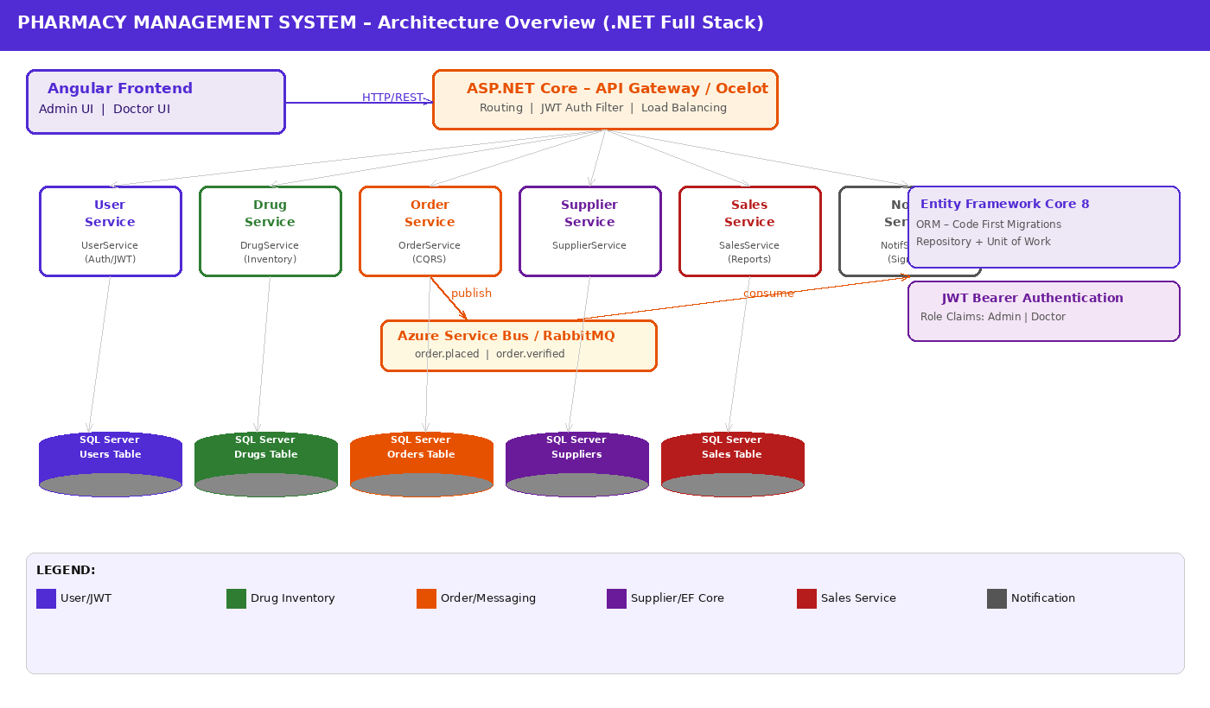
Figure 1: System Architecture – .NET Full Stack Microservices

5.2 Microservices Breakdown
Microservice | Responsibility | DB Schema
PharmacyUser.API | Admin and Doctor registration, login, JWT issuance | dbo.Users
PharmacyDrug.API | Drug inventory CRUD via EF Core | dbo.Drugs
PharmacyOrder.API | Order placement, verification, picked-up tracking | dbo.Orders, dbo.OrderItems
PharmacySupplier.API | Supplier CRUD | dbo.Suppliers
PharmacySales.API | Sales report generation, download (CSV/PDF) | dbo.Sales
PharmacyNotification.API | Consumes Service Bus messages; notifies Admin | N/A

5.3 Three-Layer Architecture (Per Service)
Layer | Components | Responsibility
Presentation | Controllers (ApiController) | Handle HTTP requests, ModelState validation, return ActionResult.
Business | Service classes (Scoped DI) | Business logic, rules, calls IRepository interfaces.
Data | EF Core DbContext + Repositories | Persist / retrieve data via LINQ to SQL Server.

5.4 Messaging – Azure Service Bus / RabbitMQ
- When a Doctor places an order, PharmacyOrder.API publishes an OrderPlacedEvent to the message bus.
- PharmacyNotification.API subscribes to OrderPlacedEvent and notifies the Admin.
- When Admin verifies an order, an OrderVerifiedEvent is published.
- MassTransit library is used for message bus abstraction.

6.0 Project Structure
Each ASP.NET Core microservice follows this standard folder layout:
PharmacyManagementSystem/
├── PharmacyUser.API/
│ ├── Controllers/ (AuthController, UserController)
│ ├── Services/ (IAuthService, AuthService)
│ ├── Repositories/ (IUserRepository, UserRepository)
│ ├── Models/ (User.cs, DTOs/)
│ ├── Data/ (PharmacyDbContext.cs)
│ ├── Middleware/ (GlobalExceptionMiddleware.cs)
│ ├── Configuration/ (JwtSettings.cs)
│ └── Program.cs
├── PharmacyDrug.API/
├── PharmacyOrder.API/
├── PharmacySupplier.API/
├── PharmacySales.API/
└── PharmacyNotification.API/

7.0 Use Cases

7.1 Use Case Diagram
The diagram below shows the two primary actors and all system use cases:

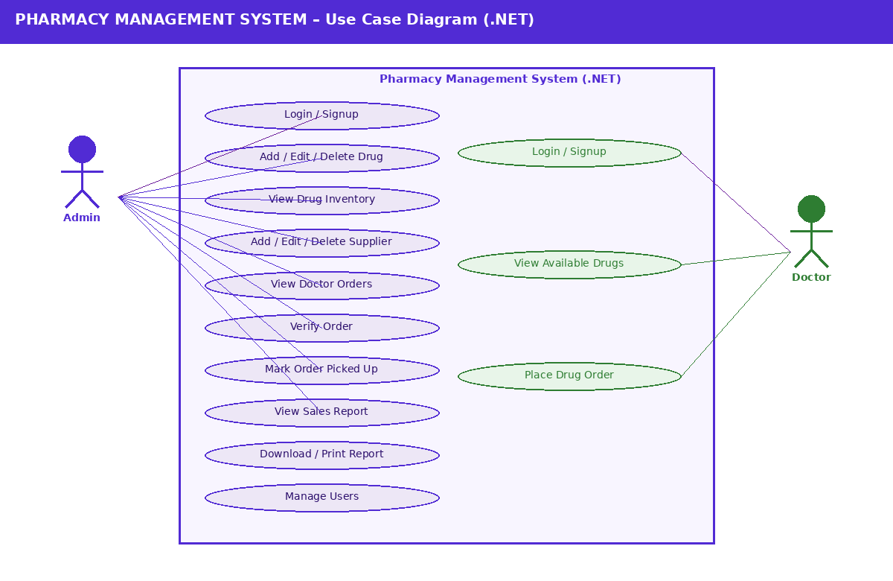
Figure 2: Use Case Diagram – Admin & Doctor

7.2 Use Case Summary
Actor | Use Case | Description
Admin | Login / Signup | Authenticate via /api/auth/signin; receive JWT.
Admin | Manage Drugs | Add, edit, delete, and view drug inventory via DrugController.
Admin | Manage Suppliers | Add, edit, delete, and view supplier details via SupplierController.
Admin | View Doctor Orders | List all orders via OrderController.GetOrders().
Admin | Verify Order | Patch order status to VERIFIED.
Admin | Mark Order Picked Up | Patch order status to PICKED_UP.
Admin | Sales Report | View, download (PDF/CSV), print via SalesController.
Doctor | Login / Signup | Authenticate via /api/auth/signin; receive JWT.
Doctor | View Drugs | GET /api/drugs – browse all available drugs.
Doctor | Place Order | POST /api/orders with OrderDto.

8.0 Data Flow Diagram (DFD)
The DFD shows how data flows between external entities (Admin, Doctor), the ASP.NET Core controllers, and SQL Server tables via EF Core repositories.

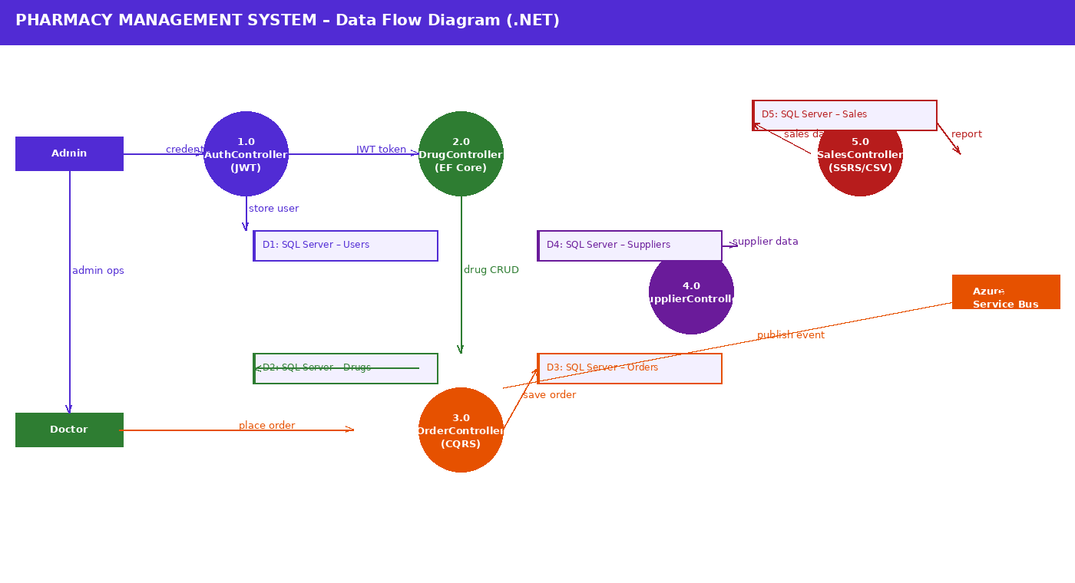
Figure 3: Data Flow Diagram – .NET Full Stack
All requests enter via the Ocelot API Gateway. Each controller delegates to a scoped service which uses EF Core repositories to read/write SQL Server. Order events flow asynchronously through Azure Service Bus to the Notification service.

9.0 Database Design (SQL Server – EF Core Code First)

9.1 PharmacyDbContext
A single shared SQL Server database (or one per microservice for full isolation). EF Core DbContext manages all entities. Migrations are run via `dotnet ef migrations add` and `dotnet ef database update`.

9.2 Table: Users
Column | C# Type | SQL Type | Constraints | Description
Id | int | INT | PK, IDENTITY(1,1) | Auto-generated user ID
FirstName | string | NVARCHAR(100) | NOT NULL | User's first name
LastName | string | NVARCHAR(100) | NOT NULL | User's last name
Email | string | NVARCHAR(255) | NOT NULL, UNIQUE | Login email / username
PasswordHash | string | NVARCHAR(500) | NOT NULL | BCrypt hashed password
Contact | string | NVARCHAR(10) | NOT NULL | 10-digit phone number
Role | string | NVARCHAR(20) | NOT NULL | Admin or Doctor
CreatedOn | DateTime | DATETIME2 | NOT NULL, DEFAULT GETDATE() | Account created timestamp
ModifiedOn | DateTime? | DATETIME2 | NULL | Last updated timestamp

9.3 Table: Drugs
Column | C# Type | SQL Type | Constraints | Description
Id | int | INT | PK, IDENTITY(1,1) | Auto-generated drug ID
DrugName | string | NVARCHAR(200) | NOT NULL | Name of the drug
DrugCode | string | NVARCHAR(50) | NOT NULL, UNIQUE | Unique drug SKU/code
Manufacturer | string | NVARCHAR(200) | NOT NULL | Manufacturer name
Category | string | NVARCHAR(100) | NOT NULL | Drug category
Price | decimal | DECIMAL(10,2) | NOT NULL, CHECK > 0 | Price per unit
QuantityInStock | int | INT | NOT NULL, CHECK >= 0 | Available stock units
ExpiryDate | DateTime | DATETIME2 | NOT NULL | Drug expiry date
Description | string? | NVARCHAR(500) | NULL | Optional description
CreatedOn | DateTime | DATETIME2 | NOT NULL, DEFAULT GETDATE() | Entry timestamp

9.4 Table: Orders
Column | C# Type | SQL Type | Constraints | Description
Id | int | INT | PK, IDENTITY(1,1) | Auto-generated order ID
OrderReference | string | NVARCHAR(50) | NOT NULL, UNIQUE | Auto-generated ref e.g. ORD-20240310-0042
DoctorId | int | INT | FK -> Users.Id, NOT NULL | Reference to ordering doctor
DoctorName | string | NVARCHAR(200) | NOT NULL | Doctor's full name
TotalAmount | decimal | DECIMAL(10,2) | NOT NULL | Calculated total
Status | string | NVARCHAR(20) | NOT NULL | PENDING | VERIFIED | PICKED_UP
OrderDate | DateTime | DATETIME2 | NOT NULL, DEFAULT GETDATE() | Order timestamp
VerifiedOn | DateTime? | DATETIME2 | NULL | Admin verify timestamp
PickedUpOn | DateTime? | DATETIME2 | NULL | Pickup timestamp

9.5 Table: OrderItems
Column | C# Type | SQL Type | Constraints | Description
Id | int | INT | PK, IDENTITY(1,1) | Auto-generated line ID
OrderId | int | INT | FK -> Orders.Id, NOT NULL | Parent order reference
DrugId | int | INT | FK -> Drugs.Id, NOT NULL | Drug being ordered
DrugName | string | NVARCHAR(200) | NOT NULL | Snapshot of drug name
Quantity | int | INT | NOT NULL, CHECK > 0 | Quantity ordered
UnitPrice | decimal | DECIMAL(10,2) | NOT NULL | Snapshot of unit price
Subtotal | decimal | DECIMAL(10,2) | Computed | Quantity x UnitPrice

9.6 Table: Suppliers
Column | C# Type | SQL Type | Constraints | Description
Id | int | INT | PK, IDENTITY(1,1) | Auto-generated supplier ID
SupplierName | string | NVARCHAR(200) | NOT NULL | Supplier name
ContactPerson | string | NVARCHAR(200) | NOT NULL | Primary contact
Email | string | NVARCHAR(255) | NOT NULL, UNIQUE | Supplier email
Phone | string | NVARCHAR(10) | NOT NULL | 10-digit phone
Address | string | NVARCHAR(500) | NOT NULL | Full address
CreatedOn | DateTime | DATETIME2 | NOT NULL, DEFAULT GETDATE() | Record timestamp

9.7 Table: Sales
Column | C# Type | SQL Type | Constraints | Description
Id | int | INT | PK, IDENTITY(1,1) | Auto-generated sale ID
OrderReference | string | NVARCHAR(50) | NOT NULL | Linked order reference
DoctorId | int | INT | NOT NULL | Doctor user ID
DrugCode | string | NVARCHAR(50) | NOT NULL | Drug sold
QuantitySold | int | INT | NOT NULL, CHECK > 0 | Quantity sold
SaleAmount | decimal | DECIMAL(10,2) | NOT NULL | Total sale amount
SaleDate | DateTime | DATETIME2 | NOT NULL | Sale timestamp

10.0 Domain Models (C# Classes)

10.1 User
C# entity class decorated with EF Core data annotations and [ApiController] attributes. Includes Id, FirstName, LastName, Email, PasswordHash, Contact, and Role. Navigation property: ICollection<Order> Orders.

10.2 Drug
Represents a drug record. Contains DrugCode (unique), DrugName, Manufacturer, Category, Price (decimal), QuantityInStock (int), ExpiryDate, and optional Description. Navigation property: ICollection<OrderItem> OrderItems.

10.3 Order
Represents a purchase order. Contains OrderReference (auto-generated), DoctorId (FK), Status (enum-mapped string), TotalAmount, and timestamps. Navigation properties: User Doctor, ICollection<OrderItem> OrderItems.

10.4 OrderItem
Child record of Order. Contains OrderId (FK), DrugId (FK), quantity, snapshot of unit price, and computed subtotal. Navigation properties: Order Order, Drug Drug.

10.5 Supplier
Supplier entity with contact details. Managed entirely by Admin via SupplierController.

10.6 Sale
Represents a completed sales record for reporting. Linked to order reference, doctor, and drug sold.

11.0 Class Diagram
The class diagram below shows the Controller → IService → IRepository dependency injection pattern across all four core services in ASP.NET Core:

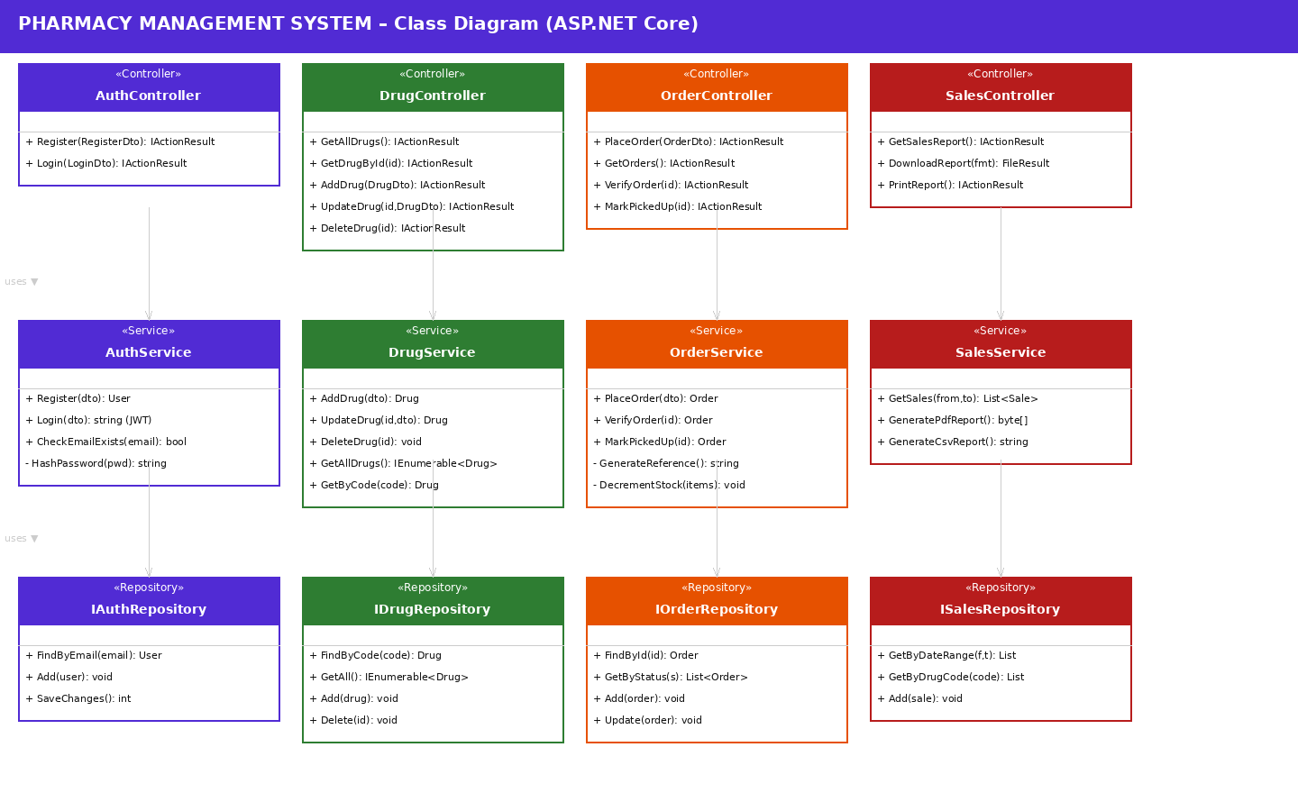
Figure 4: Class Diagram – ASP.NET Core Controller / Service / Repository

11.1 Classes – User Service (PharmacyUser.API)
# | Class / Interface | Description
1 | User.cs | EF Core entity with data annotations ([Key], [Required], [MaxLength]).
2 | RegisterDto.cs / LoginDto.cs | Input DTOs with [Required], [EmailAddress] validation attributes.
3 | AuthController.cs | [ApiController] with POST /api/auth/register and POST /api/auth/login endpoints.
4 | IAuthService.cs | Interface defining Register(RegisterDto) and Login(LoginDto) contracts.
5 | AuthService.cs | Implements IAuthService; uses BCrypt.Verify() and JwtUtil.GenerateToken().
6 | IUserRepository.cs | Interface: FindByEmail(string), Add(User), SaveChangesAsync().
7 | UserRepository.cs | Implements IUserRepository using PharmacyDbContext and EF Core LINQ.
8 | JwtUtil.cs | Generates signed JWT with claims (userId, email, role) using JwtSecurityTokenHandler.
9 | UserValidator.cs | Validates phone length, email format, password strength using FluentValidation.
10 | PharmacyDbContext.cs | EF Core DbContext with DbSet<User>; configured via OnModelCreating.

11.2 Classes – Drug Service (PharmacyDrug.API)
# | Class / Interface | Description
1 | Drug.cs | EF Core entity. Price and QuantityInStock validated via [Range].
2 | DrugDto.cs | Input DTO for create/update with [Required] and [Range(0.01, double.MaxValue)].
3 | DrugController.cs | [Authorize(Roles="Admin")] for POST/PUT/DELETE; [Authorize] for GET.
4 | IDrugService.cs | Interface: AddDrug, UpdateDrug, DeleteDrug, GetAll, GetByCode.
5 | DrugService.cs | Implements IDrugService; checks duplicate DrugCode; decrements stock on order.
6 | IDrugRepository.cs | Interface: FindByCode, GetAll, Add, Update, Delete, SaveChangesAsync.
7 | DrugRepository.cs | EF Core implementation; uses async/await throughout.
8 | DrugValidator.cs | FluentValidation: Price > 0, ExpiryDate > DateTime.Now, QuantityInStock >= 0.

11.3 Classes – Order Service (PharmacyOrder.API)
# | Class / Interface | Description
1 | Order.cs / OrderItem.cs | EF Core entities; Order has ICollection<OrderItem>.
2 | OrderDto.cs / OrderItemDto.cs | Input DTOs with [Required] and [MinLength(1)] on Items list.
3 | OrderController.cs | POST /api/orders (Doctor); GET/PUT for Admin; PATCH for verify/pickup.
4 | IOrderService.cs | Interface: PlaceOrder, VerifyOrder, MarkPickedUp, GetById, GetAll.
5 | OrderService.cs | Generates order reference, validates stock, decrements drug quantity, saves.
6 | IOrderRepository.cs | Interface: Add, FindById, GetByStatus, GetByDoctorId, Update, SaveChangesAsync.
7 | OrderRepository.cs | EF Core implementation with Include() for eager loading OrderItems and Drug.
8 | OrderPublisher.cs | Publishes OrderPlacedEvent / OrderVerifiedEvent to Azure Service Bus.
9 | OrderValidator.cs | FluentValidation: Items not empty, each quantity > 0.

11.4 Classes – Supplier Service (PharmacySupplier.API)
# | Class / Interface | Description
1 | Supplier.cs | EF Core entity with [Required] and [MaxLength] annotations.
2 | SupplierDto.cs | Input DTO with validation attributes.
3 | SupplierController.cs | Admin-only controller. CRUD endpoints.
4 | ISupplierService.cs | Interface for supplier CRUD methods.
5 | SupplierService.cs | Checks duplicate email; standard CRUD logic.
6 | ISupplierRepository.cs | Interface: FindByEmail, GetAll, Add, Update, Delete, SaveChangesAsync.
7 | SupplierRepository.cs | EF Core implementation.
8 | SupplierValidator.cs | FluentValidation: email format, phone exactly 10 digits.

11.5 Classes – Sales Service (PharmacySales.API)
# | Class / Interface | Description
1 | Sale.cs | EF Core entity mapped to dbo.Sales.
2 | SalesController.cs | GET /api/sales, GET /api/sales/download, GET /api/sales/print.
3 | ISalesService.cs | Interface: GetSales, GeneratePdf, GenerateCsv.
4 | SalesService.cs | Queries Sales table; uses CsvHelper for CSV, iTextSharp for PDF generation.
5 | ISalesRepository.cs | Interface: GetByDateRange, GetByDrugCode, Add, SaveChangesAsync.
6 | SalesRepository.cs | EF Core LINQ queries against dbo.Sales.
7 | ReportGenerator.cs | Builds byte[] PDF or string CSV from List<Sale> data.

12.0 Validations
Validation is applied at two levels: Data Annotations on DTOs (ModelState validation) and FluentValidation for complex rules.

Field | Rule | Data Annotation / FluentValidation | Error Message
FirstName / LastName | Required, max 100 chars | [Required][MaxLength(100)] | Name is required (max 100 chars).
Email | Required, valid email, unique | [Required][EmailAddress] | Invalid email format or already registered.
Password | Required, min 8 chars, 1 uppercase, 1 digit | [Required][MinLength(8)] + custom | Password must be ≥ 8 chars with uppercase and digit.
Contact | Required, exactly 10 digits | [Required][RegularExpression(@"^\d{10}$")] | Phone must be exactly 10 digits.
Role | Must be Admin or Doctor | [Required][AllowedValues("Admin","Doctor")] | Role must be Admin or Doctor.
DrugName | Required, max 200 chars | [Required][MaxLength(200)] | Drug name is required.
DrugCode | Required, unique | [Required] + Service check | Drug code already exists.
Price | Must be > 0 | [Range(0.01, double.MaxValue)] | Price must be greater than zero.
QuantityInStock | Must be >= 0 | [Range(0, int.MaxValue)] | Quantity must be zero or more.
ExpiryDate | Must be future date | FluentValidation: Must(d => d > DateTime.Now) | Expiry date must be in the future.
Order.Items | Min 1 item | [MinLength(1)] + FluentValidation | Order must have at least one drug.
OrderItem.Quantity | Must be > 0 | [Range(1, int.MaxValue)] | Quantity must be greater than zero.
SupplierEmail | Required, unique | [Required][EmailAddress] + Service check | Supplier email already exists.

13.0 API Canvas

13.1 User Service – PharmacyUser.API
Service | Path | Verb | Description | Role | Auth
PharmacyUser.API | /api/auth/register | POST | Register new Admin or Doctor | None | False
PharmacyUser.API | /api/auth/login | POST | Login and receive JWT token | None | False
PharmacyUser.API | /api/users | GET | List all users | Admin | True
PharmacyUser.API | /api/users/{id} | GET | Get user by ID | Admin | True
PharmacyUser.API | /api/users/{id} | PUT | Update user details | Admin | True
PharmacyUser.API | /api/users/{id} | DELETE | Remove a user | Admin | True

13.2 Drug Service – PharmacyDrug.API
Service | Path | Verb | Description | Role | Auth
PharmacyDrug.API | /api/drugs | GET | List all available drugs | Both | True
PharmacyDrug.API | /api/drugs/{id} | GET | Get drug by ID | Both | True
PharmacyDrug.API | /api/drugs | POST | Add a new drug | Admin | True
PharmacyDrug.API | /api/drugs/{id} | PUT | Update drug details | Admin | True
PharmacyDrug.API | /api/drugs/{id} | DELETE | Delete a drug | Admin | True

13.3 Order Service – PharmacyOrder.API
Service | Path | Verb | Description | Role | Auth
PharmacyOrder.API | /api/orders | POST | Place a new drug order | Doctor | True
PharmacyOrder.API | /api/orders | GET | List all orders | Admin | True
PharmacyOrder.API | /api/orders/{id} | GET | Get order by ID | Both | True
PharmacyOrder.API | /api/orders/{id}/verify | PATCH | Verify an order | Admin | True
PharmacyOrder.API | /api/orders/{id}/pickup | PATCH | Mark order as picked up | Admin | True

13.4 Supplier Service – PharmacySupplier.API
Service | Path | Verb | Description | Role | Auth
PharmacySupplier.API | /api/suppliers | GET | List all suppliers | Admin | True
PharmacySupplier.API | /api/suppliers/{id} | GET | Get supplier by ID | Admin | True
PharmacySupplier.API | /api/suppliers | POST | Add a new supplier | Admin | True
PharmacySupplier.API | /api/suppliers/{id} | PUT | Update supplier | Admin | True
PharmacySupplier.API | /api/suppliers/{id} | DELETE | Delete supplier | Admin | True

13.5 Sales Service – PharmacySales.API
Service | Path | Verb | Description | Role | Auth
PharmacySales.API | /api/sales | GET | View sales report | Admin | True
PharmacySales.API | /api/sales/download | GET | Download CSV or PDF report | Admin | True
PharmacySales.API | /api/sales/print | GET | Print-ready sales report | Admin | True

14.0 Key Functional Flows

14.1 Sequence Diagram – Place Drug Order
The sequence diagram below shows the full message flow for a Doctor placing a drug order through the .NET stack, including EF Core stock validation and Azure Service Bus event publishing:

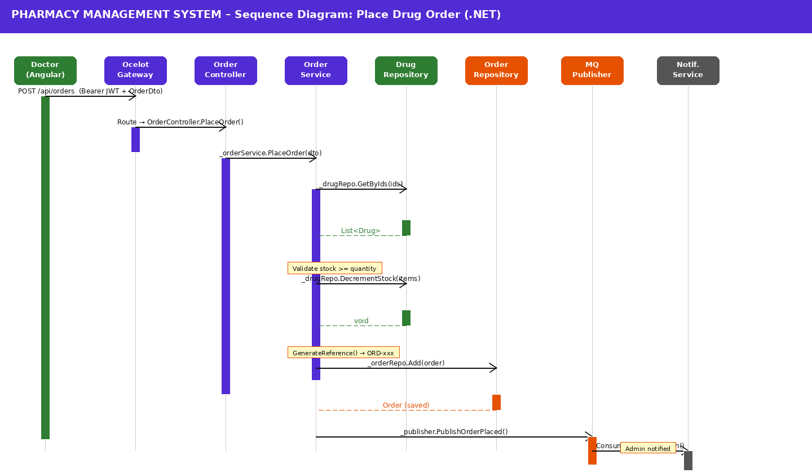
Figure 5: Sequence Diagram – Doctor Places Drug Order (.NET)

14.2 User Registration Flow
- Client POSTs RegisterDto to POST /api/auth/register via Ocelot Gateway.
- ModelState validation runs against [Required], [EmailAddress], [MinLength] annotations.
- If invalid: middleware returns 400 ProblemDetails JSON.
- AuthService.Register() calls _userRepository.FindByEmail() to check uniqueness.
- If duplicate: throws DuplicateEmailException → 409 Conflict.
- BCrypt.HashPassword() hashes the password before saving.
- _userRepository.Add(user); await SaveChangesAsync().
- Returns 201 Created with success message.

14.3 User Login Flow
- Client POSTs LoginDto (email + password) to POST /api/auth/login.
- AuthService fetches user via _userRepository.FindByEmail().
- If not found: throws UnauthorizedException → 401.
- BCrypt.Verify(password, user.PasswordHash) validates credentials.
- JwtUtil.GenerateToken() creates signed JWT with claims: userId, email, role.
- Token expires in 1 hour. Admin tokens include Role = "Admin" claim.
- Returns 200 OK with JWT string in response body.

14.4 Admin – Verify Order
- Admin sends PATCH /api/orders/{id}/verify with valid Admin JWT.
- [Authorize(Roles="Admin")] enforced at controller level.
- OrderService.VerifyOrder(id) updates Status from PENDING to VERIFIED.
- VerifiedOn = DateTime.UtcNow is set; SaveChangesAsync() persists update.
- OrderPublisher.PublishOrderVerifiedEvent() sends message to Azure Service Bus.
- Returns 200 OK with updated OrderResponseDto.

15.0 Environment Variables / appsettings.json
Key | Description | Example Value
ConnectionStrings:DefaultConnection | SQL Server connection string | Server=localhost;Database=PharmacyDB;Trusted_Connection=True;
JwtSettings:Secret | JWT signing secret key | pharmacy_jwt_secret_key_32chars
JwtSettings:Issuer | JWT issuer claim | PharmacyMS
JwtSettings:Audience | JWT audience claim | PharmacyUsers
JwtSettings:ExpiryMinutes | JWT token expiry in minutes | 60
ServiceBus:ConnectionString | Azure Service Bus connection | Endpoint=sb://...
ServiceBus:OrderQueue | Queue name for order events | order-events
Logging:LogLevel:Default | Default logging level | Information
AllowedHosts | Allowed host headers | *

16.0 HTTP Status Codes
Status Code | Meaning | When Used
200 OK | Request succeeded | Successful GET, PUT, PATCH.
201 Created | Resource created | POST: register, add drug, place order, add supplier.
400 Bad Request | Invalid input / validation failed | ModelState invalid, insufficient stock, business rule violation.
401 Unauthorized | Authentication failed | Missing/invalid/expired JWT token.
403 Forbidden | Access denied | Doctor calling Admin-only endpoint.
404 Not Found | Resource not found | Drug, Order, User, or Supplier not found by ID.
409 Conflict | Duplicate resource | Email or DrugCode already exists.
500 Internal Server Error | Unexpected error | Unhandled exception caught by GlobalExceptionMiddleware.
502 Bad Gateway | Downstream failure | Service Bus or downstream API unavailable.

17.0 Request & Response Examples

17.1 User Registration
Request: POST /api/auth/register
{
"firstName": "John",
"lastName": "Doe",
"email": "john.doe@hospital.com",
"password": "Doctor@123",
"contact": "9876543210",
"role": "Doctor"
}
Success Response: 201
{ "message": "User registered successfully." }
Error – 409
{ "status": 409, "title": "Conflict", "detail": "Email already registered." }

17.2 Place Drug Order
Request: POST /api/orders (Authorization: Bearer <token>)
{
"doctorId": 12,
"items": [
{ "drugId": 5, "quantity": 3 },
{ "drugId": 8, "quantity": 1 }
]
}
Success Response: 201
{
"orderReference": "ORD-20240310-0042",
"status": "PENDING",
"totalAmount": 750.00,
"message": "Order placed successfully."
}

17.3 Add Drug
Request: POST /api/drugs (Authorization: Bearer <Admin token>)
{
"drugName": "Amoxicillin 500mg",
"drugCode": "AMX500",
"manufacturer": "Cipla Ltd.",
"category": "Antibiotic",
"price": 25.50,
"quantityInStock": 200,
"expiryDate": "2026-12-31",
"description": "Used to treat bacterial infections."
}
Success Response: 201
{ "message": "Drug added successfully.", "drugId": 42 }

18.0 Exception Handling

18.1 GlobalExceptionMiddleware
Each microservice registers a custom GlobalExceptionMiddleware in Program.cs using app.UseMiddleware<GlobalExceptionMiddleware>(). It wraps the entire request pipeline in a try-catch and returns ProblemDetails-formatted JSON for all uncaught exceptions.

// Program.cs registration
app.UseMiddleware<GlobalExceptionMiddleware>();
app.UseAuthentication();
app.UseAuthorization();
app.MapControllers();

18.2 Exception-to-Status Mapping
Exception Class | HTTP Status Code | Trigger
ValidationException | 400 Bad Request | FluentValidation or ModelState failure.
NotFoundException | 404 Not Found | Drug, Order, User, or Supplier not found by ID.
DuplicateResourceException | 409 Conflict | Email or DrugCode already exists in DB.
UnauthorizedException | 401 Unauthorized | Invalid credentials or missing JWT.
ForbidException | 403 Forbidden | Role does not permit the requested operation.
InsufficientStockException | 400 Bad Request | Order quantity exceeds available drug stock.
Exception (catch-all) | 500 Internal Server Error | Any unhandled runtime exception.

18.3 ProblemDetails Error Format
{
"status": 404,
"title": "Not Found",
"detail": "Drug with ID 42 was not found.",
"instance": "/api/drugs/42",
"timestamp": "2024-03-10T10:30:00Z"
}

19.0 Security

19.1 JWT Bearer Authentication
- All protected endpoints require Authorization: Bearer <token> header.
- JWT signed with HMAC-SHA256 using a secret key from appsettings.json.
- Token claims: userId (NameIdentifier), email, role (Doctor or Admin), expiry (1 hour).
- Configured in Program.cs via builder.Services.AddAuthentication(JwtBearerDefaults.AuthenticationScheme).

// JWT Config in Program.cs
builder.Services.AddAuthentication(JwtBearerDefaults.AuthenticationScheme)
.AddJwtBearer(options => {
options.TokenValidationParameters = new TokenValidationParameters {
ValidateIssuer = true,
ValidateAudience = true,
ValidateLifetime = true,
ValidateIssuerSigningKey = true,
ValidIssuer = jwtSettings.Issuer,
ValidAudience = jwtSettings.Audience,
IssuerSigningKey = new SymmetricSecurityKey(
Encoding.UTF8.GetBytes(jwtSettings.Secret))
};
});

19.2 Role-Based Authorization
Endpoint Group | Required Role / Policy
POST /api/auth/register, POST /api/auth/login | [AllowAnonymous] (no auth)
GET /api/drugs, GET /api/drugs/{id} | [Authorize] (Admin or Doctor)
POST /api/drugs, PUT /api/drugs/{id}, DELETE /api/drugs/{id} | [Authorize(Roles="Admin")]
POST /api/orders | [Authorize(Roles="Doctor")]
GET /api/orders, PATCH /api/orders/{id}/verify, PATCH /api/orders/{id}/pickup | [Authorize(Roles="Admin")]
GET /api/orders/{id} | [Authorize] (own order check in service layer)
All /api/suppliers endpoints | [Authorize(Roles="Admin")]
All /api/sales endpoints | [Authorize(Roles="Admin")]
All /api/users endpoints | [Authorize(Roles="Admin")]

19.3 Password Security
- Passwords hashed with BCrypt.Net-Next (work factor 12) before storage.
- BCrypt.Verify(inputPassword, storedHash) used during login.
- Plain-text passwords never stored or written to logs.

20.0 Unit Testing

20.1 Test Framework
Tool / NuGet Package | Purpose
xUnit | Primary test framework for writing and running unit tests.
Moq | Mocking IService and IRepository interfaces for isolated controller/service tests.
Microsoft.EntityFrameworkCore.InMemory | In-memory SQL provider for EF Core – replaces SQL Server in tests.
FluentAssertions | Human-readable assertion syntax in test cases.
Microsoft.AspNetCore.Mvc.Testing | Integration tests using WebApplicationFactory<Program>.

20.2 Test Cases – User Registration
Test Case ID | Scenario | Pre-Condition | Test Steps | Expected Result | Status
TC_U_01 | Valid registration | DB empty | POST /api/auth/register with all valid fields | 201 – User registered successfully | PASS
TC_U_02 | Duplicate email | Email exists in DB | POST with same email | 409 – Email already registered | PASS
TC_U_03 | Invalid phone | — | POST with 9-digit phone | 400 – Phone must be 10 digits | PASS
TC_U_04 | Missing firstName | — | POST without firstName field | 400 – firstName is required | PASS
TC_U_05 | Weak password | — | POST with password 'abc123' | 400 – Password must contain uppercase | PASS

20.3 Test Cases – Drug Management
Test Case ID | Scenario | Pre-Condition | Test Steps | Expected Result | Status
TC_D_01 | Add valid drug | Admin JWT | POST /api/drugs with all valid fields | 201 – Drug added successfully | PASS
TC_D_02 | Duplicate DrugCode | DrugCode in DB | POST with existing DrugCode | 409 – Drug code already exists | PASS
TC_D_03 | Negative price | — | POST with price = -5 | 400 – Price must be > 0 | PASS
TC_D_04 | Past expiry date | — | POST with expiryDate = 2020-01-01 | 400 – Expiry must be future date | PASS
TC_D_05 | Delete valid drug | Drug ID exists | DELETE /api/drugs/{id} | 200 – Drug deleted successfully | PASS
TC_D_06 | Delete non-existent | Drug ID missing | DELETE /api/drugs/9999 | 404 – Drug not found | PASS

20.4 Test Cases – Order Management
Test Case ID | Scenario | Pre-Condition | Test Steps | Expected Result | Status
TC_O_01 | Place valid order | Doctor JWT; drugs in stock | POST /api/orders with valid items | 201 – Order placed with reference | PASS
TC_O_02 | Insufficient stock | Drug qty = 1 | POST order with qty = 10 | 400 – Insufficient stock | PASS
TC_O_03 | Empty items | — | POST with items = [] | 400 – Min 1 item required | PASS
TC_O_04 | Verify valid order | Order in PENDING | PATCH /api/orders/{id}/verify | 200 – Order verified | PASS
TC_O_05 | Pickup verified order | Order in VERIFIED | PATCH /api/orders/{id}/pickup | 200 – Order picked up | PASS
TC_O_06 | Non-existent order | — | GET /api/orders/9999 | 404 – Order not found | PASS

21.0 Integrations
Integration | Type | Details
Azure Service Bus / RabbitMQ | Async Messaging | MassTransit publishes OrderPlacedEvent; Notification service consumes it.
Angular 17 Frontend | REST API | HttpClient calls Ocelot Gateway; JWT stored in memory/sessionStorage.
SQL Server 2022 | Relational Database | All microservices share one SQL Server (or separate schemas for isolation).
Entity Framework Core 8 | ORM | Code First migrations manage schema; async repository pattern used throughout.
Ocelot API Gateway | API Gateway | Routes, rate-limits, and validates JWT before forwarding to microservices.
Swagger / OpenAPI | Documentation | Each service exposes /swagger endpoint; secured endpoints require JWT input.

22.0 AWS / Azure Cloud Deployment
Service | Cloud Component | Purpose
All Microservices | Azure App Service / AWS ECS (Docker) | Host each ASP.NET Core service as a containerised workload.
SQL Server | Azure SQL Database / AWS RDS (SQL Server) | Managed relational database; auto-backup and scaling.
Azure Service Bus / RabbitMQ | Azure Service Bus / Amazon MQ | Managed message broker for async events.
API Gateway | Azure API Management / Ocelot on App Service | JWT validation, routing, rate limiting.
Monitoring | Azure Application Insights / AWS CloudWatch | Logging, request tracing, performance monitoring.
Secrets | Azure Key Vault / AWS Secrets Manager | Store JWT secret, DB connection strings securely.

23.0 Summary
Aspect | Details
Architecture | Microservices – 6 independently deployable ASP.NET Core 8.0 Web API projects.
Language & Framework | C# 12 | ASP.NET Core 8.0 | Entity Framework Core 8.0
Frontend | Angular 17 consuming REST APIs via Ocelot API Gateway.
Database | SQL Server 2022; EF Core Code First with migrations.
Authentication | JWT Bearer tokens with [Authorize(Roles="Admin/Doctor")] attribute-based RBAC.
Password Security | BCrypt.Net-Next hashing; plain text never stored.
Messaging | MassTransit + Azure Service Bus / RabbitMQ for async order events.
APIs | 20+ RESTful endpoints; Swagger UI for documentation and testing.
Validation | Data Annotations + FluentValidation; GlobalExceptionMiddleware for error formatting.
Testing | xUnit + Moq + EF InMemory; 17+ unit test cases across user, drug, and order flows.
Diagrams | Architecture, Use Case, DFD, Class Diagram, Sequence Diagram included.

