Algorithmic Trade Surveillance Engine: Design Document

1. Project Overview
Build a rule-based and machine-learning-assisted trade surveillance engine that monitors simulated order flow and price/volume data for patterns resembling market manipulation (spoofing, wash trading) and other abnormal-event signatures.
Core functionality will include:
- Historical and simulated real-time market data ingestion for a watchlist of 10-20 stocks
- Strategy engine with configurable signal-generation logic
- Backtester reporting return, win rate and max drawdown
- Paper trading mode (simulated real-time trading)
- Rule-based detection pipeline (volume spikes, price velocity, volume-price divergence, time-of-day anomalies, spoofing and wash-trading patterns) using Pandas time-window analysis
- Isolation Forest anomaly detection over engineered trader behavioural features
- Real-time alert streaming with severity scoring
- React compliance dashboard: live price/volume charts, backtest results, paper-trading P&L and a surveillance alert table

2. Frontend
Language: JavaScript
Framework/Library: React
Build Tool: Vite
Package Manager: npm
Development Server: Vite dev server on localhost:5173
Charting: Recharts
Styling: CSS initially; Tailwind CSS can be considered later
Frontend responsibilities:
- Render live price/volume ticker for the watchlist
- Display backtest results, paper-trading P&L and open positions
- Display surveillance alert table with severity colour-coding
- Open a WebSocket connection to the FastAPI backend to receive alerts and live ticks in real time
- Send API requests to the FastAPI backend for historical data, backtests and configuration
- Handle user input, loading states and frontend validation

3. Backend
Language: Python
Framework: FastAPI
Data processing: Pandas (rolling time-window feature engineering and rule evaluation)
Machine learning: scikit-learn (Isolation Forest)
Real-time transport: FastAPI WebSocket endpoints
Development Server: Uvicorn/FastAPI development server on localhost:8000
Backend responsibilities:
- Expose REST endpoints for market data, backtests, paper trading and alert history
- Run the rule-based detection pipeline continuously over the price/volume stream
- Run the Isolation Forest model over engineered trader behavioural features
- Merge rule flags and anomaly scores into a single severity score per alert
- Stream flagged alerts to connected clients over WebSocket in real time
- Validate incoming requests and connect to the database via an ORM

4. Database
Development Database: SQLite temporarily during setup
Target Database: PostgreSQL (with TimescaleDB extension considered for time-series trade data) once volumes grow
Database Tool: DB Browser for SQLite for now; pgAdmin if PostgreSQL is adopted
Database responsibilities:
- Store symbols, order events, trades, alerts and backtest results
- Use ORM migrations to create and update tables
- PostgreSQL/TimescaleDB to be used once time-series volume requires it

5. API Communication
API Style: REST + WebSocket
Data Format: JSON
Frontend-backend communication:
- React calls FastAPI REST endpoints using fetch or Axios for historical/config data
- React opens a persistent WebSocket connection for live ticks and real-time alerts
- FastAPI returns JSON responses over REST and JSON messages over WebSocket
CORS Handling: FastAPI CORS middleware
Local development ports:
- React frontend: http://localhost:5173
- FastAPI backend: http://localhost:8000

6. Authentication and User Management
Initial approach: simple username/password login for analysts and compliance officers
Potential API authentication: JWT-based auth once multi-user access is required
User-related features:
- Login
- Role-based access (analyst vs admin)
- Position-level monitoring scoped to a trader's own trades

7. Surveillance Engine (Rule-Based + ML Anomaly Detection)
Is something unusual happening in the market? The surveillance engine is a rule-based and ML-assisted anomaly detector running continuously over the price/volume stream, watching for statistical patterns that resemble known manipulation or abnormal-event signatures.
Rule-based detectors:
- Volume spike detection
- Price velocity / vertical move detection
- Volume-price divergence
- Time-of-day anomaly
- Volatility-adjusted thresholds (not fixed thresholds)
- Spoofing pattern detection (rapid order placement/cancellation)
- Wash trading pattern detection (matched buy/sell activity)
Machine learning layer:
- Isolation Forest trained on engineered trader behavioural features (order-to-trade ratio, cancellation rate, inter-arrival time, order-size clustering)
- Anomaly score combined with rule flags into a single severity score per alert
Important design point: market-wide surveillance watches the entire simulated market, while position monitoring applies the same surveillance logic only to a given user's own trades.

8. Strategy Engine and Backtesting
Initial approach: configurable rule-based signal generation logic
Potential advanced approach: pluggable strategy modules if time allows
Backtester responsibilities:
- Run a strategy against historical data before risking (simulated) money
- Report return, win rate and max drawdown
- Feed into paper trading mode for simulated real-time execution
Usage:
- Validate a strategy historically before enabling paper trading
- Compare strategy performance across symbols in the watchlist

9. Package and Dependency Management
Python packages: installed via pip from PyPI (pandas, scikit-learn, fastapi, uvicorn, sqlalchemy)
JavaScript packages: installed via npm (react, recharts, vite)
Python environment: virtual environment under the backend project

10. Version Control and Development Tools
Code Editor: Visual Studio Code
Version Control: Git
Repository Platform: GitHub
API Testing: FastAPI's auto-generated Swagger/OpenAPI docs; Postman for WebSocket-adjacent REST checks

11. Deployment Considerations
Initial deployment: local development only
Potential frontend hosting: Vercel or Netlify
Potential backend hosting: Render, Railway or a small cloud VM
Potential database hosting: managed PostgreSQL (e.g. Supabase/RDS) later if required
Current priority: local full-stack prototype demonstrating the detection pipeline end to end

12. Current Local Development Setup
Backend:
- FastAPI + Uvicorn
- Pandas for time-window feature engineering
- scikit-learn for Isolation Forest
- SQLite temporarily
Frontend:
- React
- Vite
- Recharts
- npm

13. Summary Stack
Frontend: React, JavaScript, Vite, Recharts, npm
Backend: Python, FastAPI, Pandas, scikit-learn
Database: SQLite temporarily, PostgreSQL/TimescaleDB target
API: REST + WebSocket, JSON
Detection: rule-based time-window analysis + Isolation Forest anomaly detection
Version Control: Git and GitHub
IDE: Visual Studio Code
Architecture Diagram
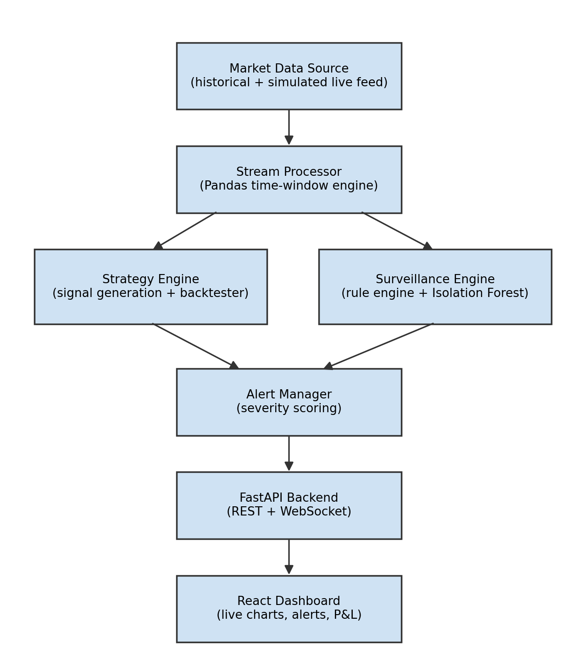
Component Diagram
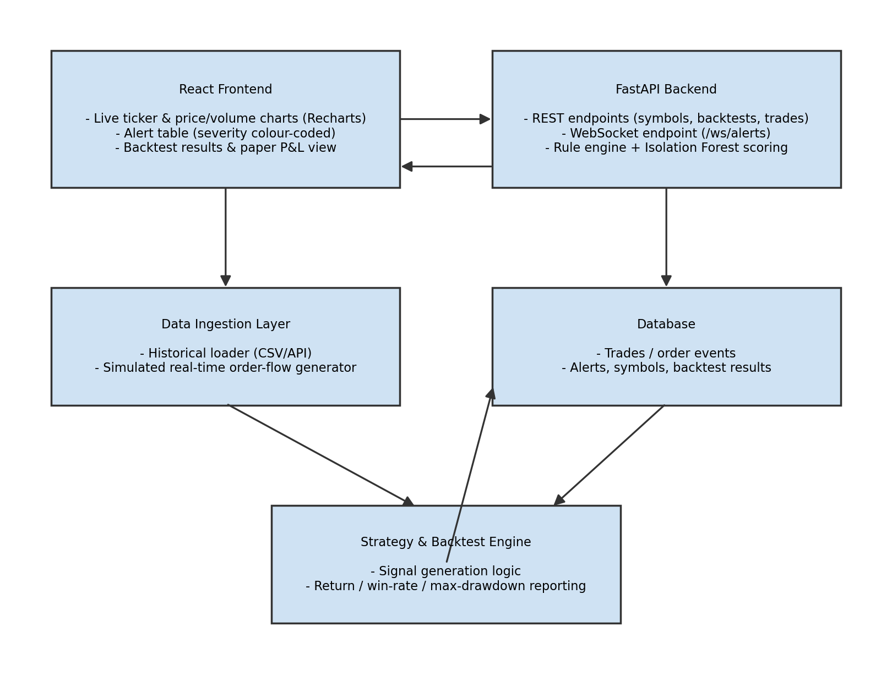
Business Flow Diagram
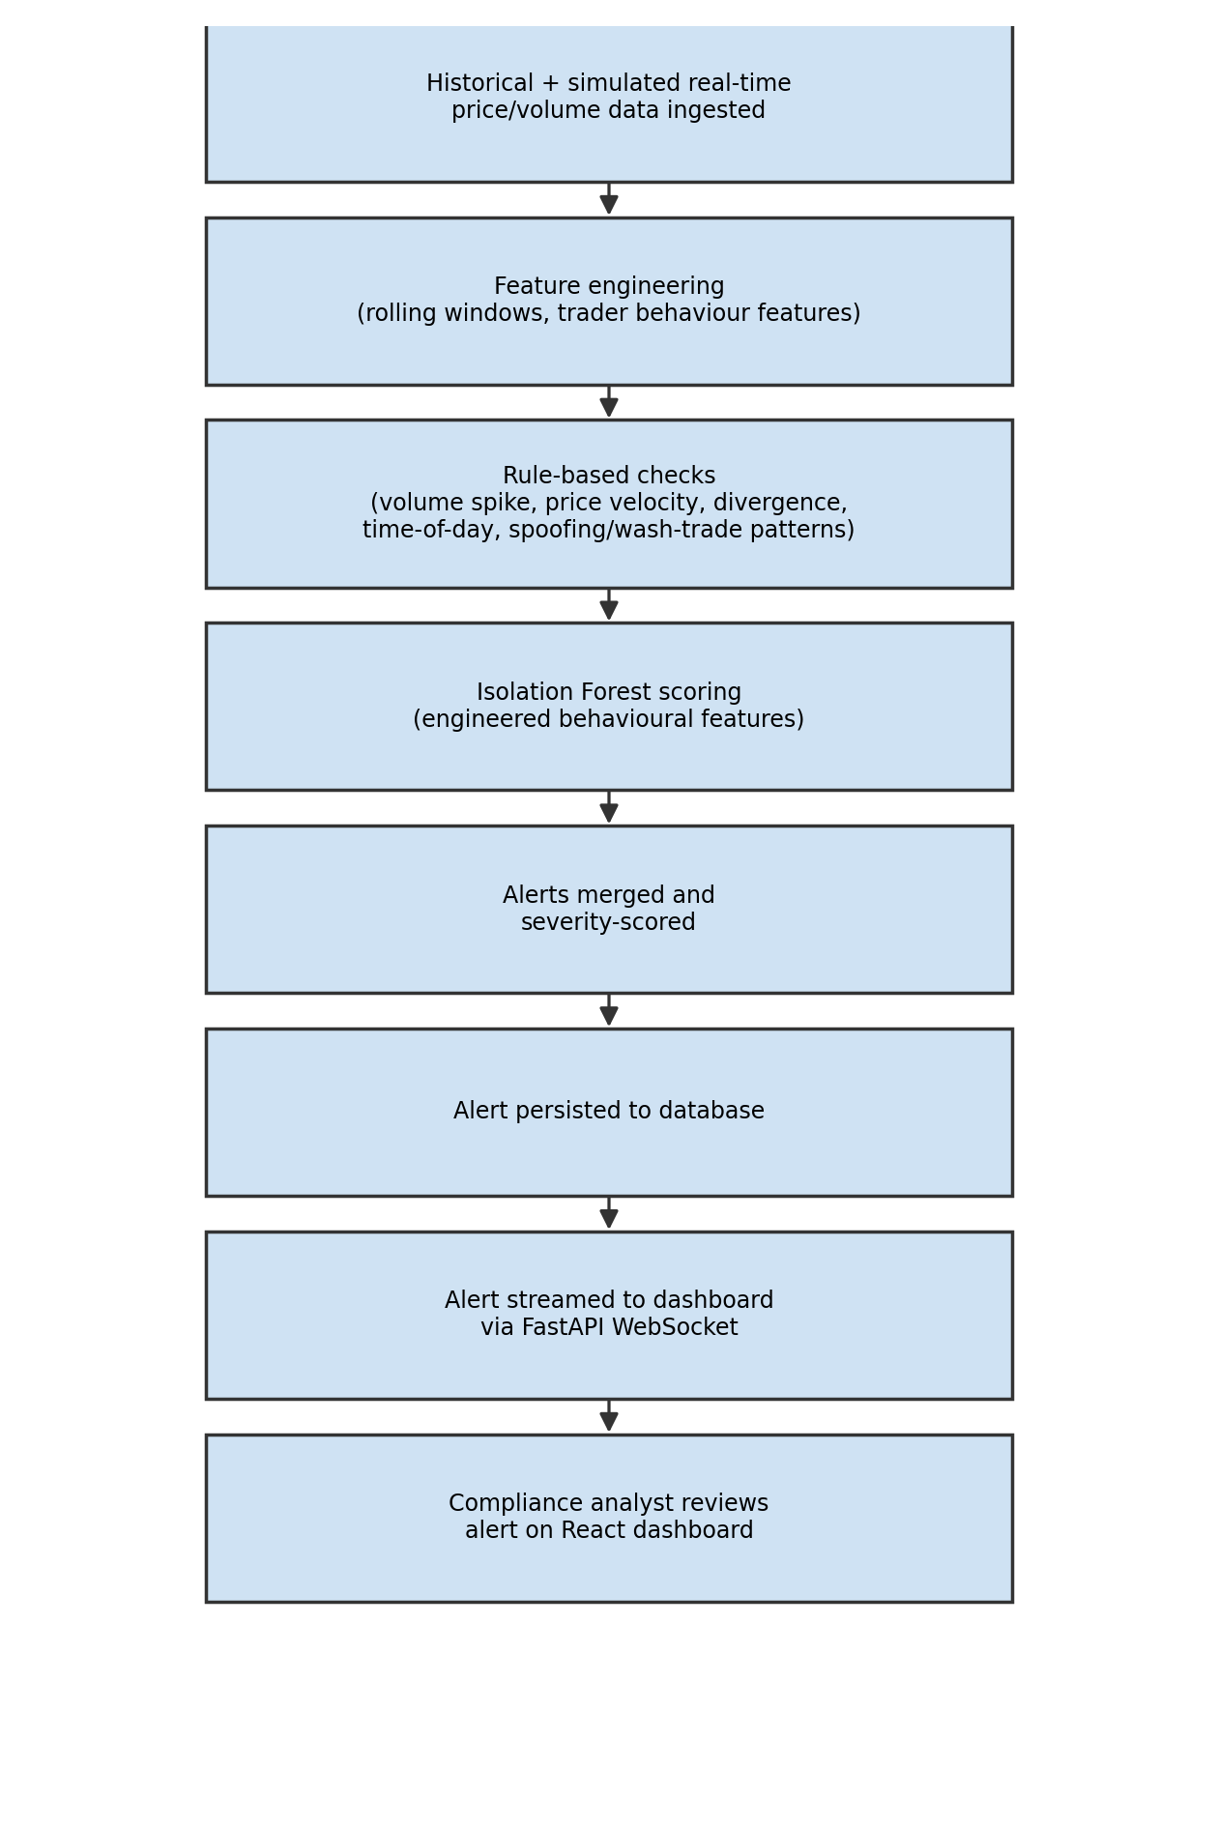
Data Model (E-R) Diagram
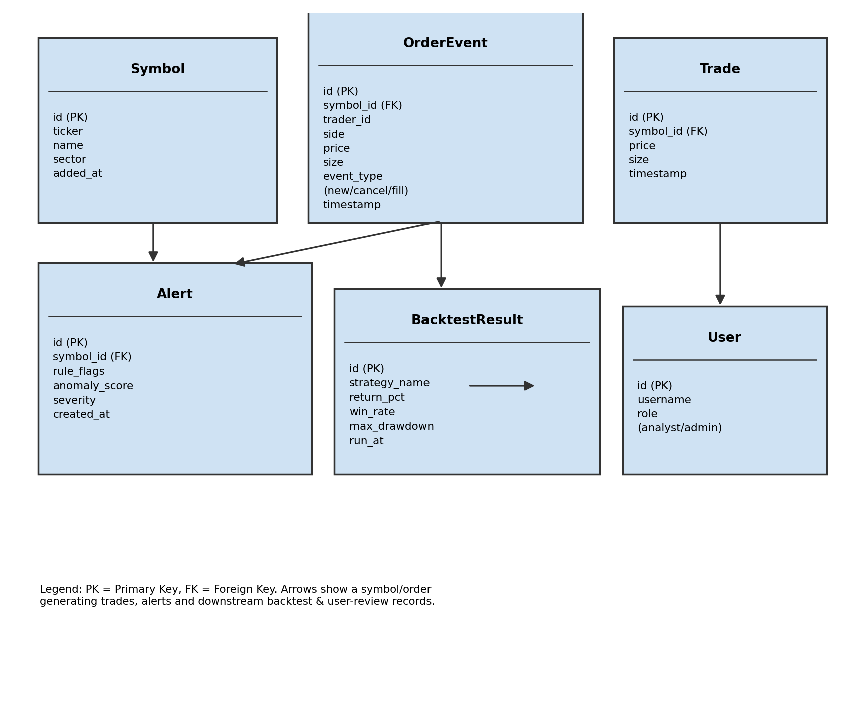
API Design
Method | Endpoint | Auth | Purpose | Status
GET | /api/symbols/ | Public | List watchlist symbols (10-20 tracked tickers) | Day 1
GET | /api/market-data/<symbol>/ | Public | Historical price/volume for backtesting & charting | Day 1
WS | /ws/live-feed/<symbol> | Public | Streamed simulated live price/volume ticks | Day 2
POST | /api/backtest/ | User | Run strategy engine over historical data (return, win rate, max drawdown) | Day 3-4
GET | /api/backtest/<id>/ | User | Retrieve a stored backtest result | Day 4
POST | /api/paper-trade/order/ | User | Submit a simulated (paper) order | Day 5
GET | /api/paper-trade/positions/ | User | Current paper-trading positions & P&L | Day 5
GET | /api/alerts/ | User | List surveillance alerts (filter by symbol, severity, date) | Day 6-7
GET | /api/alerts/<id>/ | User | Alert detail (triggering rule flags + anomaly score) | Day 7
WS | /ws/alerts | User | Real-time push of newly generated alerts | Day 7
POST | /api/surveillance/rules/ | Admin | Configure/adjust rule-based detection thresholds | Day 8
POST | /api/surveillance/model/retrain/ | Admin | Retrain Isolation Forest on latest engineered features | Day 8
GET | /api/positions/monitor/<trader_id>/ | Analyst | Position-level surveillance for a single trader's own trades | Day 9
GET·POST | /api/auth/login/ · /api/auth/register/ | Public | Analyst / compliance-officer login and account creation | Day 9
GET | /api/health/ | Public | Service health check | Day 10

