Settings
​

​
To navigate to the settings use the Sidebar: Setup > Settings
There are a few tabs under Settings
- General: Settings used to customize accounting defaults and enable features.
- Defaults: Settings that are used to set defaults.
- Print: Settings that are used to customize the Invoice Print View.
- System: Settings used to customize System defaults.
:::tip Inventory Settings
Inventory Settings are visible only when Inventory has been enabled. :::

General Settings
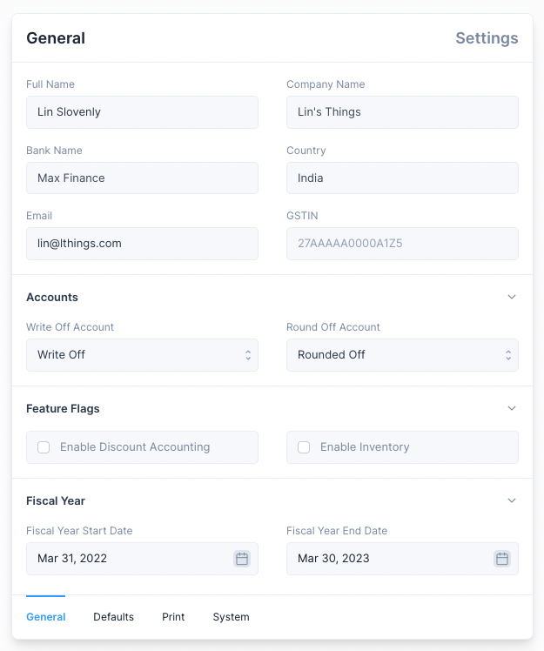
These settings are used to set and customize accounting defaults.
Settings that cannot be changed
- Full Name
- Company Name
- Country
- Bank Name
::: info Setup Wizard These values are set when setting up a new instance using the Setup Wizard. :::
Settings that can be changed
- Fiscal Year Start Date: used as the start date when displaying the reports by fiscal year.
- Fiscal Year End Date: used as the end date when displaying the reports by fiscal year.
- Write Off Account: account used when a Write Off amount is set when making a Payment
- Round Off Account: account used to settle the credit and debit difference when the General Ledger is updated.
- Enable Discount Accounting: used to enable the setting of discounts in invoices. (link)
- Enable Inventory: used to enable inventory management features. (link)
::: info GSTIN GSTIN setting is available only when the country is set to India.
Setting this value will enable the GST Reports. :::

Defaults
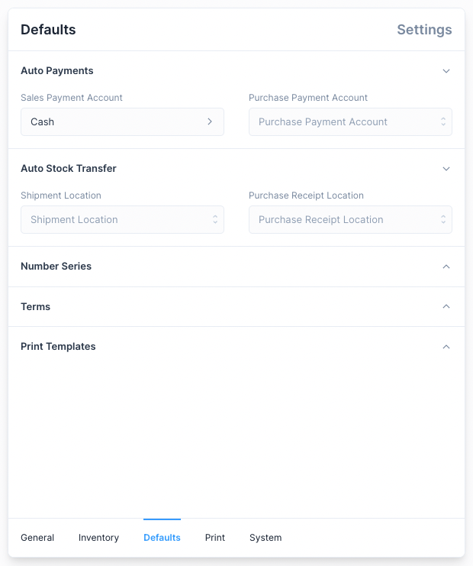
These settings are used to set default values that are selected when creating an entry. They allow for quicker creation of entries but can be changed when making entries.
The following Defaults can be set:
- Accounts used for Auto Payments.
- Locations used for Auto Stock Transfers.
- Number Series for transactional entries.
- Terms to be used for certain transactional entries.
- Print Templates to be used when printing an entry.
:::warning Auto Stock Transfer items
An Item from an Invoice is included in the auto Stock Transfer only if these conditions are met:
- The item does not use Batches.
- The item does not use Serial Numbers.
- There is sufficient quantity of the item at the set default Location.
:::

Print Settings
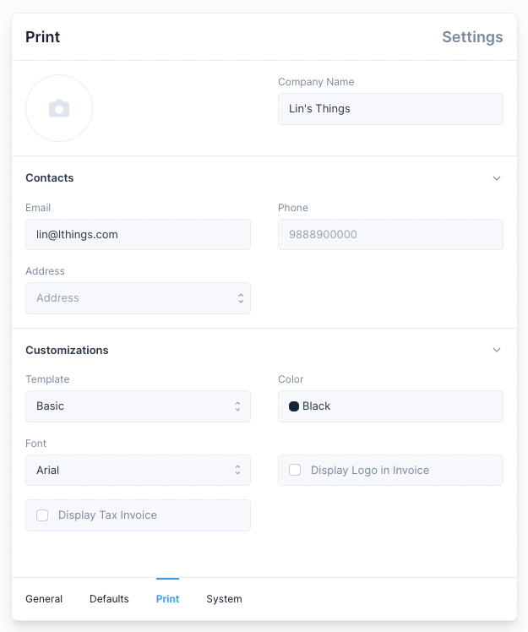
Settings here can be altered to customize the Print View of an Invoice.
::: tip Print View These settings can also be altered from the Print View of an Invoice :::

System Settings
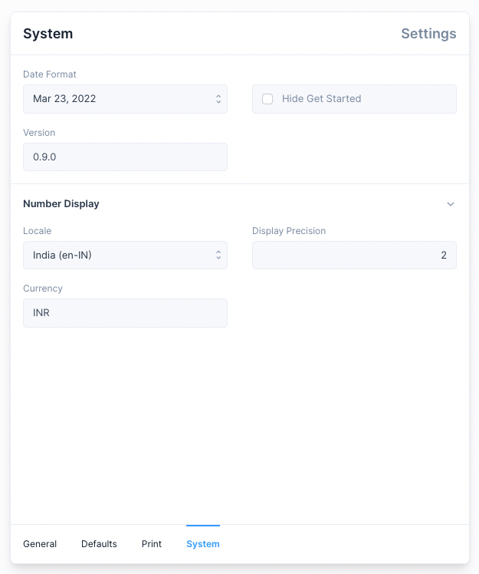
These settings are used to alter how values such as currency and time are displayed.
- Date Format: used to set how dates are displayed.
- Hide Get Started: used to hide the Get Started section from the Sidebar.
- Version: this is a read only field which tells you the current version of Nirolite .
- Locale: used to set the currency format, by default locale of the selected country is used.
- Display Precision: used to set the number of digits are shown after the decimal.
- Currency: used to set the currency used for all transactions.
::: info Get Started Get Started is auto hidden on completion. :::

Print Templates
​

​
The Print Template feature in Nirolite allows you to create personalized print templates for Invoices and a few other Entries.
To view and create Print Templates navigate to its page using the sidebar: Setup > Print Templates. Or alternatively open the Quick Search, type "Print Template" and hit enter.
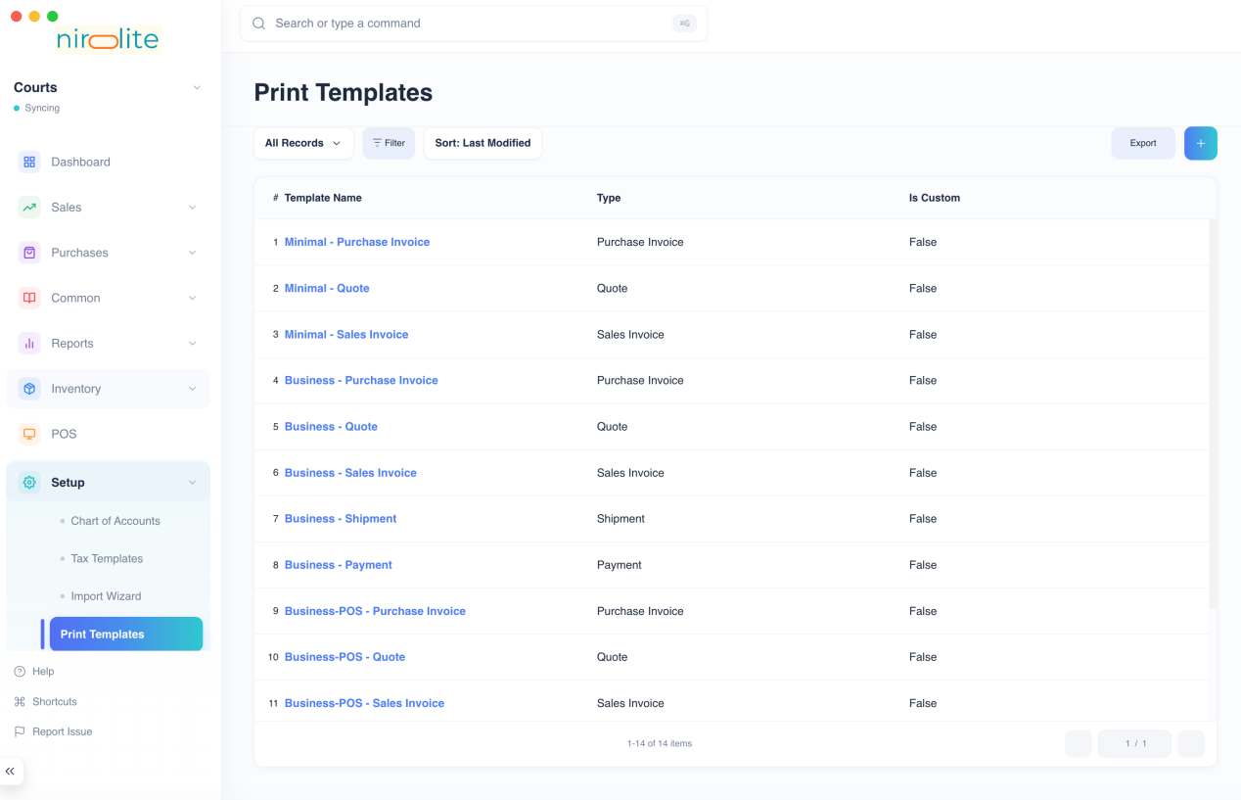
:::tip Preloaded Templates
When you create a new instance of Nirolite , it comes preloaded with a few templates.
You use these as they are, or you can Duplicate and customize them. :::
If you would like to familiarize yourself with the Template Builder interface before learning how to create a Print Template, click here.

Creating a Print Template
To create a Print Template, first navigate to the Print Template list and click on the blue + button.
You will now see the Template Builder tool.
You can enable the Edit Mode by clicking the edit button next to the Save as PDFbutton.
Next, select the template type. Sales Invoice is selected by default, but you can create Print Templates for other entry types too.
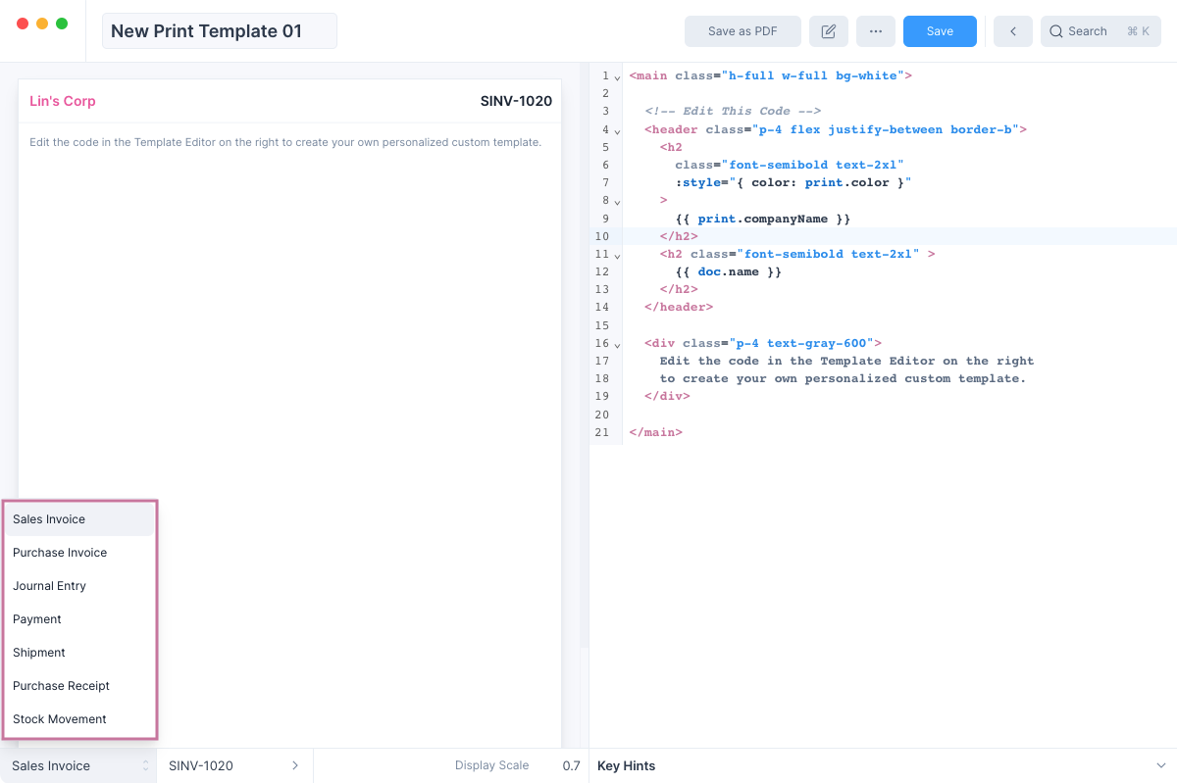
:::tip Display Entry
You can change the example Entry being displayed. By default Nirolite selects the latest entry that has been created. :::
:::tip Custom Sizes
You can adjust the size of the Print Template by clicking on the Set Print Size option in the ··· menu.
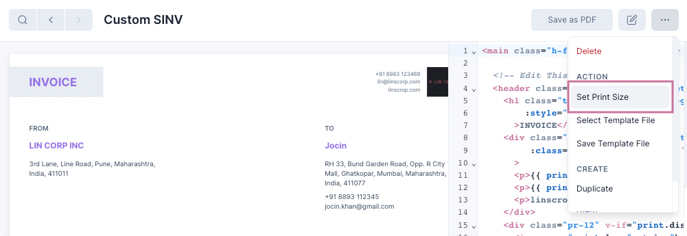:::
Now you are ready to edit the Print Template

Editing the Template
The left pane contains the Template Editor which is used to edit the template. You can remove the preset template and write the template that you want here.
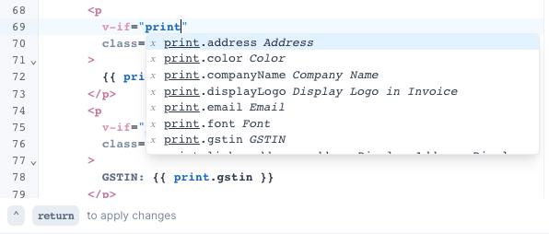
:::info Template Syntax
The templates follow the Vue.js template syntax. You can learn more about it here. :::
:::tip Resizing the Template Editor
You can resize the Template Editor by clicking on the border and dragging it.
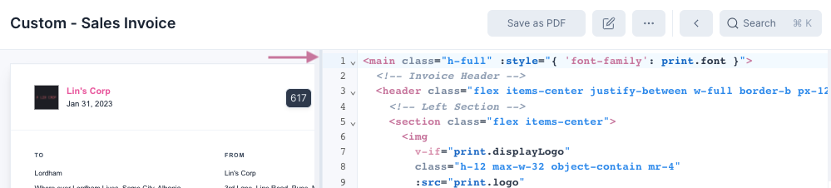:::

Displaying Values
Values can be displayed by mentioning their keys inside curly braces. For example:
1<h1>{{ doc.name }}</h1>
Here doc.name is the key for Invoice No and it will be displayed in an h1element.
The Template Editor can help you by autocompleting the keys as you type the name.
There are two sets of keys to display values:
- doc: these keys are used to display values from the entry such as Invoice No, Account, Date, etc. These keys vary depending on the Entry Type.
- print: these keys are used to read Print Settings values such as Logo, Email, Color, etc.
:::tip Key Hints If you want to see the available values you can click on the Key Hints section below the Template Editor.
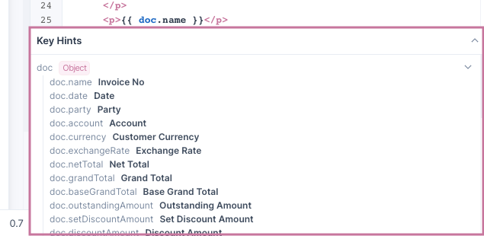:::

Template Styling
You can either use inline CSS styles or utility classes from tailwindcss to style the different components of your templates.

Applying Changes
To apply the changes made in the editor, you can:
- Click outside the template editor
- Press the shortcut keys (⌃ return for macOS and Ctrl Enter for other operating systems).

Using the Template
After you have edited your template and clicked on the blue Save button to save the changes you have made. You can use the templates save your entries as PDFs which you can send to your customers.
To use the template, navigate to the entry and click on the Print button.
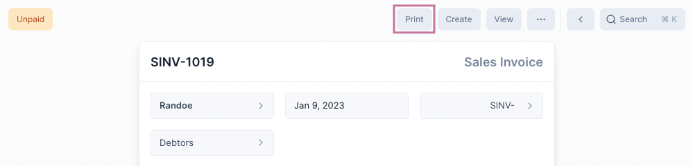
You will now see the print preview. You can change the template to be used from the list on the left.
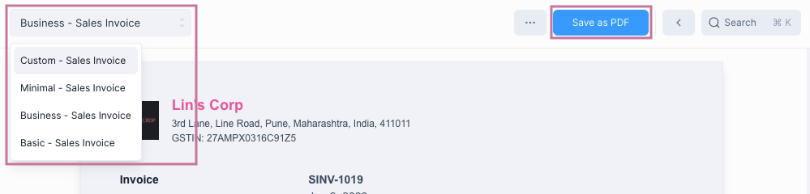
Once you are satisfied with your selection click on the blue Save as PDF button to save it.

Template Builder Interface
When you open any of the Print Templates or when you click on the blue +button to create a new Template, you will be shown the Template Builder tool.
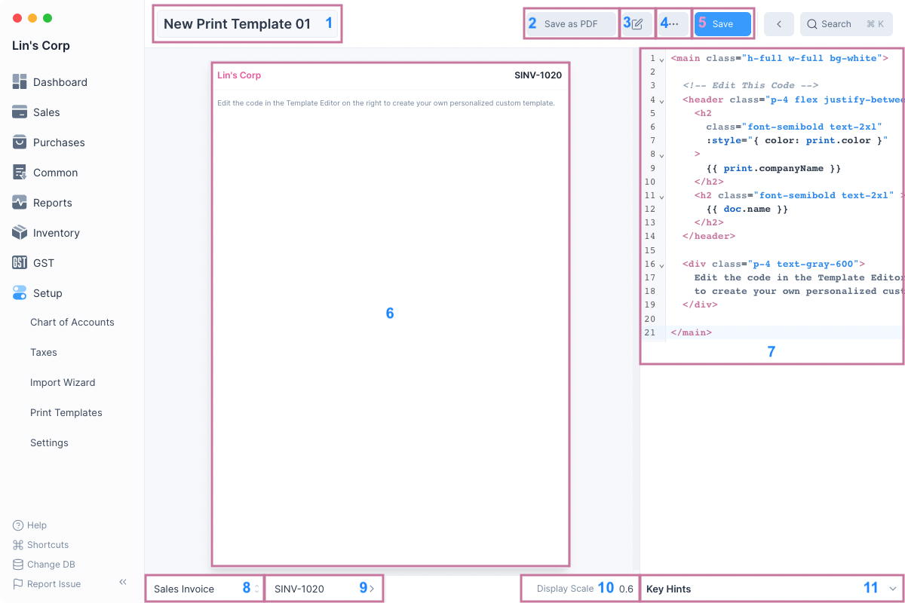
Here's a list of what each component does:
- Template Name: text input to edit the Print Template name if it has not been saved.
- Save as PDF: button to save the selected entry as a PDF file.
- Toggle Edit Mode: button to toggle edit mode.
- More: dropdown menu with options such as view the print settings, and selecting and saving the template file.
- Save: button to save the Print Template after editing its values.
- Template Preview: preview template after editing without saving it.
- Template Editor: text input to edit the template.
- Template Type: drop selector to set the template type.
- Display Entry: entry to show in the preview area.
- Display Scale: number input to change the Template Preview scale.
- Key Hints: component that shows the available keys (such as doc.name, doc.date, etc) that can be used in the template.

Tips for Creating Templates
Here are a few tips to help you create custom print templates.

Duplicating preloaded templates
If you are not familiar with HTML, CSS and Vue.js Template Syntax then you might find creating a custom template to be a bit challenging.
If this is the case, we suggest duplicating one of the Preloaded Templates and editing the duplicate.
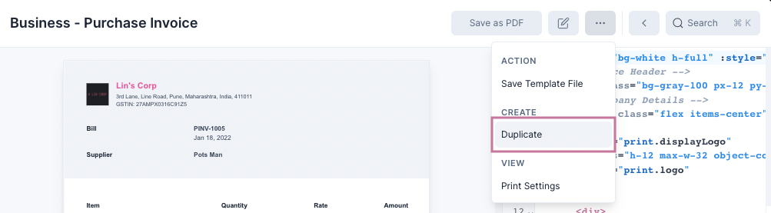
This way you can make and apply small changes and see how it affects the Preview and step by step make the template like how you want it to look.

Precaution when using tailwindcss
A few of the tailwindcss defaults (for example colors) used in Nirolite have been overriden using the tsconfig.js file.
Since these values are subject to change we suggest not relying on the overriden tailwindcss styles. Not doing this may cause your templates to change when we update the defaults.

Customize Form
​

​
Nirolite allows you to customize all forms whether it's Invoice, or Party, or Item you can use the Customize Form feature to add additional fields to it.
To be able to customize a form you need to enable it from the General Settings.
Setup > Settings > General
After you have navigated to the General Settings tab, click on the Enable Form Customization checkbox.
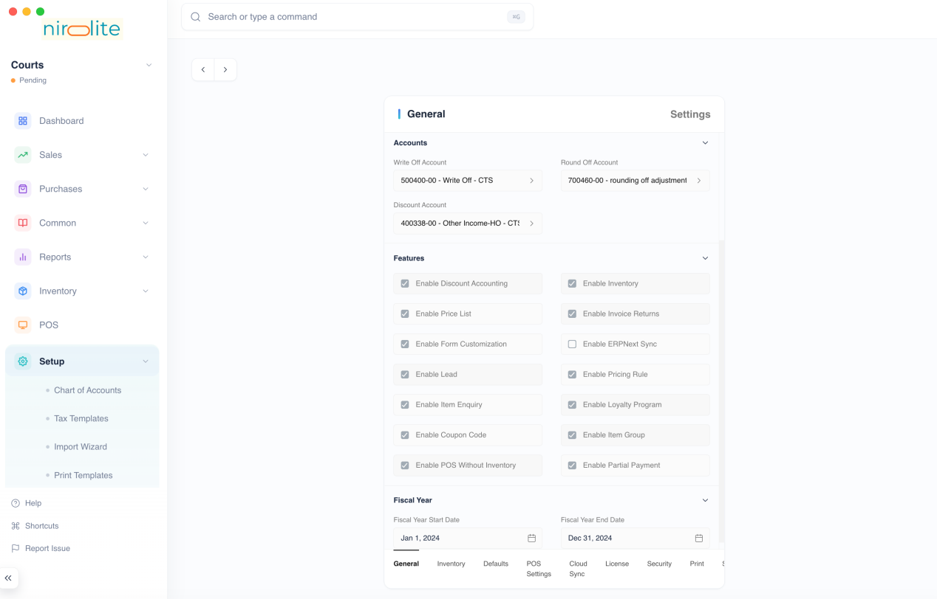
You will have to reload Nirolite to see the option, you can press Ctrl + Rif you are on Windows or linux, or command + R on macOS.
::: warning Disabling Form Customization
Disabling Form Customization will just hide the form customization option from the sidebar and search, it will not disable the customizations. :::

Customizing Forms
After enabling form customization and reloading Nirolite navigate to the Customize Form list view using the sidebar.
Setup > Customize Form
After that click on the blue + button to customize a form type. This will open a new Custom Form entry.
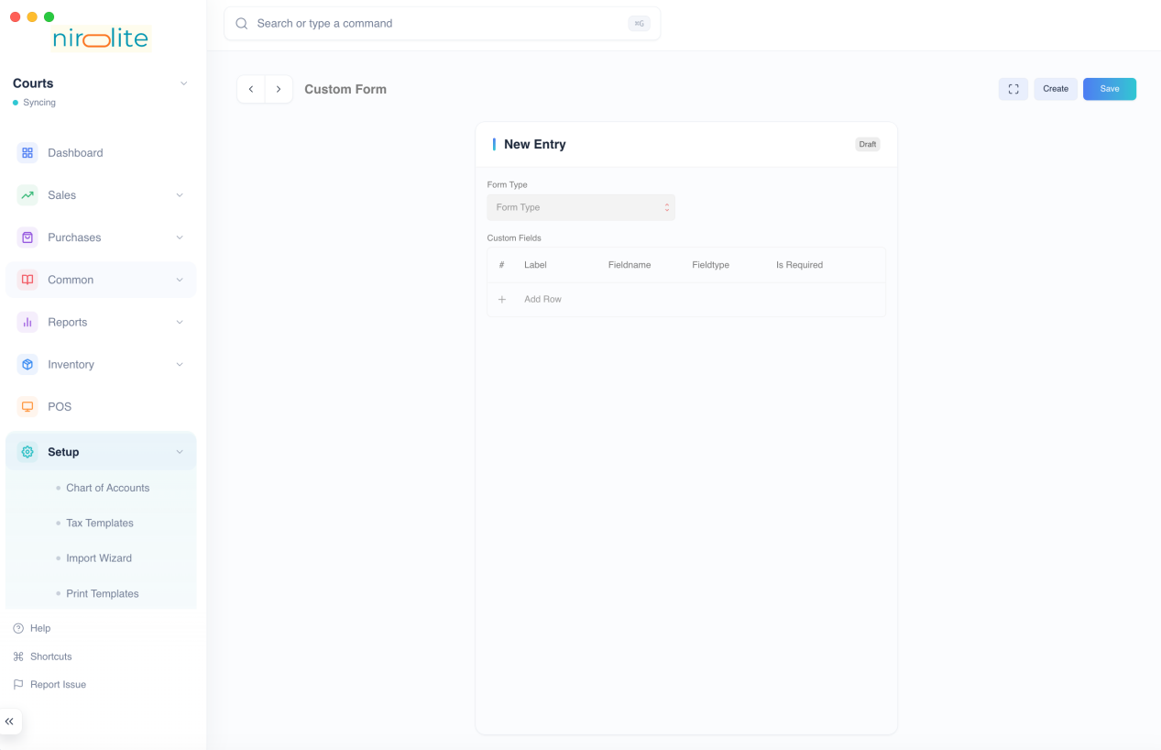
Select a Form Type to customize.
::: info Form Type
Form Type refers to the form that you want to add fields to such as Item, Party, Sales Invoice, etc.
Each Form Type can have only one Custom Form entry associated with it. :::
Once you select the Form Type you can add Custom Fields

Custom Fields
Each Form Type can have multiple custom fields. Click on the Add Row button to add a new Custom Field.
Enter its Label, for example if we want to add a color field to Item, we will set the Label as "Color".
:::tip Fieldname
Setting the Label will auto set the Fieldname value. The Fieldname is a name used to refer to the field internally. :::
After setting the Label and the Fieldname, you can select the fieldtype, for more information on fieldtype and the other fields that you can set for each Custom Field row check the sections below.
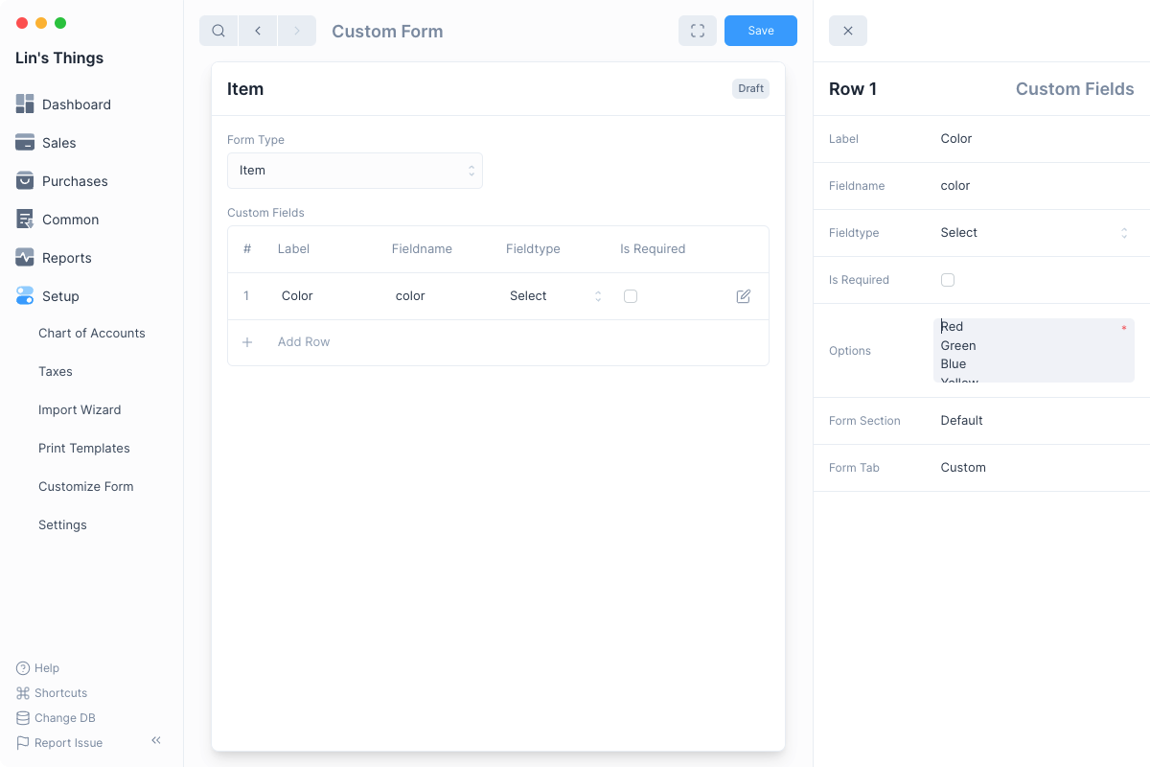
Once you are done click on the blue Save button.
:::warning Reload App
After customizing a form you must reload Nirolite to view the added fields in the forms. :::
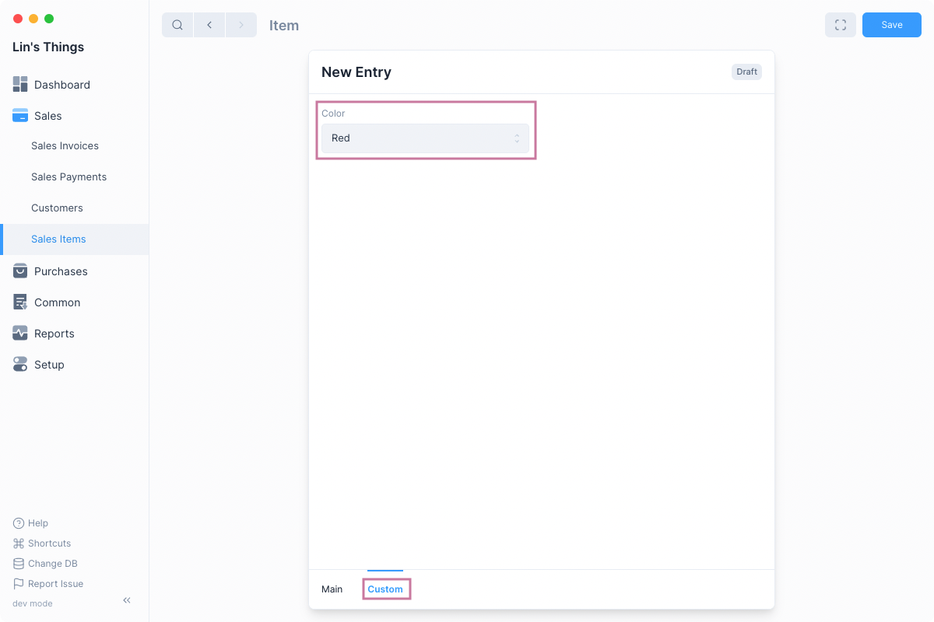
After reloading the app, you will see the new fields in the form.

Custom Field Fieldtypes
Custom Forms support 16 different Fieldtypes, each field type defines the behavior and UI of the field.
For some fields you will have to enter additional details, here's a table the describes the different Fieldtypes.
Fieldtype | Description | Example | Additional
Data | Field used for regular text input. | Full Name in Customer | -
Text | Field with larger area of input for longer text. | Notes in Sales Invoice | -
Date | Field used to input only date. | Date in Sales Invoice | -
Date Time | Field used to input date and time. | Date in Stock Movement | -
Int | Field used to input integer such as -1, 0, 3, etc. | HSN/SAC Code in Item | -
Float | Field used to input fractional numbers such as 0.12, -9.33, 100.1, etc. | Quantity in Sales Invoice Item | -
Currency | Field used to input monetary amounts. | Amount in Sales Invoice Item | -
Check | Field used to display a checkbox. | Track Item in Item | -
Select | Field used to select an item from multiple choices. Requires Options value to be set | Entry Type in Journal Entry | Options
Autocomplete | Same as Select but with autocomplete. Used for larger number of options. | Country in Address | Options
Color | Field used to select a color. Can set options to select color from. | Color in Print Settings | Options
Link | Field used to mention links to other entries. Requires Target to be set. | Customer in Sales Invoice | Target
Dynamic Link | Field used to mention links depending on a dynamic target. Requires References to be set. | Name in Payment Reference | References
Attach Image | Field used to select an image. | Image in Item | -
Attachment | Field used to select any type of file. | Add Attachment in Sales Invoice | -
Table | Field used to display a Table. This is currently not supported. | Items in Sales Invoice | Target

Other Custom Form Fields
Fields that describe behaviour:
- Is Required: Whether this field is required for a form to be saved.
- Options: New line separated list of options required by Select and Autocomplete and used by Color.
- Target: Form type from which Link field value is selected. If Table then the name of the Table form type.
- References: Fieldname of the reference field which sets the Dynamic Link target type. Eg Type in Payment Reference.
Fields that describe UI:
- Form Tab: Tab on the form under which the field is displayed.
- Form Section: Section under the entered tab where the field is displayed.

Deleting Customizations
You can delete a forms customizations by deleting its Custom Form entry:
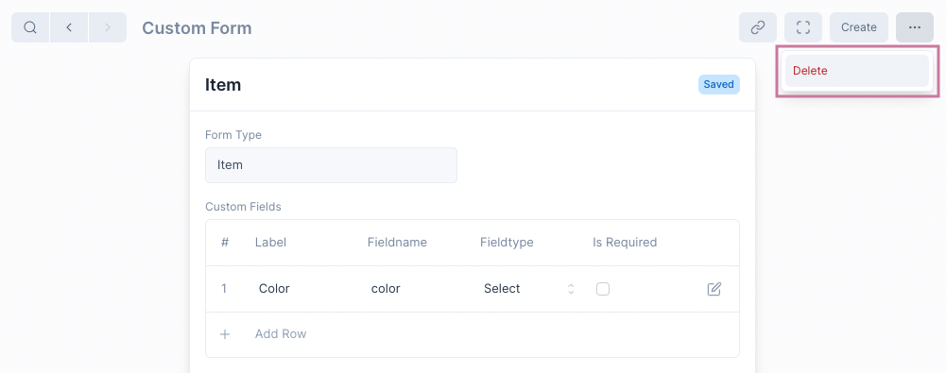
:::danger Data Loss
Deleting customizations will also delete data that had been stored in the custom fields. :::

Number Series
​

​
Number Series is used as the naming scheme for transactional entries. Multiple transactions of a single type for example Journal Entry can be grouped under a single Number Series.
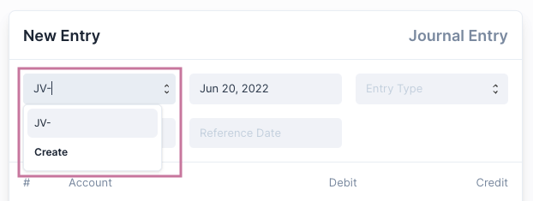

Default Number Series
By default Nirolite comes with a single Number Series for each of the transactional entry types
Type | Number Series
Sales Invoice | SINV-
Purchase Invoice | PINV-
Payment | PAY-
Journal Entry | JE-
These are selected by default when making a transactional entry. You can create new a Number Series to suit your needs.
::: warning The Number Series of a transactional entry cannot be changed once Save is clicked. :::

Creating a New Number Series
To create a new Number Series for a specific transactional entry
- Find the Number Series field on the entry form or the Quick Edit Form.
- Enter the new Number Series you would like to use in the field.
- Click on Create
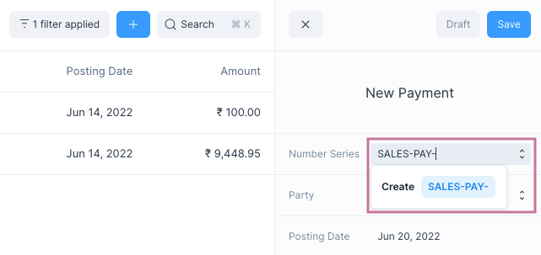
This will take you to the Number Series Quick Edit Form where you can change the number series configuration.
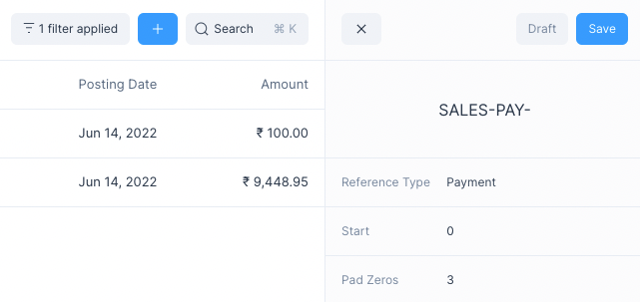
Once you are done editing, click on Save, now you can use the new Number Series for the entry.

Number Series Fields
The fields decide how the Number Series is set
- Prefix: The base prefix applied to the number series for example: SINV-
- Reference Type: The transactional entry type to which this Number Series belongs.
- Start: The number given to the first entry in the Number Series.
- Pad Zeros: The number of given as padding to the number part of the Number Series.
For example, if Name is SALES-PAY-, Start is 0, and Pad Zeros is 3, then the Number Series values assigned to the transactional entries would be:
SALES-PAY-000, SALES-PAY-001, SALES-PAY-002, SALES-PAY-003, etc.

