**Team Name – Tech Army**

**Team Leaders name -Anant Govil**

**Email id-** [**anant.govil2018@vitstudent.ac.in**](mailto:anant.govil2018@vitstudent.ac.in)

**Solution Brief Overwiew –**

**It’s a voice controlled bot which can be used in Hospitals to deliver food and medicines in hospitals to patients so Social distancing can be maintained and corona spread can be controlled as medical staff is most prone to have corona infection.**

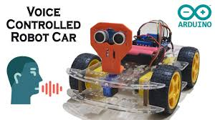

**Solution Description-**

**These days a lot of corona cases are increasing as nurses and doctors though are in PPE kits but still they catch COVID-19. As somehow or anyhow through air or somewhere else as they are so close to the patient they are most vunerable to get affected. So this Voice controlled bot can be used by doctors to supply medicines and food through it as this will maintain social distancing which the only solution for the corona virus.**

**Everyone have smartphone In this generation You just have to download our app which we made through MIT App Inventor and connect Bluetooth with the Blooth Module in the Bot .**

**After that As You say forward ,Back ,right , left the bot will move on your instructions and will reach the place . After supplying essentials it will come back to the person who is controlling it. Through this efficiently and safely our task can be done.**

**Solution Architecture-**

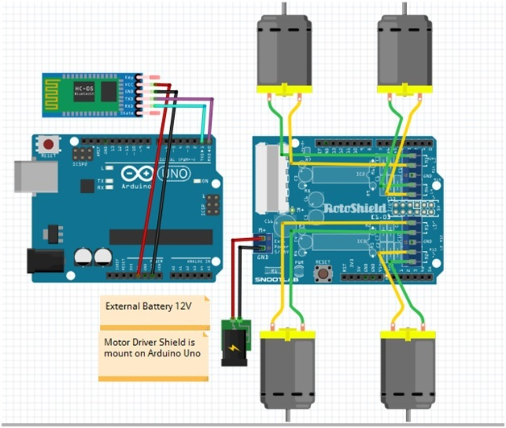

**It contains following components**

1. **Arduino UNO Board**

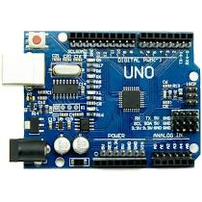

1. **Motor shield**

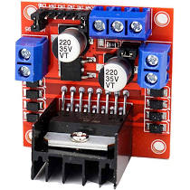

1. **Battery operated motors**

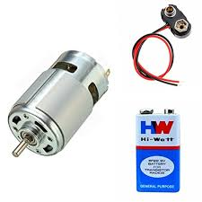

1. **HC -05 Bluetooth module**

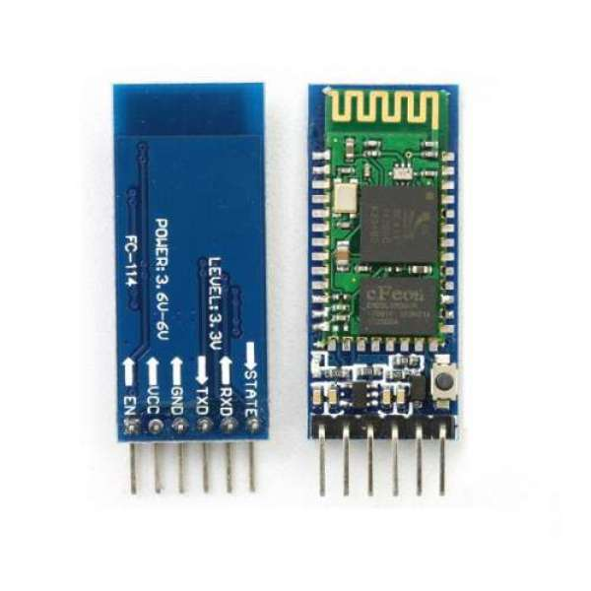

1. **Wires**

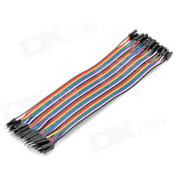

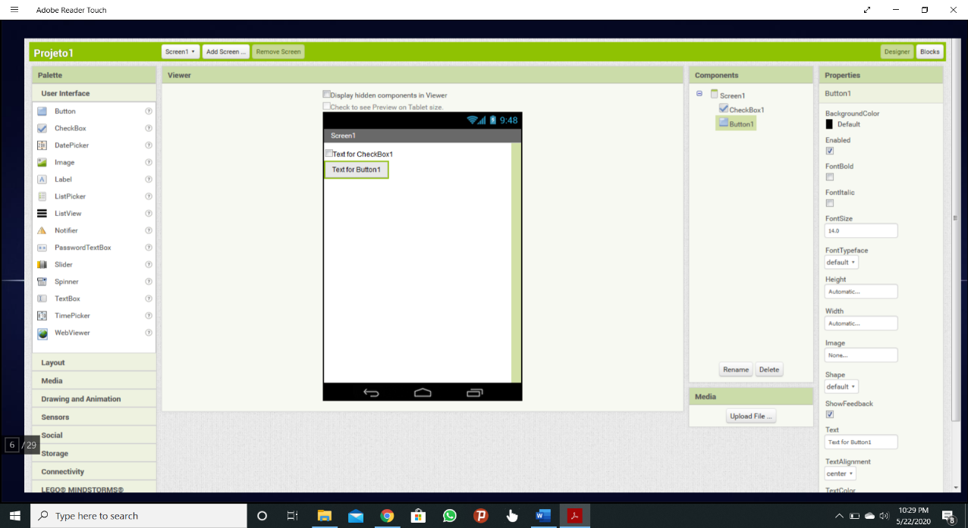**Mit App inventor which is used to create an App which through Google voice search text is taken and through Bluetooth module its connected to Arduino and bot Moves on your voice instructions .**

**So it’s a Cheap and best way to tackle and protect medical staff from corona virus and maintain social distancing.**