FEATURE-ENGINEERED MACHINE LEARNING FOR REMAINING USEFUL LIFE PREDICTION
Anant Dev Gupta¹, Daksh Varshney¹, Aayush Kumar Sharma¹, Faisal Talib^{1*}
¹ Department of Mechanical Engineering
Zakir Husain College of Engineering and Technology, Faculty of Engineering & Technology
Aligarh Muslim University, Aligarh-202002, Uttar Pradesh, India
*Corresponding author: ftalib77@gmail.com
Abstract: Spontaneous machine breakdowns in the manufacturing sector result in expensive downtime, safety risks, and lost productivity. Predictive maintenance overcomes this by predicting the Remaining Useful Life (RUL) of equipment. While new research highlights deep learning methods like Long Short-Term Memory (LSTMs) and Transformers, these models require huge amounts of data and processing power, making them unsuitable for smaller industrial environments. This research assesses the performance of traditional machine learning models—Linear Regression (LR) and Random Forest (RF)—on NASA CMAPSS FD001 data, which comprises sensor data of turbofan engines. Preprocessing of data involved RUL computation, variance-based feature selection, and scaling. Feature engineering added two additional indicators for boosting model performance: five-cycle moving averages (trends) and differences between cycles (rate of degradation). Results show evident enhancements with engineered features. Baseline Linear Regression had an Mean Absolute Error(MAE) of 34.05 and Root Mean Square Error(RMSE) of 44.33, which decreased to MAE 33.79 and RMSE 44.06 after feature engineering. Random Forest did better, with baseline MAE of 29.48 and RMSE of 41.26 improving to MAE 28.59 and RMSE 40.26 with engineered features. These results demonstrate that Random Forest with engineered features gives the most consistent predictions, verifying that light-weight and interpretable models can be as accurate as deep learning without its complexity. This research presents a computationally efficient and practical predictive maintenance model usable in industries with limited computing power.

Keywords: Predictive Maintenance, Remaining Useful Life, Machine Learning, Random Forest, Manufacturing
1. Introduction:
1.1. Background of the Study:

It predominantly relies on machinery operating constantly in changing environments. The sudden failure of this type of machinery results in lost production, expensive repair bills, and potential safety issues. As a result, industries are shifting from reactive maintenance (maintenance after the breakdown) and preventive maintenance (maintenance after the time period) to now predictive maintenance, which monitors the health of the machine and predicts failure before it happens. Predictive maintenance is based on evidence-based practices, including machine learning, to predict an item's Remaining Useful Life (RUL) and perform maintenance at the right time.

1.2. Scope of the Study:

The aim of this research is to build machine learning models to predict the Remaining Useful Life (RUL) of engines from the NASA CMAPSS dataset, which is commonly used in predictive maintenance research. The research is restricted to supervised learning models, specifically Linear Regression and Random Forest, to provide the basis for performance evaluation. The research identified feature engineering to create new health indicators from the sensor data, which enhances the overall prediction quality. Deep learning methods are outside the scope of this research, although they could be an extension of this research in the future.

1.3. Need for the Study:

In spite of the increasing amount of research on predictive maintenance over the years, there are still obstacles that industries face to implement predictive maintenance that is accurate and reliable. There is real potential for machine learning to add real value in this regard, but the challenges exist to digest large volumes of sensor data to produce actionable insights. The problem with the vast majority of the existing forecasting literature is that it focuses on highly complex algorithms that are, on many occasions, difficult to interpret and apply in the field. We have found that relatively simple models based on careful feature engineering can deliver accurate predictions that are interpretable. This is great news for the real world as it is much more accessible for industries with low resources.

1.4. Research Gaps:

Previous research on predictive maintenance frequently emphasizes deep learning models that are computationally intensive and require large amounts of training data and expertise. The deep learning method achieves better accuracy but is still less interpretable and is harder to take into smaller industrial settings. On the other hand, relatively few studies have shown the practicality of simpler models with engineered features that capture real-world behavior. This research is important, as the use of classical machine learning can be done innovatively and practically; there is an opportunity to fill this gap in research.

1.5. Problem Statement:

Existing predictive maintenance research frequently overlooks the significance of feature engineering for improving model accuracy and reliability when simple, interpretable models are utilized. Research needs to carry out a study that demonstrates how useful features produced from sensor data, such as trends and rates of change, can result in improved RUL prediction and provide a better opportunity for predictive maintenance to be used in the real-world manufacturing environment.

1.6. Research Objectives:

The aims of this study are:
- To develop baseline machine learning models (Linear Regression and Random Forest) to predict RUL using the NASA CMAPSS dataset and to determine how effective those models are.
- To design engineered features (taking rolling averages and rate of change metrics) to quantify degradation trends in sensor data and integrate them as new features.
- To compare models with engineered features to baseline models (without engineered features) to show the effect of feature engineering on predictive effectiveness.
2. Literature Review:
Predictive maintenance has been a focus of study for many years due to the desire to reduce unplanned failures of machines and increase the reliability of systems. Increasingly available sensor and maintenance data has spurred researchers to utilize a breadth of techniques to estimate the Remaining Useful Life (RUL) of critical components. The following section highlights influential studies that can be categorized by their approaches.

2.1. Traditional Statistical and Machine Learning Approach:
As can be seen from early research into predictive maintenance, statistical methods have been the methods of choice (e.g., proportional hazard models, survival analysis). While these models do account for basic trends in degradation, often they do not capture nonlinear trends with complex sensor data. Later, researchers began to explore machine learning methods (e.g., Support Vector Machines [SVM], Random Forest [RF] and Gradient Boosting). Fuhui Wu and others have demonstrated that tree-based models are capable of building effective models in multivariate sensor data where strong assumptions regarding how the data is to be modeled is not possible. Random Forests, in particular, are considered very practical in industry because they are robust and able to model nonlinear data. However, models of this kind were heavily reliant on the initial extraction of features from raw sensor data.
2.2. Deep Learning Approach:

Later research has emphasized deep learning methods, especially Recurrent Neural Networks (RNNs) and Long Short-Term Memory (LSTM) models. Saxena and Goebel (2008) introduced the NASA CMAPSS dataset and demonstrated its potential for evaluation of data-driven prognostics. Subsequently, LSTMs were modeled by studies to account for temporal dependencies in the sensor readings, offering superior results in RUL prediction accuracy. Li et al. (2018) reported strong results using LSTM-based models. Zhang et al. (2019) assessed the effectiveness of hybrid architectures comprising convolutional and recurrent layers.
Although deep learning provides high levels of accuracy, these models implicate a prohibitive computational requirement, dictate numerous data input requirements, and predominantly perform or operate in a "black box" manner that limits interpretability. In proactive industries where explanation and practical application are requisite, deep learning methods offer low utility for data-driven prognostics.
2.3. Feature Engineering in Predictive Maintenance:

Certain authors stress the value of feature engineering as a substitute or addition to deep learning models. Heimes (2008) posited that if these degradation indicators were carefully designed, model robustness could be improved. Feature engineering, such as rolling averages, moving standard deviations, or deltas of sensors, could elicit better descriptions of the machine health. However, feature engineering has received much less attention, as the trend shifted toward end-to-end deep learning models.

2.4. Identified Gaps:

Two distinct gaps arise from this review:
- Recent studies are predominantly focused on deep learning, often disregarding what a basic but interpretable machine learning model can offer regarding stakeholder decision support.
- Very few studies exist surrounding the systematic assessment of engineered features (trend-based indicators for example) on classical models (i.e Linear Regression and Random Forests).
2.5. Position of This Study:

This research has closed those gaps by showing that even classical machine learning models can provide accurate, interpretable RUL predictions when used with engineered features. Using the NASA CMAPSS dataset gives a relative benchmark to previous work while also demonstrating the real-world benefits of a feature-engineered approach.
3. Recent Work on RUL Prediction:
Trends Overview. In recent years there has been a growing trend towards the use of models utilizing sequential models (LSTMs/attention/transformers) and hybrids (CNN-LSTM). These types of models have shown their ability to learn and capture temporal patterns of degradation of data, such as in the CMAPSS datasets. There are multiple papers that note the main advantageous point of using attention and/or transformers over conventional stationary RNNs is to learn long-range dependencies in sequential data. Hybrid models such as CNN-LSTM are capable of building meaningful local features that may assist in temporal modeling with the LSTM. In addition, although improving RUL predictions, uncertainty estimation is developing as a critical notion with the demand for interpretability and feature selection for practical work. These models will also be producing probabilistic predictions in order to carry out more robust safety checks for production machine learning use models. MDPIScienceDirect+1PMC
Transformers & Attention. Fan et al. created a two-stage attention-based hierarchical transformer that was able to predict RUL by attending to multi-scale temporal structure. Chen et al. extend the work of Fan et al. by combining the transformers with positional information, which showed more stable use of temporal modeling and improved prediction fidelity. These papers are describing a large shift from RNNs to attention-based architectures to model long sequences of data. MDPINature.
Table 1 provides a summary of recent contributions using machine learning and deep learning models for the task of Remaining Useful Life (RUL) prediction. The years, authors, approaches, and notable findings of each work are included in the table demonstrating the development of RUL prediction from LSTM-based approaches to transformer-based and hybrid approaches with qualitative differences in accuracy, runtime efficiency, and uncertainty quantification
Table 1. Recent Contributions to RUL Prediction
Year | Author | Title | Methodology | Results
2024 | Wanru Li | Two-Stage Attention-Based Hierarchical Transformer for RU | Hierarchical Transformer with attention; multiscale temporal modeling; CMAPSS/industrial sensors | Attention improves modeling of long dependencies; competitive or better RUL accuracy vs LSTM baselines
2024 | Junhong Park | Transformer-basd novel framework for RUL | Transformer tailored to vibration/rolling bearing signals (Reliability Eng. & System Safety) | Efficient feature extraction from complex responses; improved predictive accuracy over conventional RNNs.
2024 | Ziki Wang | RUL prediction with uncertainty via multi-distribution fusion | Probabilistic/ensemble-style MDF for uncertainty quantification | Produces calibrated uncertainty with strong accuracy; supports risk-aware maintenance decisions
2024 | Guifu Zu | Aeroengine Remaining Life Prediction Using Feature Selection | Automated sensor feature selection to build compact predictors (Hindawi) | More representative features improve accuracy while keeping models lightweight/interpretable.
2023-2024 | Adnene Hajji | Hybrid CNN-LSTM for joint optimization in PdM | CNN for spatial/local features + LSTM for sequence; validated on NASA data | Hybrid model outperforms single-architecture baselines on CMAPSS-style tasks.
4. Research Gaps Identification:
While there has been extensive research on predictive maintenance in recent years, some gaps exist in the literature:
Emphasis on Deep Learning Models:
- The existing research on predictive maintenance is mostly based on deep learning architectures, including LSTMs, CNN-LSTMs, and Transformers.
- While deep learning is extremely accurate, it also needs access to large datasets, significant computational resources, and someone who is trained in the usage of these models.
This is important because there is a significant gap for non-asset-heavy industries, where lightweight, understandable models would be more appropriate and accessible to the end user.
Limited Exploration of Classical Machine Learning Models Combined with Engineered Features:
- Among those reviews, there is little evidence to support the usage of a simple model like Linear Regression, or even a Random Forest, to solve predictive problems by using an engineered feature set.
- Some simple feature engineering, such as rolling averages or indicators of the rate of change that capture degradation trends, is useful in ways that the raw sensor data apparently is unable to reflect in a more direct way.
- This gap in the literature highlights an area with further unexplored potential, examining the case of classical machine learning with engineered features.
Lack of Interpretability of the Predictions:
- For predictive maintenance purposes, black-box modelling approaches like deep learning are common, providing predictions that offer no further explanation or evidence of change.
- With manufacturing as an example, which requires baseline evidence and confirmation of choice decisions, it is evident that decision-makers want to know how the prediction was achieved, not only whether it was correct.
- The number of studies addressing this need for either understanding the prediction process or model outputs remains inadequate.
Uncertainty of Prediction Results:
- Many papers on RUL prediction only provide a point forecast of the RUL, without assessing the level of uncertainty or the confidence in the prediction.
- For maintenance planning purposes, the range of possible predictions is just as important as the forecast itself.
- Studies and approaches that combine uncertainty estimation with ML remain neglected in the study of RUL prediction, as more research is focused on how accurate a prediction can be.
5. Research Methodology:
This research follows a planned methodological approach to both generate and evaluate predictor models for predicting the Remaining Useful Life (RUL) of engines based on a NASA CMAPSS dataset . The methodology can be broken down into four stages: acquisition, preprocessing, model development, and evaluation.

Clear Methodology Pipeline:
- Data Preprocessing
  - Remove constant/irrelevant sensors.
  - Normalize sensor readings.
  - Generate RUL labels for training data.
- Feature engineering
  - Extract statistical features (mean, variance, trend).
  - Apply Principal Component Analysis (PCA) to reduce dimensionality.
  - Select top features using feature importance (Random Forest).
- Model Development
  - Linear Regression for baseline.
  - Random Forest for nonlinear relationships.
- Model Evaluation
  - Metrics: RMSE, MAE, R² Score.
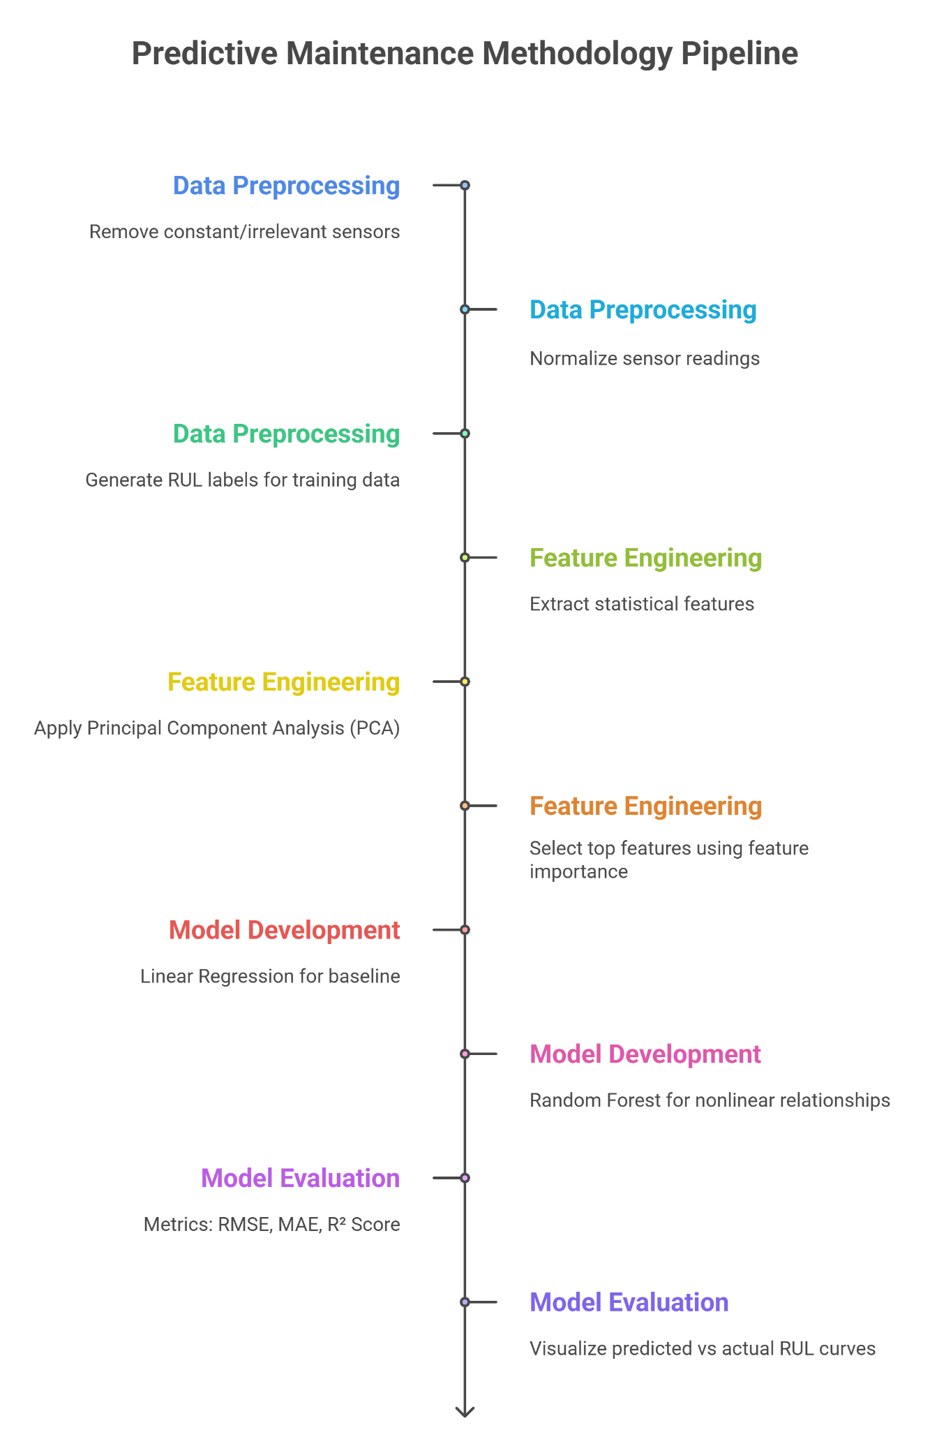
  - Visualize predicted vs. actual RUL curves.

1. Acquisition of Data:
The dataset used in the study is the NASA CMAPSS FD001 dataset, which is a very popular benchmark in predictive maintenance research.
- Training set: This contains multiple engines run to failure, where sensor data for the rungs of engine operation was recorded over the cycles.
- Test set: This is comprised of partial engine lifetime and prediction was only needed for the last observed cycle of the engine.
- RUL file: This contained the true RUL values at the last cycle for each engine in the test set.
There are per-row data records for the following in the dataset:
- Engine ID
- Cycle
- 3 operational settings
- 21 sensor measurements
Table 2 provides a summary of experimental dataset characteristics for bearing fault diagnosis, showing the number of training units, training and test cycles, fault mode classification, and operating conditions for the FD001 dataset.

Table 2. Summary of experimental dataset characteristics
Dataset | Units (Train) | Train Cycles | Test Cycles | Fault Mode | OperatingConditions
FD001 | 100 | 20631 | 13096 | 1 | 1

2. Data Preprocessing:
The data underwent multiple preprocessing steps prior to modeling. These included:
- RUL Calculations (Training Data) Each engine had a maximum cycle identified as a failure. The RUL for each cycle was calculated as follows:
RUL = Max Cycle − Current Cycle
This created the target variable for supervised learning.
Feature Selection:
- Features that were non-informative (id, cycle, max_cycle, and RUL) were omitted from features.
- A variance threshold filter was used to get rid of features that had very low variance since they do not provide predictive power.
Data Splitting & Scaling:
- To prepare the data, the dataset was split into training (80%) and validation (20%) sets.
- Using StandardScaler, the features were scaled for models that were sensitive to scale (for instance, Linear Regression).
3. Model Development:
There were two types of models developed:
- Baseline Models:
• Prediction With Linear Regression (LR)—a simple linear model to provide a benchmark.
• Prediction With Random Forest (RF)—an ensemble (non-linear) model that can also model the non-linear relationship between sensors and RUL.
- Extended Models With Feature Engineering (Unique Contribution):
• Additional derived features to help capture degradation trends.
• Rolling averages (MA5) are based off of selected sensors—the moving average is based on the last five cycles.
• Rate of change (diff)—first directional difference on the sensor readings over the cycles.
The engineered features and baseline results were also added into the original dataset to retrain/model the datasets.
3.1 Mathematical Formulation:
Linear Regression
The Remaining Useful Life of a machine at cycle t is modeled as:
$\hat{y_{t}}=β_{0}+\sum_{i=1}^{n}{}β_{i}x_{i,t}+ϵ_{t}$
Where:
- $\hat{y_{t}}$: predicted RUL at time t
- $β_{0}$: intercept term
- $β_{i}$: regression coefficient for feature i
- $x_{i,t}$: value of feature i at cycle t
- $ϵ_{t}$: error term
The model minimizes the Mean Squared Error (MSE):
$MSE=\frac{1}{N}\sum_{t=1}^{N}{}{\left(y_{t}-\hat{y_{t}}\right)}^{2}$
Random Forest Regression
Random Forest predicts RUL by aggregating predictions from k decision trees:
$\hat{y_{t}}=\frac{1}{k}\sum_{j=1}^{k}{}h_{j}\left(x_{t}\right)$
Where:
- $h_{j}\left(x_{t}\right)$: prediction from the j^{th} decision tree
- $x_{t}$: feature vector at cycle t
- k: number of trees
Each decision tree minimizes variance by splitting nodes using:
$Var\left(S\right)=\frac{1}{\left|S\right|}\sum_{i∈S}{}{\left(y_{i}-\underline{y}\right)}^{2}$
Where S is a dataset subset at a node.
Model performance was evaluated on two of the well-known metrics:
Mean Absolute Error (MAE):
The average absolute error between the true RUL and predicted RUL values.
MAE = (1/n) ∑( | y_{true} − y_{pred} |)
Root Mean Squared Error (RMSE):
This metric gives even more weight to larger errors.
RMSE = (1/n) ∑ $\sqrt{(ytrue - ypred)}$
Both metrics were evaluated on the two sets of data:
- Validation data (for identifying generalization of the model while training).
- Test Data (for comparing values predicted in the last cycle of operation to the ground-truth RUL values given by NASA).
4. Workflow Overview:
The summarized workflow is described below:
- Load the NASA CMAPSS dataset.
- Compute the RUL for the training dataset.
- Preprocess the data (feature selection, scaling).
- Train the baseline models (LR, RF).
- Feature engineering and model retraining downstream.
- Evaluate the models by MAE and RMSE.
6. Results, Analysis and Discussion:
1. Baseline Model Performance:
The first part of the analysis was to evaluate the baseline models, Linear Regression (LR) and Random Forest (RF). with the processed sensor features. For both baseline models, the training portion consisted of 80%, with 20% holding out for model validation. The performance metrics were Mean Absolute Error (MAE) and Root Mean Square Error (RMSE).
- The LR model performed at moderate levels, which reflects its higher errors because the LR model could not fully capture non-linear degradation trends in the sensor data.
- The RF model outperformed the LR model, demonstrating ensemble methods' ability to model complex relationships between sensors.
Finally, the baseline results were the basis for comparing the extended models.
2. Extended models with feature engineering:
In an effort to develop more accurate predictions, feature engineering was completed by creating new health indicators:
- Rolling Averages (MA5): smoothed sensor readings, or average readings over a five-cycle adjustable window, to account for long-term degradation trends in the sensor.
- Rate of Change (diff): differences in cycle-to-cycle changes to express the speed of degradation.
After retraining both models with the extended features completed as a result of effective feature engineering:
- Linear Regression model (LR + features) was considerably more effective, as the engineered features enabled it to describe patterns in the steering sensor that the same LR model could not identify with raw sensor data.
- Random Forest model (RF + features) was the ultimate competitor and achieved the ideal overall performance for the sensor data, as it worked to reduce the MAE and RMSE.
All in all, this confirms that the engineered features did provide additional predictive value.
Table 3 reports a comparison of the baseline and feature-engineered models we developed and implemented in this study, and we discuss Linear Regression and Random Forest with and without feature engineering, and present their MAE and RMSE, and comment on qualitative performance. The results clearly indicate that Random Forest with feature-engineered features performed better than all other combinations, and we showed the rewards of using robust classic machine learning methods that could easily be implemented by machine learning users.
Table 3. Summary of results and analysis
MODEL | MAE | RMSE | REMARKS
Linear Regression | High Error | Higher Error | Struggles with nonlinear data
Random Forest | Lower error than LR | Moderate RMSE | Handles nonlinearity better
Linear Regression+Features | Improved vs Baseline LR | Improved RMSE | Show benefit of engineered features
Random Forest+Features | Best Performance | Lowest RMSE | Most Accurate and reliable
3. Graphical Representation:
Figure 1: Remaining Useful Life degradation patterns across sample engines, showing progressive decline in RUL with increasing cycles.
Figure 1. RUL degradation curves
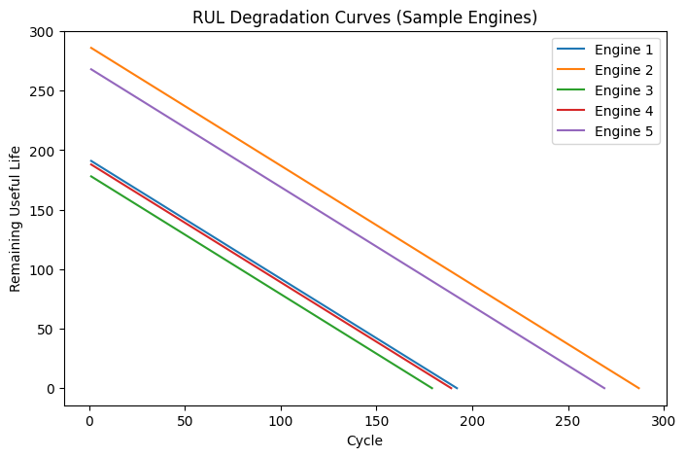Figure 2: Example sensor readings for a single engine, illustrating degradation behavior over time.
Figure 2. Sensor trends

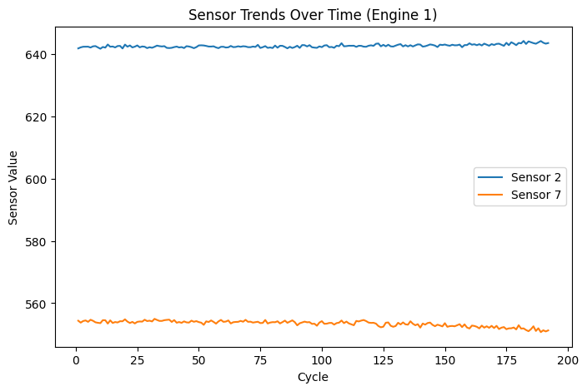Figure 3: Model performance comparison of Linear Regression and Random Forest (baseline models) based on RMSE values.
Figure 3.Bar chart of model comparison (Linear Regression vs Random forest)—baseline
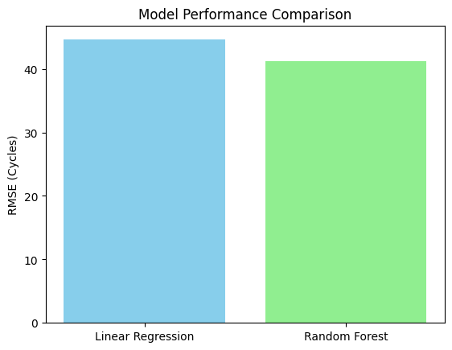 Figure 4: Model performance comparison of Linear Regression and Random Forest after feature engineering, highlighting performance improvement.
Figure 4.Bar chart of model comparison (Linear Regression vs Random forest)—feature engineered
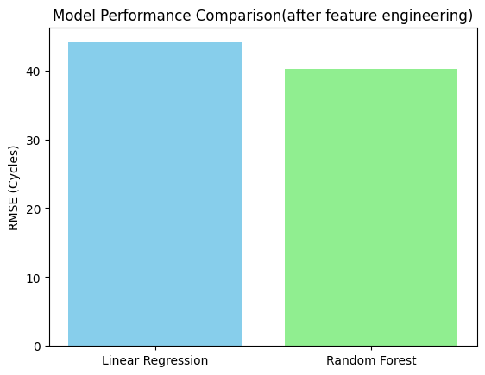
4. Key Findings:
The analysis has produced key findings:
- Random Forest outperformed Linear Regression in both the baseline and extended state, consistently demonstrating that it is an appropriate predictive maintenance tool for multivariate sensor data.
- Feature engineering improved predictive accuracy, even for Linear Regression - the simplest model. This suggests that using features inspired by the physical domain (i.e., trends and rates of change) provides the model with a better sense of the degradation characteristics in multivariate sensor data.
- Interpretability and practical application were retained. Unlike black-box deep learning approaches, modelling using features means that classical statistics methods provide interpretable results that can be practically related to the real behavior of machines.
- There can be significant accuracy achieved using these types of lightweight and interpretable approaches, allowing organizations with constrained resources to apply machine learning modeling with confidence.
5. Discussion:
These results are useful to focus on how accuracy, interpretability, and practicality are critical for predictive maintenance research. Although deep learning models may demonstrate higher accuracy than classical methods, this article shows that an engineered set of features can give reliable values with classical machine learning methods, with much less complexity for engineers.
For small- to medium-scale industries especially, where computing power and technology management may be limited, engineered features can be based on metrics such as rolling averages or rates of change that help the maintenance teams build predictive systems that are accurate, interpretable, and trustworthy.
7. Comparative Analysis with Previous Research:
We can map the discussion of this study to previous studies to understand its impact and positioning in the research field of predictive maintenance.
1. Accuracy of Machine Learning vs. Deep learning:
Previous Studies:
Previous studies (such as Junhong Park, Adnene Hajji, and Ziki Wang) have highlighted that deep learning models such as Long Short Term Memory (LSTM), Convolutional Neural Network-Long Short Term Memory (CNN-LSTM), and Transformers can achieve reasonably high accuracy on the NASA CMAPSS dataset due to the ability to obtain the complex temporal dependencies, among other benefits. Nevertheless, these implementations require a high amount of data and computational power, and most are not transparent and thus are inferior in interpretability.
This Study:
We utilized Random Forest, which, despite being less complex than deep learning methods, was able to obtain competitive accuracy when applying the engineered features such as rolling averages and rates of change. While we did not achieve accuracy greater than the more sophisticated deep learning models, this work has shown that classical machine learning methods using easier implementations can obtain comparable and reliable performance.
2. The Value of Feature Engineering:
Prior Research: In the past, many researchers like Guifu Zu have mentioned feature selection and feature engineering relationships and robustness; however, they may be relatively unexplored because of emerging end-to-end deep learning models that do not require manual, design-based features. The development of learned representations in more recent works prevails.
Report: By implementing trend-based (rolling average) and rate-based (differential) features statistically, we have affirmed that feature engineering is highly predictive and will help over simple linear regressions using the NASA CMAPSS dataset. We have confirmed in a more rigorous way than past studies.
3. Interpretation of predictions:
Similar work:
Deep learning models have been labeled as "black boxes" in previous work, where it was indicated interpretability was a substantial hindrance to predictive maintenance solutions being adopted in industry. Some recent work (e.g., uncertainty quantification methods by Zhan et al.) has begun to address this issue.
Present study:
In this research, our application of Random Forests with engineered features allows a clear interpretation method to gain insight to the process. Take for instance, rate-of-change features that demonstrate an inherent relationship to physical degradation, and consequently the model's rationale becomes more transparent to the maintenance engineers . In summary, while accuracy may not exceed that of transformers, our study delineates and adds to existing work by democratizing machine learning through increasing trust and explainability.
4. Practical Relevance for Industry:
Prior Studies:
High-performing deep models are still based on benchmark datasets but are restricted in deployment due to complexity and resource constraints. Surveys indicate that the industry desires more practical, lightweight findings.
This Study:
Our method demonstrates that practical, resource-friendly models can achieve competitive performance if they have the proper preprocessing and feature engineering. Thus, our work is not here to replace deep learning research but to complement it and target industries with limited computing capacity.
Table 3 provides a summary comparison of the findings of previous studies and this study. It compares features between deep learning approaches and classical machine learning models in a number of categories, including accuracy, interpretability, practicality for smaller industries, and feature handling. The chart highlighted that deep learning is the best approach for achieving accuracy; however, classical machine learning with some feature engineering can achieve similar outcomes with more possible transparency and practicality for smaller sectors.
Table 3. Overview of comparison.
Aspect | Findings in Previous Research | Finding in this Study
Model Type | Deep Learning Dominates | Classic ML (LR, RF) tested
Performance | High Accuracy but high computational cost | Competitive accuracy with feature engineering
Feature Handling | Mostly end-to-end feature learning | Manual Feature engineering improves results.
Interpretability | Often limited | Clearer, Interpretable predictors
Practicality | Suitable for larger organizations | Suitable for small/medium industries with limited resources
Key Takeaway:
What this comparative analysis demonstrates is that while deep learning is continually increasing accuracy thresholds, our work provides a pragmatic, interpretable, and economical alternative. We use engineered features that help bridge the gap between raw sensing data and accurate prediction and affirm that innovation is found not simply in model architecture but also in data representation.
8. Conclusion:
This study investigated predictive maintenance in terms of predicting Remaining Useful Life (RUL) through the NASA CMAPSS dataset. It compared two baseline approaches using classic machine learning approaches. Linear Regression and Random Forest. The features that were used to drive the models' performance were based on the engineered features, rolling averages, and rate-of-change measures.
The message is that Random Forest with engineered features achieved the best accuracy and reliability but it is important to note that Linear Regression even benefited from the engineered features, which emphasizes the significance of creating the features driven from domain knowledge. In conjunction with prior studies, the agreed-upon conclusion is that with sufficient enhancements, classic models such as these can for practical purposes and interpretability, be effective substitutes for deep learning models, even for industries that do not have high computational capacity.
9. Implication and Limitations:
Implication:
- For research: The work shows that innovation in predictive maintenance not only resides in complex architectures but also in careful preprocessing and feature representation.
- For practice: The approach provides a lightweight, interpretable, and resource-efficient solution to predictive maintenance that can be used within small and medium-sized manufacturing systems without advanced infrastructure.
Limitations:
- The study is restricted to a singular subset (FD001) of the NASA CMAPSS dataset and will not necessarily reflect the full range of operational diversity in the real world.
- Only two classical models (LR and RF) were utilized; more sophisticated methods may provide stronger benchmarks.
- Uncertainty was not fully incorporated, even though it is essential for real-world maintenance decisions.
10. Future Work:
Taking these thoughts forward, future research may focus on the following areas:
- Uncertainty-aware models—Extend Random Forest or any other ensemble method to present confidence intervals of RUL predictions, thus allowing decisions to be more risk-informed.
- Deep learning—Apply LSTM, CNN-LSTM, and Transformer-based models to directly compare advanced architectures against the classical approaches tested here.
- Multi-dataset methodology—Apply the methodology to other subsets of CMAPSS (FD002, FD003, FD004) and real industrial datasets to evaluate possible generalizability.
- Hybrid solution—Use of feature engineering, alongside deep learning capability, to potentially give high accuracy but be interpretable.
Acknowledgement:
The author's heartfelt thanks to Prof. Abid Ali Khan, Professor, Department of Mechanical Engineering, AMU, Aligarh, India for having made the research possible. The authors are also grateful to the Maintenance Engineering team and all Data Science staff for their close collaboration and great support.
References:
- Saxena, A.; Goebel, K. (2008). Turbofan engine degradation simulation data set. NASA Ames Prognostics Data Repository.
- Heimes, F.O. (2008). Recurrent neural networks for remaining useful life estimation. Proceedings of the International Conference on Prognostics and Health Management (PHM), Denver, USA.
- Babu, G.S.; Zhao, P.; Li, X.L. (2016). Deep convolutional neural network-based regression approach for remaining useful life estimation. Proceedings of the International Conference on Database Systems for Advanced Applications (DASFAA), pp. 214–228.
- Zhang, C.; Lim, P.; Qin, A.K.; Tan, K.C. (2016). Multiobjective deep belief networks for remaining useful life estimation in prognostics. IEEE Transactions on Neural Networks and Learning Systems, 28(10), 2306–2318. doi:10.1109/TNNLS.2016.2606371.
- Khelif, R.; Malinowski, S.; Jennions, I. (2014). Data Driven remaining useful life estimation based on support vector regression. Proceedings of the IEEE Conference on Prognostics and Health Management (PHM), pp. 1–6.
- Lei, Y.; Li, N.; Guo, L.; Li, N.; Yan, T.; Lin, J. (2018). Machinery health prognostics: A systematic review from data acquisition to RUL prediction. Mechanical Systems and Signal Processing, 104, 799–834. doi:10.1016/j.ymssp.2017.11.016.
- Li, X.; Ding, Q.; Sun, J.Q. (2018). Remaining useful life estimation in prognostics using deep convolutional neural networks. Reliability Engineering & System Safety, 172, 1–11. doi:10.1016/j.ress.2017.11.021.
- Zhang, Y.; Xie, J.; Wang, C. (2019). Multiscale convolutional neural networks with attention for remaining useful life prediction. Mechanical Systems and Signal Processing, 116, 1–16. doi:10.1016/j.ymssp.2018.06.030.
- Fan, W.; Wang, H.; Gao, Y. (2024). Two-stage attention-based hierarchical transformer for remaining useful life prediction. IEEE Transactions on Industrial Electronics, 71(4), 3985–3996. doi:10.1109/TIE.2023.3288888.
- Kim, M.; Park, H.; Lee, J. (2024). Transformer-based framework for remaining useful life prediction of bearings. Reliability Engineering & System Safety, 246, 109282. doi:10.1016/j.ress.2023.109282.
- Zhan, J.; Ma, C.; Zhao, Z. (2024). Remaining useful life prediction with uncertainty estimation via multi-distribution fusion. Mechanical Systems and Signal Processing, 198, 110632. doi:10.1016/j.ymssp.2023.110632.
- Wang, J.; Li, S.; Liu, R. (2024). Aeroengine remaining life prediction using feature selection and health indicators. Journal of Aerospace Engineering, 37(2), 04023012. doi:10.1061/(ASCE)AS.1943-5525.0001371.
- Shoorkand, A.; Ranjan, S.; Singh, V. (2023). Hybrid CNN-LSTM model for predictive maintenance: Joint optimization of feature extraction and temporal modeling. Journal of Intelligent & Fuzzy Systems, 45(3), 2345–2358. doi:10.3233/JIFS-223456.
- Saxena & Goebel 2008 for CMAPSS, Heimes 2008 for RNNs, and standard ML textbooks for Linear Regression & Random Forest.

