<https://dribbble.com/shots/24325061-Login-Screen>

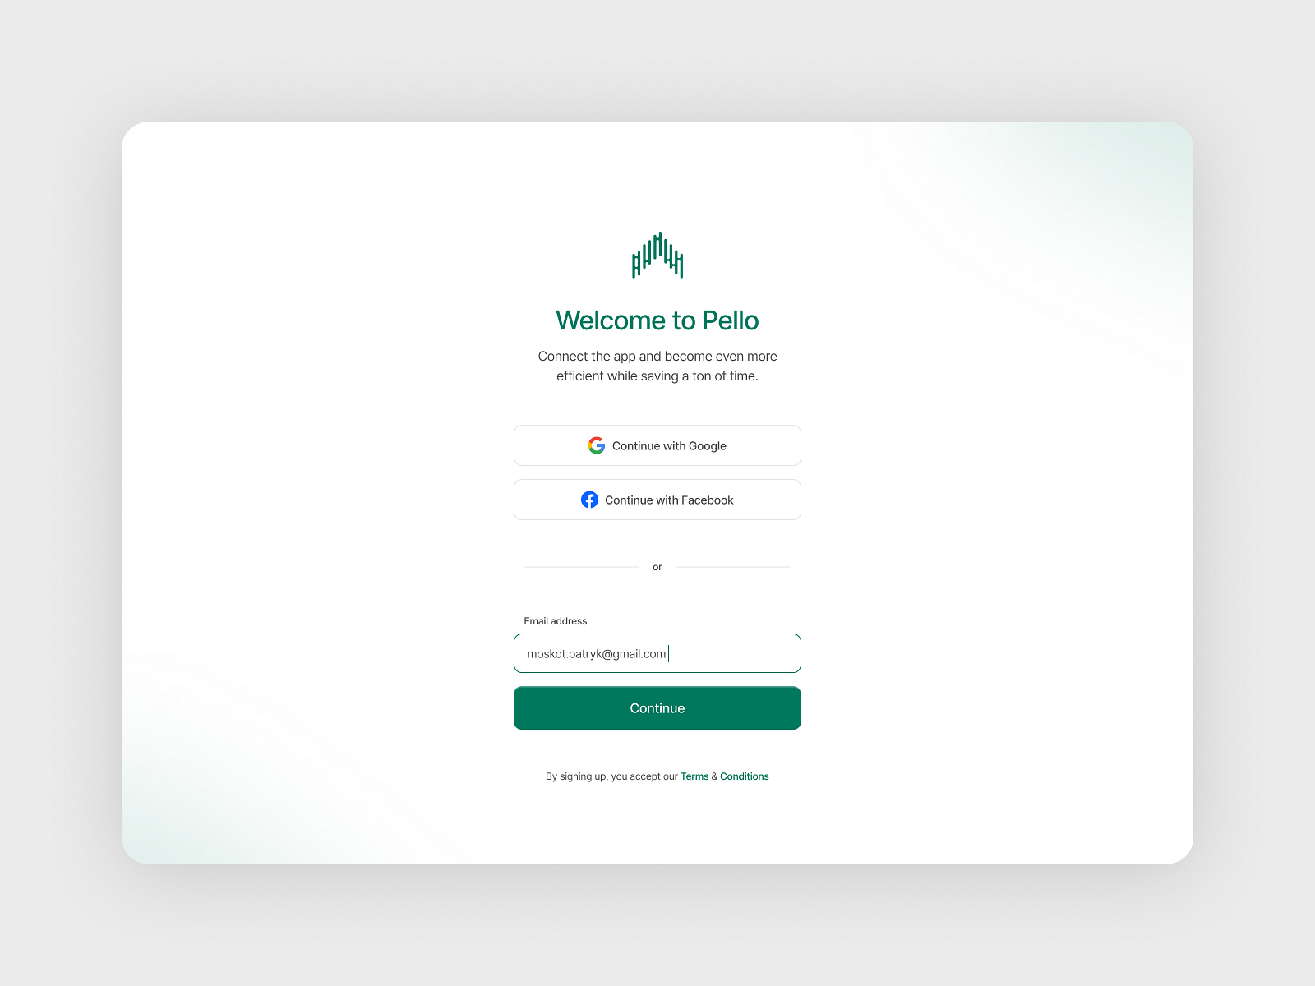

https://dribbble.com/shots/21929695-Registration-page-Sign-up-page

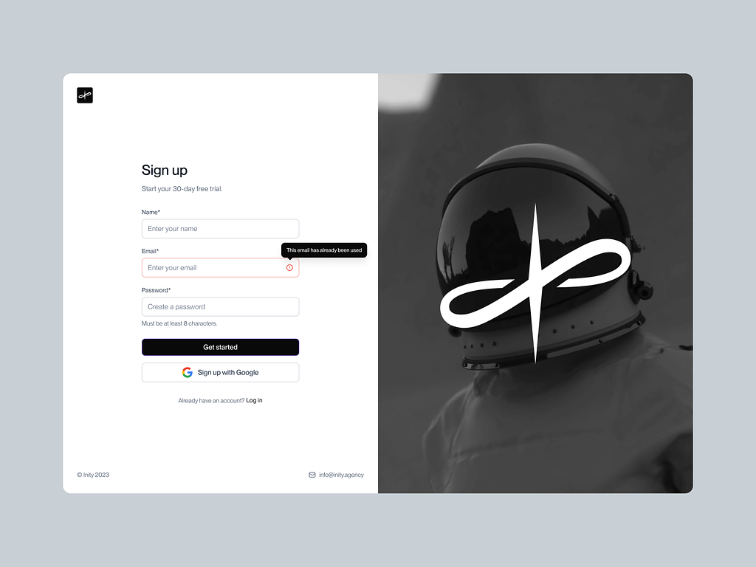

https://dribbble.com/shots/16590416-Login-Page/attachments/11616340?mode=media

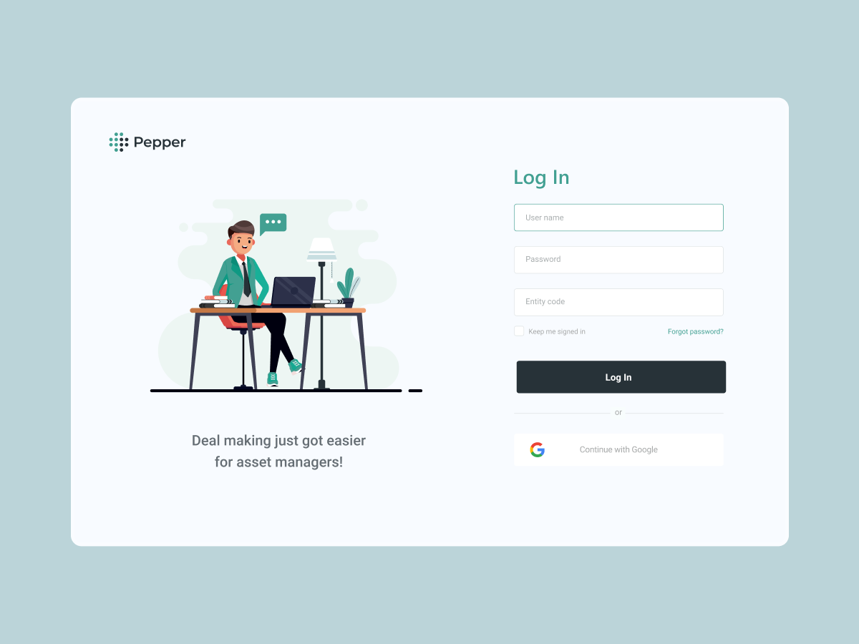

https://dribbble.com/shots/23730001-Login-page

