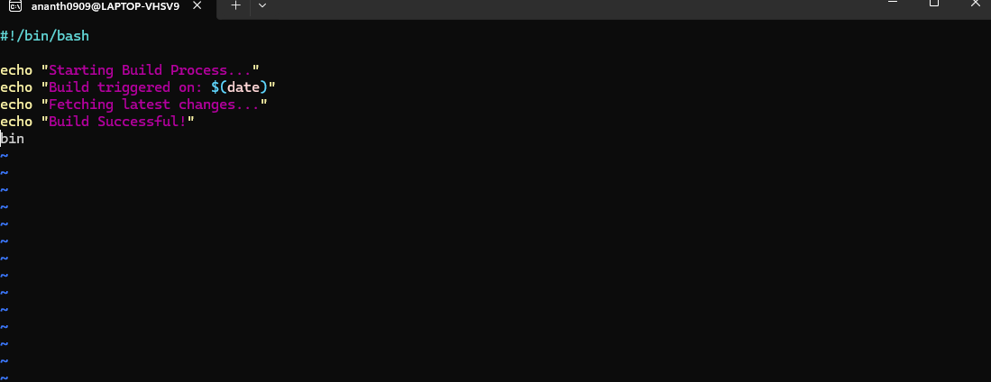

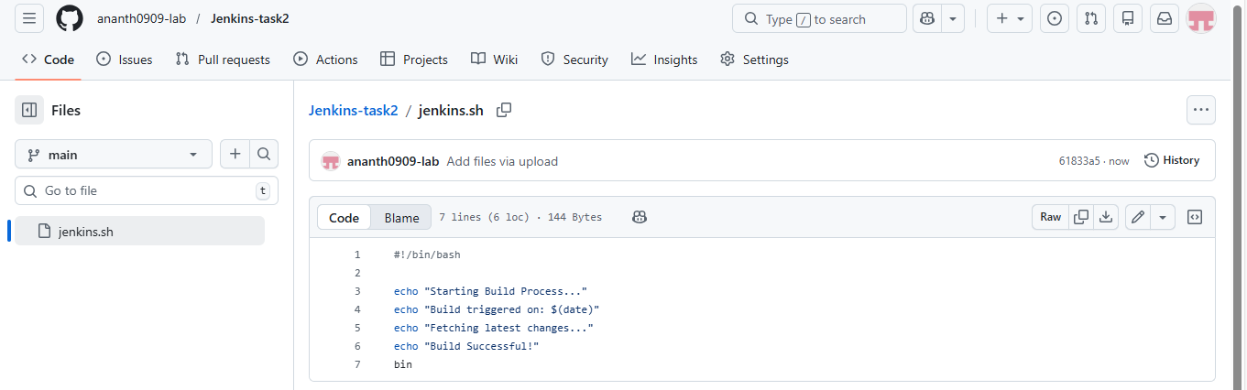

EC2 Instance
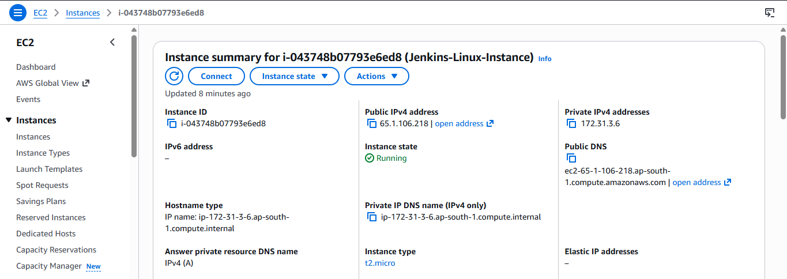

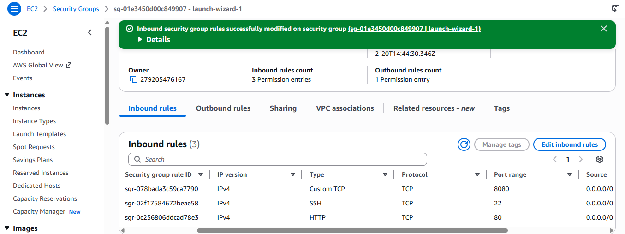

ssh -i "Linux-key-pair.pem" ec2-user@ec2-65-1-106-218.ap-south-1.compute.amazonaws.com

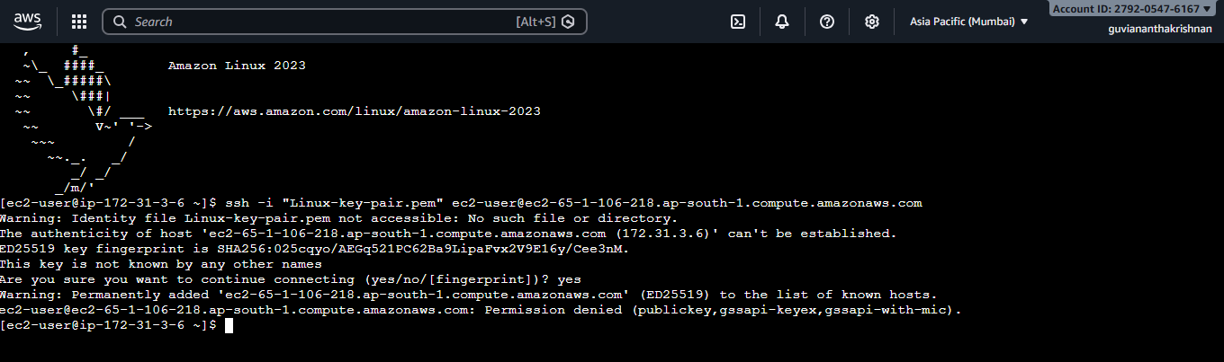
Install Java

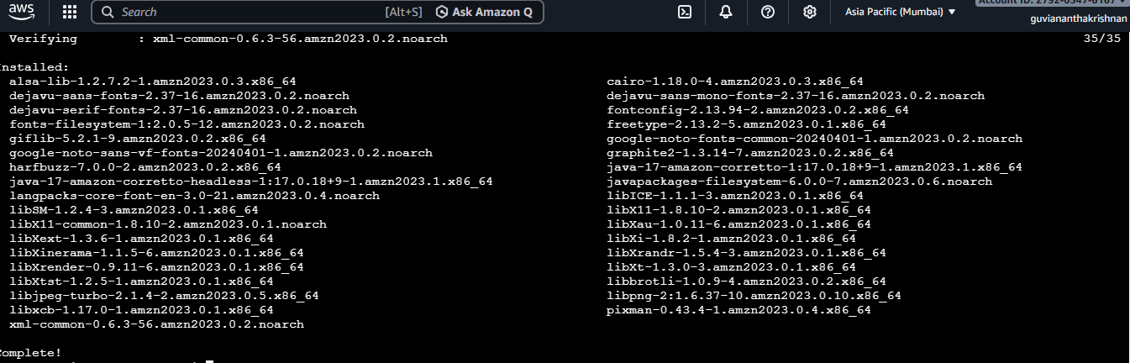

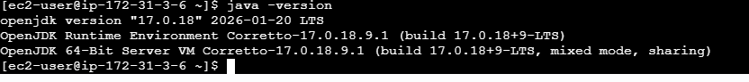

Install Jenkins

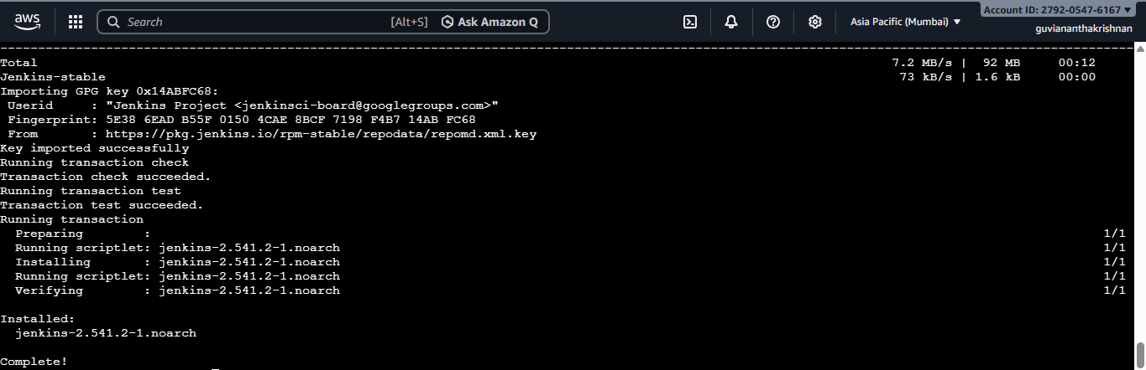

Start Jenkins

sudo systemctl start jenkins
sudo systemctl enable Jenkins

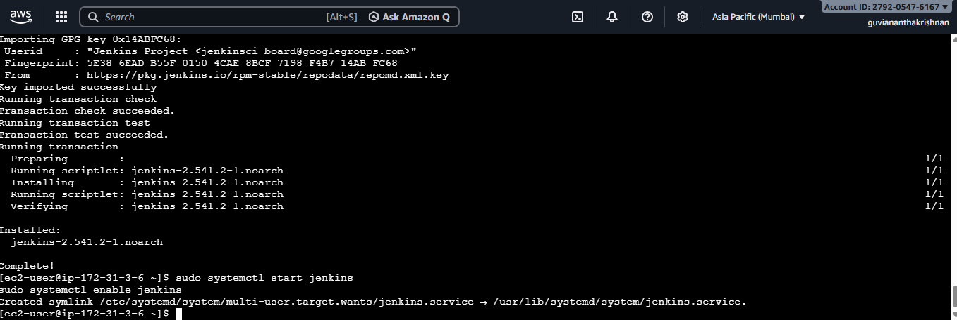

Check Status
sudo systemctl status Jenkins

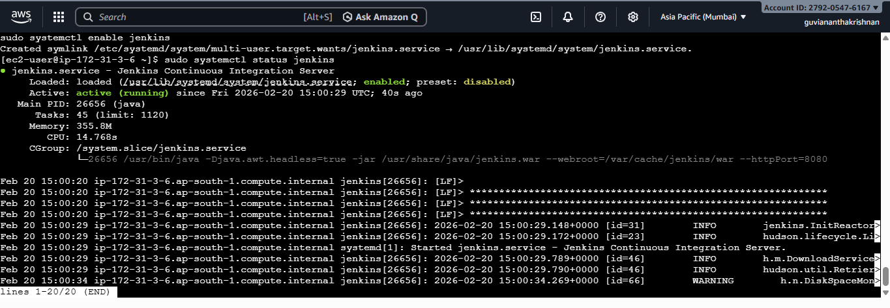

Access Jenkins
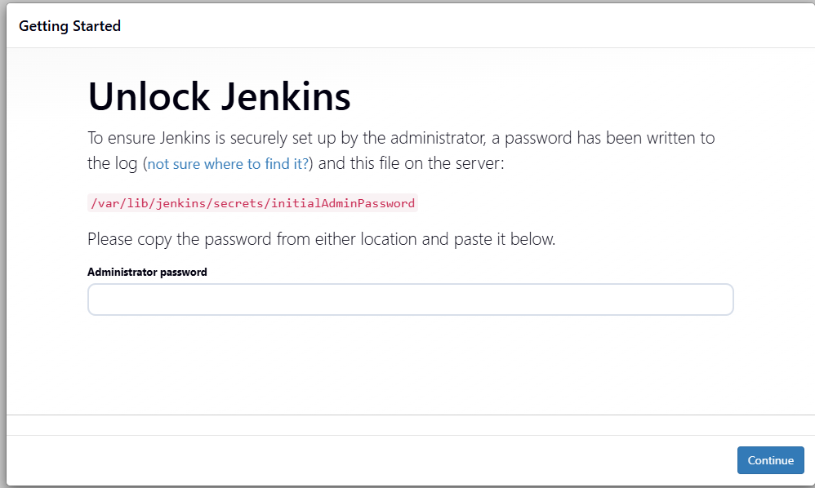

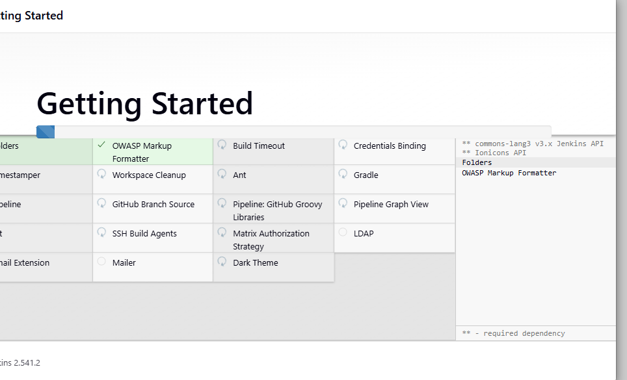

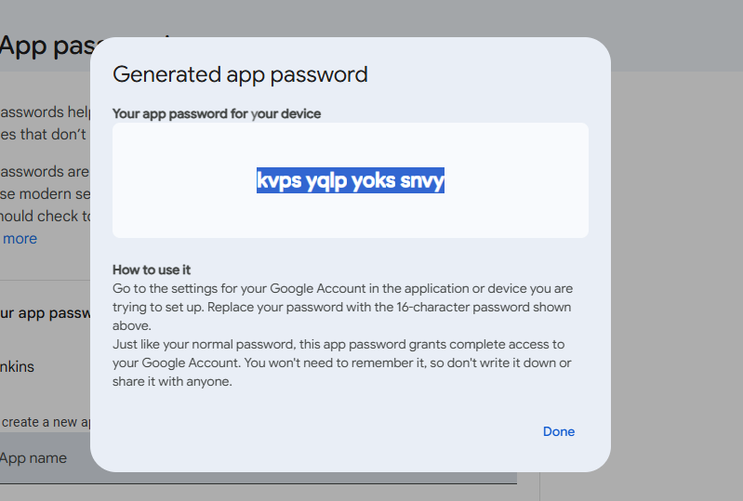

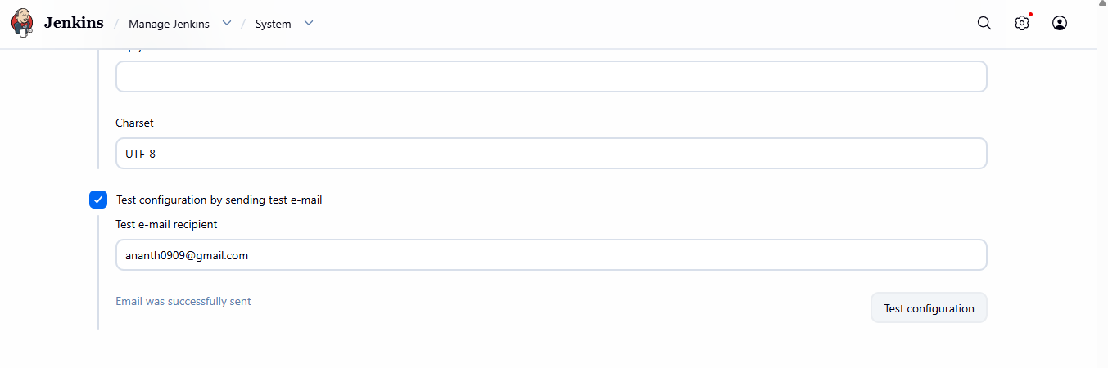

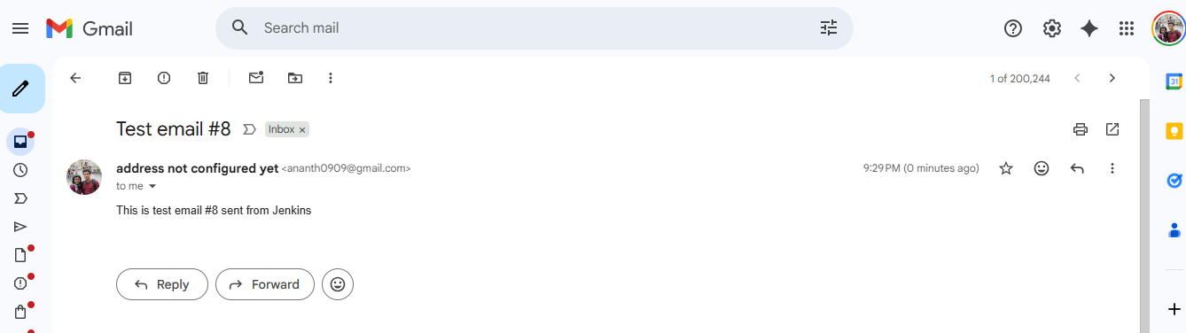

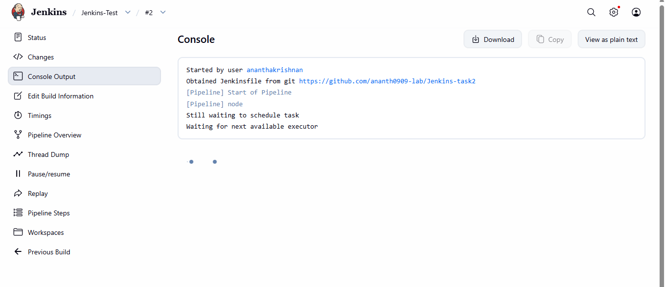
Add Jenkinsfile in Repo

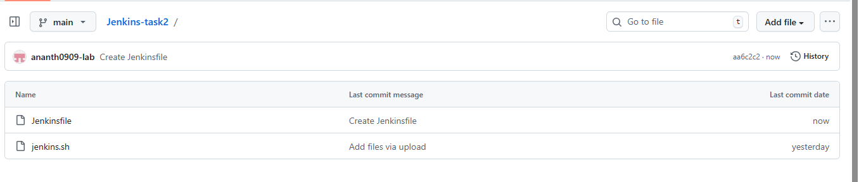

Created Jenkins Pipeline Job

