Software Architecture and Design Specification
Self-Monitoring MLOps System: An Intelligent Framework for ML Model Drift Detection, Monitoring, and Automated Recovery
Deliverable 3 — Architecture & Design

Version 1.0
Prepared on: 10 October 2026
Team Members:
Anantha Krishna M A — PES1UG24AM036
AKASH G K — PES1UG24AM022
AMIT PRASAD S G — PES1UG24AM033
Department: CSE (AI & ML)

Document Control
Field | Value
Document title | Architecture and Design - Self-Monitoring MLOps System
Version | Version 1.0
Status | Draft for academic review
Date | 10 October 2026
Owner | [Student Name / USN / Section]
Review note | Replace bracketed identity fields and confirm institution-specific template requirements before submission.

1. Introduction

1.1 Purpose
This document describes the proposed architecture and detailed design for the Self-Monitoring MLOps System, including component responsibilities, architectural pattern, security architecture, sequence flows, API contracts, error handling, and traceability to the SRS.

1.2 Scope and design principles
- Keep routine monitoring independent of long-running training and QML jobs.
- Treat drift as a signal for investigation, not proof of accuracy loss.
- Require validation and authorization before promotion.
- Record model, dataset, code, configuration, and experiment versions for reproducibility.
- Make QML experimental and non-blocking for production recovery.
- Prefer observable, testable modules with explicit interfaces.

2. Architecture Overview

2.1 Architectural pattern
The design uses a layered, modular service architecture with event-driven background analysis. The API layer handles requests and authorization; the monitoring layer collects and aggregates telemetry; model-analysis workers execute ML/DL and optional QML experiments; a policy/orchestration layer decides whether to alert or create a candidate; and persistence/observability services store metadata and expose metrics. This pattern isolates expensive jobs and supports independent testing.

2.2 Component diagram
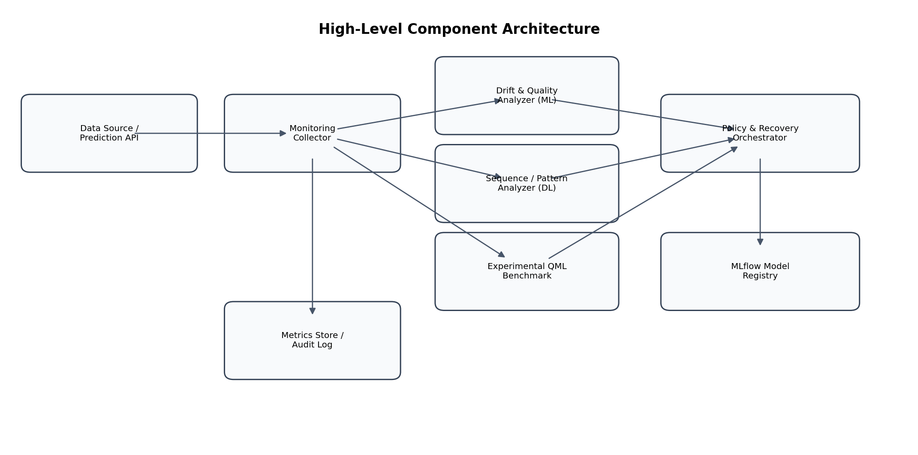
Figure 1. High-level component architecture (logical view).

2.3 Component descriptions
Component | Responsibilities | Key interfaces
Prediction API / Existing model | Serve predictions and provide response/error observations. | REST prediction endpoint; emits request metadata.
Monitoring Collector | Normalize events, aggregate windows, capture latency/errors, attach correlation IDs. | Internal event interface; metrics endpoint.
Drift & Quality Analyzer (ML) | Compute statistical drift indicators, anomaly scores, and optional degradation-risk classification. | Input: reference/current window summaries; output: score/status.
Sequence / Pattern Analyzer (DL) | Evaluate temporal patterns using an LSTM/autoencoder experiment; forecast anomaly/performance trend where data supports it. | Asynchronous job interface; outputs score, model version and metrics.
Experimental QML Benchmark | Run small simulator-based QML comparisons; store outcomes separately. | Offline job interface; cannot directly trigger promotion.
Policy & Recovery Orchestrator | Apply thresholds, deduplicate alerts, decide whether candidate evaluation is permitted, enforce approval/validation gates. | Policy API; job queue; audit events.
MLflow Model Registry / Experiment Tracker | Store run metadata, artifacts, metrics and model versions. | MLflow tracking/registry APIs.
Metrics Store / Audit Log | Expose operational telemetry and persist security/lifecycle events. | Prometheus scrape endpoint; append-oriented audit interface.
Dashboard / Alerting | Display model health, alerts, candidate outcomes, and historical trends. | Dashboard queries; Grafana panels or simple web UI.

2.4 Data flow
- Prediction requests produce output plus latency and error metadata.
- The collector aggregates current windows and compares them with the reference window.
- ML and DL analyzers evaluate monitoring features; QML runs separately as an experiment.
- The policy engine applies configured thresholds and determines whether to alert or initiate candidate evaluation.
- The candidate training pipeline records artifacts and metrics; the validator checks acceptance gates.
- An authorized ML Engineer approves or rejects the candidate; only an approved, valid candidate can be promoted.
- Post-promotion checks monitor health. Failed checks trigger rollback to the last known stable version.
- Metrics and lifecycle actions are displayed and retained for review.

2.5 Deployment view
The initial demonstration may run as Docker Compose services: API/dashboard, monitoring worker, MLflow, and Prometheus/Grafana. A local volume or lightweight database can persist prototype metadata. In a later deployment, services can be separated into containers and scheduled independently. Kubernetes is optional and not required for the minimum viable prototype.

3. Security Architecture

3.1 Security controls
Control | Design decision | Related requirement
Authentication | Require credentials/token for model-management, approval and administrative endpoints. | SR-01, FR-14
Authorization | Use role-based permissions: read-only viewer, ML Engineer, administrator; enforce server-side. | SR-02
Secret management | Read secrets from environment or secret store; exclude .env and credentials from version control. | SR-03
Input validation | Validate JSON schema, content type, size, numeric bounds, and allowed state transitions. | SR-04
Auditability | Append structured events for approvals, promotions, rollback, configuration changes and denied actions. | SR-05, FR-11
Network restriction | Restrict metrics and admin surfaces to trusted network or authenticated access. | SR-06
Artifact integrity | Record model version, artifact identifier/hash, run ID and source commit for candidates. | FR-10, NFR-04
Safe automation | Separate candidate evaluation from promotion; require validation and human approval. | NFR-10

3.2 Threats and mitigations
- Unauthorized model promotion: server-side RBAC, approval gate, and audit event.
- Poisoned or malformed monitoring input: schema/range validation and bounded payload sizes.
- Secret leakage through logs: structured logging with redaction and synthetic secret scanning tests.
- Compromised candidate artifact: record artifact hash and registry version; validate before promotion.
- Denial of service from expensive experiments: execute DL/QML jobs asynchronously with resource limits.
- False drift alarm: use configurable thresholds, suppress duplicate alerts, and distinguish drift from measured accuracy loss.

4. Detailed Design

4.1 Module design
Module | Suggested package/file | Main operations
API routes | app/api/routes.py | health(), get_metrics(), list_alerts(), candidate_decision()
Monitoring collector | app/monitoring/collector.py | record_event(), aggregate_window(), export_metrics()
Drift analyzer | app/monitoring/drift.py | compare_windows(), compute_drift_status()
ML experiment | app/models/ml_monitor.py | fit(), evaluate(), save_run_metadata()
DL experiment | app/models/dl_monitor.py | fit_sequence_model(), score_window(), evaluate()
QML benchmark | app/models/qml_benchmark.py | run_benchmark(), save_comparison()
Recovery policy | app/recovery/policy.py | evaluate_trigger(), candidate_eligible(), can_promote()
Validation service | app/recovery/validator.py | validate_candidate(), compare_to_stable()
Registry adapter | app/registry/mlflow_adapter.py | register_candidate(), promote(), rollback()
Audit logger | app/security/audit.py | record_event(), query_events()

4.2 Sequence diagram 1 — Routine monitoring cycle
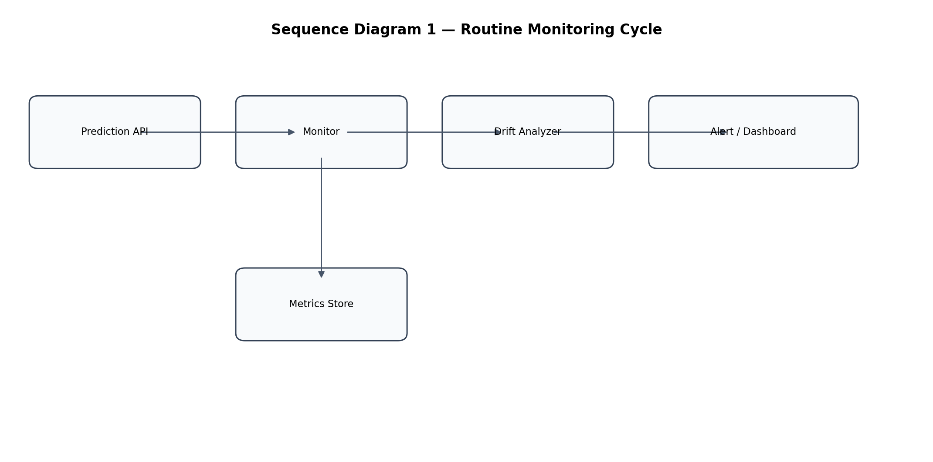
Figure 2. Logical sequence of a routine monitoring cycle. The monitor writes metrics and requests drift analysis; the result is reflected in alert/dashboard state.

4.3 Sequence diagram 2 — Controlled retraining and promotion
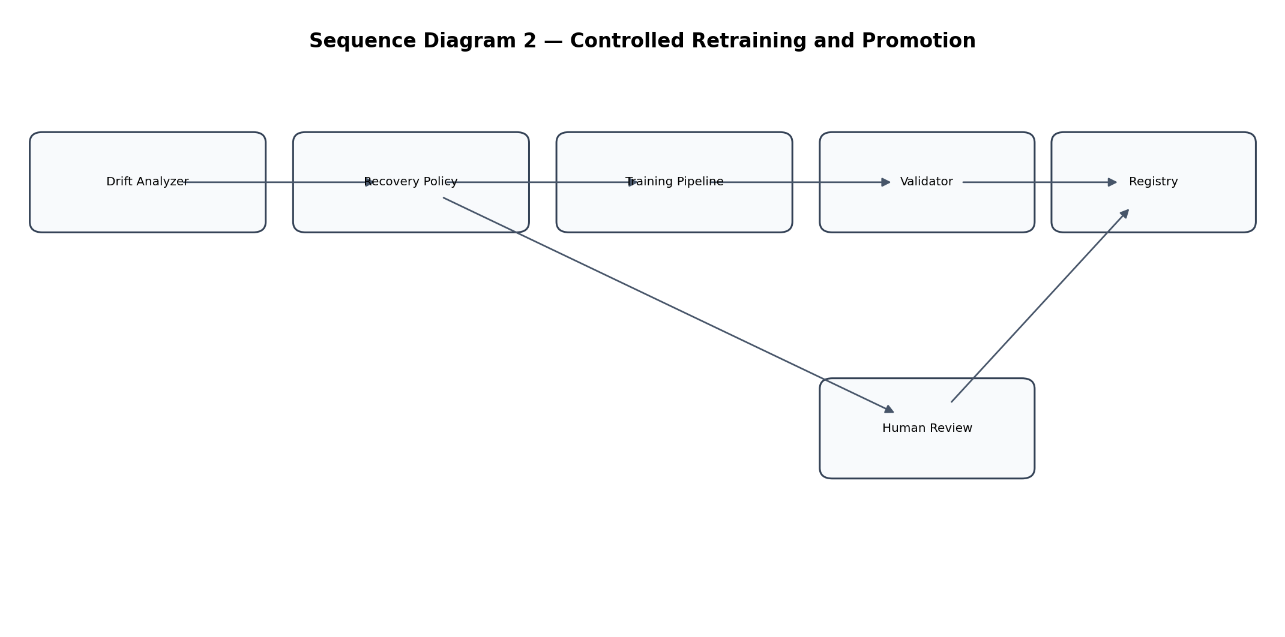
Figure 3. Logical sequence of candidate evaluation and promotion. Human approval and validation are both required; otherwise the stable model remains active.

4.4 API design
The following REST API is a proposed contract for the prototype. All management endpoints require authentication. Exact schemas and status codes should be reflected in OpenAPI generated by FastAPI.
Method and path | Purpose | Request / response summary | Access
GET /health | Liveness/readiness summary. | Response: status, app_version, timestamp. | Public only on local demo; otherwise trusted network.
GET /api/v1/metrics/summary | Read aggregate health metrics. | Response: count, error_rate, latency_p95, drift_status, model_version. | Authenticated viewer.
GET /api/v1/alerts | List alerts. | Optional status/severity filters; response includes alert_id, metric, observed_value, created_at. | Authenticated viewer.
POST /api/v1/events/prediction | Submit/record prediction metadata. | Body: request_id, model_version, latency_ms, success, feature_summary; response: accepted/event_id. | Service identity.
POST /api/v1/candidates/{candidate_id}/validate | Run or retrieve candidate validation. | Response: checks, metrics, pass/fail, run_id. | ML Engineer/admin.
POST /api/v1/candidates/{candidate_id}/decision | Approve or reject a validated candidate. | Body: decision, comment; response: state, audit_event_id. | Authorized ML Engineer/admin.
POST /api/v1/models/rollback | Rollback to stable version. | Body: target_version, reason; response: active_version, outcome. | Administrator or designated ML Engineer.

4.5 Example API payloads
POST /api/v1/events/prediction — illustrative request:
{
"request_id": "req-demo-001",
"model_version": "baseline-1",
"latency_ms": 42.7,
"success": true,
"feature_summary": {"feature_a_mean": 0.31, "feature_b_missing_rate": 0.02}
}
Illustrative response: HTTP 202 Accepted with event_id and ingestion status. Raw sensitive feature values should not be sent unless explicitly justified and protected.

4.6 Error handling
Condition | HTTP / system behavior | Logging and recovery
Malformed JSON/schema | 400 Bad Request or 422 Unprocessable Entity. | Record request ID and safe validation reason; do not log secrets.
Missing/invalid credentials | 401 Unauthorized. | Record security event without credential value.
Insufficient role | 403 Forbidden. | Record denied action and actor where known.
Unknown resource/version | 404 Not Found. | Return stable error schema.
Conflicting candidate state | 409 Conflict. | Do not change active model; return current state.
Rate/size limit exceeded | 413 or 429 as appropriate. | Reject request; maintain service availability.
Analyzer or QML worker failure | API remains available; job marked failed. | Log stack trace only in protected logs, emit failure metric and alert.
Registry unavailable | 503 Service Unavailable for affected action. | Retry bounded transient failures; never claim promotion succeeded.
Candidate validation fails | Return validation status; no promotion. | Retain stable model; record failed checks.

4.7 Persistence and data model
Entity | Important fields
PredictionEvent | event_id, request_id, timestamp, model_version, latency_ms, success, feature_summary_ref
MonitoringWindow | window_id, start/end, sample_count, drift_metrics, quality_metrics_if_available
Alert | alert_id, type, severity, observed_value, threshold, status, created_at, acknowledged_by
ExperimentRun | run_id, method, model_version, dataset_version, code_commit, seed, metrics, runtime, artifact_uri
ModelCandidate | candidate_id, source_run_id, artifact_hash, validation_status, decision, approver, status
AuditEvent | event_id, actor, action, target, timestamp, outcome, correlation_id

4.8 Model evaluation design
- Classical ML: use a transparent baseline such as Isolation Forest or gradient boosting depending on whether the target is anomaly detection or supervised degradation risk.
- DL: use an LSTM or autoencoder only if enough sequential observations are available; otherwise document the data limitation and use a small controlled demonstration.
- QML: compare a small quantum-kernel or variational classifier on a reduced feature subset and identical split where feasible. Log simulator and package versions, seeds, runtime, and metrics.
- Compare methods using appropriate measures (e.g., precision/recall/F1 for labeled drift cases, false-alert rate, detection delay, runtime, and memory). Do not claim QML advantage without evidence.
- Evaluate the recovery process with validation gates, promotion-blocking tests, and rollback tests.

5. Traceability to SRS
SRS requirement | Design element | Verification
FR-01, FR-02 | API routes; collector; metrics exporter | TC-01, TC-02
FR-03, FR-04, FR-08 | Drift analyzer; quality metrics logic; alert manager | TC-03, TC-04, TC-06
FR-05, FR-06, FR-07 | ML/DL workers; isolated QML benchmark | TC-05
FR-09, FR-10 | Recovery policy; validator; approval route | TC-07, TC-11
FR-11, SR-05 | Audit logger and persistence | TC-12, SEC-05
FR-12 | Registry adapter and rollback policy | TC-08
FR-13, FR-14 | Dashboard/API; authentication/RBAC | Dashboard acceptance test; TC-11
NFR-01, NFR-02, NFR-07, NFR-09 | Async workers, bounded jobs, Prometheus metrics | TC-09, TC-10
NFR-04–NFR-06 | MLflow metadata, pinned dependencies, Docker/CI | TC-05, TC-15
SR-01–SR-04, SR-06 | Auth middleware, validation, secret management, network policy | SEC-01–SEC-04, SEC-06

6. Deployment and DevOps Design
- Developer opens a pull request to the GitHub repository.
- GitHub Actions runs formatting/lint checks, unit tests, dependency checks, and API contract tests.
- CI builds the Docker image and runs a smoke test.
- On merge, a versioned image/artifact is created; deployment to the demo environment requires the configured approval gate.
- Prometheus scrapes metrics; Grafana displays service and model-health panels.
- MLflow tracks model experiments and candidate versions; a rollback procedure remains documented and tested.

7. Limitations and Future Enhancements
- Initial project demonstrates controlled tabular drift rather than all production failure modes.
- Ground-truth delay limits immediate confirmation of predictive-quality loss.
- QML is a benchmark and may be slower or less accurate than classical baselines.
- Future work may add richer lineage, Kubernetes deployment, notification integrations, canary evaluation, and real-world longitudinal datasets.

