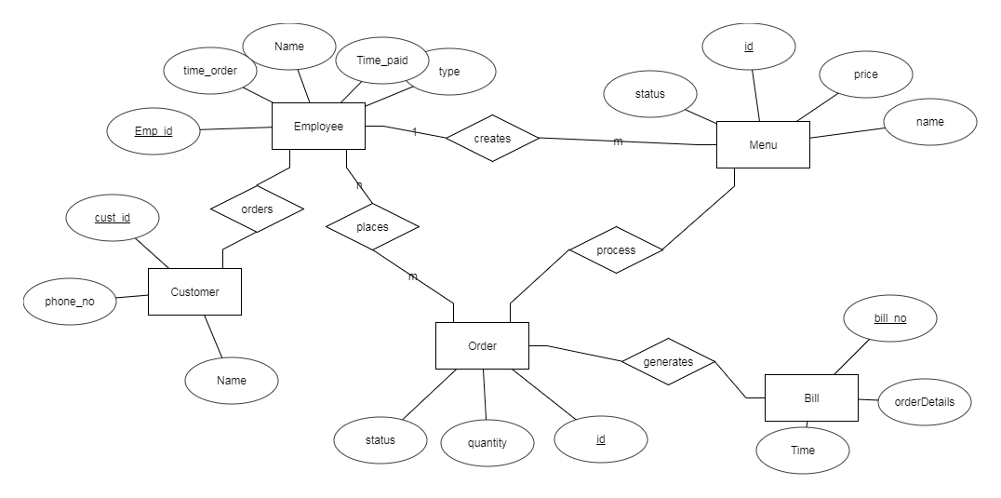

1.

ER DIAGRAM

TABLE CREATION AND INSERTION

CREATE TABLE CUSTOMER
(
cust_id INT NOT NULL,
name VARCHAR(25),
phone INT,
PRIMARY KEY(cust_id)
);

INSERT INTO CUSTOMER VALUES(1,'abc',770812345);
INSERT INTO CUSTOMER VALUES(2,'bca',990899345);

CREATE TABLE EMPLOYEE
(
emp_id INT NOT NULL,
name VARCHAR(25),
type VARCHAR(20),
time_pay TIME,
time_order TIME,
PRIMARY KEY(e_id),
);

INSERT INTO EMPLOYEE VALUES(11,'aa','waiter','20:34:50','20:39:08',1);
INSERT INTO EMPLOYEE VALUES(12,'bb','manager','20:34:50','20:45:58',2);

SELECT TIME_FORMAT(time_order-time_paid,'%i')
FROM EMPLOYEE;

CREATE TABLE MENU
(
id INT NOT NULL,
name VARCHAR(25),
price INT NOT NULL,
status TINYINT(1),
PRIMARY KEY(item_id)
);

INSERT INTO MENU VALUES(21,'ssdf',45,0);
INSERT INTO MENU VALUES(22,'sghgc',55,1);
INSERT INTO MENU VALUES(23,'vxlkjc',55,1);
INSERT INTO MENU VALUES(24,'zfghc',65,1);

CREATE TABLE ORDERS
(
id INT NOT NULL,
customer_id INT,
item_id INT,
quantity INT(10),
PRIMARY KEY(id),
FOREIGN KEY (customer_id) REFERENCES CUSTOMER(c_id),
FOREIGN KEY (item_id) REFERENCES MENU(item_id)
);

INSERT INTO ORDERS VALUES(31,1,22,1);
INSERT INTO ORDERS VALUES(31,1,23,1);
INSERT INTO ORDERS VALUES(32,2,23,1);

CREATE TABLE BILL
(
customer_id INT,
bill_id INT NOT NULL,
time DATE,
amount INT NOT NULL,
PRIMARY KEY(bill_id),
FOREIGN KEY (customer_id) REFERENCES CUSTOMER(c_id)
);

CREATE OR REPLACE VIEW CUMULATIVE1 AS
SELECT ORDERS.customer_id AS cid,ORDERS.ord_id AS oid,ORDERS.quantity * MENU.price AS p
FROM ORDERS,MENU
WHERE ORDERS.id=MENU.id;

5.1

CREATE VIEW vw_customerSnapshot AS
SELECT cust_id,COUNT(cust_id) AS c
FROM BILL
GROUP BY cust_id
LIMIT 1;

SELECT * FROM CUSTOMER WHERE c_id IN ( SELECT customer_id FROM vw_customerSnapshot);

5.2

CREATE VIEW vw_OrderSnapshot AS
SELECT id,COUNT(id)
FROM ORDERS
GROUP BY item_id
LIMIT 1;

SELECT * FROM MENU WHERE item_id IN ( SELECT item_id FROM vw_OrderSnapshot);

6.

DELIMITER //

CREATE FUNCTION fn_GetOrderTimeElapsed(CustomerID INT) RETURNS TIME
BEGIN
DECLARE res TIME;
SELECT time_order-time_pay INTO res FROM EMPLOYEE,CUSTOMER WHERE cust_id=CustomerID;
RETURN (res);
END//

CREATE PROCEDURE fn_GetOrderTimeElapsed(
IN CustomerID INT,
OUT res TIME
)
BEGIN
DECLARE res TIME;

SELECT t_order-time_pay INTO res
FROM EMPLOYEE,CUSTOMER
WHERE cust_id = CustomerID;

END//

DELIMITER ;

SELECT fn_GetOrderTimeElapsed(1);

7.

DELIMITER //

CREATE PROCEDURE sp_GetOrder
(
IN CustomerID INT
)
BEGIN
SELECT *
FROM ORDERS
WHERE cust_id=CustomerID;
END //

DELIMITER ;

8.

DELIMITER //

CREATE PROCEDURE sp_generatebill(
IN orderid INT
)
BEGIN

SELECT SUM(p) AS BILL
FROM CUMULATIVE1
GROUP BY orderid;

END//

DELIMITER ;

