SQL> CREATE TABLE Employee(Empno NUMBER(10),Ename VARCHAR(20),Job VARCHAR(20),Sal NUMBER(10));

Table created.

SQL> INSERT INTO Employee VALUES(&Empno,'&Ename','&Job',&sal);

Enter value for empno: 1

Enter value for ename: abhirami

Enter value for job: manager

Enter value for sal: 50000

old 1: INSERT INTO Employee VALUES(&Empno,'&Ename','&Job',&sal)

new 1: INSERT INTO Employee VALUES(1,'abhirami','manager',50000)

1 row created.

SQL> INSERT INTO Employee VALUES(&Empno,'&Ename','&Job',&sal);

Enter value for empno: 2

Enter value for ename: amala

Enter value for job: developer

Enter value for sal: 45000

old 1: INSERT INTO Employee VALUES(&Empno,'&Ename','&Job',&sal)

new 1: INSERT INTO Employee VALUES(2,'amala','developer',45000)

1 row created.

SQL> INSERT INTO Employee VALUES(&Empno,'&Ename','&Job',&sal);

Enter value for empno: 19

Enter value for ename: karthik

Enter value for job: tester

Enter value for sal: 40000

old 1: INSERT INTO Employee VALUES(&Empno,'&Ename','&Job',&sal)

new 1: INSERT INTO Employee VALUES(19,'karthik','tester',40000)

1 row created.

SQL> INSERT INTO Employee VALUES(&Empno,'&Ename','&Job',&sal);

Enter value for empno: 3

Enter value for ename: amal

Enter value for job: manager

Enter value for sal: 50000

old 1: INSERT INTO Employee VALUES(&Empno,'&Ename','&Job',&sal)

new 1: INSERT INTO Employee VALUES(3,'amal','manager',50000)

1 row created.

SQL> INSERT INTO Employee VALUES(&Empno,'&Ename','&Job',&sal);

Enter value for empno: 4

Enter value for ename: anju

Enter value for job: developer

Enter value for sal: 42000

old 1: INSERT INTO Employee VALUES(&Empno,'&Ename','&Job',&sal)

new 1: INSERT INTO Employee VALUES(4,'anju','developer',42000)

1 row created.

SQL> UPDATE Employee SET Job='trainee' WHERE Empno=2;

1 row updated.

SQL> SELECT *FROM Employee;

EMPNO ENAME JOB SAL

---------- -------------------- -------------------- ----------

1 abhirami manager 50000

2 amala trainee 45000

19 karthik tester 40000

3 amal manager 50000

4 anju developer 42000

SQL> ALTER TABLE Employee RENAME COLUMN Sal TO Salary;

Table altered.

SQL> DELETE FROM Employee WHERE Empno=19;

1 row deleted.

SQL> SELECT * FROM Employee;

EMPNO ENAME JOB SALARY

---------- -------------------- -------------------- ----------

1 abhirami manager 50000

2 amala trainee 45000

3 amal manager 50000

4 anju developer 42000

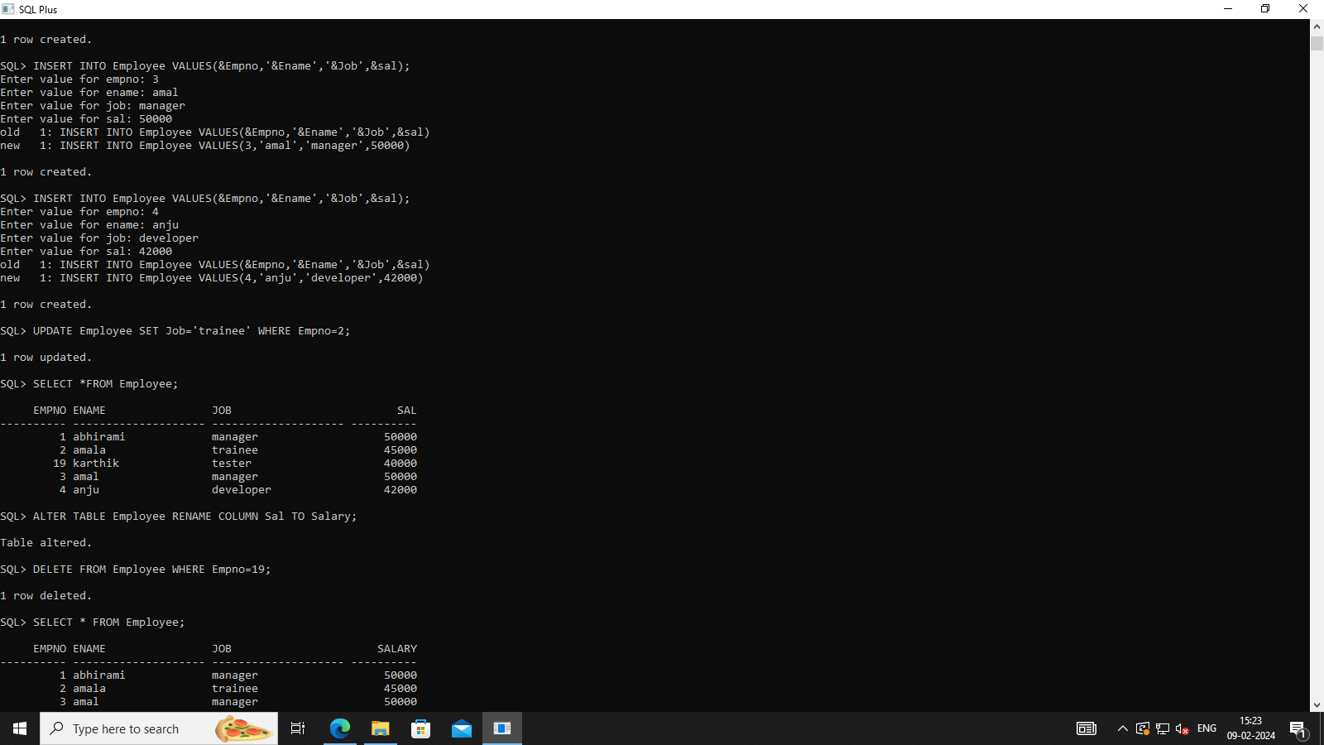

**2.DEPARTMENT**

SQL> CREATE TABLE Department(Deptno number(5) PRIMARY KEY,Deptname VARCHAR(20),Location VARCHAR(20));

Table created.

SQL> DESC Department;

Name Null? Type

----------------------------------------- -------- ----------------------------

DEPTNO NOT NULL NUMBER(5)

DEPTNAME VARCHAR2(20)

LOCATION VARCHAR2(20)

SQL> ALTER TABLE Department ADD (Designation VARCHAR(20));

Table altered.

SQL> DESC Department;

Name Null? Type

----------------------------------------- -------- ----------------------------

DEPTNO NOT NULL NUMBER(5)

DEPTNAME VARCHAR2(20)

LOCATION VARCHAR2(20)

DESIGNATION VARCHAR2(20)

SQL> INSERT INTO Department VALUES(&Deptno,'&Deptname','&Location','&Designation');

Enter value for deptno: 1

Enter value for deptname: mca

Enter value for location: francis block

Enter value for designation: professor

old 1: INSERT INTO Department VALUES(&Deptno,'&Deptname','&Location','&Designation')

new 1: INSERT INTO Department VALUES(1,'mca','francis block','professor')

1 row created.

SQL> /

Enter value for deptno: 2

Enter value for deptname: civil

Enter value for location: newton

Enter value for designation: ass.professor

old 1: INSERT INTO Department VALUES(&Deptno,'&Deptname','&Location','&Designation')

new 1: INSERT INTO Department VALUES(2,'civil','newton','ass.professor')

1 row created.

SQL> /

Enter value for deptno: 19

Enter value for deptname: mechanical

Enter value for location: st.peters block

Enter value for designation: hod

old 1: INSERT INTO Department VALUES(&Deptno,'&Deptname','&Location','&Designation')

new 1: INSERT INTO Department VALUES(19,'mechanical','st.peters block','hod')

1 row created.

SQL> SELECT * FROM Department;

DEPTNO DEPTNAME LOCATION DESIGNATION

---------- -------------------- -------------------- --------------------

1 mca francis block professor

2 civil newton ass.professor

19 mechanical st.peters block hod

SQL> SELECT Deptno,Deptname from Department GROUP BY Deptno,Deptname;

DEPTNO DEPTNAME

---------- --------------------

2 civil

19 mechanical

1 mca

SQL> UPDATE Department SET Deptname='mba' WHERE Deptno=19;

1 row updated.

SQL> SELECT * FROM Department ;

DEPTNO DEPTNAME LOCATION DESIGNATION

---------- -------------------- -------------------- --------------------

1 mca francis block professor

2 civil newton ass.professor

19 mba st.peters block hod

SQL> ALTER TABLE Department DROP COLUMN Designation;

Table altered.

SQL> SELECT * FROM Department ;

DEPTNO DEPTNAME LOCATION

---------- -------------------- --------------------

1 mca francis block

2 civil newton

19 mba st.peters block

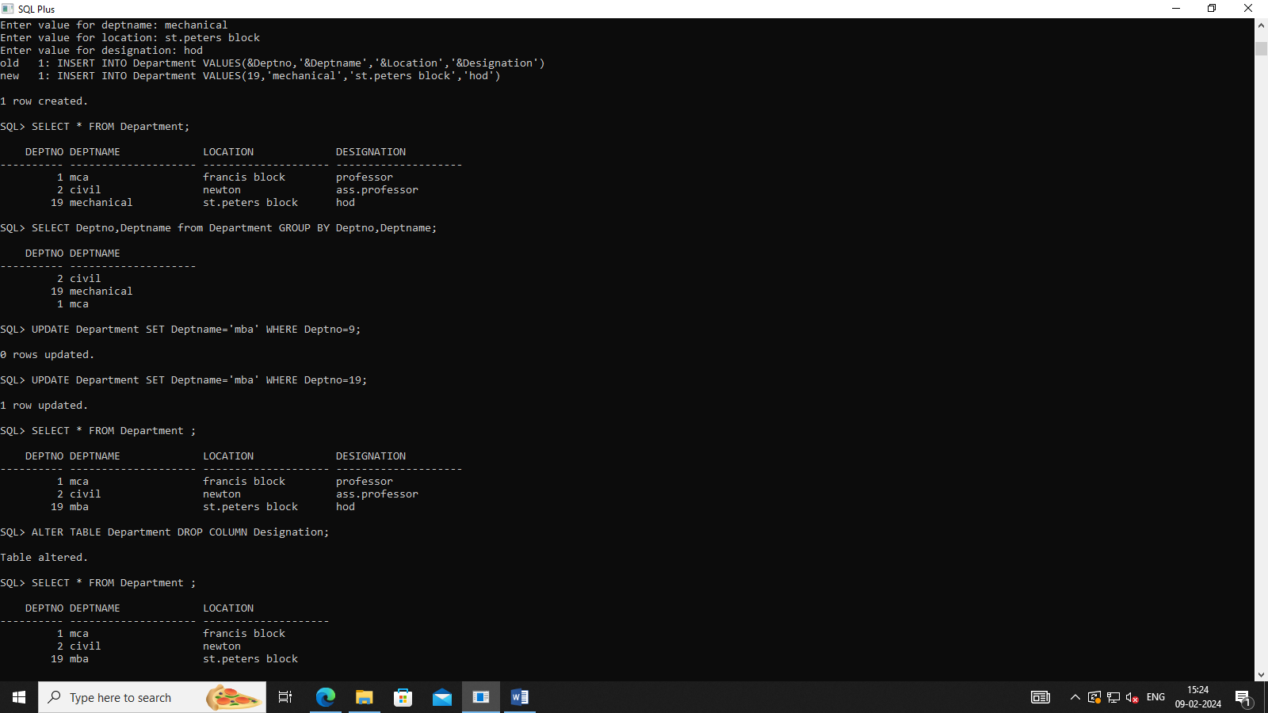

**3.CUSTOMER**

**SQL> CREATE TABLE Customer(Cust_name VARCHAR(20),Cust_street VARCHAR(20),Cust_city VARCHAR(20));**

**Table created.**

SQL> INSERT INTO Customer VALUES('&Cust_name','&Cust_street','&Cust_city');

Enter value for cust_name: abhi

Enter value for cust_street: chennai

Enter value for cust_city: tamilnadu

old 1: INSERT INTO Customer VALUES('&Cust_name','&Cust_street','&Cust_city')

new 1: INSERT INTO Customer VALUES('abhi','chennai','tamilnadu')

1 row created.

SQL> /

Enter value for cust_name: rahul

Enter value for cust_street: ameerpet

Enter value for cust_city: hyd

old 1: INSERT INTO Customer VALUES('&Cust_name','&Cust_street','&Cust_city')

new 1: INSERT INTO Customer VALUES('rahul','ameerpet','hyd')

1 row created.

SQL> ALTER TABLE Customer DROP COLUMN Salary;

Table altered.

SQL> SELECT *FROM Customer;

CUST_NAME CUST_STREET CUST_CITY

-------------------- -------------------- --------------------

abhi chennai tamilnadu

rahul ameerpet hyd

SQL> ALTER TABLE Customer ADD (Salary NUMBER(10));

Table altered.

SQL> SELECT *FROM Customer;

CUST_NAME CUST_STREET CUST_CITY SALARY

-------------------- -------------------- -------------------- ----------

abhi chennai tamilnadu

rahul ameerpet hyd

SQL> ALTER TABLE Customer DROP COLUMN Salary;

Table altered.

SQL> SELECT *FROM Customer;

CUST_NAME CUST_STREET CUST_CITY

-------------------- -------------------- --------------------

abhi chennai tamilnadu

rahul ameerpet hyd

SQL> DELETE FROM Customer WHERE Cust_city='hyd';

1 row deleted.

SQL> SELECT *FROM Customer;

CUST_NAME CUST_STREET CUST_CITY

-------------------- -------------------- --------------------

abhi chennai tamilnadu

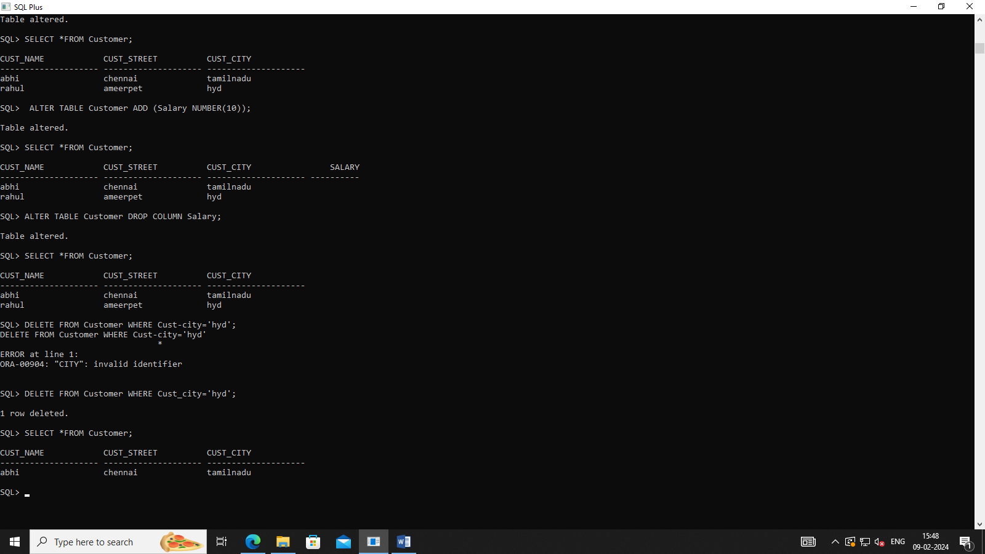

BRANCH

SQL> CREATE TABLE Branch (Bname VARCHAR(20),Bcity VARCHAR(20),Asserts NUMBER(10));

Table created.

SQL> INSERT INTO Branch VALUES('&Bname','&Bcity',&Asserts);

Enter value for bname: B1

Enter value for bcity: chennai

Enter value for asserts: 54

old 1: INSERT INTO Branch VALUES('&Bname','&Bcity',&Asserts)

new 1: INSERT INTO Branch VALUES('B1','chennai',54)

1 row created.

SQL> /

Enter value for bname: B2

Enter value for bcity: kollam

Enter value for asserts: 80

old 1: INSERT INTO Branch VALUES('&Bname','&Bcity',&Asserts)

new 1: INSERT INTO Branch VALUES('B2','kollam',80)

1 row created.

SQL> SELECT *FROM Branch;

BNAME BCITY ASSERTS

-------------------- -------------------- ----------

B1 chennai 54

B2 kollam 80

SQL> UPDATE Branch SET Bname='B5' WHERE Bcity='kollam';

1 row updated.

SQL> SELECT *FROM Branch;

BNAME BCITY ASSERTS

-------------------- -------------------- ----------

B1 chennai 54

B5 kollam 80

SQL> ALTER TABLE Branch DROP COLUMN Asserts;

Table altered.

SQL> SELECT *FROM Branch;

BNAME BCITY

-------------------- --------------------

B1 chennai

B5 kollam

