To,
The Dean,
Graduate Studies,
Tata Institute of Fundamental Research,
Mumbai – 400005
28th July, 2022

SUBJECT: Justification for re-registration along with work update and timeline

Dear Prof. Tole,

I write to you regarding my Int-PhD timeline with the request to kindly allow my re-registration, to stay in the program. I joined NCBS in 2011, and Prof. Upinder S. Bhalla’s lab in 2012.

My thesis originally aimed to study Hippocampal CA1 calcium activity sequences in Temporal tasks. I led the standardization of chronic, head-fixed, Trace Eye-Blink Conditioning (TEC) in the lab. I also was part of the team of graduate students that standardized chronic calcium imaging from Hippocampal CA1 cells, in vivo. Both these techniques required me to pick up numerous concepts and techniques in building electronic circuits and writing version-controlled custom code. While this took time, both these techniques are now established in the lab and other members are able to benefit from the work.

Next, we had been recording our main datasets for a paper looking at how hippocampal CA1 sequences adjusted to changes in the interval between the Conditioned and Unconditioned Stimuli (in TEC) and were able to get 13 high quality datasets with chronically tracked calcium activity, across 3 animals. However, before we could complete the full dataset, our aging 2-photon laser started showing wear and tear, decresing the main power delivery for excitation along with our chances to get good Signal/Noise in our deep tissue recordings. Since experiments had slowed down and the laser required repairs I had switched to a computational project.

In this new project we 1) developed the ability to generate Synthetic Calcium Activity traces with user-defined controls for important parameters like Noise, selection of Event Widths, trial-pair Imprecision, Hit Trial Ratio, and Background Activity, along with ground-truth labels (Time Cell/Other Cell),
2) set up a battery of anlaysis routines to detect Time Cells from calcium activity datasets,
3) used the synthetic datasets as benchmarks to test, study, and upgrade the analysis routines,
4) used these well developed algorithms to analyse actual real physiology datasets for Time Cells, and,
5) provide a comparative benchmark of the most popular time cell detection analyses along with their dependencies on various dataset features.

We had submitted a draft of the results of the comparative benchmarks as a BioRxiv upload (bioRxiv 2022.01.01.474717; doi: https://doi.org/10.1101/2022.01.01.474717) as well as a first submission to eNeuro on the 7th of Jan 2022. Since then, we have received reasonably favourable comments and have addressed each of them. The draft for the re-submission is mostly ready, barring any last minute updates.

The issue is that the rules do not allow me to upload my Synopsis until this main paper is accepted.
We plan to re-submit the paper manuscript within before 8th August, 2022. I plan to upload my Thesis no later than 8th September, 2022.

My Thesis Committee consists of Prof. Upinder S. Bhalla, Prof. Sumantra Chatterjee, and Dr. Mukund Thattai. All of them have approved my request and a signed Thesis Committee Report will be uploaded along with the re-registration related documents.

I humbly request you to kindly allow me to re-register for the completion of my work and thesis submission.

Thanking you,
Sincerely,
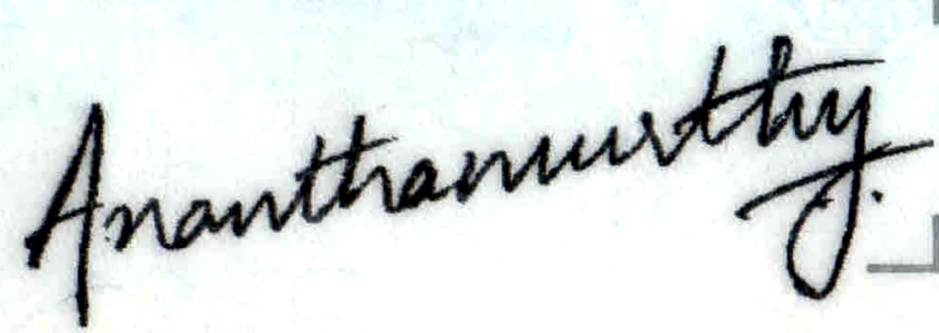

Kambadur Gundu Ananthamurthy
Int. PhD., Upi Lab, NCBS
NST-119
GS-2011 Batch

