Table of Contents

Chapter 1 – Introduction

Control and coordination

The vertebrate Central Nervous System (CNS), consisting primarily of the central ganglia (brain) and the spinal cord, samples and receives information from the external world offering top-down control over the activity of all parts of the body. Functions like exploration, food acquisition, and danger aversion, all involve complex coordination between,
- the Sensory Systems (that integrate information from the environment),
- the Memory Systems (that integrate sensory information with prior experience), and
- the Motor Systems (that integrate motor plans and execute movement).

Projects and overall goals

The overall focus of the work and experiments described in this Thesis was to study Memory Systems, specifically, in terms of,

Project I: How do sensory representations transform with learning?

Project II: How does the timing of cellular activity adjust to behavioural task variables?

Project III: What is the best way to detect and score time-tuned cellular activity?

Narrowing down, we as a lab were interested in the mammalian hippocampus, a brain structure which is important for consolidating information (from Sensory and other Memory Systems) to enable certain kinds of short-term memory and the translation of short-term memory to long-term.

Theories on the function of the hippocampus

Three main ideas of hippocampal function studied over the past few decades in increasing order of popularity are,
- Response Inhibition - Studied mostly in the 1960’s, this perspective described the Hippocampus as important to the ability of animals to inhibit their impulses and natural, habitual, or dominant behavioral responses to stimuli, in order to select more appropriate responses. This perspective was justified by two observations with regard to animals with hippocampal damage - 1) these animals tended to be hyperactive, and 2) were unable to withhold previously learnt responses. British psychologist Jeffrey Alan Gray developed this perspective to link hippocampal activity with anxiety (McNaughton & Gray, 2000)⁠.

- Episodic Memory – This perspective was popularized by the psychological studies on Patient H. M. (Henry Molaison), who had been suffering from epileptic seizures and had to undergo extensive hippocampectomy (surgical destruction of the hippocampi), as treatment. American neurosurgeon William Beecher Scoville and British-Canadian neuropsychologist Brenda Milner were pioneers of this study and were able to describe severe anterograde and partial retrograde amnesia in the patient post surgery (Scoville & Milner, 1957)⁠. Since the late 2000’s, the discovery and description of time cells (B. Kraus et al., 2013; B. J. Kraus et al., 2015; MacDonald et al., 2011, 2013; Modi et al., 2014; Pastalkova et al., 2008)⁠, has reinvigorated this perspective.

- Spatial Cognition - Originally popularized by the remarkable work of American-British neuroscientist John O’Keefe and his American psychologist Lynn Nadel, the link between Hippocampal function and spatial navigation and coding was solidified with the discovery and subsequent descriptions of Place Cells (Morris et al., 1982; O’Keefe & Dostrovsky, 1971; O’Keefe & Recce, 1993)⁠. This perspective is the most popular amongst the known and studied functions of the Hippocampus and has been the subject of a large body of work. Indeed, the Nobel Prize in Physiology or Medicine 2014 was awarded to John O’Keefe, May-Britt Moser, and Edvard I. Moser, for “The Brain’s Navigational Place and Grid Cell System”.

The hippocampus and time cells

Damage to the hippocampal system has been shown to cause the impairment of long-term memory or amnesia, in human patients, rodents, and non-human primates. Interestingly, such damage to the Hippocampus seems to have no observable effect on the capacity for acquisition and expression of skilled performance. These two results suggest the role of the Hippocampus in certain kinds of memory, but not all.

Anatomically, the hippocampal system receives input from, and in turn, projects to the neocortical brain regions that serve as the site to process higher order categories and modalities of information. It is thus suggested that the Hippocampus holds a privileged position in the brain, receiving the outcomes of the computation of the brain’s various modules, and relating to them. A large majority of the cortical information is sent to the Hippocampus via the Entorhinal Cortex (EC). This information is processed in roughly three stereotactically and molecularly separable layers of cells in the following order: EC →Dentate Gyrus → CA3 →CA1. This pathway from the EC to the CA1 has three separate synaptic connections (across the layers) and is also known as the Trisynaptic Pathway. The output of the CA1 is then sent to other cortical areas.

The activity of neurons in the hippocampus of awake, behaving animals is modulated by significant stimuli or objects in the environment as well as relationships between temporally discontiguous but relevant, paired stimuli. With the discovery of Place cells, it was clear that the CA1 of rats navigating a spatial environment, showcased location specific firing fields. With the discovery of Time cells, it was shown that the CA1 of rats could elicit spatiotemporal sequences of activity whenever the animal required to make a link between stimuli or events, even with a stimulus-free period in between. This provided an important physiological parallel to the spatial learning as well as episode learning deficit seen with damage to the Hippocampus.

The hippocampus supports a robust form of synaptic plasticity called Long-Term Potentiation (LTP), viz., brief patterned activation of particular pathways produces a stable increase in synaptic efficacy that may last for hours to weeks. This is also an important mechanism often suggested as the answer to how the hippocampus manages short-term declarative memory.

In an experiment published in 2008, Eva Pastalkova and colleagues from Gyorgy Buzsaki’s lab had rats navigate a figure 8 maze, with the animal being rewarded with water, in between trials, if they managed to alternate between the left and right arms. There was a catch however. Just before launching into the left or right arms, the animal had to spend a fixed amount of time running a treadmill, held in place. This would allow self-motion cues, but with the absence of any other external stimuli. Impressively, single-units recorded from the Hippocampal CA1 cells revealed strong correlation with the time spent on the treadmill, despite the absence of external cues, and that different cells tuned to different time points, forming a spatiotemporal sequence of activation (Pastalkova et al., 2008)⁠. In a different experiment published in 2011, Christopher J. MacDonald and colleagues from Howard Eichenbaum’s lab had rats had to go around a maze and perform a olfactory task when they were first presented with an odour, then made to wait for a delay period in a cordoned off section of the maze, before being allowed to either dig for a reward or continue on the maze, depending on the odour presented. As trials progressed, Hippocampal CA1 cells were recorded (single-units) and found to not only be modulated by the decision to be taken, but also to the amount of time spent in the delay period. Experimentally, the delay period could be elongated or shortened, each having an effect on remapping of the tuning fields of the various CA1 cells, but to different extents (MacDonald et al., 2011)⁠. This study was often scrutinized since there was the confound of the animals moving in space, potentially invoking Place cells.

In 2013, the Eichenbaum group published their findings with head-fixed rats (no movement in space) performing a Delayed Match-To Sample (DMS) task with pairs of odours, where again time tuned activity could be observed with a sequence of Hippocampal CA1 cell activations, that depended on the identity of the first odour (MacDonald et al., 2013)⁠. In 2014, Mehrab Modi, Ashesh Dhawale, and Upinder Bhalla published their results with head-fixed mice learning and performing a Trace Eye-Blink Conditioning (TEC), wherein it was observed that Hippocampal CA1 cell activity sequences emerged in close relation to the acquisition of behavioural performance, thus cementing the idea that sub-populations of Hippocampal CA1 cells could bridge temporal gaps between relevant, paired stimuli, and that they did so with the activity of time-tuned cells (Modi et al., 2014)⁠.

Finally, it was important to study if these apparently time-tuned cells were tuned to the actual duration of time in a delay period, or whether it was more important for these cells to track the distance run. In an experiment published in 2013, Benjamin Kraus and colleagues from Howard Eichenbaum’s lab again had their rats navigate a figure 8 maze, but with a motorized treadmill in the central arm, to experimentally regulate the running speed. With this setup, the study was successful at delineating that both time spent running and distance run were important features, and that different cells could tune to either of the features (B. Kraus et al., 2013)⁠. Whenever Hippocampal CA1 cells showcased time-tuned activity (as opposed to space/location-tuned activity), such cells were dubbed “Time Cells” (Eichenbaum, 2017; B. Kraus et al., 2013)⁠.

“Single-cell, multi-trial” vs. “multi-cell, single-trial” approaches in Neuroscience

A dominant, early perspective in neurophysiology had been to record activity from a single cell, over many trials, under a variety of conditions (bath applications in slice physiology, different physiological conditions like stress and genetic background). For more than one recorded cell, the process would be repeated, till the dataset was complete.

An intermediate perspective was to record from multiple cells simultaneously, yet treat each cell independently for analysis towards correlation and mechanism studies, across many repeats of experimental conditions or trials (same as above).

An important and more modern perspective is to record from multiple cells simultaneously, and use this network or population activity to decode single-trial characteristics (position, time, stimulus presence, etc.) using very powerful numerical and mathematical algorithms involving (but not limited to) Bayesian Decoding and Information Theory. The essential idea is that the neuronal code of the brain is not defined just by the activity of single neurons since they may only encode very specific fractions of the experience, but rather that the population encodes the full experience, using a number of distributed and redundant strategies.
- Bayesian Decoding: Using the activity of multiple, simultaneously recorded neurons to develop a likelihood estimate of the evidence (firing rate combinations) to the experimental parameter (spatial position, relative time, etc.) and combine this with the experimentally determined prior (probability ), to obtain estimates of the conditional or posterior probability of a parameter value, given evidence. Bayes’ Rule describes
P(A|B) = P(B|A).P(A)/P(B)
… where,
A: Parameter value (position, time, etc.)
B: Evidence (cellular firing rate)
P(A): Prior Probability (experimentally defined)
P(B): Probability of evidence (Firing Rate)
P(A|B): Posterior probability of parameter value given evidence
P(B|A): Likelihood estimate of evidence given parameter value (based on recordings)
This methodology has been used to not only successfully predict specific time points in a trial from population activity, but has also been used to observe that the population activity from a session of recording is able to predict time points in trials conducted on subsequent sessions of recording, up unto 3-4 sessions (Mau et al., 2018)⁠.
- Information Theory: Using recorded cellular activity to estimate how much information this activity carries about experimental parameters (position, time, stimuli, etc.). Three essential metrics have been used,
- Information per activity spike (I_{spike}), in bits/spike
- Information per unit time (I_{sec}), in bits/sec
- Mutual Information (MI) between evidence and parameter value, in bits
William Skaggs, Bruce McNaughton and colleagues published a series of experiments working out the value of Information Theory based approaches to Deciphering the Hippocampal code, reviewed previously (Skaggs et al., 1996)⁠. This idea was later adapted strongly by the field but focus throughout, remained on Place Cells.

An interesting study published in 2018 even used synthetic test datasets to go to the extent of estimating place cell detection algorithm performance on the basis of I_{spike}, I_{sec} and MI (Souza et al., 2018)⁠. They found,
- MI could outperform the other two in a variety of scenarios.
- I_{spike} and I_{sec} may still be useful in identifying unique subpopulations of Place Cells.
- Important algorithmic adjustments could be made to the calculations of I_{spike} and I_{sec}, to equalize performance between them and MI.
There was clear nuance in the population code that required such a perspective during analysis. Eichenbaum and colleagues popularized the use of such metrics in the context of Time Cells (Mau et al., 2018)⁠, yet a systematic approach to identifying the best algorithms for Time Cells was requisite.

A major step forward with “multi-cell, single-trial” approaches is the benefit of resolving how each cell and inter-cell interactions contribute to stimulus representation, behavioural task variables, and other brain-intrinsic computation. Technological advances in large-scale neurophysiology recordings such as the increased density of tetrode drives, neuropixels, optical sectioning and microscopy, resonant scanning, etc., have enabled the discovery of well coordinated sequences of cellular activity such as Sharp Wave Ripples (SWRs), Replay, and behavioural timescale spatio-temporal sequences, in vivo. This is primarily due to a radical improvement to an experimenter’s ability to simultaneously record from multiple cells (Foster, 2017)⁠, going from yields of ~10 cells to even ~10⁴ cells, per animal.

Single-Unit Electrophysiology vs 2-Photon Calcium Imaging to study the Hippocampus

The most well characterized and studied function of the Hippocampus and surrounding tissue (Entorhinal Cortex, Parasubiculum, etc.) is the role these tissue systems played in Spatial Navigation and Coding. Single-Unit Electrophysiology was paramount to being able to isolate the activity from individual cells, and eventually was used to discover and describe properties of Place Cells (O’Keefe & Dostrovsky, 1971), Grid Cells (Fyhn et al., 2004; Hafting et al., 2005)⁠, Head-Direction Cells (Taube et al., 1990)⁠, along with numerous other important physiological discoveries. However, even with advances in the density of tetrode recordings, the yield of recorded cells from any given animal was often limited to <100 cells. It was only with the invention of Neuropixels (Jun et al., 2017)⁠ that this yield could be expanded to ~1000 cells. We had opted to utilize calcium imaging by 2-Photon Microscopy (Denk et al., 1990; Stosiek et al., 2003)⁠. This methodology allowed us to record ~100 cells per session with our mice. In contrast, we encountered significant cost to the recording frame rate on account of the limitations of the technique.

The hippocampii (one in each hemisphere) of the mouse brain lie ~1 mm below the most superfical layers of cortex (just inside the cranium), a barrier typically too wide for typical 1-photon fluorescence imaging systems (Confocal, Spinning Disk, etc.). This poses a very difficult challenge for imaging preparations since there are hardware and other technical limits to how long the working distance of microscope objectives can be made. The use of 2-photon microscopy combined with combinations of cortical excavations (to aid physical access), microendoscopes, prisms to guide emitted fluorescence, have all been used to achieve deep brain imaging based recordings at cellular resolution, in rodents (Andermann et al., 2013; Aronov & Tank, 2014; Attardo et al., 2015; Barretto et al., 2009; D. A. Dombeck et al., 2007, 2009, 2010; D. Dombeck & Tank, 2014; Harvey et al., 2009; Murray & Levene, 2012; Velasco & Levene, 2014; Ziv et al., 2013)⁠.

All imaging preparation standardizations described in this thesis invoke 2-Photon calcium imaging of Hippocampal CA1 cells at cellular resolution (1 pix = ~1 µm), following cortical excavations just above the left hippocampus (D. A. Dombeck et al., 2010).

Calcium Imaging by 2-Photon Microscopy

Typically, as cells become activated and elicit action potentials, there is often a large concomitant influx of Ca²⁺ ions through voltage gated calcium channels all around the perisomatic membrane, amongst other cellular compartments. Several organic dyes have been developed that reversibly bind Ca²⁺ ions in the cytosol and either become fluorescent or emit greater fluorescence (often with a red shift) when in this Ca²⁺-bound state (Paredes et al., 2008)⁠. Additionally tremendous advances in molecular biology has seen the deployment of Genetically Encoded Calcium Indicators (GECIs) that may be exogenously incorporated into the genome of target cells. These GECIs serve the same function as organic calcium dyes, but may easily be replenished in the cytosol given the cell’s natural machinery for transcription and translation, and whose Fluorescence properties can be engineered for brightness, responsivity, Ca²⁺ binding K_{d}, and fluorescence emission wavelengths. The number of cells that may be recorded by fluorescence is often only limited to either the spread of the organic dye or the imaging magnification settings, allowing for yields of 100-1000.

A major advancement in Fluorescence Imaging was the invention of Confocal and Multiphoton (typically 2-Photon) Microscopes, which allowed for unprecedented recording signal-to-noise by optical sectioning. 2-Photon Imaging itself was an important development for the neurophysiology of tissue greater than 300 µm in thickness, typical of rodent brain tissue, because it avoids wasteful excitation of imaging planes that are not in focus. The 2-Photon effect requires two photons of longer wavelength (lower energy per photon), to near instantaneously excite a fluorophore, a phenomenon that is most likely only possible at the focal point of the microscope objective lens. Additionally, longer wavelengths of excitation light can more easily penetrate deeper layers of tissue, due to comparatively lower scattering or Rayleigh effect (Denk et al., 1990; Helmchen & Denk, 2005)⁠.

The hippocampus (specifically the hippocampal CA1) was the main brain structure of interest for all our physiology experiments, and lies under about 1 mm of cortical tissue for mice. This is a depth that is difficult to image even with 2-Photon Microscopy. The typical methodology employed in such cases is to perform a cortical excavation just above the Hippocampus filling the crevice with optically clearer agarose or silicone elastomer. Even so, the hippocampal CA1 cell body layer (Stratum Pyramidale) still lies about 150-300 µm below the external capsule and corpus callosum fibers (left intact for chronic imaging). Accordingly, we combined cortical excavation with 2-Photon microscopy, using a long working distance objective with a wide field of view, imaging cytosolic Ca²⁺ activity with the help of either an organic dye (OGB-1; acute imaging) or a GECI (GCaMP6f; chronic imaging).

An important perspective that has motivated the use of Imaging based physiology recordings (as opposed to Electrophysiological methods) other than potential yield, is that imaging provides anatomical confirmation of any particular recorded cell, and this in turn allows for
- Unambiguous isolation of the same cell across multiple imaging sessions (across days and weeks). Single-Units are ultimately only algorithmically resolved and this can be done only for cells that are active and are represented in multiple spatially separated electrodes. However, very recently, Ashesh Dhawale and colleagues from Bence Olveczky’s lab have devised a solution to track the movement of electrodes in tissue over time and use this information to ensure chronic recording of the same units (Dhawale et al., 2017)⁠. This technique was not available at the time when experiments for this thesis were started.
- Unambiguous detection of the lack of activity in an otherwise recorded cell. Since the cell can be anatomically identified independent of activity, it is possible to observe the absence of Ca²⁺ activity. Automated cell ROI detection (Francis et al., 2012; Maruyama et al., 2014; Mukamel et al., 2009; Pachitariu et al., 2017; Pnevmatikakis et al., 2016)⁠ (Francis et al., 2012; Maruyama et al., 2014; Mukamel et al., 2009; Pachitariu et al., 2017; Pnevmatikakis et al., 2016) simplifies the pre-processing step of cell isolation even over large batch sizes. These procedures inherently require the use of the calcium activity profiles of recorded cells. This meant that this advantage was lost in over the course of the experiments.

Automated ROI detection for large-scale Calcium Imaging datasets

A number of automated ROI detection algorithms have been cited in literature that require minimal user intervention, perform relatively fast identification for a large number of identified sources (putative cells). Some popular algorithms include PCA/ICA (Mukamel et al., 2009)⁠, Suite2p (Pachitariu et al., 2017)⁠, and Non-Negative Matrix Factorization (NNMF)(Pnevmatikakis et al., 2016)⁠, which all have been developed to the extent where comparable or oftentimes much better ROI detection is achieved than as compared to the more tedious hand-drawn ROIs which scales very poorly with orders of cells recorded.
We have strictly followed Suite2p (Pachitariu et al., 2017)⁠ for all physiological ROI (cell sources) described in this thesis.

A brief introduction to associative learning based behaviour

Prior to the early 20th century, Structuralism was a dominant perspective in Psychology, insisting on introspection - the observation and report of one’s own mind and thoughts. Experiments and discoveries by Ivan Pavlov at the Military Medical Academy in Petrograd (St. Petersburg), eventually led to a dramatic shift in perspective, with the birth of Classical Conditioning, a type of associative learning. Following the very same methodology advocated by Francis Bacon (early 17th century), quantitative data from carefully conducted animal experiments were recorded, with the idea to narrow down on a small number of hypotheses that could explain experimental observations.

Ivan Pavlov provided essential demonstrations of anticipation and made tremendous progress in understanding the circumstances on which anticipation depends, and this is why Classical Conditioning is also often referred to as Pavlovian Conditioning. Following Pavlov’s studies (Pavlov, 1927)⁠, it was proposed that Classical Conditioning was a prototypical example of Association. While it does have caveats such as covert learning when observable behaviour may be blocked (Dickinson et al., 1983; Krupa & Thompson, 2003)⁠, Associative learning is rich with a variety of animals and association tasks that have been crucial to study memory and learning over the past century.

Typically, animals require no prior training to elicit a behavioural or motor movement to biologically potent stimulus (appetitive or aversive), called an Unconditioned Stimulus (US). Examples include food, water, electrical shock, temperature shock, etc.. Without pairing with a US, a neutral stimulus elicits no observable response from an animal, and such a stimulus is called a Conditioned Stimulus (CS). Examples include simple auditory tones, flashes of light, among others.

Classical Conditioning is both the behavioural procedure as well as the learning process that results from the pairing of a previously neutral stimulus (CS) with a biologically potent stimulus (US). Repeated pairing allows animals to make implicit associations between the CS and US, and essentially anticipate the occurrence of the US, once the CS is observed. Animals report this forecasting feat by producing the same response that they would to a US, albeit often a milder version. Typical protocols for Classical Conditioning, follow the regime of Forward pairing, viz., - the CS is presented before the US, and this temporal structure will be followed unanimously across all behaviour experiments described in this thesis.

The standardization of the behavioural task, physiological recording (imaging) preparation, as well as the custom analysis routines to look for various physiological features will be described in this thesis. Combining these multi-disciplinary approaches allowed us to develop a toolkit to study Time Cells in the Hippocampus, under strict behavioural contexts.

Short Summaries of the 3 projects

Project I - How do sensory representations transform with learning?
Sensory Systems Neuroscience is a very popular field spanning studies looking at numerous brain regions and sub-regions in the cortex and hippocampus, in vivo (R. A. Andersen et al., 1993; Fassihi et al., 2017; Khan et al., 2010; Meeks et al., 2010; Petersen, 2019; Poort et al., 2015; Voelcker et al., 2022)⁠, among several others. Many if not most of these studies describe neural activity in animals with expert levels of behavioural learning and performance. Lacunae still remain as to mechanisms deployed during active or online learning especially in the early stages of behavioural training.

We deployed our experiments with the intention to study how Calcium Imaging by 2-Photon could reveal finer population level details of network activity as the animals were tested on the learning of an operant conditioning or lick behaviour task. We were able to,
- Prototype OGB-1 based calcium imaging in vivo, from head-fixed mice in a manner suited to combined behaviour and recording experiments, and
- Study preliminary data from animals that correlation based functional activity clusters of recorded CA1 cells have spatial organization during bouts of spontaneous activity.

However, we were not satisfied with the level and rate of learning in our test animals eventually leading to a search for more stable behaviour paradigms in mice. Additionally, the use of OGB-1 as the Calcium Indicator also had to be abandoned since this fundamentally disallowed multi-day tracking of the same cells. We discuss our prototyping efforts and preliminary data for this project in detail, in the first few sections each of Chapters 2 (“Behaviour”) and 3 (“Imaging”).

Project II - How does the timing of cellular activity adjust to behavioural task variables?

Research on the cerebellum has made substantial progress in the elucidation of network mechanisms correlating well with external stimulus timing based variables, as animals learn Trace Eye-Blink Conditioning and Delay Conditioning (Kalmbach, Davis, et al., 2010; Kalmbach, Ohyama, et al., 2010; Medina et al., 2000; Ohyama et al., 2003; Siegel & Mauk, 2013)⁠. The predominant studies on time cells in the hippocampus have focused on the context of appetitive reinforcing stimuli (Eichenbaum, 2004, 2017; B. Kraus et al., 2013; B. J. Kraus et al., 2015; MacDonald et al., 2011, 2013; Mau et al., 2018; Pastalkova et al., 2008). However, hippocampal mechanisms for Trace Eye-Blink conditioning have not been studied in detail, especially given the different behavioural context of aversive unconditioned stimuli.

We prototyped a GCaMP6f based in vivo Hippocampal preparation that allowed for chronic, longitudinal recordings of hippocampal CA1, by 2-Photon Calcium Imaging (D. A. Dombeck et al., 2010)⁠ that could be combined with a stable and adaptable learning protocols of Trace Eye-Blink Conditioning (Siegel et al., 2015).
From our preliminary set of recordings we were able to,
- Detect Time Cells in our population recordings,
- Observe signs of expansion of the time cell sub-population over early stages of learning, and
- Observe shifts in the timing of peak for known, chronically tracked time cells, typically moving away from the US and towards the CS.

Technical difficulties prevented us from expanding our experimental recording datasets to the point where these results could be looked at more critically and the results may be sufficient for publication. We discuss our prototyping efforts and preliminary data for this project in detail, in the last few sections each of Chapters 2 (“Behaviour”) and 3 (“Imaging”).

Project III - What is the best way to detect and score time-tuned cellular activity

Given that we had collected a reasonable sample of multi-day tracked cells while head-fixed mice were being trained to a Trace Eye-Blink Conditioning (TEC) task, we wished to move forward to identifying Time Cells in the most reliable way, with the aim to drawing quality conclusions from the physiology recordings.

The paper entitled “Synthetic Data Resource and Benchmarks for Time Cell Analysis and Detection Algorithms” (Ananthamurthy & Bhalla, 2023) was a consolidation of our progress to analyse physiology data from real and synthetic cells expressed as calcium activity trials and sessions.

Here, we used a computational approach and developed categorically labelled, user definable, large scale synthetic datasets, as a test bed to compare and benchmark the predictions made by popular time cell detection algorithms. We were able to test the sensitivity of these computational algorithms across a wide array of experimental recording parameters, and could ultimately conclude the best operational regimes for each of them. All of the code base for this project is freely available online (https://github.com/bhallalab/TimeCellAnalysis) and is intended to be a resource to researchers.

The paper is attached as Chapter 4 (“Analysis”).

Bibliography

Abe, R., Sakaguchi, T., Matsumoto, N., Matsuki, N., & Ikegaya, Y. (2014). Sound-induced hyperpolarization of hippocampal neurons. Neuroreport, 25(13), 1013–1017. https://doi.org/10.1097/WNR.0000000000000206
Ananthamurthy, K. G., & Bhalla, U. S. (2023). Synthetic Data Resource and Benchmarks for Time Cell Analysis and Detection Algorithms. ENeuro, ENEURO.0007-22.2023. https://doi.org/10.1523/ENEURO.0007-22.2023
Andermann, M. L., Gilfoy, N. B., Goldey, G. J., Sachdev, R. N. S., Wölfel, M., McCormick, D. A., Reid, R. C., & Levene, M. J. (2013). Chronic Cellular Imaging of Entire Cortical Columns in Awake Mice Using Microprisms. Neuron, 80(4), 900–913. https://doi.org/10.1016/j.neuron.2013.07.052
Andersen, P., Morris, R., Amaral, D., Bliss, T., & O’Keefe, J. (Eds.). (2006). The Hippocampus Book. Oxford University Press. https://doi.org/10.1093/acprof:oso/9780195100273.001.0001
Andersen, R. A., Snyder, L. H., Li, C.-S., & Stricanne, B. (1993). Coordinate transformations in the representation of spatial information. Current Opinion in Neurobiology, 3(2), 171–176. https://doi.org/https://doi.org/10.1016/0959-4388(93)90206-E
Aronov, D., Nevers, R., & Tank, D. W. (2017). Mapping of a non-spatial dimension by the hippocampal-entorhinal circuit. Nature, 543(7647), 719–722. https://doi.org/10.1038/nature21692
Aronov, D., & Tank, D. W. (2014). Engagement of Neural Circuits Underlying 2D Spatial Navigation in a Rodent Virtual Reality System. Neuron, 84(2). https://doi.org/10.1016/j.neuron.2014.08.042
Attardo, A., Fitzgerald, J. E., & Schnitzer, M. J. (2015). Impermanence of dendritic spines in live adult CA1 hippocampus. Nature, 523(7562), 592–596. https://doi.org/10.1038/nature14467
Barretto, R. P. J., Messerschmidt, B., & Schnitzer, M. J. (2009). In vivo fluorescence imaging with high-resolution microlenses. Nature Methods, 6(7), 511–512. https://doi.org/10.1038/nmeth.1339
Bayesian brain: Probabilistic approaches to neural coding. (2007). In K. Doya, S. Ishii, A. Pouget, & R. P. N. Rao (Eds.), Bayesian brain: Probabilistic approaches to neural coding. MIT Press.
Bellistri, E., Aguilar, J., Brotons-Mas, J. R., Foffani, G., & de la Prida, L. M. (2013). Basic properties of somatosensory-evoked responses in the dorsal hippocampus of the rat. The Journal of Physiology, 591(10), 2667–2686. https://doi.org/10.1113/jphysiol.2013.251892
Bhalla, U. S. (2014a). Chapter Fourteen - Multiscale Modeling and Synaptic Plasticity. In K. T. B. T.-P. in M. B. and T. S. Blackwell (Ed.), Computational Neuroscience (Vol. 123, pp. 351–386). Academic Press. https://doi.org/https://doi.org/10.1016/B978-0-12-397897-4.00012-7
Bhalla, U. S. (2014b). Molecular computation in neurons: a modeling perspective. Current Opinion in Neurobiology, 25, 31–37. https://doi.org/https://doi.org/10.1016/j.conb.2013.11.006
Bhalla, U. S. (2019). Dendrites, deep learning, and sequences in the hippocampus. Hippocampus, 29(3), 239–251. https://doi.org/https://doi.org/10.1002/hipo.22806
Binder, M. D., Hirokawa, N., & Windhorst, U. (Eds.). (2009). Delayed Non-match-to-Sample Task BT - Encyclopedia of Neuroscience (p. 934). Springer Berlin Heidelberg. https://doi.org/10.1007/978-3-540-29678-2_1425
Brown, G. D. (1998). Nonassociative learning processes affecting swimming probability in the seaslug Tritonia diomedea: habituation, sensitization and inhibition. Behavioural Brain Research, 95(2), 151–165. https://doi.org/https://doi.org/10.1016/S0166-4328(98)00072-2
Buzsáki, G., & Llinás, R. (2017). Space and time in the brain. Science (New York, N.Y.), 358(6362), 482–485. https://doi.org/10.1126/science.aan8869
Cai, D. J., Aharoni, D., Shuman, T., Shobe, J., Biane, J., Song, W., Wei, B., Veshkini, M., La-Vu, M., Lou, J., Flores, S. E., Kim, I., Sano, Y., Zhou, M., Baumgaertel, K., Lavi, A., Kamata, M., Tuszynski, M., Mayford, M., … Silva, A. J. (2016). A shared neural ensemble links distinct contextual memories encoded close in time. Nature, 534(7605), 115–118. https://doi.org/10.1038/nature17955
Caporale, N., & Dan, Y. (2008). Spike timing-dependent plasticity: a Hebbian learning rule. Annual Review of Neuroscience, 31, 25–46. https://doi.org/10.1146/annurev.neuro.31.060407.125639
Chen, T.-W., Wardill, T. J., Sun, Y., Pulver, S. R., Renninger, S. L., Baohan, A., Schreiter, E. R., Kerr, R. A., Orger, M. B., Jayaraman, V., Looger, L. L., Svoboda, K., & Kim, D. S. (2013). Ultrasensitive fluorescent proteins for imaging neuronal activity. Nature, 499(7458), 295–300. https://doi.org/10.1038/nature12354
Chun, M. M., & Johnson, M. K. (2011). Memory: enduring traces of perceptual and reflective attention. Neuron, 72(4), 520–535. https://doi.org/10.1016/j.neuron.2011.10.026
Conen, K. E., & Desrochers, T. M. (2022). The Neural Basis of Behavioral Sequences in Cortical and Subcortical Circuits. Oxford University Press. https://doi.org/10.1093/acrefore/9780190264086.013.421
Davidson, T. J., Kloosterman, F., & Wilson, M. A. (2009). Hippocampal replay of extended experience. Neuron, 63(4), 497–507. https://doi.org/10.1016/j.neuron.2009.07.027
Denk, W., Strickler, J. H., & Webb, W. W. (1990). Two-photon laser scanning fluorescence microscopy. Science (New York, N.Y.), 248(4951), 73–76. https://doi.org/10.1126/science.2321027
Deshmukh, S. S., & Bhalla, U. S. (2003). Representation of odor habituation and timing in the hippocampus. The Journal of Neuroscience : The Official Journal of the Society for Neuroscience, 23(5), 1903–1915. https://doi.org/10.1523/JNEUROSCI.23-05-01903.2003
Dhawale, A. K., Poddar, R., Wolff, S. B. E., Normand, V. A., Kopelowitz, E., & Ölveczky, B. P. (2017). Automated long-term recording and analysis of neural activity in behaving animals. ELife, 6, e27702. https://doi.org/10.7554/eLife.27702
Dickinson, A., Nicholas, D. J., & Mackintosh, N. J. (1983). A re-examination of one-trial blocking in conditioned suppression. The Quarterly Journal of Experimental Psychology B: Comparative and Physiological Psychology, 35, 67–79. https://doi.org/10.1080/14640748308400914
Dombeck, D. A., Graziano, M. S., & Tank, D. W. (2009). Functional clustering of neurons in motor cortex determined by cellular resolution imaging in awake behaving mice. The Journal of Neuroscience : The Official Journal of the Society for Neuroscience, 29(44), 13751–13760. https://doi.org/10.1523/JNEUROSCI.2985-09.2009
Dombeck, D. A., Harvey, C. D., Tian, L., Looger, L. L., & Tank, D. W. (2010). Functional imaging of hippocampal place cells at cellular resolution during virtual navigation. Nature Neuroscience, 13(11), 1433–1440. https://doi.org/10.1038/nn.2648
Dombeck, D. A., Khabbaz, A. N., Collman, F., Adelman, T. L., & Tank, D. W. (2007). Imaging large-scale neural activity with cellular resolution in awake, mobile mice. Neuron, 56(1), 43–57. https://doi.org/10.1016/j.neuron.2007.08.003
Dombeck, D., & Tank, D. (2014). Two-photon imaging of neural activity in awake mobile mice. Cold Spring Harbor Protocols, 2014(7), 726–736. https://doi.org/10.1101/pdb.top081810
Dudani, N., Bhalla, U. S., & Ray, S. (2013). MOOSE, the Multiscale Object-Oriented Simulation Environment BT - Encyclopedia of Computational Neuroscience (D. Jaeger & R. Jung (Eds.); pp. 1–4). Springer New York. https://doi.org/10.1007/978-1-4614-7320-6_257-1
Eichenbaum, H. (2004). Hippocampus: Cognitive processes and neural representations that underlie declarative memory. Neuron, 44(1), 109–120. https://doi.org/10.1016/j.neuron.2004.08.028
Eichenbaum, H. (2017). On the Integration of Space, Time, and Memory. Neuron, 95(5), 1007–1018. https://doi.org/10.1016/j.neuron.2017.06.036
Fanselow, M. S., & Dong, H.-W. (2010). Are the dorsal and ventral hippocampus functionally distinct structures? Neuron, 65(1), 7–19. https://doi.org/10.1016/j.neuron.2009.11.031
Fassihi, A., Akrami, A., Pulecchi, F., Schönfelder, V., & Diamond, M. E. (2017). Transformation of Perception from Sensory to Motor Cortex. Current Biology : CB, 27(11), 1585-1596.e6. https://doi.org/10.1016/j.cub.2017.05.011
Ferbinteanu, J., & Shapiro, M. L. (2003). Prospective and retrospective memory coding in the hippocampus. Neuron, 40(6), 1227–1239. https://doi.org/10.1016/s0896-6273(03)00752-9
Ferbinteanu, J., Shirvalkar, P., & Shapiro, M. L. (2011). Memory Modulates Journey-Dependent Coding in the Rat Hippocampus. The Journal of Neuroscience, 31(25), 9135 LP – 9146. https://doi.org/10.1523/JNEUROSCI.1241-11.2011
Foster, D. J. (2017). Replay Comes of Age. Annual Review of Neuroscience, 40, 581–602. https://doi.org/10.1146/annurev-neuro-072116-031538
Foster, D. J., & Wilson, M. A. (2006). Reverse replay of behavioural sequences in hippocampal place cells during the awake state. Nature, 440(7084), 680–683. https://doi.org/10.1038/nature04587
Foster, D. J., & Wilson, M. A. (2007). Hippocampal theta sequences. Hippocampus, 17(11), 1093–1099. https://doi.org/10.1002/hipo.20345
Francis, M., Qian, X., Charbel, C., Ledoux, J., Parker, J. C., & Taylor, M. S. (2012). Automated region of interest analysis of dynamic Ca²+ signals in image sequences. American Journal of Physiology. Cell Physiology, 303(3), C236-43. https://doi.org/10.1152/ajpcell.00016.2012
Frank, L. M., Brown, E. N., & Wilson, M. (2000). Trajectory encoding in the hippocampus and entorhinal cortex. Neuron, 27(1), 169–178. https://doi.org/10.1016/s0896-6273(00)00018-0
Fyhn, M., Molden, S., Witter, M. P., Moser, E. I., & Moser, M.-B. (2004). Spatial representation in the entorhinal cortex. Science (New York, N.Y.), 305(5688), 1258–1264. https://doi.org/10.1126/science.1099901
Hafting, T., Fyhn, M., Molden, S., Moser, M.-B., & Moser, E. I. (2005). Microstructure of a spatial map in the entorhinal cortex. Nature, 436(7052), 801–806. https://doi.org/10.1038/nature03721
Han, J.-H., Kushner, S. A., Yiu, A. P., Hsiang, H.-L. L., Buch, T., Waisman, A., Bontempi, B., Neve, R. L., Frankland, P. W., & Josselyn, S. A. (2009). Selective erasure of a fear memory. Science (New York, N.Y.), 323(5920), 1492–1496. https://doi.org/10.1126/science.1164139
Harvey, C. D., Collman, F., Dombeck, D. A., & Tank, D. W. (2009). Intracellular dynamics of hippocampal place cells during virtual navigation. Nature, 461(7266), 941–946. https://doi.org/10.1038/nature08499
Hebb, D. O. (1949). The organization of behavior; a neuropsychological theory. In The organization of behavior; a neuropsychological theory. Wiley.
Helmchen, F., & Denk, W. (2005). Deep tissue two-photon microscopy. 2(12), 9. https://doi.org/10.1038/nmeth818
Hjorth-Simonsen, A., & Jeune, B. (1972). Origin and termination of the hippocampal perforant path in the rat studied by silver impregnation. The Journal of Comparative Neurology, 144(2), 215–232. https://doi.org/10.1002/cne.901440206
Hubel, D. H., & Wiesel, T. N. (1962). Receptive fields, binocular interaction and functional architecture in the cat’s visual cortex. The Journal of Physiology, 160(1), 106–154. https://doi.org/10.1113/jphysiol.1962.sp006837
Hutchinson, J. B., & Turk-Browne, N. B. (2012). Memory-guided attention: control from multiple memory systems. Trends in Cognitive Sciences, 16(12), 576–579. https://doi.org/10.1016/j.tics.2012.10.003
Itskov, P. M., Vinnik, E., & Diamond, M. E. (2011). Hippocampal representation of touch-guided behavior in rats: persistent and independent traces of stimulus and reward location. PloS One, 6(1), e16462. https://doi.org/10.1371/journal.pone.0016462
Jaramillo, S., & Zador, A. M. (2014). Mice and rats achieve similar levels of performance in an adaptive decision-making task . In Frontiers in Systems Neuroscience (Vol. 8). https://www.frontiersin.org/articles/10.3389/fnsys.2014.00173
Jun, J. J., Steinmetz, N. A., Siegle, J. H., Denman, D. J., Bauza, M., Barbarits, B., Lee, A. K., Anastassiou, C. A., Andrei, A., Aydin, Ç., Barbic, M., Blanche, T. J., Bonin, V., Couto, J., Dutta, B., Gratiy, S. L., Gutnisky, D. A., Häusser, M., Karsh, B., … Harris, T. D. (2017). Fully integrated silicon probes for high-density recording of neural activity. Nature, 551(7679), 232–236. https://doi.org/10.1038/nature24636
Kaifosh, P., Lovett-Barron, M., Turi, G. F., Reardon, T. R., & Losonczy, A. (2013). Septo-hippocampal GABAergic signaling across multiple modalities in awake mice. Nature Neuroscience, 16(9), 1182–1184. https://doi.org/10.1038/nn.3482
Kalmbach, B. E., Davis, T., Ohyama, T., Riusech, F., Nores, W. L., & Mauk, M. D. (2010). Cerebellar Cortex Contributions to the Expression and Timing of Conditioned Eyelid Responses. Journal of Neurophysiology, 103(4), 2039–2049. https://doi.org/10.1152/jn.00033.2010
Kalmbach, B. E., Ohyama, T., & Mauk, M. D. (2010). Temporal Patterns of Inputs to Cerebellum Necessary and Sufficient for Trace Eyelid Conditioning. Journal of Neurophysiology, 104(2), 627–640. https://doi.org/10.1152/jn.00169.2010
Kamondi, A. (1998). Theta Oscillations in Somata and Dendrites of Hippocampal Pyramidal Cells In Vivo: Activity-Dependent Phase-Precession of Action Potentials. 261(March), 244–261.
Kauvar, I. V, Machado, T. A., Yuen, E., Kochalka, J., Choi, M., Allen, W. E., Wetzstein, G., & Deisseroth, K. (2020). Cortical Observation by Synchronous Multifocal Optical Sampling Reveals Widespread Population Encoding of Actions. Neuron, 107(2), 351-367.e19. https://doi.org/10.1016/j.neuron.2020.04.023
Khan, A. G., Parthasarathy, K., & Bhalla, U. S. (2010). Odor representations in the mammalian olfactory bulb. Wiley Interdisciplinary Reviews. Systems Biology and Medicine, 2(5), 603–611. https://doi.org/10.1002/wsbm.85
Kraus, B. J., Brandon, M. P., Robinson, R. J., Connerney, M. A., Hasselmo, M. E., & Eichenbaum, H. (2015). During Running in Place, Grid Cells Integrate Elapsed Time and Distance Run. Neuron, 88(3), 578–589. https://doi.org/10.1016/j.neuron.2015.09.031
Kraus, B., Robinson, R., White, J., Eichenbaum, H., & Hasselmo, M. (2013). Hippocampal “Time Cells”: Time versus Path Integration. Neuron, 78(6), 1090–1101. https://doi.org/10.1016/j.neuron.2013.04.015
Kropff, E., Carmichael, J. E., Moser, M.-B., & Moser, E. I. (2015). Speed cells in the medial entorhinal cortex. Nature, 523(7561), 419–424. https://doi.org/10.1038/nature14622
Krupa, D., & Thompson, R. (2003). Inhibiting the Expression of a Classically Conditioned Behavior Prevents Its Extinction. The Journal of Neuroscience : The Official Journal of the Society for Neuroscience, 23, 10577–10584. https://doi.org/10.1523/JNEUROSCI.23-33-10577.2003
Lovett-Barron, M., Kaifosh, P., Kheirbek, M. A., Danielson, N., Zaremba, J. D., Reardon, T. R., Turi, G. F., Hen, R., Zemelman, B. V, & Losonczy, A. (2014). Dendritic inhibition in the hippocampus supports fear learning. Science (New York, N.Y.), 343(6173), 857–863. https://doi.org/10.1126/science.1247485
Luo, L., Callaway, E. M., & Svoboda, K. (2018). Genetic Dissection of Neural Circuits: A Decade of Progress. Neuron, 98(2), 256–281. https://doi.org/https://doi.org/10.1016/j.neuron.2018.03.040
MacDonald, C. J., Carrow, S., Place, R., & Eichenbaum, H. (2013). Distinct hippocampal time cell sequences represent odor memories in immobilized rats. The Journal of Neuroscience : The Official Journal of the Society for Neuroscience, 33(36), 14607–14616. https://doi.org/10.1523/JNEUROSCI.1537-13.2013
MacDonald, C. J., Lepage, K. Q., Eden, U. T., & Eichenbaum, H. (2011). Hippocampal “time cells” bridge the gap in memory for discontiguous events. Neuron, 71(4), 737–749. https://doi.org/10.1016/j.neuron.2011.07.012
Manns, J. R., Clark, R. E., & Squire, L. R. (2000). Parallel acquisition of awareness and trace eyeblink classical conditioning. Learning & Memory (Cold Spring Harbor, N.Y.), 7(5), 267–272. https://doi.org/10.1101/lm.33400
Maruyama, R., Maeda, K., Moroda, H., Kato, I., Inoue, M., Miyakawa, H., & Aonishi, T. (2014). Detecting cells using non-negative matrix factorization on calcium imaging data. Neural Networks : The Official Journal of the International Neural Network Society, 55, 11–19. https://doi.org/10.1016/j.neunet.2014.03.007
Mau, W., Sullivan, D. W., Kinsky, N. R., Hasselmo, M. E., Howard, M. W., & Eichenbaum, H. (2018). The Same Hippocampal CA1 Population Simultaneously Codes Temporal Information over Multiple Timescales. Current Biology, 28(10), 1499-1508.e4. https://doi.org/10.1016/j.cub.2018.03.051
McHugh, T. J., Jones, M. W., Quinn, J. J., Balthasar, N., Coppari, R., Elmquist, J. K., Lowell, B. B., Fanselow, M. S., Wilson, M. A., & Tonegawa, S. (2007). Dentate gyrus NMDA receptors mediate rapid pattern separation in the hippocampal network. Science (New York, N.Y.), 317(5834), 94–99. https://doi.org/10.1126/science.1140263
McNaughton, N., & Gray, J. A. (2000). Anxiolytic action on the behavioural inhibition system implies multiple types of arousal contribute to anxiety. Journal of Affective Disorders, 61(3), 161–176. https://doi.org/10.1016/s0165-0327(00)00344-x
Medina, J. F., Garcia, K. S., Nores, W. L., Taylor, N. M., & Mauk, M. D. (2000). Timing mechanisms in the cerebellum: testing predictions of a large-scale computer simulation. The Journal of Neuroscience : The Official Journal of the Society for Neuroscience, 20(14), 5516–5525. https://doi.org/10.1523/JNEUROSCI.20-14-05516.2000
Meeks, J. P., Arnson, H. A., & Holy, T. E. (2010). Representation and transformation of sensory information in the mouse accessory olfactory system. Nature Neuroscience, 13(6), 723–730. https://doi.org/10.1038/nn.2546
Mizrahi, A. (2004). High-Resolution In Vivo Imaging of Hippocampal Dendrites and Spines. Journal of Neuroscience, 24(13), 3147–3151. https://doi.org/10.1523/JNEUROSCI.5218-03.2004
Modi, M. N., Dhawale, A. K., & Bhalla, U. S. (2014). CA1 cell activity sequences emerge after reorganization of network correlation structure during associative learning. ELife, 3, e01982–e01982. https://doi.org/10.7554/eLife.01982
Morris, R. G. M., Garrud, P., Rawlins, J. N. P., & O’Keefe, J. (1982). Place navigation impaired in rats with hippocampal lesions. Nature, 297(5868), 681–683. https://doi.org/10.1038/297681a0
Moser, M.-B., & Moser, E. I. (1998). Distributed encoding and retrieval of spatial memory in the hippocampus. In The Journal of Neuroscience (Vol. 18, pp. 7535–7542). Society for Neuroscience.
Moyer, J. R., Deyo, R. A., & Disterhoft, J. F. (1990). Hippocampectomy disrupts trace eye-blink conditioning in rabbits. Behavioral Neuroscience, 104(2)(Apr 1990), 243–252. https://doi.org/10.1037/0735-7044.104.2.243
Mukamel, E. A., Nimmerjahn, A., & Schnitzer, M. J. (2009). Automated analysis of cellular signals from large-scale calcium imaging data. Neuron, 63(6), 747–760. https://doi.org/10.1016/j.neuron.2009.08.009
Murray, T. A., & Levene, M. J. (2012). Singlet gradient index lens for deep in vivo multiphoton microscopy. Journal of Biomedical Optics, 17(2), 021106. https://doi.org/10.1117/1.JBO.17.2.021106
Nakashiba, T., Young, J. Z., McHugh, T. J., Buhl, D. L., & Tonegawa, S. (2008). Transgenic inhibition of synaptic transmission reveals role of CA3 output in hippocampal learning. Science (New York, N.Y.), 319(5867), 1260–1264. https://doi.org/10.1126/science.1151120
O’Keefe, J., & Dostrovsky, J. (1971). The hippocampus as a spatial map. Preliminary evidence from unit activity in the freely-moving rat. Brain Research, 34(1), 171–175. https://doi.org/10.1016/0006-8993(71)90358-1
O’Keefe, J., & Recce, M. L. (1993). Phase relationship between hippocampal place units and the EEG theta rhythm. Hippocampus, 3(3), 317–330. https://doi.org/10.1002/hipo.450030307
Ohyama, T., Nores, W. L., Murphy, M., & Mauk, M. D. (2003). What the cerebellum computes. Trends in Neurosciences, 26(4), 222–227. https://doi.org/10.1016/S0166-2236(03)00054-7
Pachitariu, M., Stringer, C., Dipoppa, M., Schröder, S., Rossi, L. F., Dalgleish, H., Carandini, M., & Harris, K. D. (2017). Suite2p: beyond 10,000 neurons with standard two-photon microscopy. BioRxiv, 61507. https://doi.org/10.1101/061507
Paredes, R. M., Etzler, J. C., Watts, L. T., Zheng, W., & Lechleiter, J. D. (2008). Chemical calcium indicators. Methods (San Diego, Calif.), 46(3), 143–151. https://doi.org/10.1016/j.ymeth.2008.09.025
Pastalkova, E., Itskov, V., Amarasingham, A., & Buzsaki, G. (2008). Internally Generated Cell Assembly Sequences in the Rat Hippocampus. Science, 321(5894), 1322–1327. https://doi.org/10.1126/science.1159775
Pavlov, I. P. (1927). Conditioned reflexes: an investigation of the physiological activity of the cerebral cortex. In Conditioned reflexes: an investigation of the physiological activity of the cerebral cortex. Oxford Univ. Press.
Peron, S. P., Freeman, J., Iyer, V., Guo, C., & Svoboda, K. (2015). A Cellular Resolution Map of Barrel Cortex Activity during Tactile Behavior. Neuron, 86(3), 783–799. https://doi.org/10.1016/j.neuron.2015.03.027
Petersen, C. C. H. (2019). Sensorimotor processing in the rodent barrel cortex. Nature Reviews. Neuroscience, 20(9), 533–546. https://doi.org/10.1038/s41583-019-0200-y
Pnevmatikakis, E. A., Soudry, D., Gao, Y., Machado, T. A., Merel, J., Pfau, D., Reardon, T., Mu, Y., Lacefield, C., Yang, W., Ahrens, M., Bruno, R., Jessell, T. M., Peterka, D. S., Yuste, R., & Paninski, L. (2016). Simultaneous Denoising, Deconvolution, and Demixing of Calcium Imaging Data. Neuron, 89(2), 285–299. https://doi.org/https://doi.org/10.1016/j.neuron.2015.11.037
Poort, J., Khan, A. G., Pachitariu, M., Nemri, A., Orsolic, I., Krupic, J., Bauza, M., Sahani, M., Keller, G. B., Mrsic-Flogel, T. D., & Hofer, S. B. (2015). Learning Enhances Sensory and Multiple Non-sensory Representations in Primary Visual Cortex. Neuron, 86(6), 1478–1490. https://doi.org/10.1016/j.neuron.2015.05.037
Ranck, J. B. (1973). Studies on single neurons in dorsal hippocampal formation and septum in unrestrained rats: Part I. Behavioral correlates and firing repertoires. Experimental Neurology, 41(2), 462–531. https://doi.org/https://doi.org/10.1016/0014-4886(73)90290-2
Ranck, J. B. (1975). Behavioral Correlates and Firing Repertoires of Neurons in the Dorsal Hippocampal Formation and Septum of Unrestrained Rats BT - The Hippocampus: Volume 2: Neurophysiology and Behavior (R. L. Isaacson & K. H. Pribram (Eds.); pp. 207–244). Springer US. https://doi.org/10.1007/978-1-4684-2979-4_7
Rao, R. P. N., & Ballard, D. H. (1999). Predictive coding in the visual cortex: a functional interpretation of some extra-classical receptive-field effects. Nature Neuroscience, 2(1), 79–87. https://doi.org/10.1038/4580
Rogerson, T., Cai, D. J., Frank, A., Sano, Y., Shobe, J., Lopez-Aranda, M. F., & Silva, A. J. (2014). Synaptic tagging during memory allocation. Nature Reviews. Neuroscience, 15(3), 157–169. https://doi.org/10.1038/nrn3667
Schreurs, B. G. (1989). Classical conditioning of model systems: A behavioral review. Psychobiology, 17(2), 145–155. https://doi.org/10.3758/BF03337830
Scoville, W. B., & Milner, B. (1957). Loss of recent memory after bilateral hippocampal lesions. In Journal of Neurology, Neurosurgery & Psychiatry (Vol. 20, pp. 11–21). BMJ Publishing Group. https://doi.org/10.1136/jnnp.20.1.11
Sheffield, M. E. J., & Dombeck, D. A. (2014). Calcium transient prevalence across the dendritic arbour predicts place field properties. Nature, 517(7533), 200–204. https://doi.org/10.1038/nature13871
Siegel, J. J., & Mauk, M. D. (2013). Persistent Activity in Prefrontal Cortex during Trace Eyelid Conditioning: Dissociating Responses That Reflect Cerebellar Output from Those That Do Not. The Journal of Neuroscience, 33(38), 15272 LP – 15284. https://doi.org/10.1523/JNEUROSCI.1238-13.2013
Siegel, J. J., Taylor, W., Gray, R., Kalmbach, B., Zemelman, B. V., Desai, N. S., Johnston, D., & Chitwood, R. A. (2015). Trace Eyeblink Conditioning in Mice Is Dependent upon the Dorsal Medial Prefrontal Cortex, Cerebellum, and Amygdala: Behavioral Characterization and Functional Circuitry. ENeuro, 2(4), ENEURO.0051-14.2015. https://doi.org/10.1523/ENEURO.0051-14.2015
Skaggs, W., McNaughton, B., Gothard, K., & Markus, E. (1996). An Information-Theoretic Approach to Deciphering the Hippocampal Code. Neural Inf. Process Syst., 5.
Souza, B. C., Pavão, R., Belchior, H., & Tort, A. B. L. (2018). On Information Metrics for Spatial Coding. Neuroscience, 375, 62–73. https://doi.org/10.1016/j.neuroscience.2018.01.066
Stosiek, C., Garaschuk, O., Holthoff, K., & Konnerth, A. (2003). In vivo two-photon calcium imaging of neuronal networks. Proceedings of the National Academy of Sciences of the United States of America, 100(12), 7319–7324. https://doi.org/10.1073/pnas.1232232100
Suh, J., Rivest, A. J., Nakashiba, T., Tominaga, T., & Tonegawa, S. (2011). Entorhinal cortex layer III input to the hippocampus is crucial for temporal association memory. Science (New York, N.Y.), 334(6061), 1415–1420. https://doi.org/10.1126/science.1210125
Taube, J. S., Muller, R. U., & Ranck, J. B. J. (1990). Head-direction cells recorded from the postsubiculum in freely moving rats. I. Description and quantitative analysis. The Journal of Neuroscience : The Official Journal of the Society for Neuroscience, 10(2), 420–435. https://doi.org/10.1523/JNEUROSCI.10-02-00420.1990
Tseng, W., Guan, R., Disterhoft, J. F., & Weiss, C. (2004). Trace eyeblink conditioning is hippocampally dependent in mice. Hippocampus, 14(1), 58–65. https://doi.org/10.1002/hipo.10157
Uncapher, M. R., Hutchinson, J. B., & Wagner, A. D. (2011). Dissociable effects of top-down and bottom-up attention during episodic encoding. The Journal of Neuroscience : The Official Journal of the Society for Neuroscience, 31(35), 12613–12628. https://doi.org/10.1523/JNEUROSCI.0152-11.2011
Velasco, M. G. M., & Levene, M. J. (2014). In vivo two-photon microscopy of the hippocampus using glass plugs. Biomedical Optics Express, 5(6), 1700–1708. https://doi.org/10.1364/BOE.5.001700
Vinogradova, O. S. (2001). Hippocampus as comparator: Role of the two input and two output systems of the hippocampus in selection and registration of information. Hippocampus, 11(5), 578–598. https://doi.org/https://doi.org/10.1002/hipo.1073
Voelcker, B., Pancholi, R., & Peron, S. (2022). Transformation of primary sensory cortical representations from layer 4 to layer 2. Nature Communications, 13(1), 5484. https://doi.org/10.1038/s41467-022-33249-1
Wood, E. R., Dudchenko, P. A., Robitsek, R. J., & Eichenbaum, H. (2000). Hippocampal Neurons Encode Information about Different Types of Memory Episodes Occurring in the Same Location. Neuron, 27(3), 623–633. https://doi.org/https://doi.org/10.1016/S0896-6273(00)00071-4
Yiu, A. P., Mercaldo, V., Yan, C., Richards, B., Rashid, A. J., Hsiang, H.-L. L., Pressey, J., Mahadevan, V., Tran, M. M., Kushner, S. A., Woodin, M. A., Frankland, P. W., & Josselyn, S. A. (2014). Neurons are recruited to a memory trace based on relative neuronal excitability immediately before training. Neuron, 83(3), 722–735. https://doi.org/10.1016/j.neuron.2014.07.017
Zhang, S., & Manahan-Vaughan, D. (2015). Spatial olfactory learning contributes to place field formation in the hippocampus. Cerebral Cortex (New York, N.Y. : 1991), 25(2), 423–432. https://doi.org/10.1093/cercor/bht239
Zhou, S., Masmanidis, S. C., & Buonomano, D. V. (2020). Neural Sequences as an Optimal Dynamical Regime for the Readout of Time. Neuron, 108(4), 651-658.e5. https://doi.org/https://doi.org/10.1016/j.neuron.2020.08.020
Zhou, Y., Won, J., Karlsson, M. G., Zhou, M., Rogerson, T., Balaji, J., Neve, R., Poirazi, P., & Silva, A. J. (2009). CREB regulates excitability and the allocation of memory to subsets of neurons in the amygdala. Nature Neuroscience, 12(11), 1438–1443. https://doi.org/10.1038/nn.2405
Ziv, Y., Burns, L. D., Cocker, E. D., Hamel, E. O., Ghosh, K. K., Kitch, L. J., El Gamal, A., & Schnitzer, M. J. (2013). Long-term dynamics of CA1 hippocampal place codes. Nature Neuroscience, 16(3), 264–266. https://doi.org/10.1038/nn.3329

Chapter 2 – Behaviour

Towards understanding brain activity in a reproducible context

Our understanding of memory and learning depends upon the type of learning that is studied (Schreurs, 1989)⁠. Two important categories of memory and learning experiments are,
- Non-associative (Habituation and Sensitization), and
- Associative learning (Classical and Operant Conditioning).

Non-associative learning paradigms provide information about how an organism responds to repeated presentations of a single stimulus (Brown, 1998)⁠. However, it was of interest to us to study how animals responded to a number of events and stimuli being associated, and how the activity of the brain relates to this. Hence, we chose to design our experiments to incorporate associative learning, which is a relatively permanent change in behaviour that results from the temporal conjunction of two or more events or stimuli.

Empirically, reproducible behaviour depends on strong associations between the events or stimuli being paired, and may often require many repeated pairings or trials. Additionally, having the animal engage in the behavioural task and pay attention to the stimuli being presented, is crucial to look for important correlations between the experiment conditions (external) and brain activity (internal).

Anaesthetized animals have been previously used to study brain activity and led to important discoveries, e.g. - visual representation of moving bars in the visual cortex (Hubel & Wiesel, 1962), habituation in the Hippocampus (Deshmukh & Bhalla, 2003). However, it was clear that similar experiments repeated in awake animals did not result in the same observations. Indeed, animals needed to navigate a known environment before the discovery of Place Cells (O’Keefe & Dostrovsky, 1971)⁠, Grid cells (Hafting et al., 2005)⁠, among others, could be made.

The reliability of the overt behavioural responses of the experiment animals then sets the conditions and parameter list to study physiology within the confines of reproducible behavioural contexts, and was considered an important mandate for the standardization of any of the behavioural tasks described in this chapter.

Operant conditioning [Project I]

Operant conditioning is both the procedure and a type of associative learning process through which the strength of a voluntarily performed behaviour is modified by reinforcement or punishment. For example, if the animal responds to a presented stimulus by performing a lick onto a water spout, then a water reward would strengthen the behaviour while a Lithium Chloride solution would weaken it.

We now describe our experiments and results with regard to operant conditioning.

Required features

For Project I, the goal was to study how the association of a neutral stimulus with a water reward modified the neurophysiological activity of the hippocampal CA1. For this, we required the following.
1 An assortment of different stimuli and modalities (light, tone, etc.) to be presented to the animal.
2 The animal must withhold any motor movement during the presentation of the stimuli, to study pure stimulus responses.
3 The animal must perform a lick for a water reward after the end of the stimulus presentation.
4 The animal must be able to make the association between stimuli and water reward within 7 days of training (at the time we did not have the ability to record for multiple days).

The behavioural state of the animal, in terms of anxiety, motivation, attention, etc., may be variable when a naïve animal is presented with different stimuli. This may cause a large variability in the activity of cells, since the animal may not be paying attention to it. Also, if the animal were rewarded for performing the task it is expected that there would be motivation to pay attention to the stimuli presented. Finally, such a task would involve the animal associating the stimuli that it is trained to with a behavioural task and this would provide an apt context to study association related changes in stimulus responses.

In this section, we discuss some important protocols that we tried and tested and a list of the various kinds of behavioural tasks we employed for head-fixed mice.

For Project I, we tried several variations of operant conditioning including Stimulus Detection tasks, Delayed Non-Match to Sample (DNMS), as well as Go/No-Go tasks. Each of these tasks requires animals to perform licks to the Conditioned Stimuli and for them to be rewarded (2-3 µL water) or punished based on the task demands and protocol design.

Water delivery and calibration

The lick port was made from a trimmed and smoothed 16 gauge syringe, connected to a water reservoir with small diameter tubing. A solenoid valve clamped onto this tubing, gated by a 12V DC signal. When this gate was opened, the volume of water could be regulated by the duration of the 12V DC signal. We calibrated the duration of gate opening to achieve ~2 µL per pulse or spurt (Jaramillo & Zador, 2014)⁠. The weight of 100 spurts was measured and then divided by 100 to get the weight of 1 spurt. 65 ms was found to be roughly providing 2.5 µL (this value is going to be used for behaviour). In the figure below (Figure 1), the measured volumes/weights are plotted as blue filled diamonds, error bars are presented as Standard Error and the linear trendline is shown in black.

Figure 1: Water delivery calibration to reward the animal consistently with the same volume of water.

Opto-islator circuit for solenoid control

To be able to programmatically control the 12V DC line to the solenoid valve, we used the following circuit (Figure 2), which accepted a 5V digital input from the DAQ (NI USB-6001) interfacing the lab computer to the behaviour rig.

Parts list
1. 470 ohm resistor
2. 15 kohm resistor
3. MCT2e
4. ULN2003
5. Bases (adaptors for MCT2e and ULN2003)
6. +5V and +12V DC inputs from a Power Supply)
7. Source of +5V DC input (DAQ, etc.)
8. Connecting wires
9. Load Resistance (Solenoid, etc.)

Figure 2: Optoisolator circuit to amplify +5V DC input to +12V DC output.

Lick detection circuit

To be able to monitor the presence or absence of licks to the port, the conductive part (metal) of the lick port syringe was connected to a MOSFET such that a 5V DC voltage could be read out, whenever the animal would make contact with the port. This was designed as a readout to Stimulus Detection by the animal. The circuit diagram is shown below (Figure 3):

Parts list
1. +5V Power Supply
2. 4.7 kohm resistor
3. 22 Mohm resistor
4. IN4007 Diode
5. NPN Transistor IRF540N (MOSFET)
Figure 3: Lick detector circuit based on a MOSFET design. Whenever the animal performed a lick, a +5V DC Output would be read out.

Controlling task details and protocol information

All protocols were controlled using custom scripts written in NI LabVIEW 8. These scripts were run on a lab desktop which interfaced with the DAQ (NI USB-6001) via USB. The DAQ,
- Sent the 5V digital input to switch on the solenoid valve regulating water delivery, and
- Received the 5V digital output of the lick detection circuit whenever a lick was produced by the animal.

Head-bar implant, Animal Handling, and Water deprivation

All experiments were planned to be conducted on head-fixed C57Bl/6 mice, with the eventual intention to perform in vivo imaging on these animals. For this, we surgically implanted metal head-bars on the skull of the animals while they were maintained on 1-2% Isoflurane, above a heating pad (35℃). Surgeries would last no longer than 30 mins per animal.

After 1-7 days of recovery after surgery, we handled the animals gently for 2 days till the animals would appear comfortable with lifting and gentle collar grabbing. Next, for 3-4 days, we kept the animals head-clamped. We restricted our animals to ~1ml of water per day, keeping check that their body weight did not fall to below 80% of the weight on day 1.

PROTOCOL 1.1: Stimulus Detection Task

We first tried the simplest version of the lick task wherein an auditory tone was followed by a water reward. The animal would have to withhold licking till the end of the stimulus presentation, and then perform the lick for the reward (Figure 4).

Total number of trials: 600/session; 1 session/day
Trial phases:
- Stimulus free pre-tone (PT): 1 s
- Tone: 5 kHz for 1 s
- Critical timeout (CT): 100 ms
- Inter-trial Interval (ITI): randomized between 2 s to 5
Figure 4: Typical trial structure with the various phases. Each trial was followed by a randomized Inter-Trial Interval (ITI).

Only licks during the critical timeout (CT) phase immediately after the Tone phase were rewarded while licks in other phases resulted in a phase restart.

PROTOCOL 1.2: Stimulus Detection Task with aversive punishment

Total number of trials: 600/session; 1 session/day

Only licks during the critical timeout (CT) phase immediately after the Tone phase were rewarded while licks in other phases resulted in a 100 air-puff to the body of the animal, before a phase restart. For Mouse 3 we started Protocol 1.2 from Session 3 while for Mouse 4 we started Protocol 1.2 from Session 2.

Results – Protocol 1.1 and 1.2

The behavioural performance for each of the experiment animals was evaluated using custom analysis scripts written in MATLAB 2011. Here are the results from two mice trained based on Protocols 1.1 and 1.2 (Figure 5).
Figure 5: Performance evaluation for two example mice trained to Protocol 1.1 and 1.2. Percentage of total licks in the various trial phases (Pre-Tone, Tone, CT, and ITI), across all sessions of training (coloured bar plots) for A) Mou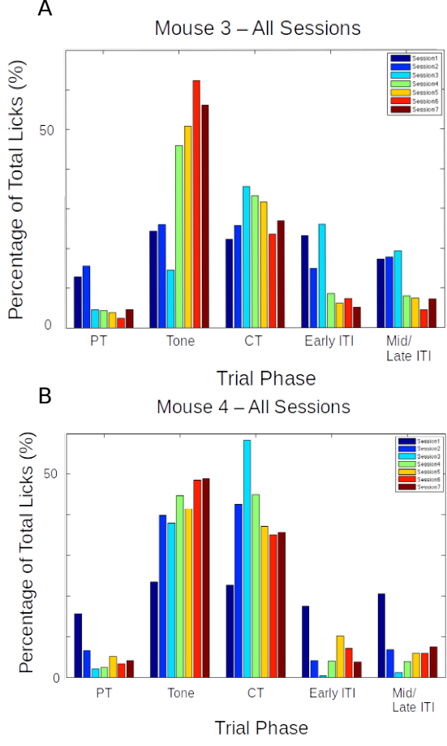se 3, and B) Mouse 4

In both the examples shown, animals would typically produce a great percentage of total licks even during the Tone period. This failure to withhold licks carried on for 7-14 sessions, and the task was ultimately unsuccessful.

Total animals trained: 2
Conclusion: Fail

Protocol 2: Stimulus Detection task with timeout box

We also tried the same Stimulus Detection protocol, without an air-puff punishment, but with incorrect licks punished by a trial abort and a stimulus-free timeout phase, which the animal could escape from if it withheld licking. We decided to train the animals in blocks, each with a specific goal that the animal had to achieve.

Trial phases:
1 Stimulus-free pre-tone (PT): 1 s
2 Tone: 5 kHz for a variable duration (based on Block)
3 Critical timeout (CT): 1000 ms
4 Inter-trial Interval (ITI): randomized between 2 s to 5 s

Figure: Typical trial structure with the various phases. Each trial was followed by a randomized Inter-Trial Interval (ITI).

Only licks during the critical timeout (CT) phase immediately after the Tone phase were rewarded while licks in other phases resulted in a phase restart.

Block 1: Unconditional Water to get the animal to associate the tone
- ~20 trials
- 100 or 200 ms Tone duration
- Unconditional water provided at the end of the tone, irrespective of lick

Block 2: Conditional Water to get the animal to learn that licking with/after tone is going to be rewarded
- 100 or 200 ms Tone duration
- 1000 ms Reward phase
- Lick during/after tone (Reward phase) = reward
- No lick = no reward
- Lick during pre-tone = no reward/abortion of trial
- Lick during ITI = no reward/abortion of trial
- Animals graduate to the next Block of training only after achieving at least 70-80% success rates

Block 3: Training the animal to learn "when" to lick
- 1000 ms pre-tone, 100 or 200 ms Tone, 1000 ms Reward phase, 3-5 s randomized ITI
- Lick during Reward phase = reward
- Any lick during the pre-tone or the tone, aborts the trial and sends the program to a Timeout phase (lasting, 2-3 s)
- The timeout phase ends only when there is a 2-3 s (specified) interval of no licking
- If the timeout phase ends, a new trial begins
- Licks during ITI are also "punished" accordingly
- Animals graduate to the next Block of training only after achieving 70-80% success rates

Block 4: Same as Block 3, but with a gradually increasing tone duration in steps of 50/100 ms
- The tone duration is gradually increased, the increase being tailored to the performance of the animal
- It will be attempted to get the animals to learn to wait for 500-700 ms
- Animals graduate to the next Block of the experiment only after achieving 70-80% success rates

Results – Protocol 2

The behavioural performance for each of the experiment animals was evaluated using custom analysis scripts written in MATLAB. Here are two representative examples of mice trained based on Protocol 2 (Block 3).

Figure: Performance evaluation for two example mice trained to Protocol 2. Percentage of total licks in the various trial phases (Pre-Tone, Tone, CT, and ITI), across all sessions of training (coloured bar plots).

Again, as is clear from the examples above, that while the mice eventually produced a decent percentage of total licks in the critical timeout (CT) phase to get a water reward, they did not learn to withhold licks during the Tone phase, even after >10 sessions. The task was ultimately unsuccessful.

Total animals trained: 4
Conclusion: Fail

Protocol 3: Delayed Non-Match to Sample (DNMS)

Delayed Non-Match to Sample (DNMS) is a task that is ideally suited to study working memory and recognition (Binder et al., 2009), but we decided to try it. This task involves trial-by-trial presentation of two stimuli separated by a stimulus-free delay interval. For any given trial, If the two pseudorandomly chosen pairs of stimuli were identical, then licks would not be rewarded. However, if the pair of stimuli were different, then licks would be rewarded with 2 µL water.

We tried to incorporate more tones, in the hope that this may improve the chances of the animals focusing on the task specifics, instead of producing licks to just any particular stimulus.

Tones used: 6000 Hz, 8500 Hz, 10000 Hz, and 11500 Hz
Trial phases:
- Pre-Tone duration (ms): 1000 ms
- CS 1 duration (ms): 350 ms
- Delay Interval duration (ms): 250 ms
- CS 2 duration (ms): 350 ms (unless a correct lick is elicited)
- ITI duration (s): randomized from 1 s to 3 s
Punishment: Timeout Box (minimum of 3s of no licks to escape)
Reward: 2 µL of water

Results – Protocol 3

>70-80% of the trials had to be aborted because the animals would not withhold licking after the 1st of the pair of tones was presented. This did not change even after 7 days (sessions) of training.

Total animals trained: 6
Conclusion: Fail

Protocol 4: Go/No-Go Task

In an attempt to simplify the behavioural task, we decided to reconfigure the DNMS task to a simpler Go/No-Go task. Here, we would again present the animal with two stimuli, but with the only condition being that the animal would have to lick after the second stimulus, and not before. This simplifies the behaviour to a certain extent, because the animals need only use the first stimulus as a cue for the second. Failure to perform this task could more easily then be attributed to a lack of attention in that trial. Only the data from the trials where the animal succeeds to do the task would be considered for analysis. Training related changes in actual stimulus representations would be carefully dissected out. Furthermore, such a task would control for the behavioural state of the animal and help provide important datasets.

In terms of imaging, we hoped to use the no-go stimulus to record a clean stimulus response without the possible contamination of movement (licking behaviour), and the go stimulus to verify attention (Figure 6).
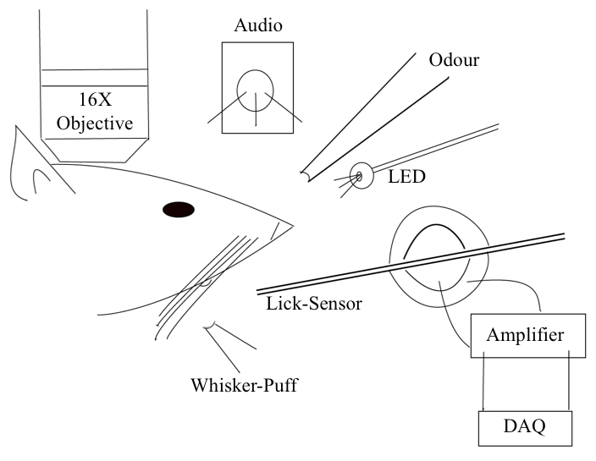Figure 6: Schematic representation of the experimental setup for a detection task where the animal must perform a lick upon correctly detecting the presence of the conditioned stimulus (CS; from a range of modalities).

Trials were designed to go through the following phases and have the animal graduate to subsequent phases, only after correctly performing the behaviour:
- Pre-tone: Stimulus-free period; no lick
- No-go tone: 7kHz tone period; no lick
- Go tone: 10kHz tone period; lick for reward
If the animal would perform an incorrect lick, the particular phase currently occurring was restarted. Only licks to the Go tone were rewarded (Figure 7).

Figure 7: Typical trial structure with the various phases and lick dependent relationships.

Results – Protocol 4

The behavioural performance improves only after several sessions of training (~3-4 sessions). This is primarily due to an increase in the percentage of trials with a correct Go tone lick, as shown (Figure 8).

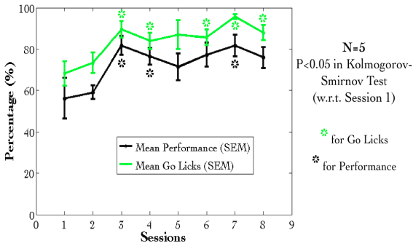Figure 8: Mean Performance (%) and Mean Go Tone Lick Percentage (%) with Session for the Go/No-Go Task, plotted in black and green, respectively.

However, a plot of the lick histogram for the various trial phases revealed that despite reaching the maximum success rate, the animals continued to lick during the no-go tone phase (incorrect lick) for a long duration of time (Figure 9). There was no difference in the amounts of time spent in the pre-tone or no-go tone phases. This suggested that the animals did not discriminate between the Go and no-go tones. Accordingly, the current protocol was not being learnt as expected.

Figure 9: The number of licks in the pre-tone (blue), no-go tone (red), and go tone (green) phases, in a representative animal, in a session with maximum Performance (%).

We were not able to get discriminatory detection. Animals would resort to performing licks continuously and agnostically to the go and no-go stimulus. In a study published many years later, it was determined that any discriminatory task such as the one described above, would require even up to 4 weeks of training, since the animal was not punished with anything more than a delay or phase restart.

Total animals trained: 5
Conclusion: Fail

Eventually, we had to abandon these experiments, to switch to an aversive conditioning task, viz., Trace Eye-Blink Conditioning (TEC). With the change in the main behavioural task we also changed the project goals. The TEC task was standardized with the intention to work on Project II which is to study how animals make complex associations between different types of stimuli and how they adapt to changes to the inter-stimulus interval (ISI).

Trace Eye-Blink Conditioning [Project II]

Eye-blink Conditioning is a class of Classical Conditioning and requires the presentation of a neutral stimulus (Conditioned Stimulus, CS) along with an eye-blink eliciting, mildly aversive stimulus (Unconditioned Stimulus, US). Depending on whether the CS presentation overlaps with the US presentation or if the two stimuli are separated by a stimulus free interval in between (Trace interval), the concomitant procedure is called Delay Conditioning or Trace Conditioning, respectively (Figure 10). In either case, precise timing of the CS and US is mandated.

Figure 10: Schematic representation to showcase the two main subtypes of Classical Conditioning (Eye-Blink Conditioning, for our experiments) based on the relative timing and presentation of the CS and US.

The CS is usually an auditory tone or a visual stimulus (e.g.- LED Flash), while the US is typically a mild air-puff to the cornea, or a gentle electric shock to the eye-lid. Naive animals (rabbits, rodents, monkeys, etc.) produce a robust, reflexive eye-blink to the US (Unconditioned Response, UR) and ignore the CS, in early trials. However, with repeated pairing of CS and US, the animals are able to associate the two, and use the CS as a cue to predict the US, producing a partial, preemptive eye-blink just before the expected time of the US (Conditioned Response, CR). The CR develops in amplitude over multiple pairings or training sessions. In well trained animals, the CR begins at a time point closer and closer to the CS onset, and usually merges with the UR. The animals produce this CR in an attempt to avoid the US.

Traditionally, Trace Eye-Blink Conditioning has been an important hippocampus-dependent behavioural task, and has been adapted to a variety of different species, spanning rabbits, rats, and mice.

Damage or inhibition of the hippocampus has been shown to limit task acquisition without affecting other non-hippocampus dependent tasks such as Delay Conditioning. In an experiment, Ibotenic Acid was used in a session dependent fashion, to observe both limitations in first acquiring the Trace Conditioning task, as well as detriments to behavioural recall, even after animals learn the task to a high degree of proficiency, suggesting the pivotal role that the hippocampus plays in temporal tasks of this nature (Tseng et al., 2004)⁠.

A single session of Trace Eye-Blink Conditioning, with strong stimuli (CS and US), has been previously employed (Modi et al., 2014)⁠, but with only upto 50% of the animals learning the task. Typically animals require around 3-7 sessions (~200-600 trials) to robustly learn the task. Accordingly, we designed and standardized a multi-session version of TEC, to allow more animals to learn and acquire the task, based on previously published work (Siegel et al., 2015)⁠.

Tracking eye-blink responses

The most foolproof way to track eye-blink responses (especially with head-fixed animals) chronically (for multiple sessions across days), is to use a video camera. We used a Point Grey Chameleon3 1.3 MP Monochrome USB3.0 camera) for this purpose. It is cost effective and with proper scaling of the resolution and field of view, can achieve recording rates of >200 frames per second. An important criteria for getting faster frame rates is to have better illumination, so that the camera may be set to lower exposure settings. We used a set of 5-10 Red colour LEDs as the light source, and these are run using a 12V DC line, with current limited resistors in series. Additionally, we used an IR-blocking filter to avoid capturing the 2-Photon excitation light (910-920 nm) when conduction behaviour and imaging experiments simultaneously. Finally, to focus the light from the eye of the animal onto the camera sensor, we used a Tamron M118FM16 lens (1/1.8, 16mm F/1.4).

Treadmill and tracking running speed

Allowing the head-fixed animals to run on a treadmill was an important behaviour rig consideration, as this allows the animals to be more comfortable and less stressed. We used a 6 inch cylindrical massage roller with a stainless steel axle running along the length. This axle had ball bearings on the two ends, to allow for free rotation against clamps. Additionally, we used linear actuators to be able to adjust the height of the treadmill relative to the head-fixing clamps.

On one side of the treadmill, we used a printed pattern of black squares (side length: 1cm) along the circumference. This allowed an IR LED - Photodetector pair to catch the edges of the black printed squares. The number of edges detected per unit time, then gave us the run speed of the animals being trained. We followed previously published routines and protocols (Siegel et al., 2015) for setting up the treadmill and run speed tracking (Figure 11).
Figure 11: Trial by trial (left), and trial-averaged running speed (right) for two example animals, A: M2 Session 12; B: M5 Session 12.

Behaviour rig and protocol control - Software

For our initial experiments we used the open-source behaviour controlling software suite Bonsai (Windows version). Later on, we were able to implement our own custom codes that allowed integration of the video camera, Arduino for stimulus delivery and treadmill tracking, and the software side of the protocols. Dilawar S. Rajput was instrumental in setting up the camera pipeline and integrating it into the Arduino code. The Camera server was implemented in C++ with Spinnaker API (Point Grey) and this fetched frames from the camera. The camera client was written in python, and this read the frames to produce a copy to monitor the video feed live, as well as write the video frames to disk as .tif files.
With this setup, the maximum memory usage was ~1.3 GB RAM, and the code (available at https://github.com/BhallaLab/PointGreyCamera) had the following dependencies:
• libopencv-dev, python-opencv
• cmake, g++, gnu-make
• libtiff-dev, python-tifffile, python-numpy
• python-gnuplotli, gnuplot-x11

An important requirement for our behaviour experiment design was to be able to train the animals systematically under reproducible conditions, with the aim to have stable behavioural training and animal performance. We used a blue LED as the Conditioned Stimulus (CS, 50 ms flash) with an air-puff to the eye serving as the Unconditioned Stimulus (US, 50 ms pulse). We used an Arduino to orchestrate stimulus delivery and protocol design. All experiments were performed on head-fixed C57Bl6 mice, since we planned to use a stationary, custom-built two-microscope to image hippocampal CA1 activity during task acquisition and recall (Figure 12, Figure 13).
Figure 12: Schematic representation of A: the behaviour rig with 2-Photon imaging, to train head-fixed mice on a Trace Eye-Blink Conditioning (TEC) task, and B: relative time intervals between the CS and US.

Figure 13: A picture of a head-fixed mouse clamped on the behaviour rig, with key components: 1) Red LED Illumination, 2) Blue LED CS, 3) Air-puff port directed to the left eye, and 4) Height-adjustable Treadmill

Analysis - TEC

Once the .tif movies of the eye of the animal being trained were saved, they were analyzed by a custom script written in MATLAB, wherein for every frame we (Figure 13),
- Adjust contrast (optional)
- Apply a median filter (optional)
- Crop out the pixels defining the eye and surrounding (identical number of pixels for all trials and animals)
- Binarize the image of the eye to get black pixels defining the visible (opened) portion of the eye
- Count the relative proportion of open vs closed eye pixels in the cropped image, and
- Assign each frame with a Fraction of Eye Closure (FEC) score.

Figure 14: Steps from behaviour video frame to Fraction of Eye-Closed (FEC) analysis

The FEC score then allowed us to analyse each trial’s worth of frames for eye-blinks. There are many features of the eye-blink that could be used to gauge the overall performance of the animal in terms of both the Conditioned Response (CR) as well as the Unconditioned Response (UR), but for our experiments, we chose to use Eye-Blink Amplitude (Siegel et al., 2015). Additionally, we studied whether the animals could produce CRs in the absence of the US, by pseudorandomly selecting 10% trials to skip the US (Probe Trials).

Results - TEC

- Animals showcase task acquisition by performing Conditioned Responses (CRs), observed as pre-emptive blinks timed to avoid the aversive US. The kinetics of the CR (timing, amplitude, etc.) are dependent on the amount of training, but are identical across paired and probe trials (Figure 14).

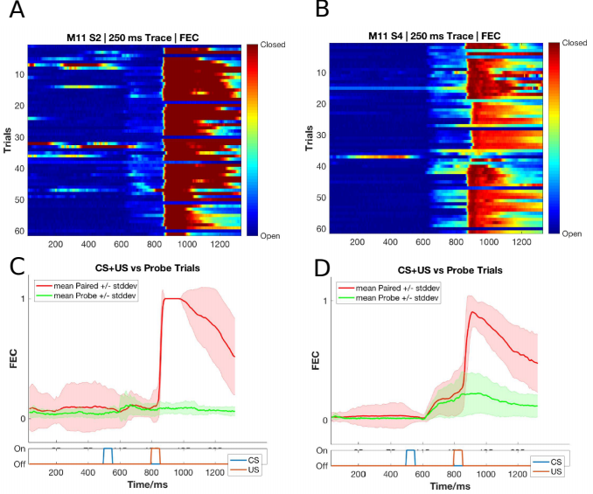
Figure 15: Conditioned Responses (CRs) are small amplitude eye-blinks triggered by the CS, and develop with multiple training sessions, while Unconditioned Responses are large eye-blinks to the US, typically consistent across sessions. (A,B) Trial-by-trial FEC traces for A) M11 Session 2, and B) Session 4. (C,D) Trial-averaged FEC traces for C) Session 2 and D) Session 4, with paired (red) and probe (green) trials.

- Most animals can pick up the task within 4-7 sessions (1 session/day, 60 trials/session), even if on water deprivation. Animals can also be subsequently trained to different inter-stimulus intervals. Using the Conditioned Response (CR) amplitude, each trial can be binarized to whether a CR was elicited (Hit Trial) or not (Miss Trial), by thresholding at mean trial FEC + 2*Std. Dev.. Performance for the session is then estimated as the ratio of Hit Trials to Total Trials (Figure 15).

Figure 16: Performance in terms of the percentage of Hit Trials to total trials across sessions, including an ISI switch from 250 ms to 350 ms.

- Animals that learn multiple ISIs, especially when the second ISI is >=2x the first ISI, showcase complex eye-blinks without extinction of the previously learnt CRs. Once an animal showcases the ability to produce Conditioned Responses (CRs) to one inter-stimulus interval (ISI), this interval can be elongated. In the example shown below we first trained the animal to a 250 ms ISI, and then switched to a 500 ms ISI (Figure 16).
- The onset of the Conditioned Response (CR) is not affected by the ISI switch, irrespective of how strongly the animals learn the task. CRs during paired and probe trials were near identical, showcasing that the animal (Figure 17, Figure 18).
Figure 17: Conditioned Responses (CRs) are preserved for previously learnt ISIs, and switching the ISI to longer intervals results in Complex (multi-CR) eye-blink responses. (A,B) Trial-by-trial FEC scores for A) 250 ms ISI (left) and B) 500 ms ISI. (C,D) Trial-averaged FEC traces for C) 250 ms ISI (left) and D) 500 ms ISI (right), with paired (red) and probe (green) trials.

Figure 18: Conditioned Response (CR) onset timing is maintained across ISI switches. Representative examples from a short ISI switch from A) 250 ms to B) 350 ms (right).
Figure 19: Bar plots for Conditioned Response (CR) onset across multiple sessions of training after ISI switch from 250 ms to 350 ms, irrespective of how strongly the animals learnt the task. A) red, strong learner, and B) blue, weak learner.
- Animals can also be trained to very long ISIs from Session 1, with acquisition taking <10-14 days. Here we tried to train animals to either a 550 ms ISI or a 750 ms ISI. Note, however, that unless multiple ISIs are taught to the same animal, the CR eye-blink is singular (Figure 19).
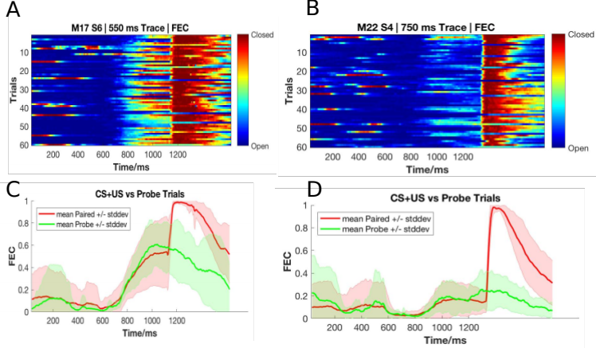

Total animals trained: 24 [>1 session]
Figure 20: Representative example of mice trained to 550 ms ISI (Session 6) and 750 ms (Session 4). (A,B), Trial-by-trial FEC responses for A) 550ms ISI, and B) 750ms ISI. (C,D) Trial-averaged FEC responses for C) 550 ms ISI, and D) 750 ms ISI, with paired (red) and probe trials (green).
Conclusion: Success

Chapter 3 – Imaging

The mammalian hippocampus is considered important in the formation of new memories about experienced events (episodic or autobiographical memory), general declarative memory (memories that can be explicitly verbalized), spatial memory and navigation, and associations between stimuli that are distinct in time, among other functions. To achieve this, the Hippocampus must integrate information from different areas of the cortex.

Much of the cortical information that enters the Hippocampus (at the Dentate Gyrus), comes through the Entorhinal Cortex, along the Perforant Path (Hjorth-Simonsen & Jeune, 1972)⁠. The Dentate Gyrus cell network then relays this information to the CA3 cell network through Mossy Fibers, which in turn relays the information to CA1 cells, through the Schaffer Collateral Fibers. This is popularly known as the Trisynaptic Circuit and there is scope and evidence for computation and information processing at every step (MacDonald et al., 2011; McHugh et al., 2007; Modi et al., 2014; Nakashiba et al., 2008; Suh et al., 2011)⁠. Finally, the CA1 cells have their outputs to other brain regions. It is important to note, however, that regions like the CA1 are known to have access to information directly from other brain regions, as well (P. Andersen et al., 2006)⁠.

Literature in the field suggests that naïve animals may have some sensory gating of “Neutral” stimuli at the level of the CA1 (Abe et al., 2014; Bellistri et al., 2013; Kamondi, 1998)⁠. The source of this inhibition (at least the step before the local interneurons) seems to be the Medial Septum, through Fimbria-Fornix (Abe et al., 2014). Also, behavioural relevance allows the CA1 to elicit depolarizations (D. A. Dombeck et al., 2010; Harvey et al., 2009; Itskov et al., 2011; MacDonald et al., 2011, 2013; Modi et al., 2014; Pastalkova et al., 2008)⁠.

The Hippocampus consists of ventral and dorsal portions both of which are of similar composition but are parts of different neural circuits (Moser & Moser, 1998)⁠. It has been reviewed that it is the dorsal hippocampus that performs primarily cognitive functions and in memory function, while the ventral hippocampus modulates emotional and affective processes (Fanselow & Dong, 2010).

Physiology in the hippocampus

The Hippocampus is located deep in the medial temporal lobe of mammals and is defined by several sub-structures, including the Dentate Gyrus (one site for information input to the hippocampus) and the Hippocampus Proper constituted by the CA1, CA2, CA3 and CA4 cellular levels.

Using extracellular tungsten microelectrodes in naïve unanesthetized rabbits serially exposed to multimodal stimuli (Vinogradova, 2001)⁠, it was reported that in the CA1,
1. A major fraction the reactive neurons have unimodal responses (41-44%)
2. Multimodal neurons are modality-unspecific but have differentiated responses to stimuli of different modalities and even to various stimuli within a single modality
3. Many neurons respond by Phasic (evoked responses last for the duration and as long as the stimulus) and Specific (stimulus-specific pattern) responses
4. Neurons with inhibitory responses are encountered less frequently than those with various types of excitatory
5. Habituation (non-responsiveness to repeatedly presented stimuli) is present though not among all the responsive cells (71-75%) and is often gradual

Imaging based activity studies have the advantage of being able to capture many more cells (>100 from the same animal) during experiments (D. A. Dombeck et al., 2010; Peron et al., 2015)⁠ as compared to typical electrophysiological measurements. Also, imaging provides an unambiguous method to identify cells that are not active during a period of interest. Finally, imaging techniques have gained momentum in the study of the hippocampal CA1 various spatial scales, from cellular resolution somatic studies (D. A. Dombeck et al., 2010; Modi et al., 2014)⁠, to dendritic (Mizrahi, 2004; Sheffield & Dombeck, 2014)⁠, as well as axonic boutons terminating on the CA1 interneuron populations (Kaifosh et al., 2013; Lovett-Barron et al., 2014)⁠, in vivo.

Firstly, it must clearly be determined if the CA1 cells in naive animals, indeed do not show depolarization responses to neutral stimuli in larger samples of CA1 cells, in vivo. Next, it becomes pivotal to understand the network and cellular mechanisms that underlie behavioral learning induced changes in CA1 responses.

Depending on the intended duration of the imaging experiments, viz., a few hours (single session) or a few days and weeks (multiple sessions), we were able to standardize both an Acute as well as a Chronic in vivo hippocampal preparation. We now discuss the in vivo hippocampal preparation, physiology recordings, and a brief summary of the results. An important perspective for our experiments was to study how sensory stimulus responses of hippocampal CA1 develop with associative learning.

Methodology – Acute and chronic imaging [Projects I & II]

The overall experiment deals with optically measuring the activity of the dorsal CA1 hippocampal neurons when different stimulus modalities are presented to a male C57BL/6 mouse. The thesis covers experiments conducted acutely (lasting <10 hours) using OGB-1 as a calcium sensor), as well as chronically (~7-21 days) using a genetically encoded calcium indicator, GCaMP6f).

The hippocampus cannot be imaged directly, through the cortex since the layer of cortex is too thick (of the order of millimeters) to allow proper excitation of the sample. The excitation light is expected to be scattered completely, well before the imaging depth of the CA1 layer. These layers of cortex have to accordingly be carefully suctioned out to allow the microscope objective to have optical access to the exposed tissue (Figure 20).

Figure 21: (A) A schematic of the rodent brain, showcasing the two hippocampi, one in each hemisphere. The hippocampi lie ~1 mm (mice) below the cortical surface. (B) The hippocampal preparation allows optical access to the deep lying hippocampal CA1 cells, relative to the skull/cortex. The CA1 cell bodies arrange in a laminar fashion, as a tight cell body layer that can be visualized by fluorescence (using either OGB-1 or GCaMP).

We first put the animal under anesthesia using a vapor chamber saturated with 3% isoflurane. Next, the animal is cheek-clamped and anesthesia is maintained using 1-2% isoflurane, provided directly to the nozzle of the animal, keeping track of ~1 Hz breathing rate and a body temperature of 35-37 ℃ (with heating pad). The animal is given a haircut and an ~5 cm circular incision is made on the scalp, revealing the skull below. We then affix headbars and skull screws with the help of dental cement, to be able to clamp the animal post surgery on the 2-Photon Microscope.

The left, dorsal hippocampus is targeted with a 3-5 mm circular craniotomy aimed at 1.5 mm left and 2.0 mm behind bregma, carefully tearing and peeling out the Dura, to reveal the cortex.

We perform a Hippocampal Preparation, to aspirate out the cortex (part of the somatosensory cortex) under repeated washes of Cortex Buffer (see table 1 for recipe), and expose a part of the dorsal hippocampal surface.
Depending on the requirement for the preparation, viz., acute or chronic imaging, we used different sensors.

Preparation of Cortex Buffer

To prepare 1000 ml of cortex buffer, weigh out the required amount of the salts, NaCL, KCl, Glucose and HEPES (see table 1 for recipe) and make up the volume of the solution with Milli Q Water till about slightly less than 1000 ml. Measure the pH using a calibrated pH meter. The expected pH is slightly acidic (around 5), so use 1M NaOH (aq) to set the pH to 7.35.
Then, fill up the volume to 1000 ml and verify the pH (should not have changed). Filter the contents through a 0.22 um membrane using a vacuum filtration, and store at 6 °C.

Table 1: Recipe for ready-to-use cortex buffer. The buffer is typically prepared and stored in aliquots to be used each week. The correct pH range of the buffer was often a crucial factor ensuring the success of the hippocampal preparation.
Ingredient | Concentration (mM) | Amount (g or ml)
NaCl (s) | 125 | 7.31 g
KCl (s) | 5 | 0.373 g
Glucose (s) | 10 | 1.8 g
HEPES (s) | 10 | 2.38 g
CaCl2 (aq) | 2 | 1.6 ml of 1.25 M stock solution
MgCl2 (aq) | 2 | 1.5 ml of 1.3 M stock solution0

Oregon Green Bapta-1 Injections for acute imaging

To prepare Oregon Green Bapta-1 (OGB-1) dye for microinjections, we first dissolve a 50 µg tube of OGB-1 in 5 µl of Pluronic Acid, and vortex the mix for 5 minutes. Separately, we dilute 20 µl of Phenol Red into 500 µl of cortex buffer, and transfer 45 µl of this solution to the OGB-1 mix. Next, we sonicate the 50 µl solution for 20 mins, followed by centrifugation at 10000 RPM for 5 seconds. The remaining supernatant is split into 7 aliquots (7 µl), and stored at -20 C for a maximum of one week (7 days).

For acute/single-day experiments, we injected OGB-1 using pulled, dye loaded micropipettes (~2 MΩ resistance, ~2 µm diameter) at a depth of 100-150 µm (Figure 20) from the topmost layer of exposed tissue, till a slow but detectable pulse of dye (visualized as a red/pink solution) may be visible just below the tissue surface. This allows the dye to be soaked up by the basal dendrites of the CA1 and takes 30-60 mins for incorporation into the cytoplasm. We typically allow the animal 1-2 hours of respite before the subsequent imaging session. High pressure ejection of the dye into the tissue may damage the neuropil, while very low pressures or clogs in the pipette affect the spread of the dye across the tissue. We aimed to image ~100 x 100 µm2 of the tissue in any particular ROI, and achieved this with 5 minute injections with each micropipette aiming to load the dye at 2-3, well separated positions spread across the entire exposed dorsal surface. We estimate that the dye volume was <1000 nl/injection. After the injection cycle with any micropipette, we leave the tissue undisturbed for at least 5-10 mins before pulling the micropipette out of the tissue.

Once all the injections are complete, the exposure is sealed using 5% low gelling agarose, just before it sets, making sure the temperature is cool enough to avoid heat-related tissue damage. Place a drop of the 5% agarose solution on the back of the hand to test the temperature.

OGB-1 is eventually cleared from the cytoplasm but allows for a limited window for imaging studies (Stosiek et al., 2003)⁠. Reopening the agarose seal and re-injections were never attempted to prevent unnecessary damage to the underlying tissue. Additionally, the agarose plug itself was found to be unstable beyond 1-3 days. This resulted in the imaging possibility being limited to the same day as the surgery (acute imaging).

GCAMP and chronic imaging

For chronic/multi-day experiments, we standardized a stereotaxic viral injection step, where we inject the gene for GCaMP5 or GCaMP6f into the dorsal hippocampus at -1.5 mm lateral, 2 mm posterior, and 1.3 mm dorsal from bregma on the skull surface (Figure 21).

Figure 22: Schematic representation for stereotaxic viral injection.

Later on, we switched to directly using GCaMP6f transgenic mice (background: C56BL/6) which express GCaMP6f in the Hippocampus (Chen et al., 2013)⁠, and thus circumvented the dye loading or viral injection steps, aiding in the potential success of the preparations, by way of tissue health and recording quality.

Results - Imaging

2-Photon calcium imaging of hippocampal CA1, in vivo

Next, we subject the CA1 cells to Imaging. The CA1 cell body layer is ~200 μm deep in through the hippocampal surface. At these depths, scattering of excitation as well as emission light is significant. However, we are able to image at these depths with Two-Photon Imaging LASER Scanning Imaging (810 nm for OGB-1 and 910 nm for GCaMP5/GCaMP6f), where a high intensity pulsed LASER allows for Two-Photons to near instantaneously excite fluorophores in a thin z-slice plane which is the focal plane of the Objective. There is scattering, but this since only the focal plane is excited any and all emitted photons that we capture are part of the signal. We use a Nikon 16x water immersion, 0.8 NA, 3 mm working distance Objective, to get a large field of view.

Acute Imaging of OGB-1 loaded hippocampal CA1

OGB-1 spreads throughout the cytoplasm and neuropil, and infiltrates the cell nucleus, giving the cells the appearance of solid circles (cells). The cell body (soma) ranges from 10-15 µm depending on the orientation of the imaging layer in 3D tissue space (Figure 22A).

Figure 23: (A) Representative Two-Photon Calcium Image of a plane of Hippocampal CA1 cells, bolus loaded with Oregon Green Bapta-1 (OGB-1), at an instant in time. Example cells marked out post-hoc as pink, green, blue and red. Scale bar 20 µm. (B) Representative dF/F (%) traces for the calcium activity recorded in a single 10s video for example cells pink, green, blue, and red. Scale bar (1 sec; 10% dF/F).
Each cell in the recorded region of interest (ROI), is identified, marked out (in pixel identity), based on local activity of correlated pixels in the time series movies. The average intensity of the pixels corresponding to each cell for each frame in each recording video, is saved as the raw calcium fluorescence trace. Next, these raw calcium traces are baseline normalized to equate the baselines for each cell at 0, and describe the dynamic range of the intensity values as 0 to 1, or 1 to 100%. Here are the corresponding time series of baseline normalized dF/F for the representative example cells (the same blue, green, and red cells as above) are shown (Figure 22B).

Chronic imaging of GCaMP expressing hippocampal CA1

For chronic imaging, tissue health was of paramount concern since it could easily degrade in time (Figure 23). With practice and standardization, we were able to get the preparations to survive for 2-4 weeks at very good signal-to-noise. Preparations that resulted in very poor signal-to-noise were often recorded but have been filtered out of the data showcased in this thesis. While preparations can sometimes last even months, typically it is crucial to consider if the ROI for recording could provide >20 cells, to continue the experiment.
GCaMP is typically designed to be cytosolic and does not typically cross into the cell nucleus. GCaMP labeled cell bodies appear as doughnuts in the imaging slice (Figure 23, Figure 24).
Figure 24: Tissue Degradation over time. Representative Two-Photon Calcium images of a snapshot in time of the Hippocampal CA1 cell body layer on A) Day 1 after the surgery and B) Day 3, after the surgery.
Recordings with very good signal-to-noise, where the same chronically labeled CA1 cells could be anatomically identified on subsequent days even >2-3 weeks post surgery (Figure 24) were eventually acquired, and are featured in the data presented in Chapter 4.

Figure 25: Chronic calcium imaging of the same Hippocampal CA1 cells over weeks. Representative 2-Photon images from A) Day 20, and B) Day 21, after surgery. Landmarks have been marked and were used to confirm frame registration and identify cells.
The magnification and resolution of the field of view are important parameters to consider when balancing magnification for the resolution and the maximization of the number of cells being simultaneously recorded from (Figure 25).

While recording at high frame rates for live imaging, we capture a relatively large number of cells (~100) in time-series imaging frames, at frame rates of around 10-15 fps. Subsequently, we subject the animal to various stimuli across trials and save these images for analysis.
Figure 26: (A) Representative Two-Photon Calcium Image of a plane of Hippocampal CA1 cells expressing GCaMP6f at an instant in time. Example cells marked out post-hoc in pink, blue, and green, with no-cell background in red. Scale bar 20 µm. (B) Representative dF/F (%) traces for the calcium activity recorded in a single 10s video for example cells in pink, blue, and green, with no-cell background in red. Scale bar (2 sec; 10% dF/F).

Spontaneous activity during non-stimulus periods

We recorded the calcium activity from a large number of hippocampal CA1 cell bodies, while presenting various neutral and conditioning stimuli, including fairly large periods of time before and after stimulus presentation. Activity of cells, typically observed in vivo, in these periods is termed spontaneous activity. Cells may showcase variable rate (number of calcium events per sec) and timing. Given proper signal isolation for identified cells in an ROI, each source or “cell” may be considered independent.

Spatial organization of activity correlated cells during spontaneous activity

We studied the Pearson’s Correlation Coefficient for the activity traces across all cell pairs. Cell pairs showcased a range of correlation coefficients (Figure 26) and we were able to cluster cells based on activity using Meta-K Means (Modi et al., 2014; unpublished data from Ashesh Dhawale’s Thesis).

These results matched the same published previously in the lab (Modi et al.., 2014).
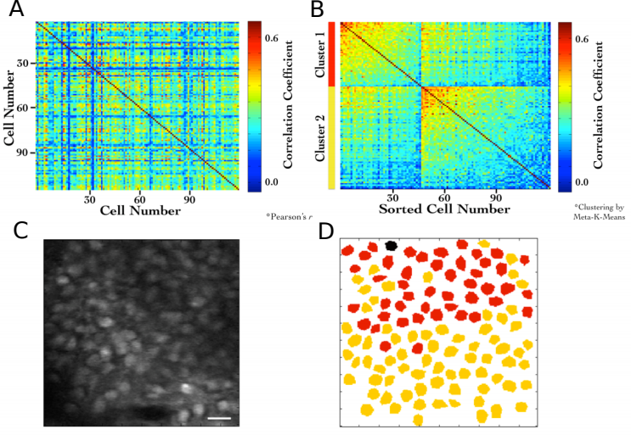Figure 27: (A) Correlation Coefficients for cell pairs from an example two-photon recording. (B) Meta-K Means clustering with cell pairs using the heuristic that within group pairs would be more similar than between group pairs. In this example, the cells were clustered into two groups (red and yellow). (C) Two-Photon image of the field of view of cells; same as Figure 23A. (D) Spatial organization of correlated cell-pair groups (Modi et al.., 2014).

Stimulus evoked responses

We also recorded calcium activity from the same cells during presentation of various neutral stimuli to the animals. Here are the results of the auditory (tone) and somatosensory (whisker) stimulus experiments.

A neutral auditory tone at 5000 Hz (for 1 sec) was presented to the animals N= 6 animals; 25 trials). We observed no clear signs of cell activity modulation by neutral tones. Below, we show an example animal with trial-averaged calcium traces as dF/F (%), across all recorded cells with a 1 sec tone presentation (Figure 27A). We also presented animals to whisker stimulation by playing a 1s long air-puff (5 LPM) to the ipsilateral (left) whisker (N = 5 animals; 25 trials). In this case, we observed whisker-stimulation based cell activity modulation. Below, we show the trial-averaged calcium traces as dF/F (%) of the same example animal as above, presented with a 1 sec whisker-puff (Figure 27B).

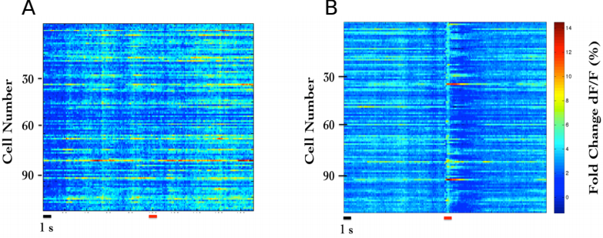Figure 28: (A) Trial-averaged (25 trials) calcium activity from ~100 CA1 cells in trials where a 5000 Hz tone was presented (red bar). (B) Trial-averaged (18 trials) calcium activity from the same cells in trials where a 5 LPM air-puff to the ipsilateral whiskers was presented (red bar).

More short-range localized clustering of groups of cell-pairs with correlated activity were observed post whisker-stimulation.

Chronic imaging now possible for weeks with the same mouse

The need for multi-day tracking was mandated for recordings through behavioural training, since the animals typically only learn Trace Eye-Blink Conditioning (TEC; Chapter 2) over the course of 3-7 days (Siegel et al., 2015)⁠. A different experiment design would have been to train animals and then perform the hippocampal preparation to record CA1 neural activity while the animal(s) exhibit learnt Conditioned Responses (CRs). However, we argued against this experimental design, on account of the following.
1. The actual cellular and network mechanisms that allow for the animal to learn the behavioural task would be very difficult to study given that the learning period would have passed.
2. The success rate of the hippocampal preparation is typically very low, while TEC is typically learnt by >50% animals (Modi et al., 2014; Siegel et al., 2015)⁠. We had argued for exposing the hippocampus for imaging before behavioural training since any successful preparations could then be subjected to the relatively more consistent behavioural training.
3. Having the preparation performed before training minimizes the number of times the animal would be subjected to surgery (to just the once), improving chances of animal health through the experiment.

Next, we discuss some preliminary results from the chronic imaging datasets. A non-overlapping set of results that feature in “Chapter 4 - Analysis” of this thesis, have been skipped here for brevity.

[Old] Analysis to identify time cells

The analysis algorithm pertaining only to the results presented here in “Chapter 3 - Imaging”, was adapted from William Mau’s Temporal Information method ((Mau et al., 2018)⁠; Chapter 4 - “Analysis”). This analysis algorithm was not developed to the extent of the Python/C++ implementation featured in “Chapter 4 - Analysis” and is expected to be subject to some degree of Type I (false positives) and Type II (false negative) errors.

- Filter to select for cells that had activity in >25% of trials (irrespective of tuning)
- Develop Event Time Histograms, using Area Under the Curve for a binsize of 3 frames, centering the “0 ms” to the onset of the Conditioned Stimulus for visualization.
- Estimate Temporal Information (TI), using
TI = 1/λ * Σj λj log2 (λj / λ) Pj
where,
λ: Average Transient rate for each cell
λj: Average transient rate for each cell in bin “j”
Pj: Probability that the mouse was in time bin “j”
For every trial, random shuffle the frame points to develop a random activity model (1000 times) and ensure that λ > λrand in more than 99% of the models. If yes, then the cell has time locking with temporal information (TI; in bits) as a measurement for time information. Filtering for cells active in >25% trials with a λ > λrand in >99% shuffles, along with the estimation of TI, provide us a handle on reliability.

Time Cells
During the experience of temporally organized events or stimuli, in this case post training to Trace Eye-Blink Conditioning, a rough contingent of ~20% of the total cells recorded, were observed to showcase time-locked calcium activity mapping the Blue LED or Conditioned Stimulus (CS) to the air-puff or Unconditioned Stimulus (US). These cells were classified as time cells. Here are some example time cells (Figure 28).

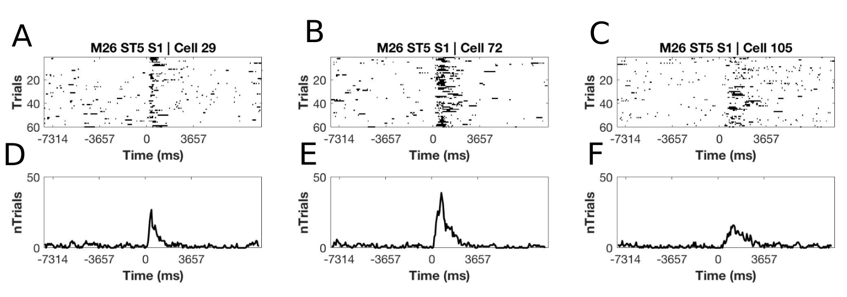
Figure 29: Example Time Cells visualized as event raster plots (A, B, C), along with the trial-summed activity profiles (D, E, F) suggesting ~50% hit trials, for cells 29 and 72 from Session 1 (session type 5) with mouse M26, and slightly lower reliability (~25% hit trials) from cell 105.

Other Cells
On the other hand, most cells did not clear our analysis algorithm checkpoints and were classified as other cells. Here are some example Other Cells (Figure 29) from the same session with mouse M26 (Session 1; session type 5).

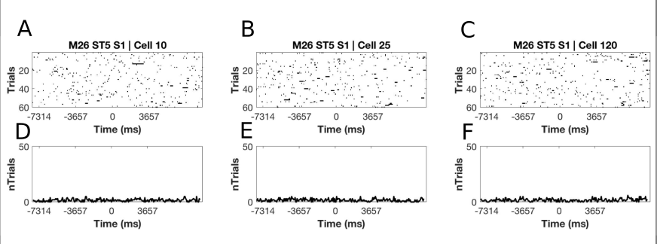Figure 30: Example Other Cells visualized as event raster plots (A, B, C), along with the trial-summed activity profiles (D, E, F) for cells 10, 25, and 120 from Session 1 (session type 5) with mouse M26
Considering only the classified time cells, we sorted cells based on the time of the peak of the trial-average activity and a spatiotemporal sequence was visualized (Figure 30; also see “Chapter 4 - Analysis Figure 7H”).

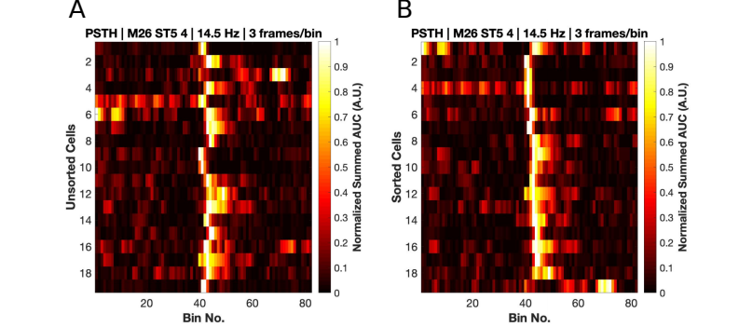Figure 31: Event Time Histograms or tuning curves for Identified Time-Locked Cells with trial-summed peaks in session 4 of training (session type 5) with mouse M26. (A) Unsorted list of Time cells. (B) Peak-sorted list of the same cells. Here, 1 bin = 3 frames = ~210 ms (sampling rate 14.5 Hz without binning; ~5 Hz with binning). As per the (legacy) session type 5 protocol, the CS (50 ms Blue LED flash) was presented in frame bin 39 a conservative stimulus-free trace interval during frame bins 40 and 41, and the US (50 ms airpuff to ipsilateral eye) presented in frame bin 42.
We did not observe any obvious trend in the temporal information of time cells with peak times. For the same cells as in Figure , we now look at the actual Temporal Information estimates (Figure 31).

Figure 32: Temporal Information (bits) vs Sorted time cell number from the analytically identified Time Cells in Session 4 (session type 5) with mouse M26. No clear trend was observed.

Tuning, re-tuning, and de-tuning of time cells across sessions

A crucial advantage of the chronic preparation was that many anatomically aligned and classified cells (as cell ROIs), could be recorded from over several days and sessions, to look for possible changes in calcium activity profiles across sessions in the same set of cells.

We noticed some evidence for an expansion of the set of identified time cells with sessions, up to a reliable pool of ~20% time cells. Altogether, from the pool of chronically aligned cells (across sessions), there was an increase from 7.7% to 23.1% of time cells. Considering the full cohort cells (irrespective of tracking across multiple training sessions) the increase was from 7.2% to 21.1% time cells. Here are the classified time cells between two independent recording sessions, early in training (Figure 32).
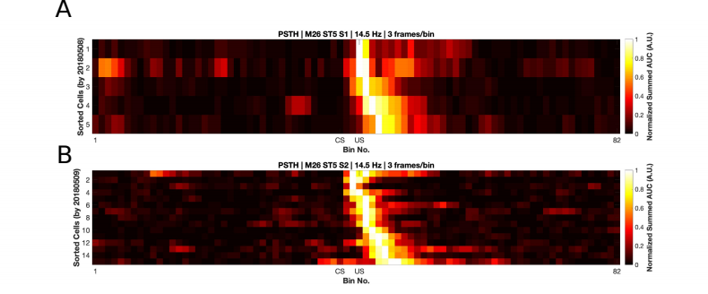Figure 33: More time cells observed to attain tuning as training sessions. Event Time Histograms of the identified set of time cells between A) Sessions 1 and (B) Session 2, with mouse M26 (session type 5).
The same may also be visualized as trial-averaged calcium activity profiles for all recorded cells across independent recording sessions (Figure 33).
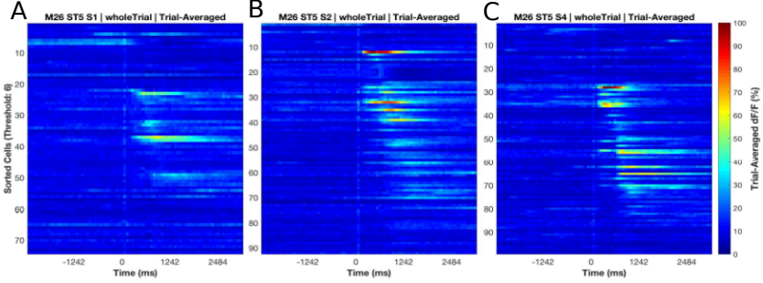Figure 34: Sorted Time Cells form Sequences that develop with learning. Trial-Averaged calcium activity traces for all recorded cells across A) Session 1, B) Session 2, and C) Session 4, with mouse M26 (sessiontype 5). Time 0 ms was aligned to the CS. The CS + Trace + US interval lasted from 0-600 ms, here.

Chronically tracked time cells that showed reliable tuning across sessions were then compared to look for any shifts in the peak tuning bin.

We observed examples of cells that maintained their tuning across pairs of sessions (Figure 34).
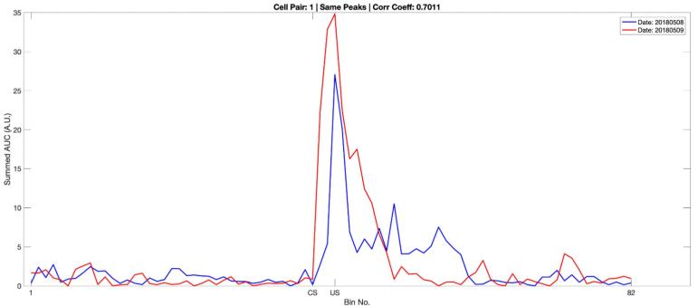
Figure 35: Same/similar tuning across session 1 and session 2 for this example time cell. Blue Event Time Histograms represent the tuning curve for the cell for session 1 (date: 20180508) and Red represent the same but for session 2 (date: 20180509). Pearson’s correlation coefficient between the two session pairs was 0.7011.

Here are examples for earlier Event Time Histogram (tuning curve) peaks across sessions (Figure 35) for Mouse M26, session type 5, session 1 vs 2.

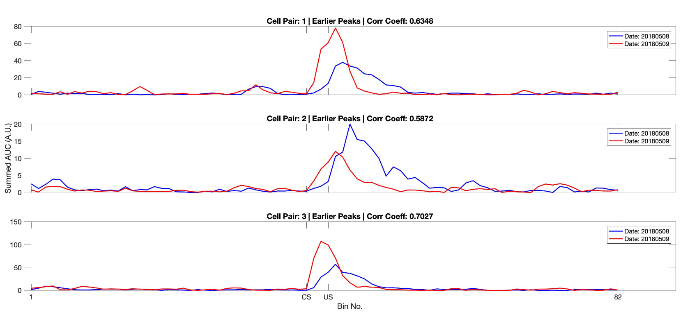Figure 36: Three example chronically tracked cell pairs with tuning peaks arriving earlier with training sessions (rows). Blue Event Time Histograms represent the tuning curve for any cell for session 1 (date: 20180508) and Red represent the same but for session 2 (date: 20180509). Pearson’s correlation coefficient between the session pairs was 0.6.348, 0.5872 and 0.7027 for A) cell pair 1, B) cell pair 2, and C) cell pair3, respectively.

Here is an example of a cell showcasing de-tuning across sessions (Figure 36).

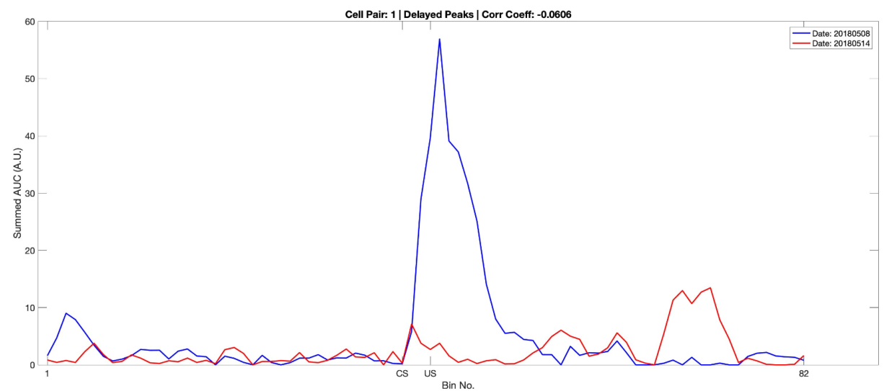Figure 37: Example chronically tracked cell pair with de-tuning between session 1 and 4. Blue Event Time Histograms represent the tuning curve for the example cell for session 1 (date: 20180508) and Red represent the same but for session 4 (date: 20180514). Pearson’s correlation coefficient between the two curves was -0.0606.

A full summary of the correlation based peak timing analysis for chronically identified time cells with mouse M26 are shown (Figure 37). Across all same cell pairs, there was positive correlation (>0.2) in 71% of Time Cells. Also a comparison of the tuning curve peaks between the same time cell pairs revealed that a majority of the re-tuned peaks occurred earlier in time, going across sessions (71%), with an equal proportion of cells without much re-tuning (14%) or de-tuning to later time points (14%).

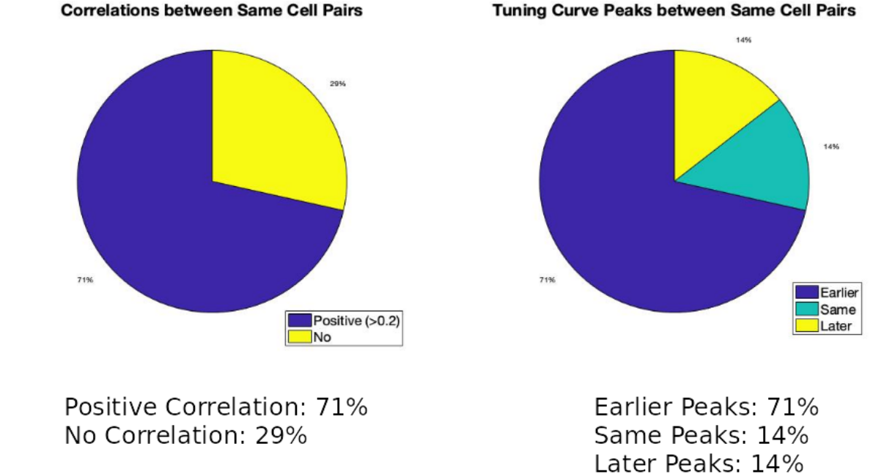Figure 38: Comparing time cells across sessions for all cells.
An essential summary of the key preliminary results observed using real physiology data:
1. Time cell tuning curve peaks typically began only after the presentation of the CS.
2. The width of the tuning curve peaks for Time Cells increased with tuning to later frame bins. This was consistent with the recordings presented in literature under physiological conditions (B. J. Kraus et al., 2015; MacDonald et al., 2011, 2013; Mau et al., 2018; Modi et al., 2014; Pastalkova et al., 2008)⁠.
3. Pairwise time cell tuning curves for different Time Cells may have some overlap in timing, but peaks were observed in all frame bins between the CS and the US. This particular observation is confounded by the short number of Trace period frames recorded and the requirement to consider 3 recording frames to every bin (Mau et al., 2018)⁠, decreasing the effective sampling rate even further (14.5 Hz without binning, to ~5 Hz with binning). Further experiments may be necessary to interpret. However the observation is still consistent with previous literature (B. J. Kraus et al., 2015; MacDonald et al., 2011, 2013; Mau et al., 2018; Modi et al., 2014; Pastalkova et al., 2008)⁠.
4. A surprisingly large number of Time cells could be identified with tuning peaks for frame bins occurring after the termination of the US.
5. Considering all chronically tracked cells, the classified and sorted Time Cells formed sequences that were dynamic across learning sessions. Many Time Cells developed tuning curves with sessions while some Time Cells lost their tuning.
6. For the majority of Time cells, re-tuning occurred with initial tuning to the timing of the US in earlier sessions, followed by a shift to earlier time points for the tuning peak, as training progressed through sessions.

Future directions to be explored in the lab include studying the reliability of a larger pool of chronically tracked cells with switches in the inter-stimulus interval (ISI) between the CS and the US as well as with a larger palette of different stimuli testing out a battery of Conditioned Stimuli (CS1, CS2, etc.) and Unconditioned Stimuli (US1, US2, etc.). The goal is to understand how well the internal neural spatiotemporal CA1 sequence maps to the external behavioural protocol parameters, in vivo.

– Bibliography

Chapter 5 – Discussion

Ramón y Cajal, one of the pioneers of neuroscience around 1900, utilized Camillo Golgi’s staining method to conclusively describe neurons in the brain as independent functional units connected to each other in intricate small-world networks with many billions of nodes. These neurons have since been described not just anatomically, but also on the basis of genetics, development, and neurophysiology.

In the sub-discipline of Learning and Memory, a very popular neuron type by way of such studies is the pyramidal neuron, an example of which is the hippocampal CA1 pyramidal neuron. This thesis describes a toolkit of techniques ranging in a wide, multi-disciplinary scope, assembled with standardized hardware and software routines studying animal behaviour, network neurophysiology, and statistical analyses.
The aim of the toolkit was to provide the experimental ability to study the hippocampal CA1 neuron network, under strictly controlled behavioural contexts designed to train experimental mice on temporal or episodic memory tasks. Specifically, these tasks such as Trace Eye-Blink Conditioning (TEC) have previously been described to elicit hippocampal CA1 sequences (B. J. Kraus et al., 2015; MacDonald et al., 2011, 2013; Mau et al., 2018; Modi et al., 2014; Pastalkova et al., 2008)⁠. This spatiotemporal network activity sequence is dynamic and built from individual hippocampal CA1 pyramidal neurons showcasing time tuned activity through spiking. These cells are called time cells (Eichenbaum, 2017)⁠.

Engrams associated with Learning and Memory

The term "engram" (coined by Richard Semon) refers to the physical substrate of memory in the organism, used for storing and recalling memories. Donald Hebb’s theory of Hebbian Plasticity (Hebb, 1949)⁠ postulated that memory formation was correlated to modulations in synaptic strength and connectivity. The theory critically emphasized that the pair of neurons connected through the synapse undergoing plasticity to strengthen efficacy, required the spiking activity of both neurons. In subsequent decades, research into the idea led to the theory of spike-timing-dependent plasticity (Caporale & Dan, 2008)⁠, a mechanism of synaptic plasticity based on the relative timing of activity of the neurons. It is still a matter of debate whether the biophysical manifestation of the engram is the synapse, the activity of the neurons, biophysical or chemical processes, but it is likely that the engram is distributed across several computational scales in the brain.

Eric Kandel’s experiments with the Aplysia sensory neurons studied gill withdrawal - an aversive but stable, adaptive behaviour. The reliability of this learned response allowed the experiments to include crucial electrophysiological and neurochemical circuit dissections that ultimately lead to the discovery of the entire neural circuit orchestrating the task, even to the level of cellular signaling. This led to decades of research focused on the plasticity of synapses across nervous systems in the animal kingdom.

Research exploring causal relationships between the physical or functional integrity of various brain regions and overt behaviour has been crucial to mapping many brain regions to specific functions and motor responses. Technological advancements in molecular neuroscience led to the development of a number of fluorescent sensors, conditional tagging, activators and inhibitors that allowed cellular resolution tracing of the engram (Luo et al., 2018)⁠.

Experiments by Sheena Josselyn, Alcino Silva, and colleagues led to the discovery that the intrinsic excitability of a pyramidal neuron in any network positively biased the probability of recruitment to the engram (Han et al., 2009; Rogerson et al., 2014; Yiu et al., 2014; Y. Zhou et al., 2009)⁠, viz., the tagged set of cells were active when memory was learnt and recalled. The engram seemed to be described in terms of the cellular sub-population involved but the experiment could only identify the same over a relatively longer window of time (~mins.). This could lead to only a static list of cells which may even have included False Positives (Type I error). Importantly, any dynamics in the spatiotemporal patterns of activity of the pyramidal neurons were not amenable to study at shorter timescales (~ms.). On the other hand, physiological recordings could describe these dynamics at short timescales, but were rarely translated to chronic measurements of the activity of the same cells across days and sessions, given technical limitations at the time.

Engrams are likely dynamic

Place cells and their role in spatial navigation have been described in great detail through decades of research ever since they were first described by John O’Keefe (O’Keefe & Dostrovsky, 1971). We did not explicitly study Place Cells in this thesis but some key discoveries in literature require mention, with the goal to build a case for a theory of CA1 ensemble sequences (Modi et al., 2014)⁠. Briefly, place cells are pyramidal neurons that showcased a higher than baseline probability of firing action potentials whenever animals navigating spatial environments visited specific locations, often in a sequence of place cells mapped to the real spatial trajectory of the animal (Ferbinteanu & Shapiro, 2003; Foster, 2017; Frank et al., 2000; Wood et al., 2000)⁠.

As the animal enters these landmark locations in any spatial context, these place cells showcase Phase Precession, firing earlier in phase to cycles of Theta a network rhythm clocked at ~4-10 Hz, as the animal’s position changes relative to the landmark. These navigation mapped place cell sequences are called Theta Sequences (Foster & Wilson, 2007)⁠, typically mapped to a few active neurons at a time.

In very specific contexts, these place cells express activity sequences synchronized to Sharp Wave Ripples, a different network activity phenomenon clocked at ~10-30 Hz, often not tied to the animal’s location, called Replay Sequences (Foster & Wilson, 2006)⁠. These sequences have been described to play out typically in temporal order to models of place cell sequences describing known trajectories in space.

There is variability in the firing of place cells in any spatial context, and studies have mapped specific sequences to very specific trajectory goals (going towards or away from locations) with modulation by both egocentric and allocentric orientations cues (Davidson et al., 2009; Ferbinteanu et al., 2011; Ferbinteanu & Shapiro, 2003; Frank et al., 2000; Wood et al., 2000)⁠ and movement speed based estimates of distance (Kropff et al., 2015)⁠.

Place cell and time cell sequences have many similarities and differences in descriptive neurophysiology, but may emerge from the same memory organization principles (Buzsáki & Llinás, 2017)⁠. It is argued that there is significance to the exact phrasing of the CA1 sequence in any given context. Furthermore, a very interesting feature observed is Time-stamping, viz., time dependent overlap of ensemble responses to different contexts and behavioural parameters (Cai et al., 2016; Mau et al., 2018)⁠.

Trace Eye-Blink Conditioning is a behavioural context which has been shown to feature CA1 time cell activity sequences. Transient increases in CA1 excitability post acquisition of the task were described up to 4-5 days (Moyer et al., 1990)⁠ and could be important to the forging of the task specific spatiotemporal sequences during learning. Moreover, Trace Eye-Blink Conditioning in mice has been previously observed to elicit CA1 activity sequences even in a single session of training (Modi et al., 2014)⁠.

Internally driven as opposed to externally driven network models of activity sequences have been proposed as the mechanism driving hippocampal CA1 sequences (Buzsáki & Llinás, 2017; Eichenbaum, 2017)⁠. The CA1 neurons participating in any sequence may represent physiologically mappable attractors in temporally specific contexts. The standardized protocols described in the thesis are expected to aid in future experiments studying hippocampal CA1 sequences.

The study of hippocampal CA1 sequences

We standardized a multi-day Trace Eye-Blink Conditioning (“Chapter 2 - Behaviour”) training system for mice based on previous literature (Modi et al., 2014; Siegel et al., 2015)⁠ and could demonstrate several types of behavioural adaptations that experimental animals could learn under a variety of experiment conditions and modulations. Notably,
1. The animals typically learnt the tasks quickly, within 1-2 weeks of training.
2. Modulating the inter-stimulus interval (ISI) between the CS and US results affected the expression of the conditioned response (CR).
3. A wide palette of stimuli may now be incorporated into existing protocols as either of the presented stimuli

Simultaneous large-scale recordings have been fundamental to the discovery of long spatiotemporal activity patterns with several participant CA1 neurons (Davidson et al., 2009; Foster, 2017)⁠. Electrical recordings provide many orders of magnitude better temporal resolution, not to mention being a direct readout of action potentials. However at the time of the design of the thesis, imaging based approaches could yield more recorded neurons per experiment animal.
We standardized 2-photon fluorescence based chronic imaging of hippocampal CA1 neurons to allow calcium imaging based recording of the spatiotemporal sequences across multiple days (”Chapter 3 - Imaging”). This gave us the ability to
1. Record neurophysiology over a large population of neurons (~100), in conjunction with temporally relevant behavioural contexts and modulations, albeit at ~100 ms temporal resolution.
2. Chronically track cells across various behaviour sessions without ambiguity.
3. Allow for scalability in the per animal yield of recording neurons with the use of faster and modern 2-photon microscope hardware utilizing Resonant Scanning instead of Galvo Scanning, as well as multi-channel imaging.

Engrams are likely distributed

An important consideration is that while different brain regions have been studied and identified with various functions, each brain region is typically involved in a variety of functions and almost the whole brain in entirety, is involved in any real life task. Imaging multiple brain regions at near cellular resolution has been reported using Cortical Observation by Synchronous Multifocal Optical Sampling or COSMOS (Kauvar et al., 2020)⁠. However, we had limited our physiology experiments strictly to the dorsal hippocampal CA1, in the left hemisphere. Multi-region imaging would require a second excitation-emission path, a technical and experimental paradigm which was not considered within the scope of this thesis.

Similarly, important engram motifs at subcellular spatial scales were beyond the scope of the experiments in this thesis. Multiscale models of network function (Bhalla, 2014a, 2014b; Dudani et al., 2013)⁠ would be required to complement any physiology, as a possible way to address the issue of engram motifs at variable spatial scales.

For our chronic 2-photon calcium imaging recordings, we had sampled from ~100-150 hippocampal CA1 neurons per mouse, using Galvo Scanning in our custom-built 2-Photon microscope (Modi et al., 2014)⁠ at a frame rate of ~14.5 Hz. We had to limit our scope of inquiry to randomly sampled populations of CA1 pyramidal neurons from the same CA1 microcircuit.

Future directions include the use of Resonant Scanning to achieve higher frame rates at better lateral resolution sampling up to ~100x more neurons.

Mapping sequences to abstract variables

The Hippocampus may use non-visuospatial resources (specifically shown using Olfaction), to generate spatial representations, when vision is compromised (Zhang & Manahan-Vaughan, 2015)⁠.

In a sound manipulation task (SMT) rats changed the frequency of auditory tones in their environment, by self-initiated joystick control, ramping logarithmic sweeps of frequency space. The rate of change in frequency could be manipulated either by the animal or pseudorandomly by the experimenter. This study describes neural activity recorded from the medial entorhinal cortex (MEC) as well as the hippocampal CA1 with sub-populations that were found tuned to specific frequency “landmarks” during the auditory sequence (Aronov et al., 2017). The CA1 were, thus, argued to be capable of tuning to abstract variables and were designed to map out sequences of events/stimuli in their own spatiotemporal patterns of activity.

The ubiquity of neural sequences in a wide variety of systems has been discussed previously (Bhalla, 2019; Conen & Desrochers, 2022; S. Zhou et al., 2020)⁠⁠, and over a century of research has discovered remarkable physiological features that may be used to identify neurons that participate in these sequences. However, research is still required to carefully dissect out the contribution that each participant neuron has to behaviour, an important goal in neuroscience (Ranck, 1973, 1975)⁠.

The use of user-configurable, categorically labeled synthetic calcium activity profiles allowed us to probe and compare a range of different time cell detection algorithms, identifying strategies to best classify time cells. We were able to identify Temporal Information as a strong contender for the choice of algorithm for such classification (“Chapter 4 - Analysis”; (Ananthamurthy & Bhalla, 2023)⁠. The algorithms developed along the way were tested within the time scales of ~100 ms, that correspond to Replay Sequences or other behaviour timescale sequences. We expect the analysis routines to be useful in a variety of different experiments that could potentially help describe the neural code in more detail.

Does the brain create or predict?

Predictive coding has been considered as a way for the brain to ultimately use external sensory information to minimize prediction errors during tasks (“Bayesian Brain Probabilistic Approaches to Neural Coding.,” 2007; Rao & Ballard, 1999). One of the core ideas of Bayesian approaches to neurophysiology and behaviour is that the brain could be modelled as a prediction machine that is constantly modelling the change of variables. These variables may be external or internal yet salient concepts to any experimental animal, arguably expressed in neurophysiology as the dynamics of engrams. The ability of the mammalian hippocampus to bind both information streams to create new, more elaborate engrams, is likely crucial to the learning of new concepts behaviourally (Eichenbaum, 2017)⁠.

Attentional states have been shown to have a bidirectional relationship with the expression of memory and learning (Chun & Johnson, 2011; Hutchinson & Turk-Browne, 2012; Uncapher et al., 2011)⁠. Specifically, Trace Eye-Blink Conditioning (TEC) performance has been suggested to be positively correlated with attention (Manns et al., 2000)⁠. The question of the effect of attentional states on the dynamics of the associated engram motivated an important milestone for the Thesis, viz., to combine stable, adaptable behaviour studies with large-scale neurophysiology.

We were able to train head-fixed mice to TEC and confirm adaptable conditioned responses to task variables. We were also able to simultaneous record from ~100 hippocampal CA1 cell bodies as the animals acquired top behavioural performance. We observed in our preliminary results that many identified time cells showcased the ability to tune to different time points across sessions or days, as has been previously reported (Mau et al., 2018)⁠. This standardization of simultaneous behaviour and imaging ensured that colleagues from our lab were able to generate production quality data, quickly.

Several more high quality recordings and behaviour modulations would be required to conclusively describe time cells physiology and engram dynamics, at least at the level of a sub-population of hippocampal CA1. However, progress has been made to suggest the best time cell detection algorithm(s) based on their sensitivity to different recording parameters (Ananthamurthy & Bhalla, 2023)⁠. We hope that the Thesis is of aid to future research on the neural mechanisms of Learning and Memory by the nervous system.

Code Availability

All our code for Synthetic Data generation and time cell Analysis is available at https://www.github.com/bhallalab/TimeCellAnalysis.

All our code for conducting Trace Eye-Blink Conditioning (TEC) behaviour is available at https://www.github.com/ananthamurthy/eyeBlinkBehaviour.

Analysis scripts for evaluating TEC performance are available at https://github.com/ananthamurthy/MATLAB/tree/master/TECAnalysis.

– Bibliography

All Bibliography

Abe, R., Sakaguchi, T., Matsumoto, N., Matsuki, N., & Ikegaya, Y. (2014). Sound-induced hyperpolarization of hippocampal neurons. Neuroreport, 25(13), 1013–1017. https://doi.org/10.1097/WNR.0000000000000206
Ananthamurthy, K. G., & Bhalla, U. S. (2023). Synthetic Data Resource and Benchmarks for Time Cell Analysis and Detection Algorithms. ENeuro, ENEURO.0007-22.2023. https://doi.org/10.1523/ENEURO.0007-22.2023
Andermann, M. L., Gilfoy, N. B., Goldey, G. J., Sachdev, R. N. S., Wölfel, M., McCormick, D. A., Reid, R. C., & Levene, M. J. (2013). Chronic Cellular Imaging of Entire Cortical Columns in Awake Mice Using Microprisms. Neuron, 80(4), 900–913. https://doi.org/10.1016/j.neuron.2013.07.052
Andersen, P., Morris, R., Amaral, D., Bliss, T., & O’Keefe, J. (Eds.). (2006). The Hippocampus Book. Oxford University Press. https://doi.org/10.1093/acprof:oso/9780195100273.001.0001
Andersen, R. A., Snyder, L. H., Li, C.-S., & Stricanne, B. (1993). Coordinate transformations in the representation of spatial information. Current Opinion in Neurobiology, 3(2), 171–176. https://doi.org/https://doi.org/10.1016/0959-4388(93)90206-E
Aronov, D., Nevers, R., & Tank, D. W. (2017). Mapping of a non-spatial dimension by the hippocampal-entorhinal circuit. Nature, 543(7647), 719–722. https://doi.org/10.1038/nature21692
Aronov, D., & Tank, D. W. (2014). Engagement of Neural Circuits Underlying 2D Spatial Navigation in a Rodent Virtual Reality System. Neuron, 84(2). https://doi.org/10.1016/j.neuron.2014.08.042
Attardo, A., Fitzgerald, J. E., & Schnitzer, M. J. (2015). Impermanence of dendritic spines in live adult CA1 hippocampus. Nature, 523(7562), 592–596. https://doi.org/10.1038/nature14467
Barretto, R. P. J., Messerschmidt, B., & Schnitzer, M. J. (2009). In vivo fluorescence imaging with high-resolution microlenses. Nature Methods, 6(7), 511–512. https://doi.org/10.1038/nmeth.1339
Bayesian brain: Probabilistic approaches to neural coding. (2007). In K. Doya, S. Ishii, A. Pouget, & R. P. N. Rao (Eds.), Bayesian brain: Probabilistic approaches to neural coding. MIT Press.
Bellistri, E., Aguilar, J., Brotons-Mas, J. R., Foffani, G., & de la Prida, L. M. (2013). Basic properties of somatosensory-evoked responses in the dorsal hippocampus of the rat. The Journal of Physiology, 591(10), 2667–2686. https://doi.org/10.1113/jphysiol.2013.251892
Bhalla, U. S. (2014a). Chapter Fourteen - Multiscale Modeling and Synaptic Plasticity. In K. T. B. T.-P. in M. B. and T. S. Blackwell (Ed.), Computational Neuroscience (Vol. 123, pp. 351–386). Academic Press. https://doi.org/https://doi.org/10.1016/B978-0-12-397897-4.00012-7
Bhalla, U. S. (2014b). Molecular computation in neurons: a modeling perspective. Current Opinion in Neurobiology, 25, 31–37. https://doi.org/https://doi.org/10.1016/j.conb.2013.11.006
Bhalla, U. S. (2019). Dendrites, deep learning, and sequences in the hippocampus. Hippocampus, 29(3), 239–251. https://doi.org/https://doi.org/10.1002/hipo.22806
Binder, M. D., Hirokawa, N., & Windhorst, U. (Eds.). (2009). Delayed Non-match-to-Sample Task BT - Encyclopedia of Neuroscience (p. 934). Springer Berlin Heidelberg. https://doi.org/10.1007/978-3-540-29678-2_1425
Brown, G. D. (1998). Nonassociative learning processes affecting swimming probability in the seaslug Tritonia diomedea: habituation, sensitization and inhibition. Behavioural Brain Research, 95(2), 151–165. https://doi.org/https://doi.org/10.1016/S0166-4328(98)00072-2
Buzsáki, G., & Llinás, R. (2017). Space and time in the brain. Science (New York, N.Y.), 358(6362), 482–485. https://doi.org/10.1126/science.aan8869
Cai, D. J., Aharoni, D., Shuman, T., Shobe, J., Biane, J., Song, W., Wei, B., Veshkini, M., La-Vu, M., Lou, J., Flores, S. E., Kim, I., Sano, Y., Zhou, M., Baumgaertel, K., Lavi, A., Kamata, M., Tuszynski, M., Mayford, M., … Silva, A. J. (2016). A shared neural ensemble links distinct contextual memories encoded close in time. Nature, 534(7605), 115–118. https://doi.org/10.1038/nature17955
Caporale, N., & Dan, Y. (2008). Spike timing-dependent plasticity: a Hebbian learning rule. Annual Review of Neuroscience, 31, 25–46. https://doi.org/10.1146/annurev.neuro.31.060407.125639
Chen, T.-W., Wardill, T. J., Sun, Y., Pulver, S. R., Renninger, S. L., Baohan, A., Schreiter, E. R., Kerr, R. A., Orger, M. B., Jayaraman, V., Looger, L. L., Svoboda, K., & Kim, D. S. (2013). Ultrasensitive fluorescent proteins for imaging neuronal activity. Nature, 499(7458), 295–300. https://doi.org/10.1038/nature12354
Chun, M. M., & Johnson, M. K. (2011). Memory: enduring traces of perceptual and reflective attention. Neuron, 72(4), 520–535. https://doi.org/10.1016/j.neuron.2011.10.026
Conen, K. E., & Desrochers, T. M. (2022). The Neural Basis of Behavioral Sequences in Cortical and Subcortical Circuits. Oxford University Press. https://doi.org/10.1093/acrefore/9780190264086.013.421
Davidson, T. J., Kloosterman, F., & Wilson, M. A. (2009). Hippocampal replay of extended experience. Neuron, 63(4), 497–507. https://doi.org/10.1016/j.neuron.2009.07.027
Denk, W., Strickler, J. H., & Webb, W. W. (1990). Two-photon laser scanning fluorescence microscopy. Science (New York, N.Y.), 248(4951), 73–76. https://doi.org/10.1126/science.2321027
Deshmukh, S. S., & Bhalla, U. S. (2003). Representation of odor habituation and timing in the hippocampus. The Journal of Neuroscience : The Official Journal of the Society for Neuroscience, 23(5), 1903–1915. https://doi.org/10.1523/JNEUROSCI.23-05-01903.2003
Dhawale, A. K., Poddar, R., Wolff, S. B. E., Normand, V. A., Kopelowitz, E., & Ölveczky, B. P. (2017). Automated long-term recording and analysis of neural activity in behaving animals. ELife, 6, e27702. https://doi.org/10.7554/eLife.27702
Dickinson, A., Nicholas, D. J., & Mackintosh, N. J. (1983). A re-examination of one-trial blocking in conditioned suppression. The Quarterly Journal of Experimental Psychology B: Comparative and Physiological Psychology, 35, 67–79. https://doi.org/10.1080/14640748308400914
Dombeck, D. A., Graziano, M. S., & Tank, D. W. (2009). Functional clustering of neurons in motor cortex determined by cellular resolution imaging in awake behaving mice. The Journal of Neuroscience : The Official Journal of the Society for Neuroscience, 29(44), 13751–13760. https://doi.org/10.1523/JNEUROSCI.2985-09.2009
Dombeck, D. A., Harvey, C. D., Tian, L., Looger, L. L., & Tank, D. W. (2010). Functional imaging of hippocampal place cells at cellular resolution during virtual navigation. Nature Neuroscience, 13(11), 1433–1440. https://doi.org/10.1038/nn.2648
Dombeck, D. A., Khabbaz, A. N., Collman, F., Adelman, T. L., & Tank, D. W. (2007). Imaging large-scale neural activity with cellular resolution in awake, mobile mice. Neuron, 56(1), 43–57. https://doi.org/10.1016/j.neuron.2007.08.003
Dombeck, D., & Tank, D. (2014). Two-photon imaging of neural activity in awake mobile mice. Cold Spring Harbor Protocols, 2014(7), 726–736. https://doi.org/10.1101/pdb.top081810
Dudani, N., Bhalla, U. S., & Ray, S. (2013). MOOSE, the Multiscale Object-Oriented Simulation Environment BT - Encyclopedia of Computational Neuroscience (D. Jaeger & R. Jung (Eds.); pp. 1–4). Springer New York. https://doi.org/10.1007/978-1-4614-7320-6_257-1
Eichenbaum, H. (2004). Hippocampus: Cognitive processes and neural representations that underlie declarative memory. Neuron, 44(1), 109–120. https://doi.org/10.1016/j.neuron.2004.08.028
Eichenbaum, H. (2017). On the Integration of Space, Time, and Memory. Neuron, 95(5), 1007–1018. https://doi.org/10.1016/j.neuron.2017.06.036
Fanselow, M. S., & Dong, H.-W. (2010). Are the dorsal and ventral hippocampus functionally distinct structures? Neuron, 65(1), 7–19. https://doi.org/10.1016/j.neuron.2009.11.031
Fassihi, A., Akrami, A., Pulecchi, F., Schönfelder, V., & Diamond, M. E. (2017). Transformation of Perception from Sensory to Motor Cortex. Current Biology : CB, 27(11), 1585-1596.e6. https://doi.org/10.1016/j.cub.2017.05.011
Ferbinteanu, J., & Shapiro, M. L. (2003). Prospective and retrospective memory coding in the hippocampus. Neuron, 40(6), 1227–1239. https://doi.org/10.1016/s0896-6273(03)00752-9
Ferbinteanu, J., Shirvalkar, P., & Shapiro, M. L. (2011). Memory Modulates Journey-Dependent Coding in the Rat Hippocampus. The Journal of Neuroscience, 31(25), 9135 LP – 9146. https://doi.org/10.1523/JNEUROSCI.1241-11.2011
Foster, D. J. (2017). Replay Comes of Age. Annual Review of Neuroscience, 40, 581–602. https://doi.org/10.1146/annurev-neuro-072116-031538
Foster, D. J., & Wilson, M. A. (2006). Reverse replay of behavioural sequences in hippocampal place cells during the awake state. Nature, 440(7084), 680–683. https://doi.org/10.1038/nature04587
Foster, D. J., & Wilson, M. A. (2007). Hippocampal theta sequences. Hippocampus, 17(11), 1093–1099. https://doi.org/10.1002/hipo.20345
Francis, M., Qian, X., Charbel, C., Ledoux, J., Parker, J. C., & Taylor, M. S. (2012). Automated region of interest analysis of dynamic Ca²+ signals in image sequences. American Journal of Physiology. Cell Physiology, 303(3), C236-43. https://doi.org/10.1152/ajpcell.00016.2012
Frank, L. M., Brown, E. N., & Wilson, M. (2000). Trajectory encoding in the hippocampus and entorhinal cortex. Neuron, 27(1), 169–178. https://doi.org/10.1016/s0896-6273(00)00018-0
Fyhn, M., Molden, S., Witter, M. P., Moser, E. I., & Moser, M.-B. (2004). Spatial representation in the entorhinal cortex. Science (New York, N.Y.), 305(5688), 1258–1264. https://doi.org/10.1126/science.1099901
Hafting, T., Fyhn, M., Molden, S., Moser, M.-B., & Moser, E. I. (2005). Microstructure of a spatial map in the entorhinal cortex. Nature, 436(7052), 801–806. https://doi.org/10.1038/nature03721
Han, J.-H., Kushner, S. A., Yiu, A. P., Hsiang, H.-L. L., Buch, T., Waisman, A., Bontempi, B., Neve, R. L., Frankland, P. W., & Josselyn, S. A. (2009). Selective erasure of a fear memory. Science (New York, N.Y.), 323(5920), 1492–1496. https://doi.org/10.1126/science.1164139
Harvey, C. D., Collman, F., Dombeck, D. A., & Tank, D. W. (2009). Intracellular dynamics of hippocampal place cells during virtual navigation. Nature, 461(7266), 941–946. https://doi.org/10.1038/nature08499
Hebb, D. O. (1949). The organization of behavior; a neuropsychological theory. In The organization of behavior; a neuropsychological theory. Wiley.
Helmchen, F., & Denk, W. (2005). Deep tissue two-photon microscopy. 2(12), 9. https://doi.org/10.1038/nmeth818
Hjorth-Simonsen, A., & Jeune, B. (1972). Origin and termination of the hippocampal perforant path in the rat studied by silver impregnation. The Journal of Comparative Neurology, 144(2), 215–232. https://doi.org/10.1002/cne.901440206
Hubel, D. H., & Wiesel, T. N. (1962). Receptive fields, binocular interaction and functional architecture in the cat’s visual cortex. The Journal of Physiology, 160(1), 106–154. https://doi.org/10.1113/jphysiol.1962.sp006837
Hutchinson, J. B., & Turk-Browne, N. B. (2012). Memory-guided attention: control from multiple memory systems. Trends in Cognitive Sciences, 16(12), 576–579. https://doi.org/10.1016/j.tics.2012.10.003
Itskov, P. M., Vinnik, E., & Diamond, M. E. (2011). Hippocampal representation of touch-guided behavior in rats: persistent and independent traces of stimulus and reward location. PloS One, 6(1), e16462. https://doi.org/10.1371/journal.pone.0016462
Jaramillo, S., & Zador, A. M. (2014). Mice and rats achieve similar levels of performance in an adaptive decision-making task . In Frontiers in Systems Neuroscience (Vol. 8). https://www.frontiersin.org/articles/10.3389/fnsys.2014.00173
Jun, J. J., Steinmetz, N. A., Siegle, J. H., Denman, D. J., Bauza, M., Barbarits, B., Lee, A. K., Anastassiou, C. A., Andrei, A., Aydin, Ç., Barbic, M., Blanche, T. J., Bonin, V., Couto, J., Dutta, B., Gratiy, S. L., Gutnisky, D. A., Häusser, M., Karsh, B., … Harris, T. D. (2017). Fully integrated silicon probes for high-density recording of neural activity. Nature, 551(7679), 232–236. https://doi.org/10.1038/nature24636
Kaifosh, P., Lovett-Barron, M., Turi, G. F., Reardon, T. R., & Losonczy, A. (2013). Septo-hippocampal GABAergic signaling across multiple modalities in awake mice. Nature Neuroscience, 16(9), 1182–1184. https://doi.org/10.1038/nn.3482
Kalmbach, B. E., Davis, T., Ohyama, T., Riusech, F., Nores, W. L., & Mauk, M. D. (2010). Cerebellar Cortex Contributions to the Expression and Timing of Conditioned Eyelid Responses. Journal of Neurophysiology, 103(4), 2039–2049. https://doi.org/10.1152/jn.00033.2010
Kalmbach, B. E., Ohyama, T., & Mauk, M. D. (2010). Temporal Patterns of Inputs to Cerebellum Necessary and Sufficient for Trace Eyelid Conditioning. Journal of Neurophysiology, 104(2), 627–640. https://doi.org/10.1152/jn.00169.2010
Kamondi, A. (1998). Theta Oscillations in Somata and Dendrites of Hippocampal Pyramidal Cells In Vivo: Activity-Dependent Phase-Precession of Action Potentials. 261(March), 244–261.
Kauvar, I. V, Machado, T. A., Yuen, E., Kochalka, J., Choi, M., Allen, W. E., Wetzstein, G., & Deisseroth, K. (2020). Cortical Observation by Synchronous Multifocal Optical Sampling Reveals Widespread Population Encoding of Actions. Neuron, 107(2), 351-367.e19. https://doi.org/10.1016/j.neuron.2020.04.023
Khan, A. G., Parthasarathy, K., & Bhalla, U. S. (2010). Odor representations in the mammalian olfactory bulb. Wiley Interdisciplinary Reviews. Systems Biology and Medicine, 2(5), 603–611. https://doi.org/10.1002/wsbm.85
Kraus, B. J., Brandon, M. P., Robinson, R. J., Connerney, M. A., Hasselmo, M. E., & Eichenbaum, H. (2015). During Running in Place, Grid Cells Integrate Elapsed Time and Distance Run. Neuron, 88(3), 578–589. https://doi.org/10.1016/j.neuron.2015.09.031
Kraus, B., Robinson, R., White, J., Eichenbaum, H., & Hasselmo, M. (2013). Hippocampal “Time Cells”: Time versus Path Integration. Neuron, 78(6), 1090–1101. https://doi.org/10.1016/j.neuron.2013.04.015
Kropff, E., Carmichael, J. E., Moser, M.-B., & Moser, E. I. (2015). Speed cells in the medial entorhinal cortex. Nature, 523(7561), 419–424. https://doi.org/10.1038/nature14622
Krupa, D., & Thompson, R. (2003). Inhibiting the Expression of a Classically Conditioned Behavior Prevents Its Extinction. The Journal of Neuroscience : The Official Journal of the Society for Neuroscience, 23, 10577–10584. https://doi.org/10.1523/JNEUROSCI.23-33-10577.2003
Lovett-Barron, M., Kaifosh, P., Kheirbek, M. A., Danielson, N., Zaremba, J. D., Reardon, T. R., Turi, G. F., Hen, R., Zemelman, B. V, & Losonczy, A. (2014). Dendritic inhibition in the hippocampus supports fear learning. Science (New York, N.Y.), 343(6173), 857–863. https://doi.org/10.1126/science.1247485
Luo, L., Callaway, E. M., & Svoboda, K. (2018). Genetic Dissection of Neural Circuits: A Decade of Progress. Neuron, 98(2), 256–281. https://doi.org/https://doi.org/10.1016/j.neuron.2018.03.040
MacDonald, C. J., Carrow, S., Place, R., & Eichenbaum, H. (2013). Distinct hippocampal time cell sequences represent odor memories in immobilized rats. The Journal of Neuroscience : The Official Journal of the Society for Neuroscience, 33(36), 14607–14616. https://doi.org/10.1523/JNEUROSCI.1537-13.2013
MacDonald, C. J., Lepage, K. Q., Eden, U. T., & Eichenbaum, H. (2011). Hippocampal “time cells” bridge the gap in memory for discontiguous events. Neuron, 71(4), 737–749. https://doi.org/10.1016/j.neuron.2011.07.012
Manns, J. R., Clark, R. E., & Squire, L. R. (2000). Parallel acquisition of awareness and trace eyeblink classical conditioning. Learning & Memory (Cold Spring Harbor, N.Y.), 7(5), 267–272. https://doi.org/10.1101/lm.33400
Maruyama, R., Maeda, K., Moroda, H., Kato, I., Inoue, M., Miyakawa, H., & Aonishi, T. (2014). Detecting cells using non-negative matrix factorization on calcium imaging data. Neural Networks : The Official Journal of the International Neural Network Society, 55, 11–19. https://doi.org/10.1016/j.neunet.2014.03.007
Mau, W., Sullivan, D. W., Kinsky, N. R., Hasselmo, M. E., Howard, M. W., & Eichenbaum, H. (2018). The Same Hippocampal CA1 Population Simultaneously Codes Temporal Information over Multiple Timescales. Current Biology, 28(10), 1499-1508.e4. https://doi.org/10.1016/j.cub.2018.03.051
McHugh, T. J., Jones, M. W., Quinn, J. J., Balthasar, N., Coppari, R., Elmquist, J. K., Lowell, B. B., Fanselow, M. S., Wilson, M. A., & Tonegawa, S. (2007). Dentate gyrus NMDA receptors mediate rapid pattern separation in the hippocampal network. Science (New York, N.Y.), 317(5834), 94–99. https://doi.org/10.1126/science.1140263
McNaughton, N., & Gray, J. A. (2000). Anxiolytic action on the behavioural inhibition system implies multiple types of arousal contribute to anxiety. Journal of Affective Disorders, 61(3), 161–176. https://doi.org/10.1016/s0165-0327(00)00344-x
Medina, J. F., Garcia, K. S., Nores, W. L., Taylor, N. M., & Mauk, M. D. (2000). Timing mechanisms in the cerebellum: testing predictions of a large-scale computer simulation. The Journal of Neuroscience : The Official Journal of the Society for Neuroscience, 20(14), 5516–5525. https://doi.org/10.1523/JNEUROSCI.20-14-05516.2000
Meeks, J. P., Arnson, H. A., & Holy, T. E. (2010). Representation and transformation of sensory information in the mouse accessory olfactory system. Nature Neuroscience, 13(6), 723–730. https://doi.org/10.1038/nn.2546
Mizrahi, A. (2004). High-Resolution In Vivo Imaging of Hippocampal Dendrites and Spines. Journal of Neuroscience, 24(13), 3147–3151. https://doi.org/10.1523/JNEUROSCI.5218-03.2004
Modi, M. N., Dhawale, A. K., & Bhalla, U. S. (2014). CA1 cell activity sequences emerge after reorganization of network correlation structure during associative learning. ELife, 3, e01982–e01982. https://doi.org/10.7554/eLife.01982
Morris, R. G. M., Garrud, P., Rawlins, J. N. P., & O’Keefe, J. (1982). Place navigation impaired in rats with hippocampal lesions. Nature, 297(5868), 681–683. https://doi.org/10.1038/297681a0
Moser, M.-B., & Moser, E. I. (1998). Distributed encoding and retrieval of spatial memory in the hippocampus. In The Journal of Neuroscience (Vol. 18, pp. 7535–7542). Society for Neuroscience.
Moyer, J. R., Deyo, R. A., & Disterhoft, J. F. (1990). Hippocampectomy disrupts trace eye-blink conditioning in rabbits. Behavioral Neuroscience, 104(2)(Apr 1990), 243–252. https://doi.org/10.1037/0735-7044.104.2.243
Mukamel, E. A., Nimmerjahn, A., & Schnitzer, M. J. (2009). Automated analysis of cellular signals from large-scale calcium imaging data. Neuron, 63(6), 747–760. https://doi.org/10.1016/j.neuron.2009.08.009
Murray, T. A., & Levene, M. J. (2012). Singlet gradient index lens for deep in vivo multiphoton microscopy. Journal of Biomedical Optics, 17(2), 021106. https://doi.org/10.1117/1.JBO.17.2.021106
Nakashiba, T., Young, J. Z., McHugh, T. J., Buhl, D. L., & Tonegawa, S. (2008). Transgenic inhibition of synaptic transmission reveals role of CA3 output in hippocampal learning. Science (New York, N.Y.), 319(5867), 1260–1264. https://doi.org/10.1126/science.1151120
O’Keefe, J., & Dostrovsky, J. (1971). The hippocampus as a spatial map. Preliminary evidence from unit activity in the freely-moving rat. Brain Research, 34(1), 171–175. https://doi.org/10.1016/0006-8993(71)90358-1
O’Keefe, J., & Recce, M. L. (1993). Phase relationship between hippocampal place units and the EEG theta rhythm. Hippocampus, 3(3), 317–330. https://doi.org/10.1002/hipo.450030307
Ohyama, T., Nores, W. L., Murphy, M., & Mauk, M. D. (2003). What the cerebellum computes. Trends in Neurosciences, 26(4), 222–227. https://doi.org/10.1016/S0166-2236(03)00054-7
Pachitariu, M., Stringer, C., Dipoppa, M., Schröder, S., Rossi, L. F., Dalgleish, H., Carandini, M., & Harris, K. D. (2017). Suite2p: beyond 10,000 neurons with standard two-photon microscopy. BioRxiv, 61507. https://doi.org/10.1101/061507
Paredes, R. M., Etzler, J. C., Watts, L. T., Zheng, W., & Lechleiter, J. D. (2008). Chemical calcium indicators. Methods (San Diego, Calif.), 46(3), 143–151. https://doi.org/10.1016/j.ymeth.2008.09.025
Pastalkova, E., Itskov, V., Amarasingham, A., & Buzsaki, G. (2008). Internally Generated Cell Assembly Sequences in the Rat Hippocampus. Science, 321(5894), 1322–1327. https://doi.org/10.1126/science.1159775
Pavlov, I. P. (1927). Conditioned reflexes: an investigation of the physiological activity of the cerebral cortex. In Conditioned reflexes: an investigation of the physiological activity of the cerebral cortex. Oxford Univ. Press.
Peron, S. P., Freeman, J., Iyer, V., Guo, C., & Svoboda, K. (2015). A Cellular Resolution Map of Barrel Cortex Activity during Tactile Behavior. Neuron, 86(3), 783–799. https://doi.org/10.1016/j.neuron.2015.03.027
Petersen, C. C. H. (2019). Sensorimotor processing in the rodent barrel cortex. Nature Reviews. Neuroscience, 20(9), 533–546. https://doi.org/10.1038/s41583-019-0200-y
Pnevmatikakis, E. A., Soudry, D., Gao, Y., Machado, T. A., Merel, J., Pfau, D., Reardon, T., Mu, Y., Lacefield, C., Yang, W., Ahrens, M., Bruno, R., Jessell, T. M., Peterka, D. S., Yuste, R., & Paninski, L. (2016). Simultaneous Denoising, Deconvolution, and Demixing of Calcium Imaging Data. Neuron, 89(2), 285–299. https://doi.org/https://doi.org/10.1016/j.neuron.2015.11.037
Poort, J., Khan, A. G., Pachitariu, M., Nemri, A., Orsolic, I., Krupic, J., Bauza, M., Sahani, M., Keller, G. B., Mrsic-Flogel, T. D., & Hofer, S. B. (2015). Learning Enhances Sensory and Multiple Non-sensory Representations in Primary Visual Cortex. Neuron, 86(6), 1478–1490. https://doi.org/10.1016/j.neuron.2015.05.037
Ranck, J. B. (1973). Studies on single neurons in dorsal hippocampal formation and septum in unrestrained rats: Part I. Behavioral correlates and firing repertoires. Experimental Neurology, 41(2), 462–531. https://doi.org/https://doi.org/10.1016/0014-4886(73)90290-2
Ranck, J. B. (1975). Behavioral Correlates and Firing Repertoires of Neurons in the Dorsal Hippocampal Formation and Septum of Unrestrained Rats BT - The Hippocampus: Volume 2: Neurophysiology and Behavior (R. L. Isaacson & K. H. Pribram (Eds.); pp. 207–244). Springer US. https://doi.org/10.1007/978-1-4684-2979-4_7
Rao, R. P. N., & Ballard, D. H. (1999). Predictive coding in the visual cortex: a functional interpretation of some extra-classical receptive-field effects. Nature Neuroscience, 2(1), 79–87. https://doi.org/10.1038/4580
Rogerson, T., Cai, D. J., Frank, A., Sano, Y., Shobe, J., Lopez-Aranda, M. F., & Silva, A. J. (2014). Synaptic tagging during memory allocation. Nature Reviews. Neuroscience, 15(3), 157–169. https://doi.org/10.1038/nrn3667
Schreurs, B. G. (1989). Classical conditioning of model systems: A behavioral review. Psychobiology, 17(2), 145–155. https://doi.org/10.3758/BF03337830
Scoville, W. B., & Milner, B. (1957). Loss of recent memory after bilateral hippocampal lesions. In Journal of Neurology, Neurosurgery & Psychiatry (Vol. 20, pp. 11–21). BMJ Publishing Group. https://doi.org/10.1136/jnnp.20.1.11
Sheffield, M. E. J., & Dombeck, D. A. (2014). Calcium transient prevalence across the dendritic arbour predicts place field properties. Nature, 517(7533), 200–204. https://doi.org/10.1038/nature13871
Siegel, J. J., & Mauk, M. D. (2013). Persistent Activity in Prefrontal Cortex during Trace Eyelid Conditioning: Dissociating Responses That Reflect Cerebellar Output from Those That Do Not. The Journal of Neuroscience, 33(38), 15272 LP – 15284. https://doi.org/10.1523/JNEUROSCI.1238-13.2013
Siegel, J. J., Taylor, W., Gray, R., Kalmbach, B., Zemelman, B. V., Desai, N. S., Johnston, D., & Chitwood, R. A. (2015). Trace Eyeblink Conditioning in Mice Is Dependent upon the Dorsal Medial Prefrontal Cortex, Cerebellum, and Amygdala: Behavioral Characterization and Functional Circuitry. ENeuro, 2(4), ENEURO.0051-14.2015. https://doi.org/10.1523/ENEURO.0051-14.2015
Skaggs, W., McNaughton, B., Gothard, K., & Markus, E. (1996). An Information-Theoretic Approach to Deciphering the Hippocampal Code. Neural Inf. Process Syst., 5.
Souza, B. C., Pavão, R., Belchior, H., & Tort, A. B. L. (2018). On Information Metrics for Spatial Coding. Neuroscience, 375, 62–73. https://doi.org/10.1016/j.neuroscience.2018.01.066
Stosiek, C., Garaschuk, O., Holthoff, K., & Konnerth, A. (2003). In vivo two-photon calcium imaging of neuronal networks. Proceedings of the National Academy of Sciences of the United States of America, 100(12), 7319–7324. https://doi.org/10.1073/pnas.1232232100
Suh, J., Rivest, A. J., Nakashiba, T., Tominaga, T., & Tonegawa, S. (2011). Entorhinal cortex layer III input to the hippocampus is crucial for temporal association memory. Science (New York, N.Y.), 334(6061), 1415–1420. https://doi.org/10.1126/science.1210125
Taube, J. S., Muller, R. U., & Ranck, J. B. J. (1990). Head-direction cells recorded from the postsubiculum in freely moving rats. I. Description and quantitative analysis. The Journal of Neuroscience : The Official Journal of the Society for Neuroscience, 10(2), 420–435. https://doi.org/10.1523/JNEUROSCI.10-02-00420.1990
Tseng, W., Guan, R., Disterhoft, J. F., & Weiss, C. (2004). Trace eyeblink conditioning is hippocampally dependent in mice. Hippocampus, 14(1), 58–65. https://doi.org/10.1002/hipo.10157
Uncapher, M. R., Hutchinson, J. B., & Wagner, A. D. (2011). Dissociable effects of top-down and bottom-up attention during episodic encoding. The Journal of Neuroscience : The Official Journal of the Society for Neuroscience, 31(35), 12613–12628. https://doi.org/10.1523/JNEUROSCI.0152-11.2011
Velasco, M. G. M., & Levene, M. J. (2014). In vivo two-photon microscopy of the hippocampus using glass plugs. Biomedical Optics Express, 5(6), 1700–1708. https://doi.org/10.1364/BOE.5.001700
Vinogradova, O. S. (2001). Hippocampus as comparator: Role of the two input and two output systems of the hippocampus in selection and registration of information. Hippocampus, 11(5), 578–598. https://doi.org/https://doi.org/10.1002/hipo.1073
Voelcker, B., Pancholi, R., & Peron, S. (2022). Transformation of primary sensory cortical representations from layer 4 to layer 2. Nature Communications, 13(1), 5484. https://doi.org/10.1038/s41467-022-33249-1
Wood, E. R., Dudchenko, P. A., Robitsek, R. J., & Eichenbaum, H. (2000). Hippocampal Neurons Encode Information about Different Types of Memory Episodes Occurring in the Same Location. Neuron, 27(3), 623–633. https://doi.org/https://doi.org/10.1016/S0896-6273(00)00071-4
Yiu, A. P., Mercaldo, V., Yan, C., Richards, B., Rashid, A. J., Hsiang, H.-L. L., Pressey, J., Mahadevan, V., Tran, M. M., Kushner, S. A., Woodin, M. A., Frankland, P. W., & Josselyn, S. A. (2014). Neurons are recruited to a memory trace based on relative neuronal excitability immediately before training. Neuron, 83(3), 722–735. https://doi.org/10.1016/j.neuron.2014.07.017
Zhang, S., & Manahan-Vaughan, D. (2015). Spatial olfactory learning contributes to place field formation in the hippocampus. Cerebral Cortex (New York, N.Y. : 1991), 25(2), 423–432. https://doi.org/10.1093/cercor/bht239
Zhou, S., Masmanidis, S. C., & Buonomano, D. V. (2020). Neural Sequences as an Optimal Dynamical Regime for the Readout of Time. Neuron, 108(4), 651-658.e5. https://doi.org/https://doi.org/10.1016/j.neuron.2020.08.020
Zhou, Y., Won, J., Karlsson, M. G., Zhou, M., Rogerson, T., Balaji, J., Neve, R., Poirazi, P., & Silva, A. J. (2009). CREB regulates excitability and the allocation of memory to subsets of neurons in the amygdala. Nature Neuroscience, 12(11), 1438–1443. https://doi.org/10.1038/nn.2405
Ziv, Y., Burns, L. D., Cocker, E. D., Hamel, E. O., Ghosh, K. K., Kitch, L. J., El Gamal, A., & Schnitzer, M. J. (2013). Long-term dynamics of CA1 hippocampal place codes. Nature Neuroscience, 16(3), 264–266. https://doi.org/10.1038/nn.3329

