THESIS SYNOPSIS

*- K.G. Ananthamurthy*

*Integrated PhD*

**PI**: Prof. Upinder S. Bhalla

**TCM**: Prof. Sumatra Chattarji, Dr. Mukund Thattai

**TITLE**: Development of a multi-disciplinary toolkit to study Time Cells in the Hippocampus

The mammalian Hippocampus is considered important for the formation of several kinds of memory, one of which is the association between stimuli occurring separately in time. Several studies have shown that small populations of Hippocampal CA1 cells fire in time-locked sequences, "bridging" the time gap in temporal tasks (Pastalkova, 2008, MacDonald et al, 2011; MacDonald et al, 2013; Kraus et al, 2013), including a single-session version of Trace Eye-Blink Conditioning or TEC (Modi et al, 2014). Such cells are commonly termed “Time Cells” (MacDonald et al, 2011; Eichenbaum 2017).

The main goal of the Thesis was to be able to study time cells under a variety of behavioural tasks and conditions, to elucidate several physiological properties. We now discuss the overall strategy, results, and the significance of the work.

**PART I *(in vivo)*** *-* “Prototyping simultaneous *in vivo* 2-photon calcium imaging of Hippocampal CA1 neurons and Trace Eyeblink Conditioning (TEC) with mice”

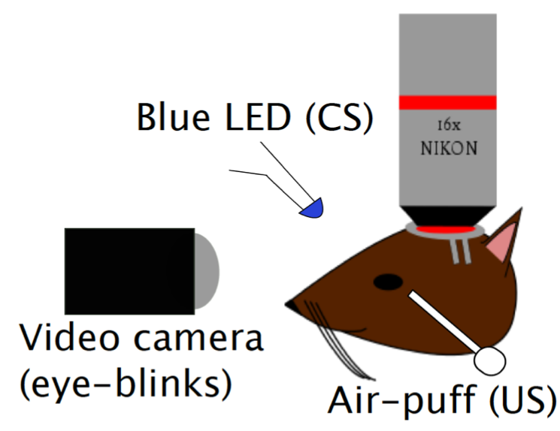

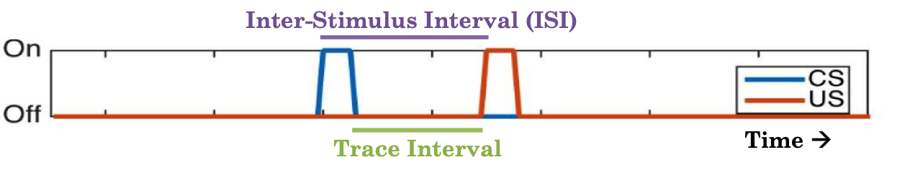

Figure 1:Simultaneous *in vivo* 2-photon calcium imaging of Hippocampal CA1 neurons and Trace Eyeblink Conditioning (TEC) with mice. IMAGING: The animal undergoes surgery for head-bar implantation and cranial window for optical access to the CA1 cells (expressing GCaMP6f, a fluorescent cytosolic Ca*2+* indicator). When head-fixed under a 2-photon microscope, healthy CA1 cells showcase calcium activity. BEHAVIOUR: The CS is a 50 ms Blue LED flash and the US is a 50 ms air-puff to the left eye. Eye-blinks are recorded using a video camera, and the behaviour routines were automated using an Arduino.

***Behavioural Training, Chronic Implants, and Two-Photon Imaging***

We standardised a multi-day Trace Eye-Blink Conditioning (TEC) protocol to train head-fixed C57Bl6 mice. TEC involves an association between a previously neutral Conditioned Stimulus (CS) with an eye-blink inducing Unconditioned Stimulus (US), across an intervening, stimulus-free, Trace Interval. All behaviour routines were controlled by programmed Arduinos and eye-blinks were measured for every trial, by video camera.

We standardized an in vivo imaging preparation to record calcium activity from Hippocampal CA1 cells, adapted from previously published methods (Dombeck et al., 2010; Modi et al., 2014). We used a custom-built two photon laser-scanning microscope and performed galvo-scans through the imaging window during TEC (Figure 1). The behaviour and Imaging was conducted simultaneously to record calcium activity as the animal learnt the task. Chronic Calcium Imaging allows us to track and record the activity of the same cells, confirmed morphologically. We can then identify time cells across sessions, and look for adaptations in tuning curves, along multiple sessions.

**RESULTS - PART I**

1. Head-fixed mice can be trained (1 session/day) for days to weeks. Most animals learn shorter ISIs (250-500 ms) within 4-7 days of training. We are now able to modulate the strength/intensity of the CS and US such that peak behavioural performance would be achieved within 3-7 days.
2. Animals can learn even large ISIs such as ~800 ms, within 10 days of training.
3. Animals can behaviourally adapt to different ISIs (250-850 ms), within 1 day of training.
4. Chronic Calcium Imaging of the same population of ~100-150 Hippocampal CA1 cells can be tracked and recorded from, over weeks and months, at cellular resolution using galvo-scanned two-photon imaging. We are now able to identify time cells across sessions, and look for adaptations in tuning curves with training sessions.

**SIGNIFICANCE STATEMENT - PART I**

The standardisation of the *in vivo* chronic 2-photon imaging preparation to record activity from Hippocampal CA1 cells is complete. Simultaneous 2-photon imaging and Trace Eye-Blink Conditioning confirmed that some CA1 cells (<50 % of total) showcase tuned activity in the interval between the CS and US. It is clear from our recordings that different CA1 cells tune to different time points and to varying degrees of reliability (frequency, exact timing, choice of calcium events, etc.). The standardisation of the behavioural protocol for TEC is complete. The experimental findings have been largely replicated (Seigel et al., 2015). Additionally, the setup is customizable. We were able to expand the repertoire of tasks, such as with the addition of other stimuli (both conditioned and unconditioned). Other lab colleagues are now able to use TEC for their own experiments and research directions.

# **PART II *(in silico) -*** “Synthetic Data Resource and Benchmarks for Time Cell Analysis and Detection Algorithms”

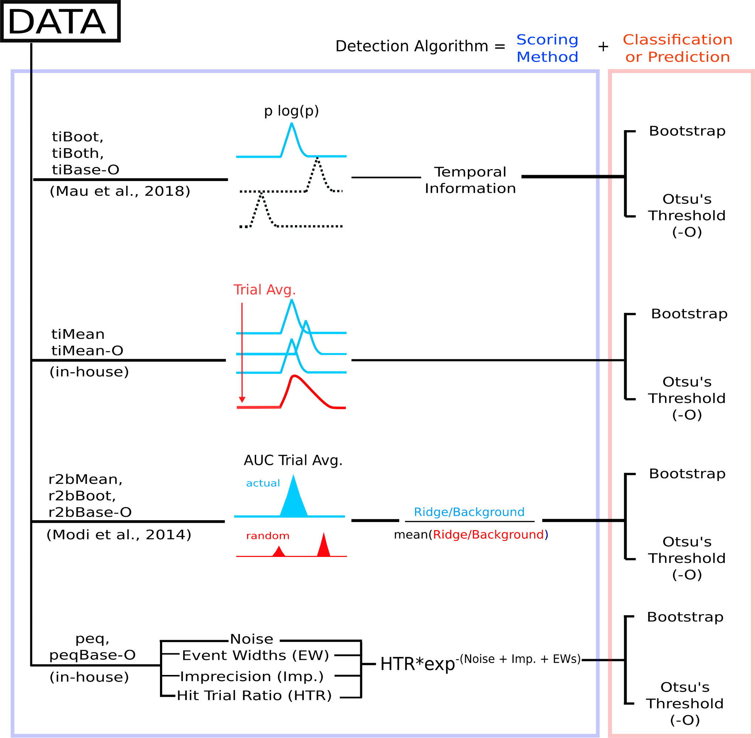

Figure 2: Schematic representation of the implemented algorithms, involving four different scoring methods followed by a classification step (Bootstrapping or Otsu’s automatic threshold) to have ten complete time cell detection algorithms.

CA1 Time Cells may each tune to different time points in a behavioural trial, and may do so with a large degree of variability (see Part I, above). This, however, meant that different mathematical and computational perspectives may accept or reject cells as Time Cells differently, leaving room for ambiguity in results. We wanted to test a variety of published and new methods (Figure 2) to score the physiological activity of cells, and then classify them accordingly. This comparative study across analysis algorithms required ground-truth and categorically labelled datasets. We resorted to a Computational approach to generate the number and variety of such datasets, for a big data scale study. Benchmarking experiments benefit from the control of key experimental parameters such as recording Noise, trial-pair event timing Imprecision, selection of Event Widths, and Hit Trial Ratios, among others.

***Curating a library of Calcium Events and Generating Synthetic Data***

We identified calcium events as signal deviations that were above a threshold (mean + 2*SD) and could curate a library for each event, for all physiologically recorded cells.

We then generated synthetic activity by recycling samples of recorded calcium transients based on the synthesis algorithm. The input parameters to this algorithm included timing, noise, imprecision, event width selection, hit-trial ratio, and several others. We aimed to cover the most likely conditions to affect timing and other experiment design properties.

The results with Part II ultimately could form a substantial portion of our paper (Ananthamurthy & Bhalla, 2023) and will be described with detail in the Thesis.

**RESULTS - PART II**

1. Automatic curation of calcium event library from recorded physiology data
2. Fast and precise generation of synthetic datasets based on user-defined feature sets
3. Fast, parallel analysis of all datasets by each of the implemented analysis algorithms
4. Physiological dependence of each analysis algorithm on experiment features identified
5. Concordance based classification model using all the algorithms created, with tunable performance.

**SIGNIFICANCE STATEMENT - PART II**

Numerous approaches have been developed to analyse time cells and neuronal activity sequences, but it is not clear if their classifications match, nor how sensitive they are to various sources of data variability. We provide two main contributions to address this: A resource of synthetic 2P Calcium activity data, and a survey of several methods for analysing time-cell data using our synthetic data as ground truth. The synthetic dataset and its generation code are useful for profiling future methods, testing analysis toolchains, and as input to computational and experimental models of sequence detection. We have characterised strengths and weaknesses of several time-cell analysis methods. Further, we benchmark how computational requirements scale with large datasets typical of recent recording technologies.

**PAPER:**

**Ananthamurthy, K. G., & Bhalla, U. S. (2023). Synthetic Data Resource and Benchmarks for Time Cell Analysis and Detection Algorithms. ENeuro, ENEURO.0007-22.2023. https://doi.org/10.1523/ENEURO.0007-22.2023**