Inter-Annual Landfast Sea Ice Deformation at Cambridge Bay from Multi-Dimensional Sentinel-1 SBAS InSAR
Sentinel-1 results for winters 2018–19 and 2020–21

1. Introduction
Landfast sea ice — ice frozen in place against the coast rather than drifting — is a defining feature of the Canadian Arctic coastline. Communities use it as a travel surface for much of the year, and its stability governs both local travel safety and the wider coastal ice regime. Because the Arctic is warming faster than the global average, the dates on which this ice forms, consolidates and breaks up are shifting, and detecting that shift requires measurements at fine spatial and temporal resolution.
Interferometric Synthetic Aperture Radar (InSAR) provides them. By comparing the phase of two radar images of the same place acquired on different dates, InSAR measures surface movement to within centimetres, independent of cloud and darkness — both of which make optical satellites unusable through the Arctic winter. The method depends on coherence, a measure of how similar the radar signal remains between the two passes. Coherence is high only where the surface has not changed much, so InSAR works over ice that has stopped drifting and fails over ice that is still mobile. That limitation is itself useful: the date on which coherence first appears is a direct measurement of when the ice became landfast.
2. Data and method
 | Winter 2018–19 | Winter 2020–21
Descending (S1A, HH) | 17 Feb – 6 Apr 2019, 4 pairs | 14 Mar – 7 Apr 2021, 2 pairs
Ascending (S1B, VV) | 21 Feb – 17 Mar 2019, 2 pairs | 18 Mar – 23 Apr 2021, 3 pairs
Two-dimensional window | 21 Feb – 17 Mar (24 days) | 18 Mar – 7 Apr (20 days)
Coherence over ice | 0.52 – 0.85 | 0.47 – 0.81

Sentinel-1 revisits Cambridge Bay every 12 days. Each pair of images yields one interferogram. Processing used ASF HyP3 INSAR_GAMMA at 20 × 4 looks (80 m pixel spacing), the Copernicus GLO-30 elevation model, minimum-cost-flow phase unwrapping, and the coherence threshold of 0.4 adopted by Chen et al. Long-wavelength atmospheric and ionospheric phase was removed by fitting a polynomial over stable land, which cannot deform; this substitutes for the split-spectrum correction used in the original study. Displacement time series were obtained by Small Baseline Subset (SBAS) inversion and referenced throughout to a fixed point on land at the Arctic Research Station (69.109° N, 105.021° W), identical in both winters.
Four monitoring points were placed on the sea ice at increasing distance from shore and held at identical coordinates in both winters, so that the two years measure the same places: P1 69.0043° N 105.1738° W (1.2 km offshore), P2 68.8701° N 105.0223° W (2.0 km), P3 68.9117° N 105.6562° W (5.6 km) and P4 68.8341° N 105.2287° W (8.2 km). P5 (68.9540° N, 104.8892° W) sits on land and serves as an independent control.
3. Measurement uncertainty
P5 lies on land 19 km from the reference point. Land cannot deform, so whatever motion the method appears to detect there is error, and it bounds the accuracy of every other value in this report.
 | P5 apparent motion, desc. | P5 apparent motion, asc. | Median residual over land | Stated uncertainty
Winter 2018–19 | 2.15 cm | 3.91 cm | 1.63 cm | ±1.6 cm
Winter 2020–21 | 0.56 cm | 3.58 cm | 0.66 cm | ±0.7 cm

The 2020–21 ascending series retains one marginal interferogram and carries ±4 cm. All ice displacements reported below are well above these limits.

4. How the two winters differed
The clearest difference between the two winters is not the size of the deformation but its timing. The table below gives the percentage of the sea-ice area that was coherent — that is, stable enough to measure — through each winter. A low value means the ice was still drifting; a high value means it had frozen into place.
Period | Winter 2018–19 | Winter 2020–21
Mid December | 9% | 6%
Late December | 15% | 53% (isolated spike, not real)
Early January | 39% | 12%
Mid January | 27% | 14%
Late January | 55% ← became stable | 10%
Mid February | 57% | 39%
Late February | 90% | 55%
Early March | 88% | 16% ← broke up again
Mid March | 96% | 95% ← became stable
Early April | 95% | 94%
Mid April | not observed | 69%
Late April | not observed | 55% ← early decay

In winter 2018–19 the ice consolidated steadily. Coherence rose through January, passed 50% at the end of January, and stayed high from February onward. The ice was landfast and measurable for the whole of February, March and early April.
Winter 2020–21 behaved quite differently. The ice remained mobile through January, recovered only partially in February, and then broke up again in early March, when coherence collapsed to 16%. It became firmly landfast only after 20 March — roughly seven weeks later than in 2018–19 — and began decaying again by mid-April. The usable observation window in 2020–21 was therefore confined to the second half of March and early April, which is why the analysis windows for the two winters differ.
In short: in 2018–19 the ice was stable from the end of January; in 2020–21 it was not stable until late March, and it started breaking up again in April.
4.1 Onset of ice stability
 | Coherent area sustained above 50% | Seasonal range | Difference
Winter 2018–19 | 30 January 2019 | 9% → 96%
Winter 2020–21 | 20 March 2021 | 6% → 95% | 49 days later

4.2 Coherence against repeat interval
Mean coherence over ice in 2020–21 was 0.78–0.81 for 12-day image pairs, with 94–95% of the ice above the 0.4 threshold, but fell to 0.54 for 24-day pairs, with only 74% of the ice usable. This confirms the finding of Chen et al. that C-band coherence over landfast ice is reliably maintained only within a 12-day repeat interval, and it is the reason longer image pairs were not used.
5. Deformation results
5.1 Agreement with Chen et al. (2021)
The directly comparable case is the 2018–19 descending series, which uses the same dates and window length as the published study (17 February – 6 April, 48 days).
Point | This study | Chen et al. (2021) | Difference
P3 | +14.8 cm | +16.7 cm | 1.9 cm
P4 | −5.6 cm | −5.4 cm | 0.2 cm

Both agree within 2 cm, comparable to the 2–44 cm spread Chen et al. report between their own sensors. This validates the processing chain used here.
5.2 Cumulative deformation at the monitoring points
Positive line-of-sight values mean motion toward the satellite; positive horizontal means eastward; positive vertical means uplift. Window lengths differ (24 days in 2018–19, 20 days in 2020–21, 44 days in Chen et al.), so totals should not be compared directly across rows.
Measurement | Source | P1 | P2 | P3 | P4
LOS descending (cm) | This study 2018–19 | 0.7 * | — | 14.8 | −5.6
 | This study 2020–21 | −16.0 | 5.8 | 60.1 † | 13.5
 | Chen et al. 2021 | −12.5 | 5.0 | 16.7 | −5.4
LOS ascending (cm) | This study 2018–19 | 11.4 | 23.8 | 21.5 | 5.0
 | This study 2020–21 | 2.8 * | 34.7 | −12.5 * | 30.8
 | Chen et al. 2021 | 18.1 | 15.7 | −13.6 | 51.2
Horizontal E–W (cm) | This study 2018–19 | −7.9 | — | −13.5 | −10.2
 | This study 2020–21 | −3.5 | −21.8 | 44.2 † | −23.5
 | Chen et al. 2021 | −28.9 | −14.8 | 21.7 | −61.8
Vertical up–down (cm) | This study 2018–19 | 7.4 | — | 17.9 | −4.3
 | This study 2020–21 | 0.8 | 20.9 | 19.3 | 28.4
 | Chen et al. 2021 | −0.7 | 6.6 | 9.4 | 9.7

— not measurable (coherence loss). * from the gridded solution over the two-dimensional window. † anomalous, see limitations.
Deformation across the whole ice area ranged from −55.2 to +51.4 cm horizontally and −11.4 to +21.1 cm vertically in 2018–19 (24 days), and from −59.7 to +44.9 cm horizontally and −15.5 to +28.5 cm vertically in 2020–21 (20 days). Chen et al. report −95 to +85 cm and −41 to +63 cm over 44 days, so the magnitudes are consistent once the different window lengths are taken into account.
5.3 Deformation rates, the comparable quantity
Because the two winters were observed over windows of different length, rates in centimetres per day rather than totals are the meaningful comparison.
Point | Horizontal 2018–19 | Horizontal 2020–21 | Vertical 2018–19 | Vertical 2020–21
P1 | −0.33 | −0.18 | +0.31 | +0.04
P2 | — | −1.09 | — | +1.05
P3 † | −0.56 | +2.21 | +0.75 | +0.97
P4 | −0.43 | −1.18 | −0.18 | +1.42

At P4, the most reliably measured point, the ice slid westward about three times faster in 2020–21 than in 2018–19 (−0.43 → −1.18 cm/day), and instead of slowly sinking it rose, about eight times faster (−0.18 → +1.42 cm/day) — consistent with ice that froze into place seven weeks later being thinner and more mobile.
6. Limitations
- No split-spectrum ionospheric correction is available in the free processing chain. Polynomial removal over land is used instead, and the residual over land (0.7–1.6 cm) is quoted as the uncertainty.
- The SBAS networks use consecutive 12-day pairs and are non-redundant. One redundant 24-day pair processed for 2020–21 failed quality control (6.4 cm land residual), so an independent phase-closure check could not be completed.
- P3 in 2020–21 (+60.1 cm line-of-sight, +44.2 cm horizontal) is anomalously large and could not be solved in the ascending orbit. It is reported for completeness but excluded from interpretation.
- P2 was not measurable in the 2018–19 descending series; coherence there falls to 0.09 in the 1–13 March interval, breaking the chain of measurements.
- Monitoring points are fixed coordinates chosen for this study, not the stations of Chen et al., so individual point values are not expected to match theirs.
- Analysis windows differ between the two winters and between the two orbits, because coherence dictated when measurement was possible. Rates should be compared rather than totals.
- Only Sentinel-1 was used. The L-band ALOS-2 and Radarsat-2 comparisons that form much of the original study were not reproduced.
7. Summary
The Sentinel-1 component of Chen et al. (2021) was reproduced using free cloud processing, agreeing to within 2 cm at the two directly comparable points. Applying the identical method to winter 2020–21 shows that landfast ice became stable 49 days later than in 2018–19 — late March rather than late January — with correspondingly higher deformation rates during the observation window, and with signs of decay already appearing by mid-April. Measurement uncertainty, established independently from a land control point, is 0.7–1.6 cm.

8. Key findings
• The published Sentinel-1 result was reproduced using free cloud processing, agreeing within 2 cm at both directly comparable points (P3: 14.8 vs 16.7 cm; P4: −5.6 vs −5.4 cm).
• Landfast ice became stable on 30 January in 2018–19 but only on 20 March in 2020–21 — 49 days later.
• In 2020–21 the ice broke up again in early March after a partial February freeze-up, and had begun decaying by mid-April.
• Deformation rates were higher in 2020–21: at P4 the horizontal rate roughly tripled and the vertical rate reversed sign.
• Measurement uncertainty, established from an independent land control point, is 0.7–1.6 cm.

8. Figures
Paste each image into the box beneath its number and delete the placeholder text. Boxes expand automatically to fit the image and can be resized or removed.
8.1 Study area
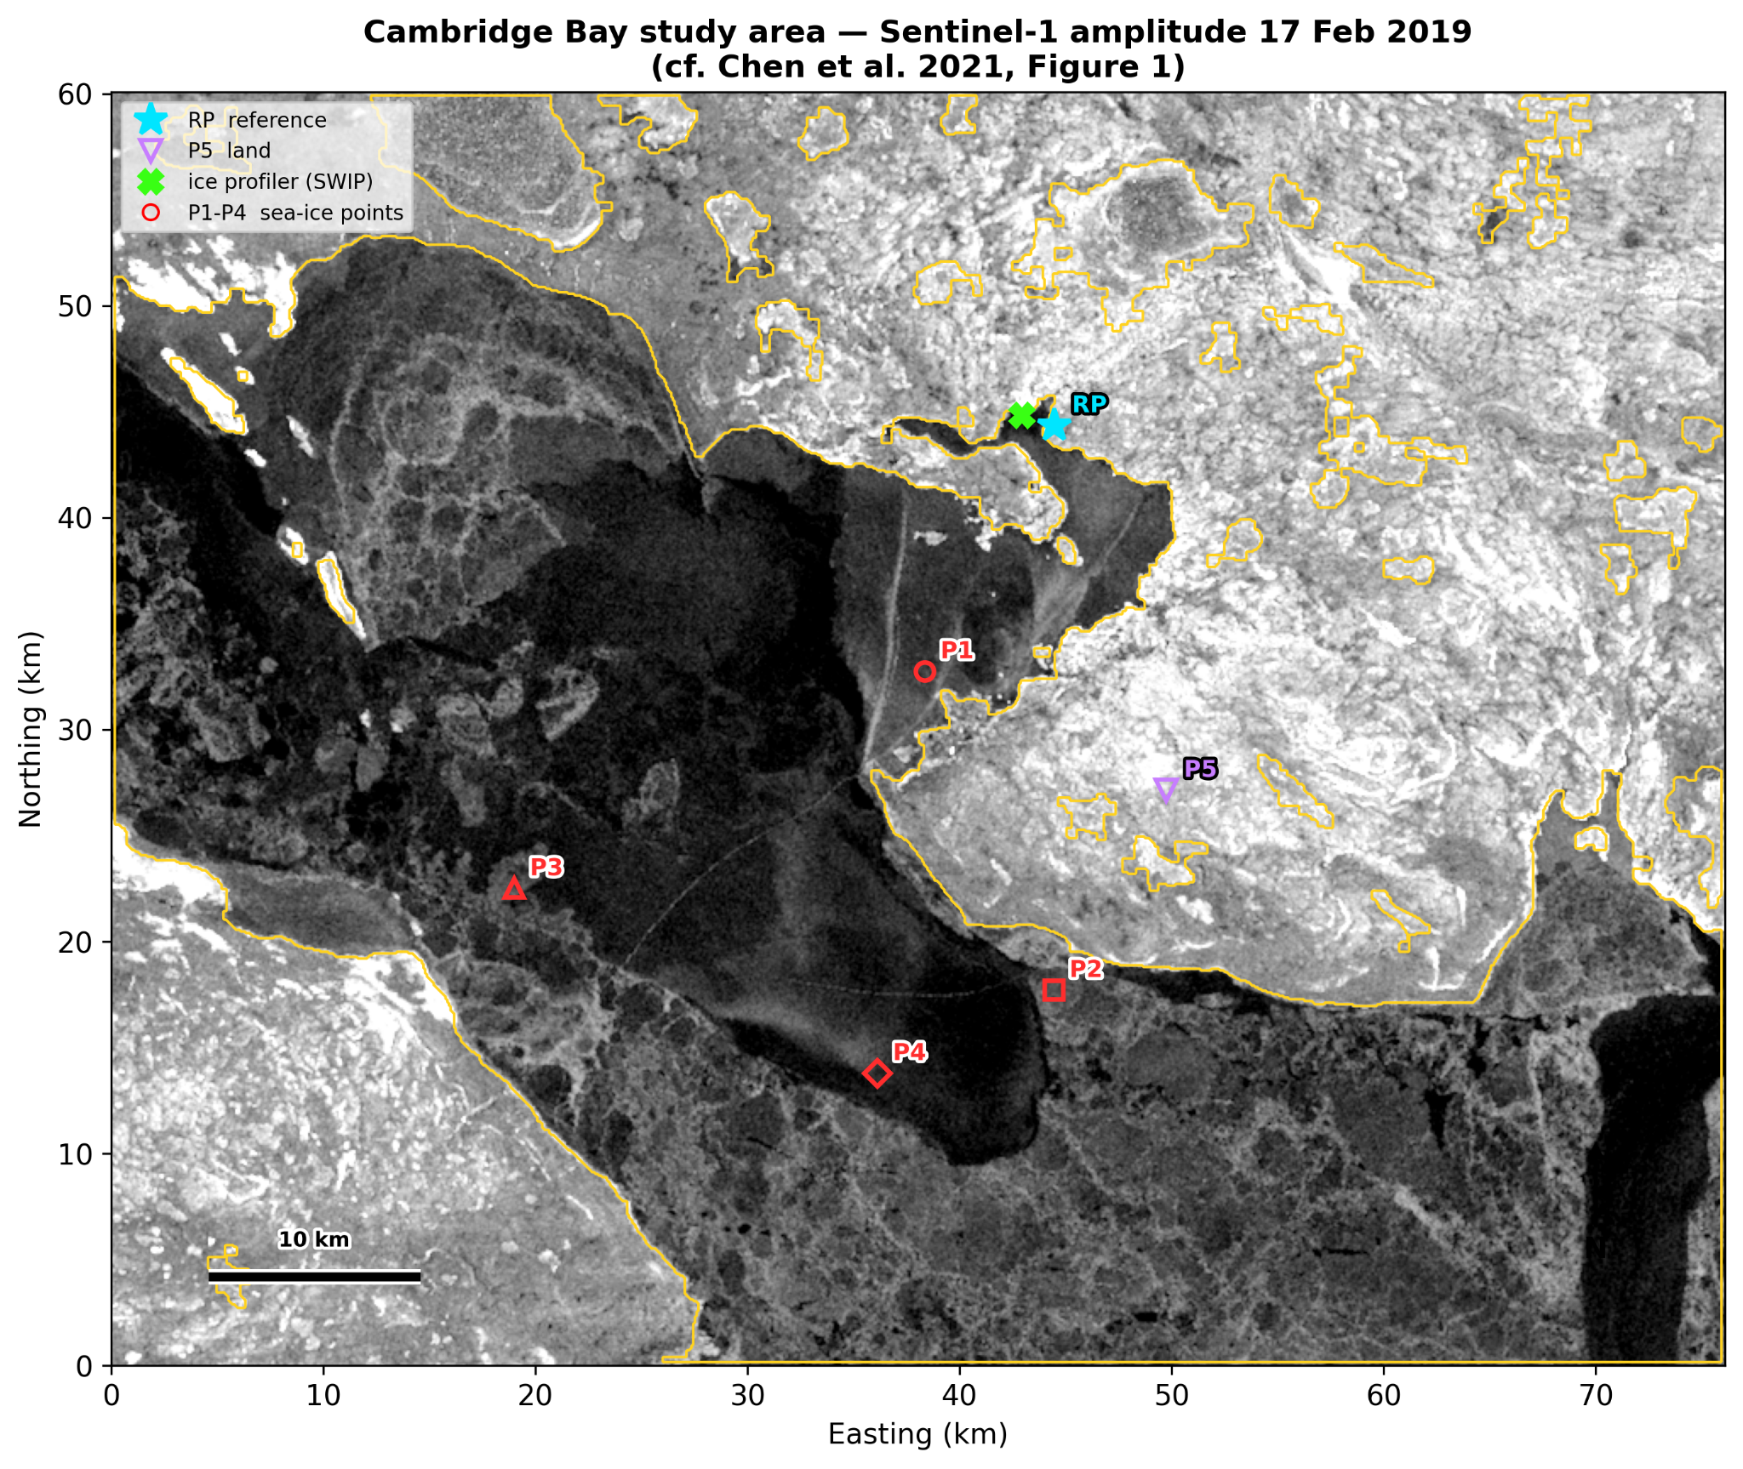
Figure 1. Study area at Cambridge Bay showing the four sea-ice monitoring points P1–P4, the land control point P5, the reference point RP and the ice profiler, on a Sentinel-1 amplitude image. Winter 2018–19.
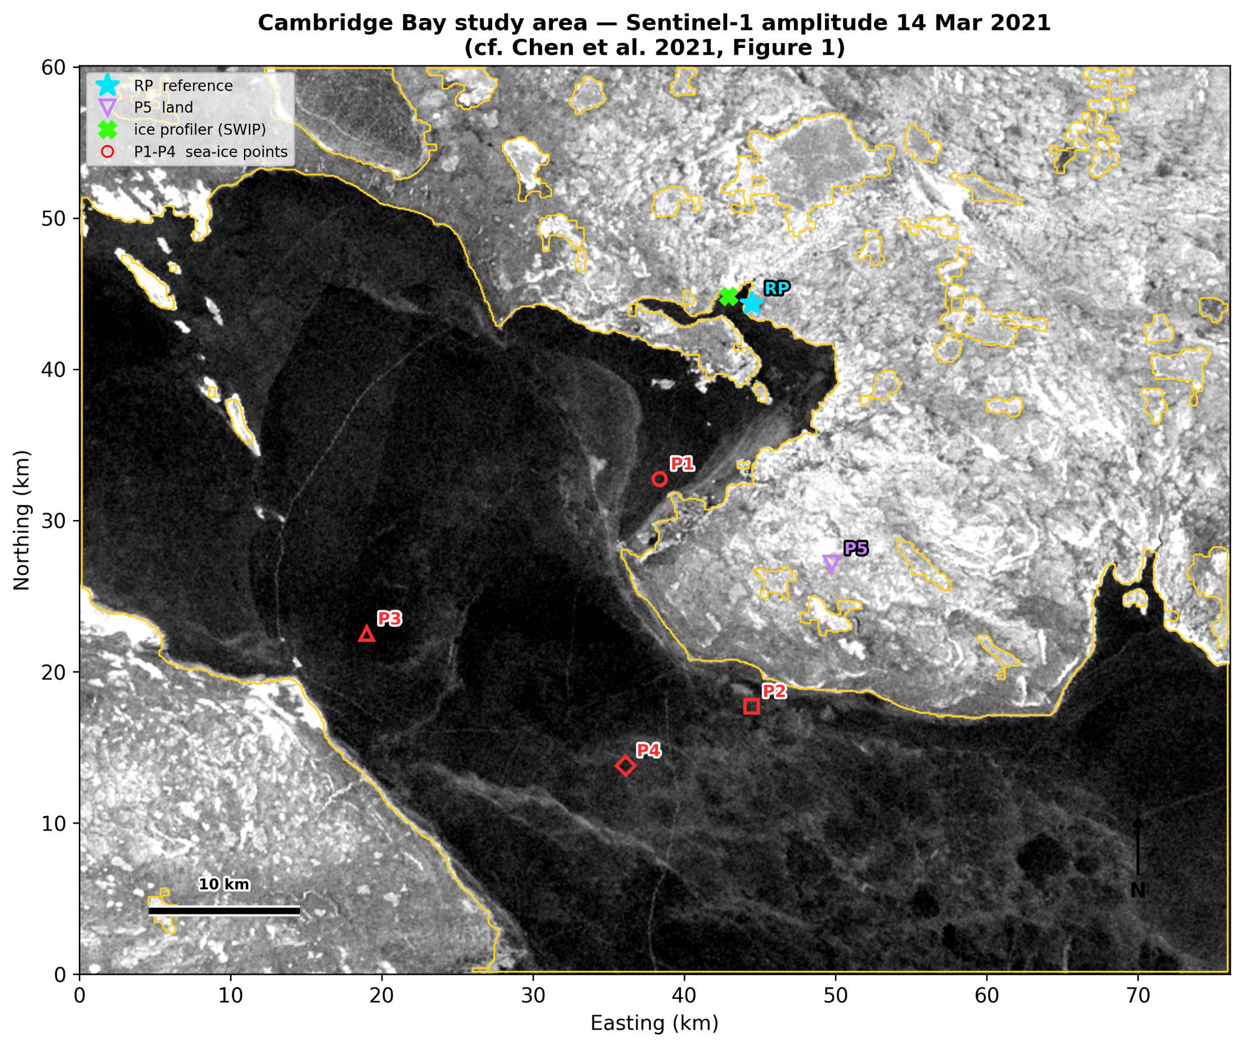
Figure 2. The same study area and identical monitoring-point coordinates, winter 2020–21.

8.2 Coherence — when the ice became measurable
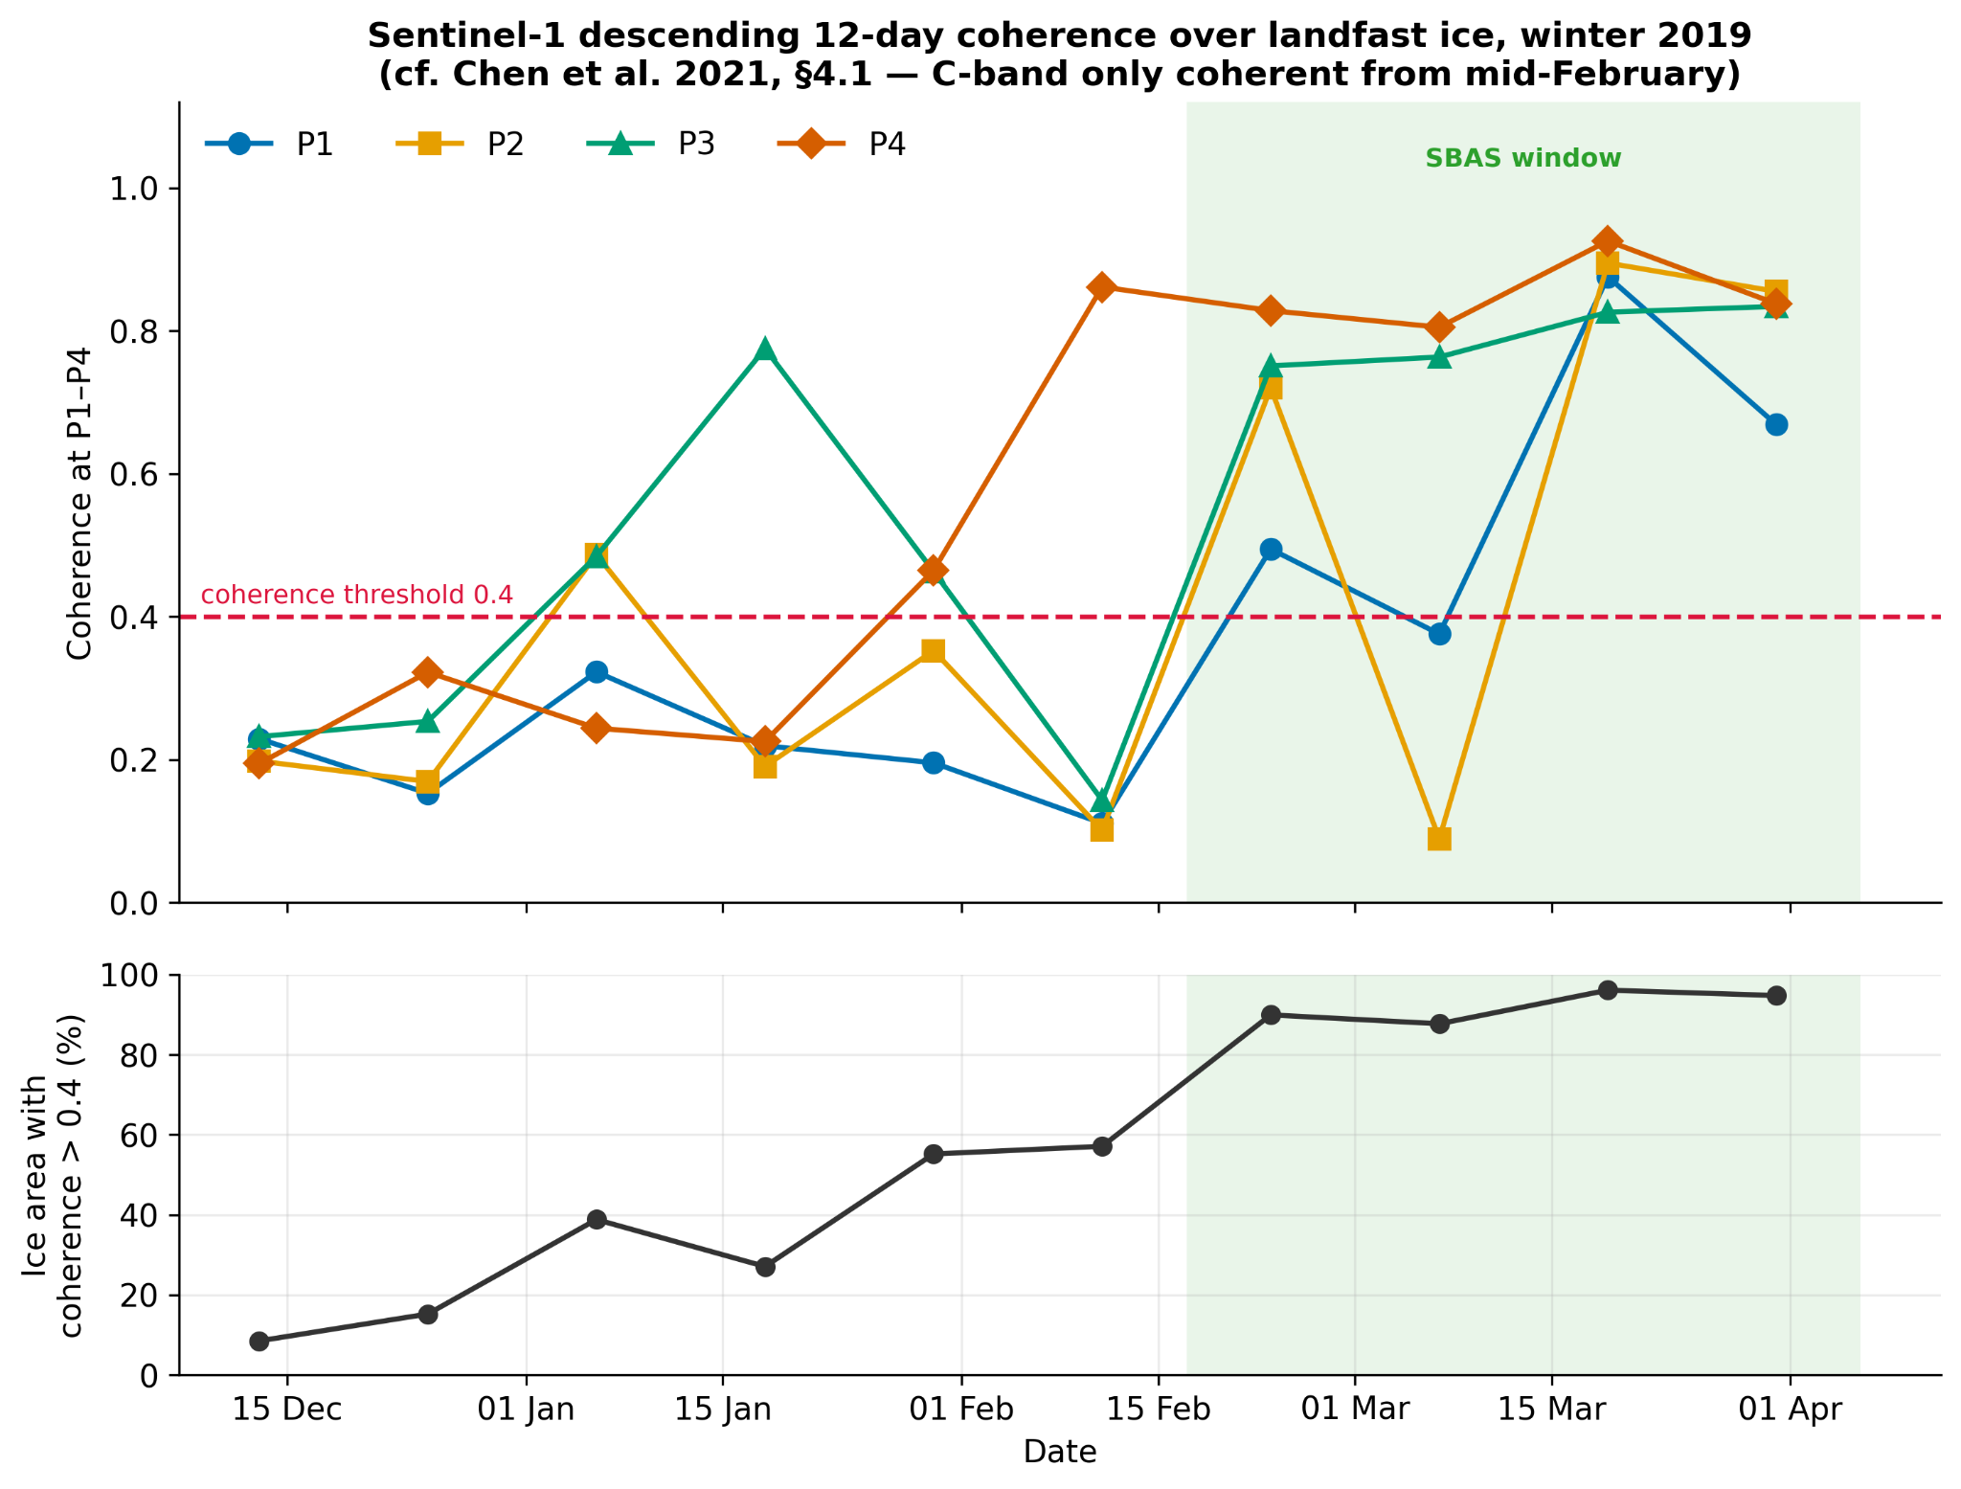
Figure 3. Coherence over landfast ice through winter 2018–19, with the 0.4 threshold and the fraction of ice area that is coherent. Coherence rises through January.
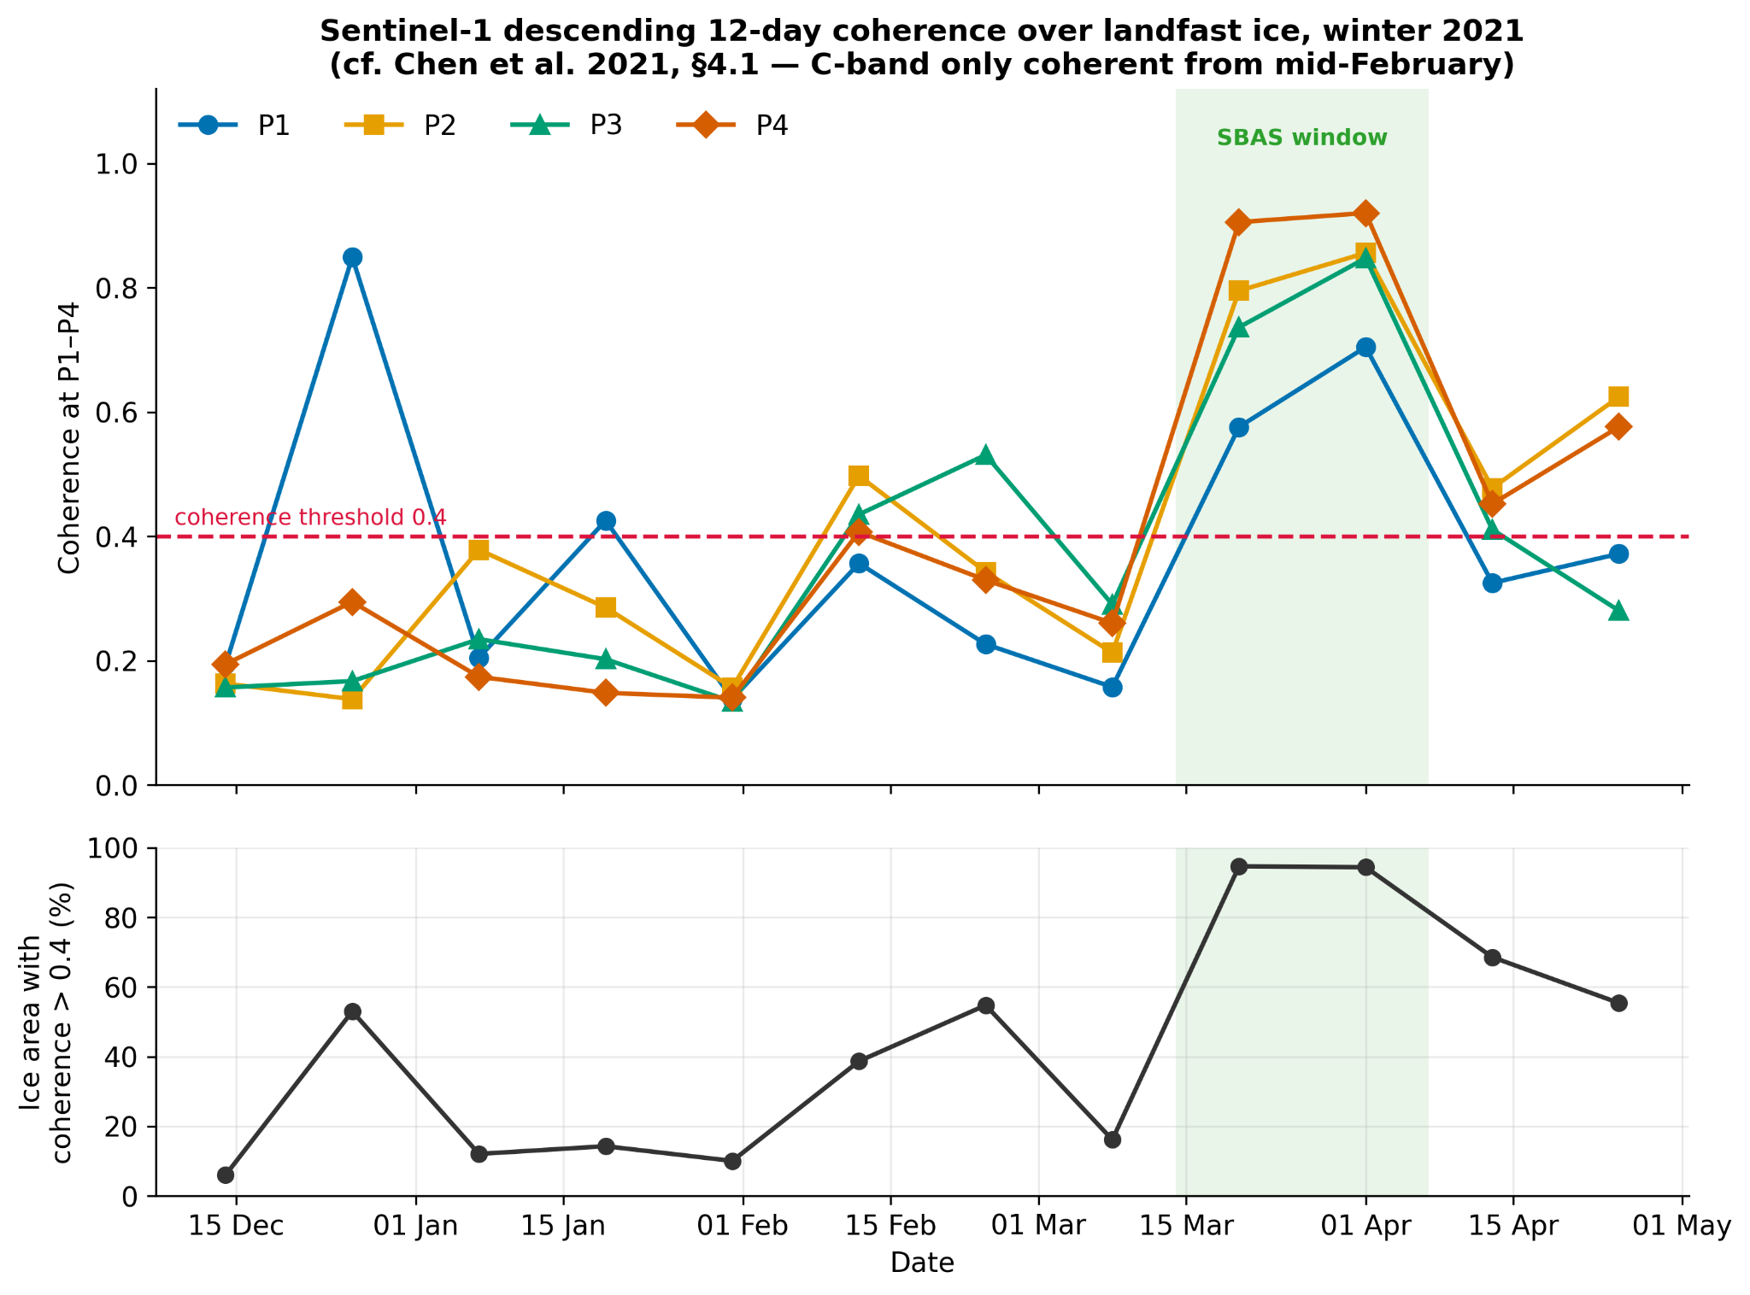
Figure 4. Coherence through winter 2020–21. Note the collapse in early March and the abrupt rise after 20 March — roughly seven weeks later than in 2018–19.
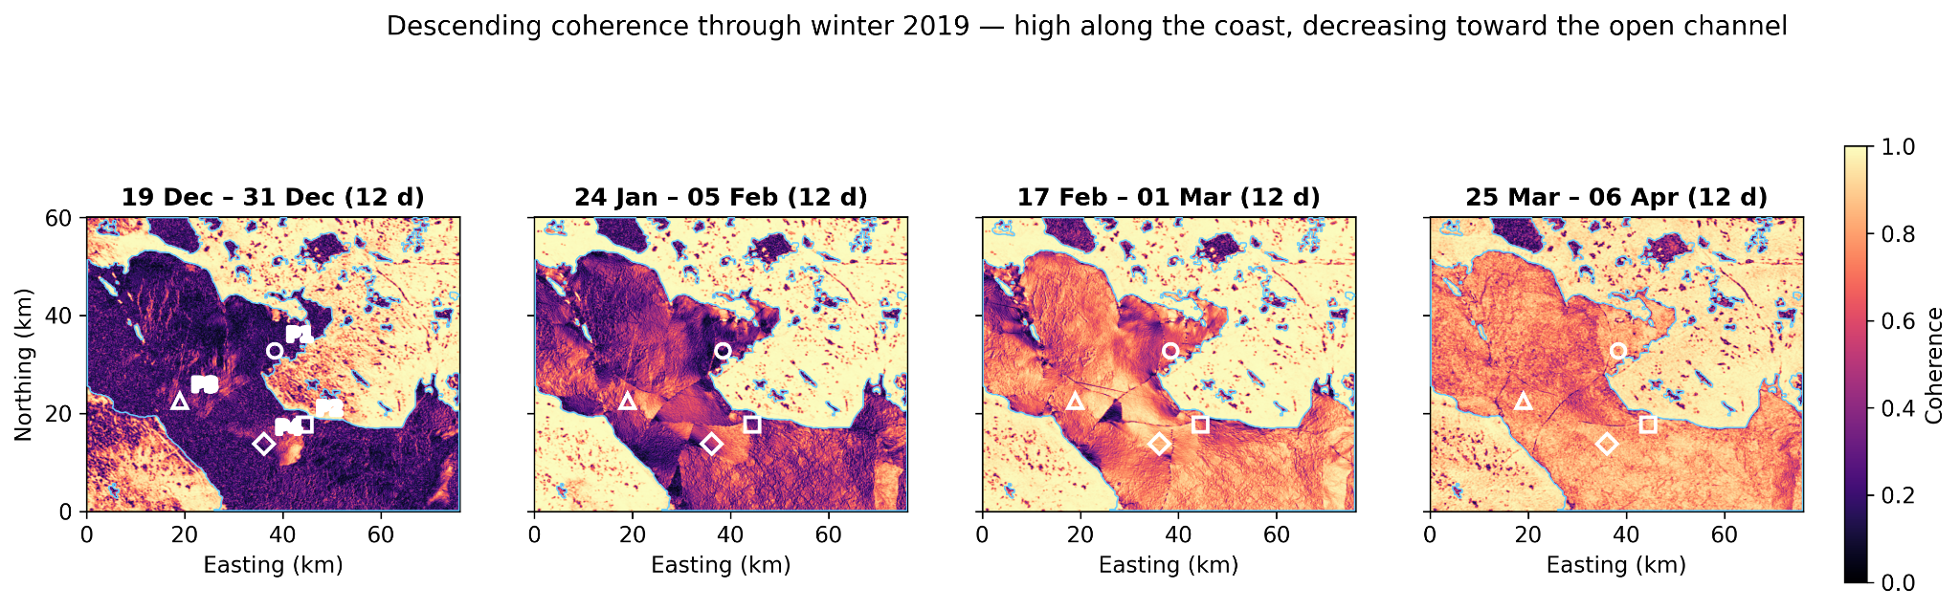
Figure 5. Coherence maps at four stages of winter 2018–19, showing coherence high along the coast and decreasing toward the open channel.
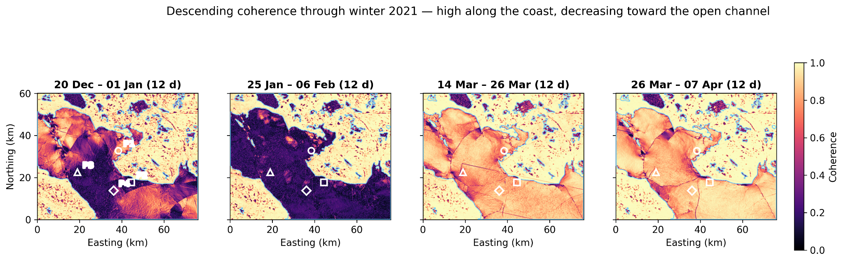
Figure 6. Coherence maps at four stages of winter 2020–21.
8.3 Interferograms — the raw deformation signal
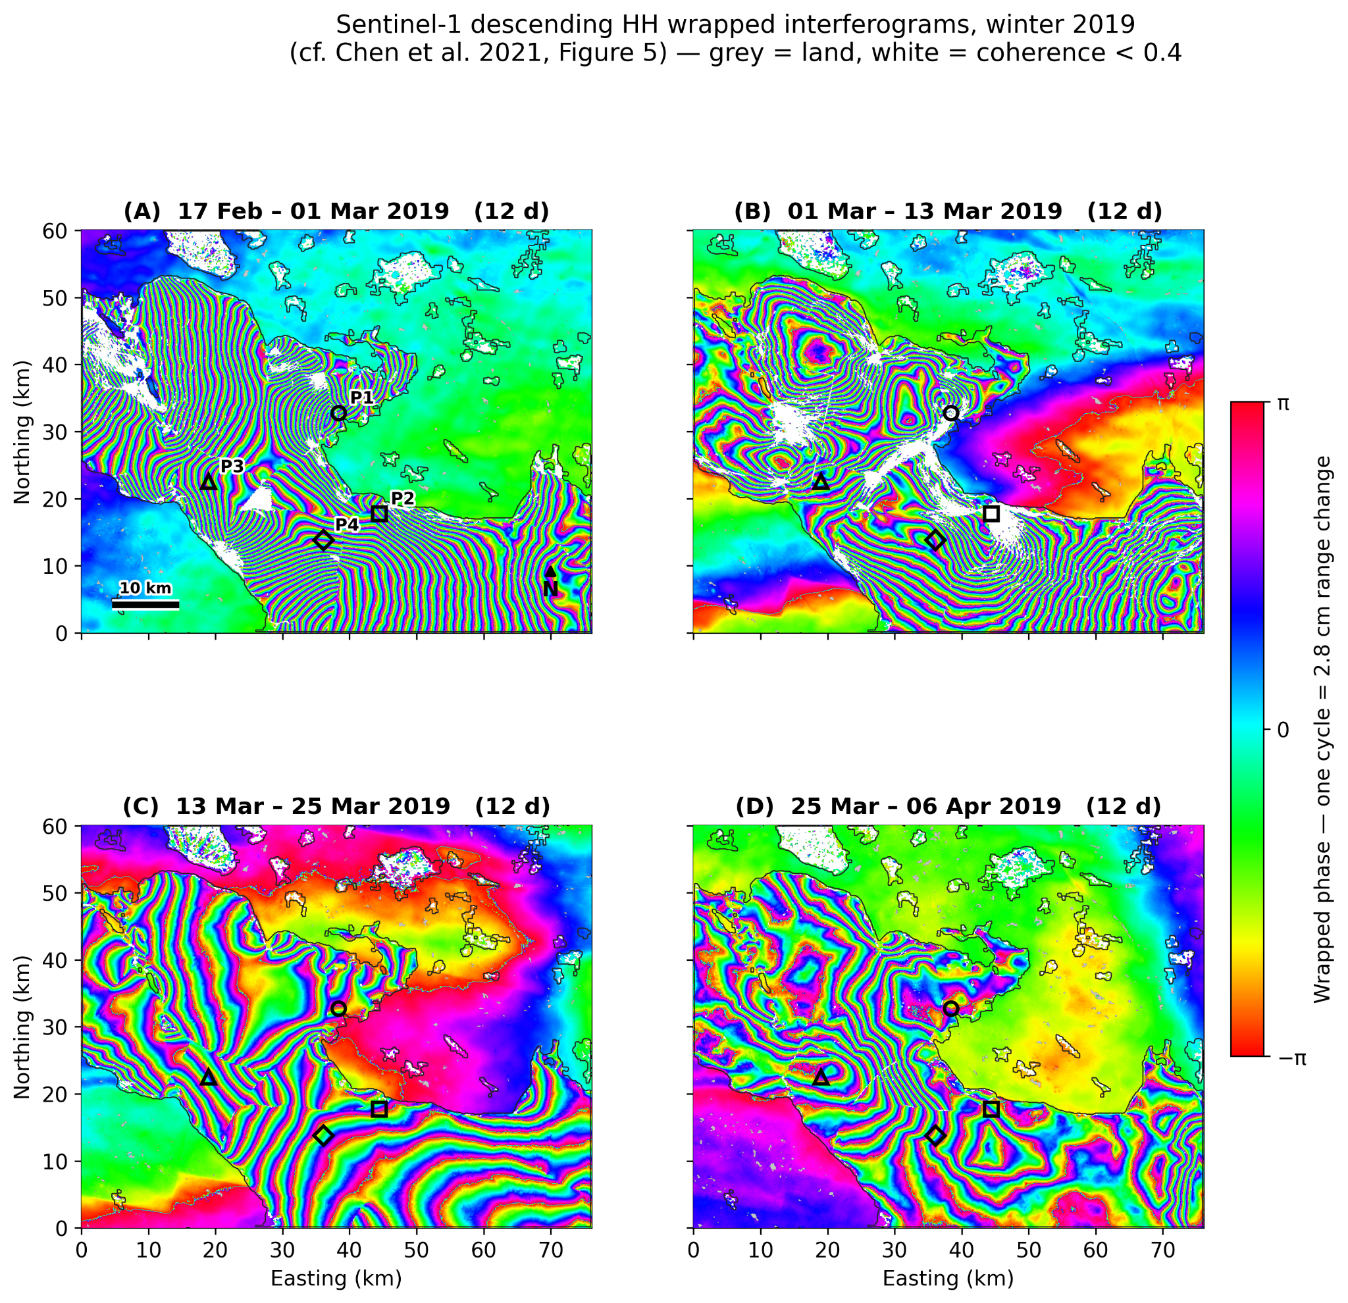
Figure 7. Descending wrapped interferograms, winter 2018–19. One full colour cycle represents 2.8 cm of range change; densely packed fringes indicate rapid deformation.
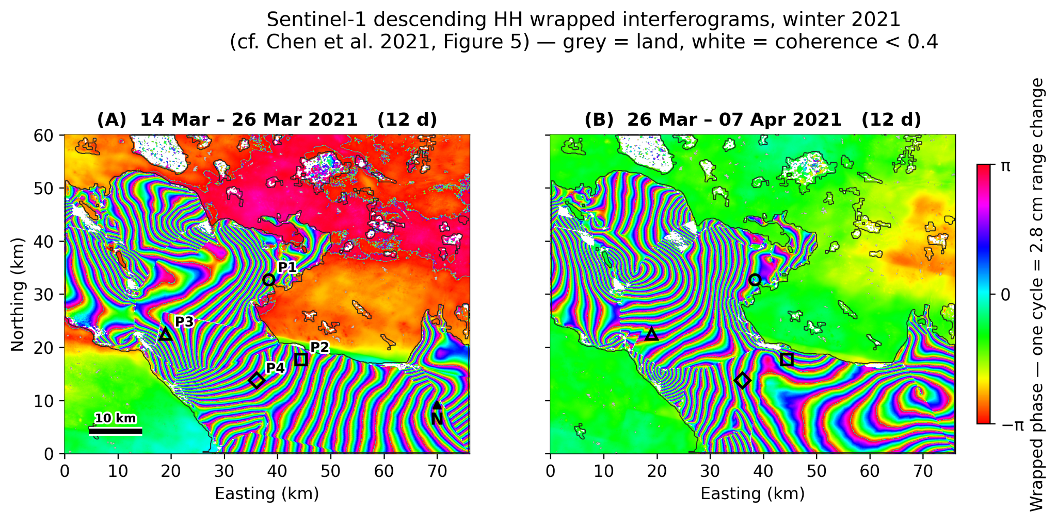
Figure 8. Descending wrapped interferograms, winter 2020–21.
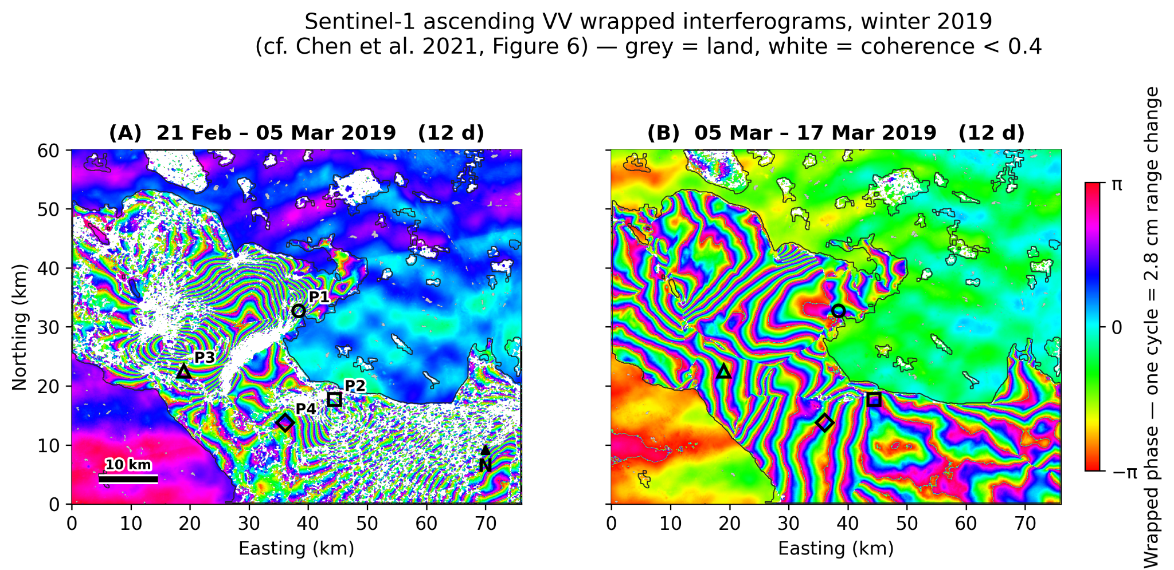
Figure 9. Ascending wrapped interferograms, winter 2018–19. The opposite viewing geometry is what allows horizontal and vertical motion to be separated.
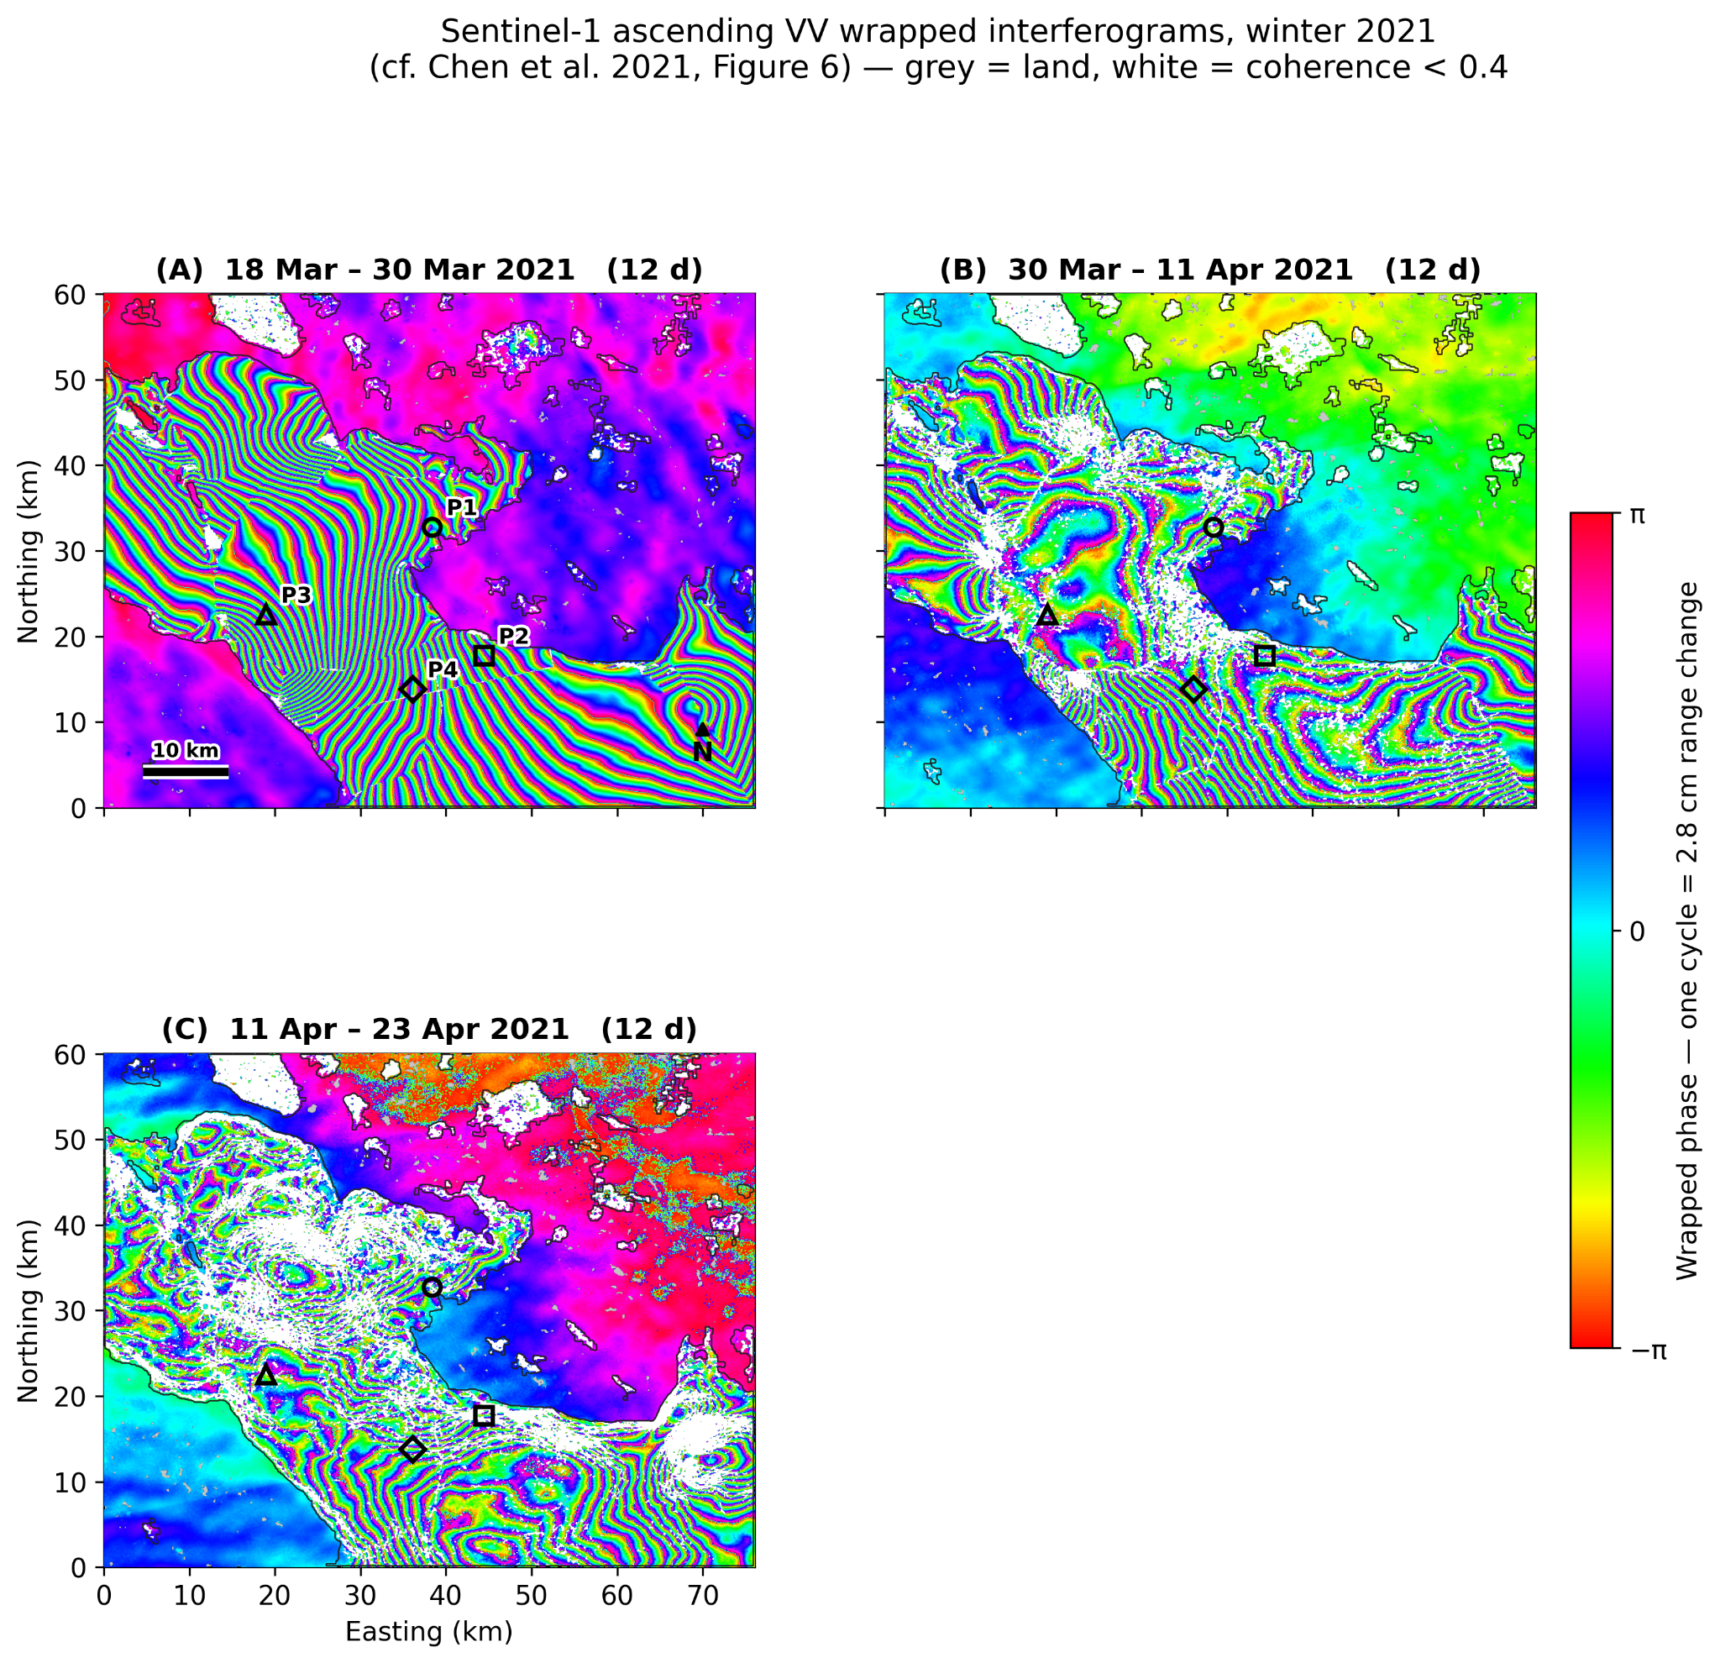
Figure 10. Ascending wrapped interferograms, winter 2020–21.
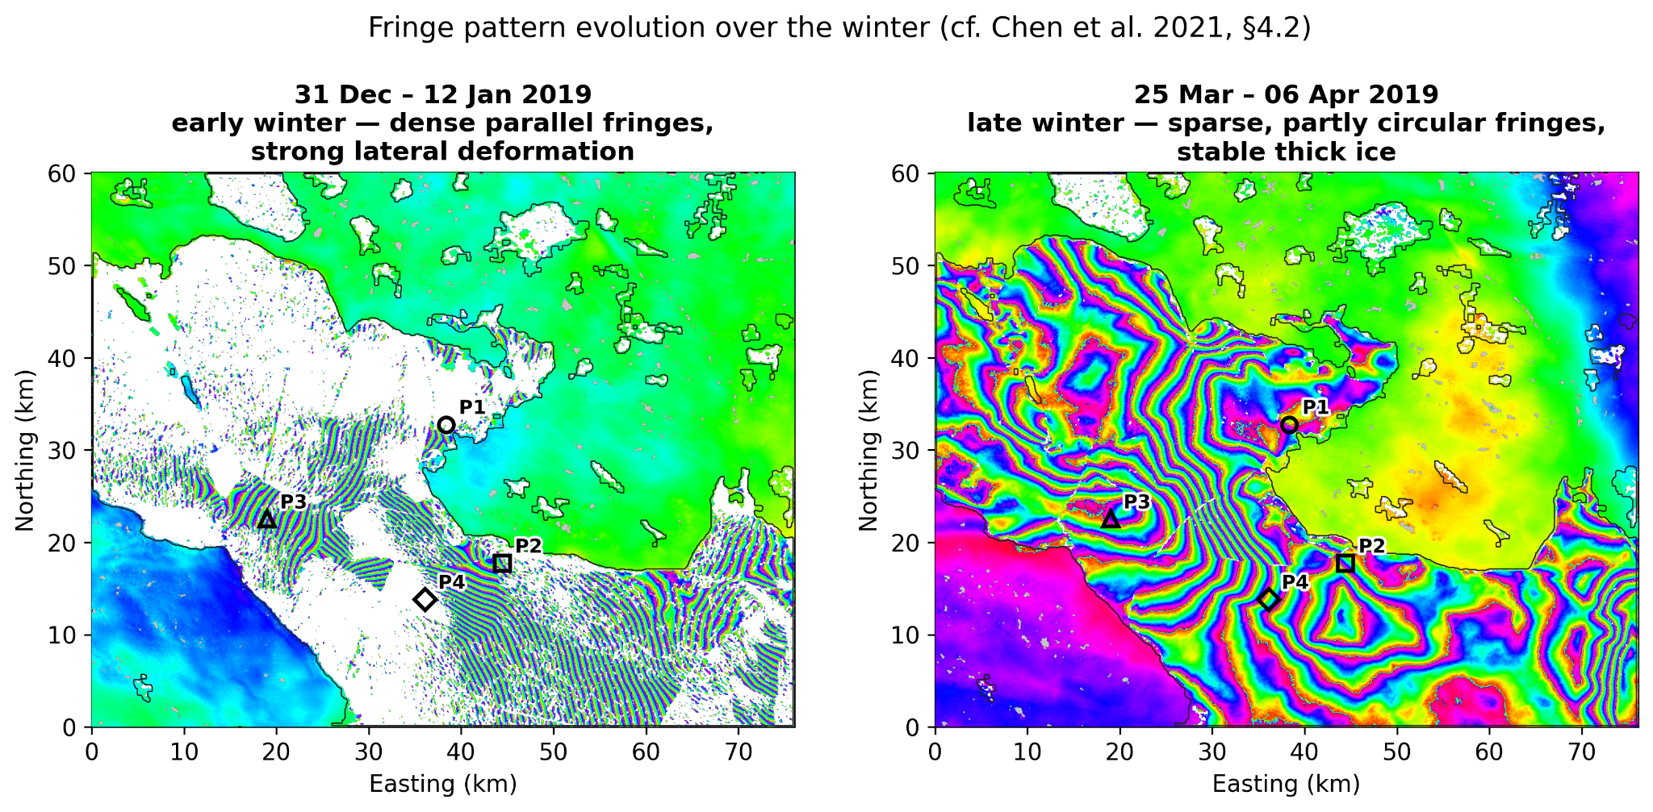
Figure 11. Fringe-pattern evolution through winter 2018–19: dense parallel fringes in early winter give way to sparser, partly circular fringes as the ice thickens.
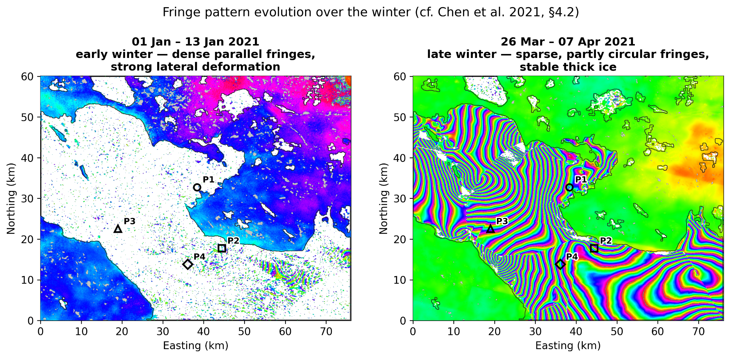
Figure 12. Fringe-pattern evolution through winter 2020–21.
8.4 Phase filtering
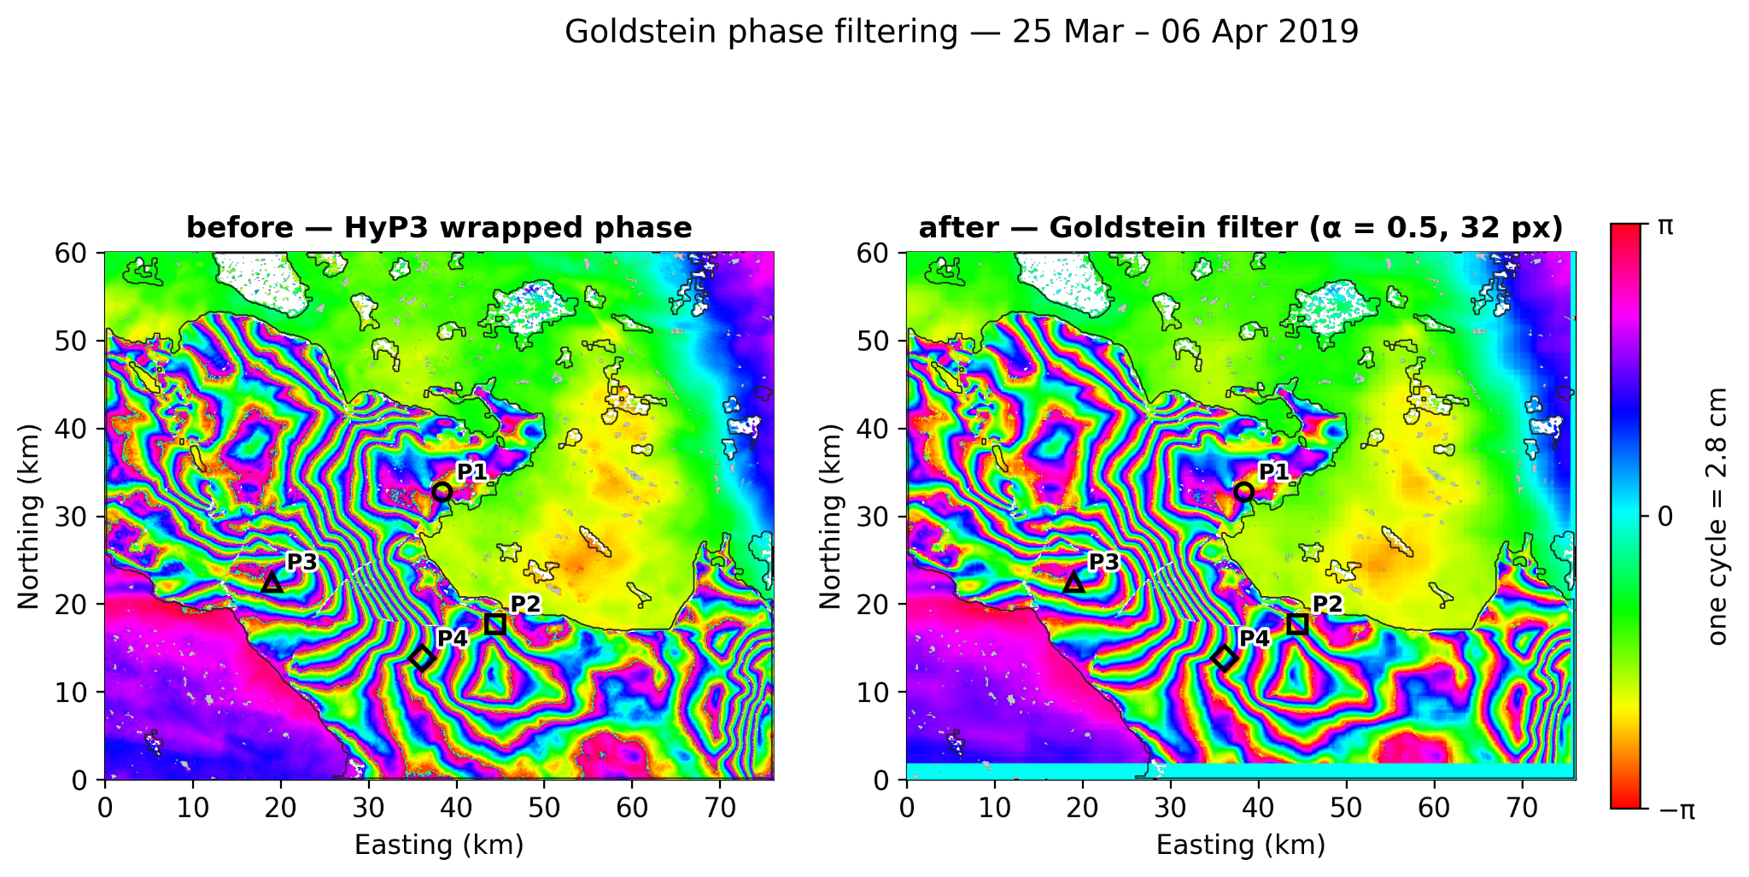
Figure 13. Effect of the Goldstein adaptive phase filter on one interferogram, winter 2018–19: before (left) and after (right).
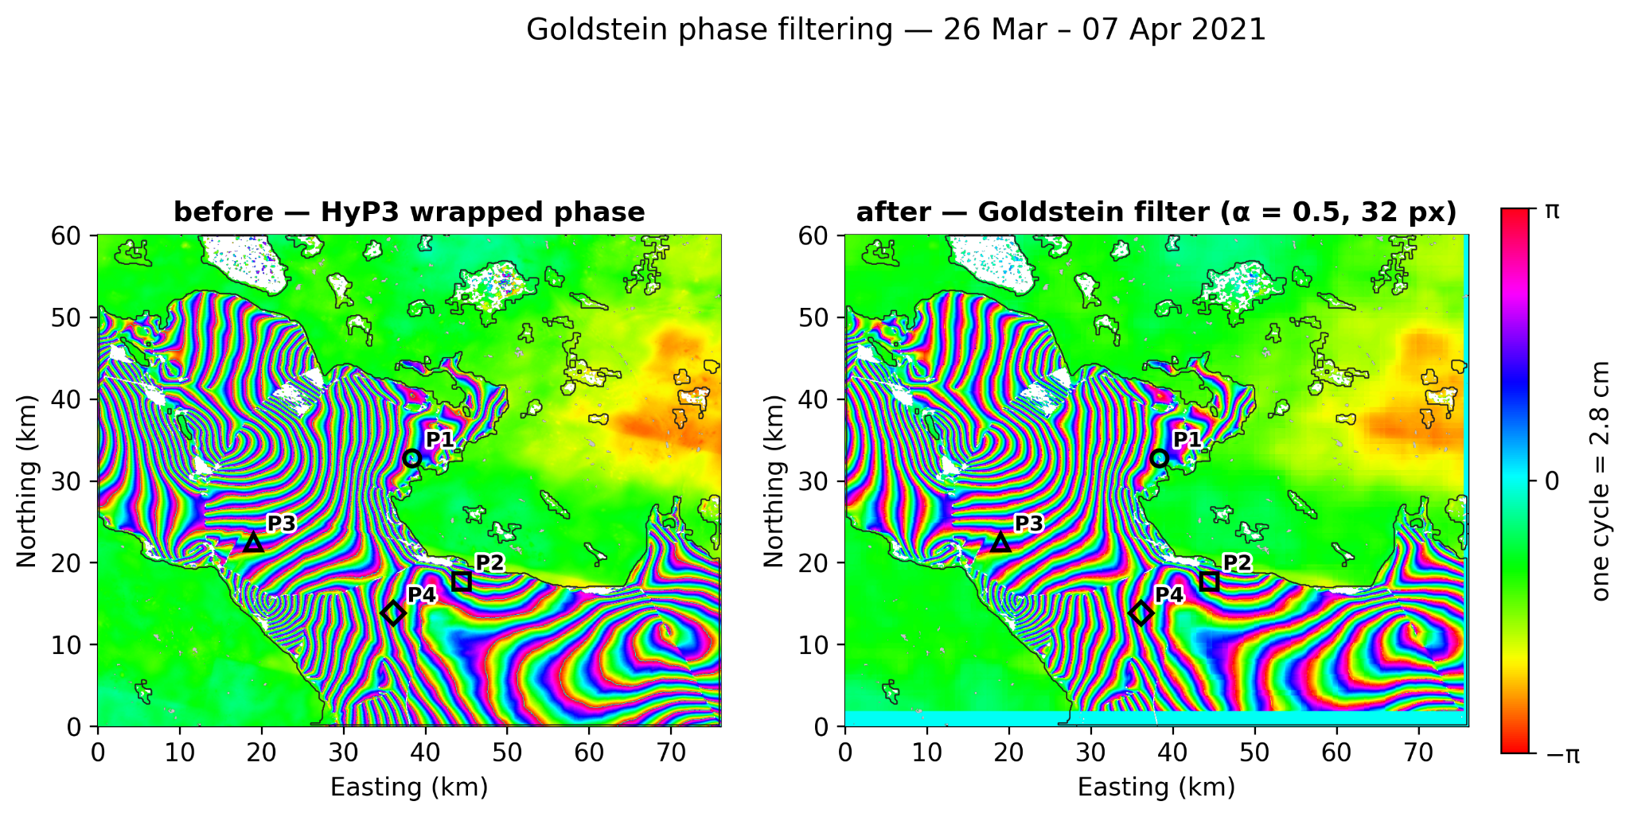
Figure 14. Effect of the Goldstein adaptive phase filter, winter 2020–21.
8.5 Displacement time series
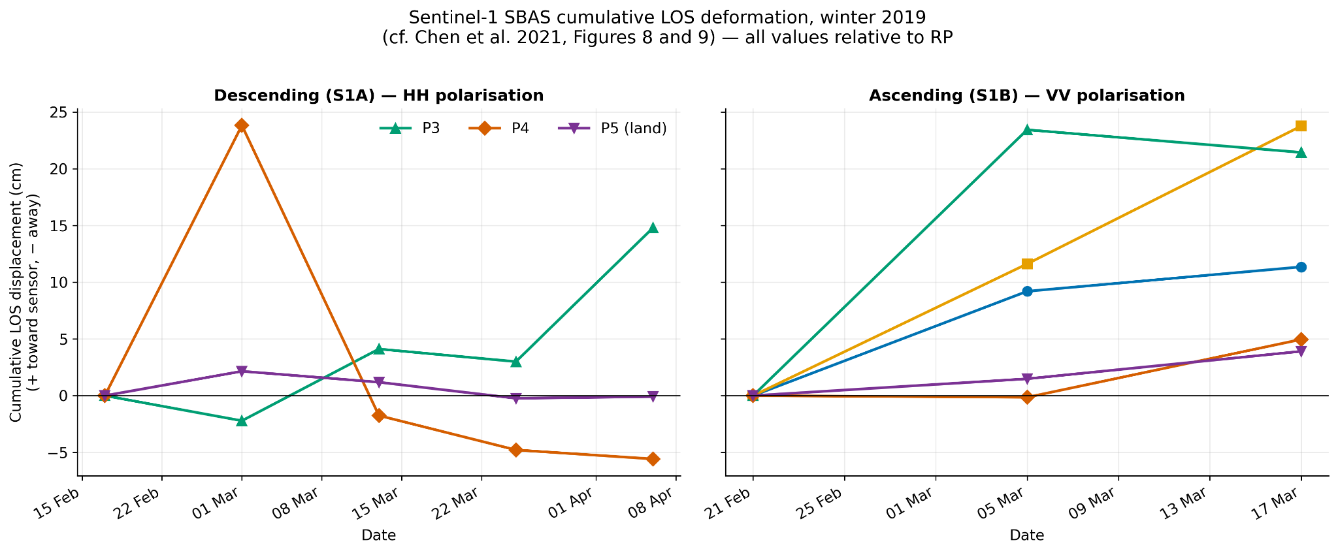
Figure 15. Cumulative line-of-sight displacement at P1–P5, winter 2018–19. P5 lies on land and remains flat, confirming the measurement is properly referenced.
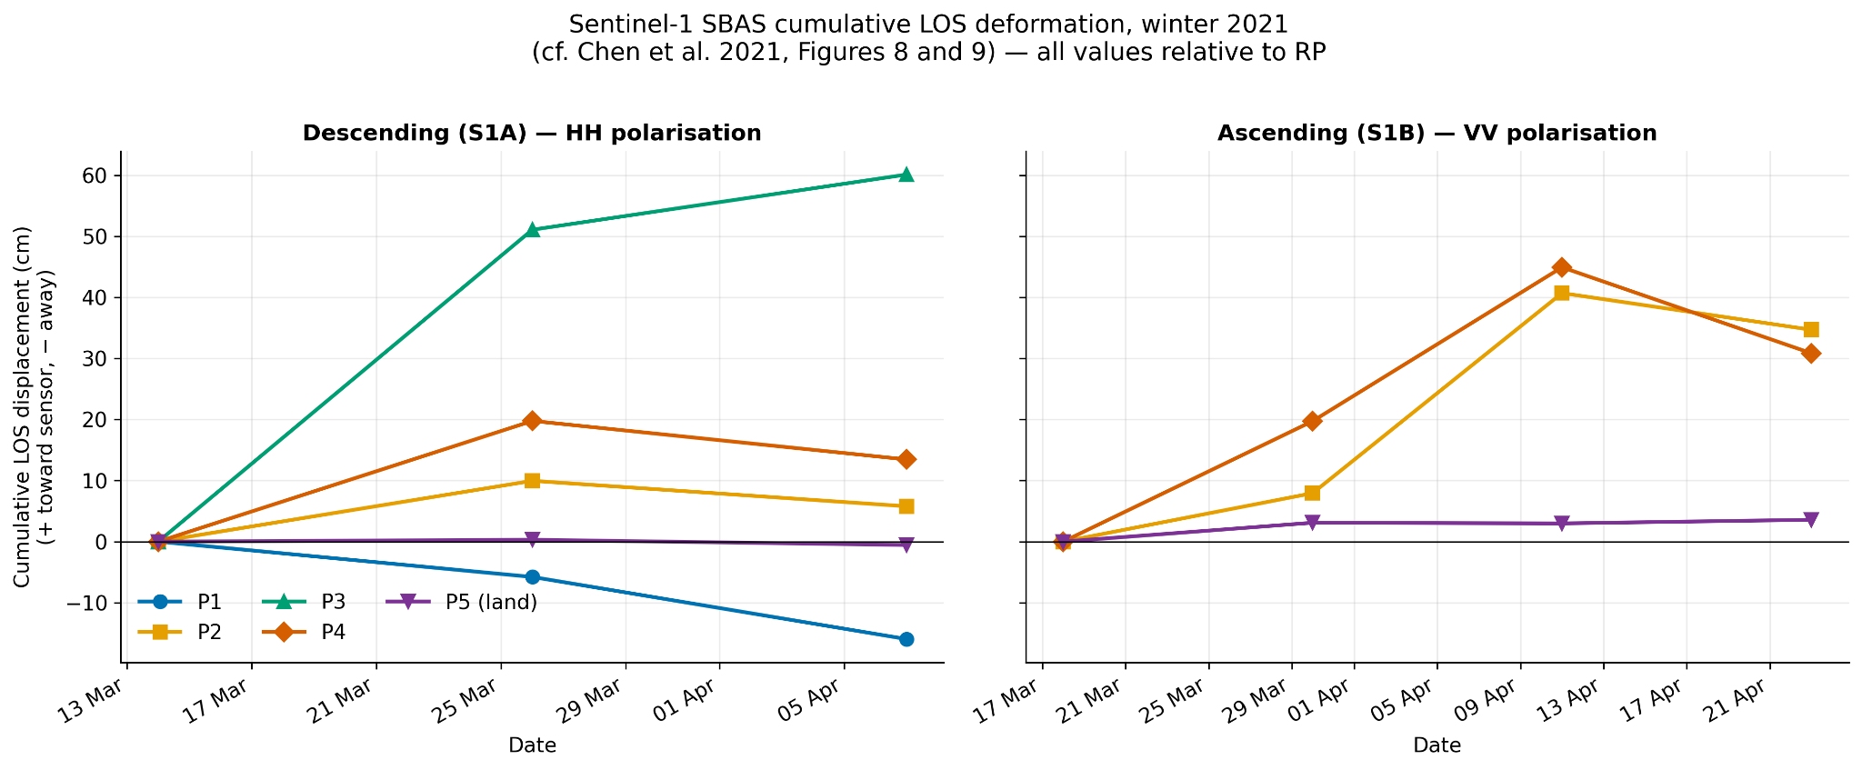
Figure 16. Cumulative line-of-sight displacement, winter 2020–21.
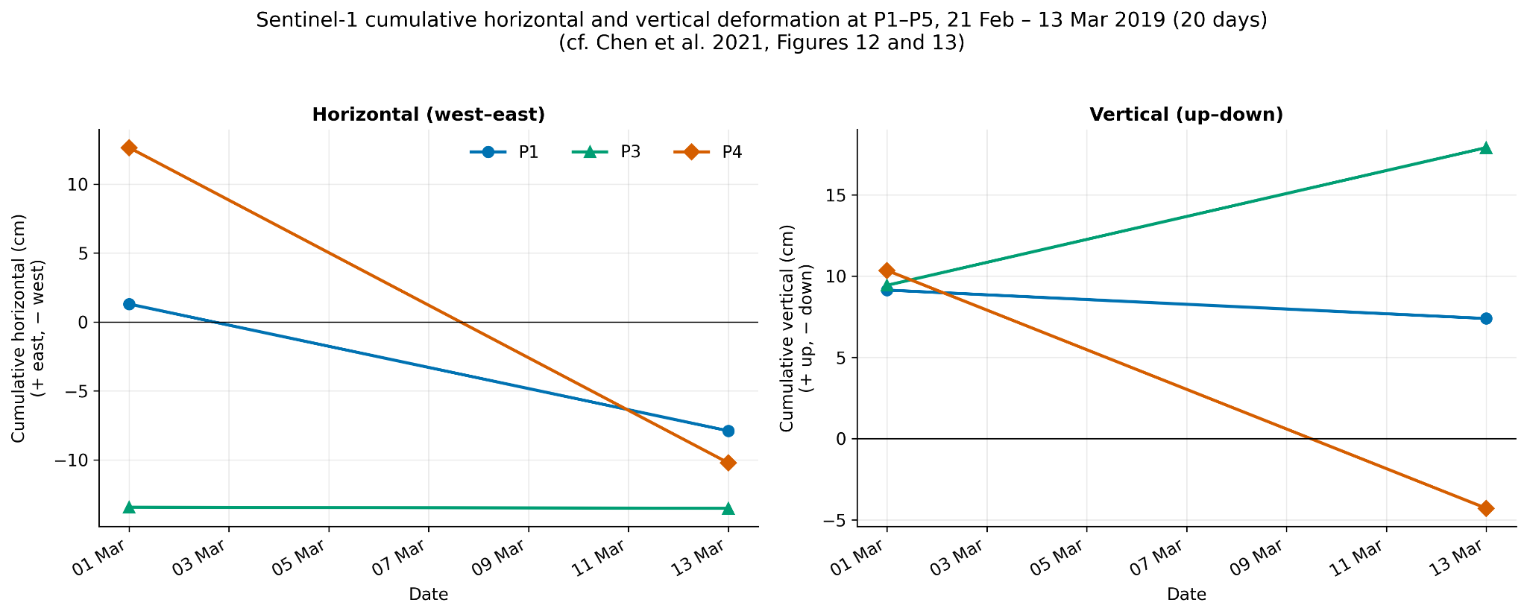
Figure 17. Cumulative horizontal and vertical displacement at the monitoring points, winter 2018–19.
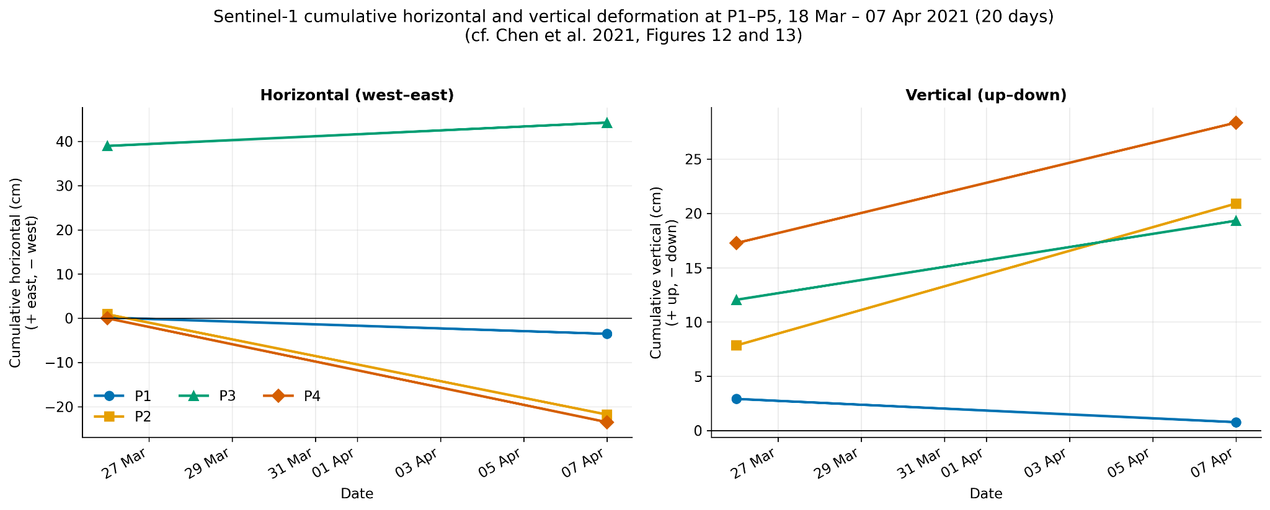
Figure 18. Cumulative horizontal and vertical displacement, winter 2020–21.
8.6 Deformation maps
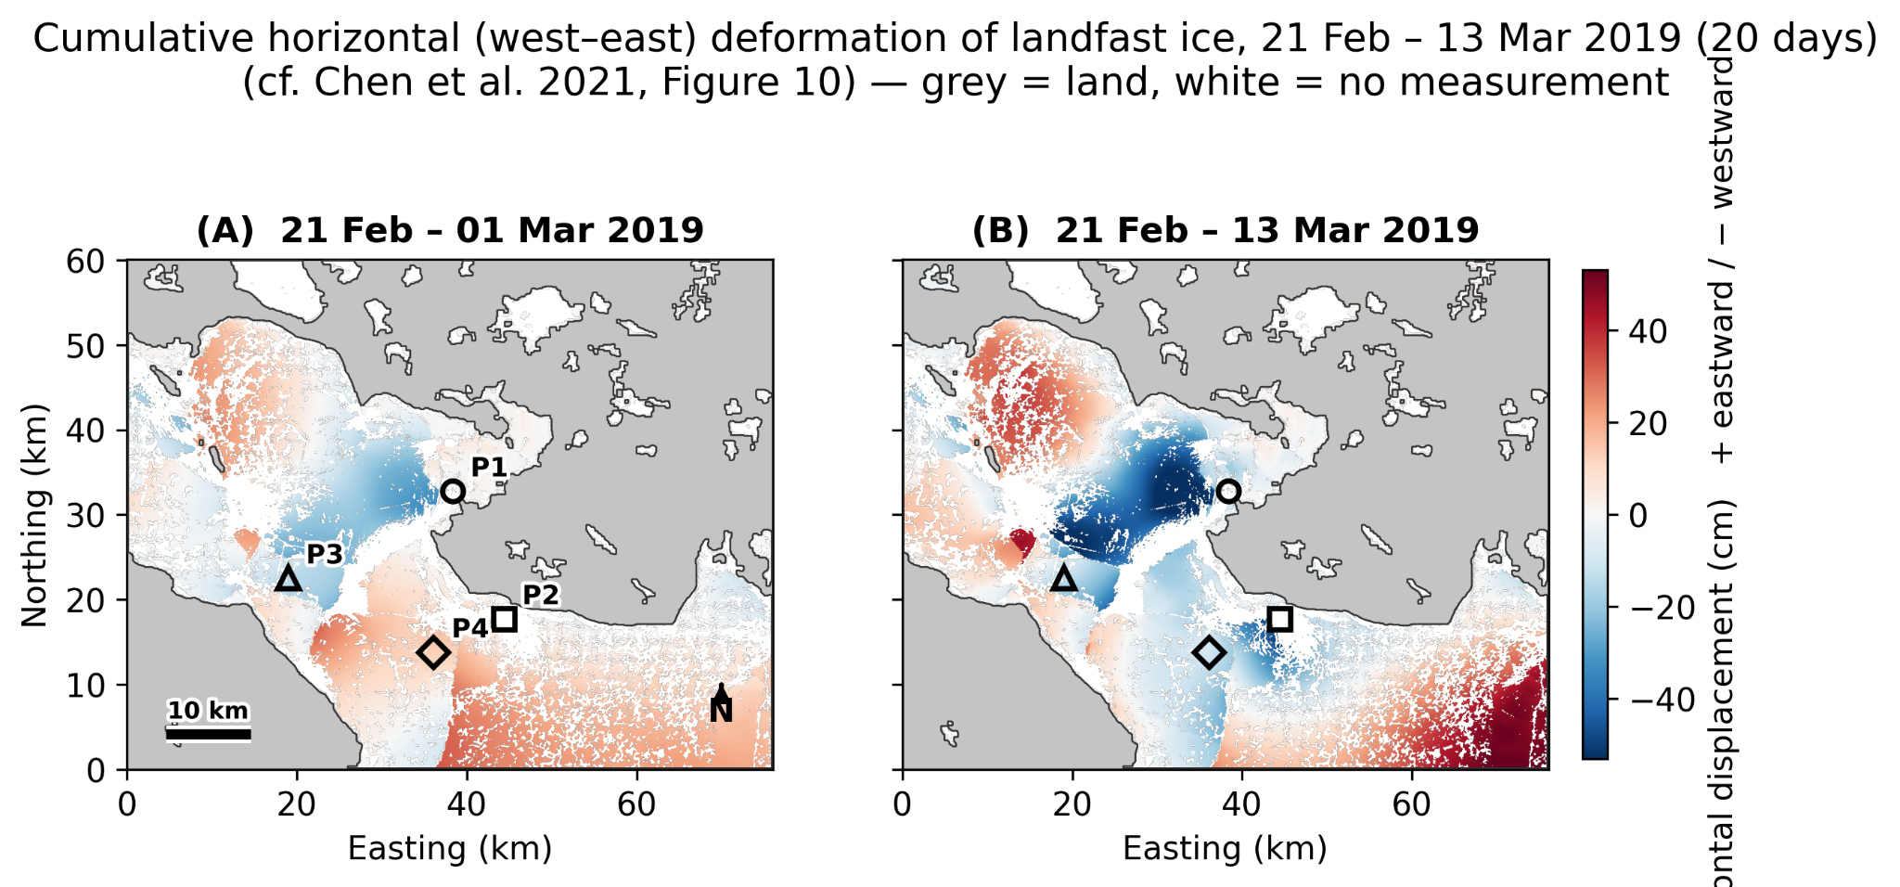

Figure 19. Cumulative horizontal (east–west) deformation of the landfast ice, winter 2018–19. Grey is land, white is no measurement.
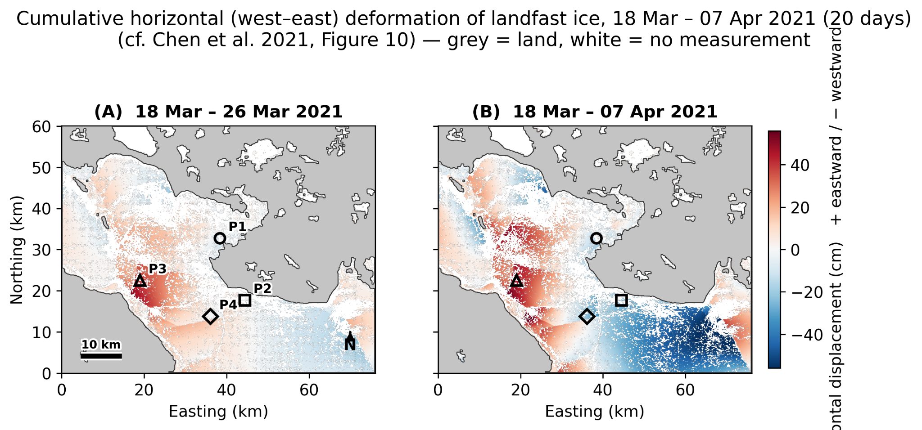
Figure 20. Cumulative horizontal (east–west) deformation, winter 2020–21.
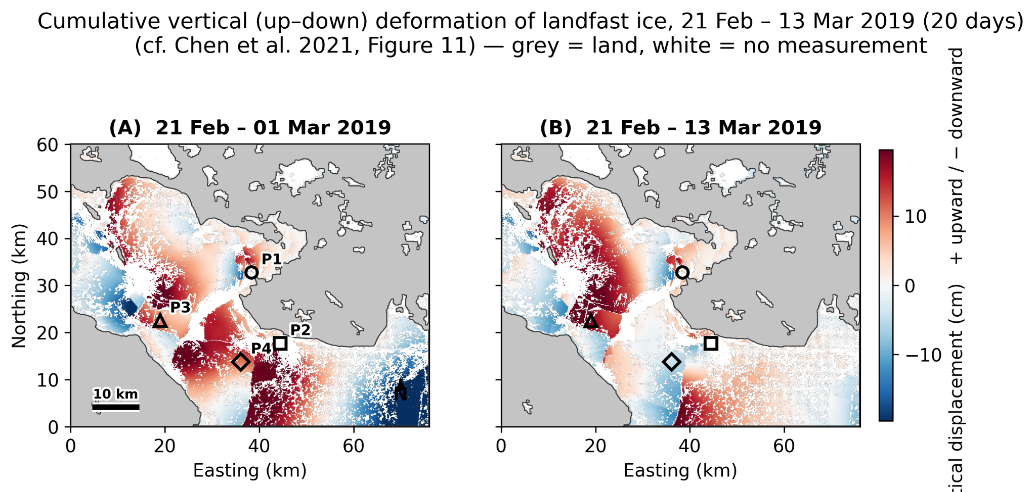
Figure 21. Cumulative vertical (up–down) deformation, winter 2018–19.
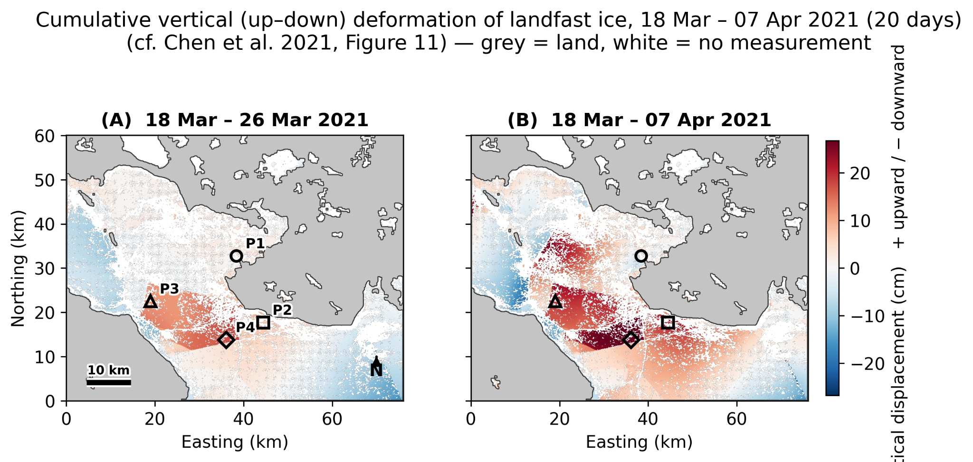
Figure 22. Cumulative vertical (up–down) deformation, winter 2020–21.
8.7 The two winters side by side
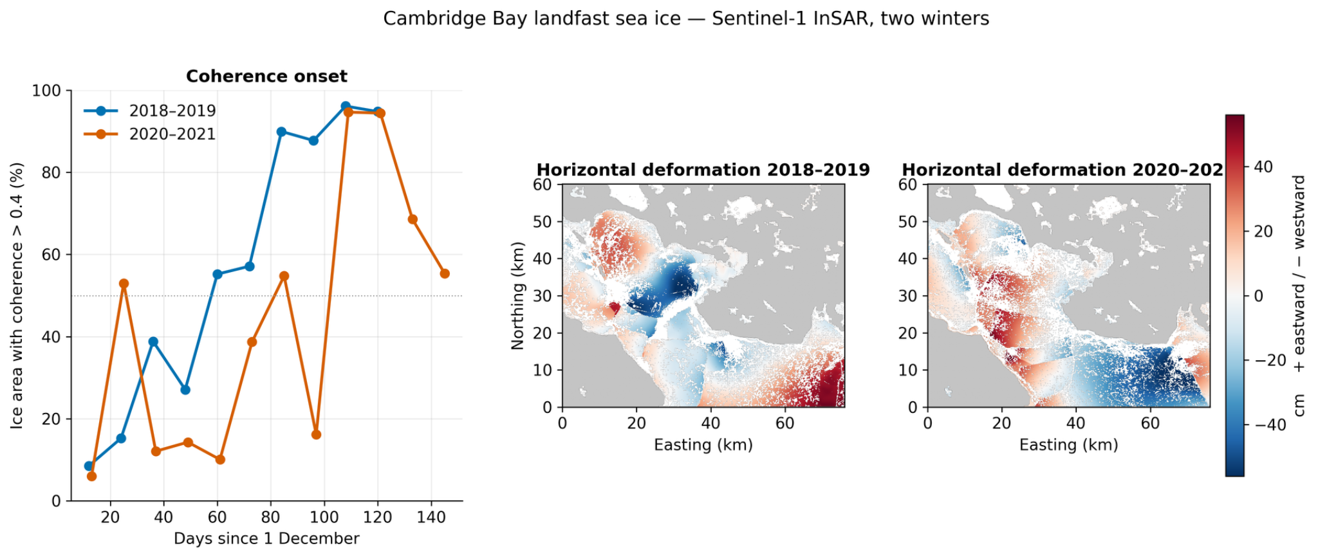
Figure 23. Combined comparison of the two winters: coherence onset (left) and horizontal deformation for 2018–19 and 2020–21 on a shared colour scale.

