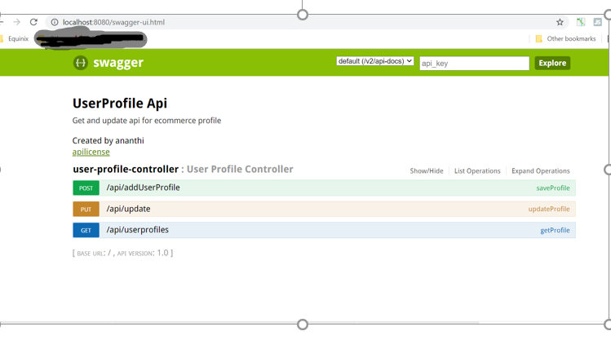

Response :

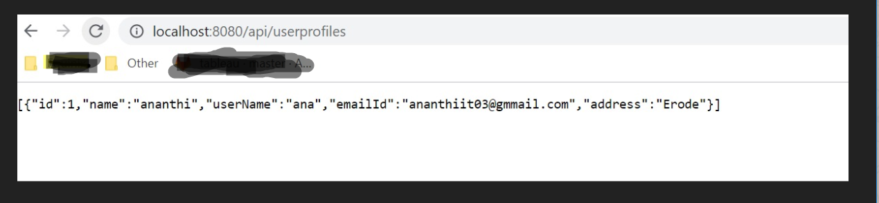

Step 1: URL : <http://localhost:8080/swagger-ui.html>

Step 2: Click post

Copy model object and click try it out

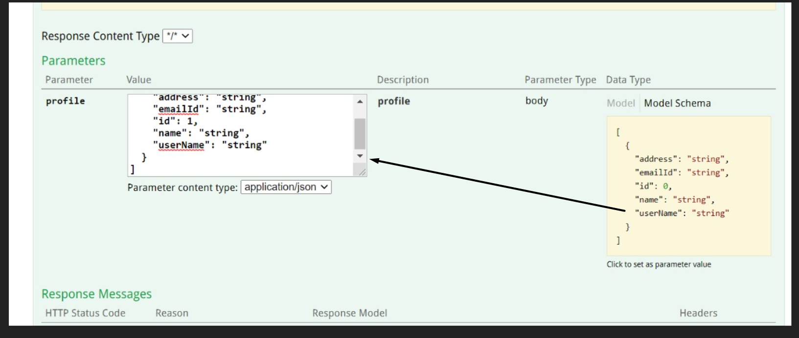

It will be saved into database.

Step 3:

Click GET and Try it out

Will get saved profile list from database.

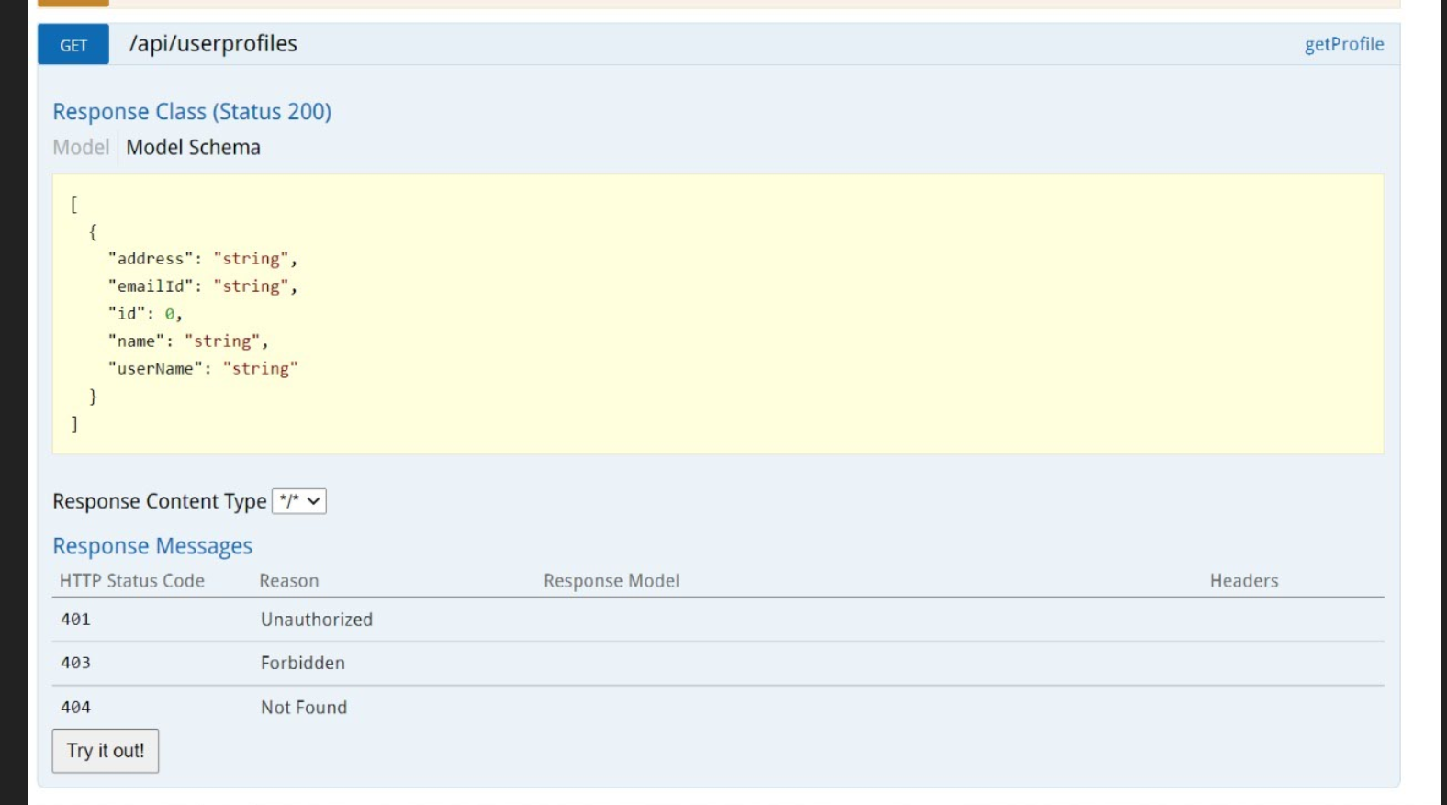

REACT URL:

Response :

