ABC-Salon
Architecture and Design Document
Phase 1: Customer Classification and Jev Demonstration
Version 2.0 (Draft) · 30 September 2026
Author: Ananth Kollipara
Repository: github.com/ananthk1010/abc-salon
Learning and portfolio project. All customer data is synthetic. Not affiliated with any salon business.

Document control
Item | Value
Title | ABC-Salon Architecture and Design Document, Phase 1
Version | 2.0 (Draft)
Date | 30 September 2026
Author | Ananth Kollipara
Status | Draft for owner review before milestone M0
Source of decisions | docs/PHASE1_PLAN.md v3 (2026-09-30) and the owner's decisions of 25 and 30 September 2026
Related documents | PHASE1_PLAN.md (plan and milestones); WORKFLOW.md and ARCHITECTURE.md (to be generated from this document in Markdown for the repository); WHITEPAPER.md (M4)

Version | Date | Change
1.0 | 2026-09-25 | First complete draft: architecture, design, call flows, component placement
2.0 | 2026-09-30 | Tier redefined as a deterministic 5-band rupee rule (was a spend-band placeholder); lifecycle field folded into tier; the mentions_medical Jev question removed; confidence-gated routing removed and replaced with one policy rule (booking within branch hours); Strands agent and all escalation deferred to Phase 2 in full

Table of contents
Document control 2
1. Introduction 5
1.1 Purpose 5
1.2 Scope 5
1.3 Audience 5
1.4 How to read verified and unverified statements 5
2. Architectural drivers 6
2.1 Goals 6
2.2 Constraints 6
2.3 Quality attributes and principles 6
3. System context 8
3.1 Actors 8
3.2 External systems 8
4. Component inventory and placement 10
5. Container view 12
6. Component design of the API 13
6.1 Module responsibilities 13
6.2 The Jev question set 14
Request shape sent to the gateway 14
Response shape (TypeSafe field names) 15
6.3 Policy engine 15
6.4 Deterministic rules 16
Tier — rules/tiers.py 16
Branch hours — rules/hours.py 16
6.5 Error handling and resilience 16
7. Decision technique map 17
8. Data model 18
9. Interface contract 19
9.1 Contract pipeline 19
10. Call flows 20
CF-1 Booking request within hours → confirmed (live mode, happy path) 20
CF-2 Booking request outside branch hours → auto-rejected 21
CF-3 Non-booking intent (complaint, price enquiry, ...) → recorded only 21
CF-4 Replay mode 21
CF-5 Contract generation and CI check 22
CF-6 Evaluation run on the golden set 22
CF-7 Deployment on git push 23
11. Deployment view 24
11.1 Environment variables and secrets 24
11.2 Operational notes 24
12. Cross-cutting concerns 26
12.1 Security 26
12.2 Privacy 26
12.3 Observability and audit 26
12.4 Testing strategy 26
13. Evaluation architecture 27
14. Extension points: Phase 2 and Phase 3 28
15. Risks and verification items 29
16. Glossary 30
Appendix A. Sources verified 31

Note. Word may ask to update fields when the document opens. Accept to populate the table of contents.

1. Introduction

1.1 Purpose
This document describes the architecture and detailed design of ABC-Salon Phase 1. It explains what each proposed component is, where it runs, what it is used for, and what it is deliberately not used for. It also gives the end-to-end call flows so that the implementation, the tests, and the whitepaper all describe the same system.

1.2 Scope
In scope for Phase 1:
- Classification of an incoming customer interaction (a phone note, a web form entry, or a mocked WhatsApp message) into typed decisions using Jev from TypeSafe AI — intent, service category, urgency, frustration, and two speculative flags.
- One deterministic workflow rule: a booking request is confirmed if it arrives within the branch's opening hours, and auto-rejected otherwise. Every other intent is classified and fully audited but creates no task.
- A deterministic customer tier (new / copper / bronze / silver / gold) computed from the last visit's spend in rupees — not a Jev question.
- A public interactive demo, an evaluation harness, and the offline lab that compares Jev with deterministic rules and conventional machine learning.
Out of scope for Phase 1: appointment creation, calendars, real WhatsApp messaging, payments, authentication of salon staff, any real customer data, confidence-gated routing, and any agent (Strands or otherwise). These are Phase 2 proposals; see section 14.

1.3 Audience
The owner as developer; reviewers of the public repository; readers of the whitepaper who want the design behind the results. Familiarity with web APIs and basic machine-learning terms is assumed. Jev-specific terms are defined in the glossary.

1.4 How to read verified and unverified statements
Facts about third-party services were checked against their primary documentation on 24 and 25 September 2026 and are listed in Appendix A. Items that could not be verified from documentation are marked as verification items in section 15 and must be confirmed during milestone M0 or M1. Nothing in this document assumes a capability that was not found in a primary source.

2. Architectural drivers

2.1 Goals
- Demonstrate, with measurements, why structured typed AI decisions are useful inside an application workflow, and where they are not the right tool — including tier, which the owner specified as exact rupee thresholds and which stays a rule for exactly that reason.
- Produce a demo that a LinkedIn visitor can use within a minute and that never costs the owner more than cents per day.
- Keep the codebase professional: typed contracts, tests, CI, reproducible evaluation, and auditable decisions.

2.2 Constraints
Constraint | Consequence for the design
TypeSafe direct signup is disabled (checked 2026-09-25) | Jev is reached through Vercel AI Gateway's TypeSafe-compatible endpoint. The client is configured by environment so the route can change without code changes.
Free hosting only; Hugging Face Docker Spaces need a paid plan | Front end on Vercel Hobby; API as a Docker image on Render Free (512 MB RAM, sleeps after 15 idle minutes). No ML libraries in the API image.
Jev is not in the gateway's free-tier model list | A small credit purchase is required. Budget cap on the gateway key, a daily budget in code, and replay mode protect the balance.
No real customer data | All customers, visits and messages are synthetic. Every accuracy number is reported as behaviour on a controlled set.
Public, unauthenticated demo | Rate limits per IP, replay mode, and no write path that could create real-world effects.
Owner decision (2026-09-30): tier is a rule, not a Jev question | Jev classifies the message only. Tier is exact arithmetic on the last visit's spend, computed in `rules/tiers.py`.
Owner decision (2026-09-30): Policy is one rule for Phase 1 | No confidence gates, no medical check. `policy/route.py` reads only the `intent` answer and the branch-hours fact.

2.3 Quality attributes and principles
Attribute | Principle applied
Explainability | Every decision stores the questions asked, every answer's probability distribution, the confidence, the policy version and the resulting action. The UI shows all of it, even for answers the policy does not act on.
Determinism where facts exist | Tier and branch hours are decided by code, not by a model — exact thresholds the owner specified directly.
Minimal, legible policy | Phase 1's policy is one rule with three possible outcomes: confirmed, rejected_outside_hours, recorded. No thresholds to mis-tune, nothing hidden in a confidence band.
Cost boundedness | Speculative fan-out puts all six questions in one call; budgets and rate limits cap spend; replay mode keeps the demo alive at zero cost.
Portability of the decision provider | The Jev client depends only on the documented request and response shape, not on an SDK, so the gateway, TypeSafe direct, or Cloudflare are one environment variable apart.
Privacy minimalism | The model never receives names or phone numbers; only the customer id, tier, recent visits, the message text and branch context.
Contract first | Pydantic models define the API; OpenAPI is generated from them; TypeScript types are generated from OpenAPI; CI fails on drift.
Reproducibility | make eval regenerates every number in the whitepaper from eval/golden.jsonl, in live or replay mode.

3. System context
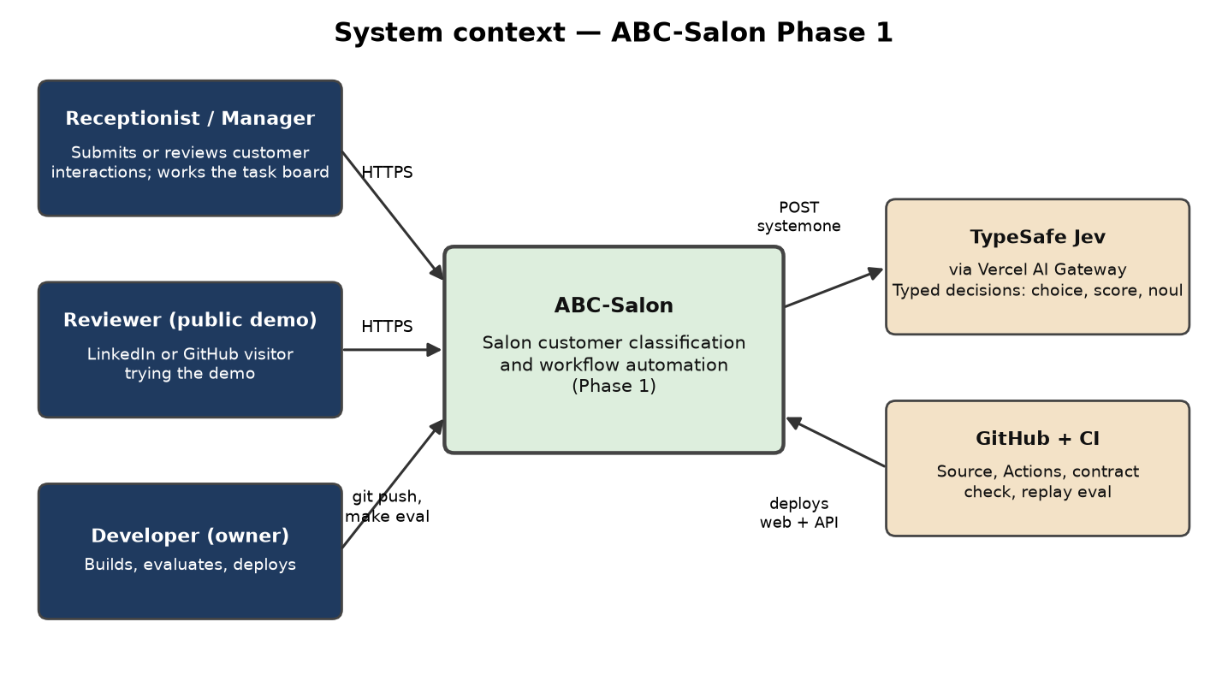
Figure 1. System context. People on the left, ABC-Salon in the centre, external services on the right. No agent or LLM provider is in the Phase 1 context.

3.1 Actors
Actor | Interaction with ABC-Salon | Phase 1 reality
Receptionist / Manager | Enters a customer's message or phone note, reviews the decision, works the task board of confirmed bookings. | Played by the demo user. No login.
Reviewer (public demo) | Opens the shared URL, picks a sample message or types one, reads the decision panel and audit trail. | Anonymous, rate-limited.
Developer (owner) | Builds, runs the evaluation, deploys through git push, writes fixtures. | Single maintainer.

3.2 External systems
System | Role | Protocol | Credential location
TypeSafe Jev via Vercel AI Gateway | Evaluates typed questions against a state; returns choices, scores, noul values, probabilities, confidence, token usage. | HTTPS POST /typesafe/v1/systemone, JSON, bearer token | Render environment (JEV_API_KEY = AI Gateway key)
GitHub + GitHub Actions | Source of truth, CI (lint, tests, contract check, replay eval), deploy triggers. | git, webhooks | Repository secrets: none needed for CI in replay mode
Vercel | Builds and serves the Next.js static export; hosts the AI Gateway key and budget. | HTTPS | Vercel dashboard
Render | Builds the API Docker image and runs it. | HTTPS | Render dashboard
Note. An LLM provider (Anthropic) and a Strands agent are not part of Phase 1's system context. They are a Phase 2 proposal — see section 14 — because their only Phase 1 use case, drafting a proposal on an escalated task, has no trigger once confidence-gated routing is removed.

4. Component inventory and placement
This section answers the question "where is each proposed component used?" for every technology named in the project brief and plan.
Component | What it is | Where it runs | Used for in Phase 1 | Deliberately not used for
Next.js + TypeScript | React framework, static export | Vercel Hobby, browser | Demo UI: message picker, decision panel (answers, probabilities, confidence), task board, API-waking banner | Server-side logic, model calls, secrets
Python 3.11 + FastAPI | Async web framework | Docker on Render Free | All API endpoints, orchestration of classify flow, OpenAPI generation | Serving the front end (two origins), ML training
Pydantic v2 | Data validation and settings | Inside FastAPI | Request/response schemas, Jev question definitions, policy config, audit records, environment settings | Nothing; it is the type backbone of the API
OpenAPI → openapi-typescript | Contract generation | Build time and CI | Typed client for the web app; drift check in CI | Runtime validation in the browser
Docker + docker compose | Packaging | Developer PC and Render | Single API image built from apps/api/Dockerfile; local dev with hot reload | Packaging the lab (runs in a venv or Colab)
Jev (TypeSafe AI) | System One model returning typed decisions | External, via Vercel AI Gateway | Classifies the message only: intent, service category, urgency, frustration, wants-stylist flag, wants-callback flag | Classifying the customer (tier is a rule, not a Jev question); text generation; tabular churn
JevClient (httpx) | Thin HTTP client | apps/api/app/jev/client.py | Calls the gateway, retries 429/529, captures usage and latency, computes confidence fallback, enforces daily budget | Replaced by an SDK (no documented base URL override in the Python SDK)
Deterministic rules | Pure Python functions | apps/api/app/rules | Customer tier (5-band ₹ rule on last visit spend, including the new-customer case), branch opening hours | Anything that requires reading free text
Policy engine | policy/route.py, one rule | apps/api/app/policy | book_appointment within branch hours → confirmed; outside hours → rejected; any other intent → recorded | Confidence gating, priority scoring, a medical check — all removed from Phase 1
Replay fixtures | Recorded Jev responses | apps/api/app/jev/replay.py, eval/fixtures | Zero-cost demo mode; CI evaluation; fallback on missing key or exhausted budget | Free-text input the fixtures do not contain (returns 503 with a hint)
Audit store (SQLite) | Embedded database file | Render container disk (ephemeral) | Decision persistence for the session (every answer, confidence and action); JSON export for the eval | Durable storage (Phase 2 adds hosted Postgres)
Logistic regression (scikit-learn) | Conventional tabular ML baseline | Offline lab | Churn risk from synthetic visit history; the "conventional ML" row of the comparison. Tier itself is not run through this comparison | Runtime decisions in Phase 1
Amazon Mitra-v2 (AutoGluon) | Tabular foundation model, Apache-2.0 | Offline lab, stretch item in M3 | Zero-shot comparator for the same churn task; demonstrates where a tabular foundation model fits | Text classification (it cannot read text); tier (exact arithmetic, stays a rule); the API image (memory)
Vercel AI Gateway | Model gateway with budgets and observability | External | Route to Jev with a Vercel key; budget cap; cost metadata per call | Native /v1/evaluate dialect (kept off for portability)
Render Free | Container host | External | Runs the API image; holds secrets | Anything memory-heavy; durable data
GitHub Actions | CI | External | Lint, unit tests, contract check, replay-mode eval on every push | Live Jev calls (no key in CI)
Note. Strands Harness, the strands-agents SDK and the Anthropic API are investigated in the plan (docs/PHASE1_PLAN.md §2.4) but are not built in Phase 1. They are proposed as a Phase 2 component once confidence-gated escalation exists for them to act on; see section 14.

5. Container view
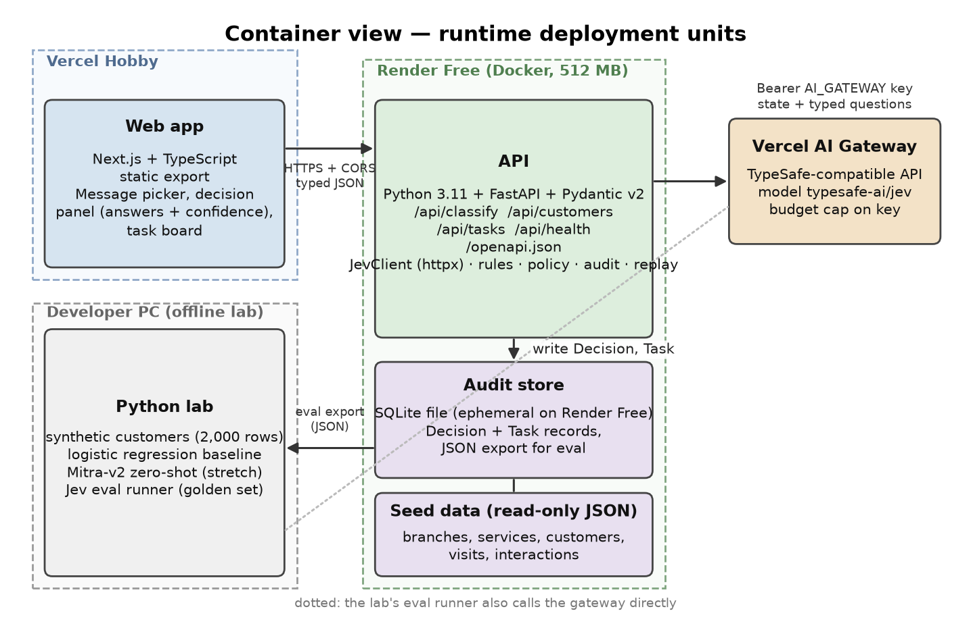
Figure 2. Container view. Dashed rectangles are hosting boundaries. The lab is offline and shares the JevClient, rules and policy code with the API.
Container | Technology | Responsibilities | Interfaces
Web app | Next.js static export on Vercel | Render UI; call API; show the decision panel (answers, probabilities, confidence) and the confirmed-booking task board; show mode badge and waking banner | Consumes the generated TypeScript contract; HTTPS to the API
API | FastAPI in Docker on Render | Validate input; build state; call Jev or replay; apply the tier/hours rules and the one policy rule; persist; expose health and export | REST/JSON under /api; /openapi.json
Audit store | SQLite file | Decision table (every answer + action, whichever of the three outcomes) | SQLAlchemy Core or sqlite3; export endpoint
Seed data | JSON files bundled in the image | Branches, services, customers, visits, interactions | Loaded at startup into memory; read-only
Python lab | Notebooks and scripts | Synthetic data generation, baselines, Mitra-v2, Jev evaluation runner | Imports app.jev, app.rules and app.policy from the API package; writes eval/results.json

6. Component design of the API
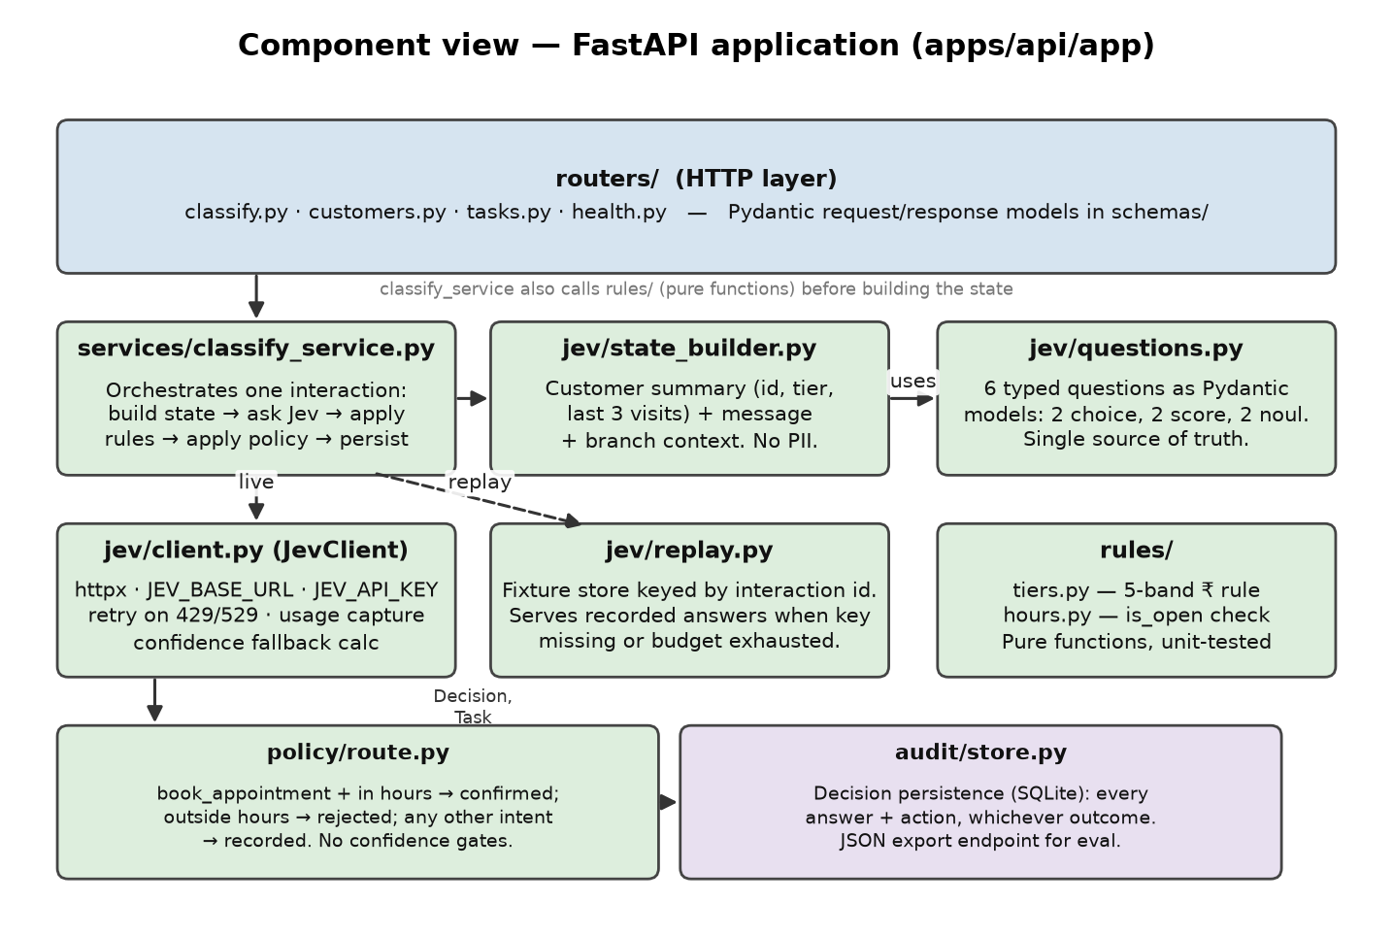
Figure 3. Component view of the FastAPI application. Green: application code. Purple: persistence. No agent module in Phase 1.

6.1 Module responsibilities
Module | Responsibility | Key types / functions | Tests
routers/ | HTTP layer only. No business logic. | classify, customers, tasks, health | FastAPI TestClient contract tests
schemas/ | Pydantic request and response models; source of OpenAPI | ClassifyRequest, ClassifyResponse, DecisionOut, TaskOut, HealthOut | Schema snapshot test
services/classify_service.py | Orchestrates one interaction end to end | classify(interaction) -> ClassifyResponse | Unit tests with a fake JevClient
jev/questions.py | The six typed questions as Pydantic models; serialises to the TypeSafe JSON shape | QUESTIONS, ChoiceQ, ScoreQ, NoulQ | Serialisation test against the documented shape
jev/state_builder.py | Builds the state object without PII | build_state(customer, visits, interaction, branch) -> dict | Unit test asserts no name/phone keys
jev/client.py | HTTP call, retries, usage capture, budget, confidence fallback | JevClient.evaluate(state, questions) -> JevAnswers | httpx MockTransport tests for 200/401/422/429/529
jev/replay.py | Fixture lookup keyed by interaction id and questions hash | ReplayStore.get(key) | Fixture round-trip test
rules/tiers.py | Pure function: last visit spend → tier | tier(customer, visits) -> Tier | Table-driven unit tests over all five bands and the two new-customer cases
rules/hours.py | Pure function: branch hours check | is_open(branch, timestamp) -> bool | Boundary tests at opening and closing time
policy/route.py | The one Phase 1 rule | route(intent, branch, received_at) -> Decision | Three-outcome test matrix; regression test against golden-set bookings
audit/store.py | Persistence and export | save_decision() -> Decision, export_json() | SQLite temp-file tests

6.2 The Jev question set
All six questions are sent in one call against the same state (speculative fan-out). Jev evaluates them independently and in parallel, so adding a question barely changes latency. Criteria wording is the equivalent of prompt engineering for Jev and is versioned with the code. Only intent is read by Policy in Phase 1; the other five are computed, shown in the decision panel, and stored in the audit trail purely as the Jev demonstration.
Id | Type | Instruction (abridged) | Criteria | Consumed by
intent | choice | What is the customer asking for? | book_appointment, reschedule, cancel, price_enquiry, complaint, feedback, other (each with a one-line description) | Policy: the only answer Phase 1 acts on
service_category | choice | Which service family is being discussed? | hair, skin, spa_body, nails, grooming, bridal, unclear | Displayed and audited only
urgency | score | How time-sensitive is the request? | 4 ordered levels from "no time pressure" to "needs action today" | Displayed and audited only
frustration | score | How frustrated does the customer appear? | 3 ordered levels: calm, frustrated but civil, very angry | Displayed and audited only
wants_specific_stylist | noul | The customer asks for a named or specific stylist. | Optional clarification | Displayed and audited only; Phase 2 availability lookup
wants_callback | noul | The customer asks to be called back. | Optional clarification | Displayed and audited only; Phase 2 callback task
Note. The mentions_medical question from the v1.0 draft was removed on 2026-09-30 at the owner's request: it did not map cleanly to a salon interaction. A better-scoped safety check (allergy to a product, a treatment unsuitable during pregnancy) is a Phase 2 proposal; see section 14.

Request shape sent to the gateway
POST https://ai-gateway.vercel.sh/typesafe/v1/systemone
Authorization: Bearer <AI_GATEWAY_API_KEY>
{
"model": "typesafe-ai/jev",
"state": {
"customer": {"id": "c_017", "tier": "gold",
"last_visits": [{"service": "hair_colour", "days_ago": 21}, ...]},
"branch": {"id": "b_lakeview"},
"interaction": {"channel": "phone_note", "text": "..."}
},
"questions": {
"intent": {"type": "choice", "instructions": "...", "criteria": {"book_appointment": "...", ...}},
"urgency": {"type": "score", "instructions": "...", "criteria": ["...", "...", "...", "..."]},
"wants_callback": {"type": "noul", "instructions": "..."}
}
}

Response shape (TypeSafe field names)
{
"model": "typesafe-ai/jev",
"answers": {
"intent": {"type": "choice", "choice": "book_appointment",
"probabilities": {"book_appointment": 0.94, "reschedule": 0.03, ...}, "confidence": 0.91},
"urgency": {"type": "score", "score": 2.6, "probabilities": {"0": 0.02, "1": 0.1, "2": 0.16, "3": 0.72}, "confidence": 0.63},
"wants_callback": {"type": "noul", "noul": 0.04}
},
"usage": {"input_tokens": 1210, "output_tokens": 18}
}

Note. Whether the gateway's TypeSafe-compatible response includes the confidence field for choice and score answers is a verification item for M1. If it is absent, JevClient computes it from the probability distribution using TypeSafe's published definition and records that it did so. Note that Policy in Phase 1 does not read confidence at all — this only affects what the decision panel displays.

6.3 Policy engine
The entire Phase 1 policy is one rule. It reads exactly one Jev answer (intent) and one deterministic fact (is the branch open now), and returns one of three outcomes. There are no thresholds to tune and nothing that reads confidence.
Intent | Branch hours | Outcome | Task created?
book_appointment | Within hours (10:00–20:00) | confirmed | Yes — booking_request, status confirmed
book_appointment | Outside hours | rejected_outside_hours | No
Any other intent (reschedule, cancel, price_enquiry, complaint, feedback, other) | Not checked | recorded | No — there is nothing to confirm or reject about a complaint or a price enquiry
def route(intent: str, branch: Branch, received_at: datetime) -> Decision:
if intent != "book_appointment":
return Decision(action="recorded", task=None)
if is_open(branch, received_at):
return Decision(action="confirmed", task=Task(type="booking_request", status="confirmed"))
return Decision(action="rejected_outside_hours", task=None)

“Booking time” is the time the interaction arrives, not a customer-requested slot — Phase 1 has no calendar or slot concept. is_open reads branch.openingHours, which is 10:00–20:00 for all three seed branches, so the rule reads exactly as the owner's original “10AM–8PM” instruction, but is data-driven rather than a hardcoded constant.
Note. Confidence-gated routing, a priority formula from urgency/frustration, and the medical override from the v1.0 draft are all removed from Phase 1 policy. They are Phase 2 proposals; see section 14.

6.4 Deterministic rules

Tier — rules/tiers.py
Tier | Condition
new | No customer record found, or a record exists but has no completed visits yet
copper | Last visit spend < ₹1,500
bronze | ₹1,501 – ₹3,000
silver | ₹3,001 – ₹5,000
gold | ₹5,001 and above (open-ended)
Owner-specified exact rupee thresholds, with two adjustments flagged and accepted before implementation: the gold band is open-ended rather than capped at ₹10,000 (a bigger spender otherwise falls into no tier at all), and “record exists but zero visits” is treated the same as “record not found” under new. “Last spend” is the most recent single visit's amount, not a 12-month total. This replaces the v1.0 draft's separate lifecycle field (new/active/lapsed); the active/lapsed distinction by visit recency is a Phase 2 proposal (section 14).

Branch hours — rules/hours.py
Rule | Definition | Why not AI
is_open | branch.openingHours checked against the interaction's arrival time; 10:00–20:00 for all three Phase 1 branches | Fact, not judgement. Exact and must be identical every time

6.5 Error handling and resilience
Condition | Detection | Behaviour
Gateway 401 | HTTP status | Log once, switch to replay mode, health reports reason=auth
Gateway 422 | HTTP status | Bug in question serialisation; fail the request with 500 and log the body; covered by the serialisation test
Gateway 429 / 529 | HTTP status | Exponential backoff, 3 attempts; then replay if a fixture exists, else 503 with Retry-After
Daily budget exhausted | Token counter in the audit store | Replay mode until midnight UTC; health reports reason=budget
Replay miss on free text | No fixture for key | 503 with message "live mode unavailable; choose a sample message"
Render cold start | UI health poll fails | Banner "waking the API"; poll every 3 s up to 90 s

7. Decision technique map
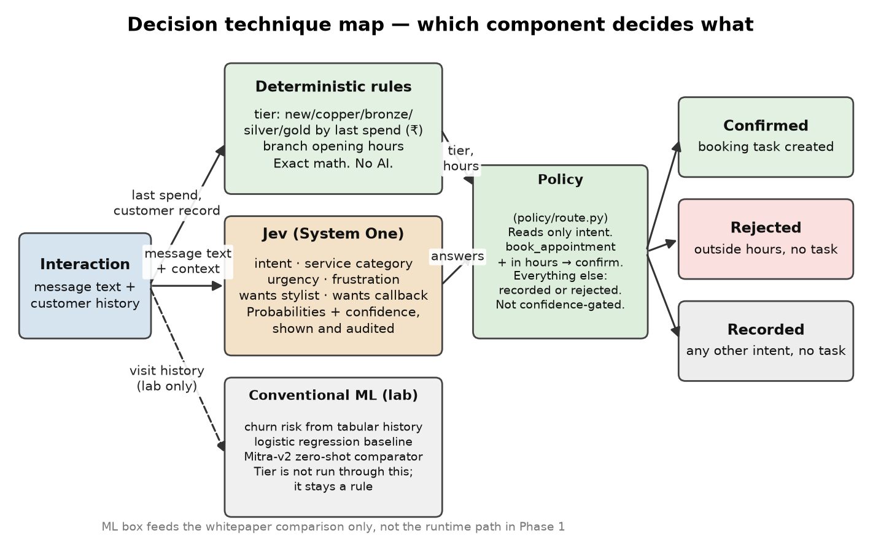
Figure 4. Which component decides what. Only rules, Jev and the one policy rule are on the runtime path in Phase 1.
Aspect | Deterministic rules | Jev (System One) | Conventional ML (lab only)
Input | Last visit spend; branch hours | Message text plus structured context | Labelled numeric visit history
Output | Exact value (tier, open/closed) | Choice / score / noul with probabilities and confidence | Class probability
Determinism | Total | Calibrated, may vary slightly between runs (measured as flip rate) | Deterministic once trained
Latency | Microseconds | About 100 ms to 1 s per call through the gateway (to be measured) | Milliseconds at inference
Cost per decision | None | A fraction of a cent per interaction | None at inference
Where used in Phase 1 | Tier (all decisions); branch-hours check (policy) | Intent (drives policy); category, urgency, frustration, stylist, callback (displayed and audited) | Churn comparison in the whitepaper only, never the runtime path
Failure mode | Wrong rule | Low confidence — not acted on in Phase 1, but visible for the calibration study | Distribution shift on synthetic data

8. Data model
Entity | Key fields | Notes
Branch | id, name, city, openingHours | Fictional names: Lakeview, Tech Park, Old Town; hours 10:00–20:00
ServiceCategory | id (hair, skin, spa_body, nails, grooming, bridal) | Matches the service_category question criteria exactly
Service | id, categoryId, name, durationMin, priceBand | Price bands, not prices
Customer | id, displayName, phoneMasked, branchId, joinedOn, tier | tier ∈ new, copper, bronze, silver, gold (computed by the rule in §6.4). displayName and phoneMasked are never sent to Jev
Visit | id, customerId, serviceId, stylistId, date, spend (₹), noShow | Feeds tier and the churn table
Interaction | id, customerId, channel, text, receivedAt | channel ∈ phone_note, web_form, whatsapp_mock
Decision | id, interactionId, questionsSnapshot, answers, confidenceMap, policyVersion, action, latencyMs, inputTokens, mode, route | action ∈ confirmed, rejected_outside_hours, recorded. One per classify call; the audit record
Task | id, decisionId, type, branchId, status | type is always booking_request; status is always confirmed in Phase 1 (nothing else creates a task)
Relationships: Branch 1..n Customer; Customer 1..n Visit; Customer 1..n Interaction; Interaction 1..1 Decision; Decision 0..1 Task (only when action = confirmed).
Note. Removed from the v1.0 draft: the separate lifecycle field (folded into tier), priority on Task (no queue to sort in Phase 1), and EscalationNote (no escalation in Phase 1; see section 14).

9. Interface contract
Method and path | Request | Response | Notes
POST /api/classify | {interactionId} or {customerId, channel, text} | ClassifyResponse: answers, confidenceMap, tier, action, task (if any), mode, route, latencyMs, inputTokens | Rate limited per IP; free text only in live mode
GET /api/customers | — | List of customers with tier, last visits, sample interactions | Seed data
GET /api/tasks | — | Confirmed-booking list | Session scope
GET /api/health | — | {mode, route, budgetRemaining, policyVersion, version} | Polled by the UI
GET /api/export/decisions | — | JSON array of Decision | Used by make eval
GET /openapi.json | — | OpenAPI 3.1 | Source of the TypeScript contract

9.1 Contract pipeline
- Pydantic models in apps/api/app/schemas define every request and response.
- make contract runs the API's export script to write packages/contracts/openapi.json.
- openapi-typescript converts it to packages/contracts/src/api.d.ts, imported by the web app.
- CI repeats steps 2 and 3 and fails if the git tree is dirty, so the API cannot change without regenerating the types.

10. Call flows
Each flow shows the participants, the messages in order, and what is verified at each step. Sequence diagrams use solid arrows for calls and dashed arrows for returns. There is no agent call flow in Phase 1 — see section 14 for the Phase 2 version of that idea.

CF-1 Booking request within hours → confirmed (live mode, happy path)
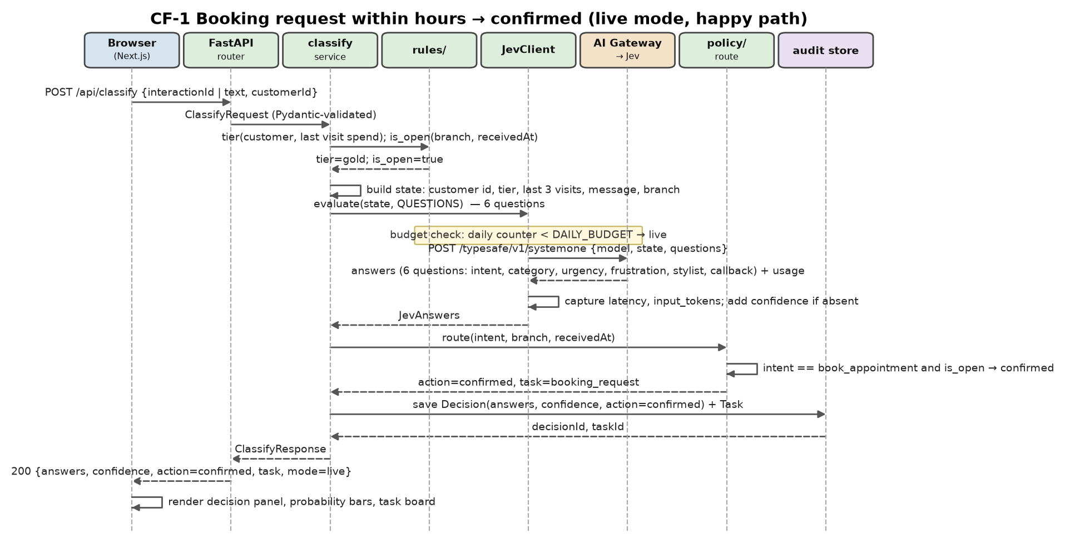
Figure 5. CF-1 sequence.
Step | From → To | What happens | Design point
1 | Browser → router | POST /api/classify with an interaction id (sample) or free text plus customer id | Pydantic rejects malformed input with 422 before any logic runs
2 | router → service | Validated ClassifyRequest | Routers hold no logic
3–4 | service → rules | tier computed from last visit spend; is_open computed from branch hours | Facts come from code, not the model
5 | service (self) | State built: customer id, tier, last three visits, message, branch | No names or phone numbers
6–7 | service → JevClient | Budget check; live mode chosen | Budget is a counter in the audit store
8–9 | JevClient → gateway | One HTTPS call carrying all six questions | Speculative fan-out: one round trip
10 | JevClient (self) | Latency and tokens captured; confidence computed if absent | Every number in the whitepaper starts here
11–12 | service → policy | intent == book_appointment and is_open → confirmed | The only rule in Phase 1
13–15 | service → audit | Decision and Task persisted | Audit record is complete before the response is sent
16–17 | → Browser | 200 with answers, confidence map, action=confirmed, task, mode=live | UI renders probability bars per question and the confirmed task

CF-2 Booking request outside branch hours → auto-rejected
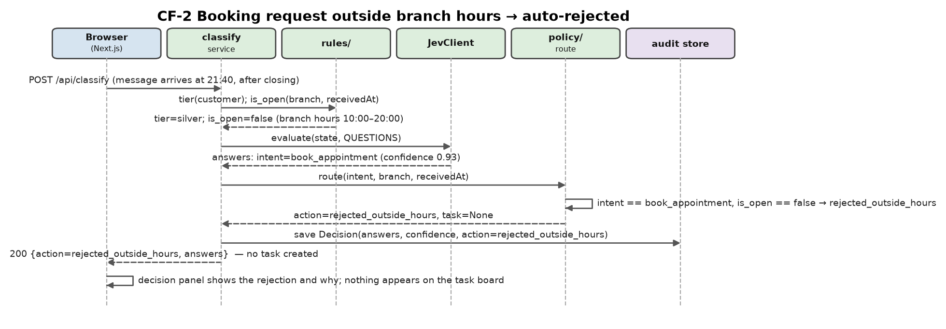
Figure 6. CF-2 sequence.
A booking message arrives after closing. is_open returns false, so Policy returns rejected_outside_hours and no task is created. The decision is still fully audited: the answers, the confidence, and the reason are all stored, and the decision panel shows the rejection. This is a straight rule check, not a model judgement — the golden-set regression test in CF-6 verifies it against the exact hours arithmetic.

CF-3 Non-booking intent (complaint, price enquiry, ...) → recorded only
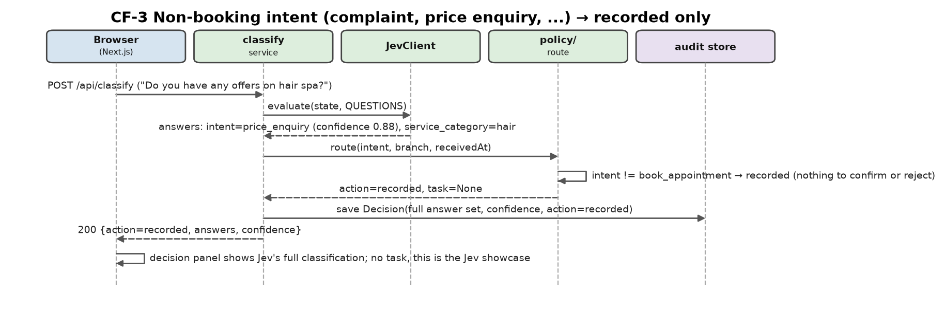
Figure 7. CF-3 sequence.
This is the majority case and the actual Jev showcase: five of Jev's six questions are consumed only here, in the audit trail and the decision panel, never by Policy. A price enquiry, a complaint, or a reschedule request is fully classified — intent, category, urgency, frustration, the two speculative flags, all with probabilities and confidence — but Phase 1 takes no workflow action on it. There is nothing to confirm or reject about a price enquiry.

CF-4 Replay mode
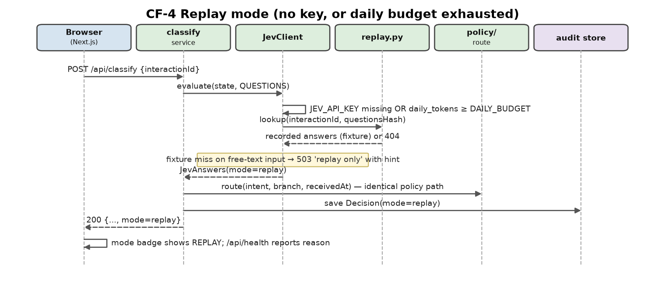
Figure 8. CF-4 sequence.
Replay mode exists for three reasons: the public demo must work with zero spend, CI must run the evaluation without a key, and the demo must survive a revoked key or an exhausted budget. Fixtures are recorded during the evaluation run and keyed by interaction id plus a hash of the question set, so a change to the questions invalidates stale fixtures automatically. The policy path is identical in both modes, which is what makes replay a faithful demonstration.

CF-5 Contract generation and CI check
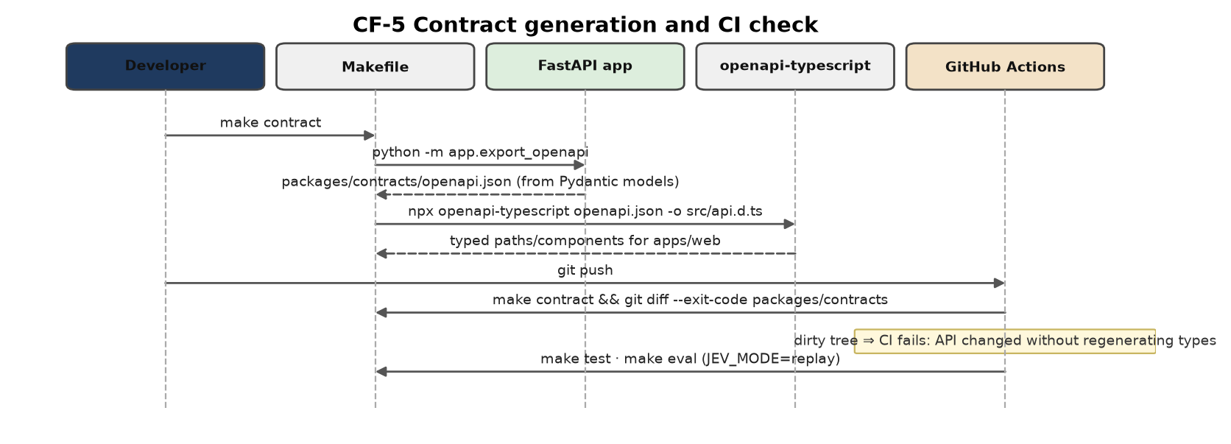
Figure 9. CF-5 sequence.

CF-6 Evaluation run on the golden set
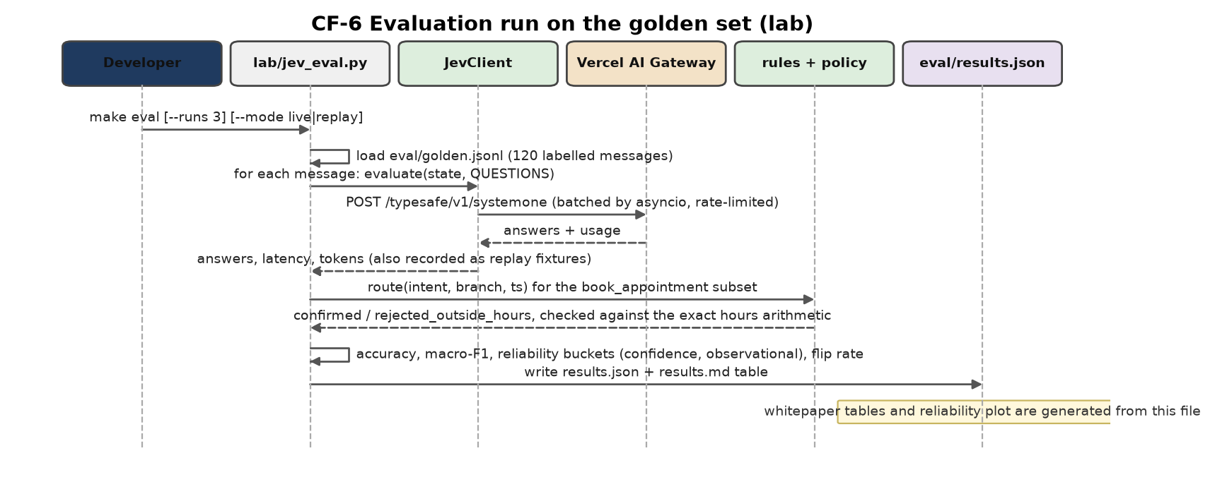
Figure 10. CF-6 sequence.
Output | Computed as | Used in
Accuracy, macro-F1 per question | Predicted choice or rounded score vs hand label, for all six questions | Whitepaper comparison table
Reliability plot | Confidence bucket vs observed accuracy — an observational study; Phase 1 does not act on confidence | Calibration section
Policy regression check | For every book_appointment message: does the rule's confirmed/rejected outcome match the exact hours arithmetic | Correctness, not a model evaluation
Latency p50/p95, tokens per call, cost | From JevClient measurements and gateway cost metadata | Cost section
Flip rate | Answers that change across three runs | Self-consistency section

CF-7 Deployment on git push
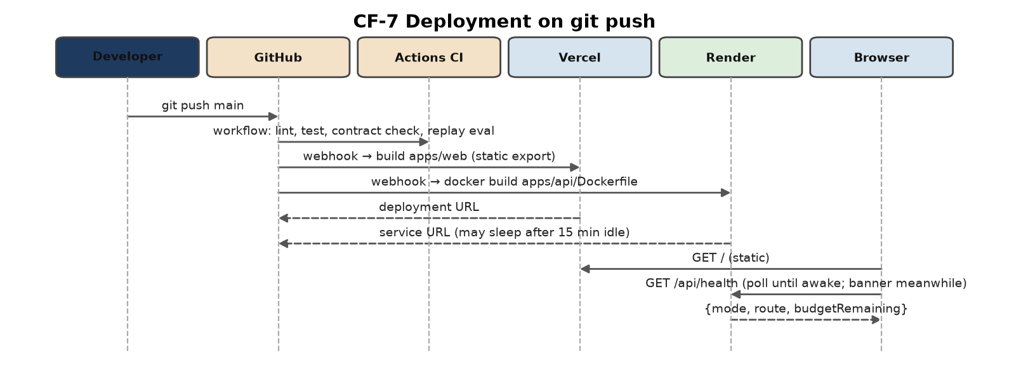
Figure 11. CF-7 sequence.

11. Deployment view
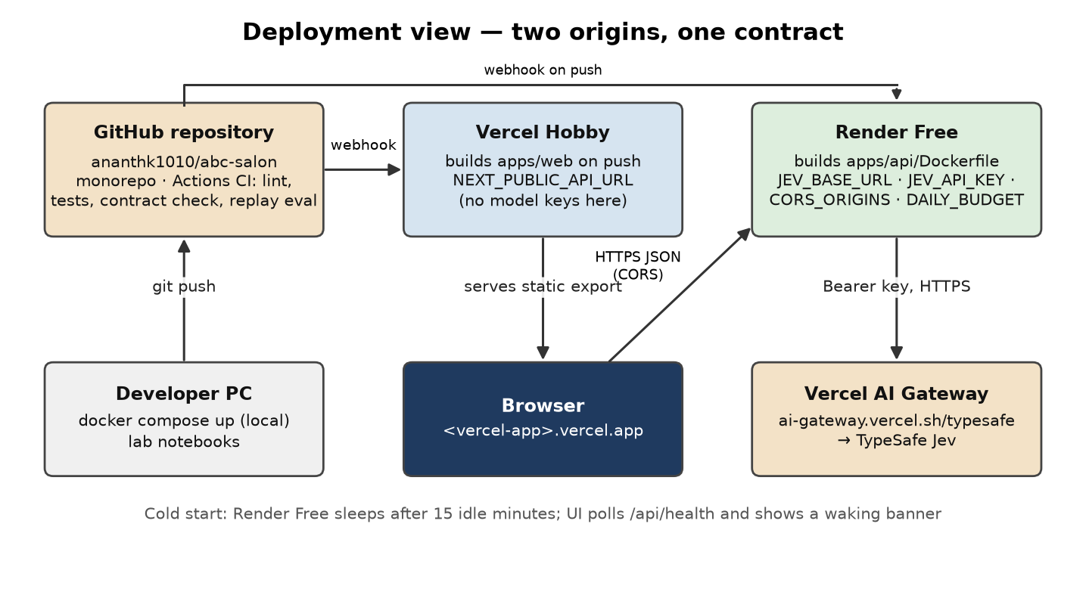
Figure 12. Deployment view. Two origins, one generated contract.

11.1 Environment variables and secrets
Variable | Where | Purpose | Secret?
NEXT_PUBLIC_API_URL | Vercel | Base URL of the Render API | No
JEV_BASE_URL | Render | https://ai-gateway.vercel.sh/typesafe (or TypeSafe direct later) | No
JEV_API_KEY | Render | AI Gateway API key | Yes
JEV_MODEL | Render | typesafe-ai/jev (or jev-latest for TypeSafe direct) | No
JEV_MODE | Render, CI | auto | live | replay | No
DAILY_BUDGET_TOKENS | Render | Daily input-token cap before replay mode | No
RATE_LIMIT_PER_MIN | Render | Per-IP limit on classify | No
CORS_ORIGINS | Render | Vercel production and preview origins | No
No LLM provider key exists in Phase 1's environment. ANTHROPIC_API_KEY and AGENT_ENABLED are Phase 2 additions; see section 14.

11.2 Operational notes
- Render Free sleeps after 15 idle minutes and takes about a minute to wake. The UI polls /api/health and shows a banner. No uptime pinger is used because it burns the 750 free instance-hours.
- The container disk is ephemeral. The audit store is a session cache; the evaluation reads the exported JSON, and Phase 2 introduces hosted Postgres.
- The API image contains FastAPI, httpx, Pydantic, PyYAML and SQLite only. AutoGluon, PyTorch and scikit-learn live in the lab's own requirements file.
- A budget cap on the AI Gateway key in the Vercel dashboard is the last line of defence; the in-code daily budget is the first.

12. Cross-cutting concerns

12.1 Security
- No model key ever reaches the browser. The Vercel deployment holds no model secrets.
- Per-IP rate limiting on the classify endpoint, the only one that can cost money.
- No authentication in Phase 1 because there is no real data and no write path with external effect.

12.2 Privacy
- All data is synthetic; even so, the state builder strips names and phone numbers so the same code is safe with real data later.
- The gateway's zero-data-retention option is a Pro-plan feature and is not used in Phase 1; this is recorded in the whitepaper.

12.3 Observability and audit
- Every Decision stores the full question snapshot, answers, confidence map, policy version, mode, route, latency and tokens — including for the five questions Policy does not act on.
- The health endpoint exposes mode, route, remaining budget and policy version so a reviewer can see why a decision was replayed.
- Gateway cost metadata per call is captured when present.

12.4 Testing strategy
Level | What | Tooling | When
Unit | tiers, hours, state builder, question serialisation, JevClient error paths, policy's three outcomes | pytest, httpx MockTransport | Every push
Contract | OpenAPI regeneration and TypeScript drift | make contract, git diff | Every push
Evaluation | Golden set in replay mode | make eval | Every push
Smoke | Deployed UI loads a sample and shows a decision | Playwright, one test | Manual before sharing the URL
Live evaluation | Golden set against the gateway, three runs | make eval JEV_MODE=live | Milestone M3

13. Evaluation architecture
The evaluation is part of the architecture, not an afterthought, because the whitepaper's claims depend on it. The lab imports the same JevClient, rules and policy modules the API uses, so the numbers describe the deployed behaviour. The golden set of 120 hand-labelled synthetic messages includes deliberately ambiguous cases so that Jev's calibration can be studied even though Phase 1 does not act on confidence. The tabular churn experiment compares logistic regression, Mitra-v2 zero-shot (stretch), and Jev given the same row rendered as text; the expected result is that Jev is not the right tool for that task, which is the point of including it. Tier itself is never run through this or any model comparison — it stays out of scope for Jev per the owner's decision in section 2.2.

14. Extension points: Phase 2 and Phase 3
Everything in this section is deferred. Nothing here is built in Phase 1, including the Strands lab walkthrough that was originally optional in v1.0 of this document — it is recorded here so it is not lost, per the owner's “hold on Phase 2” instruction of 2026-09-30.
Proposal | What it adds | Depends on
Confidence-gated escalation | Reintroduce bands on Jev's intent confidence so a genuinely ambiguous message routes to a human queue instead of just being recorded | The reliability-plot work already done in Phase 1's evaluation (§13) — Phase 2 decides whether to act on confidence, having first measured in Phase 1 whether it is trustworthy
A salon-appropriate safety check | Redesigned from the removed mentions_medical question: an allergy to a hair or skin product, a treatment unsuitable during pregnancy | Reintroducing escalation, so there is somewhere for a flagged case to go
Manager Assistant | A Strands agent (strands-agents SDK, Anthropic model, custom tools only — lookup_customer, ask_jev, propose_task; never the harness's default shell/file/web tools) that drafts a proposal on an escalated task for a human to approve | Confidence-gated escalation existing first, to produce tasks for it to act on
Stylist and slot availability | Replace the flat branch-hours check with real capacity | Appointment and stylist-schedule data, which Phase 1 does not have
Tier-based priority queueing | Gold-tier customers get faster handling | A queue to prioritise, which Phase 1 does not have (only one outcome creates a task)
Active/lapsed signal | Reintroduce visit-recency tracking, separate from spend-based tier, if churn timing turns out to matter | None — straightforward addition to rules/
Appointment booking (Phase 2 core) | Task (booking_request) becomes an Appointment after an availability check; receptionist-assisted flow | Phase 1 complete and documented, per the original project brief
Mock WhatsApp adapter (Phase 2), real provider (Phase 3) | Interaction.channel = whatsapp_mock gets a real adapter interface; Phase 3 swaps in a real provider with explicit confirmation before sending | Phase 2 booking flow

15. Risks and verification items
Item | Type | Owner / milestone | Mitigation or check
Gateway TypeSafe-compatible response may omit confidence for choice and score | Verification | M1 | Inspect a real response; compute from probabilities if absent
Minimum AI Gateway credit top-up amount | Verification | M0 | Visible at purchase in the Vercel dashboard
Render Free may require a card at signup | Verification | M0 | If so, evaluate Cloud Run always-free tier (billing account required)
Jev availability and SDK changes (released mid-September 2026) | Risk | Ongoing | Pinned versions, env-driven base URL, fixtures
512 MB RAM on Render | Risk | M2 | Slim image; measure RSS; no ML libraries
Synthetic data limits claims | Risk | M4 | Stated in every document
Mitra-v2 install on Windows | Risk | M3 (stretch) | WSL2 or Colab
Two runtimes raise setup cost for reviewers | Risk | M2 | docker compose up is the only documented way to run it
A reviewer expects Jev to explain the tier decision | Risk | M4 | Whitepaper states explicitly, with the exact rule, why tier is deterministic code and not a model call

16. Glossary
Term | Meaning
Jev | TypeSafe AI's System One model: evaluates typed questions against a state and returns structured answers with probabilities and confidence; it does not generate text.
System One model | TypeSafe's term for a model built for fast structured judgement rather than text generation.
State | The data Jev judges: a string, object or array. In ABC-Salon, the customer id and tier, recent visits, the message and branch context.
Choice / Score / Noul | Jev's three question primitives: pick one option; place on an ordered scale; answer yes/no as a probability.
Confidence | A 0 to 1 statistic of how peaked an answer's probability distribution is. Not the top probability. Computed and shown in Phase 1, but not acted on.
Tier | new / copper / bronze / silver / gold. A deterministic rule on the customer's last visit spend in rupees, not a Jev question.
Speculative fan-out | Asking every possibly relevant question in one call and letting code decide what to use.
Replay mode | Serving recorded Jev answers from fixtures instead of calling the model.
Mitra-v2 | Amazon's tabular foundation model (AutoGluon), Apache-2.0; classifies labelled tables, not text.
Strands Harness | AWS open-source, fully assembled agent built on the Strands Agents SDK; needs an LLM provider. A Phase 2 proposal, not built in Phase 1.
Vercel AI Gateway | Vercel's model gateway; exposes a TypeSafe-compatible endpoint for Jev billed at provider list price.
Golden set | Hand-labelled evaluation messages in eval/golden.jsonl.

Appendix A. Sources verified
Checked on 24 and 25 September 2026.
- TypeSafe AI docs: docs.typesafe.ai/introduction, /introduction/quickstart, /primitives, /confidence, /patterns, /patterns/intent-routing.md, /api.md, /sdk/javascript.md, /sdk/python.md
- TypeSafe AI blog: typesafe.ai/blog/introducing-system-one-models-and-jev; PyPI typesafe-sdk 0.7.1
- Vercel: vercel.com/docs/ai-gateway/sdks-and-apis/typesafe; /docs/ai-gateway/modalities/evaluation; /docs/ai-gateway/pricing; /ai-gateway/models?freeTier=true; changelog on TypeSafe-compatible API; kb/guide/typesafe-jev-and-ai-sdk
- Cloudflare: developers.cloudflare.com/ai/models/typesafe/jev/; /workers-ai/platform/pricing/
- Strands: github.com/strands-agents/harness-sdk; strandsagents.com/docs/user-guide/harness/; PyPI strands-harness
- Mitra-v2: huggingface.co/autogluon/mitra-classifier-2; auto.gluon.ai tabular foundational models tutorial
- Hosting: huggingface.co/docs/hub/en/spaces-overview and spaces-sdks-docker; huggingface.co/pricing; render.com/docs/free and /docs/docker; docs.fly.io/about/pricing; docs.cloud.google.com/free/docs/free-cloud-features
- Reference salon site (structure only): eleggancespa.com

