POWER
9-30V DC IN
Wi-Fi
NA
CELLULAR
4G/3G/2G with Dual SIM, External 5DBi antennas
PROCESSOR
MediaTek MT7628, 128/256MB DDR2 RAM, 32MB Flash, 4GB eMMC
IAB04-C

DATA SHEET

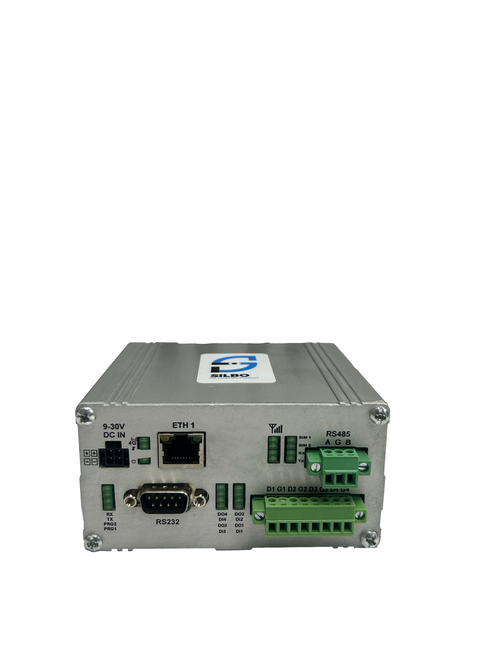
PRODUCT INFO

INTERFACE
2x LAN/WAN 10/100, 1x RS485, 1x RS232, Optional Inaterfaces ( 4x DI/O, 2x AI(1x Analog Current, 1x Analog Voltage),1x USB-H)

OPERATING SYSTEM
Open-WRT Linux

Hardware Speciﬁcation
CPU | MediaTek MT7628, 580 MHz CPU
RAM | 128MB
FLASH | 32MB
LAN | 1x 10/100 Mbps
Serial Interface | 1x RS485, 1x RS232
IO’s | 4x DI/O, 2x AI (Optional)
USB | 1x USB-H (Optional)
SIM | 2x Nano SIM (1x Active & 1x Passive)
RTC | Built-in RTC
Reset | Pinhole Reset Button
Antenna | Cellular: 2x SMA Connector
Status LED | 1x Power, 2x Cellular, 1x ACT, 1x Ethernet, Signal Strength, 2x Rx, 2x Tx, Optional (4x DI/O).
Power Connector | Molex 4-pin Snug fit connector
Input Voltage Range | 9-30 Vdc
Power Adapter | N/A
Enclosure | Industrial Aluminium Enclosure
Mounting | DIN rail mounting Kit (Optional)
Design | Fanless
Dimensions | 110 x 44 x 94 mm (W x H x D)
Weight | 400 gm
Other | Grounding Screw

Storage Temperature | -30 ~ 70 ˚C
Operating Temperature | -20 ~ 60 ˚C
Humidity | 10 ~ 90% (non-condensing)
Operational & Environmental

SOFTWARE SPECIFICATIONS
Cellular
Cellular Module | 4G (LTE) - Cat 4 up to 150 Mbps, 3G - up to 42 Mbps, 2G - up to 236.8 Kbps
Status | Single strength (RSSI), SINR, RSRP, RSRQ
Band Management | Auto/User configurable
Operator Lock | Automatic/Mannual
APN | Configurable, Auto APN
Modem conﬁguration mode | Single SIM, Dual SIM
SIM switching | Signal strength, ICMP echo, Data limit based
PDP Type | IPv4, IPv6, IPv4v6
SIM Authentication | PAP,CHAP, No Authentication
SMS | Send SMS, Read SMS, SMS Commands

Firewall & Networking
Routing | Static routing, Advanced Static Routing
Network Protocols | TCP, UDP, IPv4, IPv6, ICMP, NTP, HTTP, HTTPS, SCP, PPP, SSH, DHCP
Connection Monitoring | Ping Reboot, Scheduled Periodic Reboot
Firewall features | Port forward, trafﬁc rules, SNAT, Zone forwarding, Parental Control, Masquerading, MSS Clamping, Loopback IP, Loopback Rules.
Attack Prevention | SYN Flood Protection, Drop Invalid Packets
DHCP | Static and Dynamic
Multi-WAN Conﬁguration | Conﬁgurable Failover, load balancing between Cellular WAN, and Wired.
VLAN | Tagged VLAN, Untagged VLAN
VPN | Open VPN, IPsec, GRE, L2TP, PPTP, Wireguard, Zero Tier, IPIP Tunnel
Open VPN | TUN/TAP with TLS Certiﬁcates
IPsec | IKEv1, IKEv2, Aggressive/Main Mode
IPsec Encryption | 3DES, AES128, AES192, AES256
IPsec Authentication | SHA1, MD5, SHA256, SHA384, SHA512
IPsec DH Group | MODP768, MODP1024, MODP1536, MODP2048, MODP3072, MODP4096
PPTP/L2TP | Server & Client with/without MPPE Encryption
Monitoring Application | Modem Monitoring with ICMP Echo, Router Monitoring with ICMP Echo
Time Synchronization | NTP Client, RTC, Manual
Diagnostic | Ping, Traceroute, Modem Debug Info, Iperf, Download Logs
Other Features | MAC binding, Connection Diagnostics, URL Filtering, Router Health Monitoring, Package Manager

Remote Management

NMS | Remote Monitoring & Management Platform for SILBO Networking products
NMS VPN | Remote Access of SILBO and non-SILBO Networking Devices
TR069 | TR069 Client for CPE Management
SMS Commands | Reboot Command, Uptime Command

Gateway

Gateway Protocols | Modbus TCP Slave, Modbus TCP Master, Modbus RTU
Serial Mode | Transparent (Over IP), Modbus Gateway
Data sender | HTTP, MQTT, Azure MQTT

Operating System

Operating System | Open-WRT based Linux OS
Supported Languages | Shell scripting, C, C++
Development tools | SDK package with built environment provided (Optional)

Standard Packaging

IAB04-C Cellular Gateway with Industrial Aluminium Housing , 2x Cellular Rubber Duck Antennas, 2x Wi-Fi Rubber Duck Antennas, 0.5-meter Power Cord, 01-meter Ethernet cable.

SPATIAL MEASUREMENT:
Top View
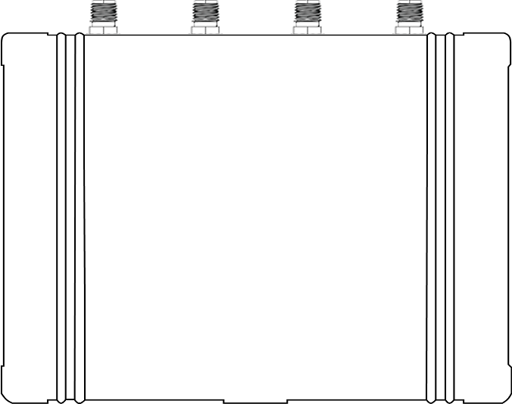
94 mm

110 mm

Front View
110 mm

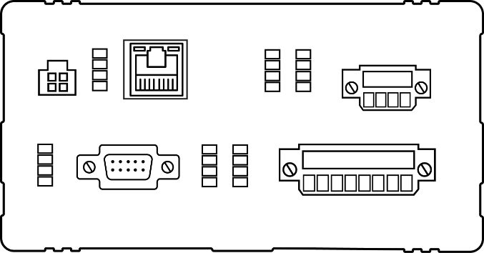
44 mm

Rear View

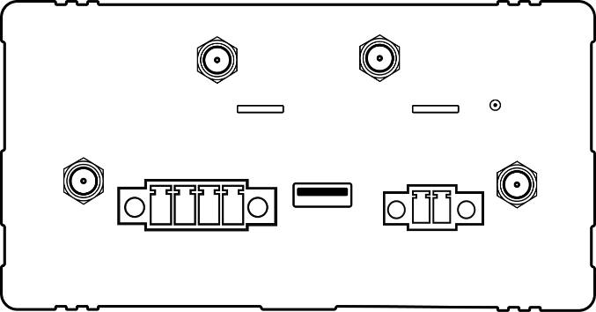
44 mm

110 mm

*All rights reserved, subject to change without prior notice.
Get in touch:
sales@invendis.com
www.silbonetworks.com
Invendis Technologies India Private Limited
No. 230, 1st Cross, 38th Main, BOOHBCS Layout, BTM 2nd Stage, Bangalore – 560 068






