POWER
Active PoE IN (IEEE 802.3af/at (48V-57V))
INTERFACE
1x 10/100/1000 (External) with PoE IN, 1 x 10/100/1000 internal for configuration
Wi-Fi
NA
PROCESSOR
MediaTek MT7621, 512MB DDR RAM, 32MB RAM

ODU-MT7621-01

DATA SHEET

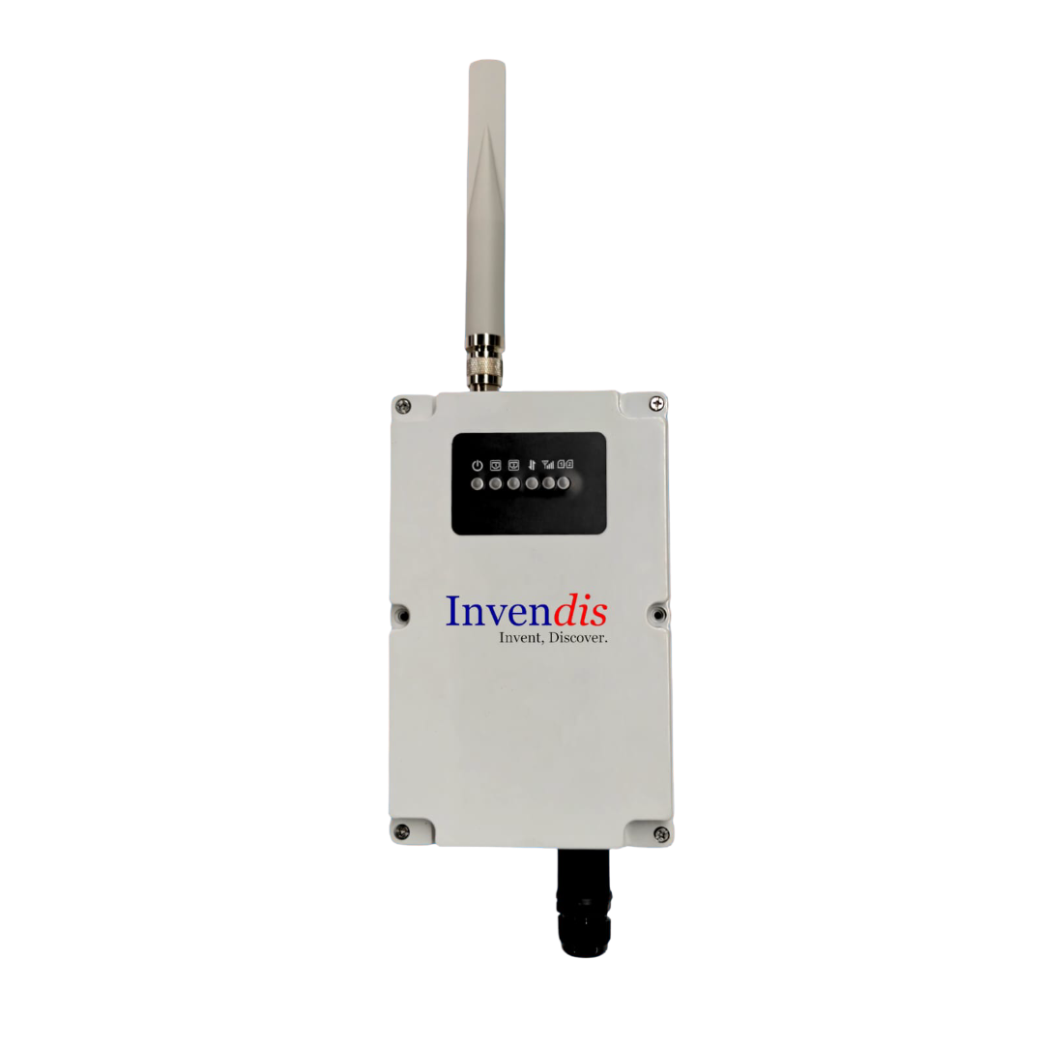

PRODUCT INFO

CELLULAR
4G/3G/2G with Dual SIM Active/Passive, Two Antennas , One IP66 External 5dBi main antenna and one 5dBI auxiliary internal Flexi Antenna

OPERATING SYSTEM
Open-WRT Linux

Hardware Speciﬁcation
CPU | MediaTek MT7621
RAM | 512MB
FLASH | 32MB
Ethernet | 1x 10/100/1000 (External) with PoE IN, 1 x 10/100/1000 internal for configuration
Cellular | 1x Onboard Quectel EC200A LTE 4G module
SIM | 2x Nano SIM with Tray (1x Active & 1x Passive)
Wi-Fi | NA
Reset | Pinhole Reset Button
Antenna | Cellular: 1x N Type Connector, 1x UFL connector
Status LED | 1x Power, 2 X Ethernet, 1 X LTE Activity, 1 X RGB LED to indicate Signal Strength, 1 X Dual Color SIM Presence
Power Connector | PoE in
Input Voltage Range | IEEE 802.3 af/at(48V-57V)
Power Adapter | No
Enclosure | ABS/PC IP66 Housing
Mounting | WALL Mount, Poll Mount
Design | Fanless
Dimensions | 140 x 75 x 224 mm (W x H x D)
Weight | 950 gm

Operational & Environmental
Storage Temperature | -20 ~ 60 ˚C
Operating Temperature | -0 ~ 50 ˚C
Humidity | 10 ~ 90% (non-condensing)

SOFTWARE SPECIFICATIONS
Cellular
Cellular Module | 4G (LTE) - Cat 4 up to 150 Mbps, 3G - up to 42 Mbps, 2G - up to 236.8 Kbps
Status | Single strength (RSSI), SINR, RSRP, RSRQ
Band Management | Auto/User configurable
Operator Lock | Automatic/Mannual
APN | Configurable, Auto APN, Dual APN (Under Development)
Modem conﬁguration mode | Single SIM, Dual SIM
SIM switching | Signal strength, ICMP echo, Data limit based
PDP Type | IPv4, IPv6, IPv4v6
SIM Authentication | PAP,CHAP, No Authentication
Passthrough | IP Passthrough (Under Development)
SMS  Firewall & Networking | Send SMS, Read SMS, SMS Commands

Routing | Static routing, Advanced Static Routing
Network Protocols | TCP, UDP, IPv4, IPv6, ICMP, NTP, HTTP, HTTPS, SCP, PPP, SSH, DHCP
Connection Monitoring | Ping Reboot, Scheduled Periodic Reboot
Firewall features | Port forward, trafﬁc rules, SNAT, Zone forwarding, Parental Control, Masquerading, MSS Clamping, Loopback IP, Loopback Rules.
Attack Prevention | SYN Flood Protection, Drop Invalid Packets
DHCP | Static and Dynamic
Multi-WAN Conﬁguration | Conﬁgurable Failover, load balancing between Cellular WAN, Wi-Fi WAN and Wired.
VLAN | Tagged VLAN, Untagged VLAN
VPN | Open VPN, IPsec, GRE, L2TP, PPTP, Wireguard, Zero Tier, IPIP Tunnel
Open VPN | TUN/TAP with TLS Certiﬁcates
IPsec | IKEv1, IKEv2, Aggressive/Main Mode
IPsec Encryption | 3DES, AES128, AES192, AES256
IPsec Authentication | SHA1, MD5, SHA256, SHA384, SHA512
IPsec DH Group | MODP768, MODP1024, MODP1536, MODP2048, MODP3072, MODP4096
PPTP/L2TP | Server & Client with/without MPPE Encryption
Monitoring Application | Modem Monitoring with ICMP Echo, Router Monitoring with ICMP Echo
Time Synchronization | NTP Client, RTC, Manual
Diagnostic | Ping, Traceroute, Modem Debug Info, Iperf, Download Logs
Other Features | MAC binding, Connection Diagnostics, URL Filtering, Router Health Monitoring, Package Manager
Remote Management
NMS | Remote Monitoring & Management Platform for SILBO Networking products
NMS VPN | Remote Access of SILBO and non-SILBO Networking Devices
TR069 | TR069 Client for CPE Management
SMS Commands | Reboot Command, Uptime Command

Operating System

Operating System | Open-WRT based Linux OS
Supported Languages | Shell scripting, C, C++
Development tools | SDK package with built environment provided (Optional)  Standard Packaging

ODU-MT7621-01 Outdoor Cellular Router with ABS/PC IP66 Housing , 1x External Antenna, 1 internal antenna, Mounting Kit.

*Star-marked features on the SILBO ODU-MT7621-Outdoor cellular router are accessible only after opening Top panel/ cover of the IP66 housing.

SPATIAL MEASUREMENT:
Top View

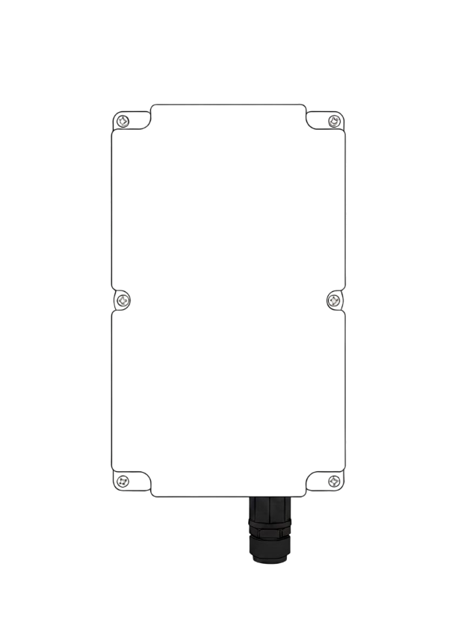
224 mm

140 mm mm

*All rights reserved, subject to change without prior notice.
Get in touch:
sales@invendis.com
www.silbonetworks.com
Invendis Technologies India Private Limited
No. 230, 1st Cross, 38th Main, BOOHBCS Layout, BTM 2nd Stage, Bangalore – 560 068






