POWER
9-30 DC IN
INTERFACE
4x LAN 10/100/1000, 1x WAN 10/100/1000
Wi-Fi
NA
CELLULAR
Single Modem 4G/3G with Dual SIM, External 5dBi antenna
PROCESSOR
MediaTek MT7981,1GB DDR RAM, 128MB NAND
RT04-1

DATA SHEET

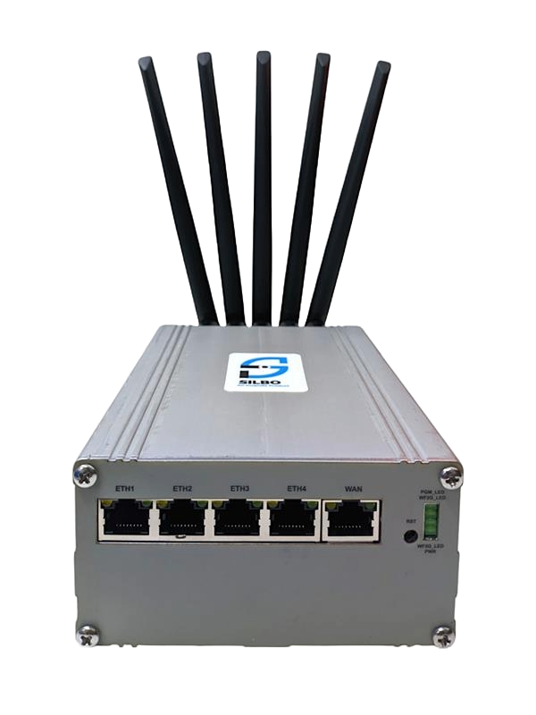
PRODUCT INFO

OPERATING SYSTEM
Open-WRT Linux

Hardware Speciﬁcation
CPU | MediaTek MT7981
RAM | 1GB
FLASH | 128MB NAND
WAN | 1x 10/100/1000
LAN | 4x 10/100/1000
Serial Interface | NA
SIM | NA
Wi-Fi | 802.11 b/g/n/ac/ax
RTC | Built-in RTC
Reset | Pinhole Reset Button
Antenna | Wi-Fi: 5x SMA connector
Status LED | 1x Power, 1x Wi-Fi 5G, 1x Wi-Fi 2G, 5x Ethernet
Power Connector | DC Jack
Input Voltage Range | 9-30 Vdc
Power Adapter | YES
Enclosure | Industrial Aluminium Enclosure
Mounting | DIN rail mounting Kit (Optional)
Design | Fanless
Dimensions | 110 x 55 x 144 mm (W x H x D)
Weight | 480 gm
Other | Grounding Screw

Storage Temperature | -30 ~ 70 ˚C
Operating Temperature | 0~ 50 ˚C
Humidity | 10 ~ 90% (non-condensing)
Operational & Environmental

SOFTWARE SPECIFICATION
Wi-Fi
Technology | 802.11 b/g/n/ac/ax
Channel Selector | Auto/Configurable
Channel Width | 20 MHz, 20/40/80/160 MHz
Wi-Fi Mode | Access Point (AP), Station, AP & Client, Guest Wi-Fi
TX Power | Configurable
Authentication | WPA (PSK), WPA2 (PSK), WPA3 (PSK), WPA & WPA2 Mixed Mode, WPA2 & WPA3 Mixed Mode
Encryption | TKIP, AES, TKIP & AES
Wi-Fi Scheduler | Scheduled ON/OFF
MAC ID Filtering | Whitelisting, Blacklisting
Other | WMM (Enabled/Disabled)

Routing | Static routing, Advanced Static Routing
Network Protocols | TCP, UDP, IPv4, IPv6, ICMP, NTP, HTTP, HTTPS, SCP, PPP, SSH, DHCP
Connection Monitoring | Ping Reboot, Scheduled Periodic Reboot, Hardware Watchdog (Enable / Disable)
Firewall features | Port forward, trafﬁc rules, SNAT, Zone forwarding, Parental Control, Masquerading, MSS Clamping, Loopback IP, Loopback Rules.
Attack Prevention | SYN Flood Protection, Drop Invalid Packets
DHCP | Static and Dynamic
Multi-WAN Conﬁguration | Conﬁgurable Failover, load balancing between Wi-Fi WAN and Wired.
VLAN | Tagged VLAN, Untagged VLAN
VPN | Open VPN, IPsec, GRE, L2TP, PPTP, Wireguard, Zero Tier, IPIP Tunnel
Open VPN | TUN/TAP with TLS Certiﬁcates
IPsec | IKEv1, IKEv2, Aggressive/Main Mode
IPsec Encryption | 3DES, AES128, AES192, AES256
IPsec Authentication | SHA1, MD5, SHA256, SHA384, SHA512
IPsec DH Group | MODP768, MODP1024, MODP1536, MODP2048, MODP3072, MODP4096
PPTP/L2TP | Server & Client with/without MPPE Encryption
Monitoring Application | Modem Monitoring with ICMP Echo, Router Monitoring with ICMP Echo
Time Synchronization | NTP Client, RTC, Manual
Diagnostic | Ping, Traceroute, Modem Debug Info, Iperf, Download Logs
Other Features | MAC binding, Connection Diagnostics, URL Filtering, Router Health Monitoring, Package Manager
Firewall & Networking
Remote Management
NMS | Remote Monitoring & Management Platform for SILBO Networking products
NMS VPN | Remote Access of SILBO and non-SILBO Networking Device
TR069 | TR069 Client for CPE Management
SMS Commands | NA

Operating System

Operating System | Open-WRT based Linux OS
Supported Languages | Shell scripting, C, C++
Development tools | SDK package with built environment provided (Optional)
Standard Packaging

RT04-1 Cellular Router with Industrial Aluminium housing, 5x Wi-Fi Rubber Duck Antennas, Power Adapter, 01-meter Ethernet cable.

SPATIAL MEASUREMENT:
Top View

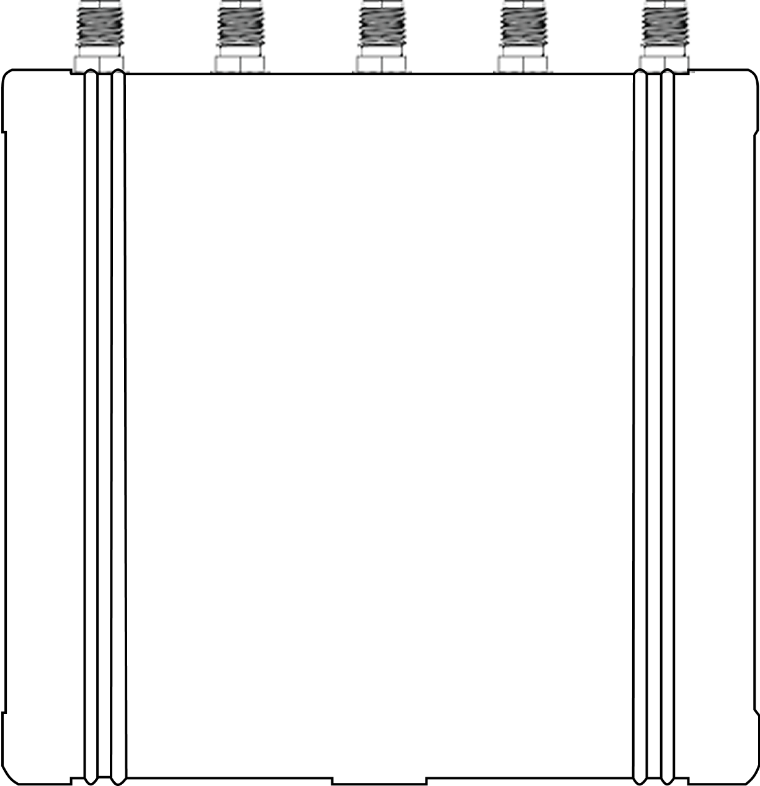

144 mm

110 mm

110 mm

Front View


55 mm

110 mm

Rear View


55 mm

s

*All rights reserved, subject to change without prior notice.
Get in touch:
sales@invendis.com
www.silbonetworks.com
Invendis Technologies India Private Limited
No. 230, 1st Cross, 38th Main, BOOHBCS Layout, BTM 2nd Stage, Bangalore – 560 068






