**Tech Saksham**

Case study Report

Data Analytics with Power BI

**“360-Degree Business Analysis of Online**

**Delivery Apps using Power BI”**

**“Kamaraj College”**

|  |  |
| --- | --- |
| **NM ID** | **NAME** |
|  |  |

Trainer Name : Arockia Jeyanthi

Master Trainer : R. Umamageshwari

**ABSTRACT**

The analysis will delve into the online delivery app industry using Power BI for data visualization and exploration. By creating a comprehensive dashboard, we can gain valuable insights into various aspects of the business. This involves comprehensive examination across multiple dimensions. It encompasses sales performance tracking, customer segmentation, delivery efficiency analysis, operational optimization, marketing effectiveness evaluation competitor benchmarking, financial scrutiny, supply chain management, regulatory compliance monitoring, and predictive analytics. By leveraging Power BI’s abstraction capabilities, business can extract valuable insights, enabling data-driven decision-making to enhance overall performance, efficiency and customer satisfaction in the dynamic landscape of online delivery services.

**INDEX**

|  |  |  |
| --- | --- | --- |
| **S. No.** | **Table of Contents** | **Page No.** |
| 1 | Chapter 1: Introduction | 4 |
| 2 | Chapter 2: Services and Tools Required | 6 |
| 3 | Chapter 3: Project Architecture | **7** |
| 4 | Chapter 4: Modelling and Result | 10 |
| 5 | Conclusion | 15 |
| 6 | Future Scope | 16 |
| 7 | Reference | 17 |
| 8 | Links | 18 |

**CHAPTER 1**

**INTRODUCTION**

* 1. **Problem Statement:**

In today's rapidly evolving digital landscape, online apps have become a cornerstone of businesses across various industries, offering convenience, accessibility, and efficiency to users. However, amidst the proliferation of online apps, businesses face numerous challenges in effectively leveraging these platforms to achieve their objectives. Key issues include identifying target demographics, optimizing user experience, maximizing revenue streams, staying ahead of technological advancements, and navigating regulatory and security concerns. Without a comprehensive understanding of these challenges and effective strategies to address them, businesses risk inefficiency, stagnation, and even failure in an increasingly competitive market. Thus, there is a critical need for a thorough business analysis of online apps to identify opportunities, mitigate risks, and drive sustainable growth.

**1.2 Proposed solution:**

The proposed solution is to develop a PowerBI dashboard that can analyze and visualize real-time online delivery fact data. The dashboard will integrate data from various sources such as fact table, country codes, and . It will provide a comprehensive view of customer preferences,which country uses more delivery services ,food ratings, and price range. The dashboard will be interactive, user-friendly, and customizable, allowing customer to tailor it to their specific needs. The real-time analysis capability of the dashboard will enable to respond promptly to changes in customer likes or preferences, identify opportunities for cross-selling and up-selling, and tailor their products and services to enhanced their styles.

**1.3 Features:**

**Predictive Analytics:** Incorporate predictive analytics models into Power BI to forecast future demand, identify potential churn risk among customers, and optimize resource allocation.

**Customer Segmentation**: Use Power BI to segment customers based on various attributes such as location, ordering frequency, order value, and preferred cuisine types. Understanding different customer segments can help in targeting marketing efforts and tailoring services to specific customer needs.

**Market Analysis**: Utilize Power BI to analyze market trends and competitive landscape. This could involve visualizing market share, customer acquisition trends, and comparing the performance of your online delivery app against competitors.

**1.4 Advantages:**

**Customer Understanding:** Analyzing customer data allows businesses to gain a deeper understanding of their target audience's behavior, preferences, and demographics. This insight enables personalized marketing strategies, tailored product offerings, and enhanced customer experiences, driving loyalty and retention.

**Strategic Planning**: Business analysis helps businesses identify strengths, weaknesses, opportunities, and threats (SWOT analysis), guiding strategic planning and decision-making processes.

**Risk Management** : Business analysis helps businesses identify and mitigate risks such as market volatility, regulatory changes, and supply chain disruptions. By proactively addressing potential threats, businesses can minimize their impact and maintain stability in uncertain environment.

**1.5 Disadvantages:**

**Risk of Data Overload:** With access to vast amounts of data, there's a risk of information overload, where businesses become overwhelmed by the sheer volume of data available.

**Cost of Implementation**:Implementing a comprehensive business analysis solution can still incur significant costs. This includes expenses related to software licenses, infrastructure, training, and on going support.

**1.6 Scope:**

**Future Outlook**: Forecasting future trends and developments in the online delivery market, including technological advancements, changing consumer preferences, regulatory changes, and competitive dynamics.

**Customer Experience**: Analyzing the end-to-end customer experience, including user interface design, ease of ordering, delivery speed, order accuracy, customer support, and satisfaction levels.

**Operational Efficiency**: Evaluating the operational efficiency of online delivery apps, including order processing, delivery logistics, driver management, inventory management, and fulfillment processes.

**CHAPTER 2**

**SERVICES AND TOOLS REQUIRED**

**2.1 Service used:**

1. **Data Integration Services:** Services for data integration are crucial for collecting and consolidating data from various sources such as transactional databases, customer feedback platforms, delivery tracking systems, and market research databases. Tools like Microsoft Power Automate, Azure Data Factory, or third-party services like Zapier can be used for seamless data integration.
2. **Data Warehousing**: Storing and organizing data efficiently is essential for performing analytics effectively. Data warehousing services such as Azure Synapse Analytics or Amazon Redshift can be used to store large volumes of structured and unstructured data for analysis.
3. **Cloud Storage**: Cloud storage solutions like Azure Blob Storage or Amazon S3 can be used to store raw data, intermediate data, and processed datasets securely, making it accessible for analysis by Power BI and other tools.
4. **Machine Learning Services**: Integrating machine learning models into the analysis pipeline can provide predictive analytics capabilities for tasks such as demand forecasting, customer segmentation, and route optimization. Azure Machine Learning or Amazon SageMaker are examples of machine learning services that can be integrated with Power BI.

**2.2 Tools & Software used :**

**Tools:**

* **PowerBI:** The main tool for this project is PowerBI, which will be used to create interactive dashboards for real-time data visualization.
* **Power Query:** This is a data connection technology that enables us to discover, connect, combine, and refine data across a wide variety of sources.

**Software Requirements:**

* **PowerBI Desktop:** This is a Windows application that we can use to createreports and publish them to PowerBI.
* **PowerBI Service:** This is an online SaaS (Software as a Service) service that we use to publish reports, create new dashboards, and share insights.
* **PowerBI Mobile:** This is a mobile application that we can use to access your reports and dashboards on the go.

**CHAPTER 3**

**PROJECT ARCHITECTURE**

**3.1 Architecture**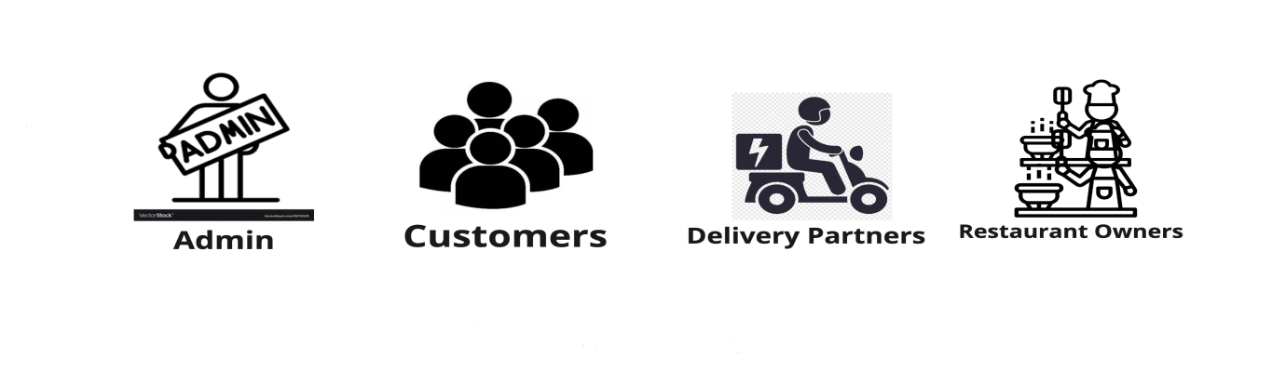

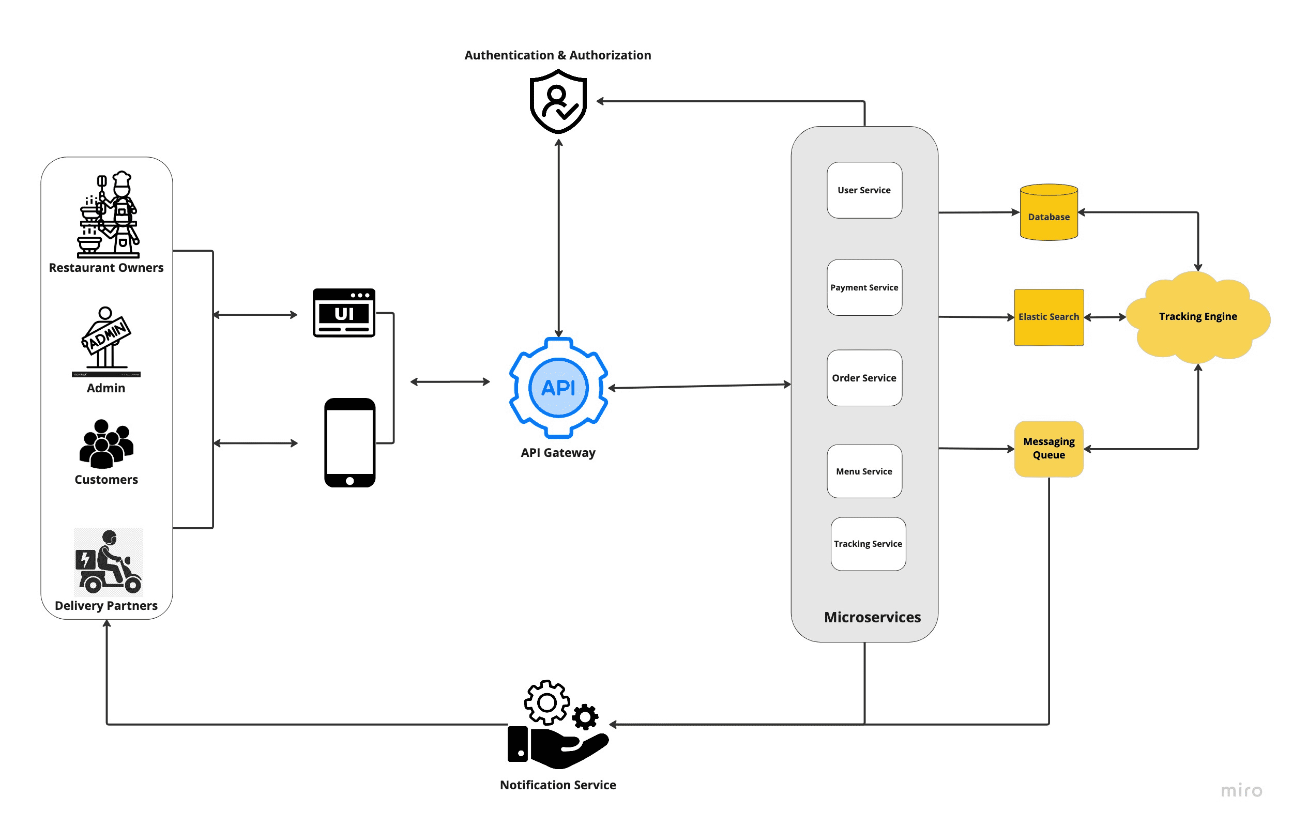

Here’s a architecture for the project:

1. **User Interfaces (UIs):**
   * Customer App: Interface for browsing restaurants, placing orders, tracking deliveries, and managing accounts.
   * Restaurant App: Interface for managing menus, receiving orders, tracking deliveries, and communication with drivers.
   * Driver App: Interface for accepting deliveries, navigating to locations, and managing communication with customers and restaurants.
   * Admin Panel: Web interface for managing the platform, including managing restaurants, drivers, promotions, analytics, and financials.
2. **Business Logic:**
   * Order Management: Processes customer orders, assigns them to restaurants, and facilitates communication between parties.
   * Delivery Management: Tracks driver location, optimizes routes, and assigns deliveries.
   * Payment Processing: Handles secure transactions between customers, restaurants, and the platform.
3. **Data Management:**
   * User Database: Stores user information, preferences, and order history.
   * Restaurant Database: Stores restaurant information, menus, locations, and ratings.
   * Driver Database: Stores driver information, location data, performance metrics, and availability.
   * Order Database: Stores order details, status, and communication logs.
4. **External Integrations:**
   * Mapping Services (e.g., Google Maps): Provides location data and route optimization.
   * Payment Gateways (e.g., Stripe, PayPal): Enables secure online transactions.
   * SMS/Push Notification Services: Facilitates communication between users, restaurants, and drivers.

**Analysis Techniques:**

* **Value Stream Mapping:** Identify the key activities involved in processing an order and delivering food, highlighting potential bottlenecks and opportunities for improvement.
* **Business Process Modelling:** Document the workflows for different user types (customer, restaurant, driver) to understand how they interact with the system.
* **Stakeholder Analysis:** Identify key stakeholders (customers, restaurants, drivers, platform) and their needs to ensure the business model caters to all parties.

By understanding this business architecture, you can effectively analysis online delivery apps and identify areas for improvement in efficiency, user experience, and overall value proposition.

**CHAPTER 4**

**MODELING AND RESULT**

**Manage relationship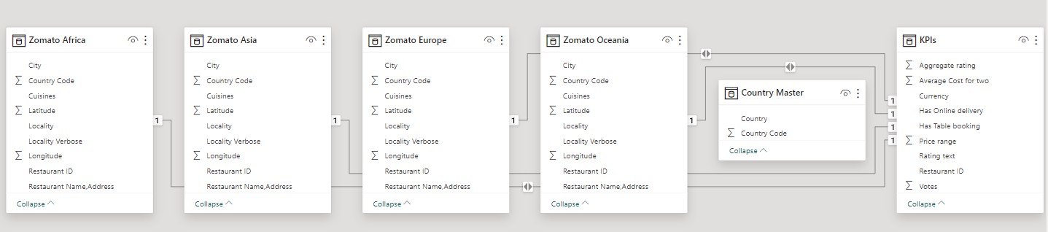:**

The “KPIs” file will be used as the main character as it contains most key identifier (Zomato Asia, Zomato Oceania, Zomato Europe, Zomato Africa) which can be use to relates the 6 data files together. The “country master” file is use to link the client profile geographically with “country code”.

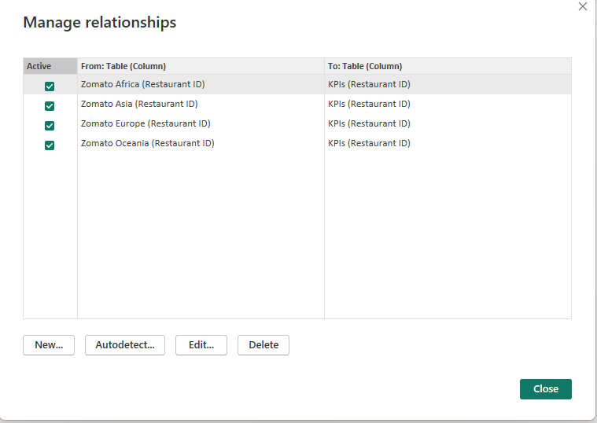

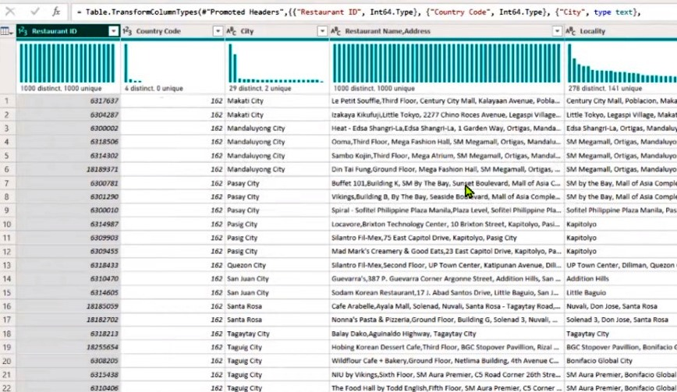

**Modelling for the data:**

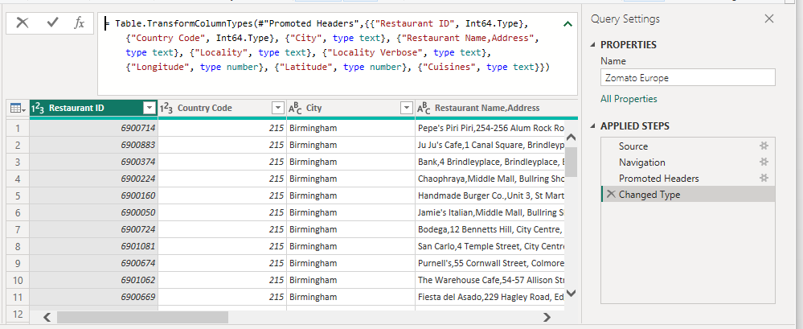

**Replacing the values:**

Set some fields to English for easy understanding, we replace the values to English with the

Power Query Editor.

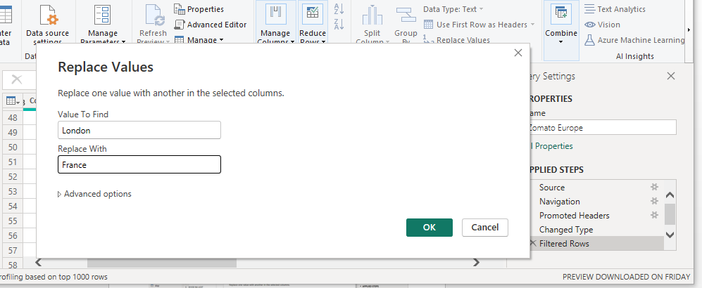

To replace the values “London” with “France” in a sentence

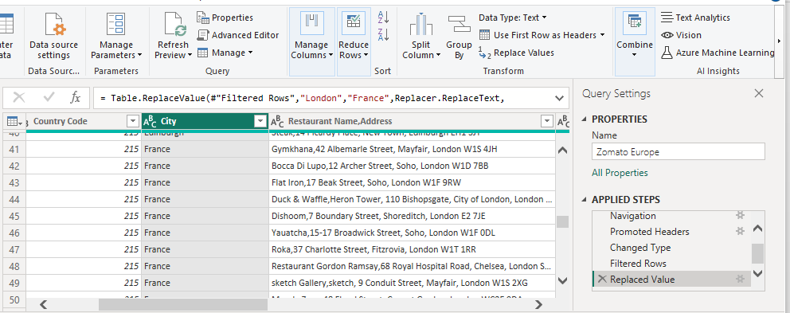

Changing the order of Town name at Power Query

Duplicate the “City/Town” then split column using space as delimiter

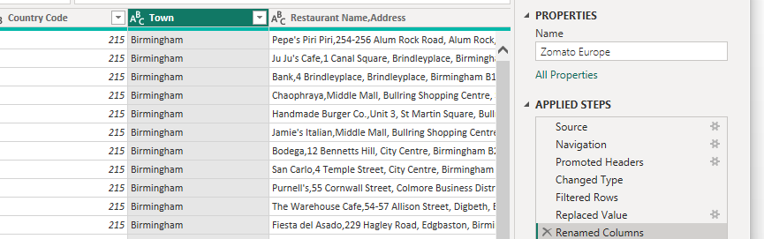

Then merge the Column by City and Locality. Refer to applied steps for details.

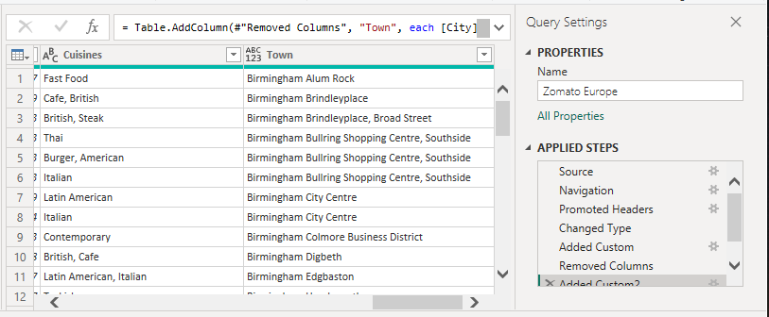

**Dashboard:**

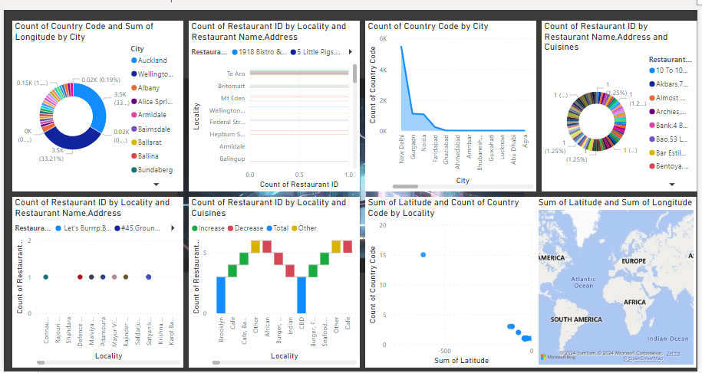

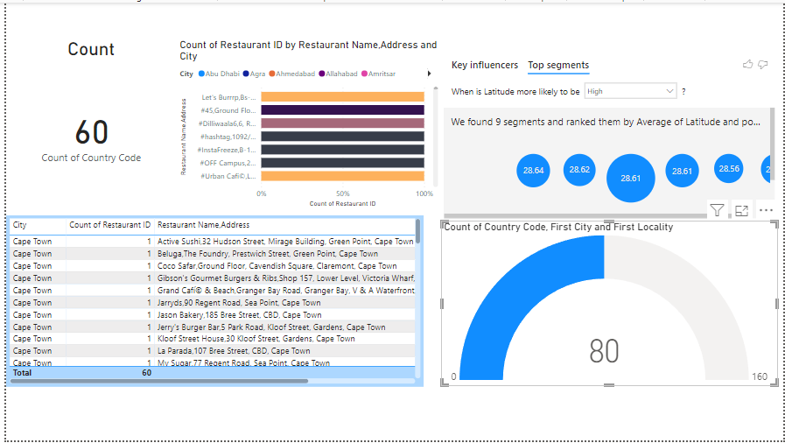

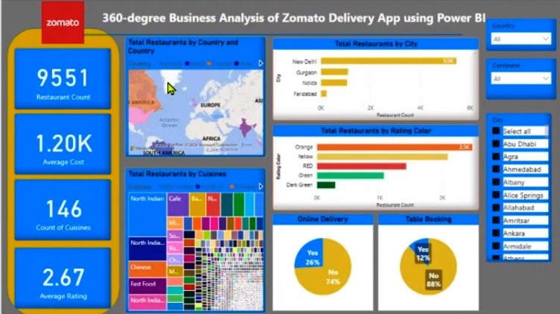

**CONCLUSION**

The project “360 degree business analysis of online delivery apps” using PowerBI has successfully demonstrated the potential of data analytics in the delivery through online apps. The business analysis of online delivery apps transformed the way consumers good service and convince never before. The interactive dashboard and reports have offered a comprehensive view of fact about delivery, ratings and scores .The project has also highlighted the importance of data visualization in making complex data more understandable and accessible. The use of PowerBI has made it possible to present data in a visually appealing and easy-to-understand format, thereby aiding in better decision-making. By adapting to evolving consumer preferences and leveraging emerging technology, online delivery apps can secure their position as indispensable components of modern commerce.

**FUTURE SCOPE**

Business analysis will focus on enhancing the overall customer experience by leveraging data insights to streamline ordering processes, improve delivery accuracy, and offer personalized recommendations. Technologies such as chatbots and virtual assistants will further enhance customer interactions and support services. The landscape of online delivery apps is dynamic and competitive, requiring continuous innovation and adaptation. With the growing emphasis on data privacy and security, business analysis for online delivery apps will prioritiz compliance with regulatory requirements such as GDPR and CCPA. Blockchain technology can enhance transparency and traceability in supply chains, while IoT devices can provide real-time tracking of deliveries and inventory.

**REFERENCE**

<https://pratapsharma.com.np/architecture-of-food-delivery-app>