CSE 598 Coding Assignment 3: LLM Serving Systems
  - Report
Ananth Sundararajan Sekar (ASU ID: 1237228176)
October 30, 2026

Part 0. Environment and Methodology

Hardware, software, model and precision
Item | Value
GPU | NVIDIA A100-SXM4-80GB on ASU Sol (MIG disabled, no other processes on the GPU)
Driver / max CUDA supported | 615.71.09 / CUDA 13.4
PyTorch (CUDA build) | 2.13.0+cu130 (CUDA 13.0), cuDNN 9.20.0
Transformers / vLLM / Python | 5.19.0 / 0.32.0 / 3.11.18
Model | gpt2 (124M parameters, 12 layers, 12 heads, head dim 64, 1024-token context)
Precision | FP16 for every run, Hugging Face and vLLM (vLLM forced to float16; its default was bfloat16)

Because gpt2 only has 1024 positions, every experiment keeps prompt + output ≤ 1024. Part 1 prompt lengths were changed from {128, 512, 1024} to {128, 256, 512, 768}, and the Part 4 workload prompts were capped at 512.

Methodology
- Timing: torch.cuda.synchronize() before and after every timed region (utils.time_cuda_safe).
- Warm-up: at least one untimed inference before measuring in every script (prompt 32 / output 4 in Parts 1–3; the first batch for static batching; a 4-request generate() for vLLM).
- Model loading: done before any timer starts, so it is never included in latency.
- Repetitions: every configuration was run 3 times and the mean is reported. Raw runs and standard deviations are in results/ (std was under 2% for almost all measurements).
- No early stop on EOS: Parts 1–3 decode a fixed number of steps; Part 4 uses min_new_tokens (Hugging Face) and ignore_eos=True (vLLM).
- Memory: torch.cuda.max_memory_allocated(), reset before each case. It includes the 0.232 GiB of FP16 weights and is lower than nvidia-smi, which also counts the CUDA context and cached-but-unused memory.
- Parts 2–4 used PYTORCH_CUDA_ALLOC_CONF=expandable_segments:True to avoid allocator fragmentation (explained in Part 2).

Question 0.1
CUDA kernels run asynchronously. model(input_ids) only queues the kernels and returns to Python before the GPU has finished, so end - start mostly measures launch overhead, not GPU execution. Work queued before start can also leak into the measurement. Calling torch.cuda.synchronize() before start makes sure the GPU is idle, and calling it again before end waits until the work is actually done. I checked this with an FP16 8192 × 8192 matmul: 0.084 ms without synchronization versus 4.528 ms with it. The synchronized number corresponds to 243 TFLOP/s, about 78% of the A100’s FP16 peak, so it is the real execution time.

Part 1. Prefill and Decode
Batch size 1; prompts 128, 256, 512, 768; outputs 32, 64, 128, 256 (16 configurations × 3 runs). TPOT = decode time / output length.

Task 1.1: Results (mean of 3 runs)
Prompt | Output | Prefill (ms) | Decode (ms) | End-to-end (ms) | TPOT (ms) | Peak mem (GiB)
128 | 32 | 8.01 | 177.1 | 185.1 | 5.53 | 0.264
128 | 64 | 7.45 | 357.5 | 365.0 | 5.59 | 0.265
128 | 128 | 7.57 | 717.4 | 725.0 | 5.60 | 0.267
128 | 256 | 7.49 | 1445.2 | 1452.7 | 5.65 | 0.272
256 | 32 | 8.06 | 183.7 | 191.8 | 5.74 | 0.280
256 | 64 | 8.85 | 363.8 | 372.6 | 5.68 | 0.281
256 | 128 | 9.42 | 724.3 | 733.7 | 5.66 | 0.284
256 | 256 | 7.67 | 1454.4 | 1462.1 | 5.68 | 0.288
512 | 32 | 13.28 | 180.0 | 193.3 | 5.62 | 0.314
512 | 64 | 9.40 | 361.0 | 370.4 | 5.64 | 0.315
512 | 128 | 9.34 | 720.1 | 729.5 | 5.63 | 0.318
512 | 256 | 9.45 | 1451.0 | 1460.5 | 5.67 | 0.335
768 | 32 | 8.35 | 179.3 | 187.7 | 5.60 | 0.349
768 | 64 | 7.56 | 357.3 | 364.8 | 5.58 | 0.350
768 | 128 | 8.07 | 713.8 | 721.9 | 5.58 | 0.351
768 | 256 | 7.67 | 1425.9 | 1433.6 | 5.57 | 0.356
The 13.28 ms prefill at 512/32 comes from one slow first run (20.9 ms) at a new prompt length; the other two runs took 9.7 and 9.3 ms. The warm-up only used a 32-token prompt, so the first call at each new shape pays a one-time kernel-selection cost.

Task 1.2: Plots
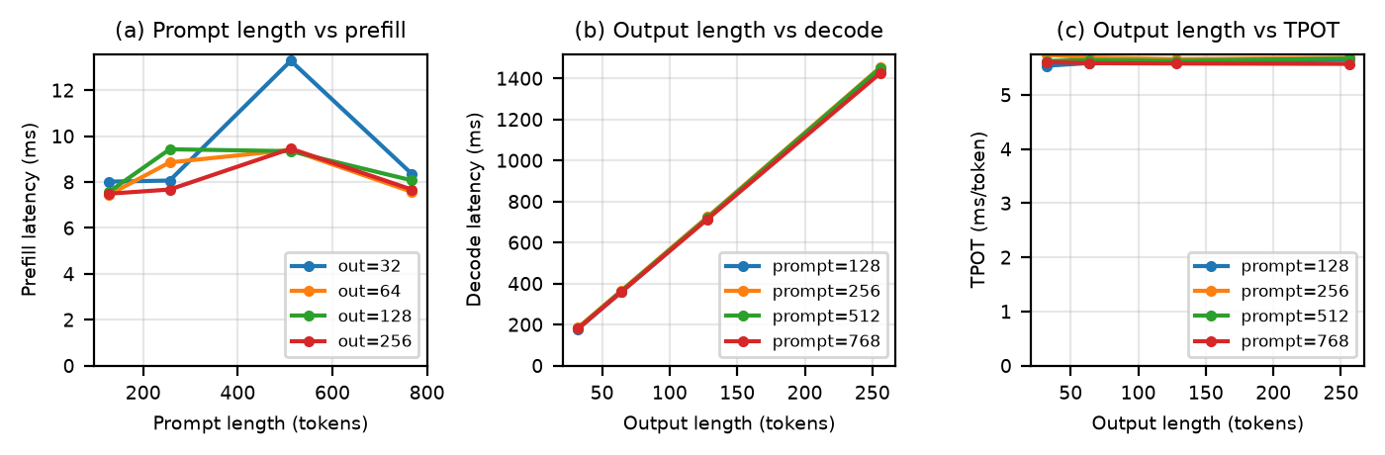
Figure 1. Part 1: (a) prompt length vs prefill latency, (b) output length vs decode latency, (c) output length vs TPOT.

Task 1.3: Analysis
1. Why does prompt length affect prefill? Prefill runs all N prompt tokens through every layer in one pass, so linear-layer work grows with N and attention work grows with N². In my runs the latency barely moved (about 7.5 to 9.4 ms from 128 to 768 tokens) because gpt2 is too small to load an A100: a 768-token prefill is about 0.19 TFLOP, roughly 0.8 ms of arithmetic, while the measured time was about 7.6 ms. The rest is fixed per-pass overhead (Python dispatch and launching a few hundred small kernels). Prompt length does show up in memory: peak memory grew 87 MiB from 128 to 768 tokens, which matches the extra prompt logits (61 MiB) plus KV cache (23 MiB). Part 3 shows prefill time clearly scaling once the GPU is saturated.
2. Why does output length affect decode? Each output token needs its own forward pass, and token t + 1 depends on token t, so the passes are sequential. Decode time is proportional to output length: the fit is 5.64 ms per token with R² = 0.9998.
3. Why can prefill expose more parallelism than decode? In prefill each layer multiplies an N × 768 matrix, so the GPU works on all prompt tokens at once and reuses each weight N times. Decode processes one token (a 1 × 768 vector), which is a matrix-vector product with little parallel work. Measured per token, prefill cost about 0.01 ms (7.6 ms for 768 tokens) while decode cost 5.6 ms, roughly 570× more.
4. Which phase is more compute intensive? Prefill. Its arithmetic intensity is about N FLOPs per byte of weights read (128–768 here), around or above the A100’s balance point of about 150 FLOP/byte.
5. Which phase is more memory-bandwidth sensitive? Decode. Every step reads all the weights (about 249 MB) and the KV cache to produce one token, about 1 FLOP per byte. For gpt2 the bandwidth floor is only about 0.12 ms per step, so my measured 5.6 ms TPOT is actually dominated by fixed launch overhead, which is an even worse form of the same under-utilization.
6. Does TPOT stay constant as context grows? In my data it did, within noise: 5.53–5.74 ms across all 16 configurations with no trend in prompt or output length. In principle TPOT grows with context because each step reads the K/V of every previous token. At 1024 tokens gpt2’s KV cache is only 36 MiB (about 0.02 ms to read), well below the run-to-run noise. For larger models or longer contexts this term becomes significant.

Part 2. KV Cache

Task 2.1: No-cache implementation
generate_without_cache() does three things per step: (1) runs the model on the whole current sequence with use_cache=False, (2) takes argmax of the last position’s logits with keepdim=True, and (3) appends the token with torch.cat(..., dim=1). At batch 1 the cached and uncached outputs were identical at every length. At batch 32, exactly 2 of up to 28,672 generated tokens differed (match rate ≥ 0.998). This is FP16 rounding: the two paths use different kernels, so a near-tie between two tokens can flip.
Two problems had to be fixed to run batch 32. The provided agreement_check() only searched row 0 for the first mismatch and crashed when a later row differed, so I changed it to look at all rows. Without the cache, every step allocates slightly larger tensors, and PyTorch’s caching allocator reserved all 80 GB for a few GB of live data and kept hitting OOM and retrying. expandable_segments:True fixed that.

Task 2.2: Results
Prompt 128; outputs 32 to 896; batch sizes 1 and 32; 3 runs each. Each cell is “cache on / cache off”. At batch 32, ms per step covers 32 tokens.
Output | B=1 latency (s) | B=1 ms/token | B=1 peak mem (GiB) | B=32 latency (s) | B=32 ms/step | B=32 peak mem (GiB) | B=32 slowdown
32 | 0.178 / 0.177 | 5.56 / 5.53 | 0.256 / 0.270 | 0.19 / 0.47 | 5.9 / 14.8 | 0.77 / 1.20 | 2.5×
128 | 0.709 / 0.703 | 5.54 / 5.49 | 0.256 / 0.288 | 0.75 / 2.44 | 5.8 / 19.1 | 0.77 / 1.78 | 3.3×
256 | 1.443 / 1.422 | 5.64 / 5.56 | 0.256 / 0.312 | 1.49 / 6.43 | 5.8 / 25.1 | 0.77 / 2.55 | 4.3×
512 | 2.854 / 2.917 | 5.57 / 5.70 | 0.263 / 0.360 | 2.96 / 19.05 | 5.8 / 37.2 | 0.97 / 4.09 | 6.4×
896 | 5.024 / 5.308 | 5.61 / 5.92 | 0.277 / 0.433 | 5.40 / 49.70 | 6.0 / 55.5 | 1.41 / 6.41 | 9.2×

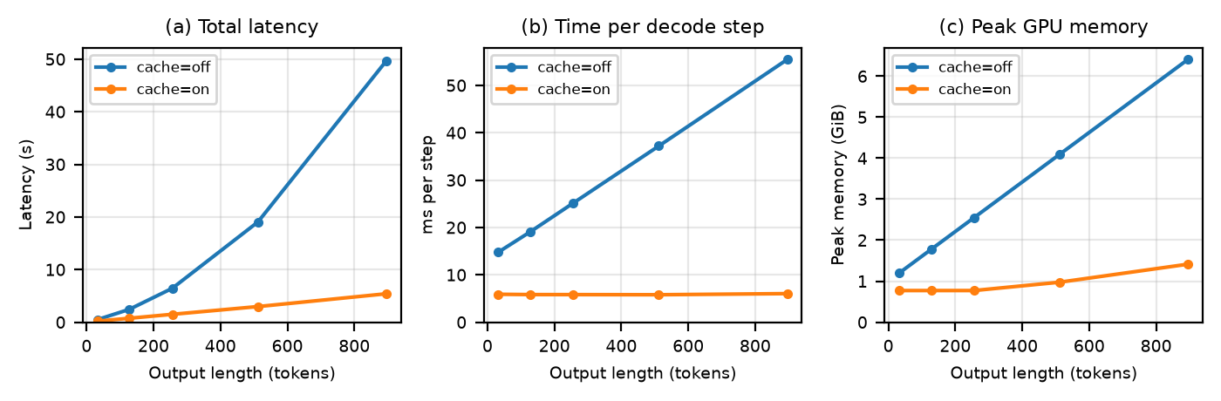
Figure 2. Part 2 at batch 32: (a) total latency, (b) time per decode step, (c) peak memory, with the KV cache on and off.
At batch 32 the no-cache latency grows quadratically (a quadratic fit gives R² = 0.9999995 versus 0.962 for a line), and dividing it by the number of token positions actually processed gives a constant 3.0–3.2 µs per token, so the extra time is all recomputation. At batch 1 the two are almost the same (0.99–1.06×) because the fixed ~5.5 ms per forward pass hides the recomputation.

Task 2.3: KV-cache memory
Each layer stores a key tensor and a value tensor of shape [B, H_{KV}, S, D]. Over L layers with b bytes per element:
M_{KV} = 2 × B × L × S × H_{KV} × D × b
The factor 2 is because keys and values are separate tensors of the same size and attention needs both: keys to compute the attention weights and values to average. Queries are not cached since each query is only used once. For gpt2 this is 2 × 12 × 12 × 64 × 2 B = 36 KiB per token per sequence.
Configuration | part2_kv_size.py result
gpt2, B = 1, S = 1024 | 37,748,736 B = 36 MiB
gpt2, B = 32, S = 1024 | 1,207,959,552 B = 1.125 GiB
Llama-8B-like defaults (L = 32, H_{KV} = 8, D = 128, S = 4096), B = 1 | 536,870,912 B = 512 MiB
The batch-32 measurement agrees: at 896 output tokens (1024 total), peak memory minus weights was 1.18 GiB against the predicted 1.125 GiB.

Task 2.4: Analysis
1. Why caching reduces redundant computation. In a causal model the K and V of token i depend only on tokens 1..i, so they never change. Without a cache every step recomputes them for the whole prefix, about nm + m²/2 token positions instead of n + m. For n = 128, m = 896 that is 515,648 versus 1,024 positions per sequence. With the cache each step only processes the new token, which is why cached time per step stayed flat at about 5.9 ms while uncached time rose to 55 ms per step.
2. Why cache memory grows with sequence length. Every new token adds one key and one value per layer and head, and they must be kept because later tokens attend to them. Memory is linear in S (36 KiB per token for gpt2). Measured cached memory at batch 32 rose from 0.77 to 1.41 GiB as the sequence grew to 1024 tokens.
3. Why long-context serving reduces concurrency. GPU memory left after the weights is a fixed KV budget, and each request needs memory proportional to its context length, so the number of concurrent requests falls as 1 / context length. For the 8B-like configuration on an 80 GB GPU (about 60 GB left for KV), 4k-token requests fit about 110 at a time, but 32k-token requests fit only about 14.
4. Why a system can be memory-limited with compute available. Decode uses very little compute per step, so adding sequences is cheap: a cached step took 5.89 ms at batch 32 versus 5.56 ms at batch 1. But every extra request needs its own growing KV cache. Once the KV memory is full, new requests have to wait even though the GPU’s compute is mostly idle. Wasted memory (reserving the maximum length up front, fragmentation) makes it worse, which is what paged KV management fixes.

Part 3. Batching
Prompt 128, output 128, batch sizes 1 to 512, 3 runs each. I extended the starter’s range (1–16) because throughput was still growing linearly at 16.
Metric definitions. TTFT approx. = prefill time of the whole batch (it ignores queueing, scheduling and network time, so it is only an approximation). TPOT = decode time / output length. Latency = prefill + decode. Requests/s = B / latency, which is only valid because all requests in the batch start and finish together. Output tokens/s = B × output length / latency (prompt tokens not counted; prefill time is included).

Task 3.1: Results (mean of 3 runs)
Batch | TTFT approx. (ms) | TPOT (ms) | Latency (s) | Requests/s | Output tokens/s | Peak mem (GiB)
1 | 7.7 | 5.49 | 0.711 | 1.4 | 180 | 0.261
2 | 7.6 | 6.03 | 0.779 | 2.6 | 331 | 0.282
4 | 8.8 | 5.56 | 0.721 | 5.6 | 711 | 0.325
8 | 11.6 | 5.54 | 0.721 | 11.1 | 1,420 | 0.410
16 | 15.6 | 5.51 | 0.721 | 22.2 | 2,840 | 0.580
32 | 15.3 | 5.78 | 0.755 | 42.4 | 5,425 | 0.919
64 | 28.5 | 5.81 | 0.772 | 82.9 | 10,612 | 1.599
128 | 56.4 | 6.44 | 0.881 | 145.2 | 18,590 | 2.958
256 | 104.1 | 11.41 | 1.565 | 163.6 | 20,941 | 5.677
512 | 205.5 | 21.57 | 2.966 | 172.6 | 22,092 | 11.114
Memory grows by about 21.7 MiB per sequence, which matches 9 MiB of KV cache plus 12.3 MiB of prompt logits per sequence.

Task 3.2: Plots
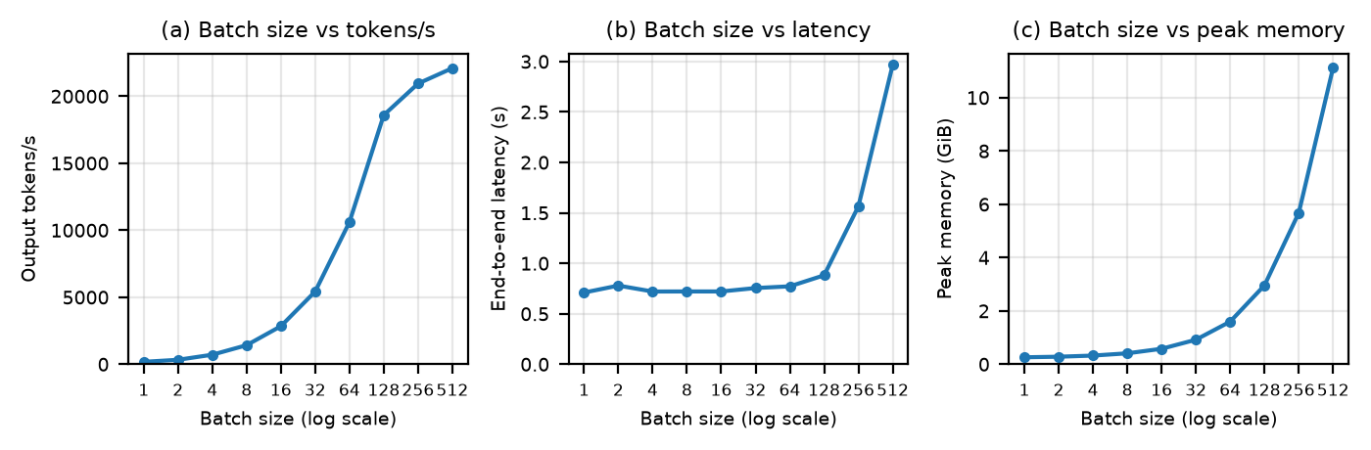
Figure 3. Part 3: batch size vs (a) output tokens/s, (b) end-to-end latency, (c) peak GPU memory.

Task 3.3: Analysis
1. Why larger batches improve utilization. A decode step has a fixed cost (reading the weights, launching kernels, Python overhead) that is shared by every sequence in the batch. At batch 1 that fixed cost is almost the whole step. With B sequences each weight read and kernel launch serves B tokens and the matrix-vector products become matrix multiplies. From batch 1 to 64, TPOT only went from 5.49 to 5.81 ms while throughput went from 180 to 10,612 tokens/s (59× for 64× the batch).
2. Why throughput does not grow linearly forever. Per-sequence work (each sequence’s own KV cache reads and its share of the FLOPs) grows with B. Once it is larger than the fixed cost, step time grows with batch size: TPOT roughly doubled for each doubling after 128 (6.44 → 11.41 → 21.57 ms). Throughput then levels off around 22k tokens/s. Memory capacity is the next limit after that.
3. Where are the diminishing returns? Between batch 128 and 256. Every doubling up to 64 gave about 1.9–2.1× more throughput and 64 → 128 gave 1.75×, but 128 → 256 gave only 1.13× and 256 → 512 gave 1.05×.
4. Why latency can increase while throughput improves. Throughput is total tokens per second for all users; latency is what each user waits. With a bigger batch, all prompts are prefilled before anyone gets a first token (TTFT 7.7 → 205 ms) and each decode step serves more sequences (TPOT 5.5 → 21.6 ms). From batch 128 to 512 throughput rose only 19% but every request’s latency rose 3.4× (0.88 → 2.97 s).
5. Would I use the maximum-throughput batch for a chatbot? No. Users notice TTFT and TPOT, not total throughput, so I would pick the largest batch that still meets the latency targets with some headroom. Batch 128 gives 84% of the maximum throughput with TPOT 6.4 ms and TTFT 56 ms, while 512 adds 19% throughput at about 3.5× worse latency. Running at saturation also leaves no slack for bursts of traffic.

Part 4. Heterogeneous Requests and Serving Engines
Workload: python workload.py --n 50 (seed 42). Prompts from {32, 64, 128, 256, 512} and outputs from {16, 32, 64, 128, 256}, 11,040 prompt tokens and 4,592 output tokens in total. Both offline scripts treat all 50 requests as ready at t = 0.

Task 4.1: Static batching
System | Time for 50 requests (s) | Requests/s | Output tokens/s | Mean latency (s) | P95 latency (s) | Prompt padding efficiency | Decode efficiency
Static B = 1 | 28.50 | 1.75 | 161 | 0.57 | 1.59 | 1.000 | 1.000
Static B = 4 | 17.51 | 2.86 | 262 | 1.38 | 1.80 | 0.513 | 0.466
Static B = 8 | 11.41 | 4.38 | 403 | 1.77 | 1.83 | 0.431 | 0.370
Static B = 16 | 5.97 | 8.37 | 769 | 1.78 | 1.84 | 0.431 | 0.370
vLLM | 0.394 | 126.8 | 11,642 | ≤ 0.394 | ≤ 0.394 | 1.000 | 1.000
Latency is the time of the batch each request belonged to (the starter’s definition). Counting the wait behind earlier batches, the P95 completion time was 17.1 s at B = 4 and 5.5 s at B = 16. Decode efficiency = requested output tokens / tokens actually generated.
Why heterogeneous prompts waste work. A batch is a rectangular [B, max prompt length] tensor, so shorter prompts are padded. The padding is masked in attention but still goes through every layer and takes KV space. For prompts 128, 150, 180 and 1024 there are 1,482 useful tokens but 4 × 1024 = 4,096 processed, so only 36.2% is useful. Since attention cost grows with length², only 26.7% of the attention work is useful. In my workload almost every batch of 8 or more contained a 512-token prompt, so padding efficiency was only 43%.

Task 4.2: Output-length heterogeneity
With outputs 20, 25, 200 and 30, the static batch runs for 200 decode steps because it only finishes when the longest request finishes. Hugging Face keeps computing the finished rows. Useful work is 275 token-steps out of 800 (34%). After step 30 only one of the four rows is useful for the remaining 170 steps (25% utilization). The lost resources are the compute and memory bandwidth spent on finished rows, the KV memory those rows keep holding, extra latency for the short requests (the 20-token request waits for 200 steps), and the waiting requests that cannot start until the batch ends. My workload showed the same thing: decode efficiency was 0.47 at B = 4 and 0.37 at B = 8 and 16. If finished requests could leave immediately and new ones take their slot (TODO 3), the batch would stay full of useful work and short requests would return early. That is continuous batching.

Task 4.3: Modern serving engine (vLLM)
vLLM 0.32 offline LLM.generate() with all 50 requests at once, FP16, exact-length token prompts and one SamplingParams per request (max_tokens = output length, ignore_eos=True, temperature=0), warm-up plus 3 runs with fresh prompts. vLLM’s startup needed a CUDA module and ninja on Sol so FlashInfer could compile its sampling kernel. vLLM reported exactly 4,592 output and 11,040 prompt tokens, the same work as static batching.
vLLM reached 126.8 requests/s and 11,642 output tokens/s, 15× the best static configuration (B = 16) and 72× batch 1 (table above). Since it was run offline there are no per-request TTFT/TPOT numbers, but all 50 requests finished within 0.394 s, so every request’s latency was below that.
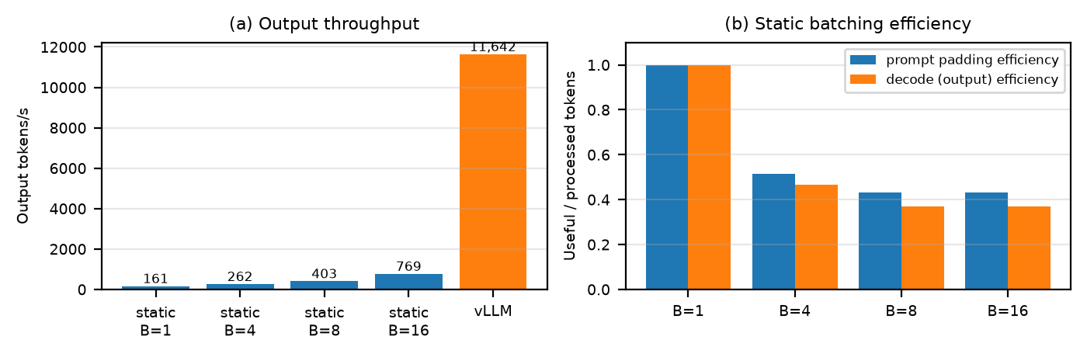
Figure 4. Part 4: (a) output throughput of static batching vs vLLM, (b) static batching prompt and decode efficiency.
Why one max_tokens is not enough (TODO 4). The starter used max_tokens=64 for every request with "hello " * n prompts. That makes every request produce 64 tokens (3,200 total instead of 4,592), removes the output-length variation that this part is about, does not stop EOS from ending a request early, and gives prompts of n + 1 tokens. All prompts also share the same prefix, so vLLM’s prefix cache can skip much of the prefill. Running that configuration gave 308.6 requests/s, 2.4× higher than the real workload, so it would overstate vLLM’s advantage.

Task 4.4: Systems mechanisms
Continuous batching. Problem: static batches keep padded rows and finished rows until the longest request is done (Tasks 4.1–4.2). How it works: the scheduler decides every iteration; finished sequences leave right away and waiting ones are admitted, and all tokens are packed into one flat batch without padding. vLLM also mixes new prompts’ prefill into decode steps (chunked prefill, 8,192 tokens per step in my log). Measurement: static B = 16 had 43% prompt and 37% decode efficiency, while vLLM processed only the useful tokens and finished all 50 requests in 0.394 s compared with a 5.5 s P95 completion time for static batching.
Paged KV-cache management. Problem: contiguous per-request KV buffers have to reserve the maximum length and fragment memory, which limits concurrency (Part 2). How it works: the KV memory is allocated once as a pool of small fixed-size blocks; each sequence has a block table, gets blocks only as it grows and frees them when it finishes. Waste is limited to one partly filled block per sequence, and blocks can be shared for common prefixes. Measurement: vLLM’s log showed 72.24 GiB of KV cache holding 2,104,240 tokens, which is 36.0 KiB per token, exactly the gpt2 value from my Part 2 formula, and room for about 2,055 full-length requests.
Optimized kernels and CUDA graphs. Problem: in Parts 1–3 Hugging Face spent about 5.5 ms per decode step mostly on Python and kernel-launch overhead. How it works: vLLM compiles the model with torch.compile, captures CUDA graphs for batch sizes 1–512 so a whole step is replayed with one launch, and uses FlashAttention-2 kernels that handle ragged batches. Measurement: the longest request needed 256 decode steps and the run took 0.394 s, so vLLM took at most 1.54 ms per step with up to 50 sequences, versus about 7 ms per step for static B = 16.

Part 5. Serving Design Challenge
Targets: P95(TTFT) < 1 s and P95(TPOT) < 50 ms/token, while maximizing throughput. I would run on an engine like vLLM (paged KV, continuous batching, CUDA graphs) and add the policy below. Controllers aim for 80% of each target (0.8 s and 40 ms) to leave room for bursts. On my measurements both targets are reachable: TPOT was only 21.6 ms even at batch 512, and the main TTFT risk is queueing, not prefill (static B = 16 had P95 TTFT around 5 s from waiting behind earlier batches, while vLLM finished everything in 0.4 s).
- Request scheduling: waiting requests are served earliest-deadline-first (deadline = arrival + 1 s), which is FCFS when all requests have the same target. Requests already decoding always get their next token before new prefills start. Short prompts may go ahead of very long ones, with aging so long requests do not starve.
- Continuous batching: sequences join and leave every iteration. The batch cap B_{max} is set by TPOT, not throughput: start at the measured knee (about 128 for gpt2) and raise it while P95 TPOT stays under 40 ms, lowering it quickly when it goes over. For gpt2 this allows about 256–512; for a larger model it would stop much earlier.
- Prefill vs decode: chunked prefill with a per-iteration token budget. Each iteration first includes one token for every running decode, then fills the rest with prefill chunks. A bigger budget improves TTFT and a smaller one protects TPOT, so the budget is adjusted based on which target is closer to being missed. Without this, one large prefill would stall every stream (a 65k-token prefill took 205 ms in Part 3).
- KV-cache allocation: paged blocks allocated on demand, prefix caching for shared prompts, and a small free reserve (about 5%) so running sequences can grow. If memory runs out, the newest low-priority request is preempted and later recomputed (cheap for short prompts; swap to CPU only for very long ones).
- Long-context requests: chunked prefill so they do not block others, a cap on the share of KV memory and the number of long prompts prefilling at once, and a separate, relaxed TTFT target when even an empty queue cannot prefill them within 1 s. Larger contexts also slow every decode step, which the B_{max} controller adjusts for.
- Admission control: a request is admitted only if its prompt fits in free KV memory, its predicted TTFT (queued prefill tokens ÷ measured prefill rate) is under the target, and the batch is under B_{max}. Otherwise it waits in a bounded queue and is rejected early (HTTP 429 with Retry-After) once it can no longer meet its deadline. By Little’s law, capacity is about throughput ÷ average output length, roughly 18.6k / 92 ≈ 200 requests/s for gpt2 at the knee.
- Overload: protect requests that are already streaming; drop requests whose deadline has passed; reject new arrivals early; pause low-priority and long-context work; cap max_tokens for new requests; and limit preemption to avoid thrashing. The metric to watch is goodput (requests meeting both targets), not raw tokens/s.
Tradeoffs. A bigger batch gives more throughput but worse TPOT/TTFT after the knee. A bigger prefill chunk improves TTFT but causes TPOT spikes. Deadline/FCFS ordering is fair but lets short requests wait behind long ones. Strict admission keeps the targets for admitted users but turns some requests away. A memory reserve and long-context quota reduce preemption but lower concurrency. Recompute avoids CPU memory traffic but repeats prefill work. Prefix caching saves time and memory for shared prompts but cached blocks take pool space.

Part 6. Reflection
Every experiment ran the same gpt2 model in FP16 on the same A100, so the arithmetic never changed. Still, the measured performance varied by about two orders of magnitude, and almost none of that came from the model itself.
First, the GPU was rarely limited by the math. A 768-token prefill needed about 0.8 ms of computation but took 7.6 ms, and a decode step took 5.6 ms when reading the weights should take about 0.12 ms. Most of the time went to launching kernels and Python overhead, so how the work is grouped matters more than the network.
Second, whether an optimization helps depends on the operating point. The KV cache made no difference at batch 1 (0.99–1.06×) but was 9.2× faster at batch 32. It also turns a compute problem into a memory problem: at 36 KiB per token, KV memory decides how many requests fit on the GPU.
Third, batching raised throughput 123× (180 to 22,092 tokens/s) without touching the model, but past batch 128 the last 19% of throughput cost 3.4× more latency per request. There is no single best configuration, only a tradeoff that has to be chosen against latency targets.
Fourth, in Part 4 the same model, GPU and requests gave very different results depending on how they were served. Static batching wasted 57–63% of its work on padding and finished rows and had a P95 completion time of 5.5 s. vLLM, with continuous batching, paged KV memory and CUDA graphs, was 15–72× faster and finished all 50 requests in 0.4 s. Even the problems I ran into were systems problems: allocator fragmentation, an unexpected bfloat16 default, and a missing compiler.
Inference is about computing the output for one input. Serving is about sharing one GPU’s compute, memory and bandwidth across many requests whose lengths and arrival times are unknown, under latency targets that conflict with throughput. Those are scheduling, caching, memory-management and admission-control problems, which is why LLM serving is a systems problem.

Expected Hypotheses and Pitfalls
Hypothesis | Result
Longer prompt ⇒ higher prefill cost | Partly. Flat latency at batch 1 (overhead-bound), but memory grew with prompt length and TTFT doubled with prompt tokens once the GPU was saturated (Part 3).
Longer output ⇒ higher decode cost | Yes. Linear, 5.64 ms per token.
KV cache ⇒ less recomputation, more memory | Yes. 9.2× faster at batch 32; cache grows 36 KiB per token. Peak memory was actually higher without the cache because each step rebuilds full-sequence logits.
Larger batch ⇒ more throughput until saturation | Yes. Near-linear to 64, saturating after 128 at about 22k tokens/s.
Larger batch ⇒ potentially worse latency | Yes. TTFT 7.7 → 205 ms and TPOT 5.5 → 21.6 ms from batch 1 to 512.
Continuous batching ⇒ better handling of heterogeneous requests | Yes. vLLM was 15× faster than the best static batching with no wasted work.
The listed pitfalls were handled as follows: synchronized timing, warm-up, model loading excluded, FP16 kept fixed (including vLLM), OOM and context limits respected, max_memory_allocated() versus nvidia-smi explained, EOS disabled, and offline queueing/TTFT limitations stated.
Reproducibility. README.md lists the environment setup and the exact command for every experiment and plot. All CSV results are in results/ and all plots in plots/.

GitHub Repo: https://github.com/ananthsekar007/LLM-Inference-Performance-Engine

