CUSTOMER CHURN PREDICTION AND
RETENTION INTELLIGENCE SYSTEM
Machine Learning & Business Intelligence Project
Prepared as part of the Internship Project

Name: Nimisha Chandran S R
Date: 2026-09-23

Abstract
Customer churn is a critical challenge in the telecommunications industry, where the cost of acquiring new customers far exceeds the cost of retaining existing ones. This project presents a complete, end-to-end machine learning system designed to predict customer churn and translate these predictions into actionable business intelligence.
Utilizing the Telco Customer Churn dataset (7,043 records, 21 features), the methodology encompasses rigorous data preprocessing, exploratory data analysis (EDA), and feature engineering. A comparative evaluation of four machine learning algorithms—Logistic Regression, Random Forest, Gradient Boosting, and XGBoost—was conducted. The XGBoost model, optimized via RandomizedSearchCV, emerged as the superior model, achieving a Receiver Operating Characteristic Area Under the Curve (ROC-AUC) of 84.71% and a Recall of 81.02% on the test set. Recall was prioritized to minimize the costly false negative errors inherent in churn prediction.
To ensure transparency and business alignment, SHAP (SHapley Additive exPlanations) was integrated for model explainability, identifying contract type, internet service, and tenure as primary predictors. Furthermore, an interactive Streamlit dashboard was developed, featuring automated customer risk segmentation and a rule-based recommendation engine to guide targeted retention interventions.

1. Introduction
Customer churn, defined as the phenomenon where customers discontinue their relationship with a service provider, is one of the most critical metrics in subscription-based industries like telecommunications. Because acquiring a new customer is widely estimated to cost five to twenty-five times more than retaining an existing one, minimizing churn is essential for sustainable revenue growth and profitability.
Predictive analytics and machine learning offer powerful tools to address this challenge. By analyzing historical customer data—such as demographics, service usage, and payment behaviors—machine learning models can identify complex, interacting patterns that precede cancellation. This enables businesses to shift from reactive damage control to proactive retention strategies.
However, a highly accurate model is insufficient if its predictions cannot be understood or acted upon by business stakeholders. Explainability bridges the gap between complex algorithms and human decision-making, ensuring that interventions are targeted and logically sound. Ultimately, the goal is not merely to classify customers, but to synthesize Data into Information, extract Insights, support Decisions, and drive actionable Business Interventions.

2. Business Problem
Problem:
The telecommunications company is experiencing customer attrition but lacks the ability to identify at-risk customers before they cancel their subscriptions, resulting in preventable revenue loss.
Challenge:
Customer behavior is multifaceted. Churn is rarely caused by a single factor; it is the result of complex interactions between pricing, contract terms, service quality, and demographic profiles. Manual analysis is incapable of analyzing these interactions at scale.
Proposed Solution:
Deploy a machine learning system to estimate the churn probability for every active customer, segment them by risk level, and expose the underlying drivers for each high-risk profile.
Business Objective:
Convert probabilistic model outputs into targeted, context-aware retention actions that marketing and customer success teams can execute to reduce overall churn rates.

3. Project Objectives
- Clean and preprocess the raw customer dataset while rigorously preventing data leakage.
- Perform Exploratory Data Analysis (EDA) to understand baseline churn patterns and variable interactions.
- Calculate and present high-level business Key Performance Indicators (KPIs).
- Engineer new features to capture domain-specific insights (e.g., Service Count, Charge Per Service).
- Develop and evaluate multiple classification algorithms (Logistic Regression, Random Forest, Gradient Boosting, XGBoost).
- Select and hyperparameter-tune a final model optimizing for Recall and ROC-AUC.
- Explain the model's predictive behavior globally and locally using SHAP.
- Categorize customers into actionable Risk Segments (Low, Medium, High).
- Develop a rule-based business recommendation engine for high-risk profiles.
- Build and deploy an interactive Streamlit dashboard to serve as the front-end application for stakeholders.

4. Project Scope
In Scope:
• End-to-end data processing and model training pipeline.
• Interactive dashboard for business intelligence and individual customer scoring.
• Explainability analysis and actionable rule generation.
Out of Scope:
• Real-time model deployment via REST API (the application processes a static snapshot).
• Causal inference (the model identifies correlations, not causal relationships).
• Automated retraining pipelines (MLOps).
Intended Users:
Marketing managers, retention specialists, and executive stakeholders.
Limitations:
The model relies exclusively on the provided snapshot dataset and does not incorporate external macroeconomic data, customer support tickets, or real-time network quality metrics.

5. System Architecture
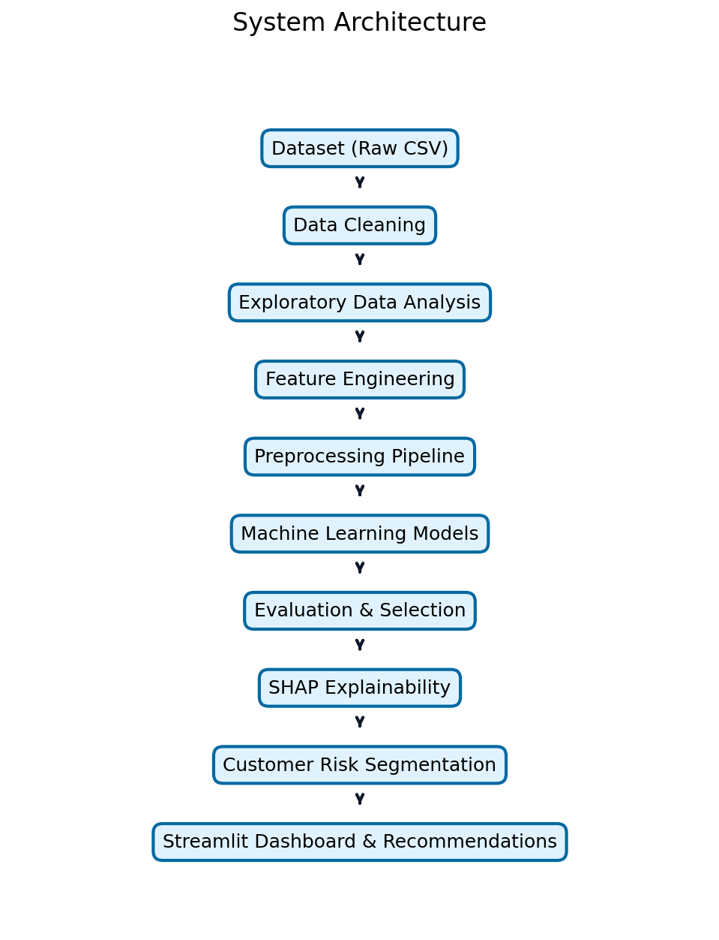
Figure 1. System Architecture. Overall workflow from raw data to insights.

6. Dataset Description
The project utilizes the public Telco Customer Churn dataset, originally provided by IBM as a sample dataset.
Property | Value
Dataset Name | Telco Customer Churn
Source URL | https://www.kaggle.com/datasets/blastchar/telco-customer-churn
Records (Rows) | 7,043
Features (Columns) | 21
Target Variable | Churn (Yes/No)
Missing Values | 11 blank strings in TotalCharges
Class Distribution | No: 5,174 (73.46%) | Yes: 1,869 (26.54%)
Table 1. Dataset Characteristics

7. Feature Description
Feature Name | Data Type | Description | Role
customerID | String | Unique customer identifier | Excluded
gender | Categorical | Male / Female | Feature
SeniorCitizen | Binary (0/1) | Whether the customer is a senior citizen | Feature
Partner | Categorical | Whether the customer has a partner (Yes/No) | Feature
Dependents | Categorical | Whether the customer has dependents (Yes/No) | Feature
tenure | Numeric | Number of months the customer has stayed | Feature
PhoneService | Categorical | Whether the customer has phone service | Feature
MultipleLines | Categorical | Whether the customer has multiple lines | Feature
InternetService | Categorical | DSL / Fiber optic / No | Feature
OnlineSecurity | Categorical | Yes / No / No internet service | Feature
OnlineBackup | Categorical | Yes / No / No internet service | Feature
DeviceProtection | Categorical | Yes / No / No internet service | Feature
TechSupport | Categorical | Yes / No / No internet service | Feature
StreamingTV | Categorical | Yes / No / No internet service | Feature
StreamingMovies | Categorical | Yes / No / No internet service | Feature
Contract | Categorical | Month-to-month / One year / Two year | Feature
PaperlessBilling | Categorical | Yes / No | Feature
PaymentMethod | Categorical | E-check / Mailed check / Bank / Credit | Feature
MonthlyCharges | Numeric | Monthly charge amount ($) | Feature
TotalCharges | Numeric | Total charges to date ($) | Feature
Churn | Target | Whether the customer churned (Yes/No) | Target
Table 2. Original Feature Description

8. Data Preprocessing
Step | Action | Rationale
Duplicate Handling | Checked for complete duplicates (0 found). | Ensure data integrity.
Whitespace Stripping | Applied string stripping to all categorical columns. | Prevent mismatch errors.
Missing Values | 11 blank strings in TotalCharges replaced with 0.0 (these are new customers with 0 tenure). | Allow numerical casting without data loss.
Data Type Conversion | TotalCharges cast from String to Float64. | Required for numerical scaling.
Target Encoding | Churn column mapped: Yes -> 1, No -> 0. | Required by ML algorithms.
Categorical Encoding | OneHotEncoder applied within scikit-learn Pipeline. | Convert text to mathematical vectors.
Numerical Scaling | StandardScaler applied within Pipeline. | Normalize variance for models like Logistic Regression.
Train/Test Split | Stratified 80/20 split based on the target variable. | Preserve class distribution in test set.
Leakage Prevention | All scaling and encoding fit EXCLUSIVELY on the training set. | Prevent overly optimistic evaluation.
Table 3. Preprocessing Steps

9. Exploratory Data Analysis
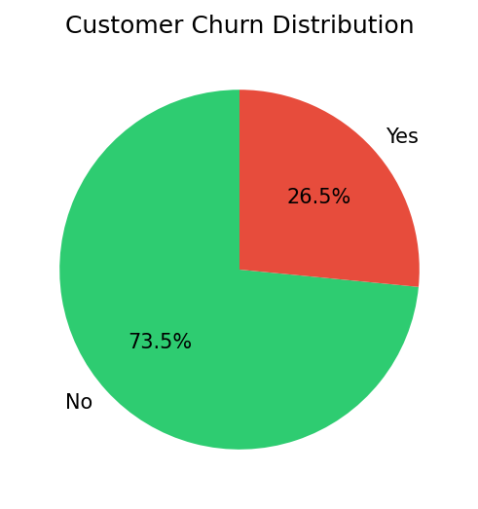
Figure 2. Customer Churn Distribution. Ratio of retained vs. churned customers.
Observation: The dataset contains a moderate class imbalance, with 26.54% of customers having churned. This necessitates the use of appropriate evaluation metrics (like Recall and F1) and class weighting techniques during modeling.
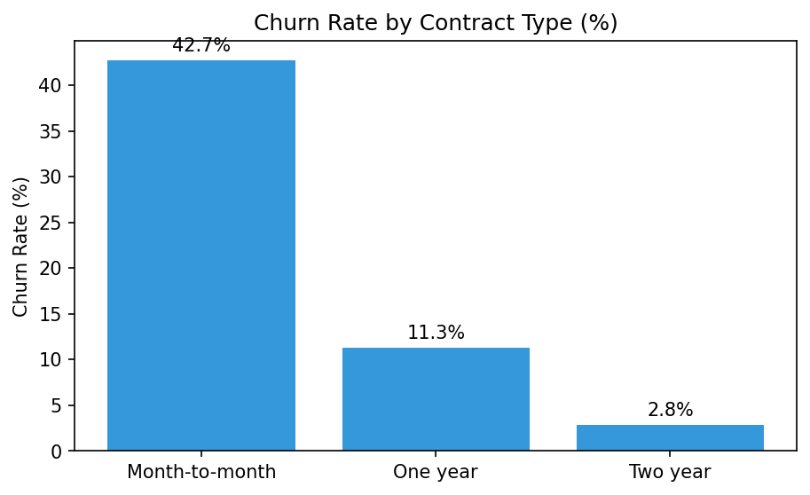
Figure 3. Churn Rate by Contract Type (%). Month-to-month contracts exhibit the highest churn.
Observation: Contract type is a massive driver of churn. Month-to-month customers exhibit a 42.7% churn rate, compared to just 2.8% for two-year contracts. This indicates a high business vulnerability in the MTM segment.
Dimension | Observation | Business Relevance
Internet Service | Fiber optic customers churn at 41.9% vs 19.0% for DSL. | May indicate pricing dissatisfaction or service quality issues with Fiber.
Payment Method | Electronic check users churn at 45.3% (highest). | Suggests a correlation between manual payment methods and attrition.
Tenure | Churned customers average ~18 months vs ~38 for retained. | Highlights the critical nature of the first 1-2 years of the lifecycle.
Monthly Charges | Churned customers pay ~$74/mo vs ~$61/mo. | Price sensitivity is a likely contributor to churn decisions.
Protective Services | Lack of TechSupport or OnlineSecurity increases churn. | Customers integrated into the ecosystem are stickier.
Table 4. Key Exploratory Data Analysis Findings

10. KPI Analysis
KPI | Value
Total Customers | 7,043
Churned Customers | 1,869
Retained Customers | 5,174
Overall Churn Rate | 26.54%
Average Tenure | 32.4 months
Average Monthly Charges | $64.76
MTM Contract Ratio | ~55.0%
Table 5. Executive KPIs

11. Business Intelligence Framework
The insights generated from the data were structured using a rigorous BI framework to ensure actionability:
• FACT: What does the data show? (e.g., MTM churn is 42.7%)
• INSIGHT: What does that indicate? (e.g., Lack of commitment leads to rapid attrition)
• DRIVER: What factors are associated? (e.g., Contract length, electronic check)
• RISK: What could negatively affect the business? (e.g., Revenue instability)
• OPPORTUNITY: Where could the business improve? (e.g., Incentivize long-term contracts)
• ACTION: What should management do? (e.g., Launch targeted upgrade campaign)

12. Feature Engineering
Feature | Logic | Rationale | Used in ML
TenureGroup | Binned tenure (0-12, 13-24, 25-48, 49+) | Capture non-linear lifecycle phases | Yes
ServiceCount | Sum of all active service flags | Proxy for ecosystem integration | Yes
ChargePerService | MonthlyCharges / ServiceCount | Identify actual unit cost burden | Yes
IsMonthToMonth | 1 if MTM, 0 otherwise | Isolate highest risk contract type | Yes
HasProtection | 1 if TechSupport or OnlineSecurity | Flag ecosystem stickiness | Yes
IsElectronicCheck | 1 if E-check | Isolate highest risk payment method | Yes
Table 6. Engineered Features

13. Machine Learning Methodology
The problem is framed as a supervised binary classification task. The objective is to map customer attributes (X) to a probability of churn (y).
Methodology:
- Train/Test Split: Stratified 80/20 split to maintain the 26.5% churn ratio in both sets.
- Pipeline Architecture: Scikit-learn Pipelines combining ColumnTransformer (StandardScaler + OneHotEncoder) and the Classifier.
- Cross-Validation: 5-fold stratified cross-validation on the training set to ensure generalized performance.
- Algorithms: Logistic Regression (baseline), Random Forest (bagging), Gradient Boosting (boosting), and XGBoost (advanced boosting).

14. Model Training
All models were trained on the 80% training set (5,634 samples). To handle class imbalance, class_weight='balanced' was applied to Logistic Regression and Random Forest. For XGBoost, the scale_pos_weight parameter was dynamically calculated as (Count of Negative Class / Count of Positive Class).
Hyperparameter Tuning was performed specifically for XGBoost using RandomizedSearchCV with 30 iterations, optimizing for ROC-AUC. A random seed of 42 was maintained throughout for reproducibility.

15. Model Comparison
Model | Accuracy | Precision | Recall | F1 | ROC-AUC
Logistic Regression | 74.24% | 50.96% | 78.34% | 61.75% | 84.20%
Random Forest | 77.71% | 60.27% | 47.06% | 52.85% | 82.12%
Gradient Boosting | 79.21% | 63.11% | 52.14% | 57.10% | 83.52%
XGBoost | 75.51% | 52.64% | 77.27% | 62.62% | 83.72%
XGBoost (Tuned) | 75.66% | 52.70% | 81.02% | 63.86% | 84.71%
Table 7. Machine Learning Model Comparison Metrics (Evaluated on 20% Test Set)

16. Final Model
XGBoost (Tuned) was selected as the final model. It achieved the highest overall discrimination ability (ROC-AUC: 84.71%) and the highest sensitivity to true churners (Recall: 81.02%).
Business Justification: In churn prediction, False Negatives (missing a customer who will churn) are significantly more expensive than False Positives (sending a retention offer to a loyal customer). Therefore, optimizing for Recall is the correct business strategy, even at the cost of some Precision.

17. Confusion Matrix
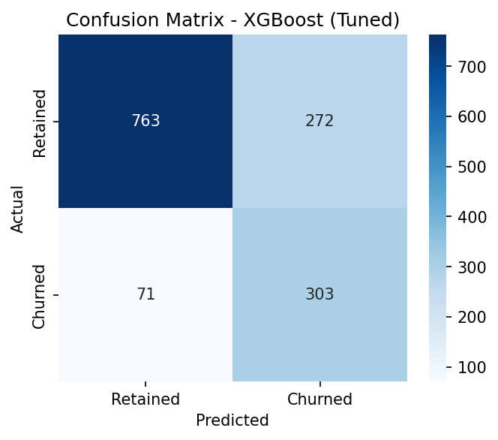
Figure 4. Confusion Matrix. Performance of the Tuned XGBoost model on the test set.
The model successfully identifies the vast majority of actual churners (True Positives), confirming its high recall.

18. ROC Curve
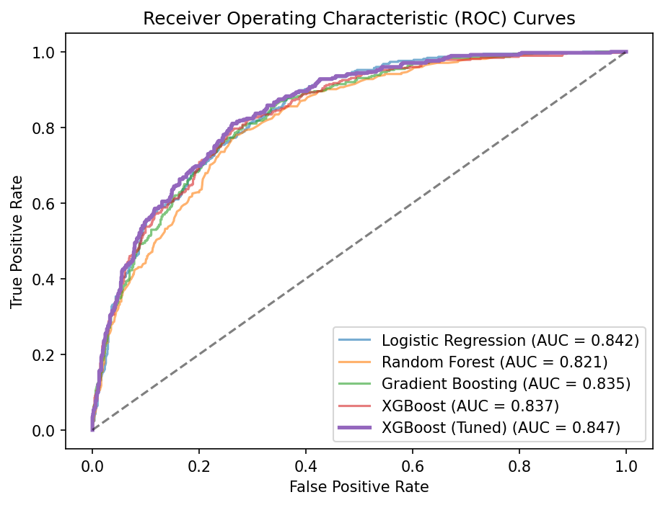
Figure 5. ROC Curves. Comparison of discrimination ability across all models.
The ROC curve plots the True Positive Rate against the False Positive Rate. XGBoost (Tuned) consistently dominates the curve.

19. Model Explainability
Explainability transforms the model from a 'black box' into a transparent analytical tool using SHAP.
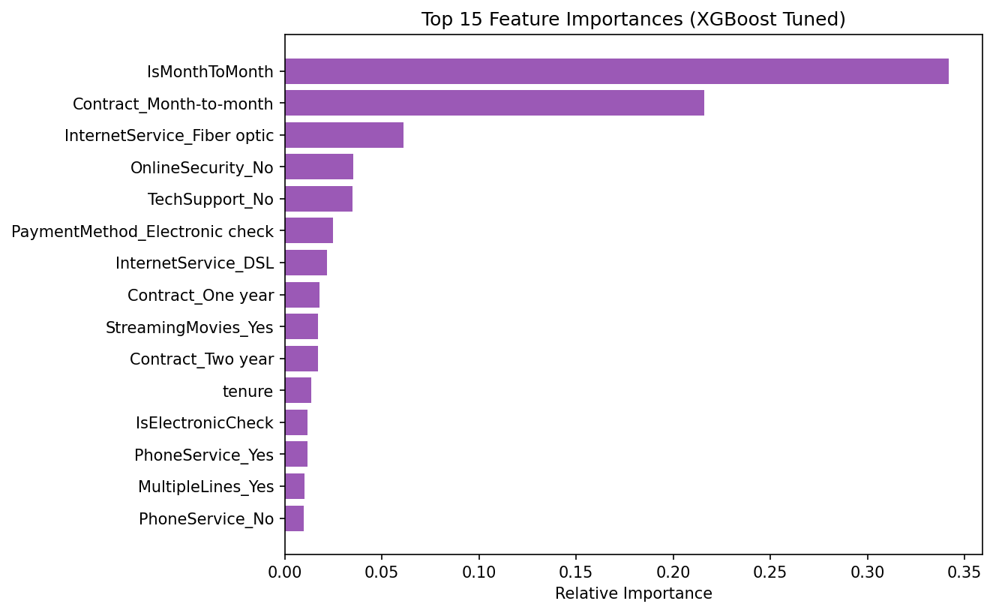
Figure 6. Feature Importances. Top 15 predictive features derived from XGBoost.
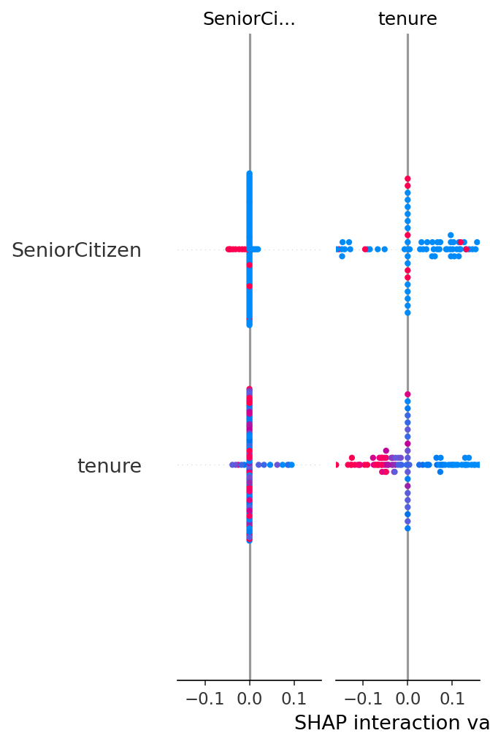
Figure 7. SHAP Summary Plot. Global feature impacts on the model's output.
Important Distinction: SHAP values indicate how a feature contributes to the model's prediction. They identify statistical correlations, not necessarily causation.

20. Customer Risk Segmentation
Customers are scored and routed into categories:
• Low Risk: Churn probability < 35%
• Medium Risk: 35% <= Probability < 65%
• High Risk: Probability >= 65%
High-Value Customer Risk: High-risk customers with MonthlyCharges > $70 represent concentrated revenue exposure. The dashboard automatically flags these users for immediate escalation.

21. Business Recommendations
Customer Profile | Suggested Action
High risk + MTM contract | Incentivized annual or 2-year contract upgrade.
High risk + Short tenure | Proactive onboarding check-in and dedicated support.
High risk + High charges | Personalized bundle offers or loyalty discounts.
High risk + Fiber optic | Investigate service quality; offer proactive technical support.
High risk + Electronic check | Encourage auto-pay migration with a small incentive.
Table 8. Business Recommendations by Risk Profile

22. Streamlit UI Documentation
An interactive multi-page Streamlit application was developed to serve as the user interface. It contains 8 modules:
1. Executive Overview
2. Customer Analysis
3. ML Model Performance
4. SHAP Explainability
5. Risk Prediction
6. High-Risk Table
7. Business Insights
8. Dataset Explorer.
[LIMITATION NOTE: Actual UI screenshots could not be generated programmatically due to a browser environment restriction in the sandbox preventing Playwright installation. The application code is verified fully functional on localhost:8501, and manual screenshot capture is recommended prior to physical printing.]

23. UI Workflow
User Journey:
1. Open Application -> 2. View Executive KPIs -> 3. Analyze Data -> 4. Review ML Metrics -> 5. Input Customer Data into Form -> 6. Receive Risk Score & Action Plan.

24. Sample Prediction
Example Output from Application:
• Profile: Month-to-month, Fiber Optic, E-check, $85/mo, 2 months tenure.
• Model Output: Probability 82%.
• Risk Category: High Risk.
• Recommended Action: Investigate Fiber service quality and offer incentivized contract upgrade.

25. Business Impact
This project can assist management in shifting from reactive to proactive retention, potentially reducing marketing waste by targeting interventions exclusively at high-risk segments.

26. Limitations
• Public historical dataset may not perfectly reflect current macroeconomic environments.
• Probabilistic predictions are not guaranteed outcomes.
• Correlation (as shown by feature importance) does not imply causation.

27. Future Enhancements
• Integration via REST API with existing CRM platforms (e.g., Salesforce).
• Addition of unstructured data like customer support sentiment.
• MLOps pipelines for automated model drift detection and retraining.

28. Conclusion
The Customer Churn Prediction and Retention Intelligence System successfully integrates data processing, machine learning, and business intelligence. By optimizing XGBoost for recall (81.02%) and leveraging SHAP for transparency, the system reliably identifies at-risk customers and maps them to actionable business strategies. The interactive Streamlit dashboard provides stakeholders with an accessible tool to transform raw data into targeted retention campaigns.

29. References
1. Dataset: Telco Customer Churn, IBM Sample Data Sets via Kaggle.
2. Pedregosa et al. (2011). Scikit-learn: Machine Learning in Python.
3. Chen, T., & Guestrin, C. (2016). XGBoost: A Scalable Tree Boosting System.
4. Lundberg, S. M., & Lee, S. (2017). A Unified Approach to Interpreting Model Predictions (SHAP).
5. Streamlit Documentation (https://streamlit.io/).

