SOFTWARE REQUIREMENTS
SPECIFICATION
AI Research Paper Recommendation System
Professional Project Documentation
Version 1.0 | September 2026

Document Type | Software Requirements Specification
Project | AI Research Paper Recommendation System
Version | 1.0
Status | Baseline / Academic Project

1. Introduction

1.1 Purpose
This Software Requirements Specification establishes the requirements and quality expectations for an AI Research Paper Recommendation System. It provides a clear baseline for design, implementation, testing, and evaluation.

1.2 Problem Statement
Students and researchers often spend substantial time searching large academic collections. Keyword-only search can produce irrelevant results or miss papers using different terminology. The proposed system combines search with AI-assisted personalization and paper similarity to improve literature discovery.

1.3 Scope
The system provides authentication, profile and research-interest management, academic-paper search, personalized recommendations, paper details, bookmarking, feedback, history, and administration. The recommendation engine may use content-based similarity, NLP features, metadata, and user interactions.

1.4 Intended Audience
Developers, testers, faculty/project guides, administrators, students, researchers, and other project stakeholders.

2. Overall Description

2.1 Product Perspective
The solution is a web-based recommendation platform comprising a presentation layer, backend/API layer, recommendation engine, database, and optional external academic-data integrations.

2.2 Major Functions
- User registration and authentication.
- Profile and research-interest management.
- Paper search, filtering, and detailed viewing.
- Personalized recommendation generation and ranking.
- Bookmarking and recommendation feedback.
- Search/recommendation history.
- Administrative management of users and paper records.

2.3 User Classes
Student/Researcher: discovers literature, receives recommendations, saves papers, and provides feedback. Administrator: manages users, paper records, and system data.

2.4 Assumptions
- Users have a modern web browser and network access.
- Paper metadata is available from a maintained database, dataset, or approved API.
- Recommendation quality depends on the quality of paper metadata and interaction data.

3. Functional Requirements
ID | Requirement | Specification
FR-01 | Registration | Allow new users to create an account.
FR-02 | Authentication | Authenticate registered users and support secure logout.
FR-03 | Profile Management | Allow users to maintain profile and research interests.
FR-04 | Paper Search | Support keyword search and filters such as author, topic, year, and category.
FR-05 | Paper Details | Display available title, authors, abstract, keywords, year, venue, and source link.
FR-06 | Recommendations | Generate a ranked list of relevant papers using available user/paper information.
FR-07 | Explanation | Show a concise matching topic, keyword, or similarity reason where feasible.
FR-08 | Bookmarking | Allow authenticated users to save and remove papers.
FR-09 | Feedback | Allow users to rate or provide feedback.
FR-10 | History | Maintain relevant search and recommendation history.
FR-11 | Administration | Allow authorized administrators to manage users and paper records.
FR-12 | Error Handling | Validate inputs and return meaningful errors for failed operations.

4. Non-Functional Requirements
ID | Attribute | Specification
NFR-01 | Performance | Provide responsive search and recommendation behavior under expected project load.
NFR-02 | Security | Use secure password hashing and authentication/role-based authorization.
NFR-03 | Usability | Provide a responsive, consistent, and easy-to-navigate interface.
NFR-04 | Reliability | Handle invalid input and common service failures gracefully.
NFR-05 | Scalability | Support growth in users, papers, and recommendation algorithms.
NFR-06 | Maintainability | Keep frontend, backend, recommendation logic, and data access modular.
NFR-07 | Privacy | Restrict user profile and activity data to authorized access.

5. External Interface Requirements

5.1 User Interface
The interface should include authentication, dashboard, paper search, recommendation feed, paper details, bookmarks/history, profile settings, and an administrator dashboard.

5.2 Software Interfaces
- Frontend: React or equivalent modern web framework.
- Backend: Node.js/Express, Flask, or equivalent REST API framework.
- Database: MongoDB, PostgreSQL, or equivalent.
- Recommendation Engine: Python/ML service or modular backend component.
- Optional academic-paper APIs or curated datasets.

5.3 Hardware Interfaces
No specialized hardware is required.

6. Data Requirements
Entity | Representative Attributes
User | user_id, name, email, password_hash, interests, role, created_at
Research Paper | paper_id, title, authors, abstract, keywords, year, venue, source_url
Bookmark | bookmark_id, user_id, paper_id, created_at
Feedback | feedback_id, user_id, paper_id, rating, comment, created_at
History | history_id, user_id, query/recommendation data, timestamp

7. System Architecture
- Presentation Layer — responsive web interface.
- Application/API Layer — authentication, search, bookmarks, feedback, history, and administration.
- Recommendation Layer — similarity calculation, personalization, ranking, and optional NLP/ML processing.
- Data Layer — users, papers, interactions, and system records.
- External Integration Layer — optional academic-paper metadata providers.

8. Use Case Specifications
ID | Use Case | Actor | Primary Flow | Outcome
UC-01 | Register / Login | Student/Researcher | Create an account or authenticate. | Authenticated session.
UC-02 | Manage Profile | Student/Researcher | Update profile/interests. | Profile saved.
UC-03 | Search Papers | Student/Researcher | Enter query and filters. | Relevant papers returned.
UC-04 | Get Recommendations | Student/Researcher | Request personalized recommendations. | Ranked results displayed.
UC-05 | View Paper Details | Student/Researcher | Open a paper. | Detailed metadata displayed.
UC-06 | Save / Bookmark | Student/Researcher | Save/remove a paper. | Bookmark updated.
UC-07 | Rate / Feedback | Student/Researcher | Submit feedback. | Feedback stored.
UC-08 | View History | Student/Researcher | Open history. | Relevant history displayed.
UC-09 | Manage Users & Papers | Administrator | Maintain authorized records. | Changes applied.

9. UML Use Case Diagram
The diagram presents the primary actors and system interactions.
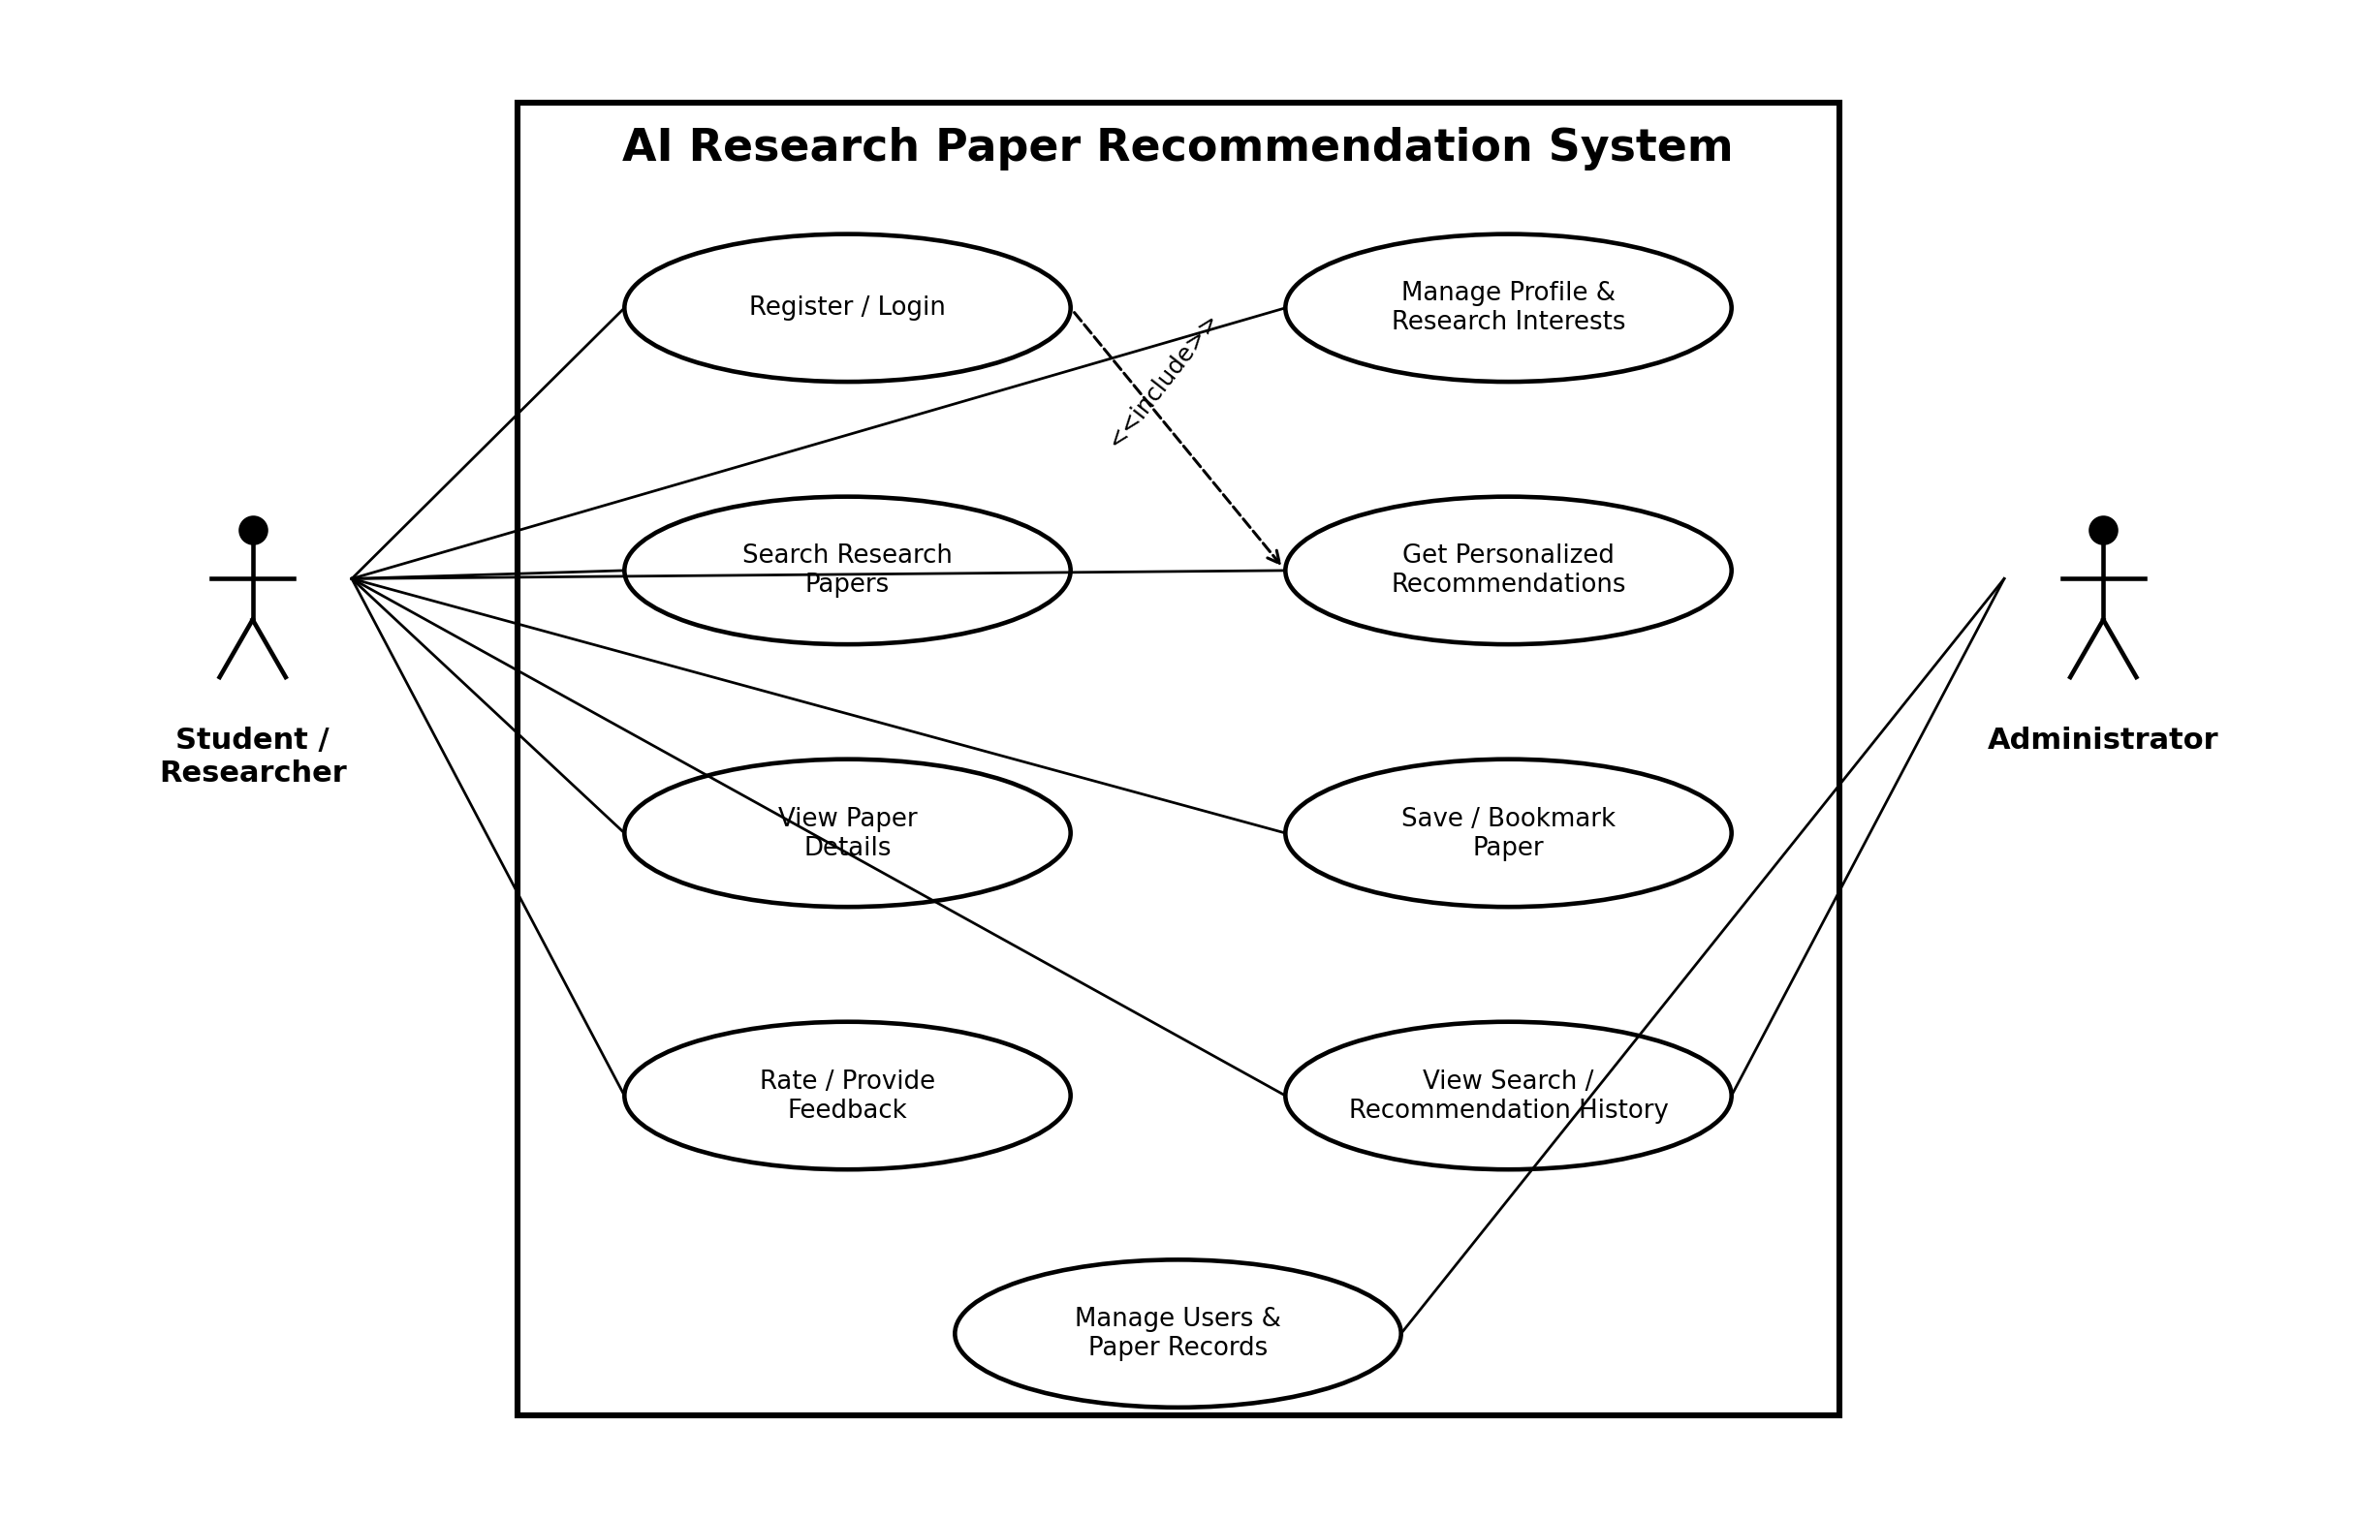

10. Security Requirements
- Passwords shall never be stored in plaintext.
- Protected operations shall require authentication.
- Administrator functions shall use role-based authorization.
- Validate and sanitize user input at API boundaries.
- Use HTTPS in production.
- Restrict personal activity and profile information to authorized access.

11. Future Enhancements
- Transformer-based semantic embeddings.
- Explainable recommendation scores.
- Privacy-conscious collaborative filtering.
- Research trend detection.
- Additional academic indexes and metadata services.
- Personalized alerts for newly available papers.

12. Acceptance Criteria
- Users can register, authenticate, and manage interests.
- Users can search, filter, and view papers.
- The system returns ranked recommendations.
- Users can bookmark papers and provide feedback.
- Authenticated users can access appropriate history.
- Administrators can manage users and paper records.
- Invalid input and common failures are handled gracefully.

13. Conclusion
The AI Research Paper Recommendation System provides a structured and extensible platform for academic literature discovery. This SRS establishes a professional baseline for implementation, testing, evaluation, and future enhancement.

