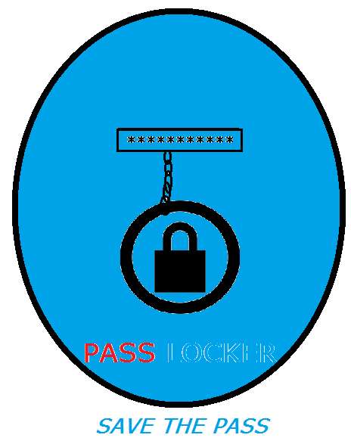

**PASS LOCKER**

PASS LOCKER is an open source app in which you can store your important user names, passwords …etc .safely without fearing any threat. PASS LOCKER is completely secure and provides you high safety for your user names, passwords.etc. You can create, edit, delete your passwords, usernames …etc

Created: Anant Narayan

Contact me : E-mail Id: anantnrg@gmail.com

Works on: Windows 7 and above, Macintosh OS X 10.8(Mountain Lion and above), Linux, UNIX and Ubuntu.

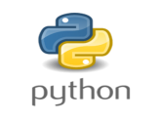

Written in: Python,

PYQT 5.0

QT DESIGNER

Version : v.2.0

v.2.0 released on : 30 January 2019