Assigment 1

**Brew Coffee shop**

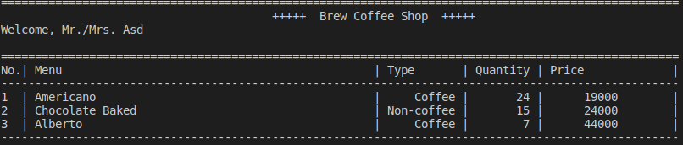Implement this program with the data structure you already learned (array, linked list, hash table, and/or binary tree).

* We will have 2 roles, first is **customer** and **admin**
* 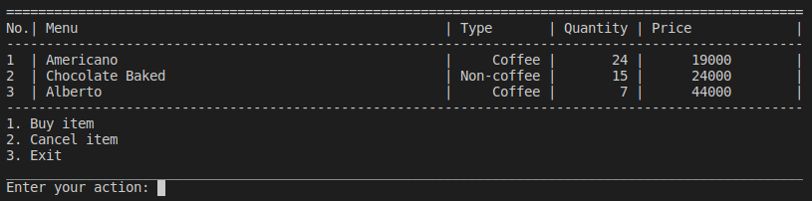For **customer** menu:
* 1. Buy item
  + Input only the available number
  + Cannot input quantity more than each item quantity

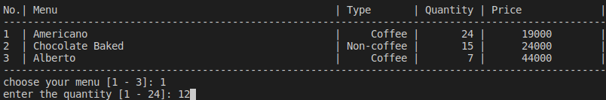-

* + You must decrease the quantity for the selected item and the price is calculated from price * quantity

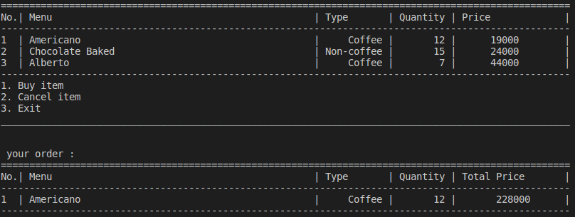

* 2. Cancel Item is just deleting all of your order (pop all)
* 3. Exit
* For **Admin** menu:

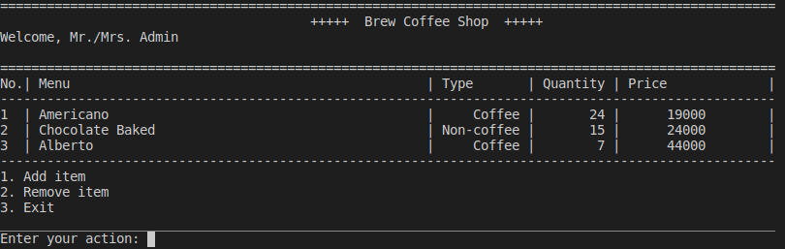

* 1. Add item
  + Length of name should be more than 5 and less than 20
  + Type of coffee only “yes” or “no” answer
  + Quantity >1 and <100
  + Price >10000 and < 200000

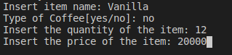

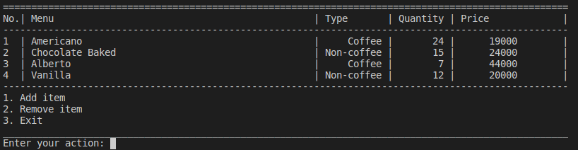

* 2. Remove item

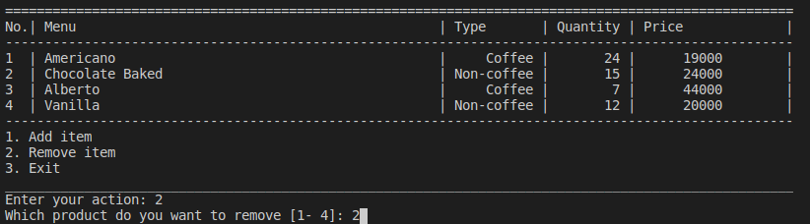

* + Only can choose the available number

